一、

1. 添加关键字

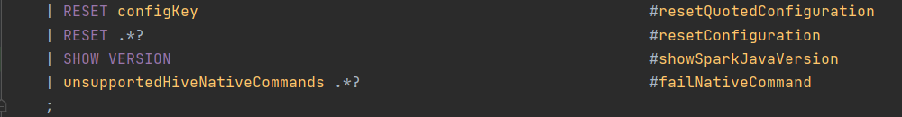

1. 在SparkSqlParser.scala添加visitShowSparkJavaVersion方法与样例类ShowSparkJavaVersionCommand()

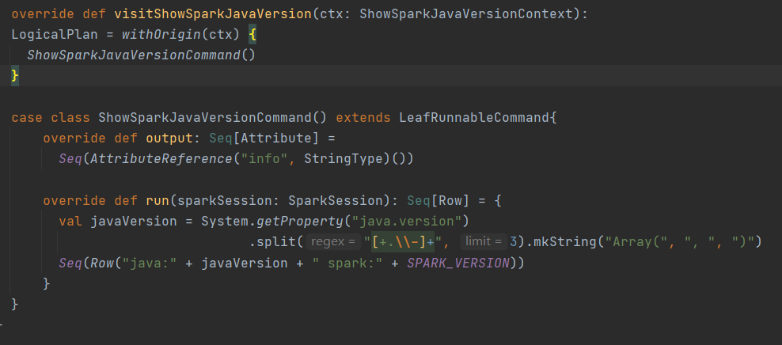

1. 编译spark

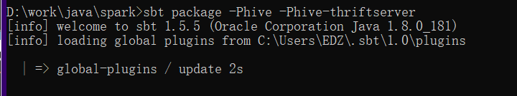

1. 运行spark-sql
2. 执行show version

二、

HIVE建表语句：

1.

1.1 规则说明

|  |  |
| --- | --- |
| CombineFilters | 合并两个相邻的filter |
| CollapseProject | 合并相邻的project |
| BooleanSimplification | 布尔值简化 |

1.2 SQL

SELECT user_name FROM ( SELECT id, user_name FROM user WHERE id > 1) WHERE id > 1 AND 1+1>1

1.3 运行结果

2.

2.1 规则说明

|  |  |
| --- | --- |
| ConstantFolding | 常量折叠 |
| PushDownPredicates | 谓词下推 |
| ReplaceDistinctWithAggregate | 将DISTINCT替换为聚合 |
| ReplaceExceptWithAntiJoin | 将EXCEPT替换为anti join |
| FoldablePropagation | 别名原始替换 |

2.2 SQL

SELECT 1+1 AS age, a.id, DISTINCT a.name AS name FROM (SELECT * FROM user) a WHERE a.id > 1 EXCEPT SELECT 1+1 as age, b.id, b.name FROM user_2 ORDER BY age

2.3 运行结果

三、