STUDENT CHECKLIST | SEPTEMBER 2026

AgentForge Student Prerequisites
Gemini API and Telegram bot preparation for the LIBA workshop
Please complete these two items before the session
You will use a lab computer during the workshop. The institute technology team will prepare the machine with Antigravity, Git, uv and the remaining software. You only need to arrive with access to your own Gemini API key and a Telegram bot that you created in advance.
Bring your phone
Keep your phone with you, signed in to Telegram and able to access your Google account. You may need your normal login or two step verification during the session.
Do not send either credential in advance
Your Gemini key and Telegram bot token work like passwords. Store them privately and enter them only when I guide you during the workshop.
Time required
Allow about 15 to 20 minutes. Complete the setup at least one day before the workshop so there is time to solve account or username issues.

Your two prerequisites
Finish both columns. Nothing else needs to be installed by you on the lab computer.
Gemini API | Telegram bot
Sign in to Google AI Studio | Install the official Telegram app on your phone
Create or locate one Gemini API key | Sign in and open the official @BotFather
Store the key privately | Create one bot with /newbot
Do not add billing unless told to | Record the bot username, numeric ID and token privately

What you need with you
- Your personal phone with Telegram installed and signed in
- Access to the Google account used for Google AI Studio
- Access to any verification method required by Google or Telegram
- A private password manager or secure note that only you can open

What the institute technology team handles
The lab team will prepare Antigravity, Git, uv, the AgentForge repository and all other machine-level software. Please do not spend time installing those tools on the lab computers before the session.

Credential rule
Do not paste your key or token into WhatsApp, email, a class group, a shared document, GitHub, a screenshot or a public AI chat. During the workshop, you will enter them locally when I ask you to.

Part 1 Create your Gemini API key
Google AI Studio is the official place to create and manage a Gemini API key.
Open: Google AI Studio API Keys page aistudio.google.com/apikey
1. Open the link and sign in with the Google account you will be able to access during the workshop.
2. Accept the Google AI Studio terms if this is your first visit.
3. Open the API Keys page. New users may already see a default project and key.
4. If you need a new key, select Create API key.
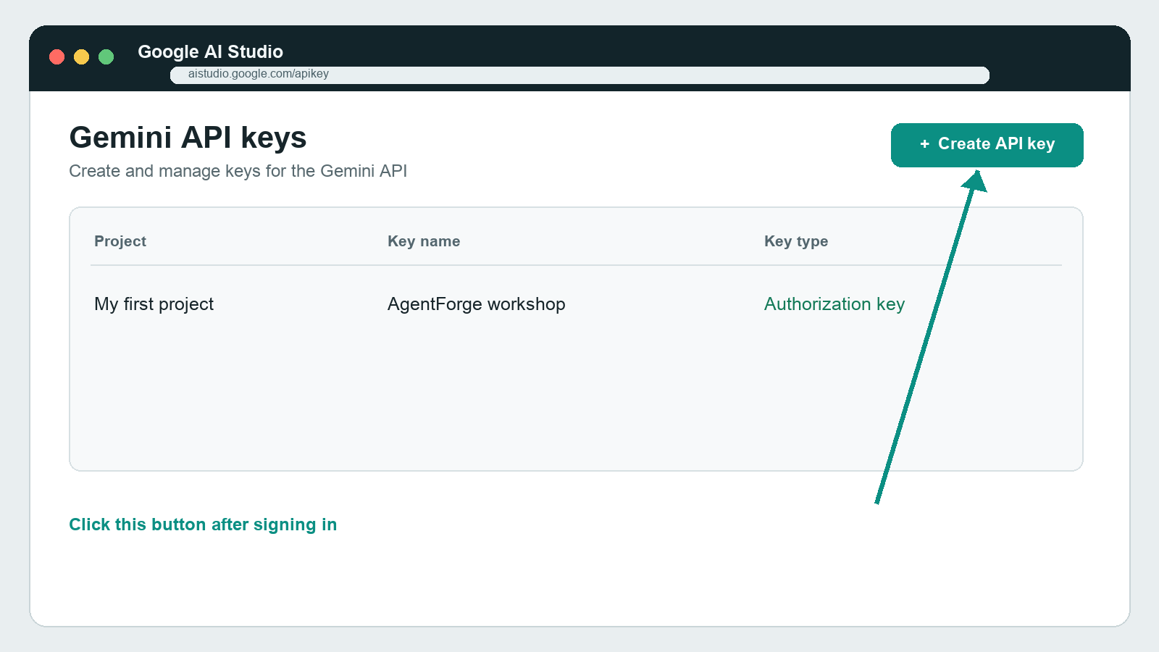
Illustrated screen guide based on the Google AI Studio API Keys page. Button placement may vary slightly.

Create and store the Gemini key
5. Choose your default project or another personal project that you control. If an institutional account blocks key creation, try your personal Google account or ask the workshop coordinator for help.
6. Give the key a clear name such as AgentForge workshop.
7. Select Create API key. Google currently creates new AI Studio keys as authorization keys.
8. Copy the key once and save it in your password manager or a private note. Do not include it in the document you submit for the workshop.
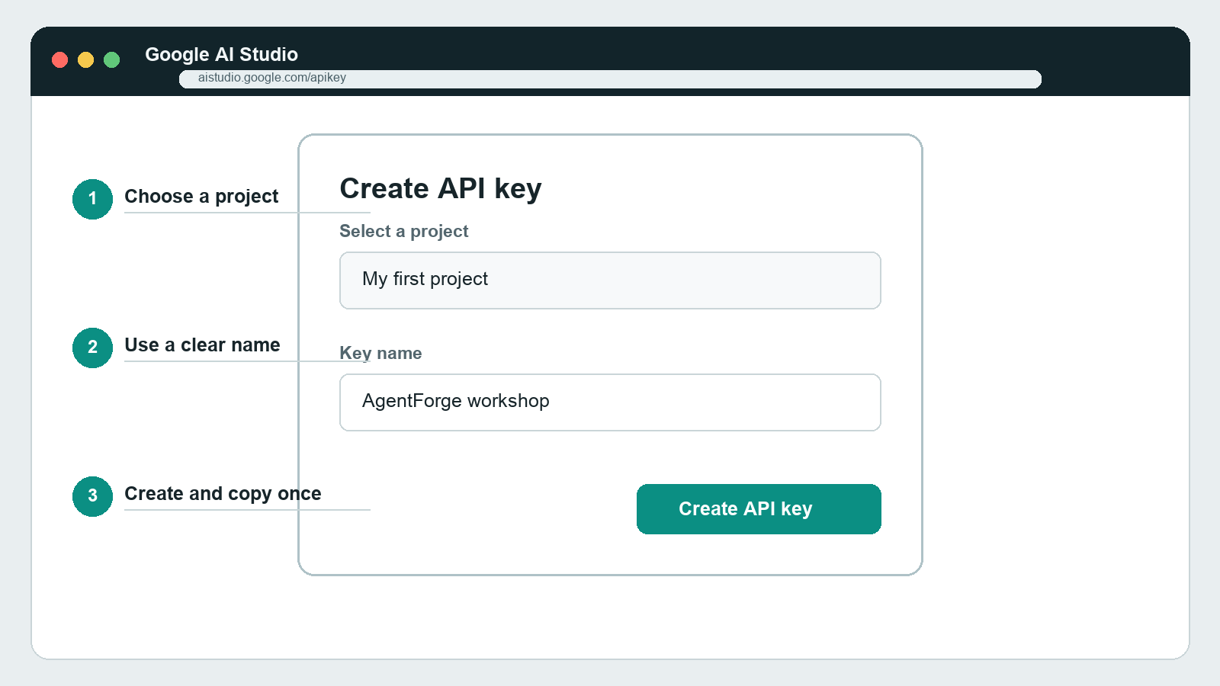
Illustrated screen guide for the key creation dialog. Never place a real key in a screenshot.

Billing
A paid subscription is not a student prerequisite for this workshop. Do not add a payment method or upgrade the project unless I or the institute gives you a separate instruction.

Your Gemini readiness check
☐ I can sign in to Google AI Studio.
☐ I can see a Gemini API key in the API Keys page.
☐ The key is stored privately and I can retrieve it during the session.
☐ I have not shared, photographed or committed the key anywhere.

Gemini problems you can solve before class
What you see | What to do
Create API key is unavailable | Use a personal Google account or ask the owner of the Cloud project for permission.
AI Studio asks you to accept terms | Read and accept the terms using the account you intend to use.
Your institute account is restricted | Use a personal account if permitted, or tell the workshop coordinator before the session.
A key is marked blocked | Create a new key in AI Studio. Do not reuse a blocked or exposed key.
You accidentally shared a key | Treat it as compromised. Generate a replacement and disable or revoke the exposed key.
AI Studio asks about billing | Stay on the free tier for this workshop unless the institute gives a separate instruction.

Why the key must remain private
Anyone who has the key may consume your project quota or create costs if billing is enabled. Google recommends keeping keys out of source control and client-side applications. AgentForge will read the key from a protected local environment when we connect it together.

Do not test by posting the key
You do not need to paste the key into a website, a public API tester or a chat to prove that it exists. Seeing the key in your AI Studio account and storing it securely is enough for the prerequisite.

Part 2 Install Telegram
Install the official Telegram app on your personal phone and sign in before creating the bot.
Official downloads: Telegram official apps page telegram.org/apps
1. Install Telegram from the official Telegram page, Google Play or the Apple App Store.
2. Sign in with the phone number you normally use for Telegram and complete Telegram's verification steps.
3. Confirm that you can open a chat and receive a message. Keep the app signed in for the workshop.
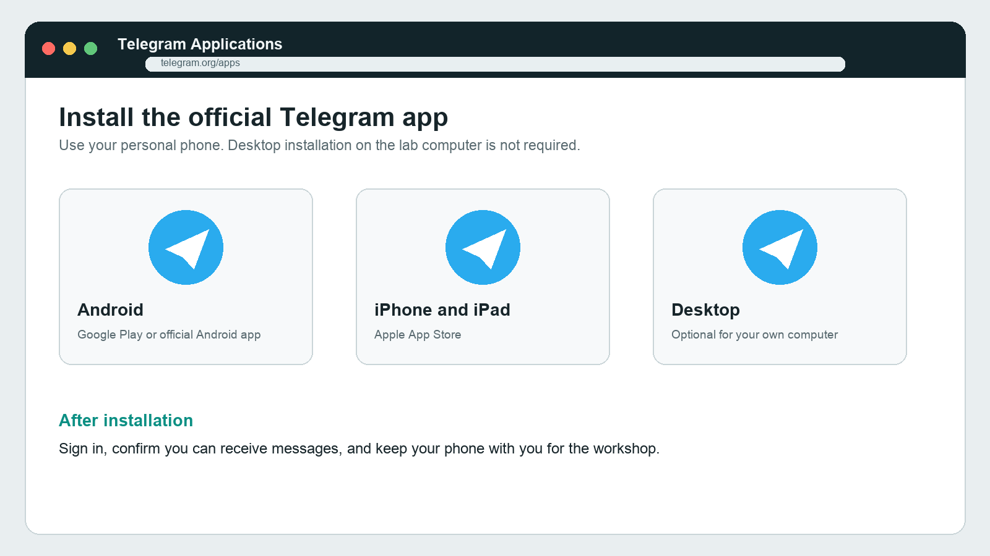
Illustrated screen guide for Telegram's official app choices.

Use your phone
Telegram Desktop is optional on your personal computer. You do not need to install or sign in to Telegram on the shared lab machine before class.

Create your Telegram bot with BotFather
Open the official bot: Official BotFather chat t.me/BotFather
1. In Telegram, search for @BotFather. Confirm the exact handle and the official verification mark before continuing.
2. Select Start, then send /newbot.
3. Choose a display name. A simple format is LIBA Team followed by your team number and AgentForge.
4. Choose a unique username that ends in bot. Example: liba_team12_agentforge_bot. If it is taken, add your section or another number.
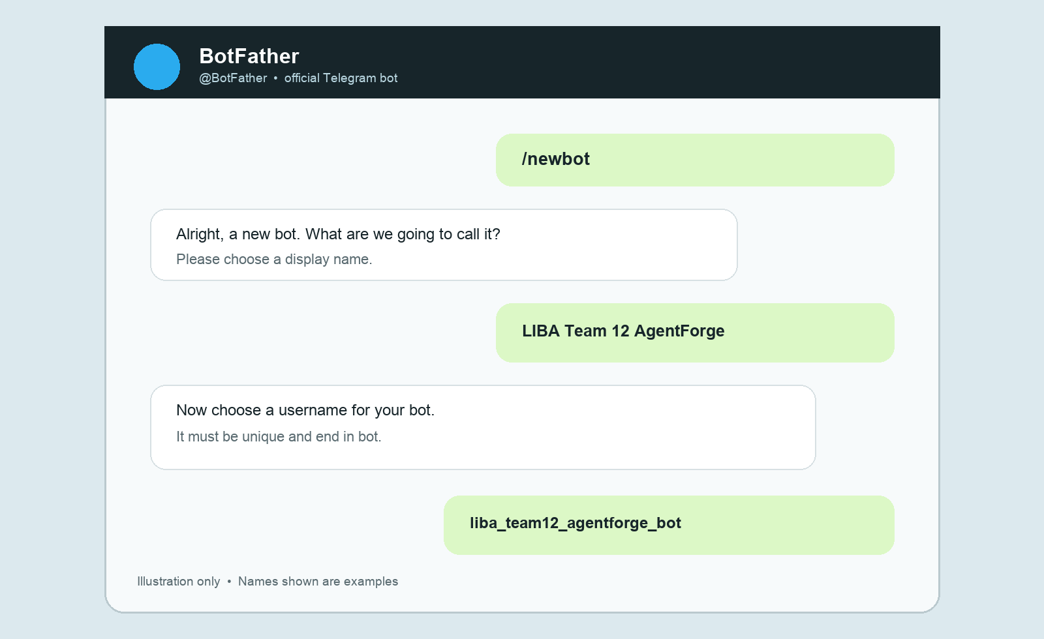
Illustrated BotFather conversation. The example name and username are fictional.
The bot may not reply to messages yet. That is expected. We will connect it to AgentForge together during the session.

Record the Telegram bot details
After the username is accepted, BotFather sends the bot's API token. Copy the details below into a password manager or private note that only you can access.
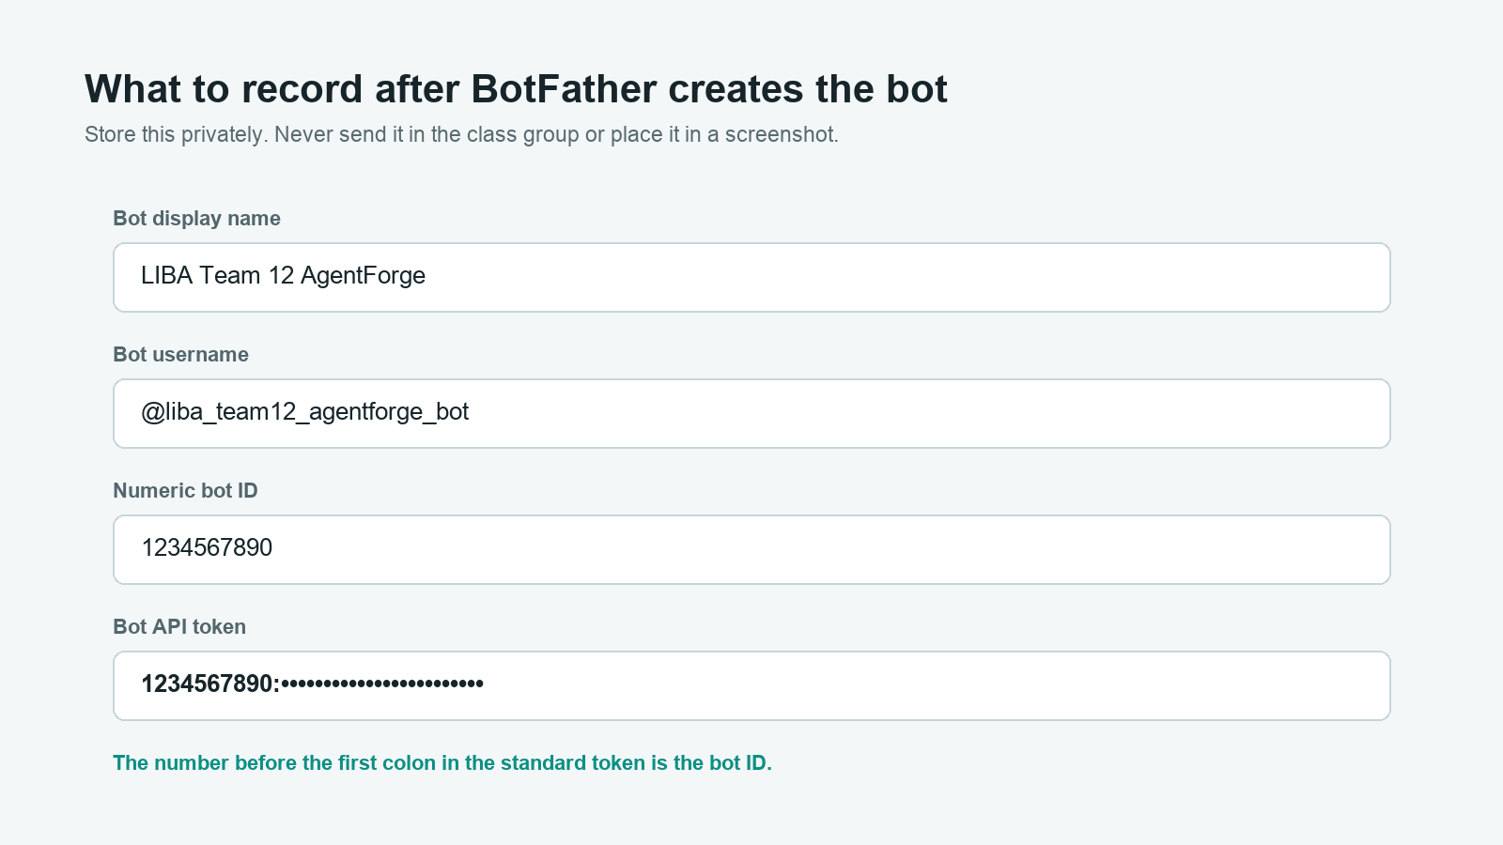
Illustrated credential record with a masked example token. Do not create a screenshot containing your real token.

The four details to keep
Detail | Example | Where it comes from
Display name | LIBA Team 12 AgentForge | The first name you give BotFather
Bot username | @liba_team12_agentforge_bot | The unique username accepted by BotFather
Numeric bot ID | 1234567890 | The digits before the first colon in the standard bot token
Bot API token | 1234567890:•••••• | The full private token returned by BotFather

Telegram safety and readiness

Do not create a Telegram developer application
AgentForge will use the Bot API token issued by BotFather. Students do not need a separate api_id or api_hash from my.telegram.org. The numeric bot ID can be verified automatically when we connect the token during the workshop.

If the token is exposed
Open BotFather and use its bot-management controls to revoke or regenerate the token. Save the replacement privately. Anyone with the token can control the bot.

Before class
☐ I can open the chat with the official @BotFather.
☐ I can open my new bot's Telegram profile using its username.
☐ My bot username is unique and ends in bot.
☐ My complete token is available in private storage.
☐ I have not posted the token or placed it in a screenshot.

A silent bot is normal
Creating a bot registers its identity and gives you the token. It does not give the bot AgentForge behavior yet. If you open the bot and it does not respond, your prerequisite can still be complete. We will connect and test the behavior together.

Final student readiness checklist
Complete this page at least one day before the workshop. Keep the credential values in your private storage; write only the non-secret details here.

Gemini
☐ I can sign in to Google AI Studio with the account I will use in class.
☐ I have one Gemini API key ready.
☐ The key is stored privately and has never been posted or shared.

Telegram
☐ The official Telegram app is installed and signed in on my phone.
☐ I created my bot using the official @BotFather.
☐ My bot username ends in bot and I can open its profile.
☐ I stored the bot username, numeric ID and complete token privately.
☐ I understand that the bot may stay silent until we connect it in class.

Bring to class
☐ My phone is charged and I can receive Google or Telegram verification prompts.
☐ I can open my private credential storage without asking someone else for access.
Student name __________________________________________
Section and team ________________________________________
Telegram bot username only @______________________________
Do not write your Gemini key or Telegram token on this page.

Send this message to students
You can copy and send this section with the document.
Hi everyone, before our AgentForge workshop, please complete two things: first, create a Gemini API key in Google AI Studio; second, install Telegram on your phone and create one bot using the official @BotFather. Keep both the Gemini key and Telegram bot token private. Do not send them to me or post them in the class group. Bring your phone and make sure you can access the Google account and Telegram account you used. The institute technology team will prepare Antigravity, Git, uv, AgentForge and the other software on the lab machines. Please finish the attached checklist at least one day before the session. We will connect your bot to AgentForge together during the workshop.

The confirmation students can send
Done. I have created my Gemini API key and Telegram bot, and I have stored both credentials privately. My bot username is @______________________. I will bring my phone and will not send either secret in this message.
Students should send only this confirmation and the bot username. They should never include the Gemini key or Telegram token.

Official references
- Google AI Studio API Keys
- Google Gemini API key documentation
- Telegram official applications
- Telegram BotFather tutorial
- Official BotFather
Instructions and interface labels checked on 4 September 2026. Screens may change slightly by device or account.

