ASSIGNMENT
2303A51595
B-10
PROMPT :
Write a Java console-based application for a retail store billing system.The program should accept the customer name, number of items purchased, and the price of each item.It should calculate the total bill amount, apply a discount based on the total purchase value (higher bill → higher discount),then calculate tax on the discounted amount and display the final payable bill clearly.The bill should show customer name, total amount, discount, tax, and final payable amount.The system should allow generating bills for multiple customers until the user chooses to exit.
CODE :
import java.util.Scanner;
public class Bank {
public static void main(String[] args) {
Scanner scanner = new Scanner(System.in);
String continueBilling;

do {
System.out.print("Enter customer name: ");
String customerName = scanner.nextLine();

System.out.print("Enter number of items purchased: ");
int itemCount = scanner.nextInt();
double totalAmount = 0;

for (int i = 1; i <= itemCount; i++) {
System.out.print("Enter price of item " + i + ": ");
double itemPrice = scanner.nextDouble();
totalAmount += itemPrice;
}

double discount = calculateDiscount(totalAmount);
double discountedAmount = totalAmount - discount;
double tax = calculateTax(discountedAmount);
double finalPayableAmount = discountedAmount + tax;

System.out.println("\n--- Bill Summary ---");
System.out.printf("Customer Name: %s%n", customerName);
System.out.printf("Total Amount: $%.2f%n", totalAmount);
System.out.printf("Discount: $%.2f%n", discount);
System.out.printf("Tax: $%.2f%n", tax);
System.out.printf("Final Payable Amount: $%.2f%n", finalPayableAmount);
System.out.println("---------------------\n");

scanner.nextLine(); // Consume newline
System.out.print("Do you want to generate another bill? (yes/no): ");
continueBilling = scanner.nextLine().trim().toLowerCase();
} while (continueBilling.equals("yes"));

scanner.close();
System.out.println("Thank you for using the billing system!");
}

private static double calculateDiscount(double amount) {
if (amount >= 500) {
return amount * 0.10; // 10% discount for bills >= $500
} else if (amount >= 200) {
return amount * 0.05; // 5% discount for bills >= $200
} else {
return 0; // No discount
}
}

private static double calculateTax(double amount) {
return amount * 0.07; // 7% tax
}
}

OUTPUT :

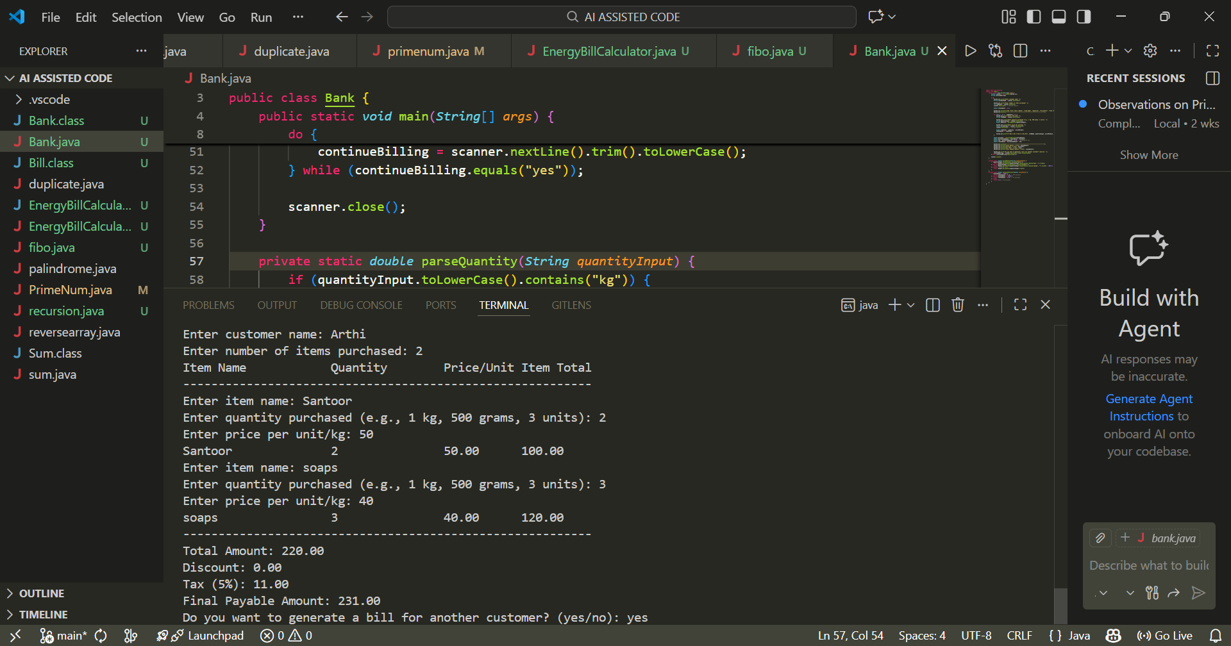

ANALYSIS :
This application reduces manual calculation errors and saves time for the cashier.
It makes billing faster, easier, and more accurate.
Using loops and conditions helps in handling multiple customers efficiently.
The program is simple, user-friendly, and suitable for small retail stores.
This project helped in understanding real-time use of Java concepts like Scanner, loops, and if-else conditions.

