ASSIGNMENT-1
2303a51595
B-10
Assignment 1: Maximum Non-Overlapping Meetings (Greedy)
Problem Statement :
You are given N meetings. Each meeting has a start time Si and an end time Ei. You wantto attend the maximum number of meetings. You can attend meeting j after meeting ionly if the start time of meeting j is strictly greater than the end time of meeting i (Sj>Ei). For each test case, output the maximum number of meetings that can be attended.

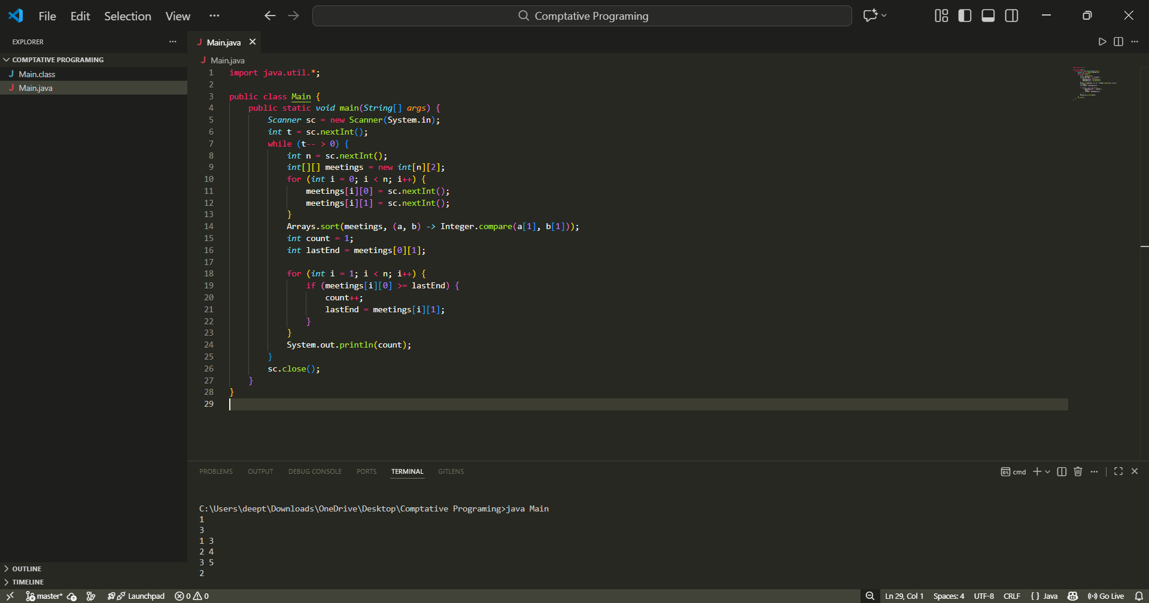
Assignment 2: Shelf Product Lookup (Divide and Conquer)
Problem Statement :
A supermarket maintains a sorted list of product IDs. For each query ID X, determinehow many times X appears in the list. You must solve using binarysearch style divideand conquer (find first occurrence and last occurrence).
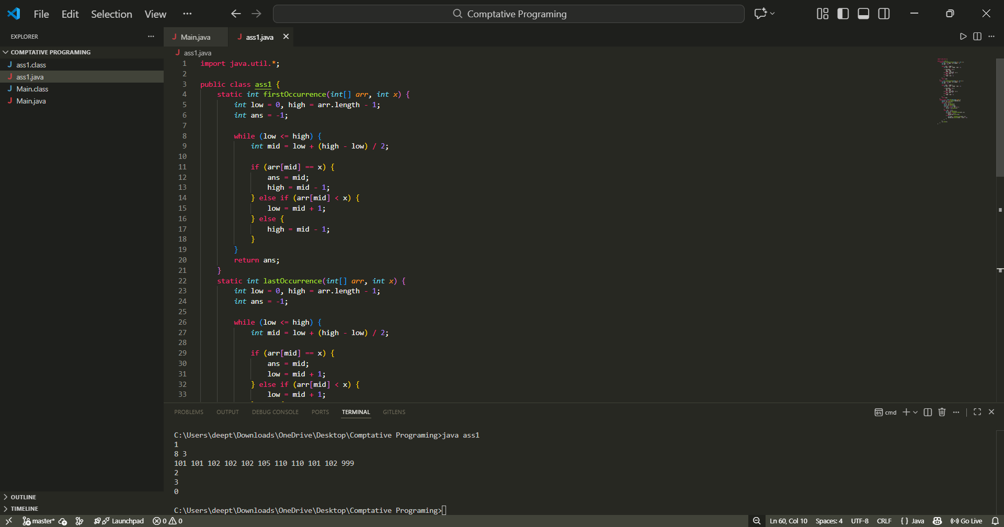

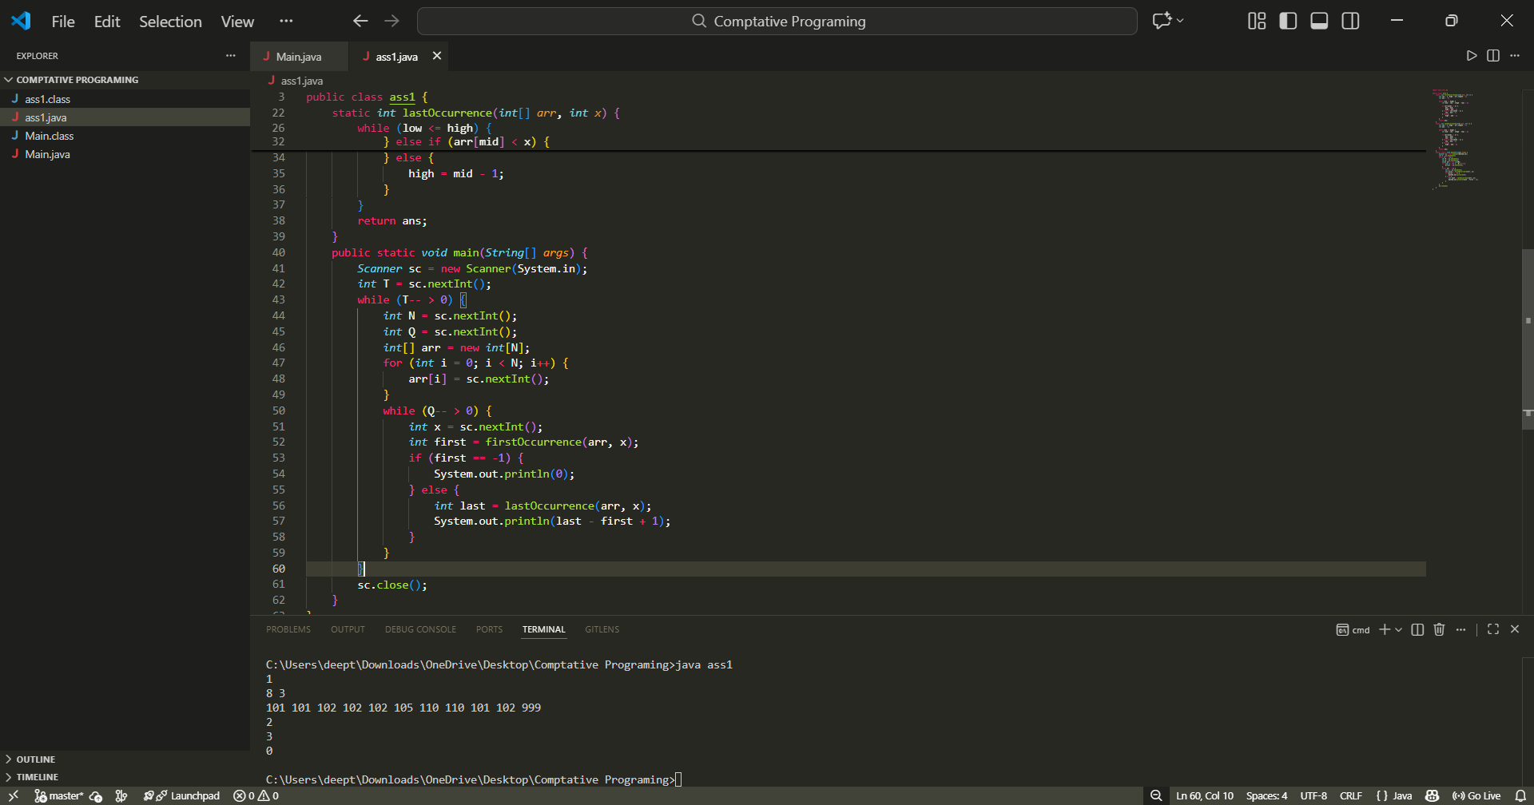
Assignment 3: Fractional Knapsack (Greedy)
Problem Statement :
You are given N items. Item i has value Vi and weight Wi. You have a knapsack of capacity W. You may take any fraction of an item (including the whole item). Your goalis to maximize the total value in the knapsack without exceeding the capacity. For each test case, output the maximum total value achievable. The result must be printed with
exactly 6 digits after the decimal point.
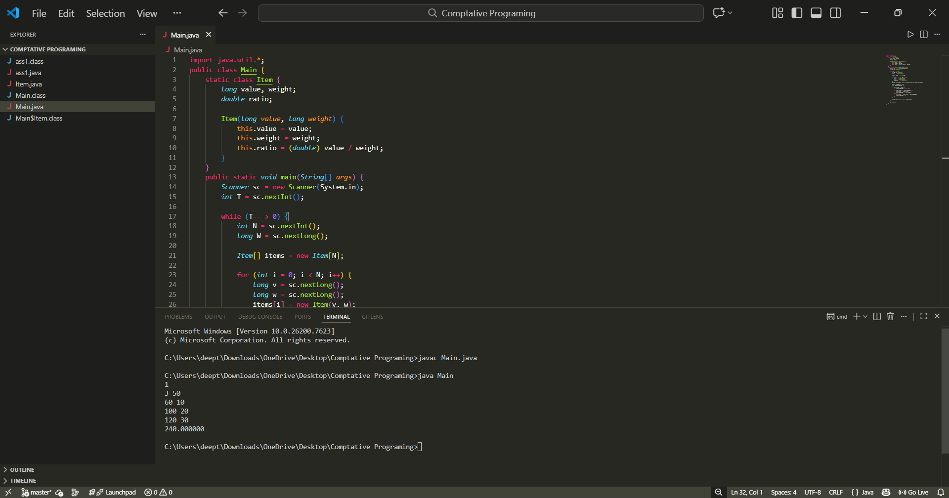

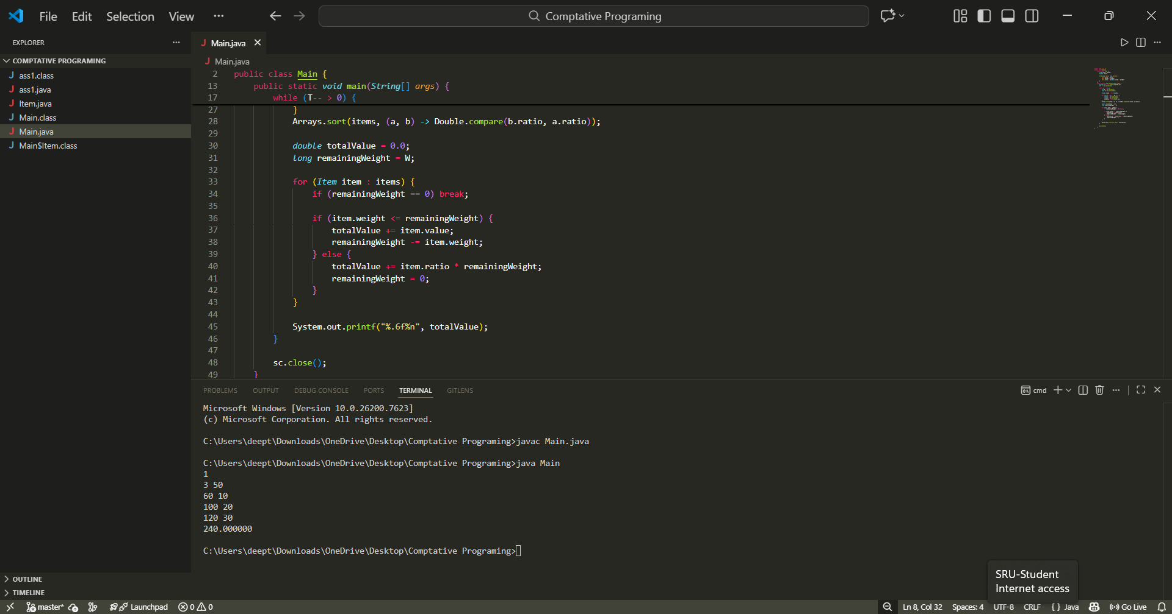

Assignment 4: Package Priority Sorting (Divide and Conquer)
Problem Statement :
A warehouse records package priority scores as integers. To dispatch efficiently, you must sort the scores in non-decreasing order using merge sort (divide and conquer). For each test case, output the sorted list.

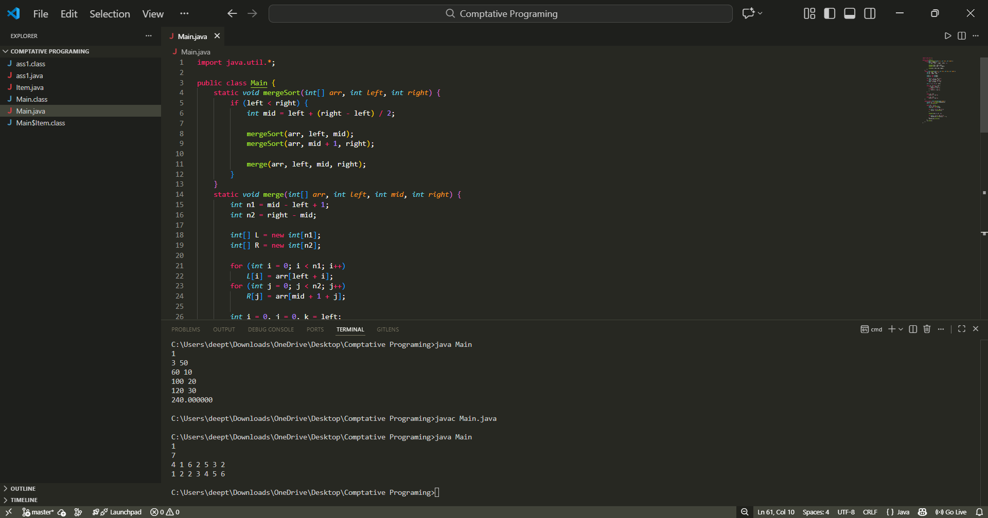

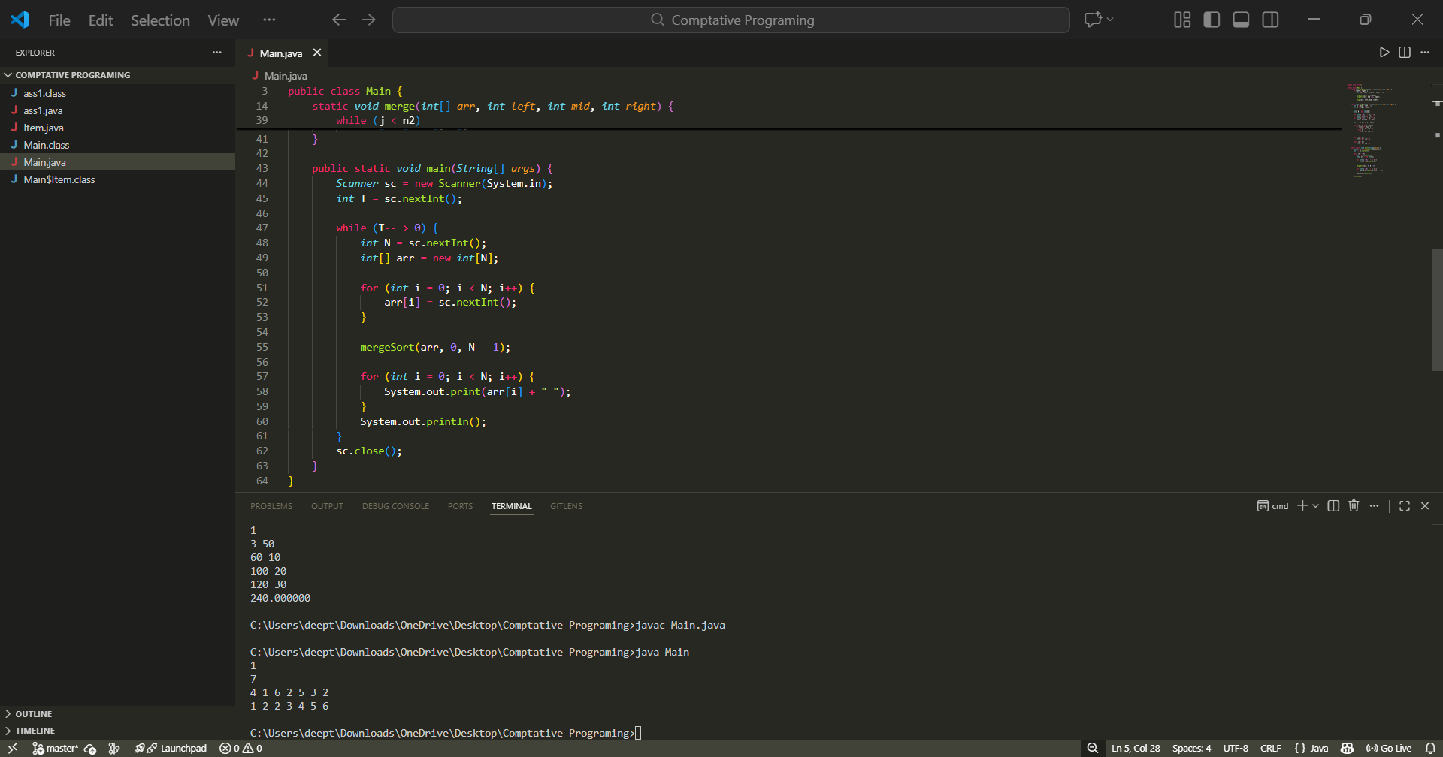
Assignment 5: Job Sequencing with Deadlines (Greedy)
Problem Statement :
You are given N jobs. Each job takes exactly 1 unit of time. Job i has a deadline Di and a profit Pi. If a job is completed on or before its deadline, its profit is earned; otherwise, it cannot be counted. You can perform at most one job at a time. Your task is to choose and schedule jobs to maximize total profit. For each test case, output: (1) the number of jobs completed (2) the maximum total profit
