Citizen Grievance Redressal and Public Service Management System
CivicPulse: AI-Powered Geospatial Governance & Municipal Accountability Platform
Comprehensive Engineering Project Report & Production System Architecture Blueprint
Domain: Full-Stack Engineering, Spatial GIS, Computer Vision & Distributed Systems
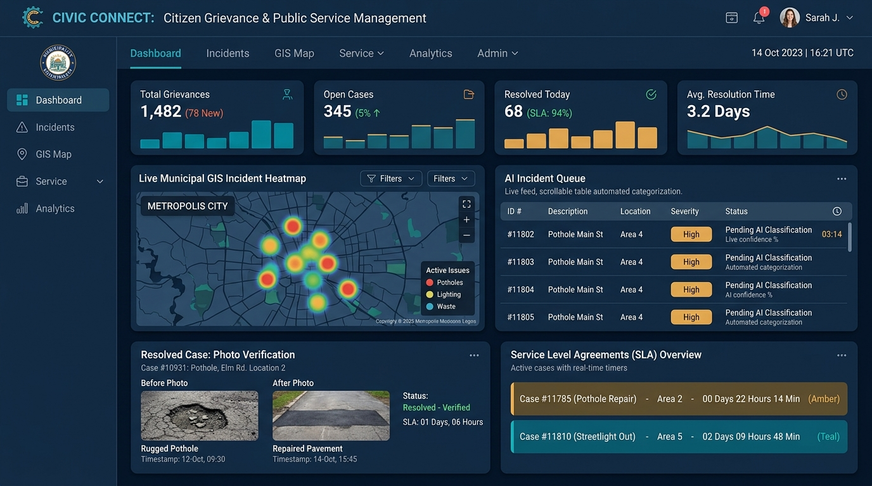
Figure 1.0: CivicPulse Municipal Command Center & AI Triage Dashboard Prototype

Table of Contents
Section | Title / Chapter | Document Anchor
1.0 | Executive Summary & Problem Definition | Section 1.0
2.0 | Next-Gen Enterprise Innovations & Differentiators | Section 2.0
3.0 | Software Requirements Specification (SRS) | Section 3.0
4.0 | Feasibility Analysis (Technical, Operational, Economic, Legal) | Section 4.0
5.0 | System Architecture & Event-Driven Microservices | Section 5.0
6.0 | UML System Modeling (Use Case, Sequence, State Machine) | Section 6.0
7.0 | Relational & Geospatial Database Design (PostgreSQL + PostGIS) | Section 7.0
8.0 | UI/UX Prototype Architecture & Interaction Design | Section 8.0
9.0 | Comprehensive Quality Assurance & Testing Plan | Section 9.0
10.0 | DevOps, Containerization & Cloud Deployment Plan | Section 10.0
11.0 | Maintenance, SLA Matrix & Incident Response Plan | Section 11.0
12.0 | Slide Deck Strategy & Oral Viva Defense Guide | Section 12.0

1.0 Executive Summary & Problem Definition
Citizens in modern urban environments routinely face severe delays, lack of transparency, and poor communication when reporting civic breakdowns such as potholes, water main leaks, defunct streetlights, and waste management failures. Existing municipal portals suffer from 'passive filing cabinet' syndrome: complaints are submitted into an unindexed queue, officers mark issues as closed without physical verification (ghost closures), contractor warranties are never tracked, and duplicate reports waste up to 40% of field worker dispatch time.
The proposed CivicPulse system introduces an AI-powered, geo-spatial, closed-loop public service platform. It combines real-time citizen intake (via Web PWA, Mobile, and Multilingual WhatsApp audio), automated Computer Vision triage, PostGIS spatial radius deduplication, dynamic hierarchical SLA escalation, and an AI Proof-of-Work resolution audit.
[CORE VALUE PROPOSITION] Transforming civic administration from a reactive, slow grievance box into an active, self-routing, transparent municipal nervous system.

2.0 Next-Gen Enterprise Innovations & Differentiators
Innovation | Technical Implementation & Real-World Impact
1. AI Proof-of-Work & Durability Audit | Uses semantic segmentation to compare Before & After photos to ensure genuine structural repair, starting a 90-day spatial monitoring window to penalize shoddy repairs.
2. Public Digital Twin & Warranty Ledger | Every road stretch or civic asset is mapped with contractor name and 3-year warranty status. If an asset fails during warranty, notices are dispatched to the contractor directly.
3. Passive Edge AI Fleet Sensing | Municipal vehicles (buses/garbage trucks) equipped with smartphone cameras running lightweight YOLO models passively detect potholes and cracks before citizens report.
4. Multilingual Voice-to-Action AI | Citizens send WhatsApp voice notes in native languages. OpenAI Whisper + LLMs transcribe and extract structured category, severity, and landmark data automatically.
5. Crisis Mode & Emergency Disaster Triage | Switches system state during severe monsoons/floods to prioritize electrical hazards, fallen trees, and waterlogging with live public safety routing.

3.0 Software Requirements Specification (SRS)

3.1 Functional Requirements (FR)
ID | Requirement Name | Functional Specification
FR-01 | Multimedia Grievance Intake | Capture GPS coordinates, timestamp, category, and photo/video evidence from Web, Mobile, or WhatsApp.
FR-02 | AI Auto-Triage & Scoring | Analyze imagery and text to score severity (1-5) and classify category with >90% target precision.
FR-03 | Spatial Radius Deduplication | Perform PostGIS ST_DWithin query within 50m radius to attach citizen to existing Master Tickets.
FR-04 | Ward Boundary Polygon Routing | Map GPS points to ward boundaries via ST_Contains and assign directly to the ward field engineer.
FR-05 | Dynamic Hierarchical SLA Engine | Track countdown timers; trigger automatic escalation from Officer to Ward Engineer to Commissioner.
FR-06 | Geo-Tagged Resolution Verification | Field officers must upload an 'After' photo within 15m of incident GPS; citizen verifies via OTP or confirmation.
FR-07 | Civic Karma & Feedback Rating | Citizens rate resolution quality (1-5 stars) and earn gamified civic reputation points for verified reporting.

3.2 Non-Functional Requirements (NFR)
Category | Non-Functional Standard & Target Metric
Performance | API response time < 250ms for core endpoints; AI image inference < 1.5s per submission.
Scalability | Support 10,000+ concurrent active requests during monsoon emergencies using horizontal autoscaling.
Security | Role-Based Access Control (RBAC with JWT), AES-256 encrypted media store, and GPS coordinate anti-tamper validation.
Availability | 99.9% uptime with Redis failover and automated daily spatial database snapshots.

4.0 Feasibility Analysis
Feasibility Dimension | Analysis & Risk Mitigation
Technical Feasibility | High. Open-source, production-grade stacks (Next.js, FastAPI/Node.js, PostgreSQL+PostGIS, YOLO/MobileNet) eliminate reliance on proprietary tooling.
Economic Feasibility | High. Zero-licensing cost with serverless free-tier deployments (Vercel, Supabase, Neon) and open-source models; minimal operational overhead.
Operational Feasibility | High. Tailored role-based interfaces for citizens, field officers, and supervisors minimize onboarding friction; WhatsApp integration removes digital literacy barriers.
Legal & Compliance | Compliant with Data Protection Acts (GDPR/DPDP), municipal accountability mandates, and zero-knowledge privacy filters for sensitive reports.

5.0 System Architecture & Event-Driven Microservices
CivicPulse employs an Event-Driven Microservices Architecture designed for high availability, decoupled processing, and sub-second responsiveness. Incoming requests are ingested via an API Gateway, authenticated with JWT, and broadcast across an asynchronous Redis message broker.
+-----------------------------------------------------------------------+
| CLIENT ACCESS LAYER |
| Citizen Web PWA (Next.js) | Mobile App (Flutter) | WhatsApp Webhook |
+-----------------------------------+-----------------------------------+
|
v
+-----------------------------------------------------------------------+
| API GATEWAY & AUTH (JWT) |
+-----------------------------------+-----------------------------------+
|
+-----------------+-----------------+
| |
v v
+-----------------------------------+ +-------------------------------+
| CORE GRIEVANCE SERVICE | | AI & VISION SERVICE |
| - Ticket Lifecycle Management |<->| - Computer Vision Triage |
| - PostGIS Spatial Routing Engine | | - NLP Embeddings Deduplication|
| - Dynamic SLA Escalation Worker | | - Whisper Voice Transcription|
+-----------------+-----------------+ +---------------+---------------+
| |
+-----------------+-------------------+
|
v
+-----------------------------------------------------------------------+
| DATA & PERSISTENCE LAYER |
| - PostgreSQL 16 + PostGIS (Spatial Polygons, GIST Spatial Indexing) |
| - Redis 7 (Async SLA Countdown Queues, Real-time WebSockets) |
| - AWS S3 / Cloudflare R2 (Encrypted Geo-Tagged Evidence Store) |
+-----------------------------------------------------------------------+

6.0 UML System Modeling & Specifications
Citizen Frontend API Gateway AI Service PostGIS DB Officer
| | | | | |
|-- 1. Upload Photo -->| | | | |
| & GPS Location |-- 2. POST Ticket -->| | | |
| | |-- 3. Infer Image->| | |
| | |<- 4. Category/Sev-| | |
| | |-- 5. ST_DWithin (50m Radius) ------>| |
| | |<- 6. No Duplicate / New Issue ------| |
| | |-- 7. ST_Contains (Ward Polygon) --->| |
| | |-- 8. Enqueue SLA & Save ------------>| |
| | |-- 9. Push Notification -------------------------------->|
| |<- 10. Ticket Created-| |
|<- 11. Tracking Card -| | |

State | Lifecycle Transition Trigger & Behavior
SUBMITTED | Initial state upon citizen report; triggers background AI triage and spatial deduplication check.
ACKNOWLEDGED | Passed spatial check, assigned to designated Ward Field Engineer based on polygon mapping.
IN_PROGRESS | Field team dispatched on-site; real-time SLA countdown active.
RESOLVED | Field officer has uploaded geo-validated 'After' photo within 15m; awaiting citizen review/OTP.
CLOSED | Citizen confirmed satisfaction or 48-hour auto-close timer elapsed with positive audit score.
ESCALATED | SLA time-to-resolve threshold breached; transferred to Ward Supervisor or Municipal Commissioner.

7.0 Relational & Geospatial Database Design (PostgreSQL + PostGIS)
-- Enable Spatial Extensions
CREATE EXTENSION IF NOT EXISTS postgis;
-- 1. Municipal Wards (Polygon Boundaries)
CREATE TABLE wards (
id UUID PRIMARY KEY DEFAULT gen_random_uuid(),
ward_number VARCHAR(20) UNIQUE NOT NULL,
ward_name VARCHAR(100) NOT NULL,
boundary GEOMETRY(Polygon, 4326) NOT NULL,
supervisor_id UUID REFERENCES users(id)
);
-- 2. Grievance Master Table with Spatial Indexing
CREATE TABLE grievances (
id UUID PRIMARY KEY DEFAULT gen_random_uuid(),
ticket_no VARCHAR(30) UNIQUE NOT NULL,
citizen_id UUID NOT NULL REFERENCES users(id),
ward_id UUID REFERENCES wards(id),
assigned_officer_id UUID REFERENCES users(id),
title VARCHAR(200) NOT NULL,
description TEXT,
category VARCHAR(50) NOT NULL,
severity VARCHAR(20) DEFAULT 'MEDIUM',
status VARCHAR(20) DEFAULT 'SUBMITTED',
geom GEOMETRY(Point, 4326) NOT NULL,
address TEXT,
sla_deadline TIMESTAMP WITH TIME ZONE NOT NULL,
is_duplicate BOOLEAN DEFAULT FALSE,
master_ticket_id UUID REFERENCES grievances(id),
created_at TIMESTAMP WITH TIME ZONE DEFAULT NOW()
);
CREATE INDEX idx_grievances_geom ON grievances USING GIST (geom);
-- 3. Spatial Deduplication Query Function (50m Radius)
SELECT id, ticket_no, ST_Distance(geom, ST_SetSRID(ST_MakePoint(77.5946, 12.9716), 4326)::geography) AS distance_meters
FROM grievances
WHERE status NOT IN ('CLOSED', 'RESOLVED')
AND category = 'POTHOLE'
AND ST_DWithin(geom::geography, ST_SetSRID(ST_MakePoint(77.5946, 12.9716), 4326)::geography, 50);

8.0 UI/UX Prototype Architecture & Interaction Design
Color & Hex Code | UI Role / Application | Psychological & Functional Rationale
Deep Navy (#1B3A5C) | Primary Brand & Sidebar | Communicates institutional authority, trust, and structural stability.
Teal (#1C7293) | Interactive Elements & Tabs | Represents modern civic technology, active states, and call-to-action buttons.
Warm Amber (#F5A623) | SLA Alerts & High Severity | Immediately draws attention to pending triage and near-breach SLA timers.
Emerald (#2ECC71) | Resolved Status & Verification | Indicates verified completion and positive civic karma metrics.
Dark Slate (#0F172A) | Command Center Canvas | Reduces visual fatigue for municipal operators monitoring 8-hour live feeds.

9.0 Comprehensive Quality Assurance & Testing Plan
Testing Level | Tooling Framework | Verification Scope & Acceptance Criteria
Unit Testing | Jest & PyTest | Validates spatial query calculations, SLA deadline generation, password hashing, and JWT token validation (>85% target coverage).
Integration Testing | Supertest & Postman | Tests end-to-end chains: S3 image upload -> AI inference microservice -> PostgreSQL spatial insert -> Redis queue.
System & Load Testing | Apache JMeter & k6 | Simulates 10,000 concurrent citizen submissions during extreme weather/monsoons; ensures p95 latency < 500ms.
User Acceptance (UAT) | Field Pilot Group | Conducted with 25 diverse citizens and 5 municipal ward officers to validate offline photo capture and UX friction.

10.0 DevOps, Containerization & Cloud Deployment Plan
DevOps Component | Technology Choice | Production Implementation Details
Containerization | Docker & Docker Compose | Multi-stage builds separating frontend, core API, AI inference engine, and Redis message queue into isolated containers.
CI/CD Automation | GitHub Actions | Triggers automated linting, test suite execution, Docker container build, and deployment to staging on git push.
Frontend Hosting | Vercel / AWS CloudFront | Global Edge CDN deployment for static asset caching and sub-100ms PWA loading times.
Backend Hosting | AWS ECS (Fargate) / Render | Serverless container execution with auto-scaling triggers based on CPU/Memory load thresholds.
Managed Database | Supabase / AWS RDS PostGIS | Automated point-in-time recovery, multi-AZ replication, and spatial query optimization.

11.0 Maintenance, SLA Matrix & Incident Response Plan
Maintenance Category | Operational Execution & SLA
Corrective Maintenance | 24/7 automated error capturing via Sentry; P0 bug hotfixes deployed within 4 hours.
Adaptive Maintenance | Quarterly updates to ward boundary GIS polygons and municipal administrative jurisdiction changes.
Perfective Maintenance | Bi-annual retraining of the Computer Vision model using anonymized, validated citizen grievance photos.
Preventive Maintenance | Automated weekly database VACUUM ANALYZE operations on spatial indices; log rotation and archive policies.

12.0 Slide Deck Strategy & Oral Viva Defense Guide
Examiner Viva Question | Winning Model Answer & Technical Justification
Q: How do you prevent citizens from spamming fake complaints? | A: Three-layer defense: 1) Computer Vision validates civic defect category (>80% confidence); 2) EXIF metadata matches device GPS; 3) Verified phone auth with Civic Karma limits unverified volume.
Q: What happens if 50 citizens report the same fallen tree? | A: PostGIS ST_DWithin query checks for active tickets of same category within 50m. All 50 citizens are attached as subscribers to one Master Ticket, preventing 49 wasted municipal dispatches.
Q: How do you stop field officers from taking fake 'Resolved' photos? | A: Officer app captures GPS hardware coordinates at the moment of photo upload and verifies officer is within 15m of the incident location before unlocking ticket closure.

