Telco Customer Churn Analysis Using R Data Visualization
Week 2 Task – Data Visualization and Insight Communication using R

1. Data Overview
The Telco Customer Churn dataset contains 7,043 customer records and information about customer demographics, services, contract details, tenure, monthly charges, total charges, and churn status. The overall churn rate in the dataset is 26.54%. The average monthly charge is 64.76, while the median customer tenure is 29 months.
During data preparation, TotalCharges was converted from text to numeric form because some entries were blank. This produced 11 missing numeric TotalCharges values. 0 duplicate rows were detected.

2. Key Variables
Variable | Description
tenure | Number of months the customer has stayed with the company
MonthlyCharges | Monthly amount charged to the customer
TotalCharges | Total amount charged over the customer relationship
Contract | Customer contract duration/type
InternetService | Internet service subscribed by the customer
PaymentMethod | Method used to pay the bill
Churn | Whether the customer left the service (Yes/No)

3. Visualization Design and Insights

1. Customer Count by Contract Type
A bar chart was selected to compare the number of customers across contract types. It provides a simple view of the customer base composition and shows that month-to-month contracts form a major portion of the dataset.
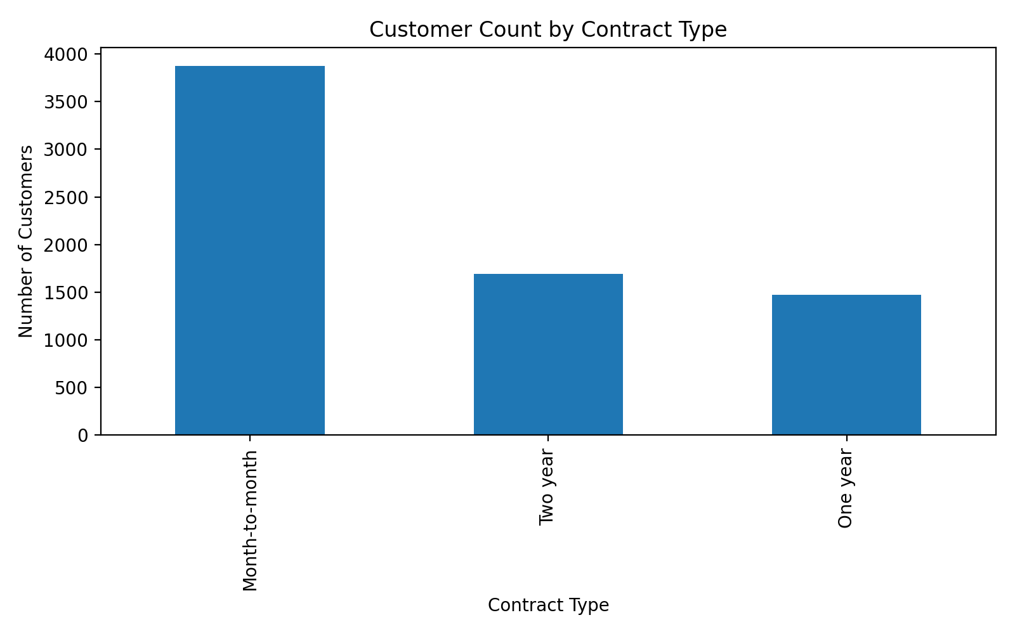

2. Churn Distribution by Contract Type
A 100% stacked bar chart was used to compare churn proportions rather than raw counts. The visualization highlights the substantially higher churn tendency among month-to-month customers compared with customers on longer contracts.
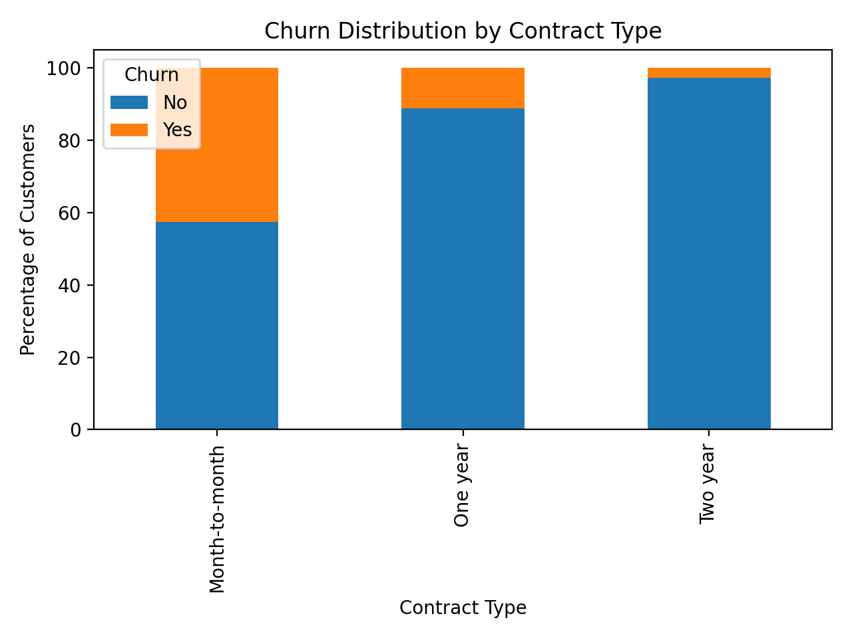

3. Distribution of Monthly Charges
A histogram was selected to show how monthly charges are distributed. It helps identify the common charging range and the overall spread of customer billing amounts.
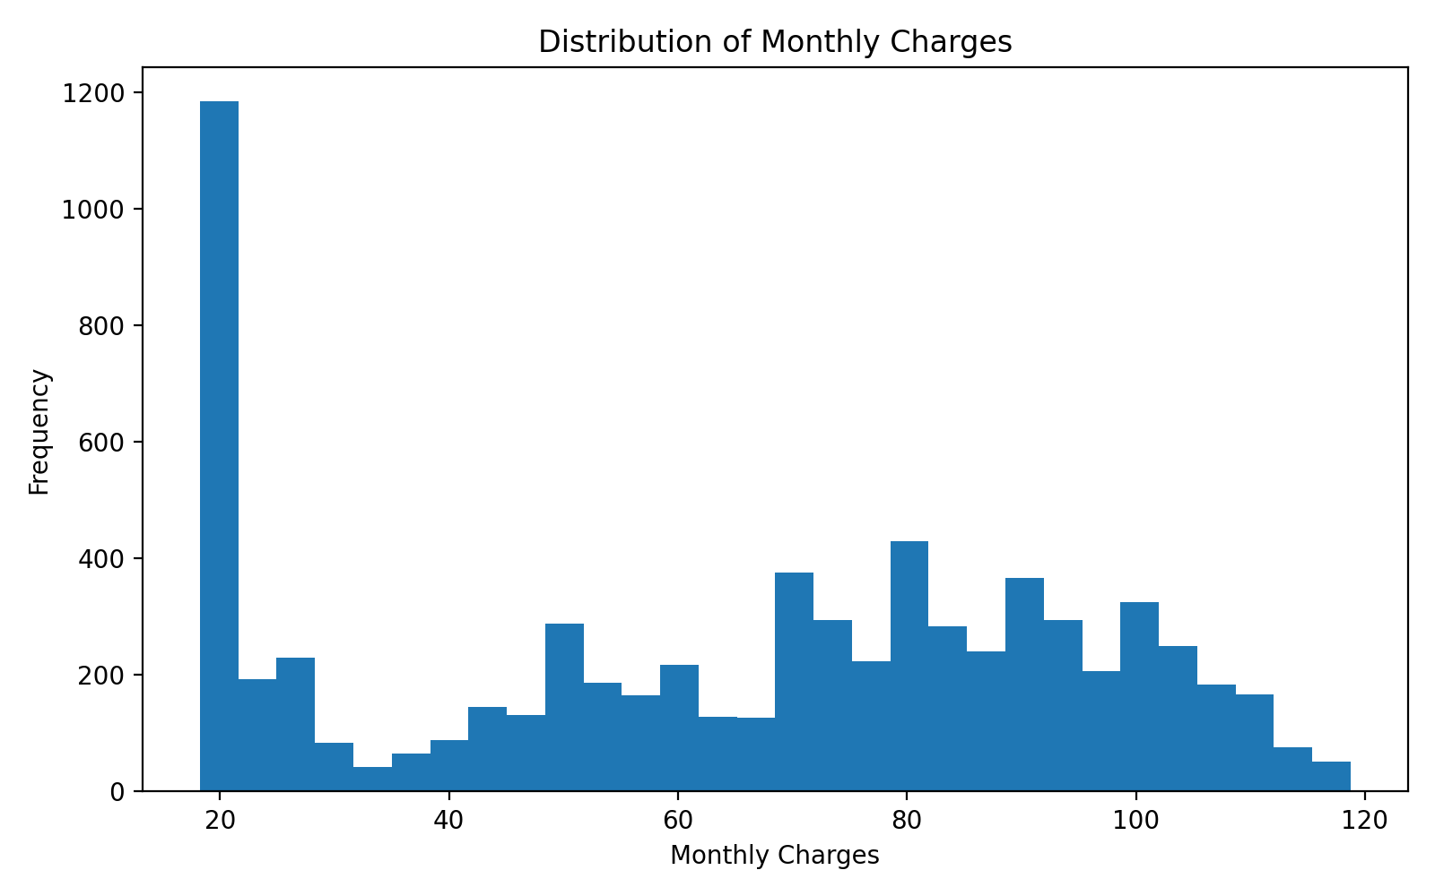

4. Monthly Charges by Churn Status
A box plot compares the distribution of monthly charges for customers who stayed and those who churned. It makes differences in the median, spread, and possible extreme values easier to identify.
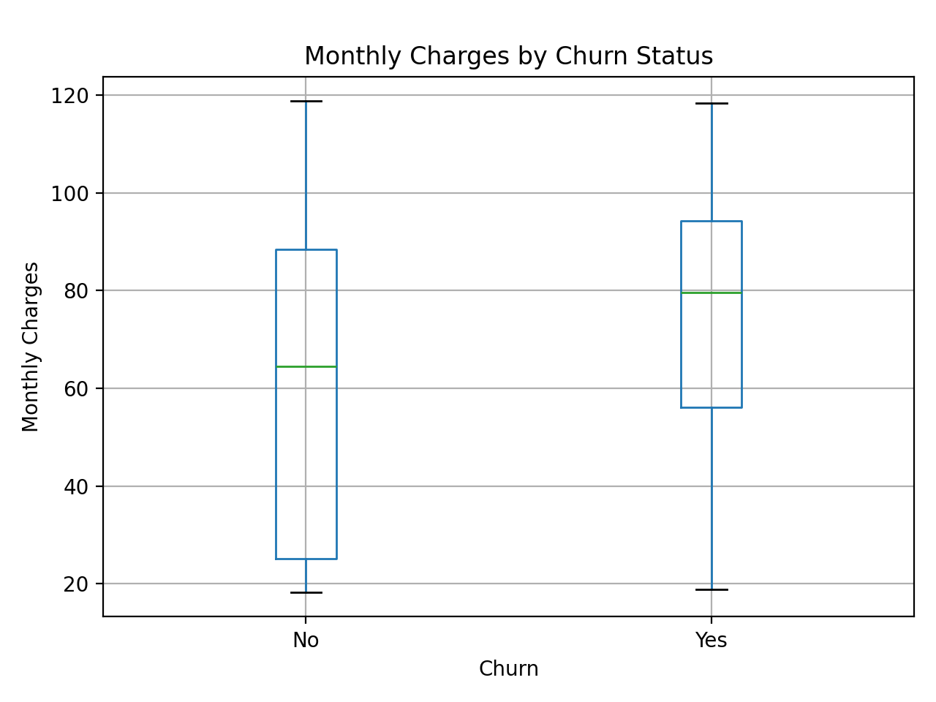

5. Tenure vs Total Charges
A scatter plot was chosen to study the relationship between customer tenure and total charges. A clear upward relationship is expected because customers who stay longer generally accumulate more total charges. Churn status adds another dimension for comparison.
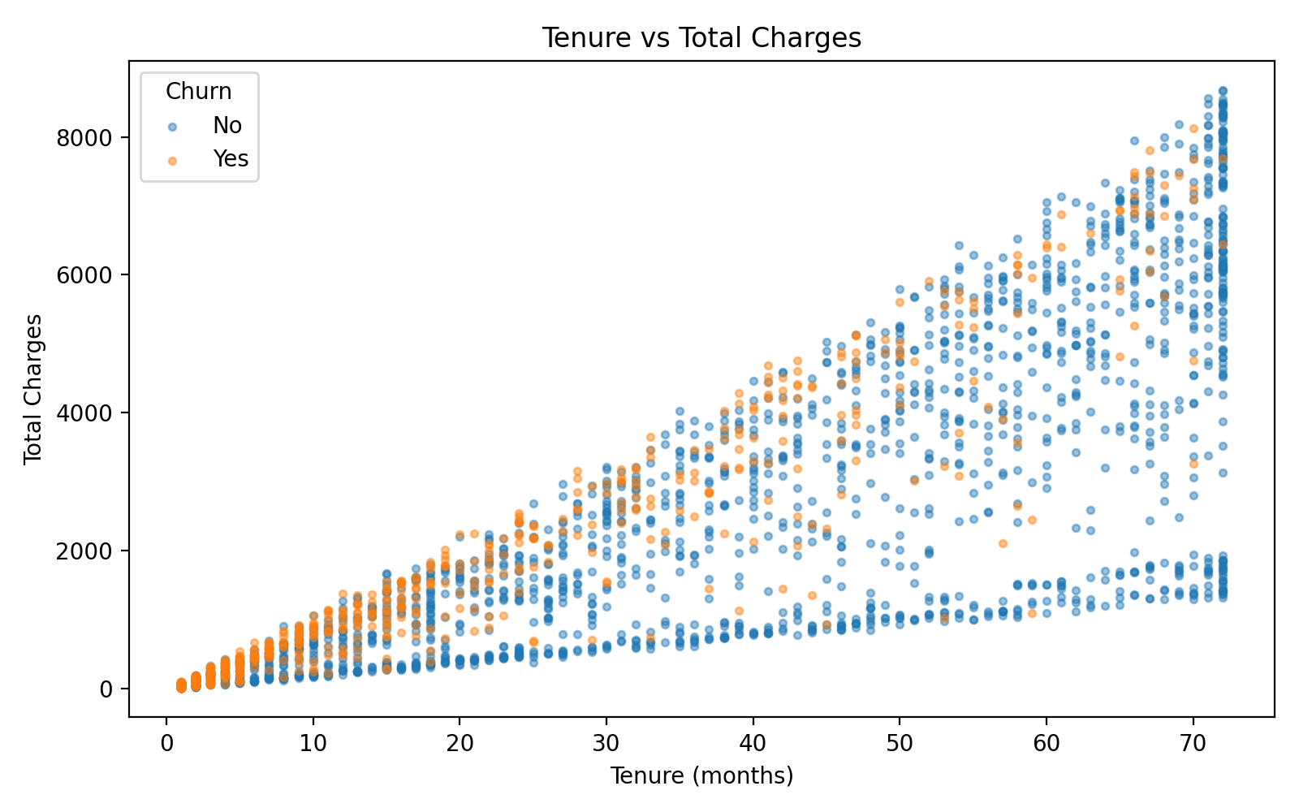

6. Churn Distribution by Internet Service
A proportional bar chart compares churn across internet-service categories. This helps identify whether churn is concentrated in particular service groups.
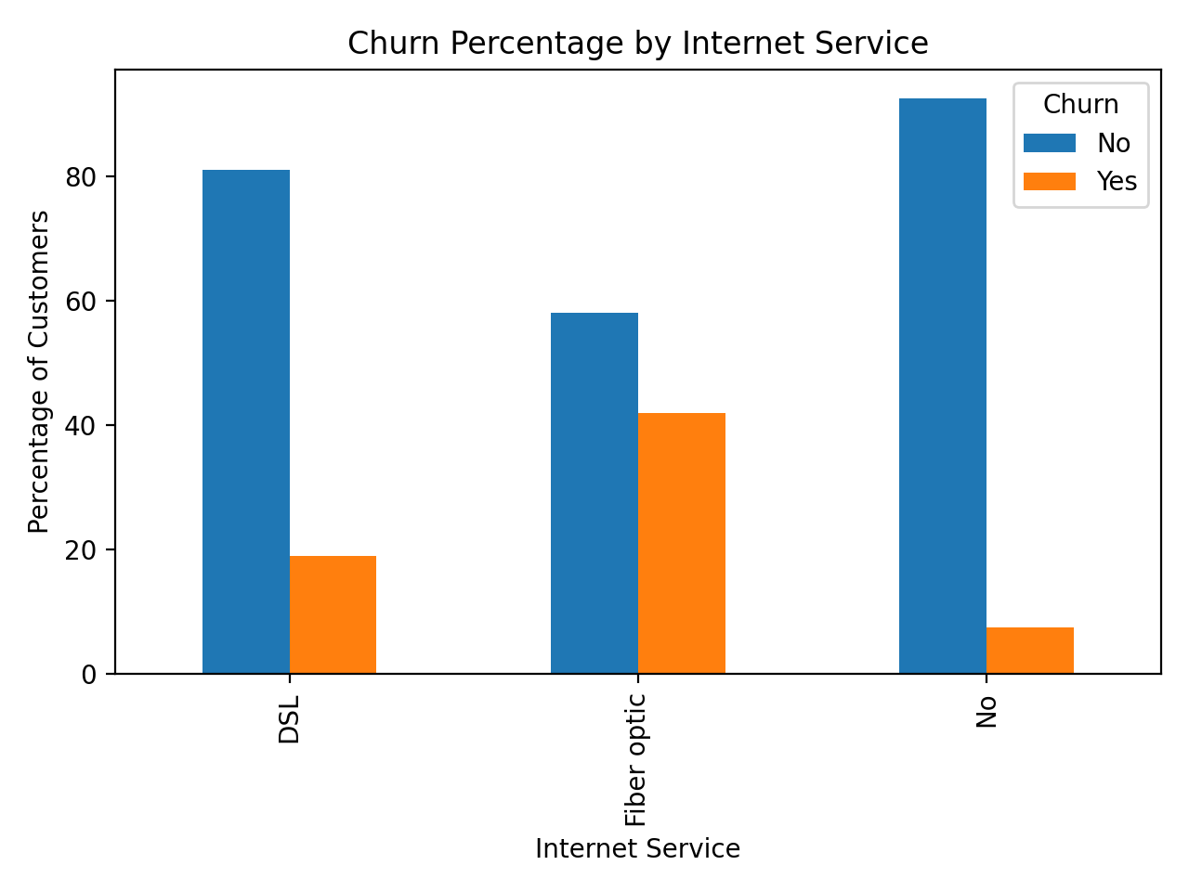

7. Churn Rate by Customer Tenure
A line chart was used because tenure is ordered numerically. It shows how churn rate changes as customers move from short-term to long-term relationships.
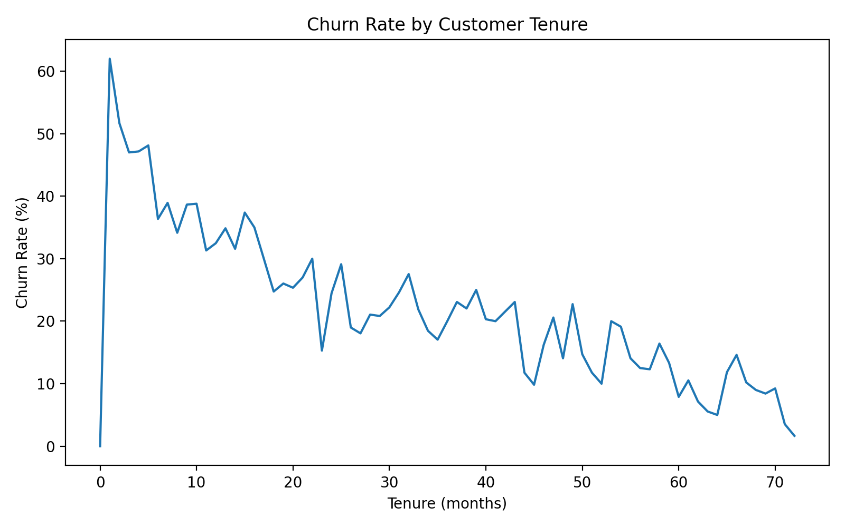

8. Churn Rate by Payment Method
A horizontal bar chart makes long payment-method labels easy to read and allows direct comparison of churn rates among payment methods.
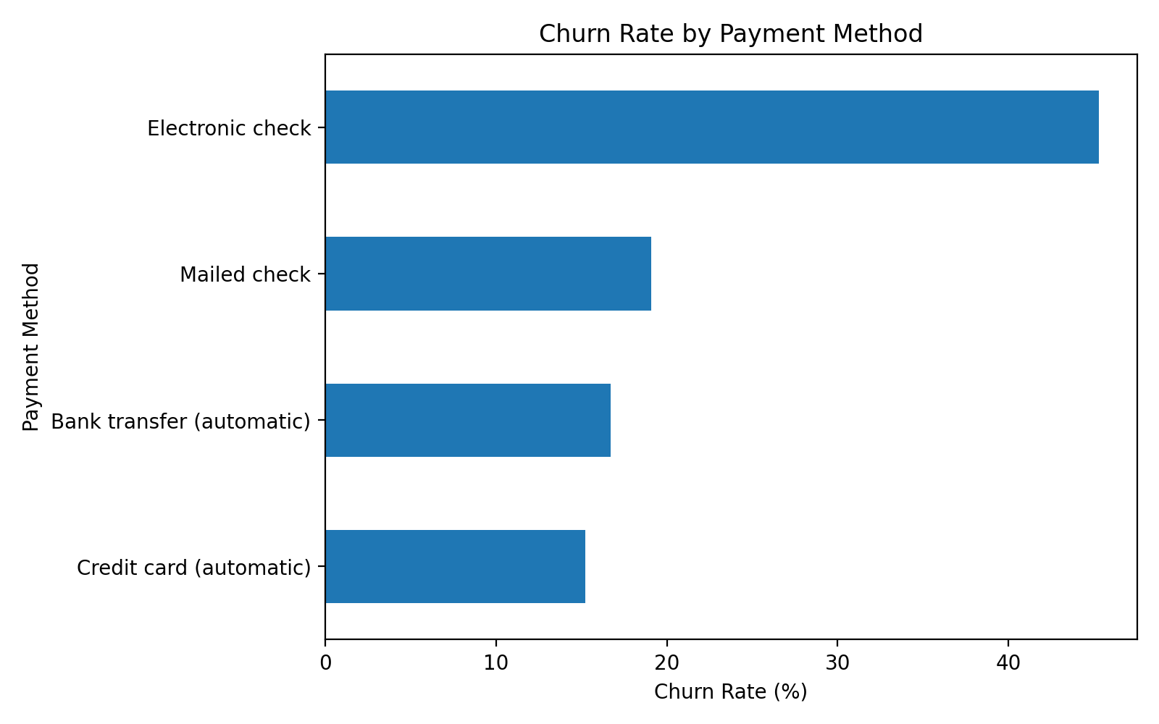

4. R Code
# Week 2 - Telco Customer Churn Visualization
library(ggplot2)
library(dplyr)
library(readr)

telco <- read_csv("WA_Fn-UseC_-Telco-Customer-Churn.csv")
telco$TotalCharges_num <- as.numeric(telco$TotalCharges)
telco$ChurnFlag <- ifelse(telco$Churn == "Yes", 1, 0)

# 1. Contract type
ggplot(telco, aes(x=Contract)) +
geom_bar() +
labs(title="Customer Count by Contract Type", x="Contract Type", y="Customers")

# 2. Churn by contract
ggplot(telco, aes(x=Contract, fill=Churn)) +
geom_bar(position="fill") +
scale_y_continuous(labels=scales::percent) +
labs(title="Churn Distribution by Contract Type", y="Percentage")

# 3. Monthly charges histogram
ggplot(telco, aes(x=MonthlyCharges)) +
geom_histogram(bins=30) +
labs(title="Distribution of Monthly Charges", x="Monthly Charges")

# 4. Monthly charges by churn
ggplot(telco, aes(x=Churn, y=MonthlyCharges)) +
geom_boxplot() +
labs(title="Monthly Charges by Churn Status")

# 5. Tenure vs total charges
ggplot(telco, aes(x=tenure, y=TotalCharges_num, color=Churn)) +
geom_point(alpha=0.4) +
labs(title="Tenure vs Total Charges", x="Tenure (months)", y="Total Charges")

# 6. Internet service vs churn
ggplot(telco, aes(x=InternetService, fill=Churn)) +
geom_bar(position="fill") +
scale_y_continuous(labels=scales::percent) +
labs(title="Churn Distribution by Internet Service", y="Percentage")

# 7. Churn rate by tenure
tenure_churn <- telco %>% group_by(tenure) %>%
summarise(churn_rate=mean(ChurnFlag)*100)

ggplot(tenure_churn, aes(x=tenure, y=churn_rate)) +
geom_line() +
labs(title="Churn Rate by Customer Tenure",
x="Tenure (months)", y="Churn Rate (%)")

# 8. Payment method
payment_churn <- telco %>% group_by(PaymentMethod) %>%
summarise(churn_rate=mean(ChurnFlag)*100)

ggplot(payment_churn, aes(x=reorder(PaymentMethod,churn_rate),
y=churn_rate)) +
geom_col() + coord_flip() +
labs(title="Churn Rate by Payment Method",
x="Payment Method", y="Churn Rate (%)")

5. Overall Insights
The visual analysis shows that customer churn is strongly associated with customer relationship and service characteristics. Contract type is particularly important: customers with short-term, month-to-month contracts show a much higher tendency to churn. Tenure and total charges have a positive relationship, while churn is more concentrated among customers with shorter relationships. Monthly charge distributions also provide useful information for identifying customer groups that may require targeted retention strategies. Payment method and internet service further reveal differences in churn behavior and can support business-focused customer retention decisions.

6. Conclusion
R and ggplot2 provide an effective way to transform the Telco Customer Churn dataset into clear visual stories. The selected bar charts, histogram, box plot, scatter plot, and line chart communicate different aspects of the data, including customer composition, churn patterns, distributions, relationships, and trends. These insights can help a telecom company identify higher-risk customer segments and design more focused retention strategies.

