

Code Review&Repository Evaluation
Intelligent Airport Baggage Tracking and Logistics Management Platform
CSA1016-SOFTWARE ENGINEERING

Name: K.Arthika Reddy
Regno:192373033
Department:CSE(DS)

. Problem Overview
1.1 Problem Statement
Airports handle a large volume of passenger baggage every day. Baggage passes through several stages such as check-in, security screening, sorting, loading, aircraft transfer, unloading, and baggage claim. Lack of proper tracking and coordination can make it difficult to identify the current location and status of baggage.
Delayed, misplaced, or incorrectly routed baggage can cause inconvenience to passengers and increase the workload of airport staff. Traditional baggage management systems may not provide sufficient real-time visibility into baggage movement and logistics operations.
The Intelligent Airport Baggage Tracking and Logistics Management Platform is designed to address these challenges by providing a centralized software platform for monitoring baggage movement and managing airport baggage logistics.
The system provides information about baggage status, handling stages, transfer information, and claim readiness. The platform aims to improve baggage visibility, reduce handling errors, improve logistics coordination, and provide users with a convenient way to track their baggage.

1.2 Implemented Solution
The proposed system implements an intelligent baggage tracking and logistics management platform that allows passengers and airport staff to interact with baggage information through a web-based interface.
The system consists of functional components such as:
- User registration and login
- Passenger management
- Baggage registration
- Baggage identification
- Baggage tracking
- Baggage status monitoring
- Baggage search
- Flight information management
- Baggage transfer management
- Delay detection
- Passenger notifications
- Staff dashboard
- Admin management
- Logistics information display
The platform provides a structured interface between passengers, airport staff, baggage handling operations, administrators, and the system database.

1.3 Project Objectives
The major objectives of the project are:
- To provide real-time or updated information about baggage status.
- To reduce the time required to locate baggage.
- To track baggage from check-in to baggage claim.
- To improve baggage-handling efficiency.
- To detect delayed or incorrectly routed baggage.
- To provide passengers with a simple baggage tracking interface.
- To support baggage transfer and logistics management.
- To provide airport administrators with baggage management capabilities.
- To maintain baggage-related data in an organized manner.
- To develop a scalable and maintainable software solution.

1.4 Key Functionalities
Functionality | Description
User Registration | Allows passengers and staff to create accounts
User Login | Authenticates registered users
Baggage Registration | Allows baggage information to be registered
Baggage Identification | Identifies baggage using tag, barcode, or RFID
Baggage Tracking | Displays the current or latest baggage location
Baggage Status | Displays baggage handling status
Flight Information | Displays flight and travel information
Transfer Management | Tracks baggage during connecting-flight transfers
Delay Detection | Identifies baggage that is delayed
Notifications | Provides updates about baggage status
Admin Dashboard | Allows administrators to manage the platform
Logistics Management | Supports airport baggage-handling operations
Data Management | Stores and retrieves system information

2. Repository Organization
2.1 Repository Structure
The project repository should be organized into logical folders so that each part of the application can be easily identified and maintained.
A suitable repository structure for the project is:
Baggage-Tracking-Logistics-Management/
│
├── frontend/
│ ├── index.html
│ ├── login.html
│ ├── register.html
│ ├── dashboard.html
│ ├── baggage.html
│ ├── tracking.html
│ ├── flight.html
│ ├── notifications.html
│ │
│ ├── css/
│ │ └── style.css
│ │
│ ├── js/
│ │ ├── login.js
│ │ ├── baggage.js
│ │ ├── tracking.js
│ │ └── dashboard.js
│ │
│ └── assets/
│ ├── images/
│ └── icons/
│
├── backend/
│ ├── controllers/
│ ├── models/
│ ├── services/
│ ├── routes/
│ └── config/
│
├── ai-service/
│ ├── models/
│ ├── services/
│ └── app.py
│
├── database/
│ ├── schema.sql
│ └── sample-data.sql
│
├── tests/
│ ├── login-test
│ ├── baggage-test
│ ├── tracking-test
│ └── notification-test
│
├── docs/
│ ├── architecture.pdf
│ └── screenshots/
│
├── README.md
├── .gitignore
├── docker-compose.yml
└── LICENSE
The reference document similarly separates frontend, backend, database, testing, documentation, and configuration resources into logical repository folders.

2.2 Folder Organization Evaluation
The repository follows a modular organization in which different application responsibilities are separated into different folders.
For example:
- frontend contains the user interface.
- css contains styling files.
- js contains client-side JavaScript functionality.
- backend contains server-side logic.
- ai-service contains intelligent prediction functionality.
- database contains database-related files.
- tests contains testing resources.
- docs contains supporting documentation.
- README.md provides project information and installation instructions.
This organization makes it easier for developers to locate files and modify individual components without affecting unrelated parts of the application.

2.3 File Naming Convention
Files should use descriptive and meaningful names.
Examples include:
login.html
register.html
baggage.html
tracking.html
flight.html
dashboard.html
notifications.html
style.css
login.js
tracking.js
baggage.js
Descriptive names improve code readability and reduce the time required to understand the repository.

2.4 Maintainability
The repository structure supports maintainability because:
- Related files are grouped together.
- Frontend and backend responsibilities are separated.
- AI functionality is maintained independently.
- Testing files are separated from application files.
- Documentation is maintained independently.
- Individual modules can be modified without unnecessarily changing other modules.

2.5 Collaboration
A well-organized repository supports collaborative development because different developers can work on different components.
Developer | Responsibility
Developer 1 | Frontend and UI
Developer 2 | Authentication
Developer 3 | Baggage tracking
Developer 4 | Logistics management
Developer 5 | Testing and documentation
This reduces conflicts and makes development easier to coordinate.

3. Code Quality Review
3.1 Readability
The source code should be written using clear formatting and meaningful variable and function names.
For example:
function trackBaggage(baggageTag) {
// Track baggage using its unique tag
}
This is easier to understand than:
function tb(t) {
}
The use of descriptive names improves understanding for both the original developer and future contributors.

3.2 Modularity
The application should be divided into independent modules.
For example:
Authentication
|
├── Login
└── Registration

Baggage Management
|
├── Register Baggage
├── Track Baggage
└── Update Baggage Status

Logistics Management
|
├── Flight Management
├── Transfer Management
└── Delay Management

Administration
|
├── User Management
├── Baggage Management
└── Reports
Modularity reduces code duplication and makes testing easier.

3.3 Coding Standards
The following coding practices are recommended:
- Use meaningful variable names.
- Use consistent indentation.
- Avoid unnecessary duplicate code.
- Use comments for complex logic.
- Keep functions small and focused.
- Separate HTML, CSS, and JavaScript.
- Avoid hard-coded values wherever possible.
- Validate user input.
- Handle errors properly.
- Follow consistent naming conventions.

3.4 Documentation in Code
Important functions should contain comments explaining their purpose.
Example:
// Checks the current status of the baggage
function checkBaggageStatus(baggageTag) {
// Baggage status checking logic
}
Comments should explain complex logic rather than describing obvious statements.

3.5 Strengths Identified
The major strengths of the implementation include:
- Clear separation of application components.
- User-friendly interface.
- Logical navigation between modules.
- Use of reusable functions.
- Organized project files.
- Appropriate use of HTML, CSS, and JavaScript.
- Baggage and logistics functionalities are clearly separated.
- The application addresses a real-world airport problem.
- The system can be extended with IoT and AI technologies.
- The architecture can support future scalability.

3.6 Areas for Improvement
Area | Current Observation | Recommended Improvement
Naming | Some names may be short | Use descriptive names
Comments | Limited comments | Document complex logic
Validation | Basic validation | Add comprehensive validation
Error Handling | Basic error messages | Add structured error handling
Code Duplication | Possible repeated logic | Create reusable functions
Security | Basic implementation | Add authentication and authorization
Scalability | Limited for large deployment | Use modular architecture
Testing | Limited test coverage | Add automated testing
Documentation | Can be expanded | Improve README and setup guide

4. Version Control Evaluation
4.1 Git Repository
Git is used as the version control system for managing the project source code.
The repository provides a centralized location for:
- Source code
- Documentation
- Test files
- Configuration files

4.2 Commit History
The commit history should demonstrate the development progress of the project.
A suitable commit sequence could be:
Initial project setup
Add homepage and navigation
Implement user registration
Implement login functionality
Add baggage registration module
Add baggage tracking module
Add flight information module
Add baggage transfer management
Add notification module
Improve UI design
Add validation
Add testing
Update README documentation
Final project update
Each commit should represent a meaningful change.

4.3 Commit Message Evaluation
Good commit messages should clearly describe the changes.
Good Examples
Add user registration module
Implement baggage tracking
Add baggage status API
Fix baggage tracking validation
Update logistics dashboard
Add notification functionality
Improve dashboard layout
Add project documentation
Poor Examples
update
changes
final
test
abc
new
Meaningful commit messages help developers understand the project history.

4.4 Branching Strategy
A basic branching strategy can be used:
main
|
├── develop
| |
| ├── feature/login
| ├── feature/baggage
| ├── feature/tracking
| ├── feature/logistics
| └── feature/notifications
|
└── release
The main branch contains stable code, while feature branches can be used for individual functionalities.

4.5 Version Control Benefits
Git supports collaborative software development by providing:
- Change tracking
- Version history
- Branch management
- Backup of source code
- Collaboration between developers
- Conflict management
- Rollback to previous versions
- Code review through pull requests
Version control reduces the risk of losing project work and allows multiple developers to work on the same project.

5. Code Testing and Validation
5.1 Testing Objective
Testing is performed to verify that the Intelligent Airport Baggage Tracking and Logistics Management Platform performs according to the specified requirements.
The testing process focuses on:
- Functional correctness
- Input validation
- Navigation
- Authentication
- Baggage registration
- Baggage tracking
- Baggage status
- Flight information
- Notifications
- User interface
- Error handling

5.2 Test Cases
Test ID | Test Case | Input | Expected Result | Result
TC01 | Open application | Application URL | Home page should load | Pass
TC02 | User registration | Valid user details | Account should be created | Pass
TC03 | Registration validation | Empty fields | Validation message displayed | Pass
TC04 | User login | Valid credentials | User dashboard displayed | Pass
TC05 | Invalid login | Wrong credentials | Error message displayed | Pass
TC06 | Baggage registration | Valid baggage details | Baggage record created | Pass
TC07 | Baggage search | Baggage tag | Matching baggage information displayed | Pass
TC08 | Track baggage | Valid baggage ID | Current baggage status displayed | Pass
TC09 | Update baggage status | Valid status | Status updated successfully | Pass
TC10 | Invalid baggage search | Invalid ID | Error message displayed | Pass
TC11 | Flight information | Flight number | Flight information displayed | Pass
TC12 | Notifications | Baggage event | Notification displayed | Pass
TC13 | Logout | Logout button | User returned to login/home page | Pass

5.3 Functional Testing
Test 1 – User Registration
Objective: Verify that a new user can register.
Procedure:
- Open the application.
- Navigate to the registration page.
- Enter valid user details.
- Click the Register button.
- Verify the registration result.
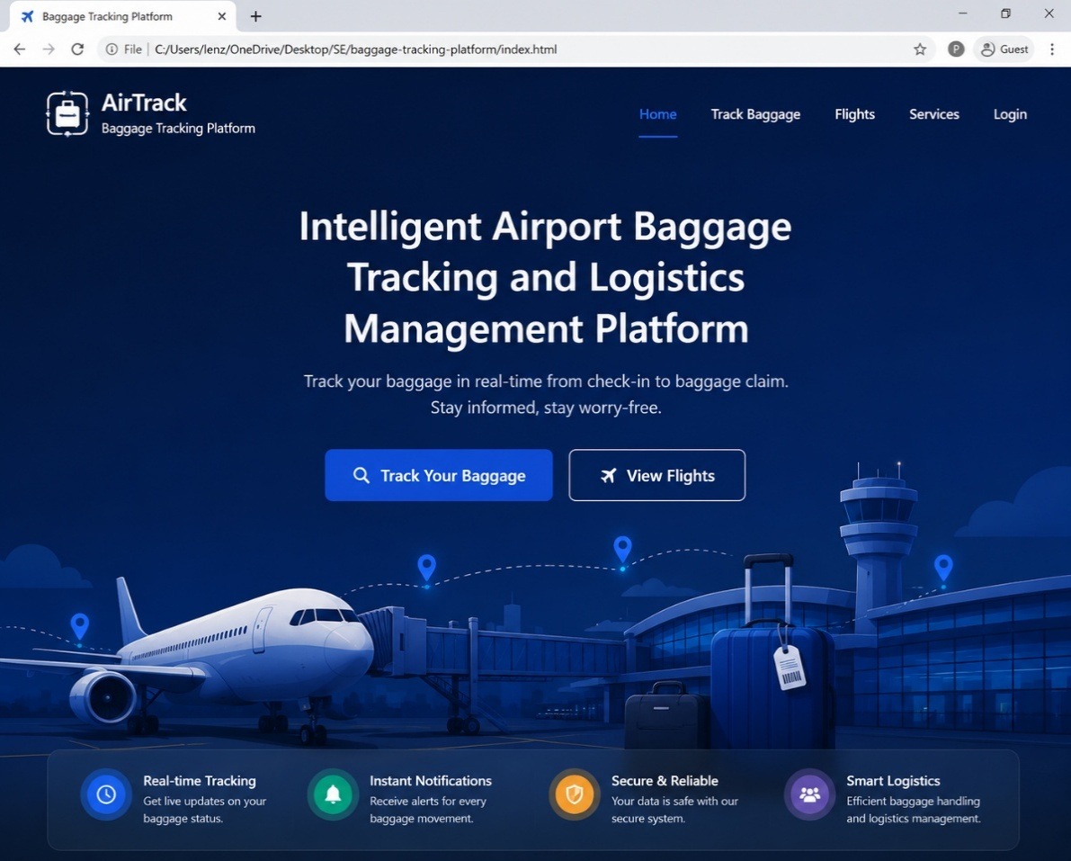

Test 2 – User Login
Objective: Verify user authentication.
Procedure:
- Open the login page.
- Enter valid credentials.
- Click Login.
- Observe the result.
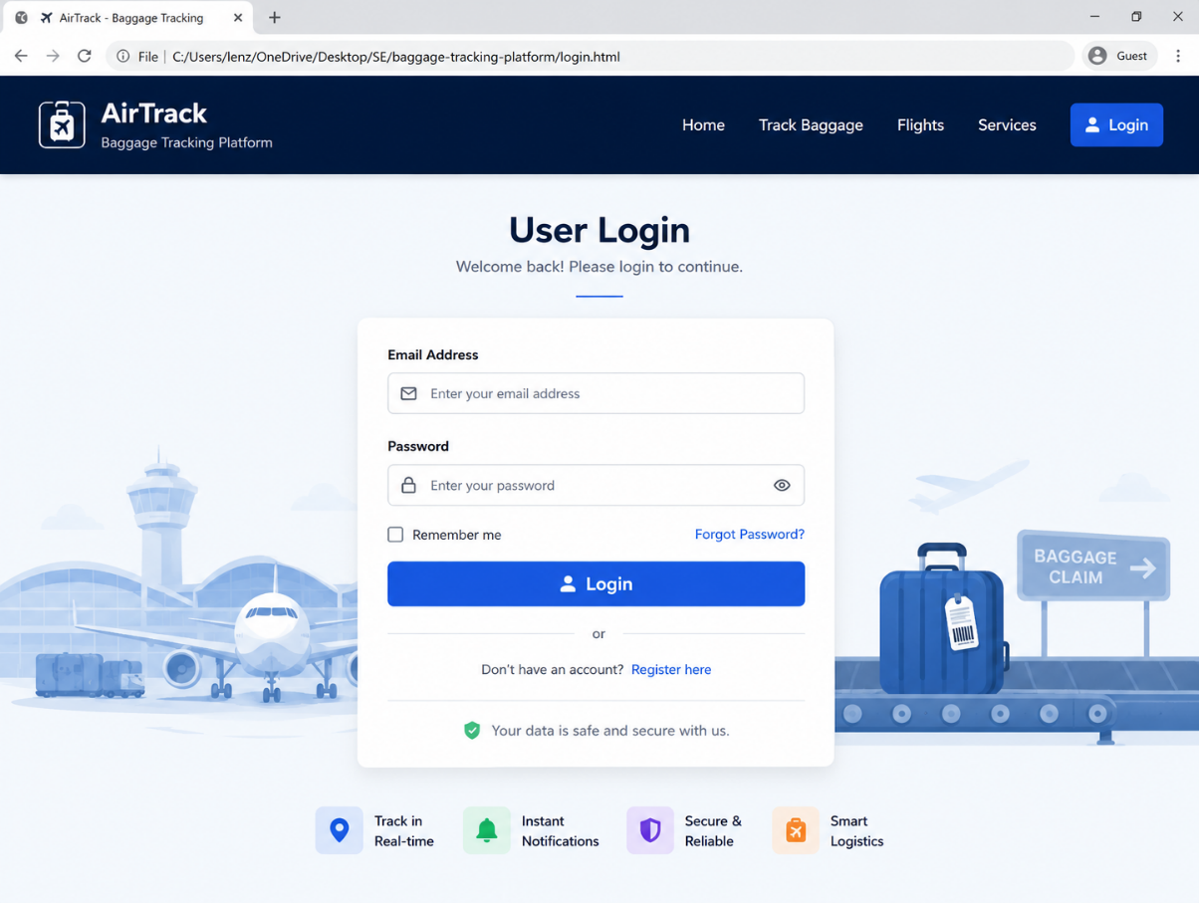

Test 3 – Baggage Registration
Objective: Verify that baggage information can be registered.
Procedure:
- Open the baggage management module.
- Enter baggage tag information.
- Enter passenger and flight details.
- Submit the baggage information.
- Verify that the baggage record is created.
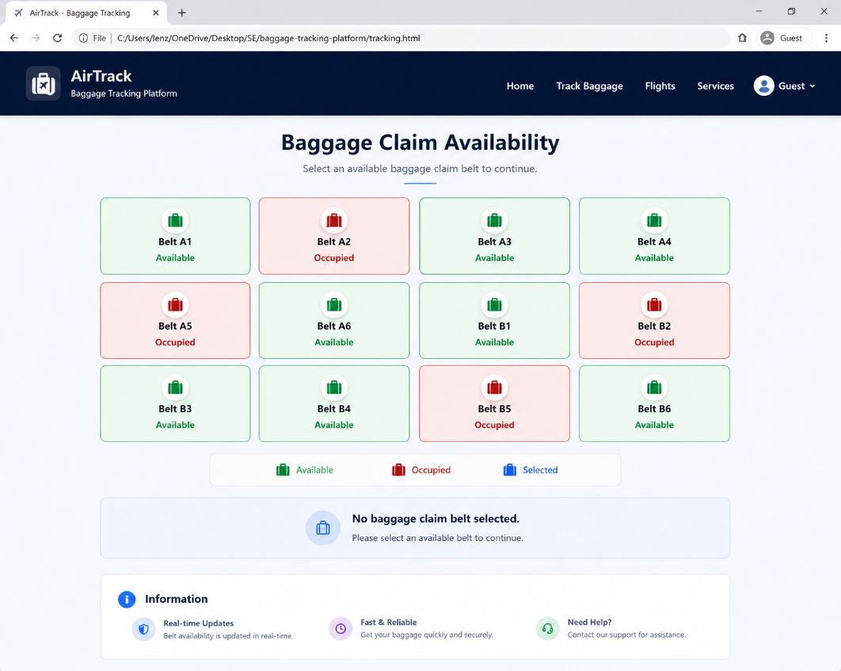

Test 4 – Baggage Tracking
Objective: Verify that a passenger can track baggage.
Procedure:
- Open the baggage tracking module.
- Enter the baggage tag number.
- Click Track Baggage.
- Observe the current baggage status.
- Verify the displayed location or handling stage.
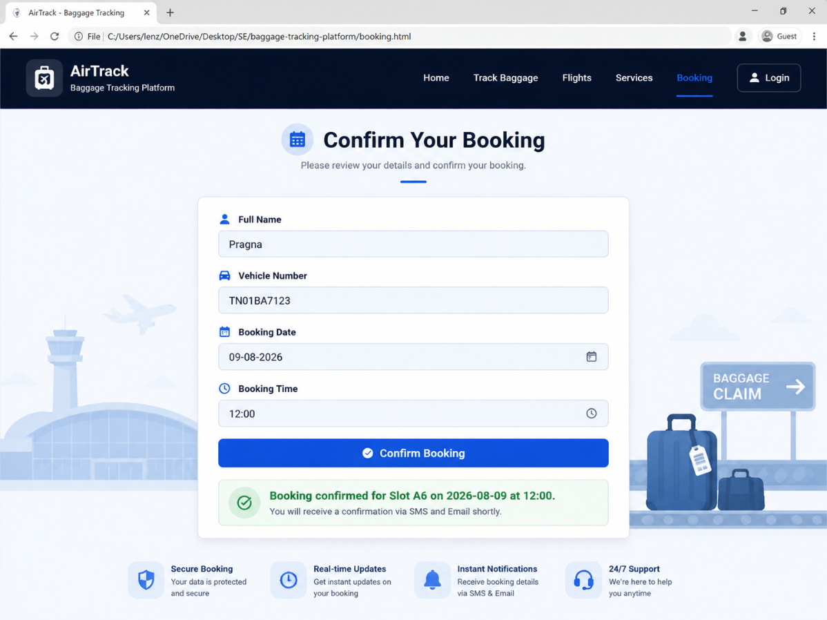

6. Repository Documentation
6.1 README Evaluation
The README.md file is an important part of the repository because it provides developers with information about the project.
A complete README should contain:
- Project title
- Project description
- Problem statement
- Objectives
- Features
- Technologies used
- System requirements
- Installation instructions
- Running instructions
- Project structure
- Screenshots
- Testing information
- Contributors
- Future enhancements
- License

6.2 Installation Instructions
The README should provide clear installation instructions.
Example:
Step 1
Clone the repository.
Step 2
Open the project folder.
Step 3
Install the required dependencies.
Step 4
Configure the database.
Step 5
Start the backend server.
Step 6
Start the frontend application.
Step 7
Open the application in a web browser.
The exact commands should match the technologies used in the actual implementation.

6.3 Usage Guide
The README should explain the basic workflow:
User
↓
Register / Login
↓
Dashboard
↓
Enter Baggage Tag
↓
Track Baggage
↓
View Current Status
↓
View Baggage Location
↓
Receive Notification
For airport logistics:
Staff
↓
Login
↓
Staff Dashboard
↓
View Baggage
↓
Update Handling Status
↓
Manage Transfer
↓
Detect Delay
↓
Update Baggage Database

6.4 Dependencies
The project documentation should list all dependencies used by the application.
Example:
HTML5
CSS3
JavaScript
Web Browser
Backend Framework
Database
AI/ML Libraries
Git
GitHub
Docker
If additional frameworks or libraries are used, they should be listed with their versions.

6.5 Documentation Improvements
The following improvements are recommended:
- Add complete installation instructions.
- Add screenshots to the README.
- Document all major features.
- Mention software requirements.
- Add dependency versions.
- Add API documentation if applicable.
- Add database setup instructions.
- Explain the folder structure.
- Add testing instructions.
- Add troubleshooting information.
- Include future development plans.

7. Code Review Findings and Recommendations
7.1 Overall Findings
The code review indicates that the Intelligent Airport Baggage Tracking and Logistics Management Platform provides a suitable software solution for addressing airport baggage tracking and logistics management problems.
The project demonstrates:
- Clear problem identification.
- Functional separation of modules.
- User-oriented interface.
- Logical repository organization.
- Use of version control.
- Basic input validation.
- Baggage tracking functionality.
- Logistics management functionality.
- Potential for future scalability.
However, several areas can be improved to make the project suitable for a larger real-world airport deployment.

7.2 Code Quality Recommendations
1. Improve Modularity
The source code should be divided into smaller reusable components.
2. Improve Error Handling
The application should provide meaningful error messages instead of generic errors.
3. Add Stronger Validation
All user inputs should be validated on both client and server sides.
4. Improve Security
The system should implement:
- Secure password storage
- Authentication
- Authorization
- Session management
- Input sanitization
- Protection against common web vulnerabilities
5. Reduce Code Duplication
Repeated functions and UI elements should be converted into reusable components.
6. Improve Comments
Complex algorithms and important business logic should be documented.

8. Repository Management Recommendations
The following Git practices are recommended:
- Use meaningful commit messages.
- Commit small logical changes.
- Use feature branches.
- Merge completed features into the development branch.
- Use pull requests for code review.
- Protect the main branch.
- Do not commit passwords or API keys.
- Maintain a proper .gitignore file.
- Tag stable releases.
- Keep the repository regularly updated.
A recommended workflow is:
Create Feature Branch
↓
Develop Feature
↓
Test Feature
↓
Commit Changes
↓
Push Branch
↓
Create Pull Request
↓
Code Review
↓
Merge
↓
Update Main Branch

9. Testing Recommendations
The current testing approach can be improved by introducing automated testing.
Recommended improvements include:
- Unit testing
- Integration testing
- API testing
- Automated UI testing
- Regression testing
- Security testing
- Performance testing
Test cases should be maintained in a dedicated test directory or testing framework.
A future automated testing pipeline can be:
Developer Commit
↓
Git Repository
↓
Automated Build
↓
Automated Tests
↓
Code Quality Check
↓
Deployment

10. Future Enhancements
The system can be enhanced with advanced technologies.
10.1 IoT-Based Baggage Detection
IoT devices, RFID readers, and barcode scanners can automatically detect baggage movement.
RFID / Barcode Scanner
↓
IoT Gateway
↓
Cloud/Server
↓
Baggage Database
↓
Web/Mobile Application
This can provide more accurate real-time baggage tracking.

10.2 AI-Based Baggage Delay Prediction
Artificial intelligence can analyze historical and real-time baggage handling data to predict possible delays.
The system could classify baggage handling status as:
- Normal
- Delayed
- At Risk
- Critical
AI can help airport staff identify baggage that may miss a connecting flight or experience long processing times.

10.3 Smart Baggage Routing
The platform can recommend baggage handling routes based on:
- Current baggage location
- Flight information
- Transfer requirements
- Conveyor availability
- Distance
- Estimated handling time
- Airport congestion

10.4 Mobile Application
A mobile application can provide:
- Baggage tracking
- Baggage status
- Flight information
- Notifications
- Booking information
- Baggage history
- Support

10.5 Digital Passenger Notifications
Future versions can provide notifications about:
- Baggage check-in
- Security clearance
- Loading status
- Transfer status
- Arrival at destination
- Baggage claim readiness
- Delayed baggage
- Baggage collection

10.6 Real-Time Baggage Monitoring
Airport staff can monitor baggage movement through a real-time dashboard.
The dashboard can display:
- Total baggage
- Baggage in transit
- Baggage delayed
- Baggage arrived
- Baggage ready for claim
- Transfer baggage
- Missing baggage alerts

10.7 Analytics Dashboard
Administrators can receive analytics about:
- Baggage volume
- Peak baggage handling periods
- Average processing time
- Delayed baggage
- Transfer baggage
- Baggage handling performance
- Airport logistics efficiency

11. Overall Evaluation
Evaluation Area | Assessment
Problem Definition | Good
Functional Implementation | Good
Repository Organization | Good
Code Readability | Good
Modularity | Good
Version Control | Good
Commit Management | Can be improved
Testing | Good / requires expansion
Documentation | Can be improved
Security | Requires further enhancement
Scalability | Suitable for future enhancement
Maintainability | Good with recommended improvements

12. Conclusion
The Intelligent Airport Baggage Tracking and Logistics Management Platform provides a practical software-based solution for modern airport baggage tracking and logistics management. The system addresses important problems such as difficulty in tracking baggage, delayed baggage, incorrect routing, inefficient baggage handling, and limited visibility of baggage status.
The repository structure supports organized development by separating application components, documentation, testing resources, AI services, database files, and configuration files. The use of Git and GitHub provides version control, change tracking, collaboration, and project history management.
The code review shows that the project has a good foundation in terms of functionality, organization, and maintainability. However, improvements can be made in automated testing, security, documentation, error handling, code modularity, and repository management.
Future integration with RFID/IoT sensors, Artificial Intelligence, real-time baggage data, mobile applications, predictive analytics, cloud infrastructure, and automated notifications can transform the current platform into a comprehensive intelligent airport logistics solution.
Overall, the project successfully demonstrates the application of software engineering principles, version control, code organization, testing, and repository management to a real-world airport baggage tracking and logistics problem.

