V8 javascript is written in language called C++

1. Node has feature => file system manipulation
2. Node -v => version
3. Node app.js => runs the node project
4. \* Its not called window its global
5. Process.exit(0); => back to command node
6. What is Node? => Node is a javascript runtime that uses the v8 javascript engine written in C++. Javascript code which compiles in machine code. Its used inside node.js and chrome browser.
7. What is I/omodel? When you are reading or writing to database model that is IO.
8. Browser has feature => manipulating what shown in window.
9. Inside browser we use windows=> which shows external objects and variables.
10. Blocking and non blocking IO model
11. 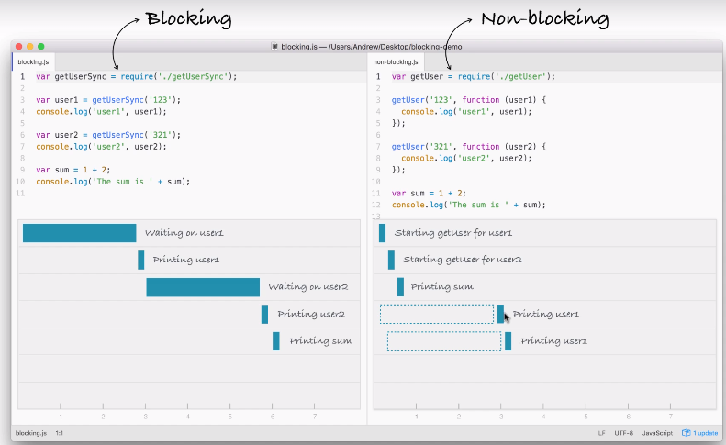

Non blocking has 1 thread and it run paralley other object and it return the output.

Blocking will exccute 1st object and it return the output then it get into other object and return output and in final it sum up.

There node.js is non blocking and more efficient.

------------------------------------------------------------------------------------------------------------------------------------------How we are gone a use module? What is using require?

Require is function that is required in any of your node.js file. Everytime when you call require it will just allow 1string.

Process.argv => to grab the information

Npm install nodemon => refresh

Yargs => very complex library

npm install yargs@4.7.1 --save