**Chapter 3**

**DESIGN PHASE**

**3.1 System Overview**

File Repository Management System is a web-based platform management system that runs in local area network or LAN. It is a centralized system which means the application system itself is run in a web server together with the file server. All students that need to access it are so called client computers.

**3.2 System Modules/Functions**

1. **Security Module** - It includes the login function, database security function and file security function.
2. **File Management Module** - It is the main module of file repository management system wherein the users can manage and organize their files.
3. **File Control Module** - It is the module for admin and faculty wherein they can control their files based on the giver permission or access level.
4. **Audit Trail Module** - It is the module for admin wherein the system can generate the logs and activities of users automatically. So, the admin can trace every possible activity happen in the system.
5. **Admin Module** - It is the main module for the administrator of the system wherein the common data and information are being encoded and maintained. It is also the module for system settings and setup.

**3.3 System Development Methodology**

**SYSTEM DEVELOPMENT LIFE CYCLE**

According to TechTarget, the System Development Life Cycle (SDLC) is a conceptual model used in project management that describes the stages involved in an information system development project, from an initial feasibility study through maintenance of the completed application.

In order to create the proposed system successfully, the proponents use a system development life cycle model to serve as a guide on the phases of the system development they must undergo. The proponents carefully choose a model that will help them organize the appropriate tasks that need to be carried out to construct the proposed system in the best possible way. The Spiral Life Cycle Model was chosen by the proponents which suits to their proposed system.

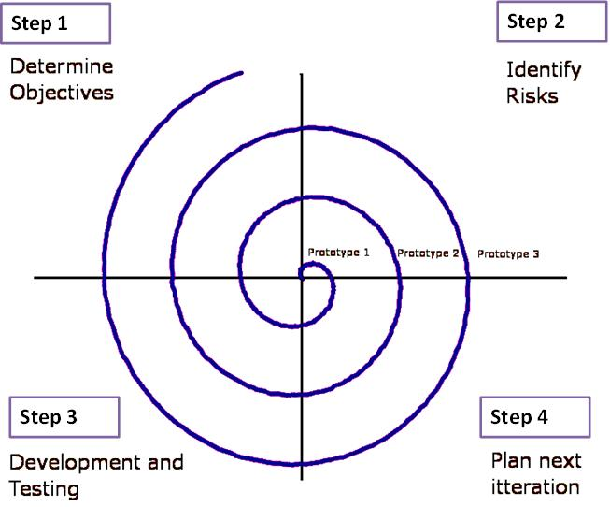

**iteration**

**Figure 4**

**Spiral Life Cycle Model**

**Determine Objectives.** To develop a system, it is a requirement to identify the purpose and objectives of the system. To determine the purpose and objectives of the system, the proponents need to identify the client’s need and requirement. In this phase, the proponents conducted an interview with the respondents to identify the problem and what they want to happen in the proposed system. It is a great helped in determining the detailed problems and client’s requirements regarding the proposed system.

**Identify Risks.** In this phase, the technical and management risks are assessed. The proponents identify the possible problems that could be encounter in the design and development of the proposed system.

**Development and Testing.** In this phase, the proponents will build representations and construct actual system. They must also provide user support such as documentation.

The proponents must have computer technology knowledge and programming expertise to be able to develop the proposed system successfully.

**Plan Next Iteration.** In this phase, iterating or repeating certain action, phases or process will be planned until the condition is met or yields desired result.

**Justification of the Model Used**

The Spiral Life Cycle Model was chosen by the proponents as a guide for the development of the software. The proponents choose the said model because for them it is the best tool that will help them develop the proposed system properly and systematically.

The proponents used the primary source in data collection which is interviewing the respondent’s to identify the client’s needs and requirements. The proponents need a System Development Life Cycle (SDLC) Model that has been explicitly designed to accommodate a system that evolves over the time. The proponents identify that the preliminary ideas for the proposed system is not fixed. The proponents take that along the development and design of the proposed system, new ideas may come up to make the proposed system much better in which additional features can

**3.4 User-Interface Design**

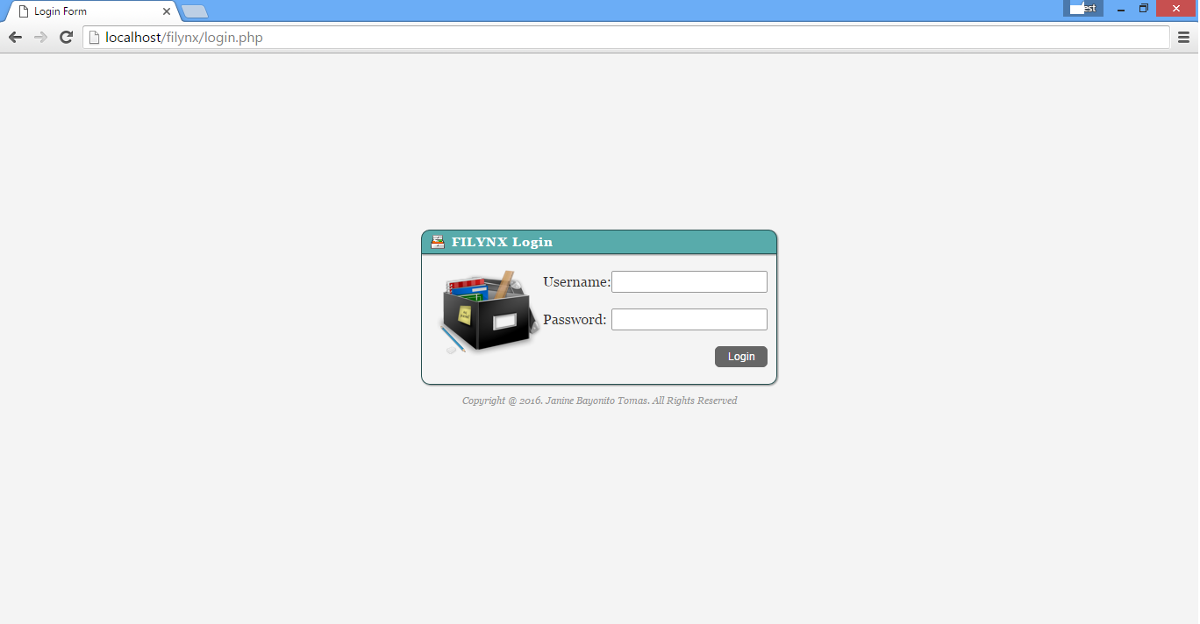

**Figure 5: System Login**

This login requires username and password of either admin or common users like students and faculty.

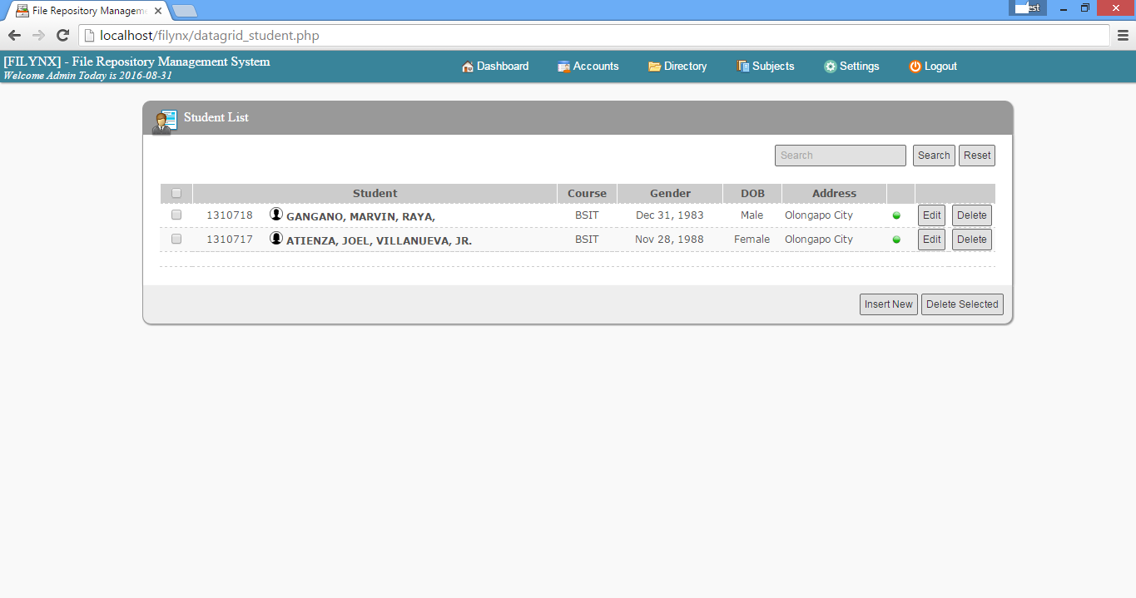

**Figure 6: Admin Page Interface**

This is admin page interface wherein the admin are the one who manage the entire system. Including in the interface are the students list in a form of data grid.

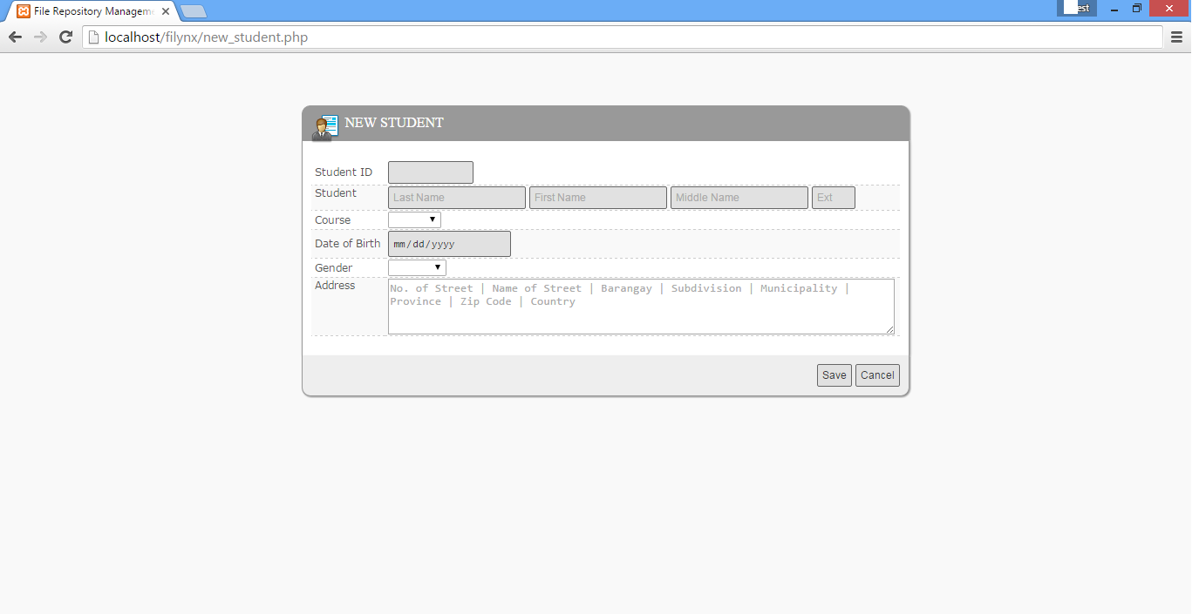

**Figure 7: New Student Page**

This is new student page wherein the administrator can add new student that will save to the database.

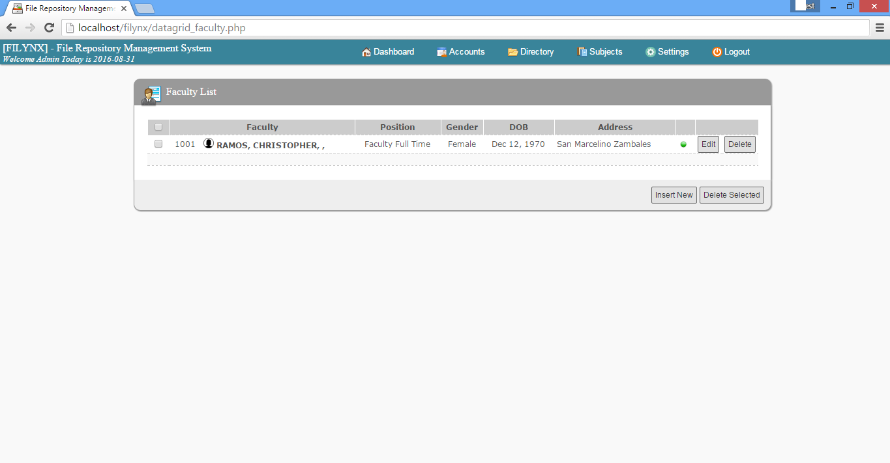

**Figure 8: Faculty List Page**

This is the faculty listing in data grid format wherein only administrator has authority to add.

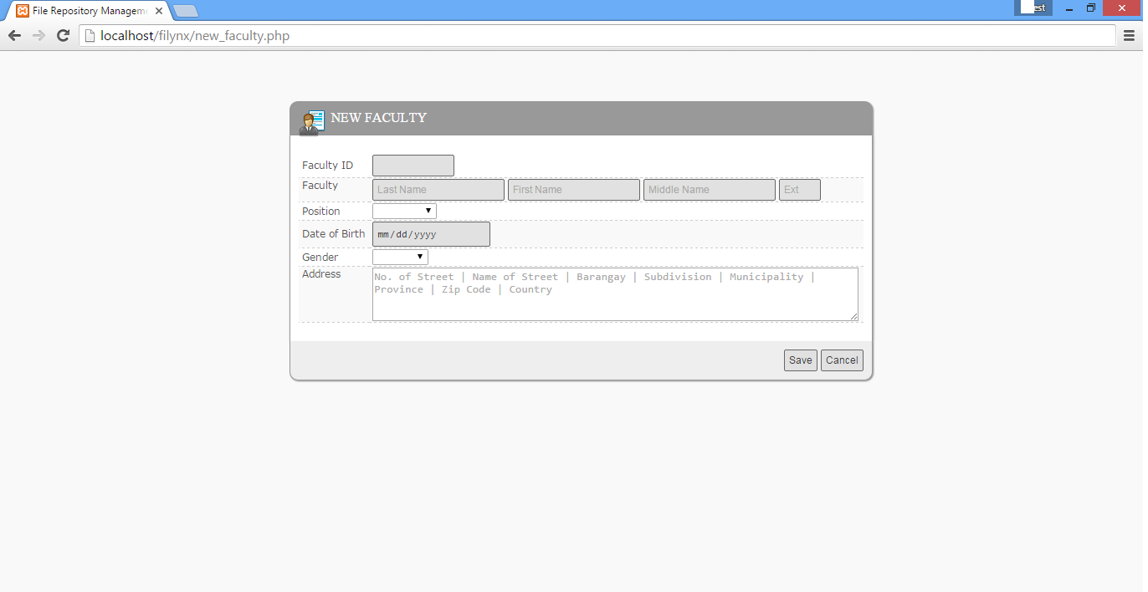

**Figure 9: New Faculty Page**

This is new faculty page wherein the administrator can add new faculty that will save to the database.

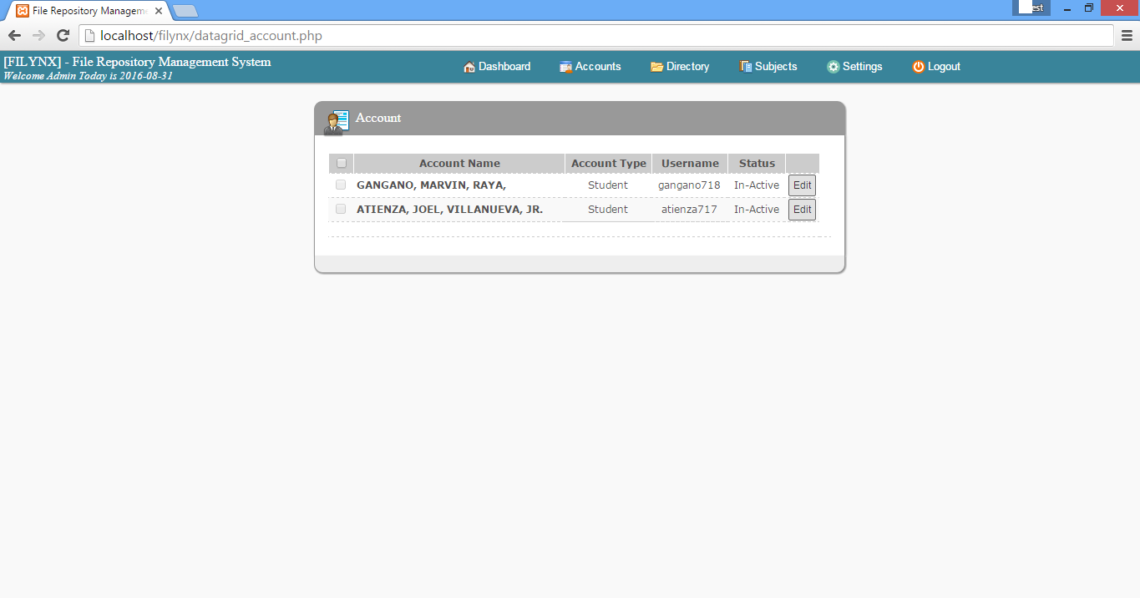

**Figure 10: Account Page**

This is summary of accounts of both students and faculty. The administrator can update their status from active to inactive.

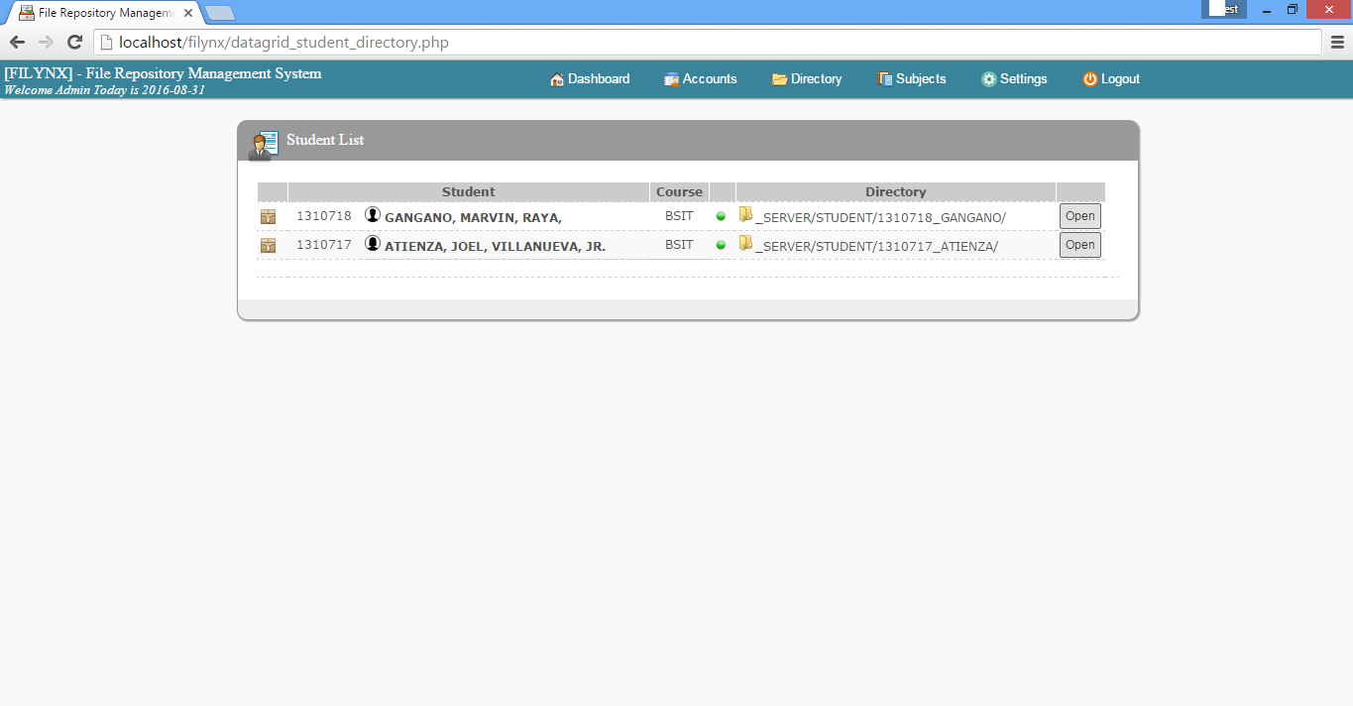

**Figure 11: Student Directory Page**

This is list of student together with their system generated directory.

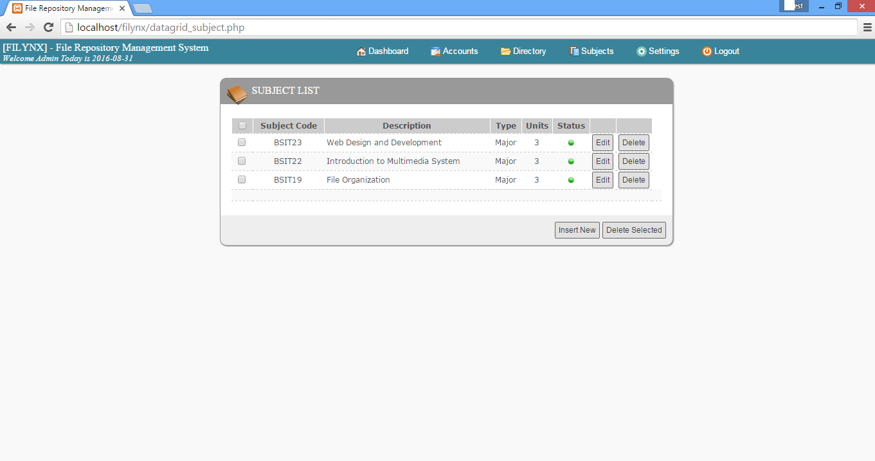

**Figure 12: Subject List Page**

This is the page subject listing in data grid format wherein only administrator has authority to add.

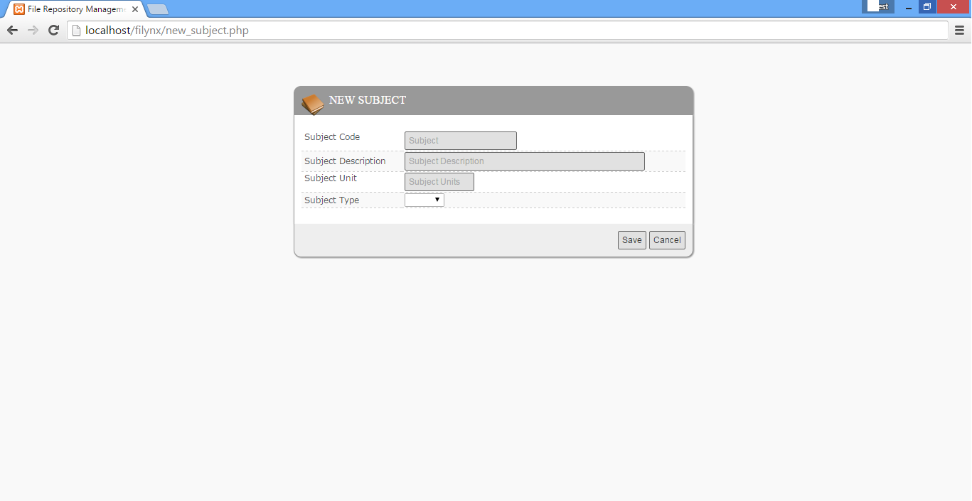

**Figure 13: New Subject Page**

In this page, the administrator can add or insert new subjects.

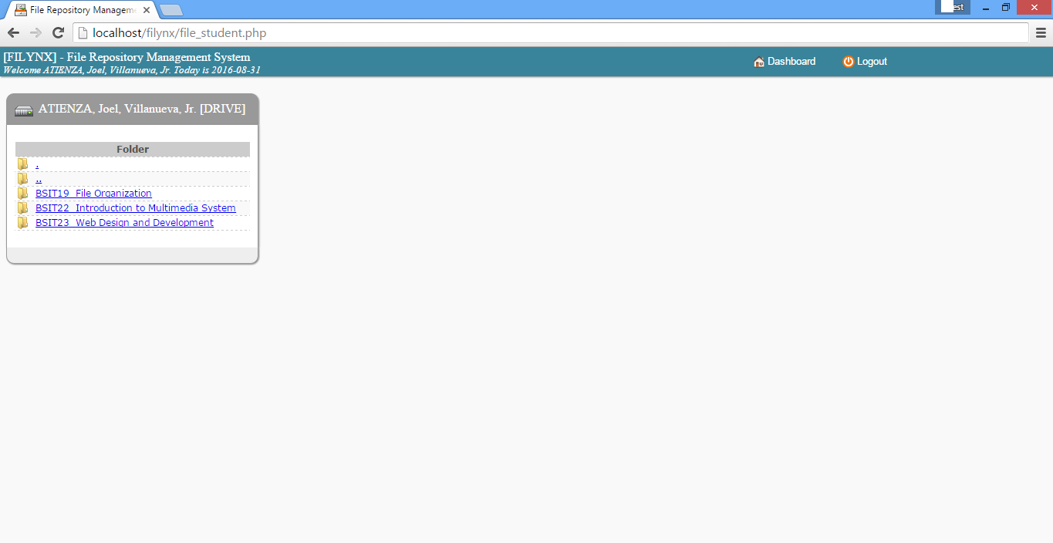

**Fig. 13**  
**Student and Faculty Interface**

In this page, the students and faculty can manage their files

**Figure 14: Student and Faculty Interface**

In this page, the students and faculty can manage their files

**Feasibility Study**

**Technical Feasibility**

To be able to meet such amount of technical aspects of the system, the proponent conducted a feasibility study such as follows.

**Hardware**

From the Point of view of hardware the proposed system entitled File Repository Management System for CCS can be implemented by the following Hardware requirements.

|  |  |  |
| --- | --- | --- |
| **Hardware** | **Minimum Requirements** | **Recommended** |
| Hard Disk (HDD) | 80 GB | 120GB or above |
| Processor | 1.8 Ghz | 2.13 Ghz or above |
| RAM | 2GB | 4GB |
| Screen Resolution | 1024 x 768 | 1250 x 800 |
| Router | With 4 ports | With 4 ports |
| LCD Monitor | 15” | 16” |
| Mouse |  |  |
| Keyboard |  |  |

**Table 17: Hardware Specification**

The Hardware requirements needed in the implementation of the proposed system are all available in the market but the stated requirement above is solely a basis for the user or client, they can use a higher specification as they want to.

**Software**

From the Point of view of software the proposed system entitled File Repository Management System can be implemented by the following software requirements.

|  |  |  |
| --- | --- | --- |
|  | **Minimum Requirements** | **Recommended** |
| Operating System | Windows Server 2003 | Windows Server 2003  R2 or higher version |
| Windows 2000 | Windows XP or higher version |
| Browser | Internet Explorer 5.5 | Internet Explorer 8 or higher version |
| Mozilla Firefox 10 | Mozilla Firefox Current Version |
| Google Chrome Version 24.0.1312.52 | Google Chrome Current Version |
| Development Language | PHP, JavaScipt, HTML, CSS | |
|  | **Minimum Requirements** | |
| Operating System | Windows Server 2003 | |

**Table 18: Software Specification**

The Software requirements needed in the implementation of the proposed system are all available in the market and some applications can be downloadable over the web but the stated requirements above is solely a basis for the user, they can use a higher version or other applications that are the same capabilities in the given requirements as they want to.

**Scheduling Feasibility**

The proposed system need to operationally implement and test in an academic year timeline wherein students are coming to school for enrollment and to be registered officially. First, the system must run and use by the students and faculty in semester period wherein they performed parallel testing the proposed system together with the network drive. If major problems and adjustment occur on a first phase, the schedule will be adjusted and need more time to update and fix the problem. If not, the last phase of the schedule will be maintenance and upgrades.

**Economic Feasibility**

To be able to meet such amount cost of the system to be implemented, the organization needs to prepare a budget of 42,000 pesos.

|  |  |  |
| --- | --- | --- |
|  | **Specification** | **Estimated Costs** |
| CPU Set | Intel Core i5-2120 Processor, 2Gb, DDR3, 500Gb HDD, 15in1 card reader, DVD RW, Keyboard, Mouse | Php 33,400.00 |
| Operating System | Windows 8 | Php 4,500.00 |
| LCD Monitor | 16”, black | Php 4,200.00 |
| Switch | DES-1008A 8-ports | Php 800.00 |
| **TOTAL** | | **Php 42, 900** |

**Figure 19: Budget Specification**

**Operational Feasibility**

To be able the proposed system to be implemented. It needs a group of committee wherein they will monitor the operation of the implementation. It serves as the key person who are individually do their task to make the system operational. Along the way, the performance of the system will be monitor accordingly.

**Fig. 13**  
**Student and Faculty Interface**

In this page, the students and faculty can manage their files

**Fig. 13**  
**Student and Faculty Interface**

In this page, the students and faculty can manage their files