**Chapter 4**

**IMPLEMENTATION PHASE**

1. **Testing**

The proponent conducted a different testing methodology to be able to meet the primary goals of the implementation phase. Thus, the available modules that are connected to the system are ready to deploy, tested, documented accordingly so all the necessary requirements that needs to meet the system are already met. Moreover, due to basic coding of the application made by the developer the quality control may not be performed or evaluated. Otherwise, it is strictly implemented in further studies or research.

**A. Unit Testing**

Since it was developed into a web-based application platform with a procedural way of programming which refers as basic coding standard, so the unit testing for classes, functions and procedures are not possible to test but in other areas it is.

It runs on apache web server and access by the client computer. All the asset files including php, javascript, css are already tested in Nusphere IDE - a software used to develop and test php files. During development - testing period, the proponent or the developer itself has a series of code testing in terms of usability of codes, syntax, optimization and loading time.

**(screenshots of the testing)**

**B. System Testing**

In this type of testing the information system must test in multiple accounts with multiple client computers. But because of limited available tools use for this kind of test, the system test may not be performed well.

Thus, the proponent has been testing the system in one to two computers only, for them to see if it is causing too much traffic on the server. All modules based on the requirement analysis perform and transacts well. The proponent also used RIPS web application for security and vulnerability testing.

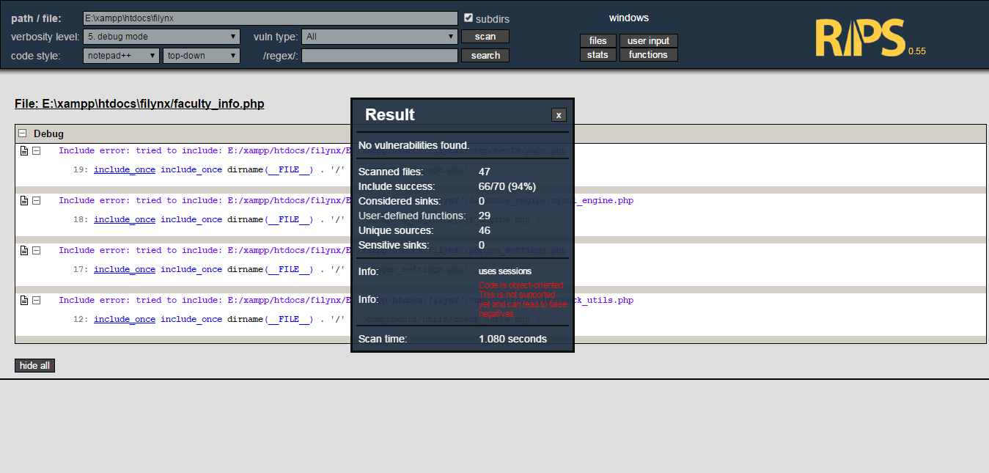

**Figure 14 (RIPS Security and Vulnerability Test)**

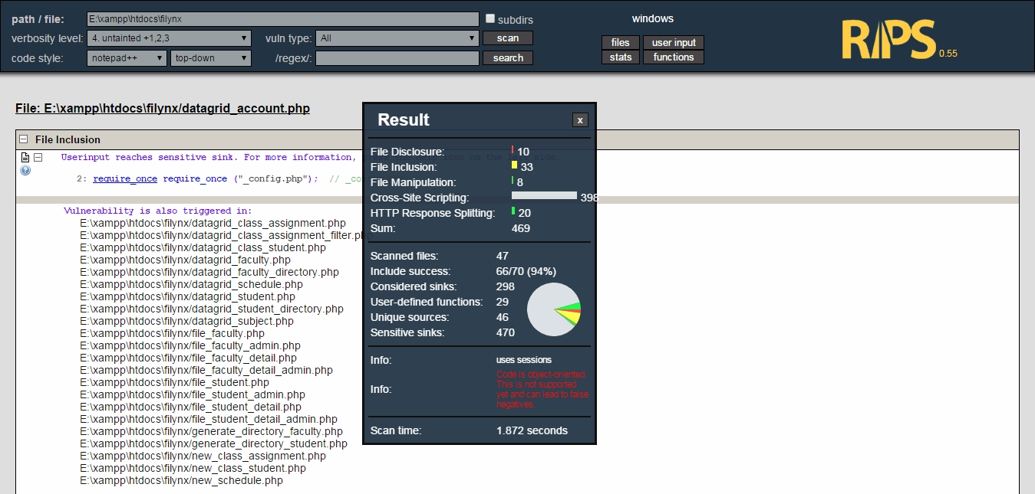

**Figure 15 (RIPS Security and Vulnerability Test)**

**C. User Acceptance Testing**

The information system has been evaluated based on the overall functionality, reliability, usability, efficiency, maintainability and portability. In functionality, the user accounts are tested from login up to logout functions. The basic operations like add, edit, delete, search, upload has been fully tested with dummy data that the proponent collected. In reliability, the user repeatedly used the system based on the system guidelines. In usability, the user rated the system based on the adaptability and ease of use with the given system guidelines and according to their personal approach in graphical user interface or GUI. In efficiency, all the data that has been tested were engaged in queries and views, so the loading time of records was optimized and efficient. The user simultaneously used the system with interconnected transaction. In maintainability, the user admin page has been tested by the common data transaction and management, which normally the responsibility of administrator itself. And lastly portability, the system itself has been tested in different servers, clients, browsers and it can access easily because there is no installation needed, it web-based application which is flexible and cloud ready.

**EVALUATION FORM RESULT**

|  |  |  |
| --- | --- | --- |
| **IOS 9126**  **Characteristics** | **Standard Quality** | **User’s Percentage Rating**  **(100 % highest- 0%lowest)** |
| Functionality | The capability of the software to perform the required task, give results as expected and protects information from unauthorized person |  |
| Reliability | The capability of the software in handling errors and restore lost data after a failure |  |
| Usability | The user can easily comprehend and learn how to use the software and its interface |  |
| Efficiency | The capability of the software to respond and utilized its resources quickly. |  |
| Maintainability | The capability of the software to be easily diagnosed modified and tested. |  |
| Portability | The capability of the software to be moved, convert and adapt to other environment be easily installed. |  |

**Table 20**

**Software Quality based on ISO 9126**