



# Assessment –

# Research & Questioning

| Name of Student | Arthur Leonard LESMANA | ID | 18780 |
| --- | --- | --- | --- |

Contents

Assessment – 1

Research & Questioning 1

***Instructions:*** 1

***Business Scenario*** 1

***Task 1: Determine support areas*** 2

***Task 2: Identify stakeholders*** 3

***Task 3: Develop support procedures*** 4

***Task 4: Assign Support Personnel*** 6

***Task 5: Short Answer Questions*** 6

***Task 6: Multiple Choice Questions*** 7

Index 12

#### This is my web support page:

https://arthleo.github.io/ecbr18780/

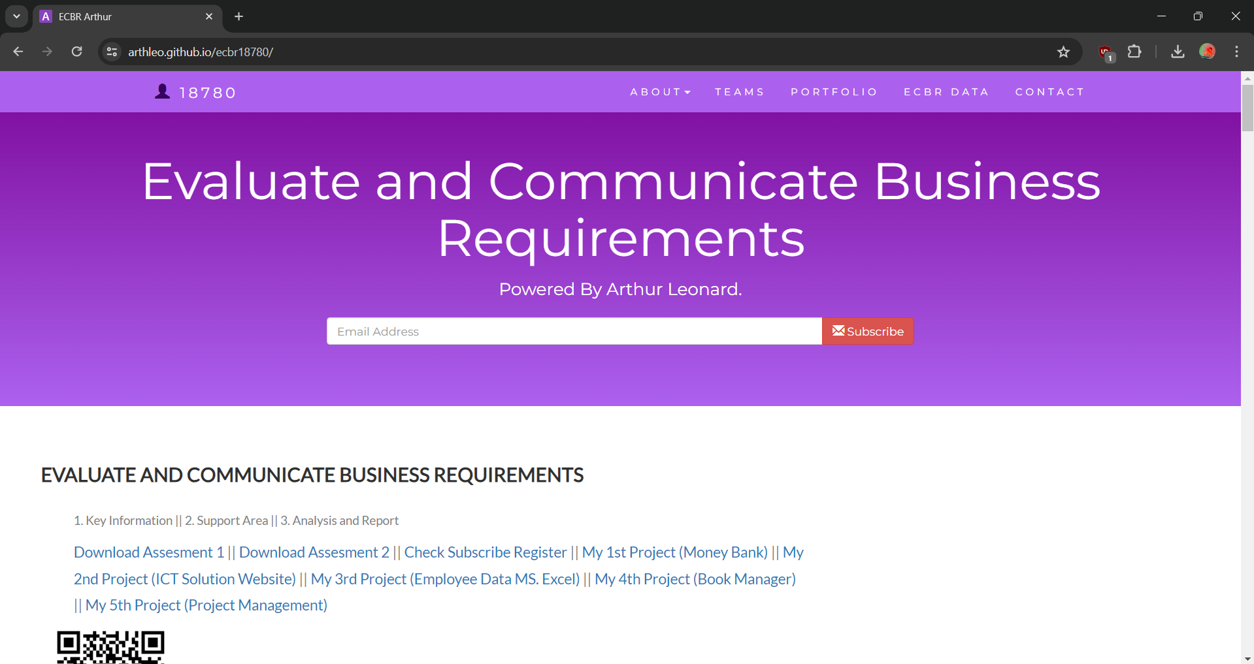

#### ***Instructions:***

This assessment is to be completed individually. In this assessment you will be working through a number of written tasks based on case scenarios or research that relate directly to each element of competency for this cluster. Outlined below is information on how each of the tasks relates the element of competency covered.

Learn how to make Google Form: <https://www.youtube.com/watch?v=BtoOHhA3aPQ&t=4s>

Your tasks:

#### ***Business Scenario***

D&K Books Pty Ltd is a bookstore owned by Mr. Dean Kerr. The business occupies two levels of an office building connected by escalators and lifts. D&K Books employs approximately six sales staff, one operation manager, two administrative officers, a bookkeeper and a marketing manager. They have an Ethernet network consisting of ten PCs (Intel I3 Desktop cloned), two switches, a router and three printers. They use the QuickBooks software to manage their entire business, including sales, inventory, ordering, accounts receivable, accounts payable, payroll and employee management. They also have two EFTPOS terminals one on each floor.

D&K Books has a Linux server that stores all of the data including the QuickBooks database. The server is backed up to tape regularly. They also have a website (hosted on an Australian ISP’s server, dynamic and static pages using asp.net) on which customers can browse the product catalogue and view current specials. They also lease a telephone system from Live Telecoms. The PABX (phone system) consists of a main switchboard and five remote phones with three incoming lines and a message-on-hold queue system.

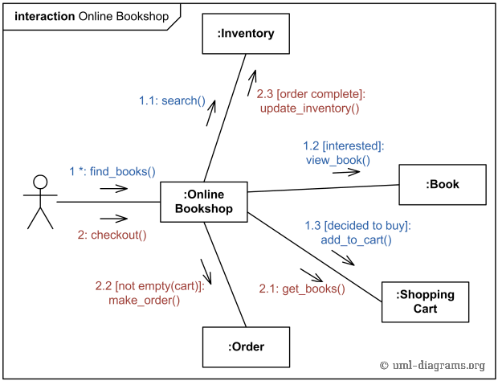

Good network system, you need setup at least:

| Hard ware | Software |
| --- | --- |
| Server X 1 | Window Server |
| Computer X 8 | Windows |
| Printer X 1 | SQL server |
| Telephone X 8 | Virus Protection |
| Modern X 2 | MS office |
| Network Cable | Eftpos machine More… |

#### ***Task 1: Determine support areas***http://imapwebsolutions.com/wp-content/uploads/2014/07/linux-dedicated-server.png

Identify information technology (HW and SW) and list the technology in use in D&K Books and consider the following:

* What sort of support does the technology require?
* Who is likely to provide this support?
* Does the support arrangement already exist?

Present your answer in a table such as the one below:

| **Technology** | **Description** | **Support Required** | **Provider** | **Support Already exists? (Yes/No)** |
| --- | --- | --- | --- | --- |
| QuickBooks Software | software that keeps track of all accounts, stock, GST, etc. | customisation, training, upgrades, bug fixes (patching), user support | [www.intuit.com.au](http://www.intuit.com.au)  online to find more | No |
| PC’s | Intel I3 Desktop cloned | upgrades, repairs, troubleshooting, maintenance, backup, customisation, network to link | **https://www.aftershockpc.com.au/** | Yes. Multiple supports is needed to do this job |
| **Server**  IconExperience » V-Collection » Server Icon | Linux Server with tape backup  May need upgrade to hard disk backup | User account management, security policy implementation, home folder management, permissions management, backup and restore, operating system patching, software installation | **https://www.hetzner.com/** | No |
| EFTPOS | Easy to use | No need | **Newsagent** | Yes |
| Telephone System | Low cost | Phone company | **Optus** | Yes |
| Website | Free | Yes | **GITHUB** | Yes |
| Network | Wireless | No External | **NONE** | No |

Please review my website: <https://wellsjohn220.github.io/ecbr/#businesscase>

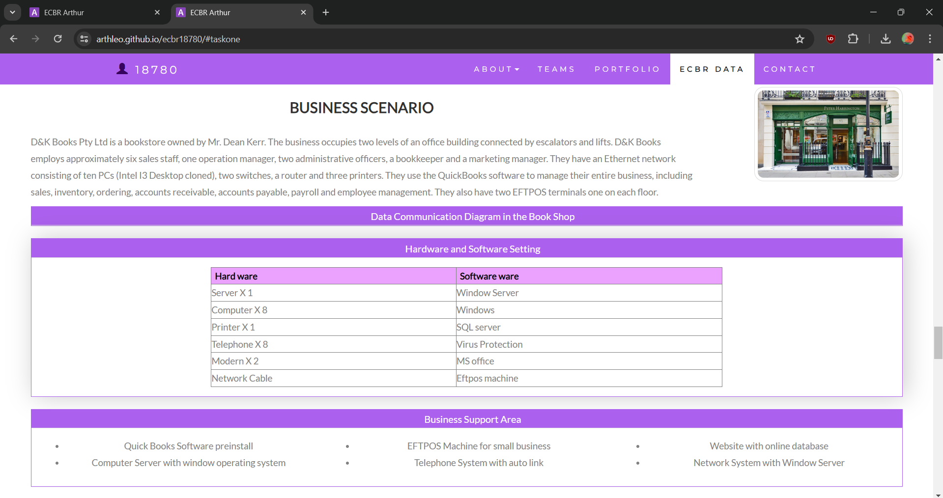

My web contact: [**https://arthleo.github.io/ecbr18780/#contact**](https://arthleo.github.io/ecbr18780/#contact)

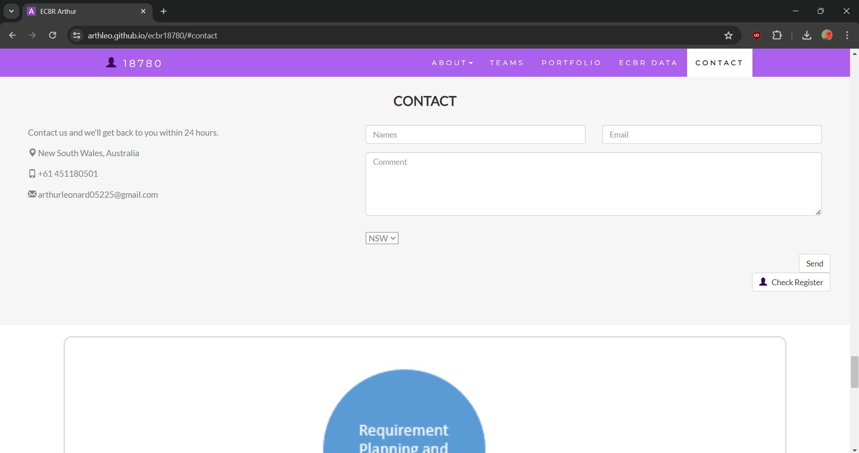

After your input, it will be recorded at:

[**https://docs.google.com/spreadsheets/d/1IM-oHo7q3Q1sT0cYdsI9XTGqjtIoQ1eII_5BmUrO6zc/edit?usp=sharing**](https://docs.google.com/spreadsheets/d/1IM-oHo7q3Q1sT0cYdsI9XTGqjtIoQ1eII_5BmUrO6zc/edit?usp=sharing)

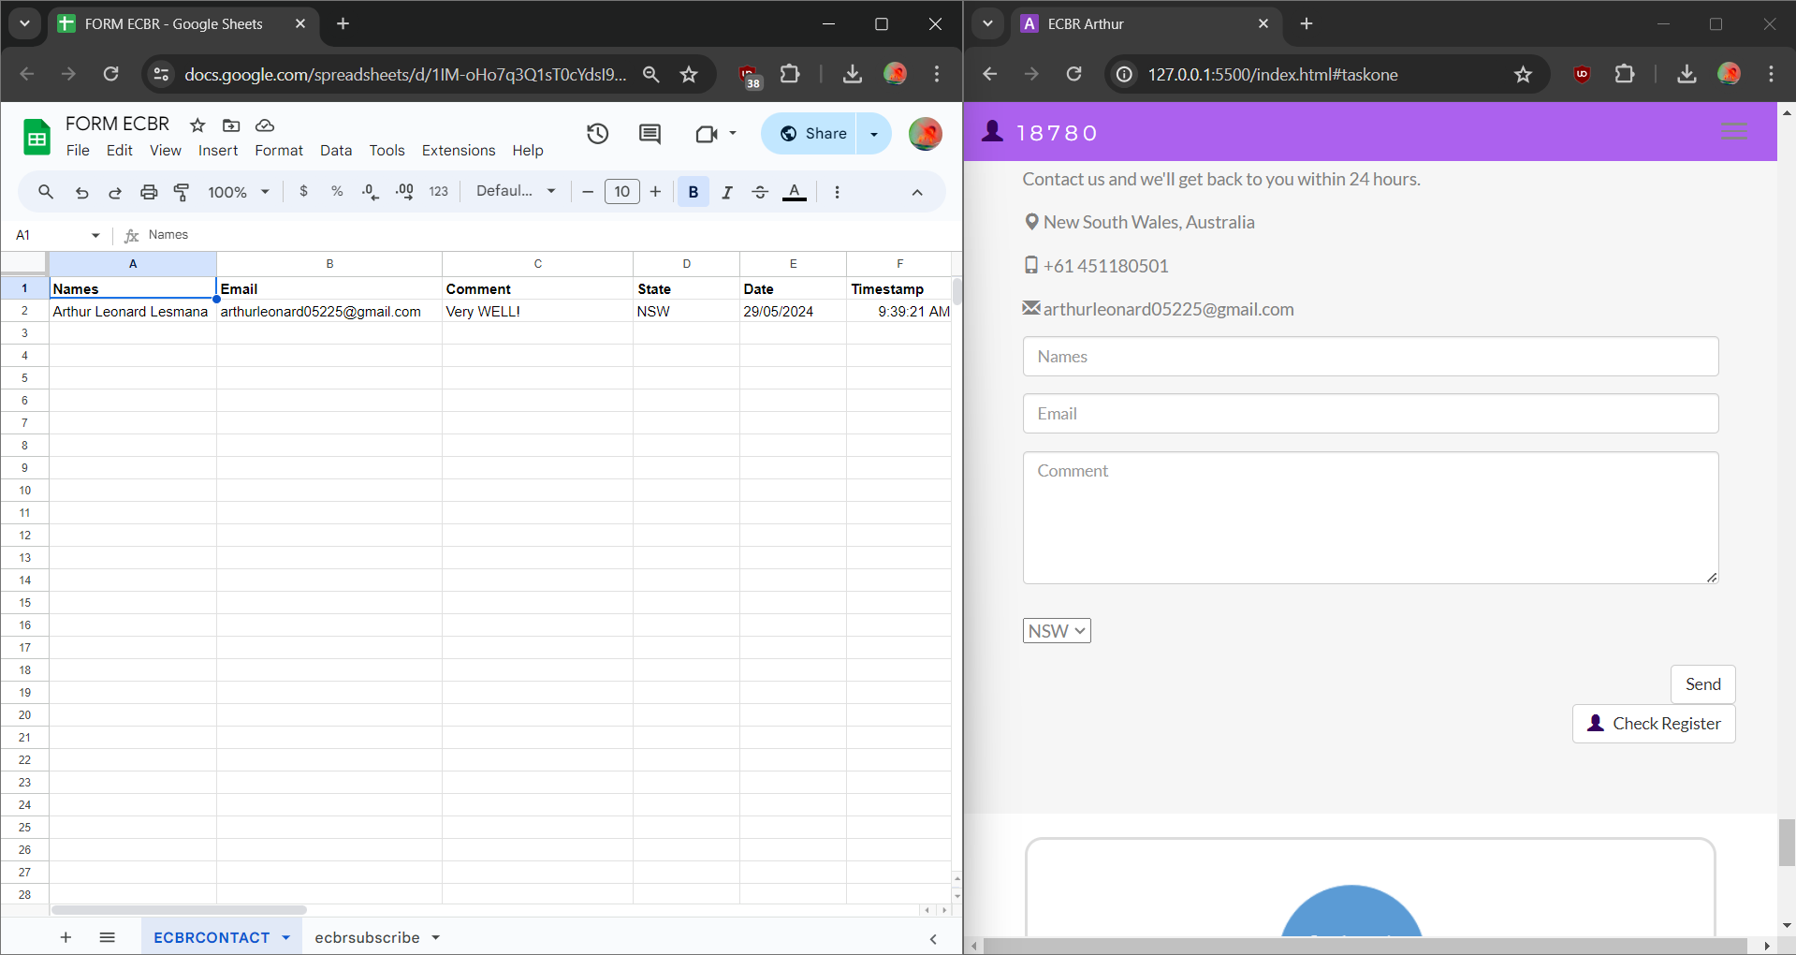

#### ***Task 2: Identify stakeholders***

Identify stakeholders related in D&K Books system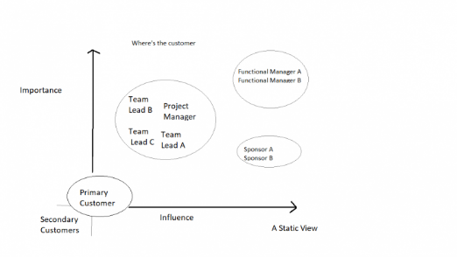

All the staffs (the business owner, the relevant manager, the local workers and the remote workers) are stakeholders

Your comment:

**In any business, all staff members—whether they are the business owner, relevant managers, local workers, or remote workers—are crucial stakeholders. Each group contributes uniquely to the company's success and has a vested interest in its outcomes. The business owner provides strategic direction and resources, managers ensure effective operations and team alignment, local workers bring hands-on expertise and maintain day-to-day functions, while remote workers add flexibility and broaden the talent pool. Recognizing the diverse roles and needs of these stakeholders is essential for fostering a cohesive and productive work environment, driving innovation, and achieving sustainable growth.**

#### ***Task 3: Develop support procedures***

1. Describe one positive and one negative experience you have had when seeking assistance from a telecommunication company, an ISP or a computer supplier. Your experience may be via telephone, email or even voice recognition.

| Type | Positive | Negative |
| --- | --- | --- |
| Telephone | Easy to get answer | Document provide |
| Email | Document, Picture, words or any media | Have to wait |
| Go to company | Face to face get answer | Cost time and money on trip |
| **ISP Customer Service** | **Contacted via telephone; knowledgeable and patient representative; problem escalated quickly; technician dispatched same day.** | **No Negative Experience** |
| **Computer Supplier** | **No Positive Experience** | **Contacted via email; slow and unhelpful responses; generic suggestions; long wait times on phone support; took three weeks to resolve.** |

1. Using the experiences described above please answer the following questions.
   1. What support aspects were professional and/or unprofessional?
   2. How long did the support process take?
   3. Were the steps logical?
   4. Did they solve your problem?
   5. Was the call deflected to another area?

| Items | professional | unprofessional |
| --- | --- | --- |
| What support aspects | Friendly, Listening | Doesn’t care about the customer. |
| How long | Very Quick | Long Waits |
| Steps logical | Yes | No |
| Solve | Good | Can not |
| Another area | If has, need solve | If has, do not care |

Using feedback form or Google survey form.

Here is the very simple survey demo:

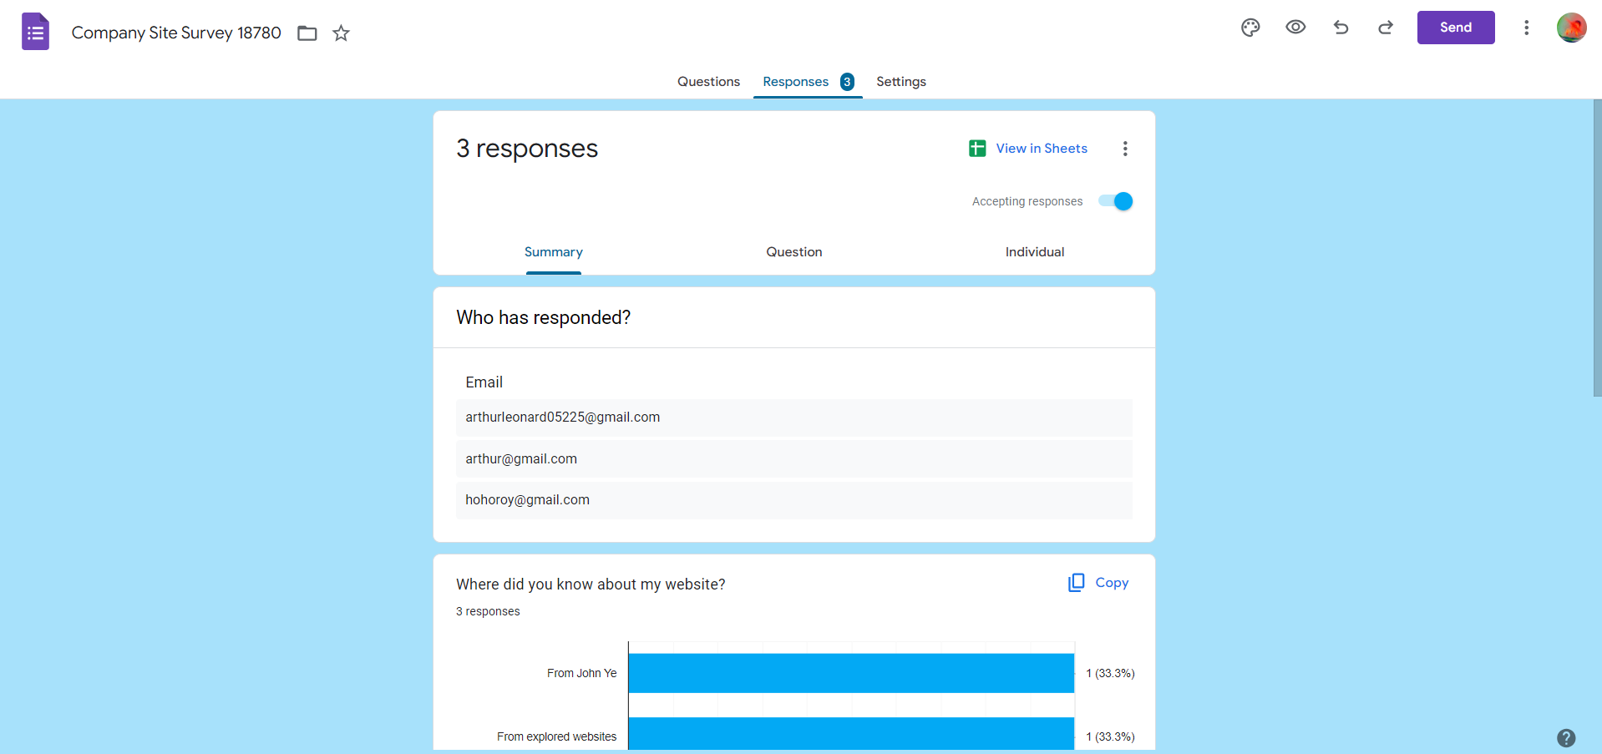

After I tested my friends, I could get nice response like:

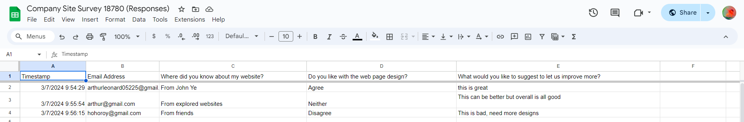

Or using link string:

**https://docs.google.com/spreadsheets/d/1Pbrgh9bM2suAGLKJTysU6X7D77Nr_nVpptkGsFG9QH8/edit?usp=sharing**

Please review my website: [**https://arthleo.github.io/ecbr18780/#taskthree**](https://arthleo.github.io/ecbr18780/#taskthree)

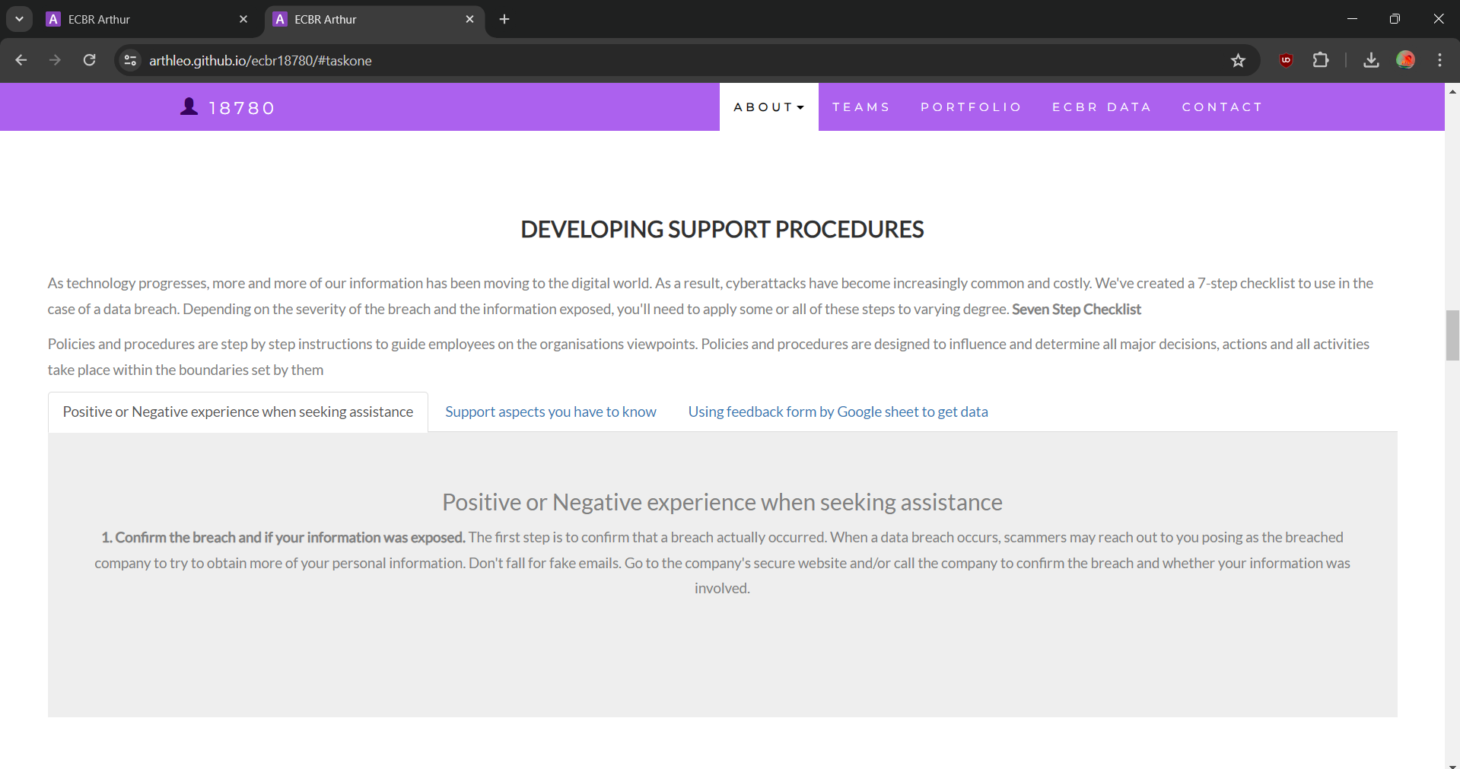

#### ***Task 4: Assign Support Personnel***

Classify the following into soft skills and technical skills. Your answer should take the form of a table shown below.

| **Skill** | **Soft skill** | **Technical skill** |
| --- | --- | --- |
| A knowledge of Linux | X |  |
| The ability to work under pressure | X |  |
| The administration of Windows 2008 Server |  | X |
| The ability to formulate network and IT policies |  | X |
| The ability to write network documentation |  | X |
| The ability to give presentations | X |  |

#### ***Task 5: Short Answer Questions***

1. Explain the relationship between data, information and knowledge. 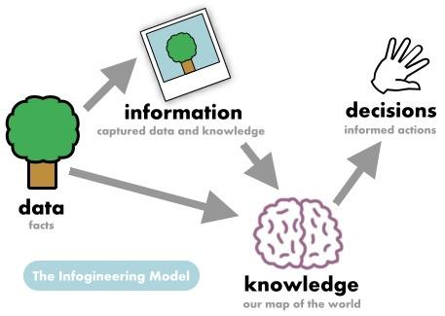

**Data is the raw input, information is processed data, and knowledge is the insightful interpretation of information.**

1. What is quantitative data and how can you use it.

**Quantitative data refers to data that can be measured and expressed numerically, allowing for statistical analysis and mathematical computations.\**

1. What is qualitative data and how can you use it.

**Qualitative data refers to non-numerical information that describes qualities or characteristics. It is often collected through methods such as interviews, focus groups, observations, and open-ended surveys, capturing people's experiences, opinions, and emotions.**

1. Give an example of how quantitative and qualitative data can be used in conjunction with each other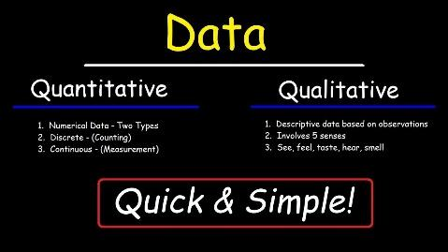

**By integrating quantitative metrics with qualitative insights, the store can validate the scale of issues and understand the underlying reasons, leading to more informed and effective decision-making.**

1. What sort of methods could you use to determine client requirements for a website design and key information sources?

**Client Interviews, Questionnaires and Surveys, Workshops and Brainstorming Sessions, Competitor Analysis, & Site Audits and Analytics Review**

1. Give some examples of client requirements for a website design

* **Web Design looks amazing.**
* **Works 24/7.**
* **Updates easily.**
* **Free upgrades.**

#### ***Task 6: Multiple Choice Questions***

1. Generally, how many points should a rating scale have? 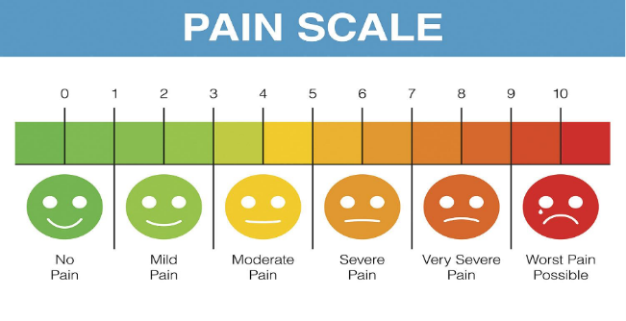
   1. Five
   2. Four
   3. Ten
   4. Somewhere from 4 to 11 points Reason

Web refer: <https://lumoa.me/blog/rating-scale>

A rating scale is a closed-end survey question that is used to evaluate how survey responders feel about a particular product or statement.

Comment: I like 10 points. It is easy and clear to get the best feedback way.

1. What is the problem(s) with this set of response categories to the question “What is your current age?”

* 1-5
* 5-10
* 10-20
* 20-30
* 30-40
  1. The categories are not mutually exclusive
  2. The categories are not exhaustive
  3. **Both a and b are problems**
  4. There is no problem with the above set of response categories

**Reason: They are not mutually exclusive because some age ranges overlap (e.g., both "5-10" and "10-20" include age 10). They are not exhaustive as they do not account for ages above 40.**

1. You should mix methods in a way that provides complementary strengths and no overlapping weaknesses. This is known as the fundamental principle of mixed research.
   1. **True**
   2. False

**Reason: The fundamental principle of mixed research is indeed to combine methods in a way that leverages their complementary strengths while minimizing or avoiding their overlapping weaknesses. This approach aims to provide a more comprehensive understanding of the research problem than could be achieved by using a single method alone.**

1. According to the text, questionnaires can address events and characteristics taking place when?
   1. In the past (retrospective questions)
   2. In the present (current time questions)
   3. In the future (prospective questions)
   4. **All of the above**

**Reason: This means that questionnaires are versatile tools that can gather information about historical events, current states, and anticipated or planned future events or characteristics.**

1. Which of the following are principles of questionnaire construction?
   1. Consider using multiple methods when measuring abstract constructs
   2. Use multiple items to measure abstract constructs
   3. Avoid double-barrelled questions
   4. **All of the above**
   5. Only b and c

**Reason: These principles collectively aim to improve the clarity, reliability, and validity of questionnaires, thereby enhancing the quality of data collected and the insights gained from research studies.**

1. Which of these is not a method of data collection?
   1. Questionnaires
   2. Interviews
   3. **Experiments**
   4. Observations

**Reason: Experiments involve manipulating variables to observe their effect on outcomes. While experiments do generate data, they are primarily used to test hypotheses and establish causal relationships rather than directly collecting data from respondents or observations in a descriptive or exploratory manner.**

1. Secondary/existing data may include which of the following?
   1. Official documents
   2. Personal documents
   3. Archived research data
   4. **All of the above**

**Reason: These sources provide researchers with pre-existing data that can be analyzed for new insights or used to complement primary data collection efforts.**

1. An item that directs participants to different follow-up questions depending on their response is called a ____________.
   1. Response set
   2. Probe
   3. Semantic differential
   4. **Contingency question**

**Reason: Contingency questions are designed to branch respondents to different paths based on their answers to specific questions. This allows for a more tailored and focused data collection process, as follow-up questions can be customized to explore relevant details based on the initial response.**

1. Which of the following terms best describes data that were originally collected at an earlier time by a different person for a different purpose?
   1. Primary data
   2. **Secondary data**
   3. Experimental data
   4. Field notes

**Reason: Secondary data refers to data that were collected by someone else (not the researcher) for a purpose other than the current research study. This data can come from various sources such as official records, personal documents, archived research data, etc., and it is used by researchers to answer new research questions or to complement primary data collection efforts.**

1. Researchers use both open-ended and closed-ended questions to collect data. Which of the following statements is true?
   1. Open-ended questions directly provide quantitative data based on the researcher’s predetermined response categories
   2. Closed-ended questions provide quantitative data in the participant’s own words
   3. **Open-ended questions provide qualitative data in the participant’s own words**
   4. Closed-ended questions directly provide qualitative data in the participants’ own words

**Reason: Open-ended questions do not provide predetermined response categories. Instead, they allow participants to respond freely and in their own words, which can yield rich qualitative data. These responses are typically descriptive and can provide insights into participants' perspectives, experiences, and feelings.**

1. Open-ended questions provide primarily ______ data.
   1. Confirmatory data
   2. **Qualitative data**
   3. Predictive data
   4. None of the above

**Reason: Qualitative data obtained from open-ended questions are descriptive in nature, capturing participants' perspectives, experiences, and explanations in their own words.**

1. Which of the following is true concerning observation?
   1. It takes less time than self-report approaches
   2. It costs less money than self-report approaches
   3. **It is often not possible to determine exactly why the people behave as they do**
   4. All of the above

**Reason: Observation involves directly watching and recording behavior in its natural setting. While observation provides valuable insights into how people behave, it does not always reveal the underlying reasons or motivations behind their behaviors.**

1. Qualitative observation is usually done for exploratory purposes; it is also called ___________ observation.
   1. Structured
   2. **Naturalistic**
   3. Complete
   4. Probed

**Reason: Naturalistic observation involves observing behaviors in their natural settings without interference or manipulation by the researcher.**

1. When constructing a questionnaire, it is important to do each of the following except ______.
   1. **Use "leading" or "loaded" questions**
   2. Use natural language
   3. Understand your research participants
   4. Pilot your test questionnaire

**Reason: These types of questions can bias respondents or steer them towards a particular answer, compromising the reliability and validity of the data collected.**

1. Another name for a Likert Scale is a(n):
   1. Interview protocol
   2. Event sampling
   3. **Summated rating scale**
   4. Ranking

**Reason: A Likert Scale is a type of psychometric scale used in survey research to measure attitudes or opinions.**

1. Which of the following is not one of the six major methods of data collection that are used by educational researchers?
   1. Observation
   2. Interviews
   3. Questionnaires
   4. **Checklists**

**Reason: Checklists, while a useful tool in educational settings for assessing specific behaviors or criteria, are more often seen as a type of assessment or evaluation tool rather than a standalone method of data collection for research purposes.**

1. The type of interview in which the specific topics are decided in advance but the sequence and wording can be modified during the interview is called:
   1. **The interview guide approach**
   2. The informal conversational interview
   3. A closed quantitative interview
   4. The standardized open-ended interview

**Reason: In an interview guide approach (also known as a semi-structured interview), the researcher prepares a list of topics or themes to be covered during the interview.**

1. Which one of the following in not a major method of data collection:
   1. Questionnaires
   2. Interviews
   3. Secondary data
   4. Focus groups
   5. **All of the above are methods of data collection**

**Reason: These methods are chosen based on their suitability for the research objectives, providing diverse approaches to gather and analyze data in both qualitative and quantitative studies.**

1. A question during an interview such as “Why do you feel that way?” is known as a:
   1. **Probe**
   2. Filter question
   3. Response
   4. Pilot

**Reason: Probes are follow-up questions used by interviewers to delve deeper into a respondent's initial response. They are designed to encourage the respondent to elaborate, clarify, or provide more detailed information about their thoughts, feelings, or experiences.**

1. A census taker often collects data through which of the following?
   1. Standardized tests
   2. **Interviews**
   3. Secondary data
   4. Observations

**Reason: During a census, which aims to gather demographic and other relevant information from an entire population, census takers typically conduct interviews or administer questionnaires to individuals or households.**

1. The researcher has secretly placed him or herself (as a member) in the group that is being studied. This researcher may be which of the following?
   1. A complete participant
   2. **An observer-as-participant**
   3. A participant-as-observer
   4. None of the above

**Reason: In the scenario described, the researcher is secretly embedded within the group, participating as a member while observing and studying the group dynamics. This aligns with the role of an observer-as-participant.**

1. Which of the following is not a major method of data collection?
   1. Questionnaires
   2. Focus groups
   3. **Correlational method**
   4. Secondary data

**Reason: While the correlational method involves data analysis rather than data collection in the traditional sense, the other options (questionnaires, focus groups, and secondary data) are methods specifically used to collect primary or secondary data directly from sources.**

1. Which type of interview allows the questions to emerge from the immediate context or course of things?
   1. Interview guide approach
   2. **Informal conversational interview**
   3. Closed quantitative interview
   4. Standardized open-ended interview

**Reason: In an informal conversational interview, the interviewer engages in a free-flowing conversation with the participant(s), allowing the discussion to evolve naturally based on the responses and interactions during the interview.**

1. When conducting an interview, asking "Anything else?, What do you mean?, Why do you feel that way?," etc, are all forms of:
   1. Contingency questions
   2. **Probes**
   3. Protocols
   4. Response categories

**Reason: Probes are follow-up questions used by interviewers to encourage respondents to elaborate further, clarify their responses, or provide additional details.**

1. When constructing a questionnaire, there are 15 principles to which you should adhere. Which of the following is not one of those principles?
   1. Do not use "leading" or "loaded" questions
   2. Avoid double-barrelled questions
   3. Avoid double negatives
   4. **Avoid using multiple items to measure a single construct**

**Reason: Using multiple items to measure a single construct is actually a common and recommended practice in questionnaire construction. This approach helps increase the reliability and validity of the measurement by capturing different facets or aspects of the construct. It allows for a more comprehensive assessment, reducing the impact of measurement errors and providing a more robust measure of the intended construct.**

1. A customer-based Service Level Agreement structure includes:
   1. An SLA covering all Customer groups and all the services they use
   2. SLAs for each service that are Customer-focused and written in business language
   3. **An SLA for each service type, covering all those Customer groups that use that Service**
   4. An SLA with each individual Customer group, covering all of the services they use

**Reason: This structure ensures that SLAs are tailored to specific services offered by the provider, and they are designed to meet the needs and expectations of the customer groups utilizing those services.**

1. Which of the following best describes the goal of Service Level Management?
   1. **To maintain and improve IT service quality in line with business requirements**
   2. To provide IT services at the lowest possible cost by agreeing with Customers their minimum requirements for service availability and ensuring performance does not exceed these targets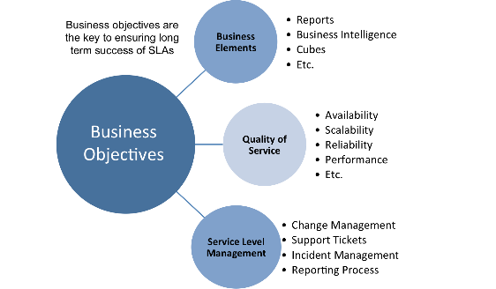
   3. To provide the highest possible level of service to Customers and continuously improve on this through ensuring all services operate at maximum availability
   4. To ensure that IT delivers the same standard of service at the least cost

**Reason: Service Level Management aims to ensure that IT services meet the agreed-upon service levels and targets that align with business needs and priorities. It involves defining, negotiating, and documenting service level targets with customers, monitoring and reporting on service levels achieved, and taking actions to improve service quality and performance as necessary.**

1. The process to implement SLAs comprises of the following activities in sequence:
   1. Draft SLAs, catalogue services, review underpinning contracts and OLAs, draft SLRs, negotiate, agree SLAs
   2. Draft SLAs, review underpinning contracts and OLAs, negotiate, catalogue services,
   3. Review underpinning contracts and OLAs, draft SLAs, catalogue services, negotiate, agree SLAs
   4. **Catalogue services, establish SLRs, review underpinning contracts and OLAs, negotiate service levels, agree SLAs**

**Reason: Implementing Service Level Agreements (SLAs) involves cataloging services, defining specific performance requirements, reviewing supporting contracts, negotiating service levels, and finalizing agreements to ensure IT services meet business needs effectively.**

1. Which of the following is an example of a service level agreement (SLA) between information systems support unit and a research unit in the laboratories of a large company?
   1. The maximum response time to get the system operational should it fail.
   2. The minimum ‘up-time’.
   3. The types of information that will be provided as standard.
   4. **All of the above**

**Reason: Service level agreements (SLAs) between the information systems support unit and a research unit in a company's laboratories define response times for system failures, minimum uptime requirements, and standard information provision, ensuring clear expectations and standards for IT service delivery.**

1. Some organisations bring a degree of formality to the internal customer concept by encouraging (or requiring) different parts of the operation to agree on:
   1. **Internal service agreements**
   2. Service level agreements
   3. Formal provision agreements
   4. Delivery agreements

**Reason: Internal service agreements formalize the expectations and responsibilities between different departments or units within an organization that provide services to each other.**

## Index

**B**

bookstore 1

**C**

categories 6

closed-ended 7

**D**

data collection 9

**L**

Linux server 2

**N**

network 1

**O**

open-ended 7

**S**

Service Level 9

service level agreement 10

service quality 10

soft skills 5

support 3

**T**

technology 2

telecommunications 3