Trade Performance Tracker

Original Requirements
Input: I will cut and paste in trade transactions from Thinkorswim. Here are some samples:
- BUY +2 BE 100 15 JAN 27 50 CALL @52.60 LMT
- SELL -7 2/2/-1/-1 CUSTOM GOOGL 100 (Weeklys) 6 FEB 26/6 FEB 26/30 JAN 26/30 JAN 26 355/295/355/295 CALL/PUT/CALL/PUT @11.99 LMT GTC
- SELL -4 CALENDAR SHOP 100 (Weeklys) 13 FEB 26/16 JAN 26 160 PUT @6.75 LMT
- SELL -20 VERT ROLL RUT 100 (Weeklys) 20 FEB 26/30 JAN 26 2730/2740/2730/2740 CALL @.40 LMT
- SELL -4 CALENDAR SHOP 100 15 MAY 26/13 FEB 26 160 PUT @7.15 LMT
- SELL -2 CL 100 20 MAR 26 85 CALL @3.55 LMT
- BUY +10 HIMS 100 18 SEP 26 40 CALL @5.45 LMT
Data structure:
- Multiple trade transactions will make up a complete position.
- Positions will be defined by manually assigning a position number when a trade is entered. All trades with the same position number will be grouped together to form the position and profit/loss for that position will be calculated
- Each position will be for a single underlying security
- The first trade transaction entered for a trade number effectively opens that position.
- Positions must be manually closed
Features:
- The interface should be a single page with summary information at the top and individual positions below.
- The summary information should include:
  - Number of active positions
  - Total trades in both active and closed positions
  - The running P&L for all open positions
  - The net P&L for all closed positions
- For positions, there will be a toggle to limit the displayed positions to be either open positions or closed positions
- Below the toggle - each position should be displayed in a tile that has summary information at the top but can be expanded for detail information
- The position summary information will include:
  - The position number
  - The underlying security
  - The type of trade structure. Trade structures include:
    - Single
    - Vertical
    - Ratio
    - Butterfly
  - The running P&L for the position
  - The days to expiration for the position
  - The number of additional trades (adjustments) after the initial position trade was opened
- Clicking on a position summary will expand the position to show all trades that make up the position.
Platform: This should be a chrome web app. Chrome may be running in MacOS, Windows, or even in iOS. The data could be stored in a google sheet or in an excel spreadsheet that is stored in the file system - likely dropbox to ensure access across my multiple computers.

Application Screenshots

Main Page
The main dashboard shows the total portfolio summary at the top with aggregate statistics across all services, followed by individual service cards. Each service card displays position counts, cost, value, current P&L, and closed P&L.
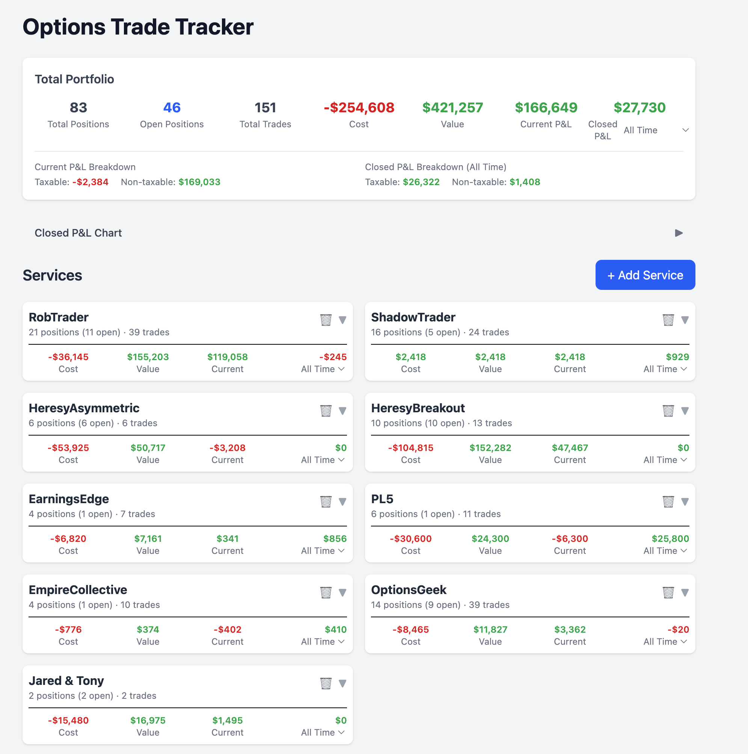
Main Page
Key elements: - Total Portfolio summary with position counts, cost, value, current P&L, and closed P&L - Current P&L Breakdown showing taxable vs non-taxable - Closed P&L Breakdown showing taxable vs non-taxable - Collapsible Closed P&L Chart - Service cards with individual metrics and “Add Service” button

Service View - Open Positions
The service detail view shows the trade entry form at the top and position cards below. The toggle switches between Open and Closed positions. Position cards show symbol, spread type, cost, value, contracts, DTE, and adjustment count.
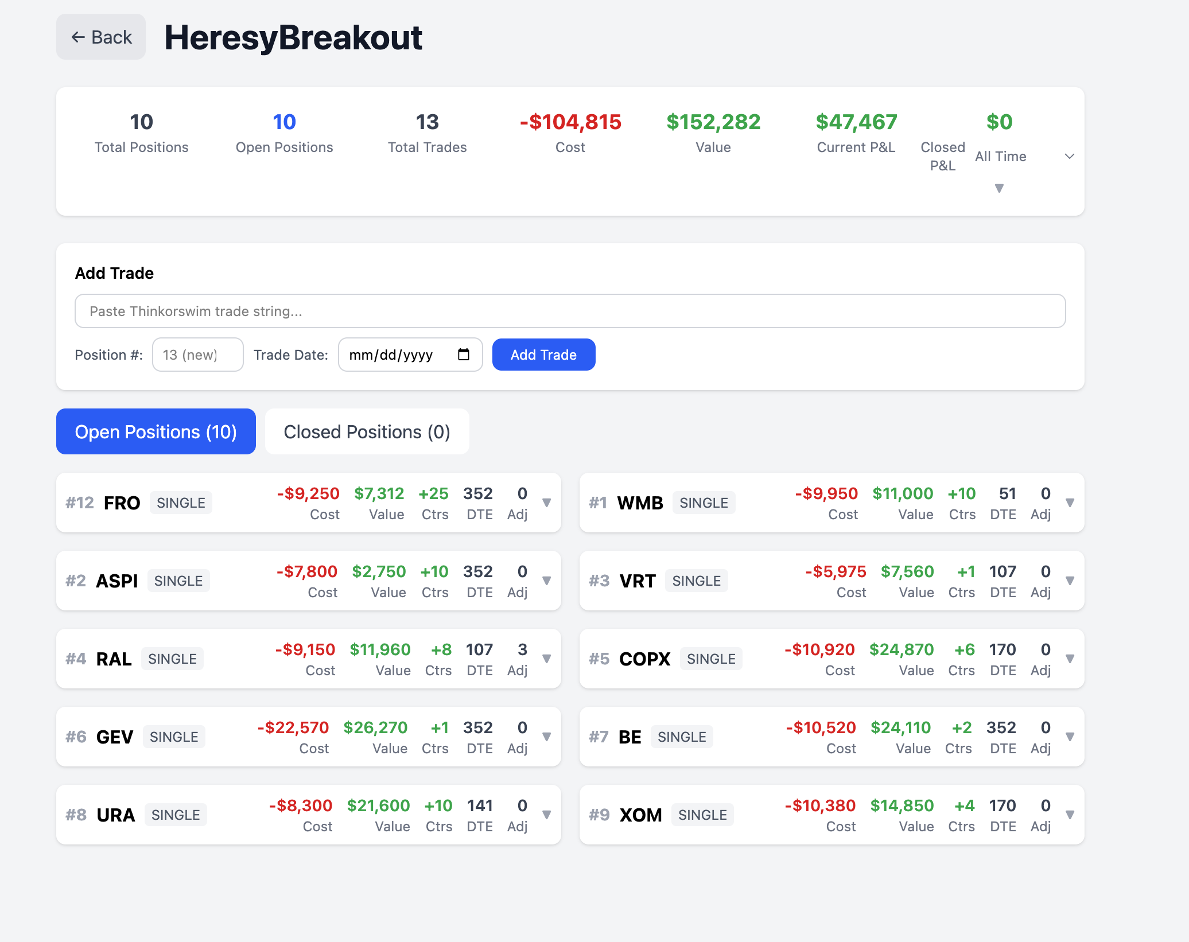
Service View - Open Positions
Key elements: - Service summary statistics - Add Trade form with Thinkorswim paste input - Position number selector (existing or new) - Trade date picker - Open/Closed Positions toggle - Position cards in a responsive grid

Service View - Expanded Position
Clicking a position card expands it to show full details including trade history, mark-to-market section, and action buttons. The taxable checkbox allows marking positions for tax tracking.
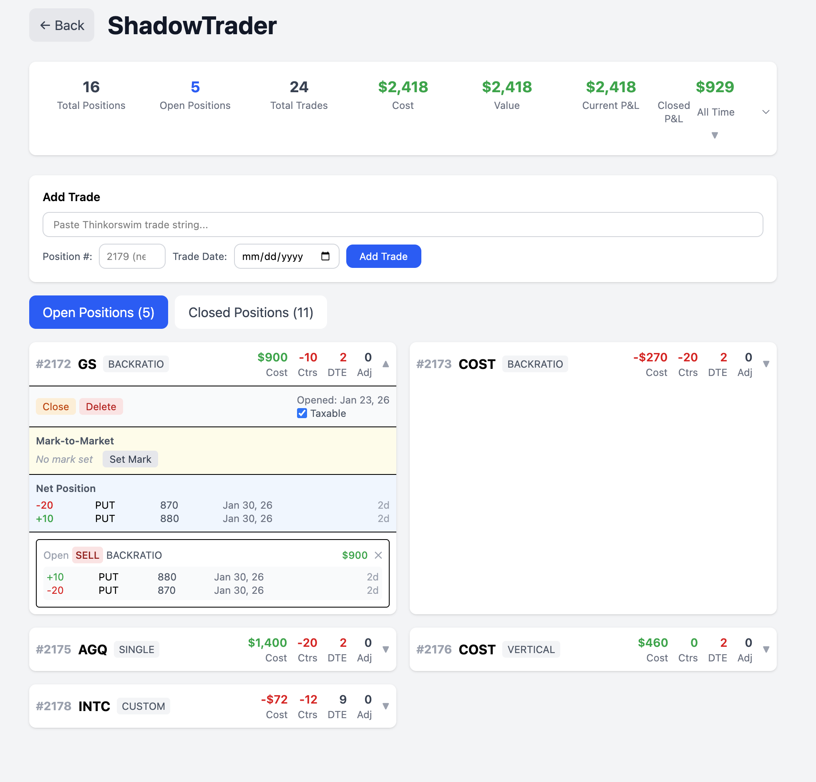
Service View - Expanded Position
Key elements: - Close/Delete buttons for position management - Taxable checkbox for tax tracking - Mark-to-Market section with current mark and set mark button - Net Position showing current leg quantities - Individual trade cards with full details (action, legs, strikes, expirations, price)

Service View - Closed Positions
The closed positions view shows positions that have been closed, with “Days Held” instead of DTE. Expanded positions show the full trade history including opening and closing trades.
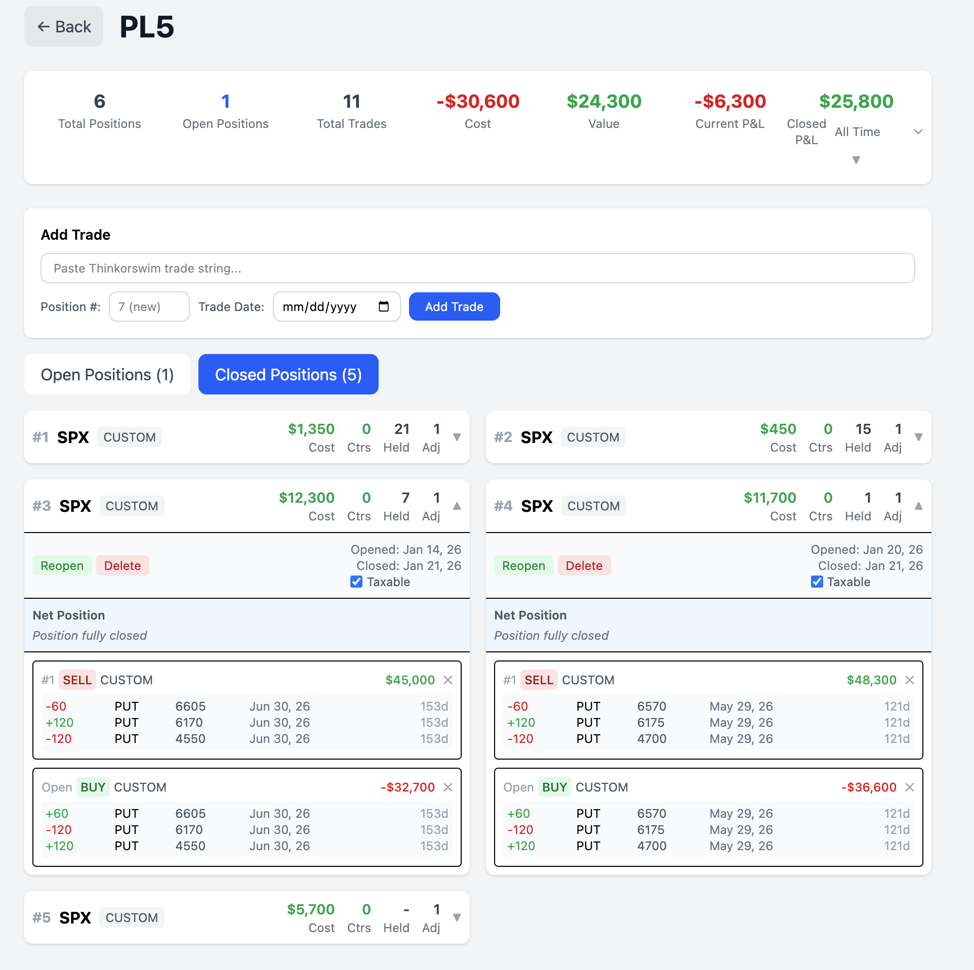
Service View - Closed Positions
Key elements: - Closed Positions toggle selected - Position cards showing closed status - Opened/Closed dates displayed - Days Held metric (instead of DTE) - Reopen/Delete buttons for closed positions - Full trade history in expanded view

Account Settings & Sync
The settings panel handles Google account authentication and cloud sync. Data can be synced to Google Sheets for backup and cross-device access.
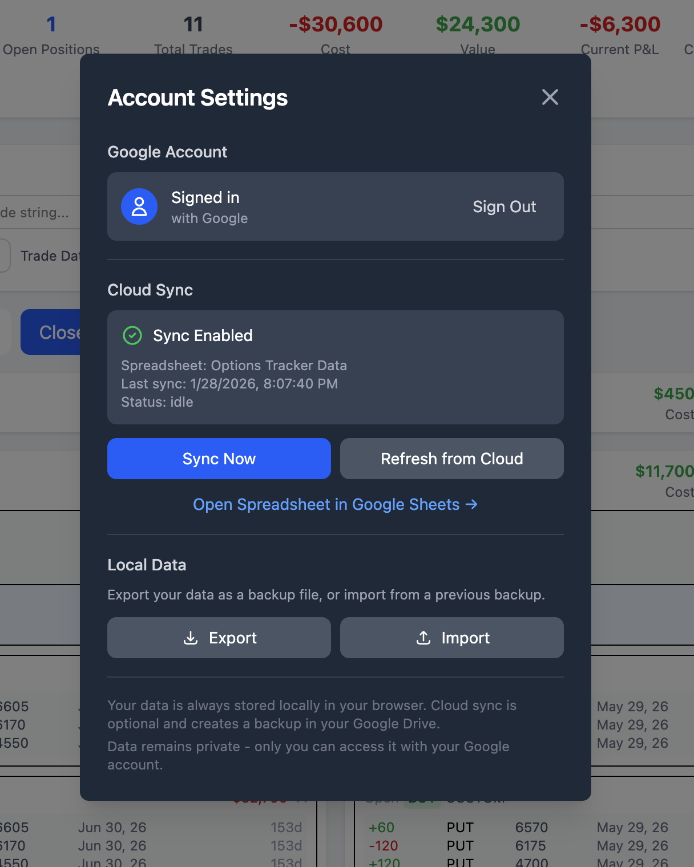
Account Settings
Key elements: - Google Account sign in/out - Cloud Sync toggle with spreadsheet name and last sync time - Sync Now and Refresh from Cloud buttons - Direct link to open spreadsheet in Google Sheets - Export/Import for local data backup

Implemented Features

Core Functionality
Trade Parsing - Parses Thinkorswim trade format automatically - Supports spread types: SINGLE, VERTICAL (VERT), CALENDAR, DIAGONAL, BUTTERFLY (BFLY), RATIO, BACKRATIO, CUSTOM, ROLL variants - Handles BUY/SELL actions with correct sign conventions - Parses weekly vs standard options - Extracts strikes, expirations, option types (CALL/PUT) - Supports GTC orders and various order types (LMT, MKT)
Position Management - Manual position assignment when entering trades - Automatic position creation on first trade - Position close/reopen functionality - Position deletion - Trade deletion within positions - Open/Closed position filtering
Services (Portfolios) - Multiple services/portfolios support - Each service has its own set of positions - Service creation, renaming, deletion - Service-level P&L aggregation

P&L Calculations
Cost Basis Calculation - BUY trades: negative cost (money out) - SELL trades: positive cost (money in/credit received) - Handles multiplier (typically 100 for options)
Current P&L Logic (for open positions) - Net credit portfolios (Cost >= 0): P&L = Value only (credits are “banked”) - Net debit portfolios (Cost < 0): P&L = Cost + Value - This logic applies at the portfolio level, not individual position level
Closed P&L - Calculated as sum of all trade costs for closed positions - Filterable by time period (All Time, YTD, 90 days, 30 days, 7 days)

Mark-to-Market
Position Marking - Manual mark value entry per position - Mark date tracking - Mark source tracking (manual vs API) - Mark values cleared when position is closed
Display - Shows current mark value - Shows mark date - Calculates unrealized P&L based on marks

Tax Tracking
Taxable Flag - Each position has isTaxable boolean flag - Default: false (non-taxable) - Toggle in position card UI - Persists to Google Sheets
Tax Breakdown Display - Closed P&L split by taxable vs non-taxable - Current P&L split by taxable vs non-taxable - Shown on main summary page

UI Features
Main Page - Summary statistics at top - Service cards with key metrics - Collapsible Closed P&L chart (bar chart by period) - Service cards show expired position indicator (red tint)
Service View - Open/Closed position toggle - Position cards with expandable details - Days to Expiration (DTE) for open positions - Days Held for closed positions - Expired positions highlighted with red tint
Position Cards - Symbol, structure type, P&L - Trade count and adjustment count - Expandable trade details - Mark-to-market input - Taxable toggle checkbox - Close/Reopen/Delete actions - Edit position dates
Trade Entry - Text input for Thinkorswim format - Position number assignment (existing or new) - Parse preview before save - Delete individual trades

Data Persistence
Local Storage - Automatic save to browser localStorage - Rehydrates dates on load - Supports legacy data migration (markPrice -> markValue)
Google Sheets Sync - OAuth authentication with Google - Automatic spreadsheet creation - 5 sheets: Metadata, Services, Positions, Trades, Legs - Full sync (read/write all data) - Schema versioning
Spreadsheet Schema - Metadata: appTitle, schemaVersion, lastModified - Services: id, name, createdAt, nextPositionId - Positions: id, serviceId, symbol, structure, isOpen, openDate, closeDate, markValue, markDate, markSource, isTaxable - Trades: id, positionId, serviceId, rawInput, action, totalQuantity, symbol, multiplier, isWeekly, spreadType, price, orderType, isGTC, tradeDate - Legs: tradeId, legIndex, quantity, expiration, strike, optionType, legAction

Deployment
Vercel Hosting - Static site deployment - Auto-deploy from GitHub - Production URL: https://options-tracker-phi.vercel.app
Google OAuth Configuration - Requires VITE_GOOGLE_CLIENT_ID environment variable - Authorized origins and redirect URIs configured - Currently in testing mode (manual user approval required)

Technology Stack
- Frontend: React 19 with TypeScript
- Build Tool: Vite 7
- Styling: Tailwind CSS 4
- Charts: Chart.js with react-chartjs-2
- APIs: Google Sheets API, Google Drive API
- Hosting: Vercel
- Version Control: Git/GitHub

Future Considerations
- Schwab API Integration: Real-time mark values from brokerage
  - Challenges: Position matching (legs to spreads), multiple accounts, Net Liq calculation
- Google OAuth Verification: Required for public access beyond test users
- Additional reporting/export features

