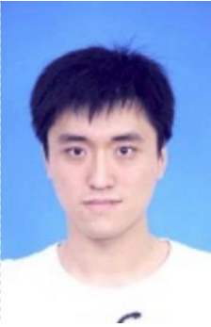

Zhang Hengjian

Name: Arthors

Mobile: +8618516056615

E-mail: arthors.zhang@gmail.com

Address: No. 880 Zixing Rd, Minhang Dist, Shanghai

Objective:

Software Engineer

**Experience**

IBM internship

Working at IBM System-X Uefi team, design and implement the continuous integration test framework. Meanwhile, a kind of black box testing tool is completed.

Intel internship

Working at webrtc team as a Software test engineer, to design and implement the unit test case, complete the nightly test for webrtc android app.

**EDUCATION**

● Graduating University: Southeast University

● Major: Software engineering

● Degree: Master of software engineering expected March, 2015

● Specialized courses included data structure, algorithm,

computer composition principle, object oriented programming

**SKILLS**

* **Computer**

**Good at using Python & Shell programming**

Familiar with Java language;

Familiar with Agile Modeling ;

Familiar with Android development mode

Sound knowledge with software such as Windows, Office2013, PhotoShop, CorelDraw, Dreamweaver, etc;

* **Language**

Native speaker of Chinese;

**Fluent in English;**

**AWARDS**

● 2010~2011 school year third scholarship, obtains the forth scholarship

● 2009~2010 school year, the third university scholarship

● 2008~2009 school year the third scholarship, obtains the forth scholarship

● The higher education community in 2010 Cup National Undergraduate

Mathematical Modeling Contest (undergraduate group) successful participants

● First 2010 Jilin Province Undergraduate Mathematical Contest in modeling

(undergraduate group) successful participants

● The higher education community in 2009 Cup National Undergraduate

Mathematical Modeling Contest (undergraduate group) third prize

**CERTIFICATES**

● College English Test Band 6

● Computer software technology and professional technical qualifications in

2011 people's Republic of China the title intermediate

--------Network Engineer

● Office automation test issued 2011 information and Industry Ministry

**PERSONAL DATA**

● Birth: July 8th 1989 Gender: Male Health: Excellent

● Place of Birth: Jilin City, Jilin Province

● Interest: Enjoy setting-up exercise, photograph & traveling