

Warehouse Rx Web Client

Customer – Location

2019-06-28

Version 0

This page intentionally left blank.

# Version History

|  |  |  |  |
| --- | --- | --- | --- |
| Date | Version | Author | Changes |
| 2019-06-27 | 0 |  | Initial version |
|  |  |  |  |
|  |  |  |  |
|  |  |  |  |
|  |  |  |  |

Table of Contents

Version History 1

Introduction 3

Starting the Web Client 3

Login 3

Typical Screen Controls 4

Web Client Screens 5

Welcome Screen 5

Facility 5

Devices 6

Locations 7

Inventory 9

Loads 10

Moves 13

Orders 14

Expected Receipts 15

Order Maintenance 16

Tools 18

Equipment Monitor 19

Load Recovery 24

Log Viewer 26

Transaction History 27

Users 28

User Permissions 29

User Sessions 31

Users 32

Help 32

Recovery Procedures 33

# Introduction

Insert introduction here.

# Starting the Web Client

Navigate to http://WRxServerNameOrIP

## Login

Warehouse Rx comes preconfigured with 4 user logins, each corresponding to a different role.

* Read Only Role – can view most things but cannot edit.
  + User ID: readonly
  + Password: readonly
* Operator Role – can perform basic operations as well as recovery operations like deleting tracking or modifying load data.
  + User ID: operator
  + Password: operator
* Administrator Role – all permissions, including the creation of users and assignment of roles.
  + User ID: administrator
  + Password: administrator

# Typical Screen Controls

Typical screen controls. Not all screens have all controls.

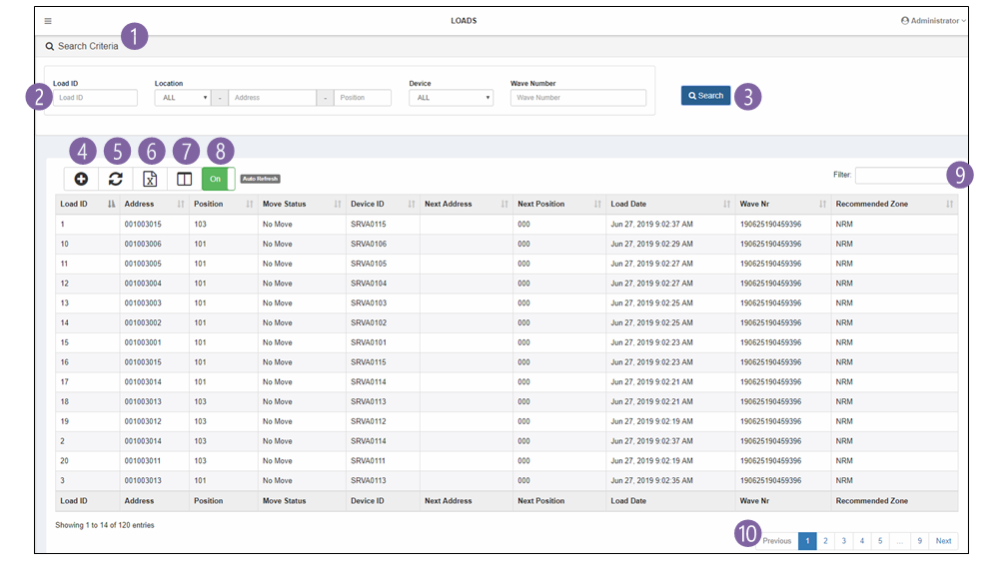

1. Click to show or hide Search Criteria
2. Enter data to filter data from the database
3. Click to query the database
4. Click to open the Add dialog
5. Click to refresh the table
6. Click to export the table
7. Click to select which columns to display
8. Click to toggle auto-refresh
9. Type to filter across all columns in the current table data
10. Select the page to view when the tables are large.

# Web Client Screens

## Welcome Screen

The welcome screen has a sidebar menu on the left as well as quick link tiles to frequently used screens.

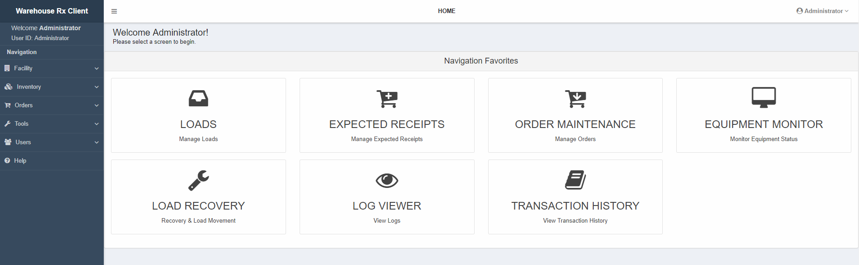

## Facility

The Facility menu group contains two options:

* Devices – Shows the list of devices with their configurations and statuses.
* Locations – Shows the list of locations with their configurations and statuses.

Click the option to open the screen.

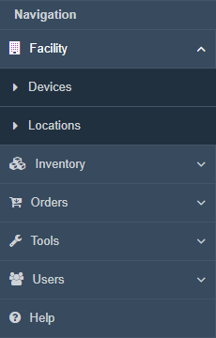

### Devices

The Devices screen shows the list of devices with their configurations and statuses. This screen is provided for information only.

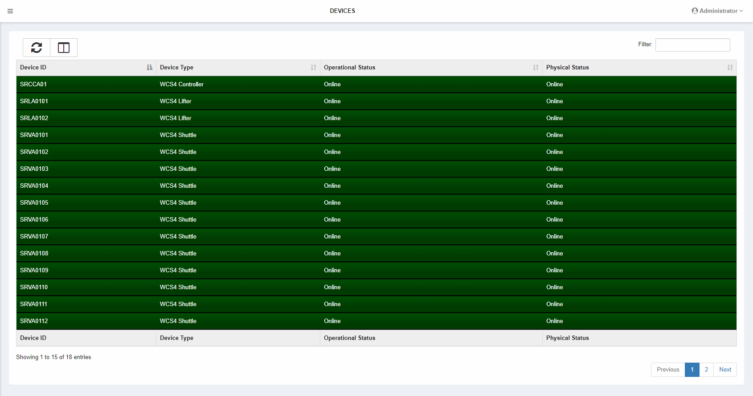

#### Columns

|  |  |
| --- | --- |
| Column | Notes |
| Device ID | The ID for the device. |
| Device Type | The type of the device. |
| Operational Status | The operational status for the device.   * Online – the device is available for storage and retrieval. * Offline – the device is unavailable for storage. If the device is physically online, retrievals will still be performed. * Inoperable – the device is unavailable. |
| Physical Status | The physical status for the device.   * Online – the device is online * Offline – the device is offline (stopped, in error, etc.) |
| Read/Write Port | The name of the port controller for this device. |
| Comm Device | The name of the communications device for this device. |
| Scheduler Name | The name of the scheduler for this device. |
| Allocator Name | The name of the allocator for this device. |
| Emulation Mode | The emulation mode for this device.   * No Emulation – software is connected to a physical device * Full Emulation – software is connected to an emulated device. |

### Locations

The Locations screen shows the list of locations with their configurations and statuses.

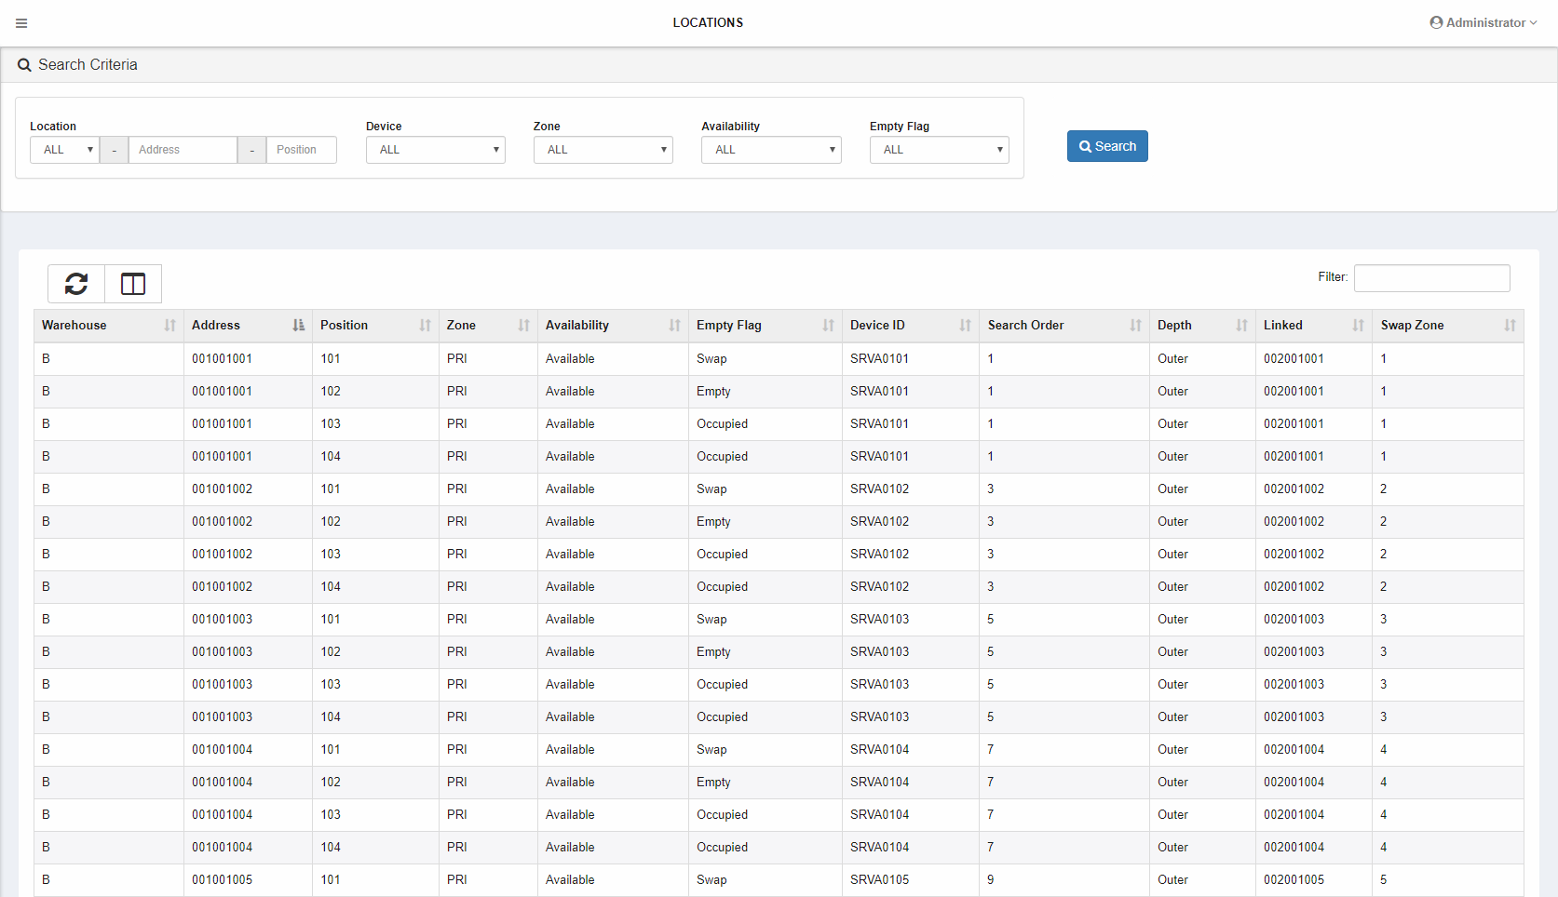

#### Columns

|  |  |
| --- | --- |
| Column | Notes |
| Warehouse | The warehouse designation for this location. |
| Address | The address for this location. Addresses are in RRRBBBTTT format:   * RRR – Row (or bank) * BBB – Bay (or column) * TTT – Tier (or level) |
| Position | The position for this location. |
| Zone | The zone for this location. |
| Height | The maximum height for this location. |
| Length | The assigned length for this location. |
| Availability | The availability for a location:   * Available – Available for storage with a length pattern assigned. * Prohibited – Storage at this location is prohibited. For use when a shelf is damaged. * Unavailable – Unavailable for storage/retrieval. * Unassigned – Available for storage with no length pattern assigned. |
| Empty Flag | The empty status for a location:   * Empty – The location is empty. * Occupied – The location is occupied. * Reserved – The location is reserved for a load that is in the process of storing. * Double-deep movement – The inner location is reserved during movement to or from an outer location. * Swap – The location is reserved as a swap location. Swap locations are used when an inner location needs to be emptied so the container in the outer location may be retrieved. |
| Device ID | The device ID of the device that controls this location. |
| Search Order | The search order for this location that is used when searching for an empty location. |
| Depth | The depth of this location   * Inner – The location is between the shuttle and the outer location. * Outer – The location is behind the inner location. |
| Linked | The address of the location that is connected to this location. |
| Swap Zone | The swap zone for this location. There is a swap zone for every device + zone + height combination. |

#### List Operations

Users with ROLE_ELEVATED permissions can modify a location to correct its status. Right-click a row and select Modify to modify it.

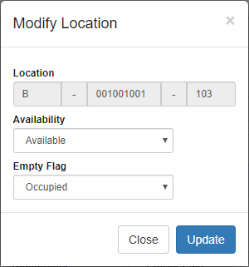

## Inventory

The Inventory menu group contains two options:

* Loads – Shows a list of loads (containers) with their locations and statuses.
* Moves – Show a list of moves, which show allocations for outbound orders.

Click the option to open the screen.

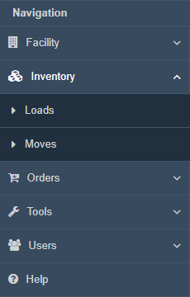

### Loads

The Loads screen shows a list of loads (containers) with their locations and statuses.

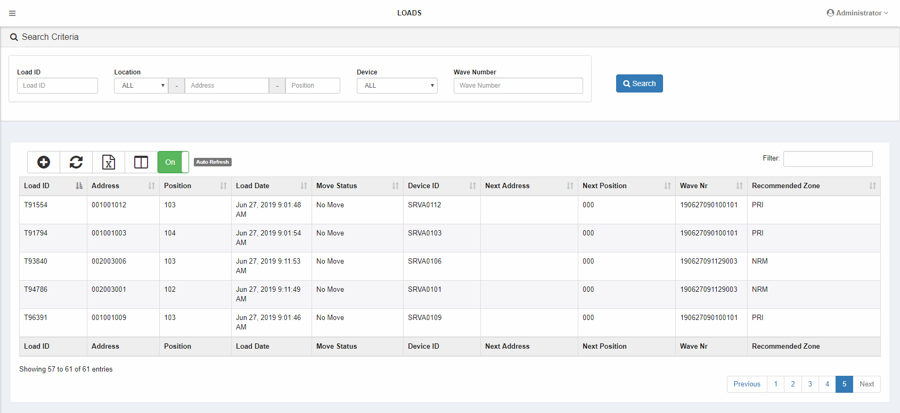

#### Columns

|  |  |
| --- | --- |
| Column | Notes |
| Load ID | The barcode for this load. |
| Warehouse | The warehouse for this load. |
| Address | The address for this load. |
| Position | The position for this load. |
| Load Date | The date of the last load movement. |
| Move Status | The move status for this load.   * Arrived – The load has arrived at a station is awaiting a user operation. * Arrival Pending – The load is awaiting an arrival message from the equipment. * Move Error – The controller rejected the station-to-station move command for this load. * Move Pending – This load is waiting for a station-to-station move command to be sent to the controller. * Move Sent – This load is waiting for a response to a station-to-station move command. * Moving – This load is moving from station to station. * No Move – This load is not moving (it is stored on a shelf). * Retrieve Error – The controller rejected the location-to-station or location-to-location move command for this load.      * Retrieve Pending – This load is waiting for a location-to-station or location-to-location move command to be sent to the controller. * Retrieve Sent – This load is waiting for a response to a location-to-station or location-to-location move command. * Retrieving – This load is moving from a location to a station or another location. * Store Error – The controller rejected the station-to-location move command for this load. * Store Pending – This load is waiting for a station-to-location move command to be sent to the controller. * Store Sent – This load is waiting for a response to a station-to-location move command. * Storing – This load is moving from a station to a location. |
| Device ID | The device ID of the device that controls this load. |
| Next Warehouse | The next warehouse for this load. |
| Next Address | The next address for this load. |
| Next Position | The next position for this load. Default for this is 000. |
| Wave Nr | The Wave Number assigned to this load. |
| Recommended Zone | The recommended zone for this load. |

#### List Operations – Add Button

To add a load, click the Add icon above the list (ROLE_ELEVATED or higher). Populate the fields in the dialog and click Add.

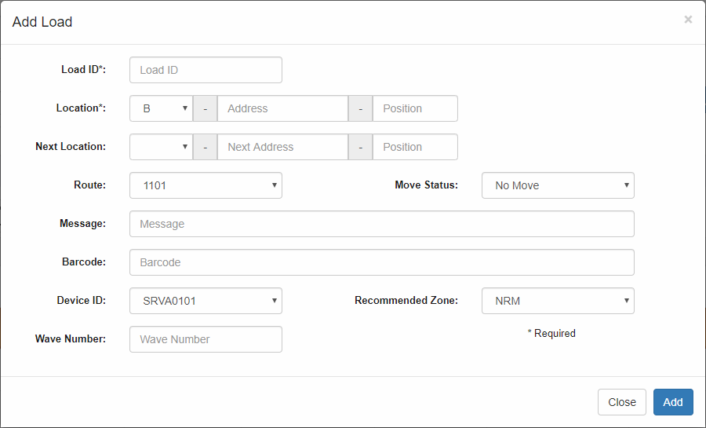

#### List Operations – Context Menu

A pop-up menu is available with options depending on the user’s roles. Right-click to display the pop-up menu.

* Retrieve – ROLE_USER or higher.
* Modify – ROLE_ELEVATED or higher. Modify the selected load in a pop-up dialog.
* Delete – ROLE_ELEVATED or higher. Delete the selected load.
* Show Location – ROLE_READONLY or higher. Show location information in a pop-up dialog.
* Show Moves – ROLE_READONLY or higher. Show move information in a pop-up dialog.

### Moves

The Moves screen shows a list of moves which show allocations for outbound orders. This screen is provided for information only.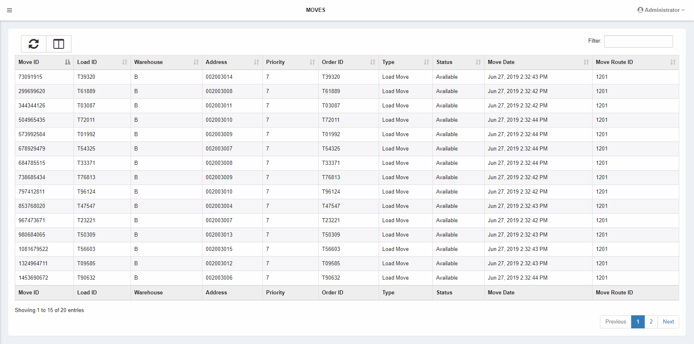

#### Columns

|  |  |
| --- | --- |
| Column | Notes |
| Move ID | The system-generated unique ID for the move. |
| Load ID | The barcode for this load. |
| Warehouse | The warehouse for this load. |
| Address | The address for this load. |
| Priority | The priority for the move (based upon the order). |
| Order ID | The order ID for the move. |
| Type | The type of move. |
| Status | The status of the move. |
| Move Date | The date and time the move was created. |
| Move Route ID | The destination for this movement.   * 1201 – Shipping * 1203 – Recirculation |

## Orders

The Orders menu group contains two options:

* Expected Receipts – Shows a list of expected receipts, or inbound load orders.
* Order Maintenance – Shows a list of outbound orders.

Click the option to open the screen.

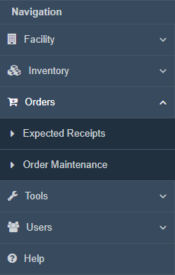

### Expected Receipts

The Expected Receipts screen shows a list of expected receipts, or inbound load orders.

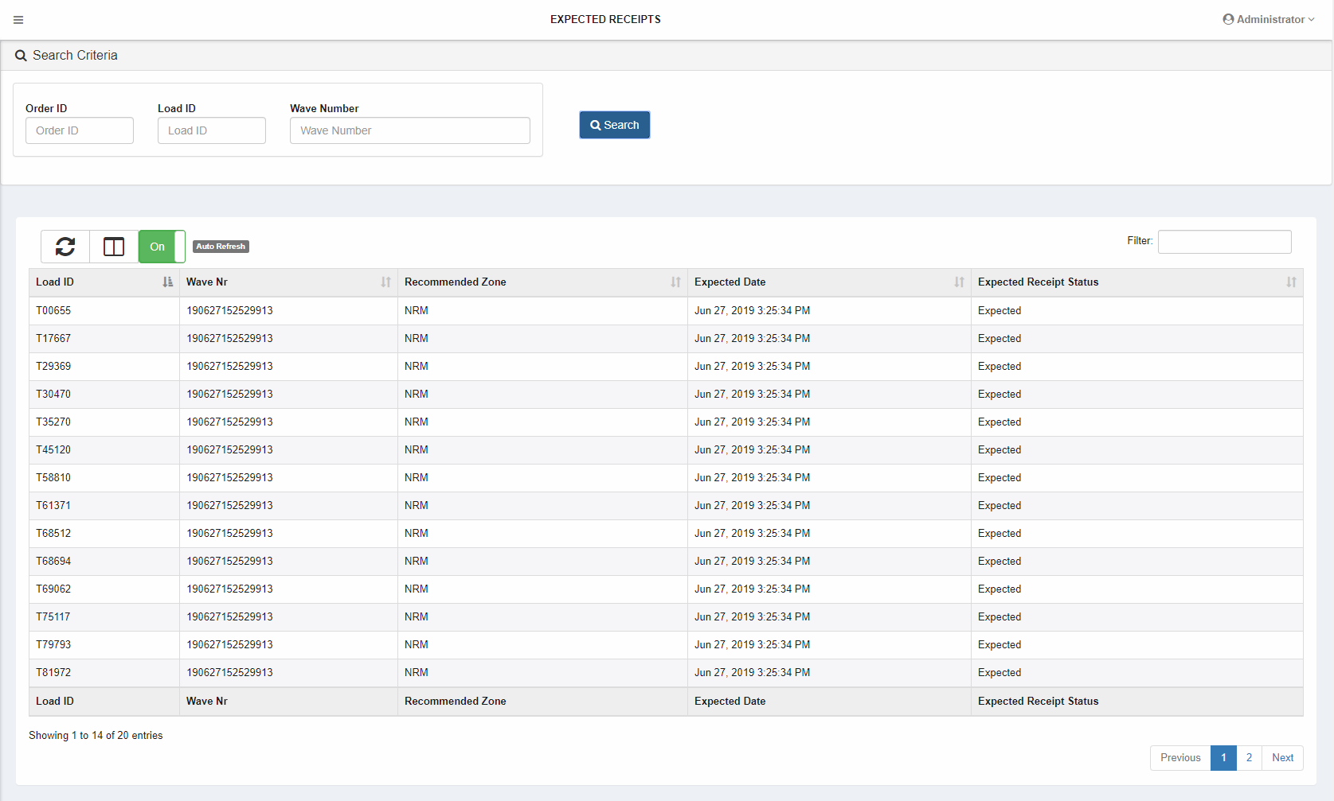

#### Columns

|  |  |
| --- | --- |
| Column | Notes |
| Load ID | The barcode for this load. |
| Wave Nr | The wave number for this load. |
| Recommended Zone | The recommended zone for this load. If the recommended zone is not available, it will be stored in the alternate zone. |
| Expected Date | The date and time the expected receipt was created. |
| Expected Receipt Status | The status for the expected receipt. |

#### List Operations – Context Menu

A pop-up menu is available with options depending on the user’s roles. Right-click to display the pop-up menu.

* Delete – ROLE_ELEVATED or higher. Delete the selected expected receipt.
* Show Details – ROLE_READONLY or higher. Show detail information in a pop-up dialog.

### Order Maintenance

The Order Maintenance screen shows a list of outbound orders.

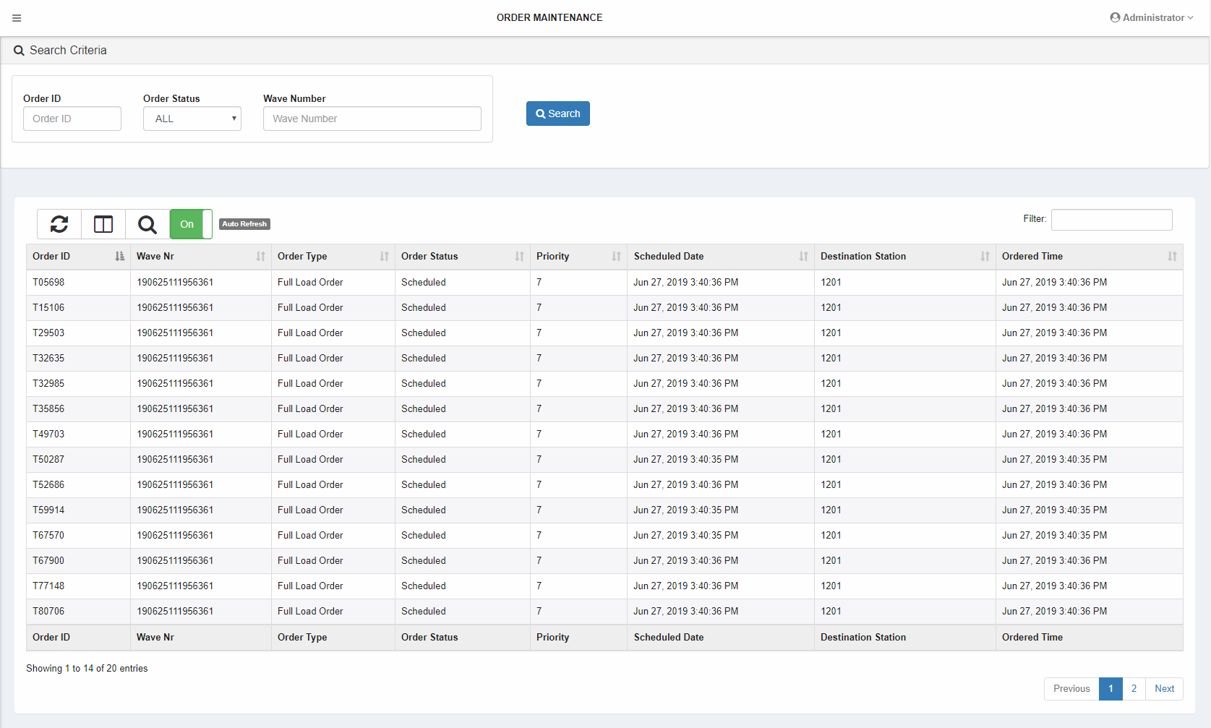

#### Columns

|  |  |
| --- | --- |
| Column | Notes |
| Order ID | The order ID, which matches barcode for the ordered load. |
| Wave Nr | The wave number for this order. |
| Order Type | The type of order. |
| Order Status | The status for the order.   * Allocate Now – the system should allocate this order immediately. * Allocating – the system is allocating this order. * Hold – the system should not allocate this order. * Ready – the system should allocate this order when the equipment is available. * Scheduled – this order has been allocated.   Orders in this system are created with an Allocate Now status. |
| Priority | The priority of the order. |
| Scheduled Date | The date and time this order was scheduled. |
| Destination Station | The destination for this order.   * 1201 – Shipping * 1203 – Recirculation |
| Ordered Time | The date and time this order was created. |

#### List Operations – Context Menu

A pop-up menu is available with options depending on the user’s roles. Right-click to display the pop-up menu.

* Mark Ready – ROLE_USER or higher. Change the status of an order from Hold to Ready.
* Hold – ROLE_USER or higher. Change the status of an order to Hold.
* Delete – ROLE_ELEVATED or higher. Delete the selected order.
* Show Details – ROLE_READONLY or higher. Show detail information in a pop-up dialog.
* Show Moves – ROLE_READONLY or higher. Show move information in a pop-up dialog.

## Tools

The Tools menu group contains four options:

* Equipment Monitor – Shows equipment status and allows start, stop, and error reset operations.
* Load Recovery – Shows a list of moving loads (containers) and provides recovery options.
* Log Viewer – Shows a list of error logs.
* Transaction History – Shows a list of historical data.

Click the option to open the screen.

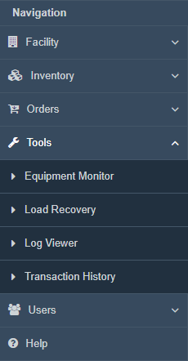

### Equipment Monitor

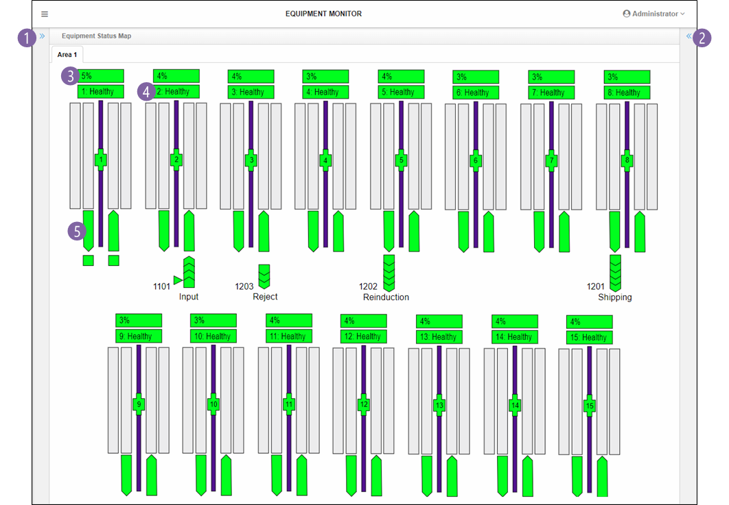The Equipment Monitor screen shows equipment status and allows start, stop, and error reset operations.

1. Click to open the Command Center sidebar.
2. Click to open the Equipment Detail sidebar.
3. Fullness indicator which shows how full a tier is. Click to open the Equipment Detail sidebar.
4. Swap zone status indicator. Click to open the Equipment Detail sidebar.
5. Equipment status indicator. Click to open the Equipment Detail sidebar.

#### Command Center Sidebar (Right)

The Command Center sidebar provides system commands, shows additional status, and contains legends.

##### Commands

The commands menu contains options that apply to the whole system.

* Start System – start all equipment
* Stop System – stop all equipment
* Reset Errors – reset errors on all equipment
* Silence Alarms – silence audible alarms on all equipment.

##### Connection Status

Shows the status of the Warehouse Rx and host database connections.

##### Equipment Status

This section is a legend for the Equipment Monitor.

##### Light Tower Status

This section is a legend for the light tower(s) on the physical equipment.

#### Equipment Detail Sidebar (Left)

The Equipment Detail sidebar shows the status of a piece of equipment and contains a button to enable or disable load a tracking display for supported equipment.

The sidebar may be stretched by clicking and dragging the left edge.

When tracking is enabled, tracking data is requested from the controller and filtered by the selected equipment. The filter may be removed to view all data.

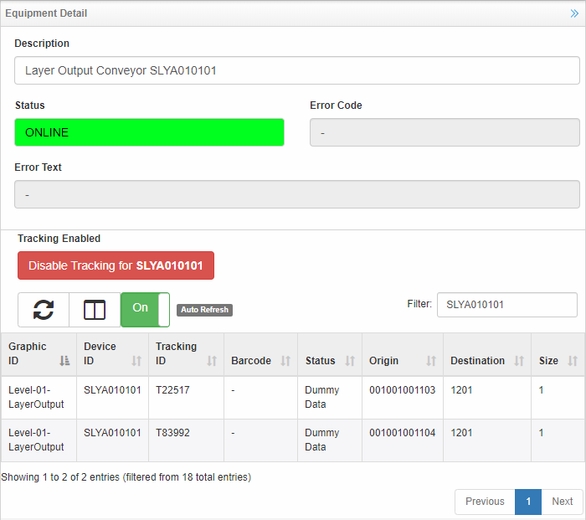

|  |  |
| --- | --- |
| Column | Notes |
| Graphic ID | The ID of the graphic on the screen. |
| Device ID | The ID of the physical equipment. |
| Tracking ID | The ID of the tracked load. |
| Barcode | Barcode data (if different from the Tracking ID). |
| Status | Status description from the equipment. |
| Origin | The origin location for the tracked load. |
| Destination | The destination location for the tracked load. |
| Size | The size profile for the tracked load. |

##### List Operations – Context Menu

A pop-up menu is available with options depending on the user’s roles. Right-click to display the pop-up menu.

* Delete – Delete the selected tracking data. The equipment must be stopped to delete.

#### Equipment Graphics

The equipment graphics show status have context menu options to enable control of the system.

##### Tooltip

Hovering over a graphic shows more information in a tooltip. Sample tooltips:

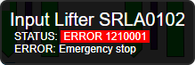 

##### Context Menus

Graphics have context menu options. Not all graphics contain all options.

* Error Guidance – Get recovery help for an error. If the selected equipment is in error, then the error code for that equipment is the default. An error code may also be manually provided.
* Reset Error – Request an error reset.
* Silence Alarm – Silence the audible alarm without resetting the error.
* Start – Start the equipment.
* Stop – Stop the equipment.
* SRC Online – Request the equipment’s controller to turn online.
* SRC Offline – Request the equipment’s controller to turn offline.
* Latch Clear – Request a latch clear from the conveyor PLC.
* Disconnect – Take a piece of equipment out of service.
* Reconnect – Place a disconnected piece of equipment back into service.
* Save Logs – Request the controller save its logs. It is best if the controller is Offline when saving logs.
* Test MOS Comm. – Send a test message over the MOS (status) port.

### Load Recovery

The Load Recovery screen shows a list of moving loads and provides recovery options.

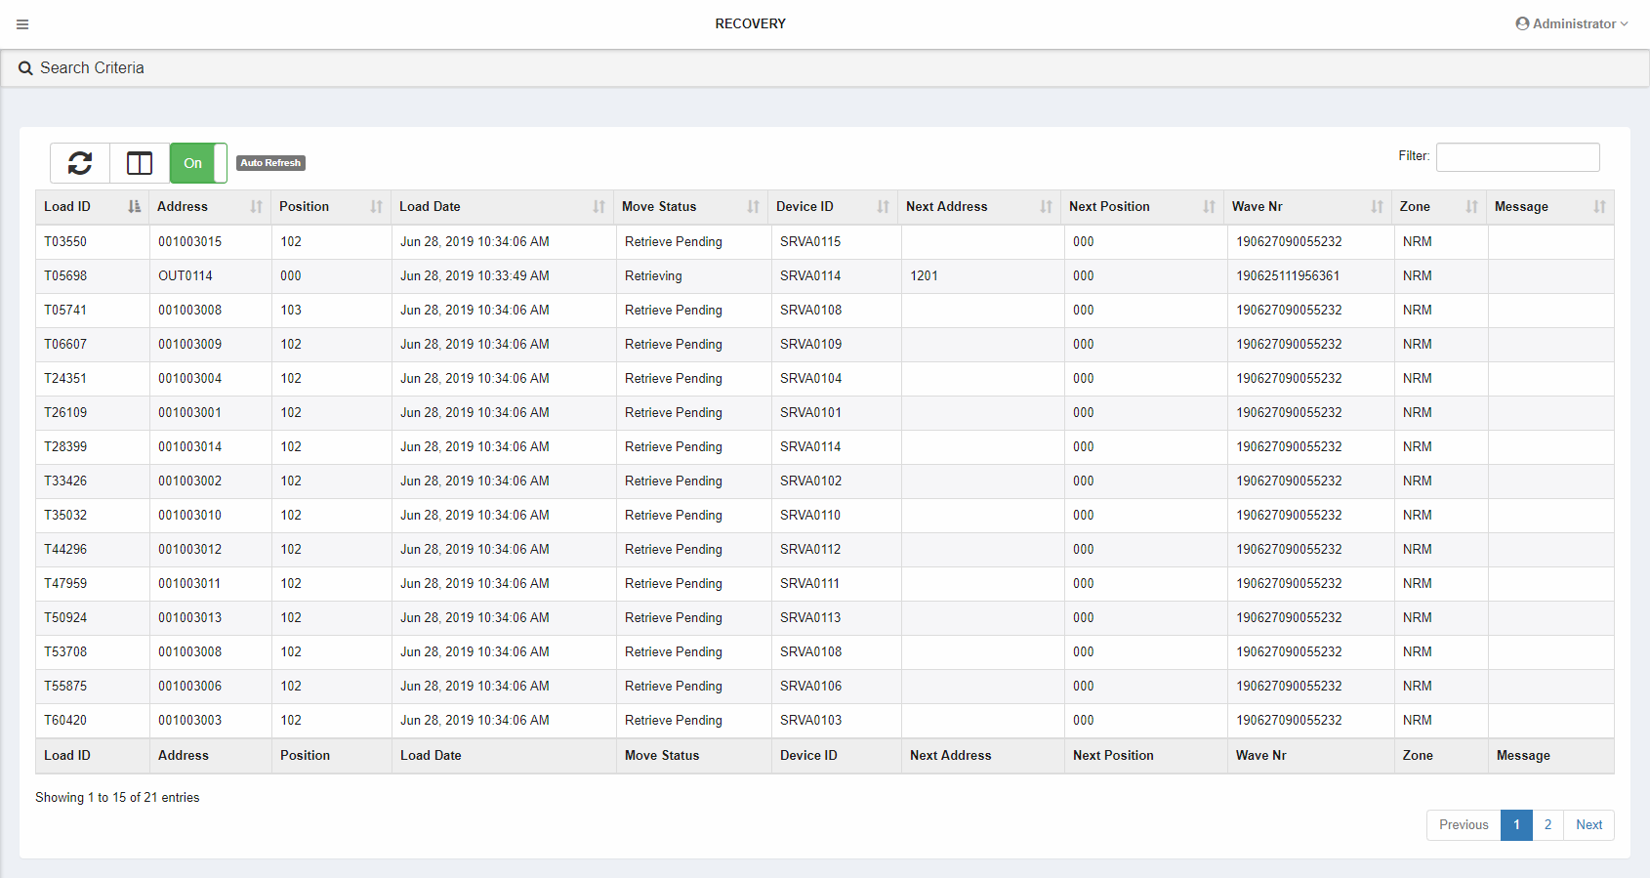

#### Columns

|  |  |
| --- | --- |
| Column | Notes |
| Load ID | The barcode for this load. |
| Warehouse | The warehouse for this load. |
| Address | The address for this load. |
| Position | The position for this load. |
| Load Date | The date of the last load movement. |
| Move Status | The move status for this load.   * Arrived – The load has arrived at a station is awaiting a user operation. * Arrival Pending – The load is awaiting an arrival message from the equipment. * Move Error – The controller rejected the station-to-station move command for this load. * Move Pending – This load is waiting for a station-to-station move command to be sent to the controller. * Move Sent – This load is waiting for a response to a station-to-station move command. * Moving – This load is moving from station to station. * No Move – This load is not moving (it is stored on a shelf). * Retrieve Error – The controller rejected the location-to-station or location-to-location move command for this load.      * Retrieve Pending – This load is waiting for a location-to-station or location-to-location move command to be sent to the controller. * Retrieve Sent – This load is waiting for a response to a location-to-station or location-to-location move command. * Retrieving – This load is moving from a location to a station or another location. * Store Error – The controller rejected the station-to-location move command for this load. * Store Pending – This load is waiting for a station-to-location move command to be sent to the controller. * Store Sent – This load is waiting for a response to a station-to-location move command.   Storing – This load is moving from a station to a location. |
| Device ID | The device ID of the device that controls this load. |
| Next Warehouse | The next warehouse for this load. |
| Next Address | The next address for this load. |
| Next Position | The next position for this load. Default for this is 000. |
| Wave Nr | The Wave Number assigned to this load. |
| Recommended Zone | The recommended zone for this load. |
| Message | Recovery-related messages. |

#### List Operations – Context Menu

A pop-up menu is available with options depending on the user’s roles. Right-click to display the pop-up menu.

* Recover – ROLE_ELEVATED or higher. Attempt to recover a load. See Recovery Procedures for details.
* Delete – ROLE_ELEVATED or higher. Delete the selected load.
* Show Location – ROLE_READONLY or higher. Show location information in a pop-up dialog.
* Show Moves – ROLE_READONLY or higher. Show move information in a pop-up dialog.

### Log Viewer

The Log Viewer shows a list of error logs.

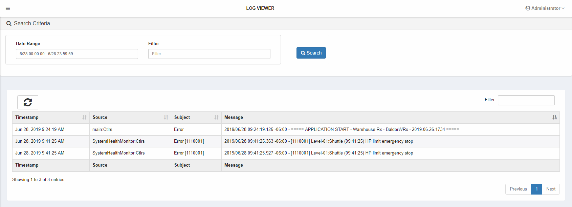

### Transaction History

The Transaction History screen shows a list of historical data. It can be used in troubleshooting or researching.

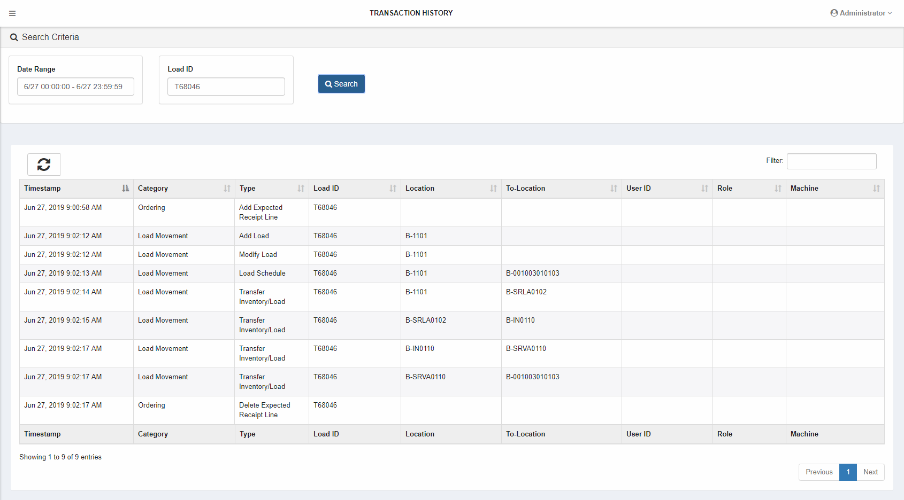

In this example, information is displayed for load T68046. These transactions were created under emulation, which is faster than physical equipment.

* An expected receipt was created for it at 9:00 am.
* At 9:02:12 am the barcode was scanned at the input station (1101).
* It was then modified internally as it was linked to the expected receipt.
* At 9:02:13 am the load was assigned to a storage location (001003010103).
  + Row 001
  + Bay 003
  + Tier 010
  + Position 103
* At 9:02:14 am the load was picked up by the lifter (SRLA0102).
* At 9:02:15 am the load was deposited by the lifter onto the tier 10 input conveyor (IN0110).
* At 9:02:17 am the load was picked up by the shuttle (SRVA0110).
* After that it was deposited at the storage location (001003010103).
* Finally, the associated expected receipt was deleted.

## Users

The Users menu group contains three options:

* User Permissions – Manage user permissions.
* User Sessions – Shows a list of logged in users.
* Users – Manage users.

Click the option to open the screen.

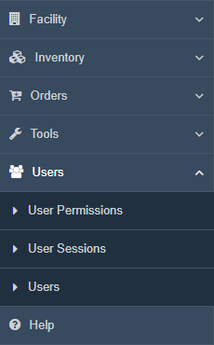

### User Permissions

The User Permissions screen is for user role management.

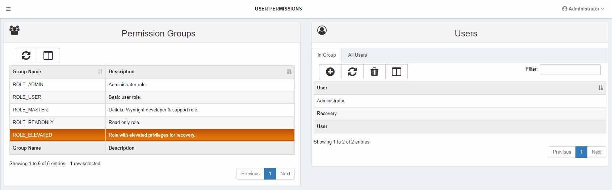

#### Permission Groups

The Permission Groups table lists the available permission groups. Clicking on a row causes the Users table to populate with matching users.

#### Users

The Users table starts empty and populates once a Permission Group row is selected.

#### List Operations – Add Button

Click the add icon at the top of the list to add one or more users to a permission group. A dialog appears listing all users that do not have the indicated permission group. Select the users to add, then click Grant User(s) Access.

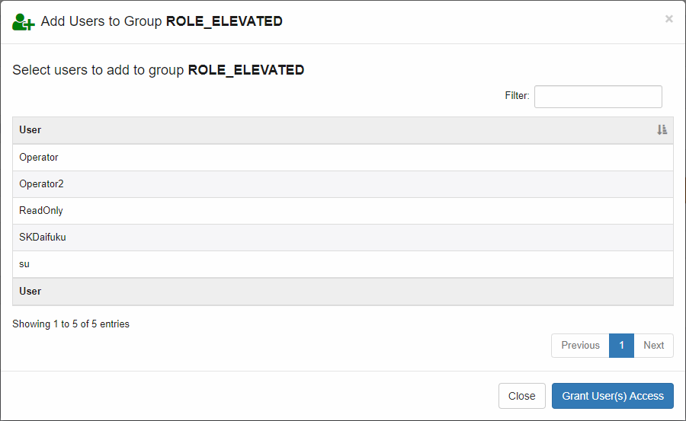

#### List Operations – Delete Button

Click the delete icon at the top of the list to remove one or more users to a permissions group. A dialog appears listing all users that have the indicated permission group. Select the users to remove, then click Revoke User(s) Access.

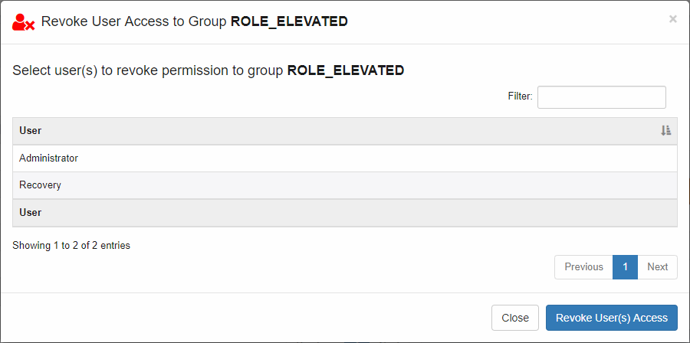

### User Sessions

The User Sessions screens displays current login information.

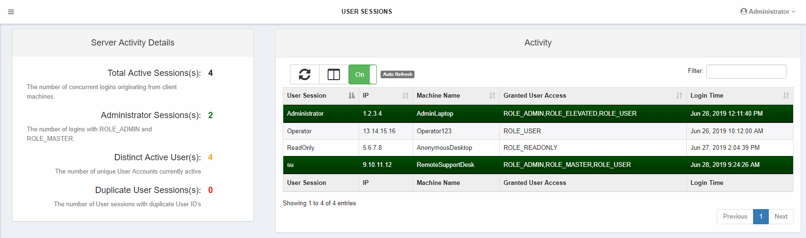

|  |  |
| --- | --- |
| Column | Notes |
| User Session | User ID for the session. |
| IP | IP of the client machine. |
| Machine Name | Name of the client machine. |
| Granted User Access | Roles – See User Permissions. |
| Login Time | Date and time that the session started. |

### Users

The Users screen is for user management. Users may be added, modified, and deleted.

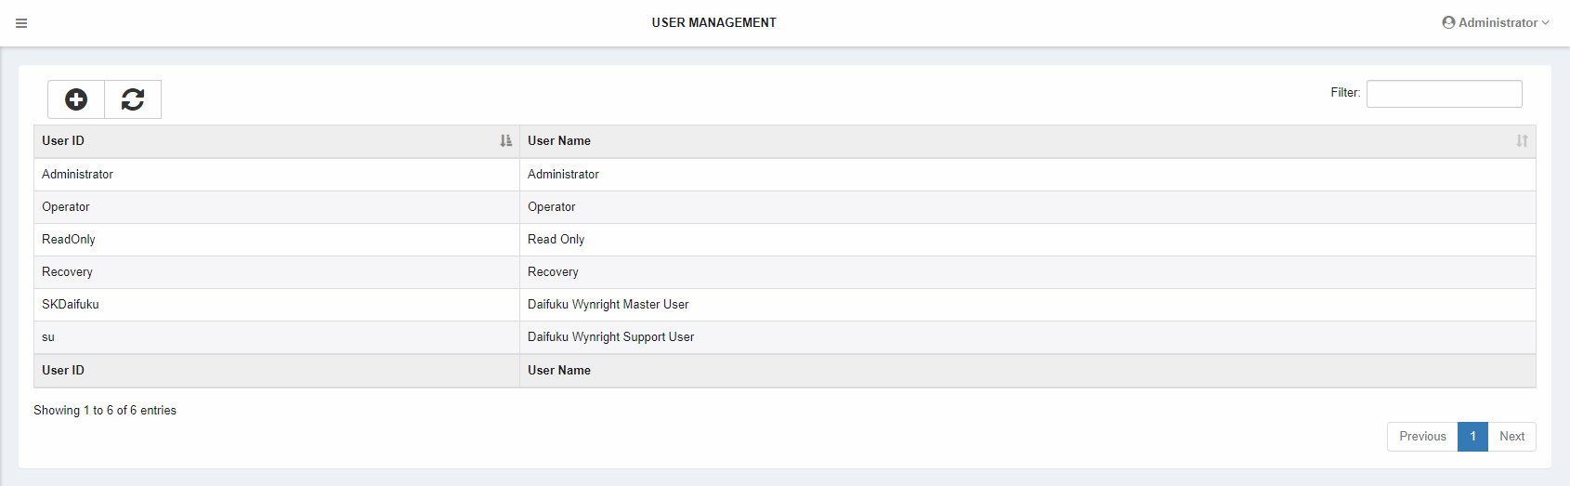

#### List Operations – Add Button

Click the add icon at the top of the list to add a user.

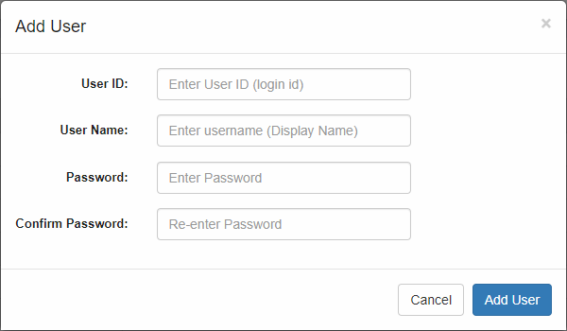

#### List Operations – Context Menu

A pop-up menu is available with options depending on the user’s roles. Right-click to display the pop-up menu.

* Modify – Modify the selected user. This option may be used to reset a user’s password.
* Delete – Delete the selected tracking data. The equipment must be stopped to delete.

## Help

The Help menu option opens this document.

# Recovery Procedures

Insert recovery procedures here