**Employee table:**

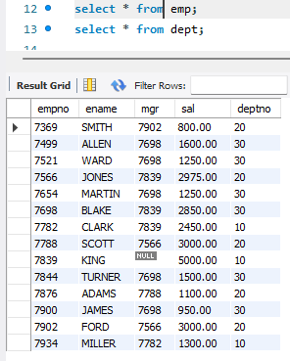

**Department table:**

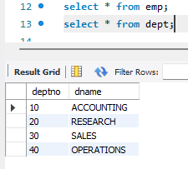

**1.Write a SQL query to find Employees who have the biggest salary in their Department.**

/*Query 1*/

SELECT D.dname,E.ename,E.sal FROM emp E JOIN dept D ON E.deptno=D.deptno  
 WHERE E.sal IN (select MAX(sal) from emp group BY deptno);

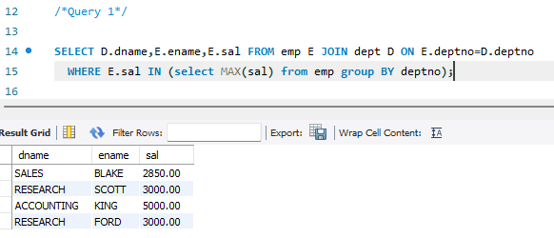

**2.Write a SQL query to find Departments that have less than 3 people in it.**  
/*Query 2*/  
select dept.dname,count(emp.empno) as People from dept left join emp on dept.deptno=emp.deptno group by dept.dname having count(dept.deptno)<4;

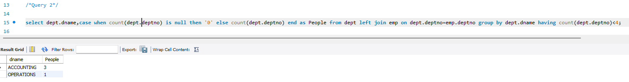

**3.Wr****ite a SQL query to find All department along with the number of people there.**   
/*Query 3*/  
SELECT dept.dname,count(emp.deptno) as people from dept left join emp on dept.deptno=emp.deptno group by dept.dname;

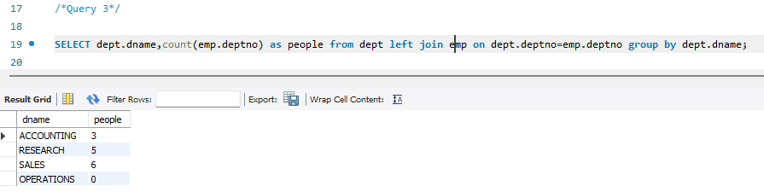

**4.****write a SQL query to find All Department along with the total salary there.**  
/*Query 4*/  
SELECT dept.dname,case when sum(emp.sal) is null then '0' else sum(emp.sal) end as TotalSalary from emp right join dept on dept.deptno=emp.deptno group by dept.dname;

