1.write a SQL query to find the salesperson and customer who reside in the same city. Return Salesman, cust_name and city
/*Query 1*/
select salesman.name as salesman_name,customer.cust_name as customer_name ,salesman.city from salesman inner join customer on salesman.city=customer.city;
2.write a SQL query to find those orders where the order amount exists between 500 and 2000. Return ord_no, purch_amt, cust_name, city
/*Query 2*/
select orders.ord_no,orders.pur_amt,customer.cust_name,customer.city from orders inner join customer on orders.pur_amt between 500 and 2000 and customer.customer_id=orders.customer_id;
3.write a SQL query to find the salesperson(s) and the customer(s) he represents. Return Customer Name, city, Salesman, commission
/*Query 3*/
select customer.cust_name as customer,customer.city,salesman.name as salesman,salesman.commission from salesman inner join customer on orders.customer_id=customer.customer_id inner join orders on orders.salesman_id=salesman.salesman_id;

4.write a SQL query to find salespeople who received commissions of more than 12 percent from the company. Return Customer Name, customer city, Salesman, commission.
/*Query 4*/
select customer.cust_name, customer.city,salesman.name,salesman.commission from orders inner join customer on orders.customer_id=customer.customer_id inner join salesman on salesman.commission>0.12*orders.pur_amt and orders.salesman_id=salesman.salesman_id;
5.write a SQL query to locate those salespeople who do not live in the same city where their customers live and have received a commission of more than 12% from the company. Return Customer Name, customer city, Salesman, salesman city, commission
/*Query 5*/
select customer.cust_name,customer.city,salesman.name,salesman.city,salesman.commission from salesman,customer,orders where salesman.city!=customer.city and salesman.commission>0.12*orders.pur_amt and orders.salesman_id=salesman.salesman_id and orders.customer_id=customer.customer_id;
6.write a SQL query to find the details of an order. Return ord_no, ord_date, purch_amt, Customer Name, grade, Salesman, commission
/*Query 6*/
select orders.ord_no,orders.ord_date,orders.pur_amt,customer.cust_name,customer.grade,salesman.name,salesman.commission from orders inner join salesman on salesman.salesman_id=orders.salesman_id inner join customer on customer.customer_id=orders.customer_id;

7.Write a SQL statement to join the tables salesman, customer and orders so that the same column of each table appears once and only the relational rows are returned.
/*Query 7*/
SELECT * FROM salesman join customer on salesman.salesman_id=customer.salesman_id join orders on salesman.salesman_id=orders.salesman_id;
8.write a SQL query to display the customer name, customer city, grade, salesman, salesman city. The results should be sorted by ascending customer_id.
/*Query 8*/
select customer.cust_name, customer.city, customer.grade, salesman.name, salesman.city from salesman inner join customer on salesman.salesman_id=customer.salesman_id order by customer_id;
9.write a SQL query to find those customers with a grade less than 300. Return cust_name, customer city, grade, Salesman, salesmancity. The result should be ordered by ascending customer_id.
/*Query 9*/
select customer.cust_name, customer.city, customer.grade, salesman.name, salesman.city from salesman inner join customer on customer.grade<3 and salesman.salesman_id=customer.salesman_id order by customer_id;

10.Write a SQL statement to make a report with customer name, city, order number, order date, and order amount in ascending order according to the order date to determine whether any of the existing customers have placed an order or not
/*Query 10*/
select customer.cust_name, customer.city,orders.ord_no, orders.ord_date,orders.pur_amt, CASE when orders.customer_id=customer.customer_id then 'yes' else 'no' end as 'abc' from customer left join orders on orders.salesman_id=customer.salesman_id
order by orders.ord_date;
11.Write a SQL statement to generate a report with customer name, city, order number, order date, order amount, salesperson name, and commission to determine if any of the existing customers have not placed orders or if they have placed orders through their salesman or by themselves
/*Query 11*/
select customer.cust_name, customer.city,orders.ord_no, orders.ord_date,orders.pur_amt,salesman.name,salesman.commission, CASE when customer.customer_id!=orders.customer_id then 'Not placed' else 'Placed' end as 'abc' from customer,salesman,orders
where orders.salesman_id=customer.salesman_id and orders.salesman_id=salesman.salesman_id;

12.Write a SQL statement to generate a list in ascending order of salespersons who work either for one or more customers or have not yet joined any of the customers
/*Query 12*/
select salesman.name from customer right join salesman on salesman.salesman_id=customer.salesman_id order by count(salesman.salesman_name);
13.write a SQL query to list all salespersons along with customer name, city, grade, order number, date, and amount.
/*Query 13*/
select salesman.name,customer.cust_name, salesman.city, customer.grade, orders.ord_no, orders.ord_date,orders.pur_amt from salesman join customer on salesman.salesman_id=customer.salesman_id join orders on salesman.salesman_id=orders.salesman_id;
14.Write a SQL statement to make a list for the salesmen who either work for one or more customers or yet to join any of the customers. The customer may have placed, either one or more orders on or above order amount 2000 and must have a grade, or he may not have placed any order to the associated supplier.
/*Query 14*/
select salesman.salesman_id,salesman.name FROM salesman
left join orders ON orders.salesman_id=salesman.salesman_id
left join customer ON salesman.salesman_id=customer.salesman_id
where orders.pur_amt>2000 AND customer.grade IS not null;
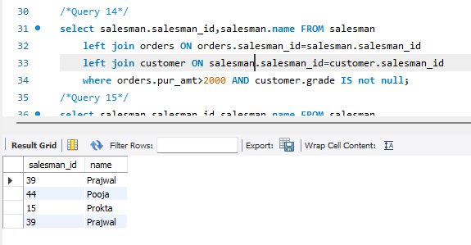

15.Write a SQL statement to generate a list of all the salesmen who either work for one or more customers or have yet to join any of them. The customer may have placed one or more orders at or above order amount 2000, and must have a grade, or he may not have placed any orders to the associated supplier.
/*Query 15*/
select salesman.salesman_id,salesman.name FROM salesman
left join orders ON orders.salesman_id=salesman.salesman_id
left join customer ON salesman.salesman_id=customer.salesman_id
where orders.pur_amt>2000 AND customer.grade IS not null;
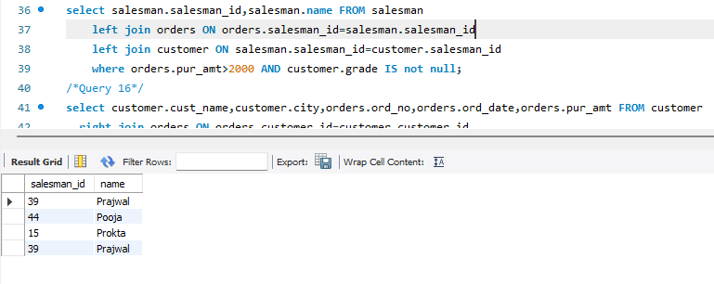
16.Write a SQL statement to generate a report with the customer name, city, order no. order date, purchase amount for only those customers on the list who must have a grade and placed one or more orders or which order(s) have been placed by the customer who neither is on the list nor has a grade.
/*Query 16*/
select customer.cust_name,customer.city,orders.ord_no,orders.ord_date,orders.pur_amt FROM customer
right join orders ON orders.customer_id=customer.customer_id
where grade IS NOT NULL;
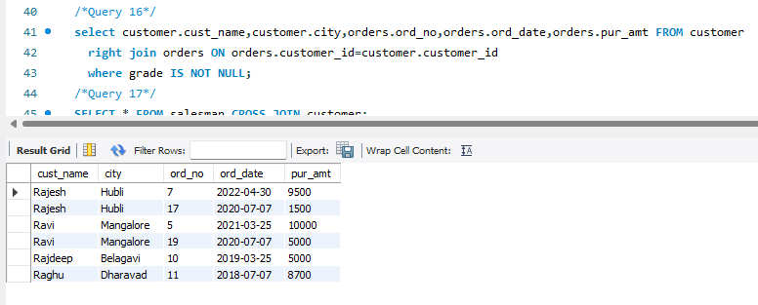

17.Write a SQL query to combine each row of the salesman table with each row of the customer table
/*Query 17*/
SELECT * FROM salesman CROSS JOIN customer;

18.Write a SQL statement to create a Cartesian product between salesperson and customer, i.e. each salesperson will appear for all customers and vice versa for that salesperson who belongs to that city
/*Query 18*/
SELECT * FROM salesman CROSS JOIN customer where salesman.city is not null;

19.Write a SQL statement to create a Cartesian product between salesperson and customer, i.e. each salesperson will appear for every customer and vice versa for those salesmen who belong to a city and customers who require a grade
/*Query 19*/
SELECT * FROM salesman CROSS JOIN customer where salesman.city is not null and customer.grade is not null;

20.Write a SQL statement to make a Cartesian product between salesman and customer i.e. each salesman will appear for all customers and vice versa for those salesmen who must belong to a city which is not the same as his customer and the customers should have their own grade
/*Query 20*/
SELECT * FROM salesman CROSS JOIN customer where salesman.city!=customer.city and customer.grade is not null;

