USEME file for Calendar GUI

- Run the jar file using the command java -jar Assignment6.jar
- It will open the calendar GUI. There are few buttons and a dropdown available on the main page.
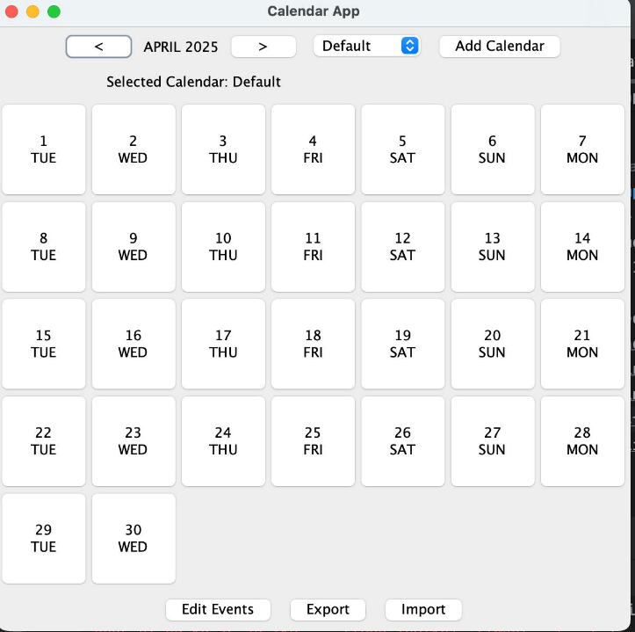

- The previous < and next > buttons help you to navigate from one month to another.
- There is an add calendar button next to the dropdown. You can press this button which will prompt you to add a new calendar by specifying a unique name and a valid time zone for the calendar.
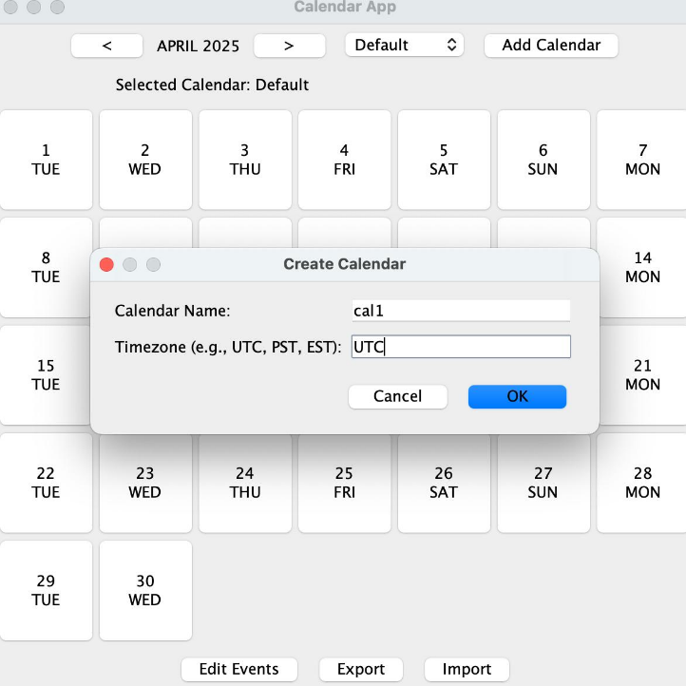

- Once you have entered the unique calendar name and a valid time zone you can press the ok button to add the calendar. If the specified calendar name is not unique or the time zone is invalid an error message will be shown to you. In that case you can again press the add calendar button and enter the correct details.
- Once the calendar is added successfully, on the main page, in the dropdown you can choose that calendar or keep using default according to your own choice.
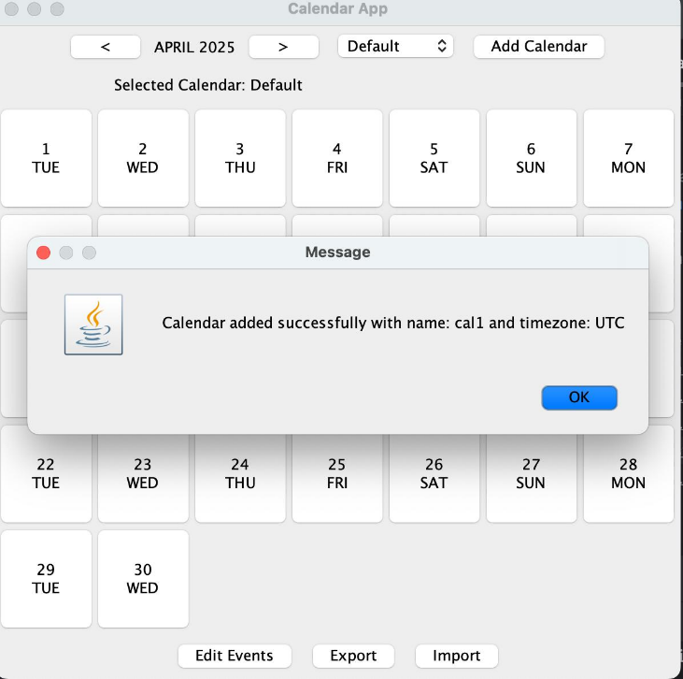
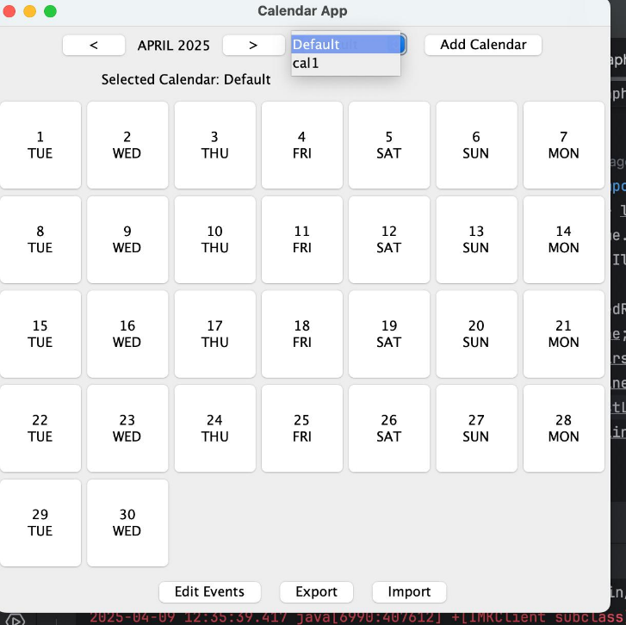

- On the bottom panel of the main page, you will see three buttons, import, export and edit events.
- If you press import button a dialog will popup asking you to select a csv file to import from your system.
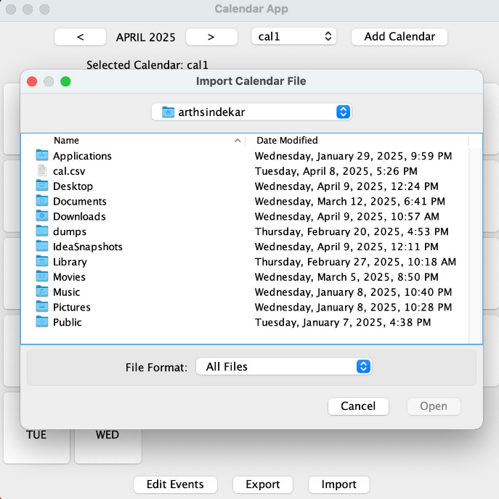

- You can choose a correct csv file. The csv file should contain first line as event fields. The fields and once uploaded it will import the events listed in csv file to the GUI calendar. If there are issues with the csv format or incorrect values in csv file, it will not import any events to the GUI calendar.
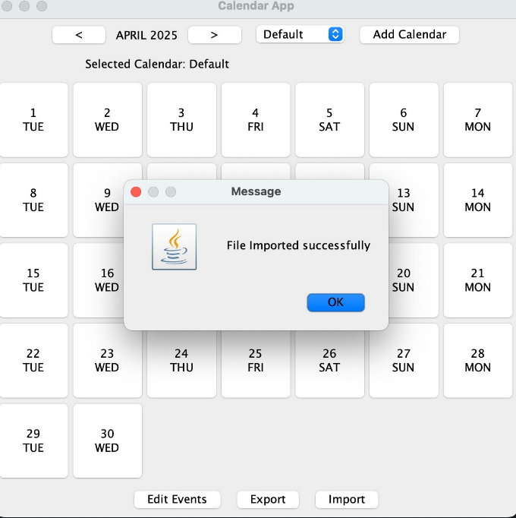

- If you press the export button a dialog opens and ask for a file name, please enter a .csv extension to the filename for example eportedEvents.csv You can verify this file by opening it in any other application or uploading it to google calendar.
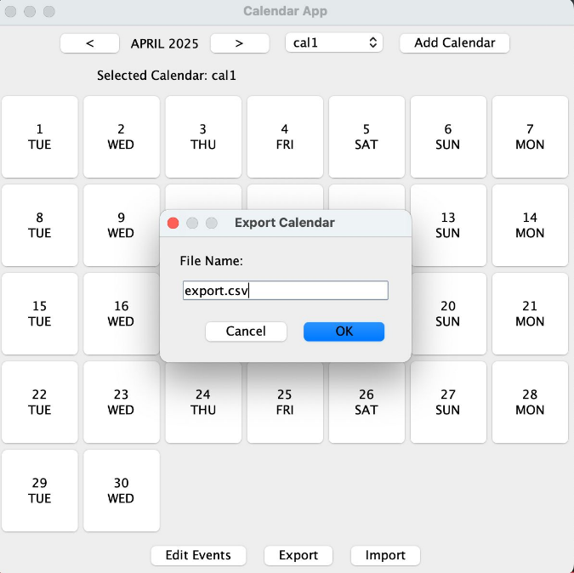

- If you want to edit multiple events with the same subject name together, you can press the edit events button. A dialog box will open where you can put a particular date and time after which the events matching the subject or event name would be edited or you can tick all events check box which would edit all events matching the subject.
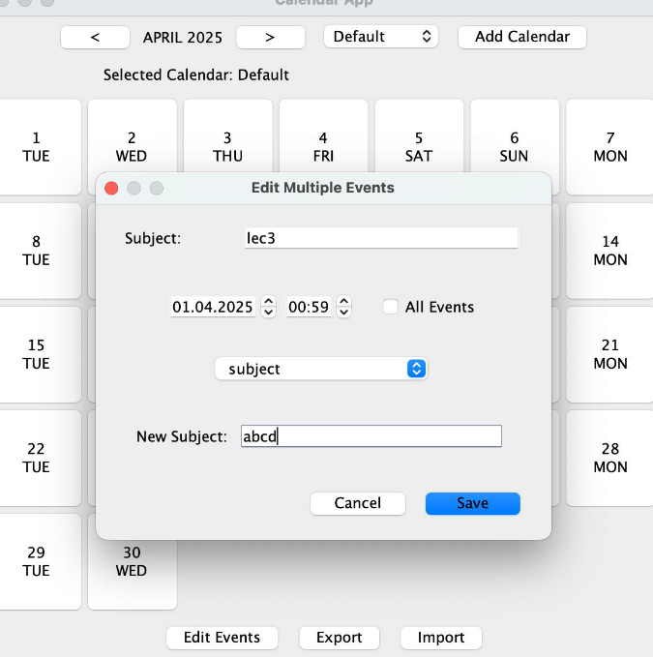
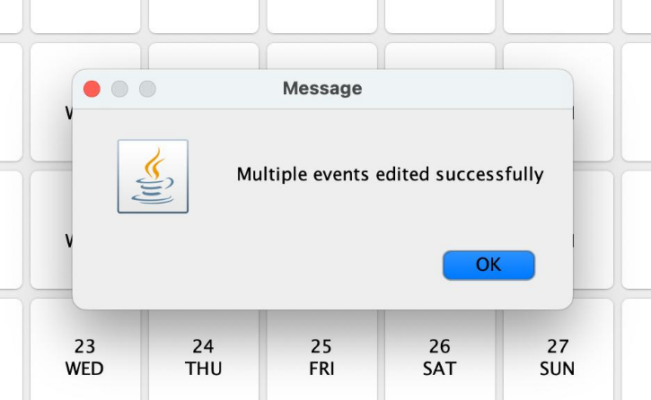

- After that in the dropdown you can choose which field of the event you want to edit. And then enter the new value in the following text box. After you press save button it will edit all the events according to your specified details, you can verify this by clicking on the date of the event and then clicking on the event button.
- The dates shown in the calendar are clickable buttons. You can click on the date button it will show a popup which has all the events on that day and a new event button at the bottom.
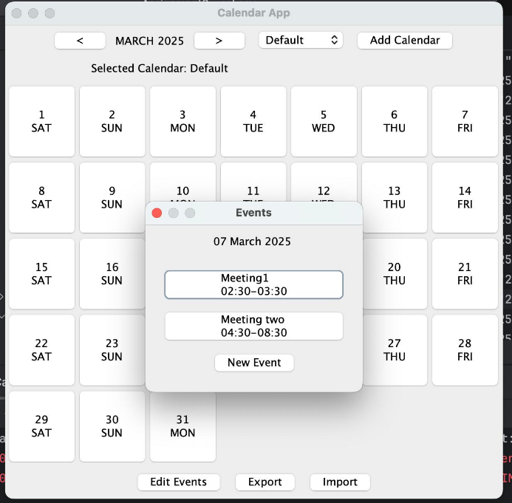

- All the events shown are also clickable buttons, if you click on the button all the details of events will be displayed in edit mode.
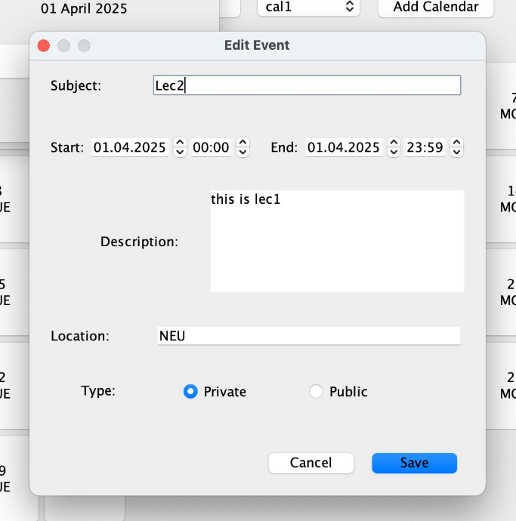

- You can edit each field in that window and once you press save it will edit the event or if it has some issues like wrong values entered or conflicting with other events it will show the error message and discard the edit.
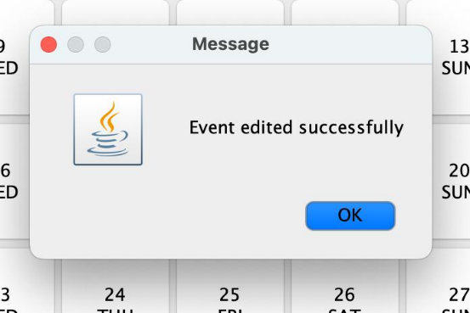
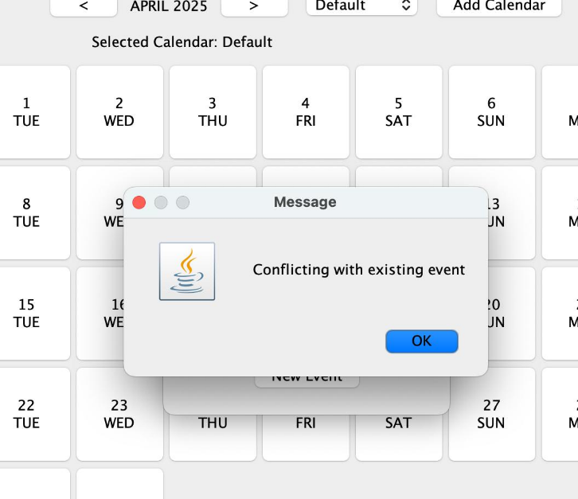

- You can also create a new event by pressing the new event button. Here you can fill in all the basic details for an event.
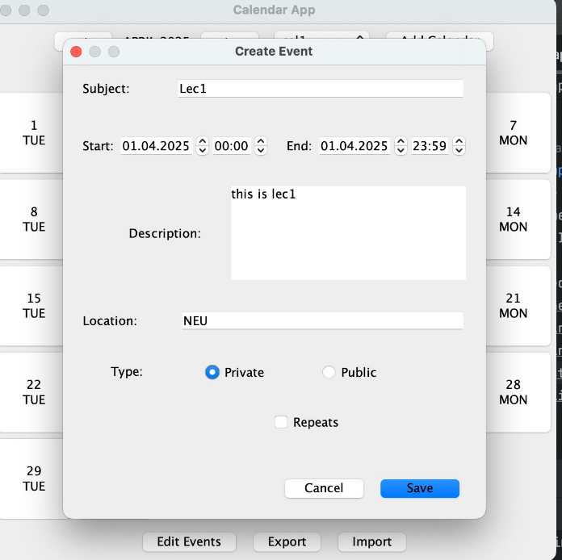
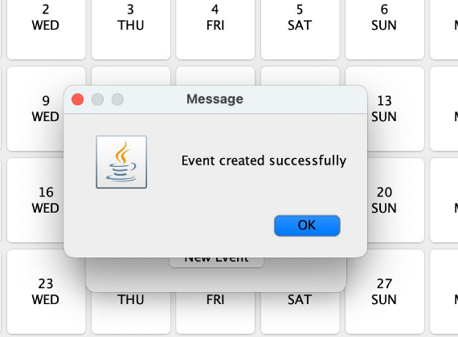

- There is a check box repeats, if you tick this you can make the event recurring event and select days of week it will repeat on and specify either occurrences or specific end date for the recurring event. When you press save button it will either create the events successfully or show an error message if the details provided are wrong or event created is conflicting with existing events.
- For all the dialog boxes there is a cancel button provided on pressing this button no changes will be made, and the calendar will remain in the previous state.
- To exit calendar GUI application, you can press the red cross button at the top.

