Supplementary Material

Arthur M. Albuquerque

May 25, 2022

Table of Contents

## * The library is already synchronized with the lockfile.

# Effect Modifiers

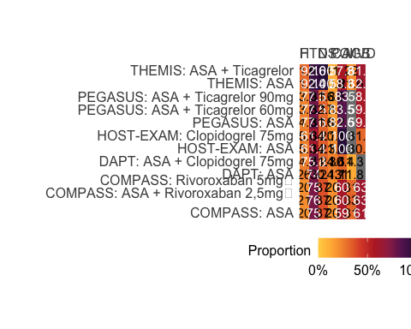

# Pooled Ticagrelor Networks: MACE and Bleeding

## League Tables

### Credible Intervals

Hazard ratios (95% credible interval) for the MACE or Bleeding outcomes. Treatments are shown in the diagonal. Results to the right of this diagonal (right upper half table) correspond to the MACE outcome. Results to the left (left lower half table) correspond to the Bleeding outcome. Comparisons between treatments should be read from left to right and the estimate is in the cell in common between the column-defining treatment and the row-defining treatment. For both outcomes, a hazard ratio < 1.0 favors the column-defining treatment. For example, in the Rivaroxaban 5mg vs. AAS comparison for MACE, the corresponding HR (95% CrI) was 0.89 (0.78, 1.02), favoring Rivaroxaban 5mg (ie, HR < 1.0).

### Posterior Probability (Prob) < 1

Posterior probabilities (%) of hazard ratio < 1.0 for the MACE or Bleeding outcomes. Treatments are shown in the diagonal. Results to the right of this diagonal (right upper half table) correspond to the MACE outcome. Results to the left (left lower half table) correspond to the Bleeding outcome. Comparisons between treatments should be read from left to right and the estimate is in the cell in common between the column-defining treatment and the row-defining treatment. For both outcomes, a hazard ratio < 1.0 favors the column-defining treatment. For example, in the Rivaroxaban 5mg vs. AAS comparison for MACE, there was a posterior probability of 95.31% that the hazard ratio is below 1.0 (ie, there was a 95.31% probability for Rivaroxaban 5mg superiority).

### Prob < 0.8

Posterior probabilities (%) of hazard ratio < 0.8 for the MACE or Bleeding outcomes. Treatments are shown in the diagonal. Results to the right of this diagonal (right upper half table) correspond to the MACE outcome. Results to the left (left lower half table) correspond to the Bleeding outcome. Comparisons between treatments should be read from left to right and the estimate is in the cell in common between the column-defining treatment and the row-defining treatment. For both outcomes, a hazard ratio < 1.0 favors the column-defining treatment. For example, in the Rivaroxaban 5mg vs. AAS comparison for MACE, there was a posterior probability of 5.58% that the hazard ratio is below 0.8 (ie, there was a 5.58% probability for Rivaroxaban 5mg superiority).

### Prob > 1.25

Posterior probabilities (%) of hazard ratio > 1.25 for the MACE or Bleeding outcomes. Treatments are shown in the diagonal. Results to the right of this diagonal (right upper half table) correspond to the MACE outcome. Results to the left (left lower half table) correspond to the Bleeding outcome. Comparisons between treatments should be read from left to right and the estimate is in the cell in common between the column-defining treatment and the row-defining treatment. For both outcomes, a hazard ratio < 1.0 favors the column-defining treatment. For example, in the Rivaroxaban 5mg vs. AAS comparison for MACE, there was a posterior probability of 0.00% that the hazard ratio is above 1.25.

### Prob ROPE

Posterior probabilities (%) of hazard ratio within the region of practical equivalence (ROPE), ie, between 0.80 and 1.25, for the MACE or Bleeding outcomes. Treatments are shown in the diagonal. Results to the right of this diagonal (right upper half table) correspond to the MACE outcome. Results to the left (left lower half table) correspond to the Bleeding outcome. Comparisons between treatments should be read from left to right and the estimate is in the cell in common between the column-defining treatment and the row-defining treatment. For both outcomes, a hazard ratio < 1.0 favors the column-defining treatment. For example, in the Rivaroxaban 5mg vs. AAS comparison for MACE, there was a posterior probability of 94.42% that the hazard ratio is within the ROPE.

## Ranks

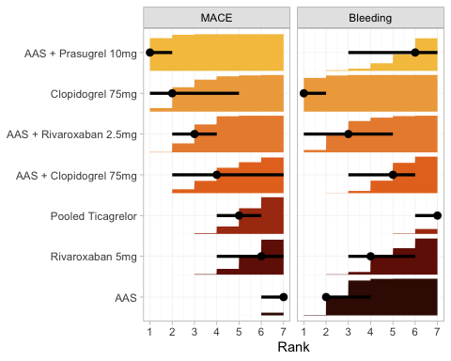

Marginal posterior distributions for the rank of each treatment. Left panel depicts ranks for MACE, while right panel for the Bleeding outcome. In each panel, there are a point estimate, interval bar, and bar plot for each treatment (Y-axis). The point estimate represents the median rank. The interval bar shows the 95% credible (quantile) interval of the underlying marginal posterior distribution. Lastly, the bar plot shows the cumulative distribution function (CDF).

# Separate Doses Ticagrelor Networks: MACE and Bleeding

## Network (pending)

placeholder

## Forest

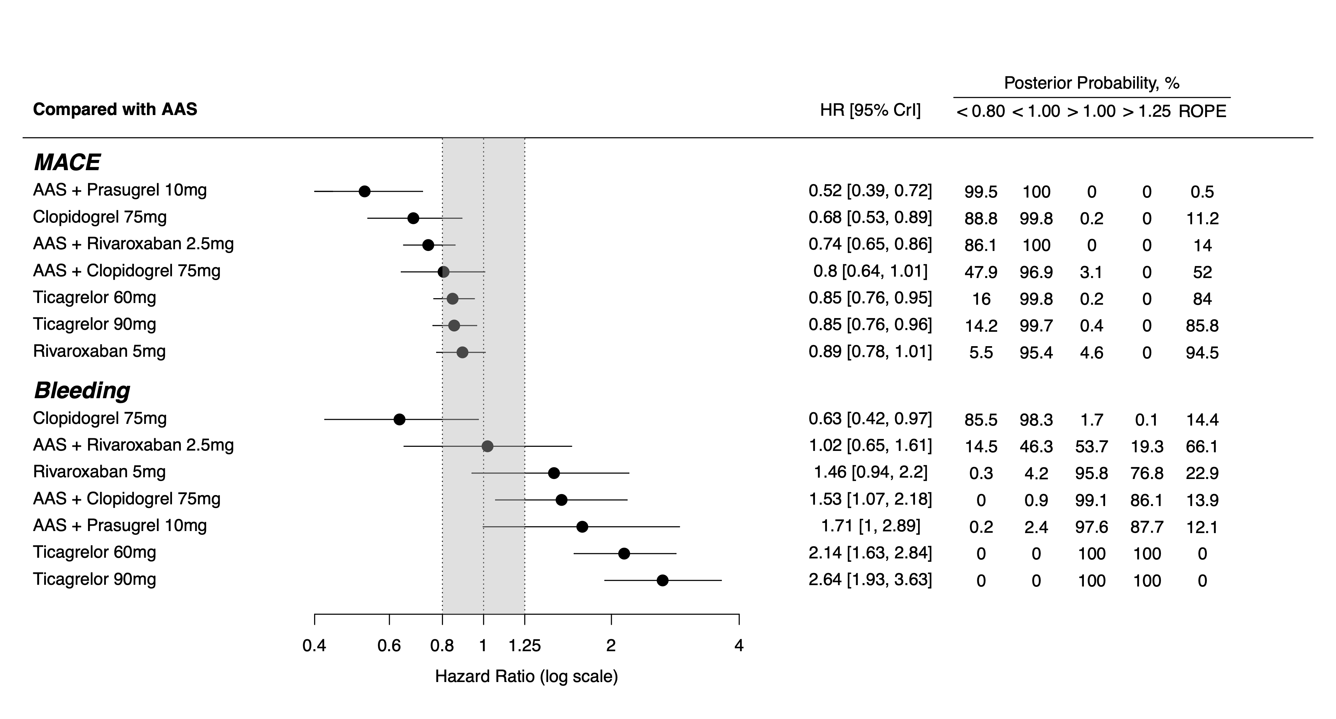

Treatment effects compared to AAS on MACE and Bleeding outcomes, ordered according to underlying SUCRA values. HR below 1.0 favors the experimental treatment. On the left, treatment names are depicted. In the middle, forest plot shows each treatment effect median and 95% credible intervals. Gray area corresponds to the ROPE (from 0.8 to 1.25 HR). On the right, exact effect sizes along with posterior probabilities are shown.

Abbreviations: ROPE, region of practical equivalence; HR, hazard ratio.

## League tables

### Credible Intervals

Hazard ratios (95% credible interval) for the MACE or Bleeding outcomes. Treatments are shown in the diagonal. Results to the right of this diagonal (right upper half table) correspond to the MACE outcome. Results to the left (left lower half table) correspond to the Bleeding outcome. Comparisons between treatments should be read from left to right and the estimate is in the cell in common between the column-defining treatment and the row-defining treatment. For both outcomes, a hazard ratio < 1.0 favors the column-defining treatment. For example, in the Rivaroxaban 5mg vs. AAS comparison for MACE, the corresponding HR (95% CrI) was 0.89 (0.78, 1.01), favoring Rivaroxaban 5mg (ie, HR < 1.0).

### Prob < 1

Hazard ratios (95% credible interval) for the MACE or Bleeding outcomes. Treatments are shown in the diagonal. Results to the right of this diagonal (right upper half table) correspond to the MACE outcome. Results to the left (left lower half table) correspond to the Bleeding outcome. Comparisons between treatments should be read from left to right and the estimate is in the cell in common between the column-defining treatment and the row-defining treatment. For both outcomes, a hazard ratio < 1.0 favors the column-defining treatment. For example, in the Rivaroxaban 5mg vs. AAS comparison for MACE, the corresponding HR (95% CrI) was 95.41, favoring Rivaroxaban 5mg (ie, HR < 1.0).

### Prob < 0.8

Posterior probabilities (%) of hazard ratio < 0.8 for the MACE or Bleeding outcomes. Treatments are shown in the diagonal. Results to the right of this diagonal (right upper half table) correspond to the MACE outcome. Results to the left (left lower half table) correspond to the Bleeding outcome. Comparisons between treatments should be read from left to right and the estimate is in the cell in common between the column-defining treatment and the row-defining treatment. For both outcomes, a hazard ratio < 1.0 favors the column-defining treatment. For example, in the Rivaroxaban 5mg vs. AAS comparison for MACE, there was a posterior probability of 5.53% that the hazard ratio is below 0.8 (ie, there was a 5.53% probability for Rivaroxaban 5mg superiority).

### Prob > 1.25

Posterior probabilities (%) of hazard ratio < 0.8 for the MACE or Bleeding outcomes. Treatments are shown in the diagonal. Results to the right of this diagonal (right upper half table) correspond to the MACE outcome. Results to the left (left lower half table) correspond to the Bleeding outcome. Comparisons between treatments should be read from left to right and the estimate is in the cell in common between the column-defining treatment and the row-defining treatment. For both outcomes, a hazard ratio < 1.0 favors the column-defining treatment. For example, in the Rivaroxaban 5mg vs. AAS comparison for MACE, there was a posterior probability of 0.00% that the hazard ratio is below 0.8 (ie, there was a 0.00% probability for Rivaroxaban 5mg superiority).

### Prob ROPE

Posterior probabilities (%) of hazard ratio within the region of practical equivalence (ROPE), ie, between 0.80 and 1.25, for the MACE or Bleeding outcomes. Treatments are shown in the diagonal. Results to the right of this diagonal (right upper half table) correspond to the MACE outcome. Results to the left (left lower half table) correspond to the Bleeding outcome. Comparisons between treatments should be read from left to right and the estimate is in the cell in common between the column-defining treatment and the row-defining treatment. For both outcomes, a hazard ratio < 1.0 favors the column-defining treatment. For example, in the Rivaroxaban 5mg vs. AAS comparison for MACE, there was a posterior probability of 94.47% that the hazard ratio is within the ROPE.

## Ranks + SUCRA

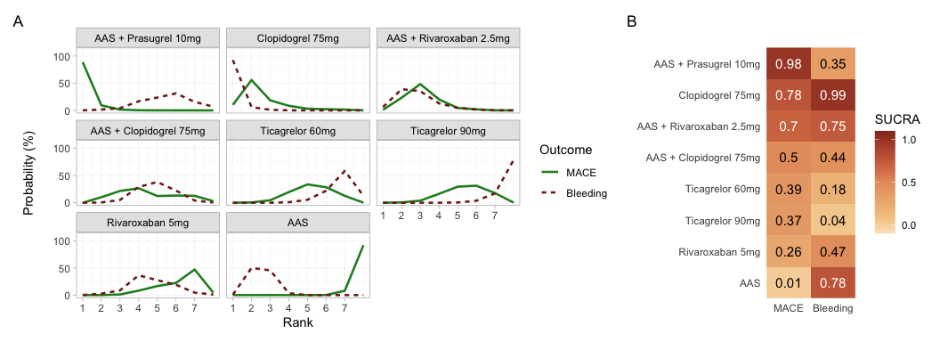

Panel A: Ranking probabilities for MACE (solid line) and Bleeding (dotted line) outcomes for each treatment. Panel B: Heatmap with corresponding SUCRA values. While each row corresponds to a treatment, each column depicts one outcome.

## Ranks

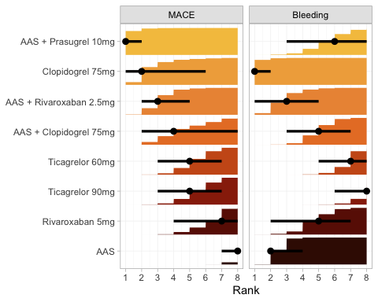

Marginal posterior distributions for the rank of each treatment. Left panel depicts ranks for MACE, while right panel for the Bleeding outcome. In each panel, there are a point estimate, interval bar, and bar plot for each treatment (Y-axis). The point estimate represents the median rank. The interval bar shows the 95% credible interval of the underlying marginal posterior distribution. Lastly, the bar plot shows the cumulative distribution function (CDF).

# Pooled Ticagrelor Networks: Secondary outcomes

## Networks (pending)

placeholder

## Forest

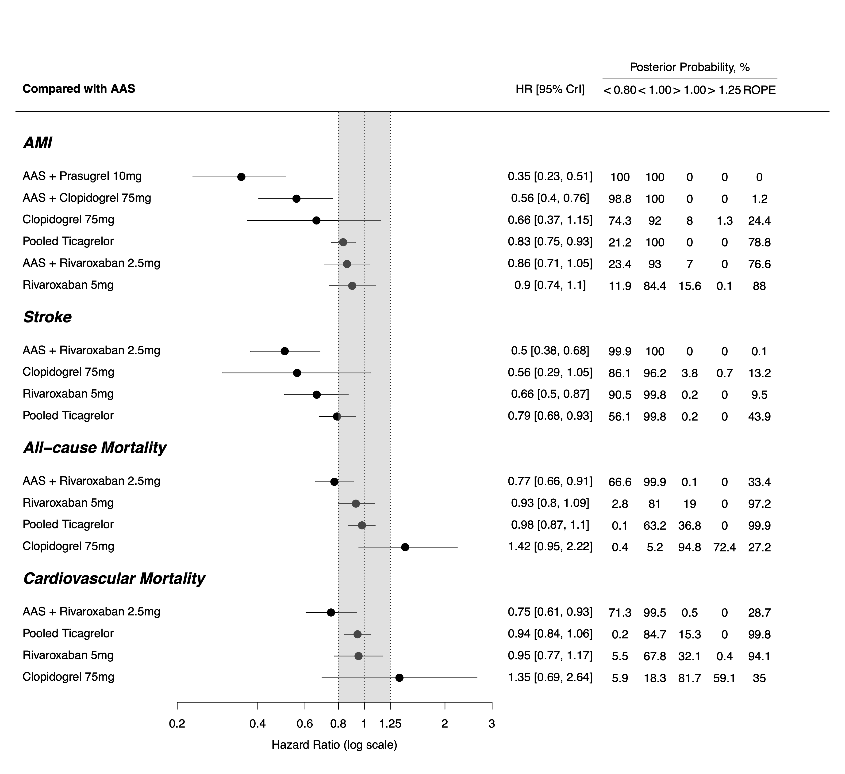

Treatment effects compared to AAS on MACE and Bleeding outcomes, ordered according to underlying SUCRA values. HR below 1.0 favors the experimental treatment. On the left, treatment names are depicted. In the middle, forest plot shows each treatment effect median and 95% credible intervals. Gray area corresponds to the ROPE (from 0.8 to 1.25 HR). On the right, exact effect sizes along with posterior probabilities are shown.

Abbreviations: ROPE, region of practical equivalence; HR, hazard ratio.

## League Tables

### Credible Intervals

Hazard ratios (95% credible interval) for the Acute Myocardial Infarction outcome. Treatments are shown in the diagonal. Comparisons between treatments should be read from left to right and the estimate is in the cell in common between the column-defining treatment and the row-defining treatment. A hazard ratio < 1.0 favors the column-defining treatment. For example, in the Rivaroxaban 5mg vs. AAS comparison, the corresponding HR (95% CrI) was 0.90 (0.74, 1.10), favoring Rivaroxaban 5mg (ie, HR < 1.0).

Hazard ratios (95% credible interval) for the Ischemic Stroke outcome. Treatments are shown in the diagonal. Comparisons between treatments should be read from left to right and the estimate is in the cell in common between the column-defining treatment and the row-defining treatment. A hazard ratio < 1.0 favors the column-defining treatment. For example, in the Rivaroxaban 5mg vs. AAS comparison, the corresponding HR (95% CrI) was 0.66 (0.50, 0.87), favoring Rivaroxaban 5mg (ie, HR < 1.0).

Hazard ratios (95% credible interval) for the All-cause or Cardiovascular mortality outcomes. Treatments are shown in the diagonal. Results to the right of this diagonal (right upper half table) correspond to the All-cause mortality outcome. Results to the left (left lower half table) correspond to the Cardiovascular mortality outcome. Comparisons between treatments should be read from left to right and the estimate is in the cell in common between the column-defining treatment and the row-defining treatment. For both outcomes, a hazard ratio < 1.0 favors the column-defining treatment. For example, in the Rivaroxaban 5mg vs. AAS comparison for All-cause mortality, the corresponding HR (95% CrI) was 0.93 (0.80, 1.09), favoring Rivaroxaban 5mg (ie, HR < 1.0).

### Prob < 1

Posterior probabilities (%) of hazard ratio < 1.0 for the Acute Myocardial Infarction outcome. Treatments are shown in the diagonal. Comparisons between treatments should be read from left to right and the estimate is in the cell in common between the column-defining treatment and the row-defining treatment. A hazard ratio < 1.0 favors the column-defining treatment. For example, in the Rivaroxaban 5mg vs. AAS comparison, there was a posterior probability of 84.41% that the hazard ratio is below 1.0 (ie, there was a 84.41% probability for Rivaroxaban 5mg superiority).

Posterior probabilities (%) of hazard ratio < 1.0 for the Ischemic Stroke outcome. Treatments are shown in the diagonal. Comparisons between treatments should be read from left to right and the estimate is in the cell in common between the column-defining treatment and the row-defining treatment. A hazard ratio < 1.0 favors the column-defining treatment. For example, in the Rivaroxaban 5mg vs. AAS comparison, there was a posterior probability of 99.78% that the hazard ratio is below 1.0 (ie, there was a 99.78% probability for Rivaroxaban 5mg superiority).

Posterior probabilities (%) of hazard ratio < 1.0 for the All-cause or Cardiovascular mortality outcomes. Treatments are shown in the diagonal. Results to the right of this diagonal (right upper half table) correspond to the All-cause mortality outcome. Results to the left (left lower half table) correspond to the Cardiovascular mortality outcome. Comparisons between treatments should be read from left to right and the estimate is in the cell in common between the column-defining treatment and the row-defining treatment. For both outcomes, a hazard ratio < 1.0 favors the column-defining treatment. For example, in the Rivaroxaban 5mg vs. AAS comparison for All-cause mortality, there was a posterior probability of 81.00% that the hazard ratio is below 1.0 (ie, there was a 81.00% probability for Rivaroxaban 5mg superiority).

### Prob < 0.8

Posterior probabilities (%) of hazard ratio < 0.80 for the Acute Myocardial Infarction outcome. Treatments are shown in the diagonal. Comparisons between treatments should be read from left to right and the estimate is in the cell in common between the column-defining treatment and the row-defining treatment. A hazard ratio < 1.0 favors the column-defining treatment. For example, in the Rivaroxaban 5mg vs. AAS comparison, there was a posterior probability of 11.95% that the hazard ratio is below 0.80.

Posterior probabilities (%) of hazard ratio < 0.80 for the Ischemic Stroke outcome. Treatments are shown in the diagonal. Comparisons between treatments should be read from left to right and the estimate is in the cell in common between the column-defining treatment and the row-defining treatment. A hazard ratio < 1.0 favors the column-defining treatment. For example, in the Rivaroxaban 5mg vs. AAS comparison, there was a posterior probability of 90.46% that the hazard ratio is below 0.80.

Posterior probabilities (%) of hazard ratio < 0.80 for the All-cause or Cardiovascular mortality outcomes. Treatments are shown in the diagonal. Results to the right of this diagonal (right upper half table) correspond to the All-cause mortality outcome. Results to the left (left lower half table) correspond to the Cardiovascular mortality outcome. Comparisons between treatments should be read from left to right and the estimate is in the cell in common between the column-defining treatment and the row-defining treatment. For both outcomes, a hazard ratio < 1.0 favors the column-defining treatment. For example, in the Rivaroxaban 5mg vs. AAS comparison for All-cause mortality, there was a posterior probability of 2.84% that the hazard ratio is below 0.80.

### Prob > 1.25

Posterior probabilities (%) of hazard ratio > 1.25 for the Acute Myocardial Infarction outcome. Treatments are shown in the diagonal. Comparisons between treatments should be read from left to right and the estimate is in the cell in common between the column-defining treatment and the row-defining treatment. For both outcomes, a hazard ratio < 1.0 favors the column-defining treatment. For example, in the Rivaroxaban 5mg vs. AAS comparison, there was a posterior probability of 0.06% that the hazard ratio is above 1.25.

Posterior probabilities (%) of hazard ratio > 1.25 for the Ischemic Stroke outcome. Treatments are shown in the diagonal. Comparisons between treatments should be read from left to right and the estimate is in the cell in common between the column-defining treatment and the row-defining treatment. For both outcomes, a hazard ratio < 1.0 favors the column-defining treatment. For example, in the Rivaroxaban 5mg vs. AAS comparison, there was a posterior probability of 0.00% that the hazard ratio is above 1.25.

Posterior probabilities (%) of hazard ratio > 1.25 for the All-cause or Cardiovascular mortality outcomes. Treatments are shown in the diagonal. Results to the right of this diagonal (right upper half table) correspond to the All-cause mortality outcome. Results to the left (left lower half table) correspond to the Cardiovascular mortality outcome. Comparisons between treatments should be read from left to right and the estimate is in the cell in common between the column-defining treatment and the row-defining treatment. For both outcomes, a hazard ratio < 1.0 favors the column-defining treatment. For example, in the Rivaroxaban 5mg vs. AAS comparison for MACE, there was a posterior probability of 0.00% that the hazard ratio is above 1.25.

### Prob ROPE

Posterior probabilities (%) of hazard ratio within the region of practical equivalence (ROPE), ie, between 0.80 and 1.25, for the Acute Myocardial Infarction outcome. Treatments are shown in the diagonal. Comparisons between treatments should be read from left to right and the estimate is in the cell in common between the column-defining treatment and the row-defining treatment. For both outcomes, a hazard ratio < 1.0 favors the column-defining treatment. For example, in the Rivaroxaban 5mg vs. AAS comparison, there was a posterior probability of 87.99% that the hazard ratio is within the ROPE.

Posterior probabilities (%) of hazard ratio within the region of practical equivalence (ROPE), ie, between 0.80 and 1.25, for the Ischemic Stroke outcome. Treatments are shown in the diagonal. Comparisons between treatments should be read from left to right and the estimate is in the cell in common between the column-defining treatment and the row-defining treatment. For both outcomes, a hazard ratio < 1.0 favors the column-defining treatment. For example, in the Rivaroxaban 5mg vs. AAS comparison, there was a posterior probability of 9.54% that the hazard ratio is within the ROPE.

Posterior probabilities (%) of hazard ratio within the region of practical equivalence (ROPE), ie, between 0.80 and 1.25, for the All-cause or Cardiovascular mortality outcomes. Treatments are shown in the diagonal. Results to the right of this diagonal (right upper half table) correspond to the All-cause mortality outcome. Results to the left (left lower half table) correspond to the Cardiovascular mortality outcome. Comparisons between treatments should be read from left to right and the estimate is in the cell in common between the column-defining treatment and the row-defining treatment. For both outcomes, a hazard ratio < 1.0 favors the column-defining treatment. For example, in the Rivaroxaban 5mg vs. AAS comparison for All-cause mortality, there was a posterior probability of 97.16% that the hazard ratio is within the ROPE.

## Ranks + SUCRA

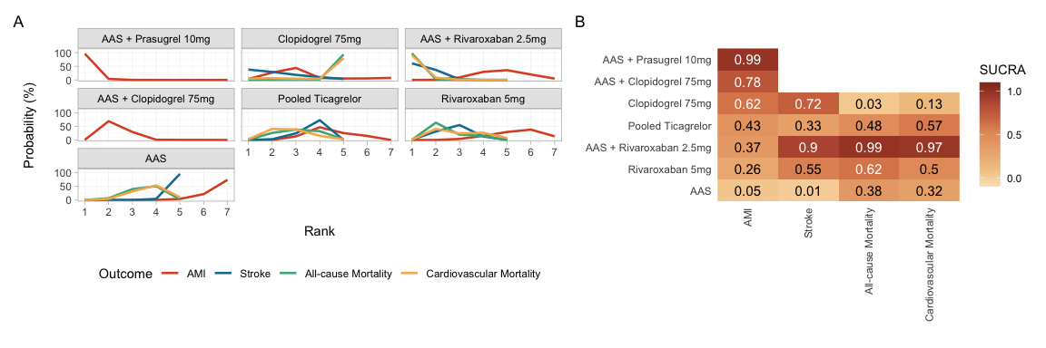

Panel A: Ranking probabilities for Acute Myocardical Infarction (AMI), Stroke, All-cause and Cardiovascular Mortality outcomes for each treatment. There are only AMI rankings for “AAS + Prasugrel 10mg” and “AAS + Clopidogrel 75mg” because there was no data available for other outcomes in corresponding studies. Panel B: Heatmap with corresponding SUCRA values. While each row corresponds to a treatment, each column depicts one outcome.

## Ranks

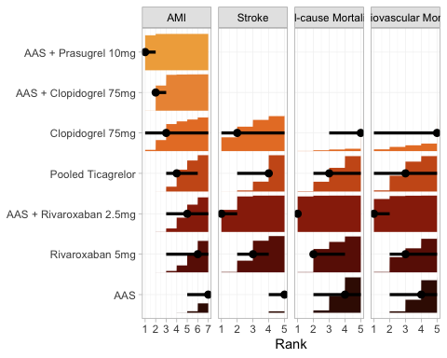

Marginal posterior distributions for the rank of each treatment. Each panel corresponds to a separate outcome, labeled on top. In each panel, there are a point estimate, interval bar, and bar plot for each treatment (Y-axis). The point estimate represents the median rank. The interval bar shows the 95% credible (quantile) interval of the underlying marginal posterior distribution. Lastly, the bar plot shows the cumulative distribution function (CDF).