

BINV2120-1

2BIN English as a Foreign Language

BURNY Pauline

Léonard De Vinci University-College

*UNIT 4: DARK PATTERNS*

**LISTENING**

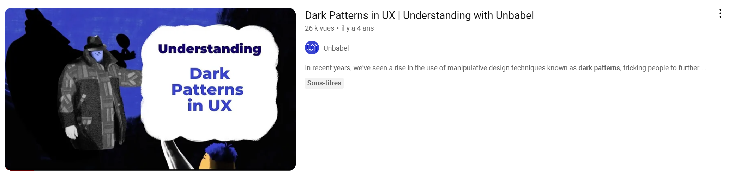

What do companies use to manipulate users? What is the purpose?

What is confirmshaming?

What is the Roach Motel technique?

What is the technique mainly used in the travel industry? How does it manifest?

What is the risk for companies using dark patterns?

**THEORY**

| **Dark Pattern** | **Definition** | **Example** |
| --- | --- | --- |
| **Forced Continuity** | The user is enrolled in a service with an ongoing cost without clear and explicit consent. | Signing up for a free trial of an online service that automatically converts into a paid subscription without a prominent notice or easy cancellation process. |
| **Disguised Ads** | Ads that are designed to look like native content, making users interact with them unintentionally. | A news website displaying sponsored content that closely resembles regular articles, leading users to click on it thinking it's genuine news. |
| **Friend Spam** | Users are misled into sending invitations or requests to their contacts, often without clear consent. | A social media platform suggesting to connect with friends but automatically sending friend requests or invitations to the user's entire contact list. |
| **Hidden Costs** | Additional fees or charges are not transparently disclosed to the user during the initial interaction. | Purchasing concert tickets online, and only at the final checkout step discovering hidden fees such as service charges or processing fees. |
| **Misdirection** | The design intentionally guides users towards a particular action while diverting attention from other important information. | A website interface leading users to click on a brightly colored button for a "free trial" but hiding the terms and conditions link in less noticeable text. |
| **Cost Comparison Prevention** | The design makes it difficult for users to compare the costs of different options or services. | An online travel booking site that doesn't display all fees and charges together, making it challenging for users to compare the total cost of flights from different providers. |
| **Privacy Zuckering** | Users are encouraged to share more information than they initially intended, often through deceptive or confusing interface designs. | A social media platform encouraging users to update their profiles and share more personal information through engaging quizzes and prompts. |
| **Trick Questions** | Questions that are designed to confuse or mislead users, leading them to unintended or undesired outcomes. | A website asking users if they want to "opt-out of receiving amazing offers" with the intention of getting them to inadvertently subscribe to promotional emails. |
| **Roach Motel** | Users can easily get into a situation but find it difficult to leave. | Subscribing to a service online is straightforward, but canceling the subscription involves a complex process with hidden options and confusing steps. |
| **Sneak into Basket** | Items or services are added to the user's shopping basket without clear consent. | While browsing an online store, clicking on an innocuous-looking button results in the automatic addition of a subscription service to the shopping cart without the user's explicit agreement. |
| **Confirm Shaming** | Users are guilt-tripped or shamed into accepting an offer or agreement. | A pop-up window asking users to subscribe to a newsletter with the decline option phrased as "No, I prefer to remain uninformed and ignorant." |
| **Bait and Switch** | Users are enticed with one offer but are presented with a different, less favorable option after committing. | Clicking on an attractive online ad for a discounted product, only to find out that the advertised item is out of stock, and users are redirected to a more expensive alternative. |