**KWAME NKRUMAH UNIVERSITY OF SCIENCE AND TECHNOLOGY**

**COLLEGE OF ENGINEERING**

# **DEPARTMENT OF COMPUTER ENGINEERING**

**BIOMEDICAL ENGINEERING**



**AUTOMATED NEONATAL EXCHANGE TRANSFUSION (ANET 4.0)**

**AMEYAW ARTHUR SAMUEL**

**BANDOMA GIDEON**

**CANN JOSEPHINE ESI**

**SUPERVISED BY: MR. PRINCE ODAME**

**APRIL, 2023**

# **DECLARATION**

We declare that this project is our work as a requirement for the award of a BSc. Biomedical Engineering degree, under the supervision of Mr. Prince Odame. We also declare that except where references were made and credit is duly given, the project is a result of our collective effort, ingenuity, research, and skills

NAME SIGNATURE DATE

AMEYAW ARTHUR SAMUEL ………………………………

BANDOMA GIDEON ………………………………

CANN JOSEPHINE ESI ……………………………….

SUPERVISOR

Mr. PRINCE ODAME …………………………….

## ACKNOWLEDGEMENT

We give God the glory for His faithfulness to us throughout our journey.

Our heartfelt gratitude also goes out to our parents for their unflinching continuous support in all aspects.

We also acknowledge our supervisor, Mr. Prince Odame for his advice, corrections, and the time he invested in us for this project.

We also express our sincerest appreciation to Apedele Bede Abisba, a member of the group that worked on ANET 3.0 for his valuable contributions and suggestions.

Lastly, we are grateful to all teaching assistants, colleagues, and friends, for their support.

# CHAPTER ONE

INTRODUCTION

The background of the project, its relevance, scope, and objectives, and its significance to the advancement of the health sector in Ghana are discussed in this chapter.

## 1.1 BACKGROUND

During pregnancy, the placenta excretes bilirubin (Children's Hospital, 2023; Michael *et al*., 2020).

According to recent statistics, 80% of preterm and 60% of term neonates develop jaundice (Children's Hospital, 2023; Woodgate & Jardine, 2011), which can be attributed to the underdevelopment of organs like the liver leading to the build-up of bilirubin (unconjugated bilirubin) in the blood, other tissues, and fluids of the body of neonates. This condition is termed hyperbilirubinemia (Woodgate & Jardine, 2011). Hyperbilirubinemia is a leading cause of long-term neurodevelopmental impairment such as kernicterus and bilirubin-induced neurologic dysfunction (BIND)(Michael *et al*., 2020). In Sub-Saharan Africa, long-term impairment following kernicterus is eight times more common than in high-income countries.

Diagnostic methods of hyperbilirubinemia include direct and indirect bilirubin levels, red blood cell (RBC) counts, blood type, and testing for Rh compatibility. Neonates whose mothers are diabetic and have Rh disease are more prone(Children's Hospital, 2023; Lee et al., 1977). And in a country like Ghana, where there is a high prevalence of the inherited condition, glucose-6phosphate dehydrogenase (G6PD) deficiency, hyperbilirubinemia is quite common(Seneadza *et al*., 2022). Some neonates may develop breastmilk hyperbilirubinema, or breastfeeding hyperbilirubinemia. Benign neonatal hyperbilirubinemia is a transient and normal increase in bilirubin levels occurring in nearly all neonates. It was previously termed "physiologic jaundice". But for most neonates, this usually does not happen (Bhutani et al., 2004).

Treatment methods include phototherapy, fiberoptic blanket, exchange transfusion, and ceasing breastfeeding for one or two days(Bhutani et al., 2004; Children's Hospital, 2023; Duan et al., 2006).Researchh also in China according (Dto uan et al., 2006) to depicts these methods of treatment. Globally, the most predominant modality is phototherapy especially when there is early detection of hyperbilirubinemia(Roelandts, 2002).

However, in severe cases of hyperbilirubinemia, usually as a result of late detection, phototherapy becomes a less effective treatment method as shown in figure 2, and considering the cost of phototherapy units, exchange transfusion becomes a more preferred approach in our part of the world(Furlan et al., 2005; Roelandts, 2002). Exchange transfusion is an allogenic procedure where the neonate’s blood which is contaminated with very high levels of bilirubin, is replaced with fresh blood from a donor (Ullah et al., 2016). Exchange transfusion is a procedure that involves alternating giving and withdrawing blood in small amounts through a vein or artery (Bhat Y, 2007). If bilirubin levels remain high, the procedure may need to be repeated. This procedure is strictly performed in the Neonatal Intensive Care Unit (NICU) (Gartner, 2001).

The project aims to design a cost-effective, time-saving workable device to make the procedure of exchange a smooth one with less human intervention for use in our part of the world.

### 1.2 PROBLEM STATEMENT

A neonatal exchange transfusion is a critical procedure that is performed on newborn infants suffering from severe medical conditions, such as hemolytic disease (HDN), which is caused by incompatibility between the mother's and baby's blood types, jaundice, anemia, or metabolic disorders (Fonger et al., 2014).

Although the procedure replaces a large volume of the baby's blood and is life-saving, it poses several challenges that threaten the infant's well-being and survival. Other complications can arise during or after the procedure, including bleeding, transfusion reactions, infections, and, most importantly, iron overload, which damages the infant's heart, liver, and lungs (Sabzehei et al., 2015). It is crucial to control the transfusion rate carefully to prevent overloading the infant's circulatory system. The transfusion should also be performed slowly to reduce the risk of adverse reactions and complications, such as transfusion reactions, bleeding, and infections (Lee et al., 1977).

The procedure must be performed accurately and consistently in order to ensure thtoomes for the newborn, but since it takes such a long time, it is tedious and prone to human error.

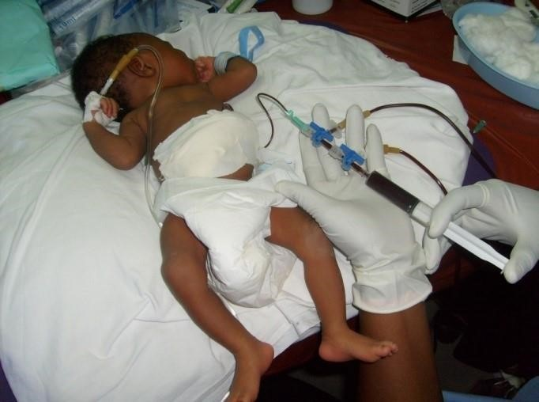

*Figure 1: A neonate undergoing exchange transfusion*

(Ciko et al., 2010)

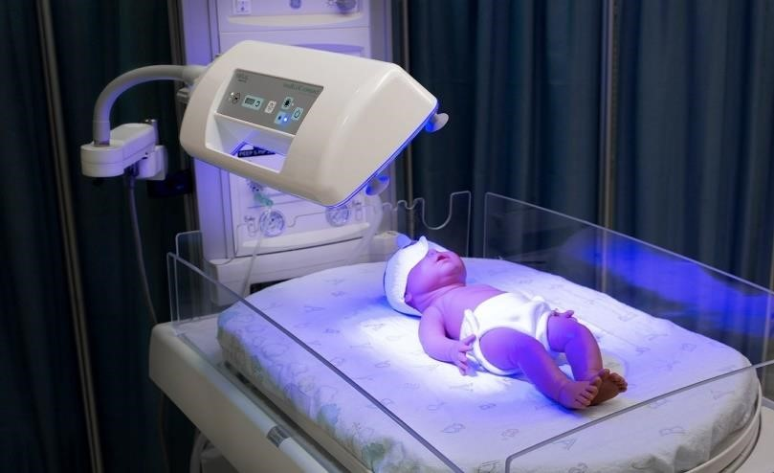

*Figure 2: Phototherapy used to treat a patient.*

(repository, 2021)

## 1.3 OBJECTIVES

This project's main goal is to develop, build, and test the machine on lab subjects that automates the neonatal exchange transfusion procedure. The machine will then be used in clinical settings and intended for commercial purposes as well. All the information utilized in the manual procedure is included in the device's functionality. A motor will be programmed to move the syringe at a constant speed to draw and inject blood. Motors will also take the role of the doctor manually switching valves throughout the exchange operation. By doing this, human interference in the process will be eliminated. The automatic shut-off would turn the machine off when the process was complete using the alarm system.

### 1.3.1 SPECIFIC OBJECTIVES

The following are the project's specific goals:

1. Use programming, classical electronics, and mechanics to virtually automate the exchange transfusion procedure.
2. Include all the information from the manual procedure in our design
3. Create an educational user interface
4. Produce a workable, cost-effective effective and energy-efficient device for the public.

# CHAPTER TWO

LITERATURE REVIEW

This chapter talks about the exchange transfusion as a medical procedure, principle of operation of the device and previous editions of ANET.

## 2.1 THE EXCHANGE TRANSFUSION PROCESS

The process involves taking aliquots of the patient's blood that are considered to be "bad blood" is taken and exchanged with aliquots of the donor's blood that are considered to be "good blood." This is what gives exchange transfusions its name; blood is taken out and replaced; there is an exchange (Kaneshiro, 2021; Ohto & Anderson, 1996).

Simple blood transfusions do not include the exchange of blood; blood is only supplied but not taken out (Underwood, 2019). Since some "old" blood and "new" blood are mixed or fused, the procedure is known as a blood transfusion. Exchange transfusions are always allogeneic, meaning that fresh, healthy blood always comes from a donor(ANDREW et al., 2022).

## 2.2 HISTORY OF NEONATAL EXCHANGE TRANSFUSION

Neonatal exchange transfusion has become a rare activity in most advanced countries but remains a frequent emergency procedure for severe hyperbilirubinemia in many underdeveloped countries, Ghana inclusive.(Underwood, 2019)

The history of NET may be traced to the Talmudic era (1st century C.E.) when the then-Jewish physicians used it as a last option for a number of ailments(Brecher, 2018). A Greek philosopher of the same era Aristotle also mentioned using it to treat jaundice (Sakhuja & Naik, 2008). Because the techniques required to assure the safe transfer of blood between donors and recipients had not yet been invented, exchange transfusions were not often offered until late in the twentieth century. Before the actual exchange transfusion procedure was developed, physicians often used a technique called 'bloodletting' to treat various medical conditions (Brecher, 2018).

This practice involved draining a patient’s blood and replacing it with replacement fluids such as wine or animal milk. In 1906, the first successful exchange transfusion was performed by Dr. George Washington Crile in the United States (Brecher, 2018). Dr. Crile performed the procedure on a patient suffering from jaundice, replacing the patient’s blood with stored blood from a donor(Teichler-Zallen, 2004).

The patient survived and eventually recovered from jaundice. In the following decades, exchange transfusions were further developed and refined. The approach, interchange even though it was Alexander Weiner who invented and gave the term "transfusion" its initial suggested by Dr. Bruce Robertson, a Canadian physician, in 1921(LK, 1947). The technique was applied in the therapy for children with serious burns. In the 1930s, researchers began to use the technique to treat severe anemia in premature babies (LK, 1947). A doctor from the hospital in Toronto Dr. Alfred P. Hart was the first to execute an exchange transfusion for sick children in 1925 to treat newborns with hemolytic disease (Funato & T, 1997).

It involves drawing blood from the femoral vein to replace the young child's radial artery, longitudinal sinus, or external jugular vein, or it with new donor blood through an ankle cut-down. This was how in the past they used as a process to withdraw blood from the neonate(Cogan, 1978; Spaeth & Cottrille, 1958).

Exchange transfusions have saved countless lives over the past century, and continue to be an important medical procedure used to treat a wide range of medical conditions (Elizabeth, 1975).

Recently, technological advancements like the development and use of Rh-immunoglobin, improvements in prenatal ultrasound, intensive phototherapy, and revised American Academy of Pediatrics (AAP) guidelines for hyperbilirubinemia have caused a declined need for blood exchange transfusion in the last 2 or 3 decades (Kaneshiro, 2021). The need for expertise for this procedure in most developed countries has drastically dropped. In developing countries, technological breakthroughs and simulations have evolved to improve the safety of this procedure(Murki & Kumar, 2011).

In underdeveloped countries like Ghana however, exchange transfusion remains the most used procedure because of the absence of community-based use of phototherapy, below-standard or ineffective phototherapy devices, and late recognition of high levels of bilirubin(Murki & Kumar, 2011).

## 2.3 RELEVANCE OF NEONATAL EXCHANGE TRANSFUSION

While the exchange transfusion procedure may be performed for infants, specifically neonates as well as adults, this project addresses neonatal exchange transfusion. Exchange transfusion is done when methods like phototherapy alone is ineffective for treating hyperbilirubinemia(Okrah & Kisser, 2021). It involves withdrawing the neonate’s damaged blood and simultaneously replacing with ‘fresh’ donor blood, (or more specifically red blood cells (RBC) reconstituted with plasma/FFP)(Tala, 2020).

Indications of hyperbilirubinemia include severe unconjugated hyperbilirubinemia, hemolytic disease of the newborn (HDN), neonatal hemochromatosis, polycythemia, anemia, and many more.

The neonate’s red blood cells are measured in hemoglobin (Hgb) or hematocrit (Hct). Hct is related to gestational age. The average Hct at birth for a term neonate is approximately 50, and approximately 40-45 for a preterm neonate.(Tala, 2020)

Hemolytic Disease of the Newborn (HDN), also called erythroblastosis fetalis is a condition where the neonate at birth, is found to have very low levels of RBC’s(anemia) due to premature hemolysis of the RBC’s during pregnancy. This may be attributed to Rh or ABO incompatibility of mother and baby. At the latter part of pregnancy or during childbirth, there may be mixing of the fetus’ blood and the mother’s blood across the placenta(Physiology&Anatomy, 2014). When the Rhesus Factor of the mother and the fetus are different, (suppose the mother is Rh-negative and the fetus is Rh-positive.

The presence of an antigen distinguishes Rh positive and Rh negative) the body of the mother produces antibodies to fight the red blood cells of the fetus since it recognizes them as foreign bodies. This causes the breakdown of the fetus’ red blood cells (hemolysis)(Teichler-Zallen, 2004). The hemolysis occurs faster than the bone marrow produces new RBCs. Exchange transfusion is done to replace the damaged RBCs of the neonate and to increase the RBC count.

Severe unconjugated hyperbilirubinemia is a condition where there are very high levels of unconjugated bilirubin in the blood of the neonate. Bilirubin in this form is fat-soluble and can cross the blood-brain barrier and cause kernicterus which can further cause neurologic impairments and to prevent this an exchange transfusion is performed on the neonate. Bilirubin is an end product of the breakdown of red blood cells(Hospital, 2005). Ideally, bilirubin should bind with albumin in order to be converted by UGT (Uridine diphosphate-glucuronosyltransferase) to form conjugated water-soluble bilirubin in the liver, then further excreted (Heirwegh & Blanckaert, 1981). But this does not happen in the body of the neonates due to the undeveloped nature of the liver, leading to a build-up of the unconjugated bilirubin in the blood of the neonate (Steventon, 2020). This leads to severe unconjugated hyperbilirubinemia or neonatal jaundice (NNJ). Exchange transfusion is done to provide fresh albumin binding sites for RBCs in the blood of neonates.

According to (RCH, 2009), the final decision to perform an exchange transfusion will be made by the Consultant Neonatologist on service, with the consent of the parents of the neonate, and will be based on the following:

* Trend of serum bilirubin levels and response to treatment
* Clinical presentation of infant (signs of bilirubin encephalopathy)
* Underlying condition
* Previous treatment at referring hospital if applicable (including in-utero management of underlying condition.

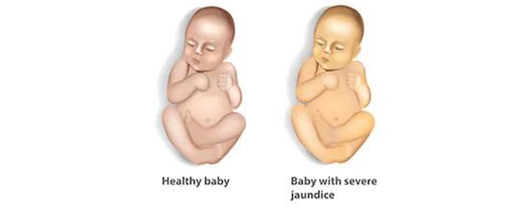

*Figure 3 : Neonatal Jaundice*

(Ar-Rayyan, 2020)

## 2.4 STEPS IN THE EXCHANGE TRANSFUSION PROCESS: SINGLE CATHETER

Before beginning the procedure, the donor blood should undergo screening. Ideally, irradiate the donor blood within 24 hours before transfusion to prevent graft versus host disease. The blood should be warmed to body temperature.(Murki & Kumar, 2011)

1. Without resistance, the catheter can usually be pushed to about 8cm in preterm and 11m in term neonates, with the tip lying in the inferior vena cava. If there is resistance, the catheter can be removed to about 3cm in preterm and 5cm in the term.
2. The neonate is placed on the radiant warmer or flat incubator mattress and there is continuous monitoring of the vital signs of the neonate.
3. Use of anesthesia is not necessary. Soothing techniques, sucrose solutions, and gentle restraints are needed to minimize discomfort and ensure a sterile field.
4. The neonate is not fed and if it has been fed 2-3 hours prior to the procedure, the contents of the stomach are emptied using a gastric tube.
5. Diapers are used to ensure hygiene.
6. The periumbilical region is cleaned using Betadine or Chlorhexidine and covered with sterile surgical drapes.
7. A loose purse string is placed around the base of the cord for hemostasis.
8. An umbilical venous catheter of French size 5 or 8, prefilled with saline and attached to a 10ml syringe is gently inserted into the umbilical vein to the desired location. All the associations ought to be prefilled with saline to avoid air cavitation arriving at the umbilical catheter. The catheter or the associations should never be passed on open to the air to forestall any air embolism. Air embolism is a significant gamble; in this manner, the needle ought to be vertical during the mixture, and air cavitation ought to be kept away from the withdrawal stage. Imbuement of blood with reliable hematocrit requires continuous blending (delicate shaking or plying) of the giver blood sack each 5-10 cycles. Utilization of citrate anticoagulants in benefactor blood might prompt a diminishing in the newborn child's serum calcium ensuing in changes in calcitonin.
9. The catheter is connected to 2 three-way stopcocks or 1 four-way stopcock.
10. During the procedure, the size of each aliquot should be approximately 5%-8% of the neonate’s estimated blood volume. In a term newborn child with a body weight fitting for gestational age, normally 15-to 20-mL aliquots might be removed or imbued at a pace of 5ml/kg/min. For low-birthweight and preterm newborn children, it is a general practice to be careful and withdrawal/imbuement ought to be restricted to roughly 5 mL/kg. Noticing that is significant as the aliquot volume diminishes, the extent of dead space volume would increment making the BET less compelling. Hence, an aliquot of volumes 2 mL is not suggested.

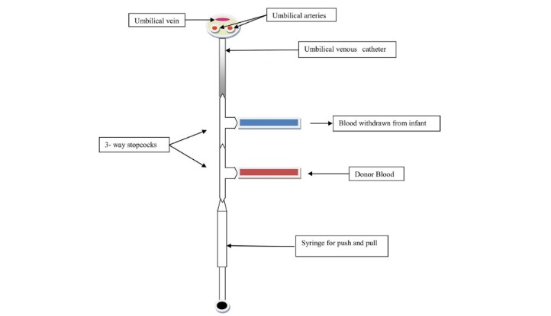

*Figure 4: Flow diagram of the single catheter exchange transfusion*

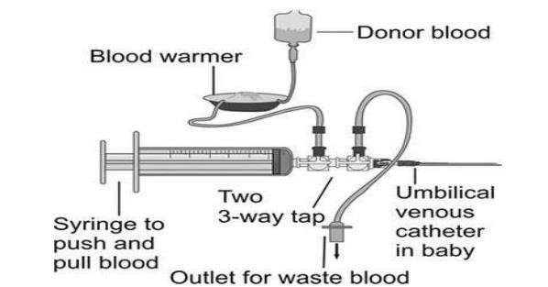

*Figure 5:Two three-way valves connected in series*

(Okrah & Kisser, 2021)

## 2.5 EXCHANGE TECHNIQUES

The exchange techniques are the procedures or approaches to which the exchange transfusion is done.

* Single catheter pull-push technique: The umbilical vein reaches the inferior vena cava below its junction with the right atrium.
* Double catheter pull-push technique: This process is used with a catheter each in the umbilical vein and umbilical artery.
* Substitute catheter: In the technique, the substitute catheter is placed in either a peripheral artery (usually a radial artery) and/or a large-sized peripheral vein. Usually, a large peripheral or branchial vein is enough. Rarely, one may have to cannulate the jugular or femoral vein if the infant is severely hydrated and peripheral veins are collapsed.

### *2.5.1 SINGLE CATHETER PULL-PUSH TECHNIQUE*

One medical professional often uses this technique in exchange transfusion process without the need for an extra medical professional (Chatterjee et al., 2023). It is a conventional technique that uses just one umbilical venous catheter. The end of this series connection is attached to a syringe, and the umbilical vein catheter is connected to two three-way taps or stopcocks that are connected in parallel. Depending on the size of the infant, blood is extracted in aliquots of 5–20 mL, and the correct amount of blood is then restored. This is due to the fact that depending on the baby's weight if more blood is collected than necessary, the newborn may lose consciousness or have organ failure (Sakhuja & Naik, 2008).

Furthermore, blood is removed at a rate of 1.5–2 mL/kg/min (Doggett et al., 2019). A nurse keeps track of each cycle's blood amount collected and delivered during the operation. The various vitals of the neonate are also checked periodically.

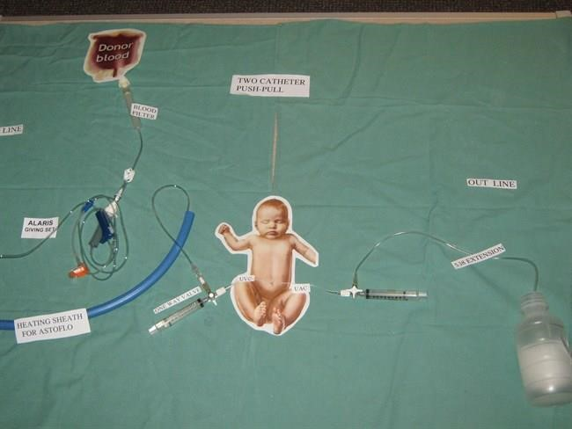

*Figure 6: Single Catheter illustration*

(Starship, 2018)

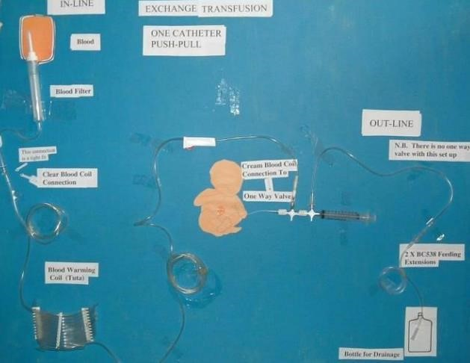

*Figure 7 : One catheter push-pull*

### *2.5.2 DOUBLE CATHETER PULL-PUSH TECHNIQUE*

Two people are involved in this procedure. Here, many catheters inserted in various bloodlines are used to concurrently remove and deliver equal amounts of blood. The utilized blood lines include the umbilical artery and vein. Via the umbilical artery, blood is removed from the infant, while at the same time, blood is fed into the infant through the umbilical vein.(Doggett et al., 2019)

This is also possible with other bloodlines; however arterial lines are often used for withdrawals rather than for giving out donor blood since arterial blood pressure is significantly greater than venous blood pressure. It is also called the Isovolumetric method.(Gajjar et al., 2016)



*Figure 8 : Double Catheter illustration*

(Starship, 2018)

## 2.6 COMPLICATIONS OF EXCHANGE TRANSFUSION

Exchange Transfusion is regarded as a safe and successful treatment (Altunhan et al., 2016), it is not without risk as in table 1. According to a study conducted (Badiee, 2007; Jackson, 1997), it was observed that the process can result in the death of neonates as well. The current guidelines for doing an exchange transfusion are based on a balance between the risks of encephalopathy and the problems linked to the treatment. Its death rates range from 0.5% to 3.3% (Bhat et al., 2011). But, if the process is done extremely carefully and bilirubin levels are consistently monitored (Davutoğlu et al., 2010), with the appropriate hygiene, and care, the majority of these issues may be avoided. Typically, pausing or slowing down the trade is the best way to handle these issues(Murki & Kumar, 2011; Victoria., 2018).

*Table 1 : Complication table*

|  |  |
| --- | --- |
| Complications during the procedure | Complications after the procedure |
| Air Embolus | Infection |
| Volume Imbalance | Thrombocytopenia |
| Hyperkalaemia | Hypoglycaemia |
| Arrhythmias | Blood transmitted infections |
| Respiratory Distresses | Hypocalcaemia |
| Anaemia/ Polycythaemia | Anaemia/ Polycythaemia |
| Acidosis | Hypernatremia |

*Table 2 : Complications*

|  |  |  |  |
| --- | --- | --- | --- |
| **DONOR BLOOD** | | **INFANT COMPLICATION** | **PREVENTION/TREATMENT** |
| Old blood (high K  platelets) | +, low | Hyperkalemia, thrombocytopenia | Use blood less than 5 days old. Monitor ECG during and after procedure. Watch for signs of bleeding |
| Citrate blood |  | Hypocalcemia and  hypomagnesemia | Consider 1-2 mL kg-1 of calcium gluconate after 50-100 mL of blood exchange in sick infants. Monitor serum calcium 2 h after an exchange. In case of unexplained arrhythmia use 2 ml/kg of 10% calcium gluconate infusion |
| Cold |  | Hypothermia | Prewarm the blood. |
| High glucose |  | Rebound hypoglycemia | Check blood glucose 2 hours after exchange transfusion. Initiate early enteral feeds |
| Glucose 6-phospho  dehydrogenase deficient | | Increased hemolysis, rebound hyperbilirubinemia | In endemic areas screen for glucose 6-phospho dehydrogenase status of donor blood |

## 2.5 BLOOD VOLUME CALCULATIONS

The difficulty in calculating the amount of exchange blood needed for newborns is related to how much blood is needed to raise their hemoglobin levels to an acceptable level. Nonetheless, a formula has been developed based on the supposition that the rise in hemoglobin

Throughout the operation, concentration is a linear function of volume exchange (Marsaglia & Thomas, 1971). The early stages of the blood exchange are when the change in hemoglobin concentration is largest, and it gradually decreases as the blood is exchanged.

The total volume of the cells and plasma in the circulatory system is what we refer to as blood volume (Brecher et al., 1997; Gregersen & Rawson, 1959). The dilemma of whether or not the techniques for calculating plasma and cell volume include or omit these extravascular components immediately emerges because all components of the blood, including created elements, are to some extent present outside blood arteries (Brecher et al., 1997; Gregersen & Rawson, 1959).

The general exchange volume parameter is given as:

The product of the total volume to be delivered and the weight of the baby which is all divided by 1kg.

Mathematically expressed as:

𝑇𝑜𝑡𝑎𝑙 𝑉𝑜𝑙𝑢𝑚𝑒 𝑡𝑜 𝑏𝑒 𝑑𝑒𝑙𝑖𝑣𝑒𝑟𝑒𝑑

𝑥 𝑤𝑒𝑖𝑔ℎ𝑡 𝑜𝑓 𝑡ℎ𝑒 𝑏𝑎𝑏𝑦

1.0𝑘𝑔

|  |  |  |  |
| --- | --- | --- | --- |
|  | Weight | Exchange Volume | Total Volume of Blood |
| Preterm | 1𝑘𝑔 | 200𝑚𝑙  𝑥 1.0 𝑘𝑔  1.0𝑘𝑔 | 200𝑚𝑙 |
| Term | 2𝑘𝑔 | 169𝑚𝑙  𝑥 2.0 𝑘𝑔  1.0 𝑘𝑔 | 320𝑚𝑙 |

According to the Table above, during the exchange operation, 200 ml and 320 ml of fluid will be given to preterm and term newborns, respectively. The exchange volume parameter provides the foundation for this computation. To calculate the number of cycles and the duration that the process will last, the formulars below are used:

𝑇𝑜𝑡𝑎𝑙 𝐸𝑥𝑐ℎ𝑎𝑛𝑔𝑒 𝑉𝑜𝑙𝑢𝑚𝑒

𝑁𝑢𝑚𝑏𝑒𝑟 𝑜𝑓 𝑐𝑦𝑐𝑙𝑒𝑠 =

𝑏𝑙𝑜𝑜𝑑 𝑣𝑜𝑙𝑢𝑚𝑒 𝑝𝑒𝑟 𝑐𝑦𝑐𝑙𝑒

𝐷𝑢𝑟𝑎𝑡𝑖𝑜𝑛 = 𝑁𝑢𝑚𝑏𝑒𝑟 𝑜𝑓 𝐶𝑦𝑐𝑙𝑒𝑠 𝑥 𝑡𝑖𝑚𝑒 𝑡𝑎𝑘𝑒𝑛 𝑝𝑒𝑟 𝑐𝑦𝑐𝑙𝑒

### *2.5.1 SINGLE VOLUME*

The baby’s blood volume is the same as the amount of the blood volume we estimate.

For instance, just 80ml/kg of blood volume would be needed to do a single-volume transfusion on a term. This method substitutes 60–65% of the baby's red blood volume.(Wadsworth, 2002)

Preterm or term babies mostly in the example table above, are given a total of 320ml and 200ml during the exchange procedure. (Wadsworth, 2002)

### *2.5.2 DOUBLE VOLUME*

Double Volume Exchange Transfusion involves repeating the single volume exchange transfusion. The blood to drawn from the neonate is estimated to be twice the baby's blood volume in circulation.(Mineshima et al., 1998)

The blood to drawn from the neonate Between 85-88% of the baby's red blood cells or blood volume are replaced.(Wadsworth, 2002)

The end part of this process is most popular and mostly used to treat newborns with chronic jaundice (hyperbilirubinemia)

The efficiency of the double volume exchange transfusion should have been twice as high as the single volume exchange transfusion, one may have predicted.

Yet this is not the case. Just a 25% average gain in efficiency is observed (i.e., from 80 to 85).

Nearly all of the baby's blood's circulation cannot be exchanged. This occurs as a result of circulation mixing the baby's blood with the blood flowing in. The double volume exchange transfusion is best when efficiency is compared to the total amount of blood that is circulated since it minimizes waste by using less time, energy, and resources while maintaining high efficiency.(Pstras et al., 2021)

The amount of blood exchanged as an aliquot depends on the weight of the infant. This is because, depending on the weight of the infant, if more blood than a specific quantity is withheld, the child may lose consciousness or have organ failure. As a result, the following criterion is used to determine how much blood should be exchanged during a cycle.(Convertino, 2007)

Due to the circumstances surrounding the infant, the doctor may not strictly adhere to this and instead utilize quantities that are lower or higher.

In light of everything that has just been discussed, take into account the following: noting that the infant will get an exchange transfusion:

A premature infant with a mass of around one kilogram.

As the infant is premature, the standard quantity of blood exchange is around 200 ml per kilogram of the infant. By dividing this statistic by the baby's weight, we can determine the total volume of blood that has to be exchanged. 𝑖.𝑒. 200𝑚𝑙𝑘𝑔 ×1.0𝑘𝑔 =200𝑚𝑙.

This suggests that a total volume exchange of around 200 ml is required. Also, because the infant weighs less than 1.5 kg, it follows that 5 ml-sized blood aliquots should be switched each cycle.

We divide the entire blood volume by the volume per cycle to determine the number of cycles necessary to exchange the complete blood volume. 𝑖.𝑒. 200𝑚𝑙 = 40 𝑐𝑦𝑐𝑙𝑒𝑠

5𝑚𝑙

The process is carried out extremely slowly, taking 4-5 minutes every cycle, as was already said. Taking this instance into consideration, the total time for the exchange transfusion on the newborn will be equal to the time utilized each cycle times the overall number of cycles. 𝑖.𝑒. 40 𝑐𝑦𝑐𝑙𝑒𝑠 ×4𝑚𝑖𝑛𝑠 𝑐𝑦𝑐𝑙𝑒\s=160𝑚𝑖𝑛𝑠 = 2 ℎ𝑟𝑠 40 𝑚𝑖𝑛.

The following guidelines for exchange transfusion levels are based on the American Academy of Pediatric Guidelines and are adapted from the Department of Human Services (Victoria) Neonatal Handbook(RCH, 2009; Victoria., 2018)

*Table 3 :Guidelines For Exchange Transfusion In Infants 35 Or More Weeks Of Gestation*

|  |  |  |  |
| --- | --- | --- | --- |
| Age (hrs) | Infants at higher risk 35-37+6 weeks + risk factors | Infants at medium risk  ≥38 weeks + risk factors or 35-37+6 weeks and well | Infants at lower risk  38 weeks and well |
|  | SBR (micromol/L) | SBR (micromol/L) | SBR (micromol/L) |
| Birth | 200 | 235 | 270 |
| 12 hours | 230 | 255 | 295 |
| 24 hours | 255 | 280 | 320 |
| 48 hours | 290 | 320 | 375 |
| 72 hours | 315 | 360 | 405 |
| 96 hours | 320 | 380 | 425 |
| 5 days | 320 | 380 | 425 |
| 6 days | 320 | 380 | 425 |
| 7 days | 320 | 380 | 425 |

*Table 4 : Guidelines For Exchange Transfusion In Low Birthweight Infants Based On Age*

|  |  |  |  |
| --- | --- | --- | --- |
| Age | Wt <1500g | Wt 1550-200g | Wt >2000g |
| Hours | SBR (micromol/L) | SBR (micromol/L) | SBR (micromol/L) |
| <24 hours | >170-255 | >255 | >270-310 |
| 24-28 | >170-255 | >255 | >270-310 |
| 49-72 | >170-255 | >270 | >290-320 |
| >72 | >255 | >290 | >310-340 |

## 2.6 PRINCIPLE OF OPERATION

*2.6.1 BOYLE’S LAW*

The automated neonatal exchange transfusion device works on the principle of **Boyle’s Law.**

The automated neonatal exchange transfusion device works on the principle of Boyle’s Law, the same principle applied to syringe pumps, infusion pumps, etc. Boyle’s Law states that for gases, the pressure is inversely proportional to the volume. That is, P1⁄V.

The basic working principle of a syringe pump is that it converts the rotary motion of the motor in the pump to the reciprocating motion of the piston of the syringe. The syringe, which works on Boyle’s Law principle is fits into the syringe pump. The motor of the syringe pump drives the movement of the piston, guided by its driver, a screw rod, and the reciprocating screw. The screw is connected to the piston in the syringe.

The syringe contains the medication to be administered. In the automatic versions, the pressure and rate are set according to the dose set, and hence the motor only acts on that amount, leading to smooth pulsating pressure. This is called the ‘Thread Row Mechanism’ because of the interconnection of all the parts of the machine driving one another (BiologyEye, 2023).

When the plunger of the syringe is pulled, the inside pressure, Pi decreases as the volume, Vi increases. At the same time the atmospheric pressure, Patm remains greater than the inside pressure of the syringe. Inversely when the syringe is pushed, the inside pressure, Pi increases as the volume Vi decreases (Savin, 2020).

*2.6.2 FLOW CHEMISTRY*

The simultaneous withdrawal and delivery of blood in the automated neonatal exchange transfusion device are based on the principle of Flow Chemistry.

The concept of "flow chemistry" defines a very general range of chemical processes that occur in a continuous flowing stream, conventionally taking place in a reactor zone. The application of flow chemistry relies on the concept of pumping reagents using many reactors types to perform specific reactions. (Battilocchio & Ley, 2023) Flow chemistry depends on Stoichiometry, Residence Time, flow rate, steady rate.

## 2.6 PREVIOUS PROJECTS ON ANET

### 2.6.1 ANET 1.0

The whole idea of Automated Neonatal Exchange Transfusion started from here. This project involved the use of motors to control the movement of blood through valves to and from designated locations in the exchange transfusion set-up. The project would almost eliminate any human intervention in the procedure.(YIDDI *et al*., 2020)

The automation employed a syringe pump design to control the pumping of blood in and out of the baby, and a valve control design to control the direction of blood flow. The device was designed and built to 95% completion, with some few analyses run on it. Their inability to complete the project implementation was due to the outbreak of the coronavirus pandemic.(YIDDI *et al*., 2020)

### 2.6.2 ANET 2.0

Automated Neonatal Exchange Transfusion (ANET) 2.0 combined mechanics, electronics, and programming to bring the idea of reducing human interference and removing human errors into fruition.

This was accomplished using the following methods: A push and pull segment made up of a bipolar stepper motor, a lead screw, and guiding rods were employed to accomplish this function. The clockwise rotation of the stepper motor. The threaded rod moves in that direction as the motor rotates counterclockwise to provide a sucking action. The physicians' manual blood drawing and delivery procedures were replaced by this system (Okrah & Kisser, 2021).

This innovative method for switching valves that use motors driven by software that was built for the microcontroller to replace the manual switching of valves. The project synchronizes the pushpull segment and the valve control segment to carry out the procedures of blood withdrawal and donor blood replacement.(Okrah & Kisser, 2021)

Two unipolar stepper motors, two three-way valves connected in series, and a catheter end attached to the infant, the waste container, and the donor blood bag made up the valveswitching system utilized in ANET 2.0.(Okrah & Kisser, 2021)

The three-way valves that are employed in this system, however, had to be manipulated by human hands, which presented an issue for connecting the motors with them.(Okrah & Kisser, 2021)

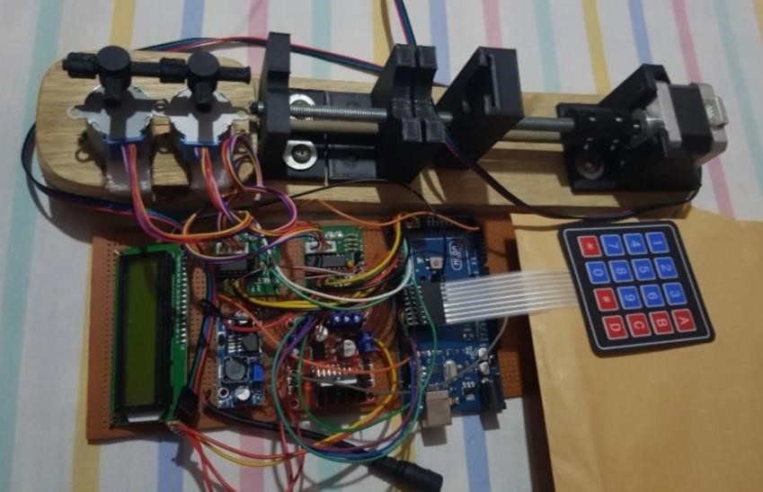

*Figure 9 : Finished Design of ANET 2.0*

### 2.6.3 ANET 3.0

The work of the automated Neonatal Exchange Transfusion version 3.0 looked at the flaws of the existing ones from ANET 1.0 and 2.0. Their objective was to also pick up from where the previous editions of ANET had ended and make the Neonatal Exchange Transfusion an automated process.(Agbedor et al., 2022)

They combined mechanics, electronics, and programming to achieve this. The design of the device was a little bit different because most of the parts were 3D printed and used for the purpose without building it from scratch.(Agbedor et al., 2022)

The three-way valve was manipulated by another motor in this case so the physician would not have to control it. The device was further tested on animal lab subjects.(Agbedor et al., 2022)

Aside from these positive breakthroughs that ANET 3.0 was able to make, it had some challenges.

The valve was rotating as well as moving the handle. The intended purpose was for it to rotate on its own so friction is not generated. As a result of this, excess heat was generated and the device was working after a while.(Agbedor et al., 2022)

Also, the push and pull block had a very rigid sense of motion in plunging.(Agbedor et al., 2022)

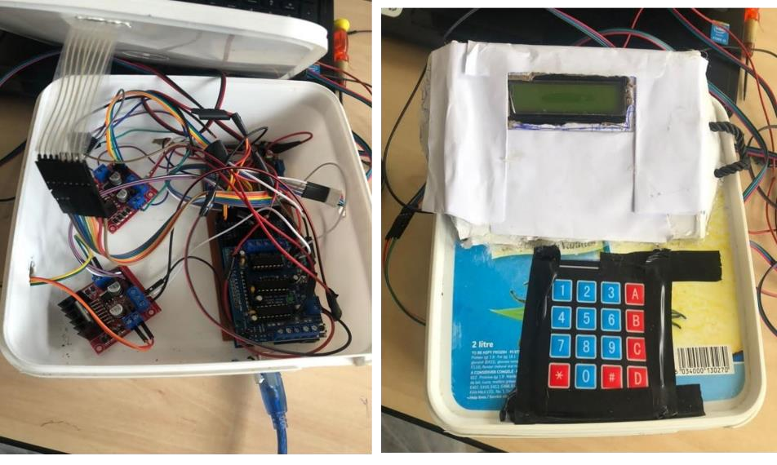

*Figure 10 : Electronics part of ANET 2.0*

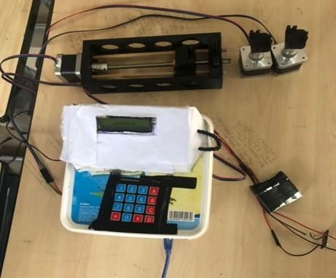

*Figure 11 : Finished design of ANET 3.0*

# CHAPTER THREE

METHODOLOGY

This chapter discusses into the step-by-step procedures involved in the data acquisition, analysis process, tools, and materials used in the entire course to design the automated neonatal exchange transfusion device.

## 3.1 DATA COLLECTION

Primary and secondary data were used in the data collection process. Much information was gathered via conversations with ANET 2.0 and ANET 3.0 project developers. Both devices were run as well to help gather much more information needed to build ANET 4.0. The reports of these two generations of ANET were very useful in the data collection process.

The school of veterinary medicine was visited, and questions regarding the kinds of animal testing conducted there and how they were carried out were raised.

The pharmacy department's animal house was the next place to go for information on animal experiments, and there we received guidance on how to conduct our animal tests.

On the other side, secondary data came from readings such papers and journals as well as watching YouTube videos with information on the following subjects:

1. Hyperbilirubinemia
2. Hemolytic disease
3. Exchange transfusion.
4. Anatomy of the neonate
5. RH and ABO incompatibility
6. Mechanics of motors, nuts, and threaded rods
7. Valving technology
8. Bubble trap technology among others
9. Syringe Pump Design
10. Flow Chemistry

## 3.2 DATA ANALYSIS

A qualitative approach was mostly used to analyze the data. This involves use of descriptive data and semi-structured observation methods in analysis. The analysis approach was influenced by brainstorming meetings and going through prior material. Our choice of animal subject for tests as well as the procedures to be used was guided by prior research on animal testing carried out on ANET-related devices such as dialysis machines as well as information gathered from officials of the veterinary medicine school and lab technicians of the pharmacy department animal house.

The shortcomings of ANET 2.0 and ANET 3.0 that would present difficulties during animal tests were identified with the help of discussions with the device's creators and bench tests on the apparatus.

## 3.3 DESIGN PROCESS

This project combines mechanics, electronics, and programming in order to operate the full exchange transfusion setup and run tests on it to demonstrate its usefulness.

To do this, tests will be run on the automation device's existing prototype, ANET 3.0, from which the device's shortcomings and obstacles will be determined to help with future enhancement of the device in ANET 4.0.

The present model is an improvement to one that currently exists (ANET 3.0). Our goal was to strengthen the model's strong features while addressing all of the flaws inherited from the previous models, which had both positive and negative qualities. The device's primary problems and the solutions utilized to fix them are mentioned below.

* Designing a new coupling to transfer the rotational motion of the motor to turn the valves and to rotate only the handle without rotating the valves.
* Design a power system on its own that will provide enough power for the motors so that the rotations and plunging will be done smoothly.
* Designing a cooling system to prevent the voltage boosters from overheating.

The threaded rod is responsible for converting the rotatory motion of the bipolar stepper motor into a linear motion. To do this, the rod is coupled with the motor using a coupler. The nut moves along the rod when it rotates. From simulations, the threaded rod recorded very large stress values. This was quite understandable, considering the work it does in converting rotatory motion into linear motion. This is also due to the fact that threaded rods are made for fastening purposes and thus the high friction they create.

The threaded rod is very stiff and this will be solved using classical electronics to affect the plunging effect. The Clinician does not get a notice when the process is done so as a solution to this a part of the code prompts the clinician when the process is done. Also, as part of this project, we will include a part to the code which will allow the clinician cancel or pause the procedure.

### 3.3.1 DEVICE TESTING

The goal of the initial test of the existing device is to check the mechanical parts are responding to code performing as planned, check for its clinical effectiveness, check for failures and the risk at hand, and the adverse effects that may arise in its usage. The device will be evaluated using an animal test, which often offers preliminary proof of the devices' safety, their potential performance in a live system, and the biological reaction that a living system may mount to the device.

### 3.3.2 ANIMAL TESTING

The use of non-human animals in medical experiments is referred to as animal testing or animal experimentation, and in this concept in vivo testing. Major advances in the treatment of to diseases like breast cancer, brain injury, childhood leukemia, cystic fibrosis, multiple sclerosis, tuberculosis, and others have been made with the help of animal research.

Pacemakers, cardiac valve replacements, and anesthetics have also been developed thanks to animal research. The use of animals in testing is heavily controlled because worries about "cruelty" to animals and their humane treatment are legitimate ones.

Permission was obtained on the usage of the lab subject as a means to means of paying heed to the set rules.

### 3.3.3 SIGNIFICANCE OF ANIMAL TESTING

Prior to entering the clinical phase, a medical product must be thoroughly examined for safety, efficacy, and efficiency. This helps us decide what modifications need to be done before being put on the market. In order to evaluate these devices, animal experiments are frequently done.

These studies usually give preliminary proof of the devices' safety, their potential performance when used in a live system, and the biological reaction that a living system may mount against the device.

The FDA advises that animal studies for medical devices be planned with the goal of analyzing the hazards expected by the device's design, any known dangers associated with the device type, and any new concerns that may have surfaced in earlier investigations.

For instance, several skincare and cosmetic products are tested on animals to guarantee their safety, and many medical professionals and biomedical researchers support the practice since it contributes to the humane treatment of diverse animals and their safety with regard to medical device standards.

### 3.3.4 MAIN OBJECTIVES OF ANIMAL TESTING

This is to see the operation of the existing device, the advances, drawbacks, and additions that can be added to the device.

This helps to see the flaws of the work that was done by the previous years and to see the additions that can be added to make the device a well-improved and commercial one.

#### 3.3.4.1 EVALUATE THE EFFICACY OF THE DEVICE OR DEMONSTRATE PROOF OF PRINCIPLE

This would entail confirming the consistency and correctness of cycle length, blood volume (aliquots) every cycle, and the entire treatment. It would also entail monitoring for any symptoms of illness during or after the procedure.

#### 3.3.4.*2* PROVIDE EVIDENCE OF SAFETY

Proof demonstrating the device's safety, including its handling and performance when compared to current automation techniques and practices. Performance and handling, device safety, physiological response, determining whether or not the device can have effects distant from the site of use (mechanical or biologic stresses), unexpected morbidity and mortality, or all observed instances of animal illness and death, and determining whether or not such events are device related are all recommendations for evaluating safety.

#### 3.3.4.3 RISK ASSESSMENT FOR RISK MANAGEMENT

A risk is a mix of the likelihood that harm will occur and how serious that harm will be. Risk analysis and evaluation are the two steps that makeup risk assessment. The process of identifying risks and estimating the risk is known as risk analysis.

Comparing the projected risk to predetermined risk criteria, on the other hand, is the process of determining if the risk is acceptable.

Animal experiments and research are being undertaken on a variety of species. These creatures include fish and birds as well as rats, mice, rabbits, guinea pigs, dogs, primates, chimps, and orangutans. Every one of these creatures has distinctive traits and peculiarities that help researchers get the most useful results from their scientific investigations.

The most productive animals to utilize in the development of cosmetic and skin care products are rats and mice. The greatest choice would be rabbits since they have a physiology that is most similar to that of humans and because their weight is most similar to that of newborns.

The size of the gadget and its components in relation to the test subject is an additional crucial factor. The catheter, for instance, would have to fit into the blood vessels of the test subject

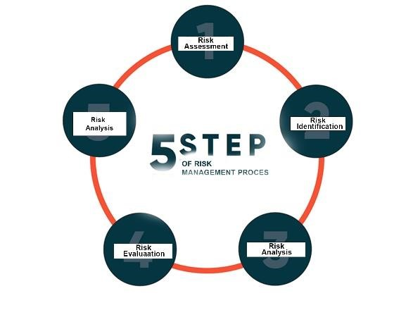

*Figure 12 : Stages of risk assessment*

### 3.3.6 ANIMAL TEST PROCEDURE

3.3.6.1 HOW WILL THE DATA BE COLLECTED

The goal of the animal experiments is to gather information that will be used to evaluate the device and provide proof of concept and design verification. The quantities removed or transfused each cycle, the duration of each cycle, and cumulative volumes will all be recorded in order to calculate the total amount transfused.

3.3.6.2 COMPLICATIONS OF EXCHANGE TRANSFUSION

There are certain problems with exchange transfusion. Current guidelines for doing an exchange transfusion are based on a balance between the risks of encephalopathy and the problems linked to the treatment. Its death rates range between 0.5% and 3.3%.(Murki & Kumar, 2011).

But, if the process is done extremely carefully, with the appropriate hygiene, and care, the majority of these issues may be avoided. Typically, slowing down or pausing the trade is the best way to handle these issues.(Murki & Kumar, 2011)

#### 3.3.7 RISK ANALYSIS AND EVALUATION

The hazards associated with the device are grouped into;

**I. Hazards associated with blood related devices and exchange transfusion.**

These are hazards that have been identified from literature to be associated to most blood

contacting devices and the exchange transfusion process. These hazards include;

* Catheter related complications
* Air emboli
* Thrombosis
* Hypo and hyperthermia
* Hemodynamic (related to excess removal of injection of blood ): hypo or
* hypertension
* Hypo or hyperglycemia

#### **II. Hazards predicted from design and bench testing of device**

These hazards where identified as possible complications that can arise from the device design and bench tests performed on the device.

* Coagulation of blood
* Air emboli
* Thrombosis
* Endurance of device
* Ergonomic hazards (repetitive movements, improper set up)

#### **III. General device hazards**

These are hazards related to general device use in both normal and fault conditions.

Some examples include;

* Electrical hazards
* Misuse
* Mechanical hazards
* And Unforeseen malfunctions

##### 3.3.7.1 Risk Assessment Table

The tables below are the description of the hazards associated:

*Table 5 :Hazards predicted and bench testing*

|  |  |  |  |  |  |
| --- | --- | --- | --- | --- | --- |
| **Hazard** | **Reasonable foreseeable sequence or**  **combination**  **of events** | **Hazardous Situation** | **Harm** | **Probability of**  **occurrence** | **Severity** |
| Coagulation of blood | Blood clots after leaving  patient body  or  donor bag | Thrombosis | Pain and  swelling  Stroke /heart attack  Death |  |  |
| Air emboli | Air bubble or  foam trapped  in  blood line  due to line – pump separation | Blood vessels blocked | Heart attack stroke Respiratory  failure  Death |  |  |
| Thrombosis | Blood clots  get into the blood  vessels from the blood line | Blood clots accumulate or block blood vessels | Pain and  swelling  Stroke /heart attack  Death |  |  |
| Endurance of device | Device ability  to perform  well  for long  periods | Device stops before procedure is completed | Shock  Inconsistencies in  operations  Death |  |  |
| Ergonomic hazards (repetitive movements, improper set up) | Device not  setup correctly Blood  line separation | Inaccurate measurements  Air emboli Pressure altered |  |  |  |

*Table 6 : Hazards associated with blood related devices and exchange transfusion*

|  |  |  |  |  |  |
| --- | --- | --- | --- | --- | --- |
| **Hazard** | **Reasonable foreseeable sequence or combination of events** | **Hazardous**  **Situations** | **Harm** | **Probability of**  **occurrence** | **Severity** |
| Catheter related complications | Allergy, Poor catheterization , Blood line breaks | The wrong type of catheter or catheterization used | Thrombosis  Air emboli |  |  |
| air emboli; thrombosis | Air bubble, foam or clots blocking blood vessel | Blood vessels blocked | Heart attack stroke Respiratory failure  Death |  |  |
| Hypo or hyperthermia | Reactions to blood being exchanged | Temperature rises above normal temperature |  |  |  |
| Hemodynamic  (related to excess removal of injection of blood): hypo or hypertension | Inaccurate timing of blood pumping, Inaccurate, inconsistent volume drawn and pumped | Too much or  too little blood drawn or pumped Blood drawn or pumped too early or too late | Shock  Heart rate complications  Heart attack  Death |  |  |
| Hypo or hyperglycemia | Inaccurate, inconsistent volume drawn and pumped | Too much or  too little blood drawn or pumped | Shock  Death |  |  |

*Table 7 : General device hazards*

|  |  |  |  |  |  |
| --- | --- | --- | --- | --- | --- |
| **Hazards** | **Reasonable foreseeable sequence or combination of events** | **Hazardous**  **Situation** | **Harm** | **Probability of**  **occurrence** | **Severity** |
| Electrical hazards | User comes into contact with live wire, Fluids come into contact with electrical  components | User is exposed to electricity | * Injury * Death |  |  |
| Mechanical hazards | Improper contact or entanglement to machine parts | Exposure to injurious machine parts | * Injury * Death |  |  |
| Misuse | Use of device or its parts for  wrong purpose |  |  |  |  |
| Unforeseen malfunctions |  |  |  |  |  |

3.3.8. TEST WITH PREVIOUS A.N.E.T (ANET 3.0)

A clinical test was conducted for the reasons stated below;

1. To understand the general system employed in Automating Neonatal Transfusion.
2. To identify the problems encountered with the previous model.

In our version of the clinical test, we were provided with a blood sample of a California rabbit in an EDTA test tube. This provision was made by Mr. Gyan and Mr. Godwin of the Faculty of Pharmacy. The setup was made (see figure.). In the setup dyed normal saline to serve as the donor blood, and the blood sample provided as the waste blood from the neonate. The clinical text was partially successful. This is because, the machine was in a very bad state at the time. The leaded rod which was meant to rotate in order to move the pusher block forward and backward had removed from the coupling which was meant to secure the threaded rod to the stepper motor. Again, the motor shield which was used with the Stepper motors provide pulse to move at specified number of steps, speed, direction and rate, would automatically go off when the procedure is started.

3.3.8.1 CONCLUSIONS DRAWN FROM THE TEST

3.4 A.N.E.T. 4.0

ANET 4.0, based on the problems encountered in ANET 1.0, ANET 2.0, and ANET 3.0, as well as the results of animal trials, would differ and differ significantly from previous editions. These new additions aim to address issues that have arisen in previous editions by utilizing classical electronics to ensure a smooth plunging effect, resolving overheating issues that have occurred in all previous generations of the ANET, and addressing numerous other issues that have been identified.

3.4.1 MECHANICAL COMPONENTS

3.4.1.1 Push and Pull Segment

This segment aims to replace clinicians' manual drawing and delivering of blood with a customized automated syringe pump. This syringe pump consists of

• a bipolar stepper motor

• Flex coupler

• 3D printed parts

Front Support

Hand Knob (9 mm)

Hand Knob (8 mm)

Hand Knob (7 mm)

Top Syringe Holder

Side Syringe Holder

Limit Stop

Plunger Holders

Carriage

Endstop Switch

Slider

Back support

• lead screw and nut

• 8mm guiding rods and linear bearings

The stepper motor rotates in the clockwise direction. Because of its attachment to the motor's shaft, its rotation causes the lead screw to rotate in the same direction. The pusher block, which is attached to the lead screw, moves forward in a straight line. The linear motion is accomplished through the use of guide rods, which prevent the pusher block from moving sideways. As the pusher block advances, it pushes the plunger of the syringe, causing a pumping action.

To produce a sucking action, the motor rotates counterclockwise, causing the threaded rod to rotate in the same direction. Because the pusher block's syringe holder grips the syringe tightly, it pulls the plunger of the syringe along, causing a sucking action as it moves backward. The stepper motor's continuous rotation and direction cause us to suck and pump blood into and out of the baby.

* Stepper motor

A stepper motor is an electric motor whose main characteristic is that its shaft rotates in steps, or by moving a fixed number of degrees. Stepper motors produce high torque in a small package and are ideal for quick acceleration and response. It consists of a stator and a rotor.

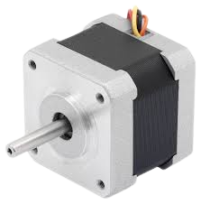

* Flex coupler

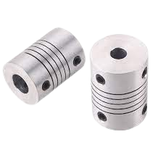Couplers are used to connect two rotating shafts. In our application, the coupler connects the stepper motor's rotating shaft and the lead screw, which are inserted at opposite ends to transmit the motor's rotatory motion to the lead screw, which provides drive for the push pull segment. Misalignment of a machine's shaft can limit its performance, cause excessive vibration, high reaction loads, and accelerated wear, and frequently leads to premature equipment failure. Flex couplers, which transmit torque while compensating for parallel, angular, and axial misalignment between drive components, can help prevent these problems. Flexible shaft couplings, when properly installed, can also reduce vibration, noise, and protect driveshaft components.

* 3d printed parts

The whole body of the design is going to be 3D printed and these parts include;

Front Support

Hand Knob (9 mm)

Hand Knob (8 mm)

Hand Knob (7 mm)

Top Syringe Holder

Side Syringe Holder

Limit Stop

Plunger Holders

Carriage

Endstop Switch

Slider

Back support

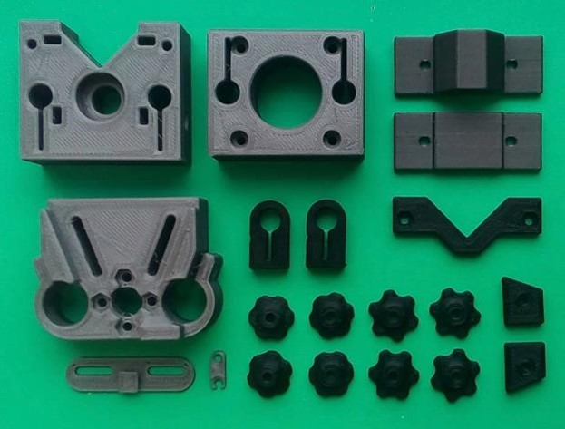

3.4.1.2 Automated Valve Switching Segment

The approach is to replace the physician's manual valve switching with motors that turn the valves. A program written for a microcontroller will control the motors. To successfully complete the processes of drawing out blood and replacing it with fresh donor blood, the program synchronizes the push-pull segment and the valve control segment. The valve control segment includes the following components;

* two Nema 17 stepper motors

• Flex couplers

• 3d printed clutch

• two three-way valves in series and catheter ends connecting to the donor blood bag, waste container and to the baby.

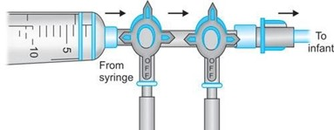

* 3D Printed clutch

This is a 3D printer item that sits on top of the motor, connected to the flex coupler, and its top rests on the bottom of the valves. The outer edges of the valve are held by the 3D printed clutch, and the valves can be turned using the drive given by the stepper motor via the flex coupler.

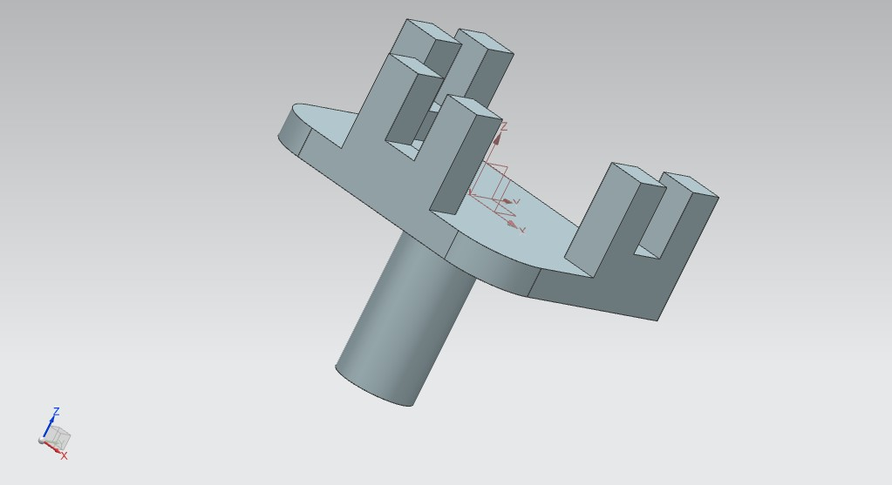

* 2 Three-way valves connected in series and catheter ends connecting to the donor blood bag, waste container and to the baby.

The valves are responsible for directing blood flow. They allow blood to travel or flow in three separate ways. The majority of the automation is concentrated here because each cycle requires around four manual valve rotations to obtain the appropriate flow.

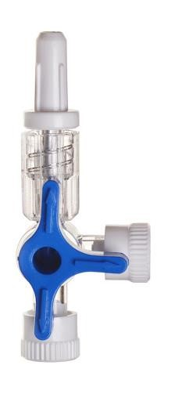

Lead and Screw nut.

A lead screw shaft is a cylindrical shaft with grooves running the length of it. A mechanical linear actuator is a device that converts rotational motion to linear motion. It operates by sliding the screw and nut threads with no ball bearings in between.

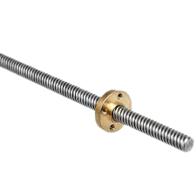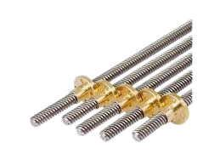

3.4.2 Electronic Components

### a) The arduino mega 2560

The ATmega2560-based Arduino Mega 2560 is a microcontroller board (datasheet). It contains 54 digital I/O pins (14 of which are PWM outputs), 16 analog I/O pins, 4 UARTs (hardware serial ports), a 16 MHz crystal oscillator, a USB connection, a power jack, an ICSP header, and a reset button. It comes with everything you need to support the microcontroller; simply connect it to a computer through USB or power it with an AC-to-DC

adapter or battery to get started. The Mega is compatible with the majority of Arduino shields.

# 

b) The Power Source.

c) Liquified Crystal Display (LCD)

LCD 162 is a type of electronic gadget that displays data and messages. As the name implies, it has 16 Columns and 2 Rows, allowing it to display 32 characters (162=32) in total, with each character made up of 58 (40) Pixel Dots. Hence the total number of pixels in this LCD can be computed as 32 × 40, or 1280 pixels. Nonetheless, the LCD 162 is widely utilized in devices, DIY circuits, and electronic projects due to its low cost, programmability, and ease of access. The specifications of the L.C.D are;

* The operating voltage of this display ranges from 4.7V to 5.3V
* The display bezel is 72 x 25mm
* The operating current is 1mA without a backlight
* PCB size of the module is 80L x 36W x 10H mm
* Number of columns – 16
* Number of rows – 2
* Number of LCD pins – 16
* Characters – 32
* It works in 4-bit and 8-bit modes
* Pixel box of each character is 5×8 pixel
* Font size of character is 0.125Width x 0.200height

The basic operation of an LCD is to transfer light from layer to layer through modules. These modules will vibrate and align themselves at 90o, allowing light to travel through the polarized sheet.

# 

d) 12 LCD adapter

An I2C LCD adaptor is a device that contains a PCF8574 microcontroller chip. This microcontroller is an I/O expander that uses a two-wire communication protocol to interface with other microcontroller chips. Anybody may use this adaptor to operate a 16x2 LCD with only two wires (SDA, SCL). It saves several arduino or other microcontroller pins. It has a potentiometer for controlling the LCD contrast. The I2C address is 0x27 by default. Its address can be changed by connecting A0, A1, and A2.

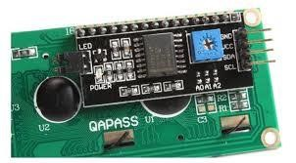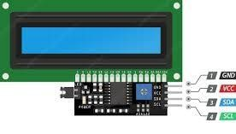

e) Keypad

The buttons on the 4X4 membrane keypad are organized in rows and columns in a 4X4 matrix. Membrane switches are located beneath the buttons. Each switch in a row that is beneath a button key is linked to another switch in the same row by an electrically conductive trace put beneath the keypad buttons; there are four rows in total. Likewise, each switch in a column under a button key is linked to another switch in the same column by an electrically conductive trace buried beneath the keypad keys, and there are four columns in total. The 4X4 matrix keypad has 8 pins made up of 4 rows and 4 columns.\

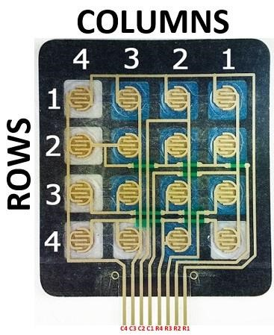

Pressing a button joins a row and a column, thereby creating an electrical conducting path between the row and the column. See image below.

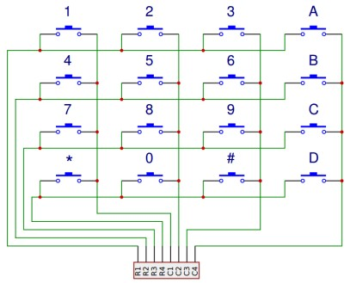

How Arduino detects pressed button

Here's how Arduino determines which button is pushed by determining which rows and columns are linked.

• When no key/button is pressed, the Arduino “keypad.h” library code causes the row pins to go LOW and the column pins to go HIGH. See image below.

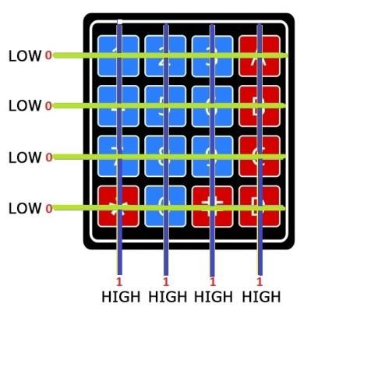

When a key or button is pushed, a row key and a column key are linked. Because the row pins were initially pushed LOW by the Arduino "keypad.h" library code, any column pin that now comes into contact with a row as a result of the pressed button will be pulled LOW from its initial HIGH position. As a result, we now know which column the key/button was pushed in. Please see the image below.

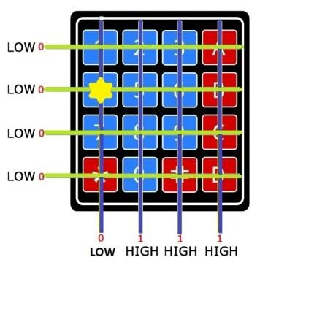

The Arduino, using the "keypad.h" library, will cause the row pins to go high consecutively while concurrently reading the column pins to determine which row pin will trigger a column key to go high from a LOW state, because all of the column pins have been on HIGH since the beginning and have not shifted state except the column that was pressed and turned to LOW, it is this same pin that will switch from LOW to HIGH. The Arduino now knows which row pin was pressed as a result of this. We can determine the specific key/button that was pressed by merging the row and column pins. From the explanation above, we can say that row 2 and column 1 pins were connected when the button was pressed, hence, with this information, we can deduce that button 4 was pressed

f) Switch

A device switch was added to the set up of design electronic components for the device to conserve energy by toggling between on and off.

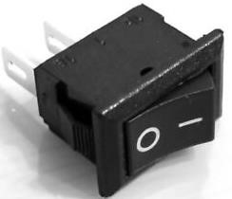

g) Motor Shield

Stepper motors need to be pulsed in order to move at a specific number of steps, speed, direction, and rate. These pulses are sent by a motor driver. An Arduino motor shield was interfaced with the Arduino mega microcontroller to drive the syringe pump's bipolar stepper motor. The motor shield provides channels for controlling four DC motors, two stepper motors, and two servo motors. It also features headers for attaching input and output lines. The motor shield can safely deliver up to 12V and 2A per motor channel or 4A to a single channel when connected to an external power supply.

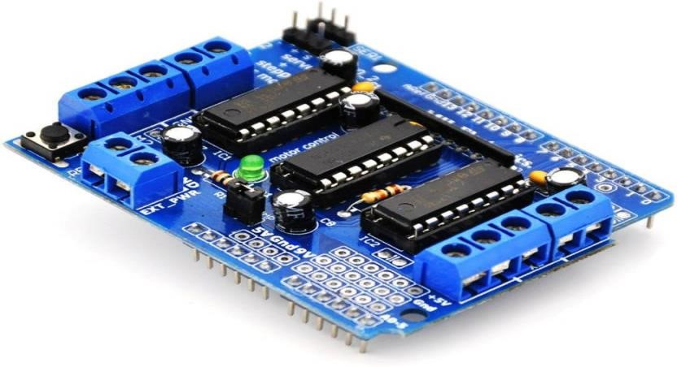

h) Voltage Boosters

This DC-DC switching boost converter can drive a 4A load while maintaining a good line and load control. The XL6009 IC, the main switching component, is available with fixed output voltages of 3.3 V, 5V, and 12V, as well as an adjustable output version. It is an efficient switching regulator with much better output efficiency than common boost regulators. At higher input voltages, the regulator operates at a switching frequency of 400kHz, allowing for a lower and more space-efficient total board footprint.

This device is used to step up the supply voltage. Its output voltage is adjustable by a potentiometer.

* Small size, high efficiency
* Easy to install
* Stable and reliable
* It can make the output stabilized

Features:

* Input voltage range: 3.2 to 30Vdc.
* Output voltage range: 5 to 35Vdc.
* Output rated current: 2A.
* Output maximum current: 3A (need to add heat sink).
* Pinout:

IN+ = Input voltage

IN- = Ground

OUT+ = Output voltage

OUT- = Ground

* 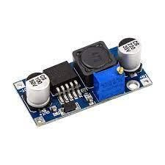Dimension: 41 x 20 x 14 mm.
* Weight: 12g

### L298N motor drivers

The L298N is a dual H-Bridge motor driver that, as the name indicates, provides for motor speed and direction control. A single L298N IC can drive two DC motors at the same time, and the two motors and one stepper motor, as well as their directions, may be separately controlled. Stepper motors need to be pulsed in order to move at a specific number of steps, speed, direction, and rate. These pulses are sent by a motor driver. L298N motor drivers controlled the movement of the two stepper motors used to turn the valves.

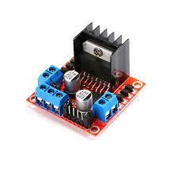

# REFERENCES

Agbedor, A., Abisba, A., & Frimpong, N. (2022). Automated Neonatal Exchange Transfusion System 3.0. *Kwame Nkrumah University of Science and Technology*(1), 10 - 40.

Altunhan, H., Annagür, A., Tarakçi, N., Konak, M., Ertuğrul, S., & Örs, R. (2016). Fully automated simultaneous umbilical arteriovenous exchange transfusion in term and late preterm infants with neonatal hyperbilirubinemia. *The Journal of Maternal-Fetal & Neonatal Medicine*, *29*(8), 1274-1278.

ANDREW, A., ABISBA, A. B., & FRIMPONG, N. K. ( 2022). *Automated Neonatal Exchange*

*Transfusion System 3.0* Kwame Nkrumah University of Science and Technology].

Ar-Rayyan. (2020). *How to Care for Your Baby with Jaundice*.

Badiee, Z. (2007). Exchange transfusion in neonatal hyperbilirubinaemia: experience in Isfahan, Iran. *Singapore medical journal*, *48*(5), 421.

Battilocchio, C., & Ley, S. V. (2023). Flow Chemistry. *Organic chemistry*, *2*, 12 -19. <https://www.organic-chemistry.org/topics/flowchemistry.shtm>

Bhat, A. W., Churoo, B., Iqbal, Q., Sheikh, M., Iqbal, J., & Aziz, R. (2011). Complication of exchange transfusion at a tertiary care hospital. *Seizure*, *1*(1).

Bhat Y, R. (2007). Management of neonatal hyperbilirubinemia-What is the efficacy of exchange transfusion by different techniques? *Journal of Neonatology*, *21*(1), 68-70.

Bhutani, V. K., Johnson, L. H., & Keren, R. (2004). Diagnosis and management of hyperbilirubinemia in the term neonate: for a safer first week. *Pediatric Clinics*, *51*(4), 843-861.

BiologyEye. (2023). Syringe Pump Working Principle. *Syringe Pump Working Principle - BiologyEye*, *2*.

Brecher, M., Monk, T., & Goodnough, L. (1997). A standardized method for calculating blood loss. *Transfusion*, *37*(10), 1070-1074.

Brecher, M. E. (2018). A History of Blood Transfusion from Ancient Times to the 21st Century.

*Transfusion Medicine Reviews*, *32*(2), 59 - 75.

Chatterjee, A., Verma, S., Dutta, S., Singh, S., Singh, G., Sharma, R. R., Sachdev, S., Attri, S., &

Bhatia, P. (2023). Novel device for automating exchange transfusions through umbilical

venous route in neonates. *Eur J Pediatr*, *182*(3), 1229-1238.

<https://doi.org/10.1007/s00431-022-04791-3>

Children's Hospital, B. (2023, March 19,2023). Hyperbilirubinemia and Jaundice.

Ciko, D., Herron, B., May, A., Stanforth, D., Appiah, J. A., & Vogt, R. (2010). Automated Blood Transfusion Device. *Global Health Design Initiative*, *2*(3), 15.

Cogan, D. G. (1978). The Rise and Fall of Eponyms. *Arch. Ophthalmol*, *1*.

Convertino, V. A. (2007). Blood volume response to physical activity and inactivity. *Am J Med*

*Sci*, *334*(1), 72-79. <https://doi.org/10.1097/MAJ.0b013e318063c6e4>

Davutoğlu, M., Garipardiç, M., Güler, E., Karabiber, H., & Erhan, D. (2010). The etiology of severe neonatal hyperbilirubinemia and complications of exchange transfusion. *Turk J Pediatr*, *52*(2), 163-166.

Doggett, B. M., Session-Augustine, N., Roig, J., Strunk, M., Valiyaparambil, S., Sarode, R., & De Simone, N. (2019). Single-needle: an effective alternative to dual-needle peripheral access in therapeutic plasma exchange. *J Clin Apher*, *34*(1), 21-25.

<https://doi.org/10.1002/jca.21665>

Duan, Z.-J., Li, L.-L., Ju, J., Gao, Z.-H., & He, G.-H. (2006). Treatment of hyperbilirubinemia with blood purification in China. *World journal of gastroenterology: WJG*, *12*(46), 7467.

Elizabeth, J. (1975). Phototherapy in neonatal hyperbilirubinemia. *Aust Paediat*, *2*, 23 -25.

Fonger, G. C., Hakkinen, P., Jordan, S., & Publicker, S. (2014). The National Library of Medicine’s (NLM) Hazardous Substances Data Bank (HSDB): background, recent enhancements and future plans. *Toxicology*, *325*, 209-216.

Funato, M., & T, H. (1997). Trends in neonatal exchange transfusions at Yodogawa Christian

Hospital. *Acta Paediatr Jpn*.

Furlan, A. D., van Tulder, M., Cherkin, D., Tsukayama, H., Lao, L., Koes, B., & Berman, B. (2005). Acupuncture and dry-needling for low back pain: an updated systematic review within the framework of the cochrane collaboration. *Spine*, *30*(8), 944-963.

Gajjar, M., Patel, T., Bhatnagar, N., Solanki, M., Patel, V., & Soni, S. (2016). Therapeutic plasma exchange in pediatric patients of Guillain-Barre syndrome: Experience from a Tertiary

Care Centre. *Asian J Transfus Sci*, *10*(1), 98-100. [https://doi.org/10.4103/09736247.165834](https://doi.org/10.4103/0973-6247.165834)

Gartner, L. M. (2001). Breastfeeding and jaundice. *Journal of Perinatology*, *21*(1), S25-S29.

Gregersen, M. I., & Rawson, R. A. (1959). Blood volume. *Physiological Reviews*, *39*(2), 307-342.

Heirwegh, K. P., & Blanckaert, N. (1981). Analysis of bilirubin conjugates. In *Methods in enzymology* (Vol. 77, pp. 391-398). Elsevier.

Hospital, B. C. (2005). *Hyperbilirubinemia and Jaundice*.

<https://www.childrenshospital.org/conditions/hyperbilirubinemia-and-jaundice>

Jackson, J. C. (1997). Adverse events associated with exchange transfusion in healthy and ill newborns. *Pediatrics*, *99*(5), e7-e7.

Kaneshiro, N. K. (2021). Exchange Transfusion. *MedlinePlus - National Library of Medicine*, 1-2.

Lee, K.-s., Gartner, L. M., Eidelman, A. I., & Ezhuthachan, S. (1977). Unconjugated hyperbilirubinemia in very low birth weight infants. *Clinics in Perinatology*, *4*(2), 305320.

LK, D. (1947). Erythroblastosis foetalis or haemolytic disease of the newborn. *National Library*

*of Medicine*.

Marsaglia, G., & Thomas, E. (1971). Mathematical consideration of cross circulation and exchange transfusion. *Transfusion*, *11*(4), 216-219.

Michael, K., Wong, R. J., Burgis, J. C., Sibley, E., & Stevenson, D. K. (2020). *Fanaroff and Martin's Neonatal-Perinatal Medicine* (Vol. 91).

Mineshima, M., Eguchi, K., Horibe, K., Yokoi, R., Kaneko, I., Kimata, N., Sanaka, T., Nihei, H., & Agishi, T. (1998). Continuous monitoring of blood volume in double filtration plasmapheresis. *Asaio j*, *44*(5), M465-469. [https://doi.org/10.1097/00002480199809000-00029](https://doi.org/10.1097/00002480-199809000-00029)

Murki, S., & Kumar, P. (2011). Blood Exchange Transfusion for Infants with Severe Neonatal Hyperbilirubinemia. *Semin Perinato*, *35*, 175-184.

Ohto, H., & Anderson, K. C. (1996). Survey of transfusion-associated graft-versus-host disease in immunocompetent recipients. *Transfusion Medicine Reviews*, *10*(1), 31-43.

Okrah, P. A. K., & Kisser, B. A. (2021). *AUTOMATED NEONATAL EXCHANGE*

*TRANSFUSION* Kwame Nkrumah University of Science and Technology].

Physiology&Anatomy. (2014, Oct 27, 2014). *Hemolytic Disease of the Newborn*.

Pstras, L., Waniewski, J., & Lindholm, B. (2021). Monitoring relative blood volume changes during hemodialysis: Impact of the priming procedure. *Artif Organs*, *45*(10), 1189-1194.

<https://doi.org/10.1111/aor.13972>

RCH. (2009). Exchange Transfusion: Neonatal. In M. The Royal Children's Hospital (Ed.). repository, S. (2021). Phototherapy and its Applications.

Roelandts, R. (2002). The history of phototherapy: something new under the sun? *Journal of the American Academy of Dermatology*, *46*(6), 926-930.

Sabzehei, M. K., Basiri, B., Shokouhi, M., & Torabian, S. (2015). Complications of exchange transfusion in hospitalized neonates in two neonatal centers in Hamadan, a five-year experience. *Journal of Comprehensive Pediatrics*, *6*(2).

Sakhuja, P., & Naik, R. (2008). Exchange transfusion. *Indian Pediatrics*, *45*(6), 479-484.

Savin, C. P. [[https://youtu.be/6du231tKkLE]](https://youtu.be/6du231tKkLE). (2020). *Working principle of Syringe || Boyle's Law*

Seneadza, N. A. H., Insaidoo, G., Boye, H., Ani-Amponsah, M., Leung, T., Meek, J., & EnweronuLaryea, C. (2022). Neonatal jaundice in Ghanaian children: Assessing maternal knowledge, attitude, and perceptions

*PLoS One*, *17*

(3), 10. <https://doi.org/>10.1371/journal.pone.0264694

Spaeth, W. S., & Cottrille, J. P. P. A. (1958). The importance of exchange transfusions in the treatment of hyperbilirubinemias of the newborn. *The Journal of the American Osteopathic Association*, *2*(58), 93–96.

Starship. (2018). Exchange Transfusion in the Neonate.

<https://starship.org.nz/guidelines/exchange-transfusion-in-the-neonate/>

Steventon, G. (2020). Uridine diphosphate glucuronosyltransferase 1A1. *Xenobiotica*, *50*(1), 64-

76.

Tala. (2020, Dec 21, 2020). *What is a double-volume exchange transfusion?* Youtube.

Teichler-Zallen, D. C. (2004). *The Rhesus factor and disease prevention* History of Medicine, Ullah, S., Rahman, K., & Hedayati, M. (2016). Hyperbilirubinemia in neonates: types, causes, clinical examinations, preventive measures and treatments: a narrative review article.

*Iranian journal of public health*, *45*(5), 558.

Underwood, C. (2019). Automated journalism–AI applications at New York Times, Reuters, and other media giants. *Tech emergence*.

Victoria., S. C. (2018). *Umbilical vein catheterisation for neonates* (Vol. 2). Neonatal ehandbook.

Wadsworth, G. R. (2002). Blood-volume: a commentary. *Singapore Med J*, *43*(8), 426-431.

Woodgate, P., & Jardine, L. A. (2011). Neonatal jaundice. *BMJ clinical evidence*, *2011*.

YIDDI, G. W., AMANKWAH, E., & DARKO, E. (2020). *AUTOMATED NEONATAL EXCHANGE*

*TRANSFUSION (ANET)SYSTEM* Kwame Nkrumah University of Science and Technology].