Phase 2: Midterm Progress & Troubleshooting

0. Student Information
Name: 안형준
Student ID: 20221250

1. Initial Training & Loss Analysis

Problem and model recap
$$\frac{∂θ}{∂τ}=\frac{∂^{2}θ}{∂X^{2}}-βθ+Si{\left(τ\right)}^{2}g\left(X\right), β=\frac{hPL^{2}}{kA}, S=\frac{q_{0}I_{ref}^{2}L^{2}}{kΔT_{ref}}$$
then $h,q_{0}$ are recovered after training.
• Boundary/initial conditions(both axial ends adiabatic):
$$θ\left(X,0\right)=0, θ_{X}\left(0,τ\right)=0,{ θ}_{X}\left(1,τ\right)=0$$
• Convection enters as the distributed sink $-βθ$ (side-surface cooling), not as a boundary condition.
• $g\left(X\right)=\text{exp}\left[-\frac{{(X-0.30)}^{2}}{{2\left(0.10\right)}^{2}}\right]$ : Gaussian heat source centered at $X=0.30$
• $i\left(τ\right)=\frac{I\left(t\right)}{I_{ref}}$

Baseline PINN configuration
Setting | Baseline value
Backend / device | PyTorch backend, CPU forced (PINN_FORCE_CPU=1) — MPS disabled on M1
Network | dde.nn.FNN([2,32,32,32,1], "tanh", "Glorot normal")
Depth × width | 3 × 32
Optimizer / lr | Adam, 1e-3 (optional L-BFGS polishing)
Iterations | 100,000
Collocation | num_domain=512, num_boundary=64, num_initial=64, num_test=200
Sensors | 3 sensors at X=0.25, 0.55, 0.85; sensor_time_points=41 (123 points)
Synthetic data | generated in the FDM reference solver section of the notebook.
Current profile | 0–300 s on (I = I_ref),  300–600 s off,  600–900 s on (I = I_ref),  900–1200 s off

Loss components and weighting
Loss term | Meaning | Weight (baseline)
Loss_PDE | MSE of PDE residual f | 5
Loss_IC | $θ\left(X,0\right)=0$ mismatch | 10
Loss_BC (left+right) | adiabatic $θ_{X}=0$ at $X=\left(0,1\right)$ | 10 + 10
Loss_data | sensor data mismatch | 200
weight vector = [PDE, IC, lBC, rBC, data] = [5, 10, 10, 10, 200]

Loss-weight balancing study
Case | Weights [PDE,IC,lBC,rBC,data] | beta err | S err | Rel L2
A1 | [5,10,10,10,100] | -0.199% | -0.777% | 5.46e-03
A2 | [5,10,20,20,100] | -0.355% | -0.571% | 7.32e-03
A3 | [10,10,10,10,100] | +0.472% | +0.042% | 4.41e-03
A4 | [5,10,10,10,200] | -0.005% | -0.351% | 4.60e-03
A5 | [10,10,10,10,200] | +0.508% | -0.442% | 5.76e-03

A1 [5,10,10,10,100]: used a moderate PDE weight and a sensor-data weight of 100 as the starting configuration. Recovery was reasonable, but S error remained relatively high (-0.777%).
A2 [5,10,20,20,100]: increased the two boundary-condition weights. This did not help — test loss and Rel L2 got worse, so over-weighting the adiabatic BCs is counter-productive here.
A3 [10,10,10,10,100]: raised the PDE weight while keeping the IC/BC/data weights unchanged. Best full-field Rel L2 of the set and near-zero S error, but beta error rose to +0.472%.
A4 [5,10,10,10,200]: doubled the sensor-data weight to 200 while keeping PDE moderate. Decisive change — near-perfect beta recovery (-0.005%) and the lowest MAE. Selected as baseline.
A5 [10,10,10,10,200]: additionally raised the PDE weight on top of A4. No meaningful gain (beta error back up to +0.508%), confirming that the data weight — not the PDE weight — drives parameter identifiability.
In this inverse setting a high sensor-data weight is what makes h and q0 identifiable, while the PDE/BC weights mainly affect full-field smoothness. A4 is therefore taken as the baseline; its convergence curves and final summary follow in 1.5 and 1.6.

Loss convergence curves and stability analysis

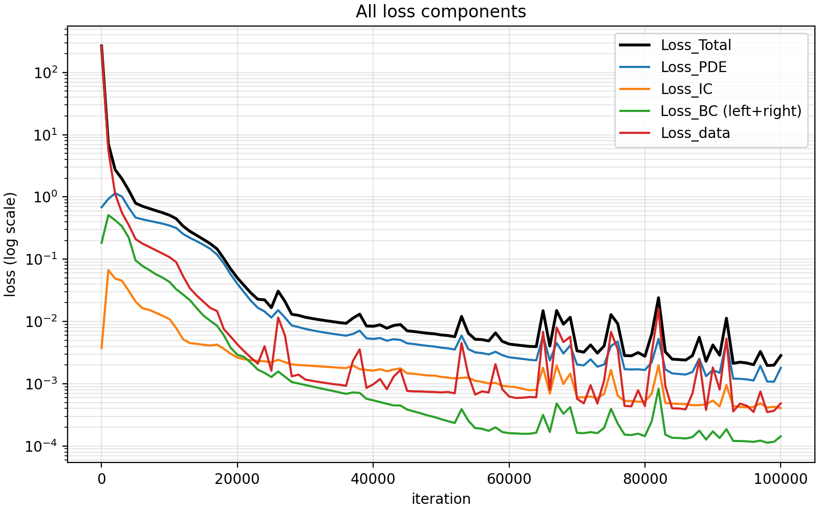
Figure 1.5 — Loss convergence for the selected A4 baseline (weights [5, 10, 10, 10, 200], 3×32 network, 100,000 Adam iterations). Best train/test loss = 1.97×10⁻³ / 8.37×10⁻³ at step 98,000
All plotted loss components decrease roughly by three to five orders of magnitude and settle onto a stable plateau, indicating a converged, non‑divergent training run. The selected A4 baseline reaches train loss = 1.97×10⁻³ and test loss = 8.37×10⁻³ at its best step (98,000 / 100,000), consistent with the parameter and full‑field errors reported for A4 in Section 1.6 (h err −0.005 %, $q_{0}$ err −0.351 %, Rel L² 4.60×10⁻³).
Early transient (0 – ~5,000 iters): Loss_Total drops sharply from roughly 2.5×10² to below 1. Loss_BC shows a brief initial rise (to ~5×10⁻¹) before falling; this is expected, as the network first fits the dominant PDE/IC/data terms and only then drives the adiabatic boundaries to zero. It is a transient, not an instability.
Main descent (~5,000 – 50,000 iters): All curves decrease smoothly and roughly in parallel on the log scale, the expected Adam behaviour. Only one minor bump appears (around iter 26,000) and recovers immediately.
Plateau (>~50,000 iters): Loss_Total levels off near 2×10⁻³ and Loss_PDE near 1–2×10⁻³, matching the converged train loss (1.97×10⁻³) reported for A4 in Section 1.6. Intermittent upward spikes occur — the largest peaks at about 2.4×10⁻² near iter 82,000, coinciding with rises in Loss_PDE — but each spike decays back to the plateau within a few hundred iterations. These oscillations are attributed to Adam adaptive-update dynamics and the competing effects between PDE residual minimization and sparse sensor-data fitting; there is no upward drift and no sustained high plateau.
Term balance: Loss_PDE tracks Loss_Total almost exactly, so the PDE residual is the binding (hardest) term, while Loss_BC sits about one to two orders of magnitude lower throughout — the adiabatic ends $θ_{X}$ = 0 are the easiest condition to satisfy. With the [5, 10, 10, 10, 200] weighting, the weighted terms reach comparable magnitude and the optimizer is effectively limited by the PDE residual rather than by the boundary or data terms.
Stability verdict: The loss decreases smoothly with only mild, self‑correcting Adam oscillations; no exploding gradients or divergence are observed. Convergence is essentially reached by ~50,000 – 60,000 iterations, and the remaining iterations yield only marginal improvement.

Selected baseline case and convergence summary
Quantity | A3 (full-field priority) | A4 (parameter priority)
beta error / h error | +0.472% | -0.005%
S error / q0 error | +0.042% | -0.351%
MAE | 2.175e-03 | 1.534e-03
RMSE | 4.314e-03 | 4.504e-03
Rel L2 | 4.410e-03 | 4.60e-03
A4 is adopted as the baseline. The reasoning is given in Section 1.4; this section reports its converged performance and contrasts it with the next-best candidate, A3.
A4 gives near-perfect parameter recovery (h err −0.005%, lowest MAE), so it is preferred for an inverse problem whose primary goal is identifying h and q₀. A3 attains a marginally better full-field Rel L²/RMSE, but A4's only weakness is a slightly larger local pointwise error near the switching times, as shown in the error map of Figure 1.6. This is the expected consequence of the high sensor-data weight (200) and reduced PDE weight (5): the network fits the sparse sensor data tightly at the cost of slightly weaker pointwise PDE enforcement.
The largest pointwise error occurs near the current-switching instants, where the input i(τ)² changes abruptly — the same effect documented in Section 3.3.
The FDM solution is used only to generate synthetic sensor data and to provide a post-training reference field. The inverse solver itself is the DeepXDE-based PINN trained with sparse sensor data, PDE residual, IC, and BC constraints.
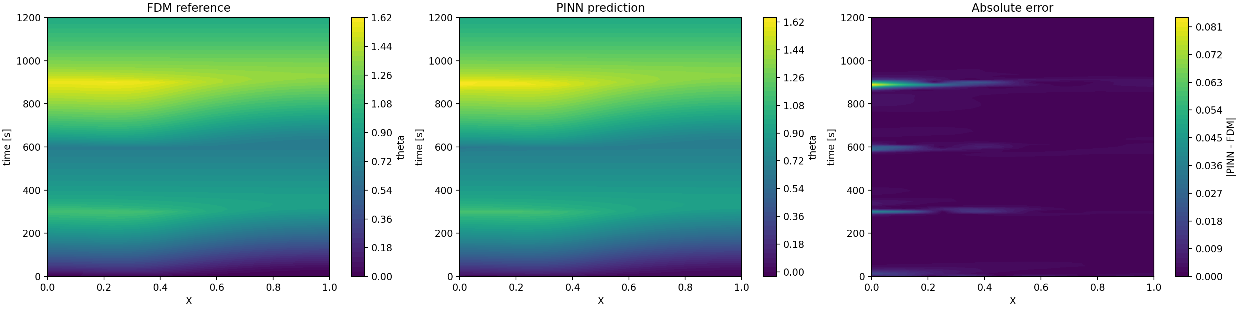
Figure 1.6 — FDM reference field, PINN reconstructed field, and absolute error for the selected A4 baseline. The error is localized near the current-switching times (t = 300, 600, 900 s), while the overall transient field is well reconstructed.
The reconstructed field is physically consistent with the imposed current profile. During current-on intervals, the temperature increases due to the Joule heating source term. During current-off intervals, the temperature decays due to the convective sink term. The highest temperature region appears around the Gaussian heat source center near $X=0.30$, and the absolute error is mostly localized around current-switching times rather than spread over the entire domain.

2. Ablation Study

Evaluation metrics
Each case is compared on two axes - the result (accuracy of the recovered solution) and the convergence (training behaviour):
- Result - parameter recovery: $h$ error (%) and $q_{0}$ error (%) against the true values $h_{TRUE}=40 W/m^{2}K$ and $q_{0,TRUE}=8.0×{10}^{4} W/\left(m^{3}A^{2}\right)$.
- Result - full field: relative L2 of the predicted theta field vs. the FDM reference (MAE / max error where useful).
- Convergence: final Loss_PDE / Loss_Total and qualitative stability of the loss curve (smooth decrease vs. high plateau or divergence).

Activation function ablation: Tanh vs ReLU
Only the activation is changed: To isolate the effect of the activation function, this ablation uses the same configuration as the selected A4 baseline: a 3×32 network, loss weights [5,10,10,10,200], 100k Adam iterations, num_domain=512, num_boundary=64, num_initial=64, num_test=200, and the same sparse sensor data. Therefore, any difference between the two cases can be attributed to the activation function.
Why this activation choice matters for a 2nd-order PDE: the residual needs the second spatial derivative $θ_{XX}$, formed by differentiating the network twice through autograd. Tanh is smooth ($C^{∞}$), so second and higher derivatives are well defined. ReLU is piecewise linear, so its second derivative is zero almost everywhere - $θ_{XX}$ collapses and the PDE residual can barely be enforced. This makes the activation-function choice physically important for a second-order heat-conduction PINN.
Setup:
To isolate the effect of the activation function, all settings are kept identical to the selected A4 baseline. Only the activation function is changed.
Item | Control | Ablated case
Activation | tanh | relu
Network | [2] + [32]x3 + [1] | identical
Loss weights / iterations | [5,10,10,10,200] / 100k Adam | identical
Collocation | num_domain/boundary/initial/test = 512/64/64/200 | Identical
Sensors | 3 at X=0.25,0.55,0.85; 41 time pts (123 pts) | Identical

Results:
Metric | Tanh | ReLU
Final Loss_PDE | 1.804e‑03 | 1.631e+00
Train / test loss | 1.97e‑03 / 8.37e‑03 | 2.58 / 2.31
h error (%) | −0.005 | -100.0
q0 error (%) | −0.351 | −78.179
Rel L2 (full field) | 4.60e‑03 | 6.098e‑02
In this activation ablation, the Tanh case uses the same configuration as the selected A4 baseline. The network size, loss weights, collocation point numbers, sensor data, and training iterations are fixed, and only the activation function is changed from Tanh to ReLU.
Convergence difference: Under the identical A4 baseline setting, the Tanh model shows stable convergence, reaching a final PDE loss of $1.804×{10}^{-3}$ and train/test losses of $1.97×{10}^{-3}$ and $8.37×{10}^{-3}$, respectively. In contrast, the ReLU model remains at a much higher loss level, with final PDE loss $1.631$, train loss $2.58$, and test loss $2.31$. Therefore, the final PDE loss of ReLU is about $9.0×{10}^{2}$ times larger than that of Tanh. This indicates that the ReLU case does not simply converge more slowly; rather, it fails to represent the second-order heat-conduction physics required by the PDE residual.
Result difference: The Tanh model accurately recovers both inverse parameters. The errors are only $-0.005\%$ for $h$ and $-0.351\%$ for $q_{0}$, and the full-field relative $L_{2}$ error is $4.589×{10}^{-3}$. In contrast, the ReLU model fails to recover the physical parameters, giving $h$ error of $-100.0\%$ and $q_{0}$ error of $-78.179\%$. The full-field relative $L_{2}$ error also increases to $6.098×{10}^{-2}$. Thus, the ReLU full-field error is about 13.3 times larger than the Tanh case, and the magnitude of the $q_{0}$ error is more than 200 times larger.
Why ReLU fails: The failure of ReLU is physically consistent with the structure of the governing equation. The PDE residual contains the second spatial derivative $θ_{XX}$, which represents axial heat conduction. A Tanh network is smooth and twice differentiable, so it can provide meaningful first and second derivatives through automatic differentiation. In contrast, ReLU is piecewise linear, so its second derivative is zero almost everywhere. As a result, the ReLU network cannot properly represent the conduction term in the PDE residual. This causes the inverse parameter estimation to fail, as shown by the $-100.0\%$ error in $h$, the $-78.179\%$ error in $q_{0}$, and the much larger full-field relative $L_{2}$ error.

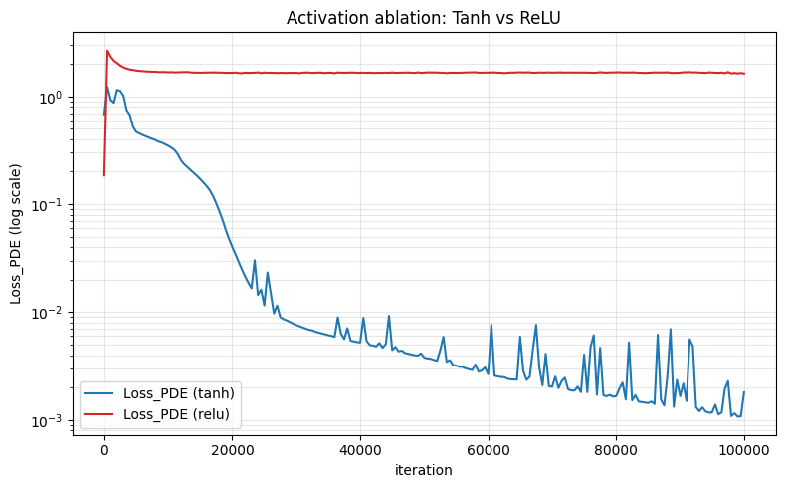
Figure 2.2 — Activation-function ablation under the selected A4 baseline setting.
All training settings are identical except for the activation function. Tanh shows stable convergence, while ReLU remains at a much higher PDE-loss level because it cannot properly represent the second derivative $θ_{XX}$.
Tanh decreases by roughly three orders of magnitude and reaches a low PDE-loss level of $1.804×{10}^{-3}$, whereas ReLU rises to approximately $1.6$ within the first few hundred iterations and then stays nearly flat for the remaining 100k iterations. The ReLU curve confirms the mechanism: with $θ_{XX}=0$ almost everywhere, the conduction term cannot be represented properly, so the PDE loss remains trapped at a high plateau. This visual gap mirrors the metric gap in the table above, where the final Loss_PDE is $1.804×{10}^{-3}$ for Tanh and $1.631$ for ReLU.

3. Troubleshooting Experience (Flexible Reporting)

Scaling issue in inverse PINN training
A major difficulty during training was the scaling of the inverse problem. The physical parameters h and q₀ have very different units and magnitudes, and the Joule heating term $q_{0}I{\left(t\right)}^{2}g\left(x\right)$ can dominate the PDE residual if the equation is written directly in dimensional form, which makes the loss balance sensitive and can lead to unstable parameter updates. To resolve this, the governing equation was nondimensionalized:
$$X=\frac{x}{L}, τ=\frac{αt}{L^{2}}, θ=\frac{T-T_{∞}}{ΔT_{ref}}, i\left(τ\right)=\frac{I\left(t\right)}{I_{ref}}$$
and, instead of directly learning h and q₀, the PINN learns the nondimensional parameters
$$β=\frac{hPL^{2}}{kA}, S=\frac{q_{0}I_{ref}^{2}L^{2}}{k ΔT_{ref}}$$
which are converted back to h and q₀ after training. This scaling keeps the network inputs and outputs near order one and prevents any single term from dominating the loss. Finally, to keep β and S physically positive throughout optimization, softplus is applied to the raw trainable variables:
$$β=softplus\left({raw}_{β}\right), S=softplus\left({raw}_{S}\right)$$

Inconsistent synthetic data from a local-ODE approximation
Another issue was the construction of the synthetic sensor data. The initial approximation was based on a local ODE model that ignored the axial conduction term $θ_{XX}$, whereas the PINN is trained with the full PDE including axial conduction. This created an inconsistency between the data loss and the physics loss. To fix it, the synthetic sensor data were regenerated from a finite-difference solution of the full nondimensional PDE (nx = 101, adiabatic ends), and the sensor values used in PointSetBC were extracted from this FDM reference field. The data constraint is now consistent with the PDE residual used in training, and the same FDM field is reused for the full-field comparison.

Remaining mismatch near current-switching times
A remaining limitation is the mismatch near current-switching times. Even when the learned inverse parameters are close to the true values, the PINN temperature field can deviate from the FDM reference near abrupt changes in the current input. This is likely because the current profile is piecewise constant while the network represents the temperature field as a smooth function, so it cannot resolve the sharp temporal transition as tightly as the FDM grid. For this reason the full-field FDM comparison was added as an essential verification step (Section 1.6). Planned improvements include adding more collocation points near the switching times, slightly smoothing the current profile, and comparing different current profiles in future validation tests.

Loss-weight balancing and inverse parameter identifiability
The weight sweep itself is in Section 1.4; here we focus on why it matters for identifiability. A practical issue was the balance between the physics loss and the sensor-data loss. In the inverse PINN, the PDE residual enforces the heat equation, but the unknown parameters β and S cannot be accurately identified unless the sparse sensor data provide a strong enough constraint. In the early loss-weight trials, increasing the PDE or boundary-condition weights alone improved some parts of the physics residual but did not consistently improve parameter recovery.
The loss-weight study showed that the data loss weight was especially important for parameter identifiability. When the sensor-data weight was increased to 200 while keeping a moderate PDE weight, the model achieved near-perfect recovery of β and h, with only a small error in S and q0. Therefore, the case [5, 10, 10, 10, 200] was selected as the baseline.
This result suggests that, for this inverse problem, the sensor data mainly determine the unknown thermal parameters, while the PDE and boundary-condition losses regularize the solution and enforce physical consistency. If the data weight is too small, the network may satisfy the PDE but fail to recover the correct parameters. If the data weight is too large, the model may fit the sensor points tightly but show slightly larger local full-field errors. Therefore, the final baseline was chosen as a compromise between parameter accuracy and full-field reconstruction accuracy.

