Drought impacts on the regional availability of zooplankton resources in the San Francisco Bay-Delta

# Authors:

Arthur Barros (arthur.barros@wildlife.ca.gov)

Rosemary Hartman

Sam Bashevkin

Christina Burdi

# Abstract

The Sacramento-San Joaquin Delta and San Francisco Estuary (estuary) in California face significant challenges in managing water resources during extended droughts. Zooplankton, the primary consumers of phytoplankton in the estuary, are a vital trophic link between phytoplankton producers and higher-level consumers. However, there is still much to be learned about what drives zooplankton abundance and how they respond to drastic changes in environmental conditions, such as extreme droughts. We found that during drought years, zooplankton abundance and distribution changed across the estuary, but changes varied depending on the examined taxa. Significant declines in the abundance of *Daphnia* spp. and the copepod *Pseudodiaptomus forbesi* occurred in the downstream Suisun Marsh and Suisun Bay regions, while the abundance of the invasive copepod *Limnoithona tetraspina* increased during the same drought conditions. We found salinity was a strong determinant in the presence and abundance of the studied taxa due to their individual salinity tolerances. We showed that changes in the distribution of salinity due to low outflow drought conditions were an important factor in the regional availability of zooplankton. Due to the expected increase of frequency and severity of regional droughts, understanding how these conditions impact the abundance and distribution of zooplankton in the estuary will benefit scientists and resource managers.

## Key Words

Zooplankton, drought, copepods, mysids, cladocera, salinity

# Introduction

Extended droughts present a significant challenge in managing water resources in the Sacramento-San Juaquin Delta and San Francisco Estuary (estuary). Many fish species of concern have documented declines with decreased outflow, but the mechanisms behind these declines are often poorly understood. As the primary consumers of phytoplankton within the estuary, zooplankton facilitate a vital trophic link between phytoplankton producers and higher-level consumers. In the estuary zooplankton are a key food source for several endangered and threatened species, notably the Delta Smelt (*Hypomesus transpacificus*) (Slater and Baxter 2014, Slater et al. 2019), Longfin Smelt (*Spirinchus thaleichthys*) (Jungbluth et al. 2021, Barros et al. 2022), juvenile Chinook Salmon (Tiffan et al. 2014, Goertler et al. 2018), and the larval stages of most fish species (Hunter 1981). Because of their importance in fish diets, zooplankton have been studied extensively, however much remains to be learned about what drives zooplankton abundance and how zooplankton respond to environmental conditions (Hartman et al. 2021). One key question is how zooplankton respond to extremes, including extremes of flood and drought.

This paper is one of a series of papers that came out of the Interagency Ecological Program Drought Synthesis Team. The team was formed in 2021 to respond to the extremely dry water year. The team analyzed impacts of drought on a broad suite of environmental parameters, from hydrology to water quality, to phytoplankton, to invertebrates, to fish. While there is no single agreed-upon definition for “drought”, droughts in California generally occur when there are multiple years of low precipitation and a resulting water supply shortage (DWR 2020). In this series of papers, the authors define “drought” as two or more consecutive years with a Sacramento Valley Index of Below Normal, Dry, or Critically Dry, similar to (Mahardja et al. 2021). “Wet” years are defined as two or more consecutive years with a Sacramento Valley Index of Above Normal or Wet. Each paper in this series can stand alone, but many of the papers refer to each other and provide complementary information.

Zooplankton have been monitored regularly in the estuary since 1972, when the California Department of Fish and Wildlife (CDFW) Zooplankton study began (Bashevkin et al. 2022). Long term monitoring has enabled the detection of key changes in the zooplankton community. Most notably. the significant decrease in abundance of zooplankton coinciding with the introduction and spread of the invasive clam, *Potamocorbula amurensis,* in the mid-1980s (Carlton et al. 1990, Kimmerer et al. 1994). In addition, the introduction of several non-native zooplankton species (e.g. the cyclopoid copepod Limnoithona tetraspina, the calanoid copepod Pseudodiaptomus forbesi, and the mysid Hyperacanthomysis longirostris) also caused shifts in community composition. Declines in zooplankton abundance, and changes in community composition have been linked to major declines in the pelagic fishes of the upper estuary known as the “Pelagic Organism Decline”. The increase in occurrence and length of drought conditions could compound stressors in an already heavily disturbed ecosystem.

Few studies have examined the impact of extended droughts on distribution and abundance of zooplankton in the estuary, though there are relatively more studies examining relationships between zooplankton abundance and freshwater flow. Historically, abundance of several important zooplankton species, such as *Neomysis mercedis* were positively correlated with outflow (Jassby et al. 1995, Kimmerer 2002). However, not all species show this relationship (e.g. *Eurytemora affinis* was negatively correlated with outflow; Kimmerer 2002), the relationship has changed over time (e.g. *Neomysis mercedis* decreased with flow before 1987 and increased with flow afterwards, Kimmerer et al 2002), or varies by region (Bollens et al. 2011, Kimmerer et al. 2018b). Extended droughts may favor non-native zooplankton, such as *L. tetraspina* and *P. forbesi*, over native species since they are better able to escape predation by invasive clams (Gould and Kimmerer 2010), and they can feed on alternative food sources in conditions of low phytoplankton availability (Winder et al. 2011).

During drought years, freshwater outflow decreases drastically, and understanding the impact to the zooplankton community is integral to management decisions. One possible mechanism for how outflow during drought years can impacts zooplankton is through shifts ofthe low-salinity zone (LSZ) (1 – 6ppt). Before the invasion of *P. amurensis*, positioning of the LSZ in the shallower areas of Suisun Bay during spring and summer led to higher productivity due to higher water residence time and turbulent mixing(Cloern et al. 1983). Since the invasion, chlorophyll in Suisun Bay dropped dramatically (Cloern 2019, Hammock et al. 2019), and Suisun now typically has lower chlorophyll and phytoplankton biomass than upstream regions in the central and south Delta (CITE WATER QUALITY/PHYTOPLANKTON PAPER). Because of this low in situ productivity, the Suisun region is now reliant on transport of high densities of freshwater copepods, such as *P. forbesi* from upstream to subsidize the zooplankton community (Kimmerer et al. 2018a, Kimmerer et al. 2018b).

Most zooplankton move with the prevailing currents, although some taxa can use vertical migration to exploit vertical gradients in current speed and direction (Kimmerer et al. 1998). The environmental conditions of the water; such as salinity, turbidity, dissolved oxygen, and temperature, can be the most determinant factors of whether or not zooplankton will be present in a given region. The distribution and abundance of many zooplankton species is strongly correlated to the distribution of salinity gradients across the estuary, based on each species salinity tolerances (Ambler et al. 1985, Hamilton et al. 2020)(Rollwagen-Bollens et al. 2011, Bollens et al. 2014), though inter-specific interactions may also control zooplankton distributions (Kayfetz and Kimmerer 2017). When abundance decreases in a particular geographic region of the estuary, it could represent either local changes in zooplankton production, or shifts in the population from one region to another. Spatial subsidies of freshwater zooplankton from the Delta to Suisun Bay and Suisun Marsh are reduced during low-flow conditions (Kimmerer et al. 2018a, Kimmerer et al. 2019). To better understand how years of drought impact zooplankton in the estuary, we examined three questions in relation to four important taxa in the region. 1) Do zooplankton abundances change regionally between drought and wet years? 2) To what extent does salinity drive the presence and abundance of each taxon? 3) Do drought years effect the abundance of each taxon within it’s ? We used four abundant target taxa in our analysis: the cladoceran *Daphnia* spp., the mysid *H. longirostris*,the cyclopoid copepod *L. tetraspina*, and the calanoid copepod *P. forbesi*.

## Target Taxa

*Hyperacanthomysis longirostris* (formerly *Acanthomysis bowmani*), is a mysid shrimp native to the Ariake sea in Japan(Suzuki et al. 2009). It was first documented in the estuary in 1993, where it was most likely introduced via ballast water )(Modlin and Orsi. 1997). After its introduction, *H. longirostris* quickly became the most abundant mysid in the estuary, dominating catches of the CDFW Zooplankton Survey and Fall Midwater Trawl mysid trawls (Avila and Hartman 2020, Barros 2021, Burdi et al. 2022)). It is found throughout the upper estuary, appears to have higher temperature and salinity tolerances, and is smaller at maturity than the native mysid*, Neomysis mercedis* (Avila and Hartman 2020).. H. longirostris abundance is usually highest in the summer (June-August), with lower abundances in fall, winter, and spring (Barros 2021). This species is relatively understudied in the estuary, however, it has been shown to play an important role in fish diets, particularly Longfin Smelt(Burris et al. 2022).

The introduced calanoid copepod *P. forbesi* was first detected in 1988, and quickly became the most abundant calanoid in the upper estuary, generally replacing the once abundant *E. affinis* as the primary copepod of choice for the endangered Delta Smelt (Moyle et al. 1992, Slater et al. 2019). Since its introduction, *P. forbesi* soon became the numerically dominant calanoid in the estuary and remains the most abundant to this day (Barros 2021). The introduction of the predatory calanoid copepod *Acartiella sinensis* in 1993 is hypothesized to have narrowed the range of *P. forbesi* away from the LSZ and towards the freshwater zone of the upper estuary due to its predation on *P. forbesi* nauplii*.* (Slaughter et al. 2016; Kayfetz & Kimmerer 2017).

*Limnoithona tetraspina*, a cyclopoid copepod, was also introduced in 1993 (Orsi and Ohtsuka 1999), and rapidly became the most abundant copepod in the Low Salinity Zone (Bouley and Kimmerer 2006). Due to their high abundance, the total biomass of *L. tetraspina* in the estuary is similar to that of the larger calanoids *E. affinis* and *P. forbesi* combined despite *L. tetraspina* being approximately one-tenth the mass (Bouley and Kimmerer 2006). *L. tetraspina* is most abundant late summer to fall.

*Daphnia* spp. is a globally distributed genus of cladocerans, primarily found in freshwater. Cladocerans (mostly *Daphnia* spp*.* and the smaller-bodied *Bosmina* spp.) historically dominated zooplankton biomass in the freshwater reaches of the estuary, but have declined by 6% per year from 1972-2008 (Winder and Jassby 2011). *Daphnia* spp. are especially abundant in the off-channel (floodplain and rice field) zooplankton community (Corline et al. 2021) and in the summer to late fall months)(Turner 1966). They are omnivorous, feeding on microplankton (e.g., ciliates) and phytoplankton (Gifford et al. 2007), but tend to provide poorer food quality to their fish predators compared with copepods)(Kratina and Winder 2015). However, *Daphnia* spp. and other cladocerans are important food for fishes including Chinook Salmon )(Goertler et al. 2018) and Delta Smelt (Slater et al. 2019), especially during wet years and seasons.

# Methods

## Study Area

The area of study for this research was the Upper San Francisco Estuary, limited by Carquinez Strait at its western extent, and the South Central Delta to the east (Figure 1). This includes the areas of Suisun Bay, Suisun Marsh, and the confluence of the Sacramento and San Joaquin Rivers. One key characteristic of the Upper San Francisco Estuary is its range of salinity, which can vary depending on the amount of fresh water entering the estuary from upstream sources. In the summer, especially during drought years, brackish water >2ppt salinity can reach up above the confluence up into the San Joaquin and Sacramento rivers. During wet years however, with especially high outflows, the brackish water zone can be pushed much farther down stream, with freshwater being found into Suisun Bay and Suisun Marsh.

## Abundance Calculations

Zooplankton Catch Per Unit Effort (CPUE, organisms/m3) data was downloaded using the zooper package (<https://github.com/InteragencyEcologicalProgram/zooper>), an R package that synthesizes zooplankton data from multiple IEP studies (Bashevkin et al. 2022). Using R we joined CPUE data for macro (500-505 μm mesh), meso (150-160 μm mesh), and micro (43 μm mesh) nets into one data frame. We then joined biomass lookup data for meso (*P. forbesi* and *Daphnia spp.)* and micro zooplankton (*L. tetraspina*), which use fixed biomass conversions for each ~~taxa~~ taxon (μg) (Bashevkin et al 2022). BPUE for macro zooplankton (*H. longirostris*) was calculated using length-weight equations (Burdi et al. 2021). Sampling data used in the analysis excluded winter months (December – February) due to historical inconsistency in winter sampling. Samples were then filtered to include data from 1994-2021, the period in which all examined taxa were present in the estuary.

Sampling stations were assigned to regions (Suisun Marsh, Suisun Bay, the confluence of the Sacramento and San Joaquin Rivers (Confluence), the North Delta, and the South Central Delta) using the deltamapr package (Bashevkin 2021). Data from the “North” were excluded due to lack of consistent long-term zooplankton sampling in the region

Figure Map of sampling regions and stations (red dots) with the dashed line representing in river distance from the farthest up-river station to the Golden Gate Bridge. RKM values represent distance in river kilometers to the Golden Gate Bridge.

For all samples, the adjusted year was calculated for each sample by including Decembers with the following year. This was done so that winters did not overlap multiple years. Water year hydrologic classifications for the Sacramento Valley were downloaded from the Department of Water Resources California Data Exchange Center (<https://cdec.water.ca.gov/reportapp/javareports?name=WSIHIST>). Water years were then categorized as “Drought” for multiple dry, below normal, or critically dry years in a row, and “Wet” periods for multiple wet or above average years in a row. For this paper, we only compared Drought and Wet periods, years that did not fall into either category, or ‘Neutral’ years were not included in the analysis.

## Modeling

To analyze regional abundance differences between drought and wet years, BPUE data for each of the four taxa examined were averaged for each region and year. Due to the abundance of all taxa examined being highest during the warmer months, our yearly averages only included samples collected from May through November of each year. Then, for each taxon and region combination, analysis of variance was conducted on the natural log transformed yearly BPUE averages for each year type (drought vs. wet).

To examine the effect of salinity on the BPUE of the four taxa, generalized additive models (GAM) were fit for sample-level BPUE and salinity data using the mgcv R package ((v1.8-34; Wood 2011). For each taxon, two different GAMs were run due to the high presence of zero abundances in our sampling effort. The first model for each taxon was a presence/absence binomial GAM, while the second model was a BPUE negative-binomial GAM, using only samples that had the target taxon present. For all the taxa the binomial model was:

$m1: Presence \sim f(salinity)$

Where the response variable is the presence of the target zooplankton taxa and the predictor variable is a smooth function of the salinity measured during sampling. For all the taxa except *Daphnia*, the second model was:

$$m2:\ln\left(BPUE \right)\sim f\left(salinity)+f(month\right)$$

Where the response variable is the natural log of the BPUE and the predictor variables are smooth functions of the salinity and the month.

Due to regional differences in the abundance of *Daphnia* between the Sacramento River and the San Joaquin River (i.e., geographic variability unattributable to salinity), we included station as a random effect in its abundance model:

$m2 (Daphnia):\ln\left(BPUE\right)\sim f(salinity)+f(month)+(1|station$)

For each taxon, the model predictions were generated for each of the two models, multiplied together, and plotted with 95% confidence intervals to visualize trends.

To determine if drought impacted how salinity correlated with BPUE, we first calculated each taxon’s ‘preferred’ salinity range. We calculated the mean salinity range for each taxon, weighted by BPUE, as well as the standard deviation. The ‘preferred’ salinity range of each taxon was then noted as the weighted mean ± the standard deviation, with the lower limit set to 0 because salinity cannot be negative. An ANOVA was used to determine if there were any significant differences in the BPUE of a target taxon between drought and wet years, limited to only samples collected within that taxa’s ‘preferred’ salinity zone. Finally, we plotted the distribution of each taxon’s ‘preferred’ salinity zone across the estuary during drought and wet years to further examine how these zones changed across the estuary.

# Results

## Regional Drought effects

Several significant (p < 0.05) differences in zooplankton BPUE were found between Drought and Wet years (Figure 1), however not all taxa showed this relationship, and not in all regions. The abundance of *Daphnia* spp. significantly decreased in the Suisun Marsh (-89.7% change) and Suisun Bay (-93.3% change) regions during Drought years but didn’t have any significant changes in upstream regions. The invasive cyclopoid *L. tetraspina* saw very large increases during Drought years in Suisun Marsh (205.4% change) and the Confluence (99.6% change), while the mysid *H. longirostris* was the only taxon that saw no significant changes during Drought. The calanoid copepod *P. forbesi* saw significant changes in abundance during Drought years in each region, increasing in the upstream regions (South Central = 64.2% change, Confluence = 4.9% change) and decreasing in the downstream regions (Suisun marsh = -67.4% change Suisun Bay = -73.5% change).

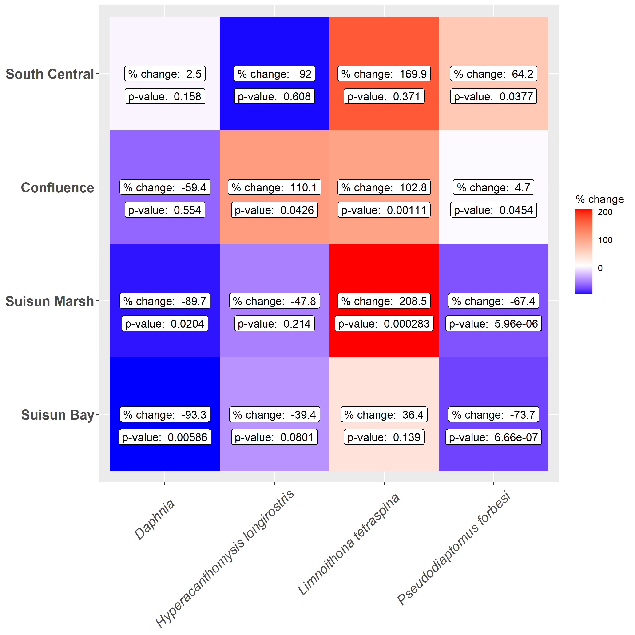

Figure 2 Changes in average annual BPUE for target taxa and each analyzed region. Percent change shown represents the average change in BPUE from Wet to Drought years. Red shading represents an increase, blue shading represents a decrease in abundance.

## Environmental Parameters

Salinity was a significant factor in predicting the abundance of all taxa in the study area (Table 1). Salinity had the greatest impact on *Daphnia* spp. presence (adjusted r2 = 0.239) of all the taxa, likely because of its restriction to the narrow freshwater range (Figure 2). While the presence of *P. forbesi* has a weaker correlation with salinity and was found from freshwater through the LSZ, its highest abundances were in the freshwater range of the estuary. Both *H. longirostris* and *L. tetraspina* had a wide salinity range correlated with higher abundances that stretched across the low-salinity zone.

Table 1 Model outputs for each taxa.

|  |  |  |  |
| --- | --- | --- | --- |
| **Taxa** | **Model** | **P-value** | **R-sq.(adj)** |
| *Daphnia spp.* | Presence ~ s(salinity) | <2e-16 | 0.239 |
| *Daphnia spp.* | BPUE ~ s(salinity) + s(month, k = 5) + s(Station, bs = "re") | <2e-16 | 0.161 |
| *H. longirostris* | Presence ~ s(salinity) | <2e-16 | 0.035 |
| *H. longirostris* | BPUE ~ s(salinity) + s(month, k = 5) | <2e-16 | 0.0634 |
| *L. tetraspina* | Presence ~ s(salinity) | <2e-16 | 0.0248 |
| *L. tetraspina* | BPUE ~ s(salinity) + s(month, k = 5) | <2e-16 | 0.351 |
| *P. forbesi* | Presence ~ s(salinity) | 0.00119 | 0.0353 |
| *P. forbesi* | BPUE ~ s(salinity) + s(month, k = 5) | <2e-16 | 0.184 |

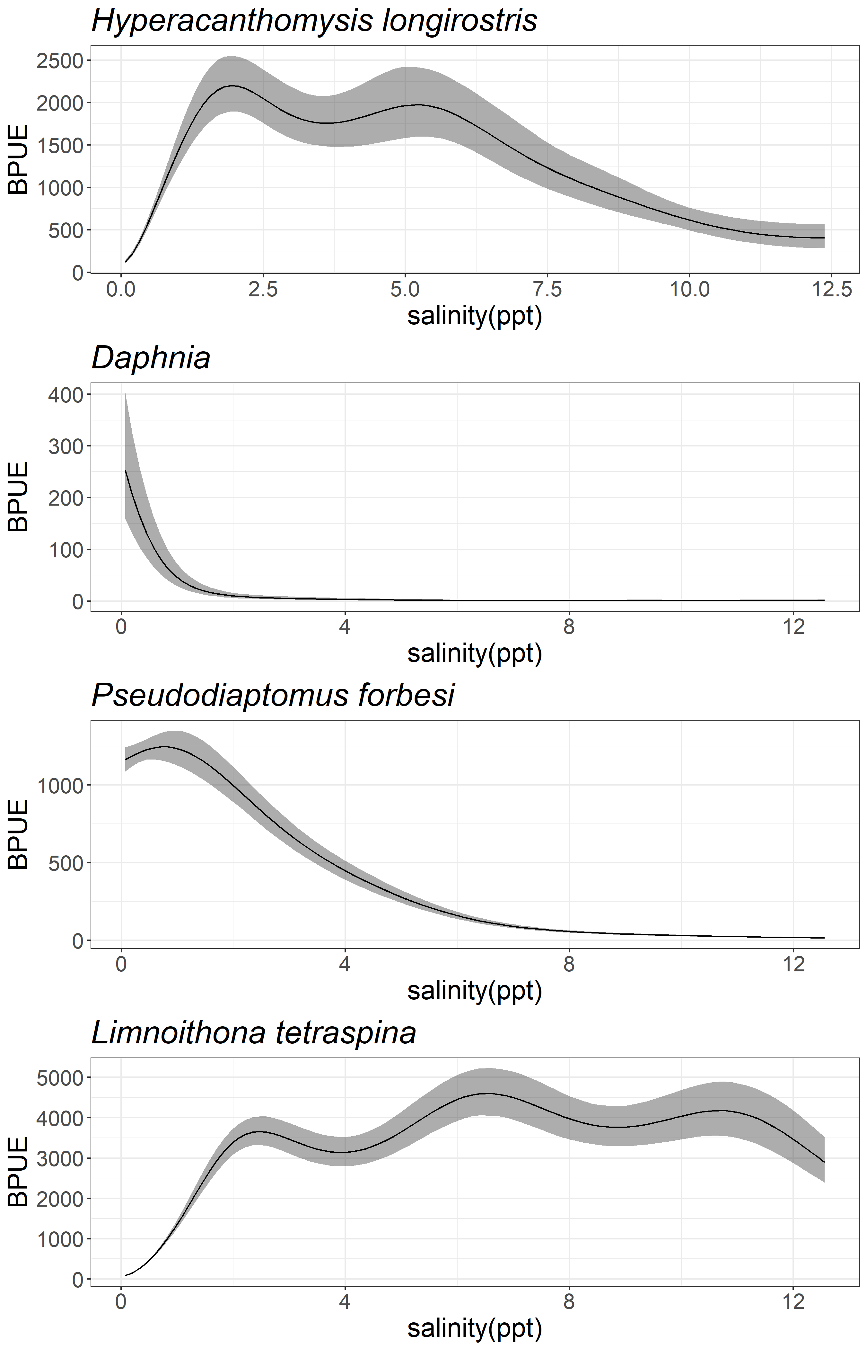

Figure 3 Model predictions for the impact of salinity on combined predictions from the presence/absence and abundance models (i.e., predicted probability of presence was multiplied by predicted abundance given presence) for all four taxa.

## Drought and Salinity Zones

*Daphnia* spp.had the smallest range of ‘preferred’ salinity, with its highest abundances being present in salinities below 0.5 ppt (Figure 3). *P. forbesi* was also most abundant in fresher water up to 1.8 ppt. Both *L. tetraspina* and *H. longirostris* had their highest abundances in the brackish regions, with a wide range of tolerable salinity.

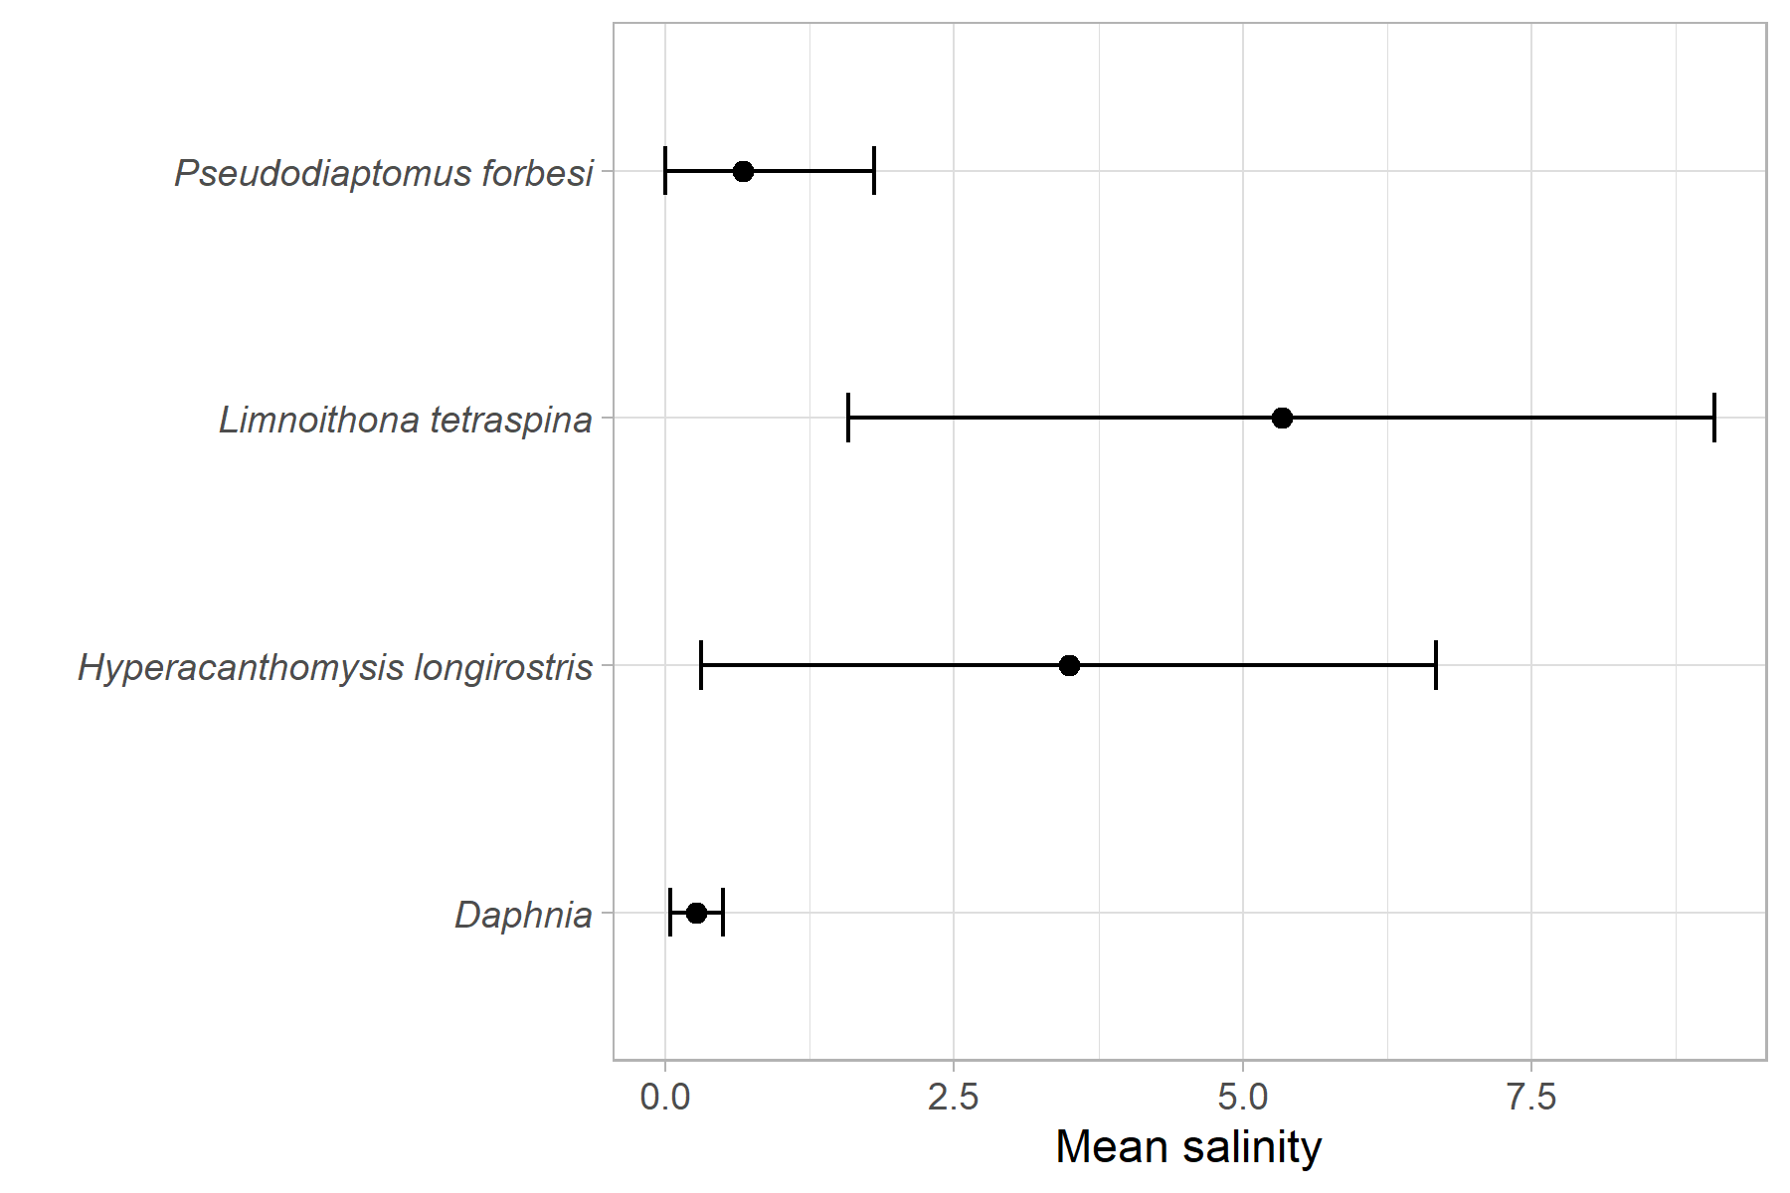

Figure 4 Range of preferred salinity for each taxon, with mean salinity weighted by average BPUE, +/- the standard deviation. As salinity cannot be negative, the lower limit for each range is set to 0.

Within their ‘preferred’ salinity zone, only *L. tetraspina* a significant effect of Drought, increasing in abundance (X% change) during Drought years (Table 2, Figure 4). The other three taxa saw no significant effect of Drought on average annual BPUE within their ‘preferred’ salinity range.

Table 2 ANOVA model (log(BPUE + 1) ~ Drought ) outputs and Tukey HSD comparisons for each taxon's abundance between Drought and Wet years within their ‘preferred’ salinity zones.

|  |  |  |  |  |
| --- | --- | --- | --- | --- |
| **Taxa** | **Preferred Salinity Zone** | **ANOVA F-value** | **ANOVA P-value** | **W-D Tukey p-value** |
| *Daphnia* | 0-0.5 ppt | 0.339 | 0.564 | 0.5612784 |
| *H. longirostris* | 3.2 – 6.7 ppt | 1.041 | 0.309 | 0.309038 |
| *L. tetraspina* | 1.6 – 9.1 ppt | 7.627 | **0.00552** | **0.0063117** |
| *P. forbesi* | 0 – 1.8 ppt | 1.228 | 0.269 | 0.3829747 |

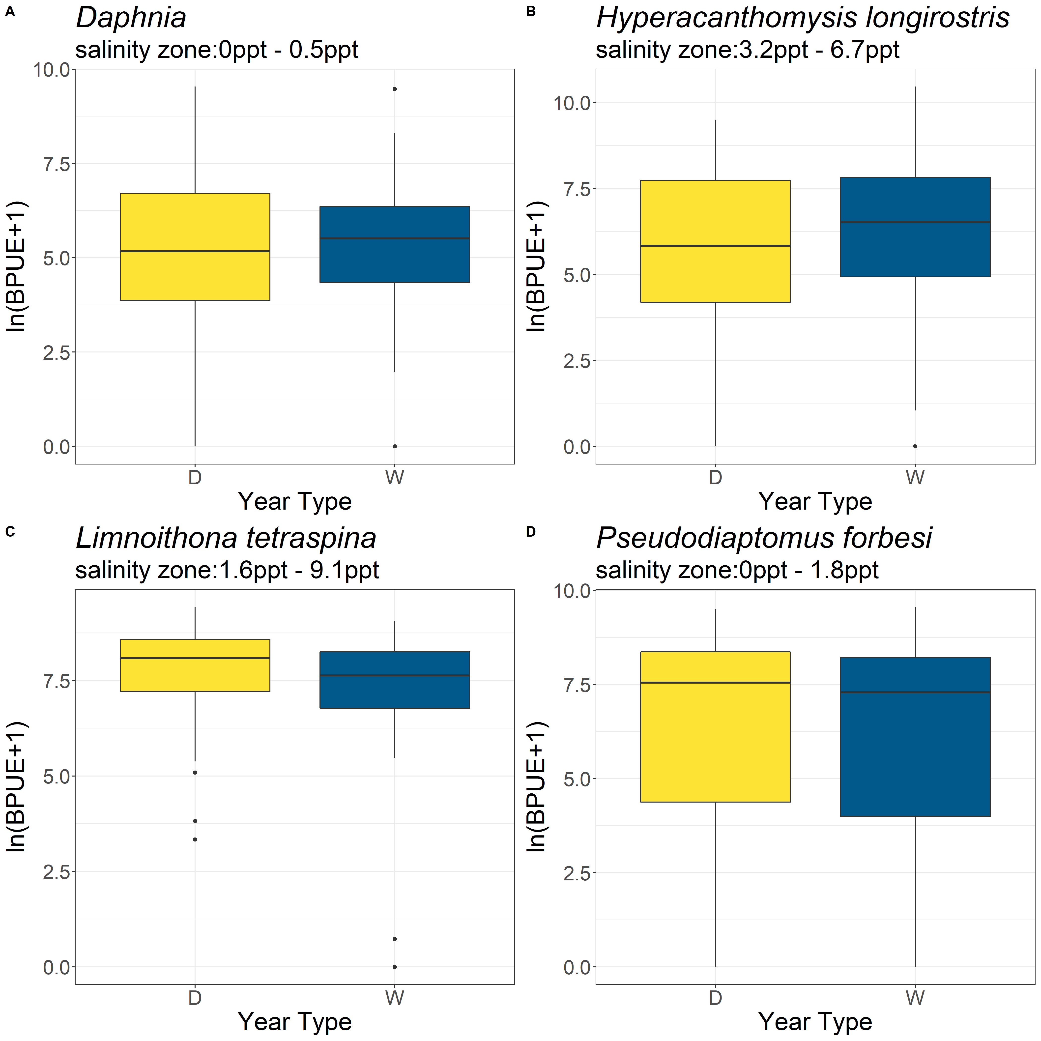

Figure 5 Boxplots of each taxon’s average annual BPUE within their 'preferred' salinity zone for Drought and Wet years.

Both *Daphnia* spp*.* and *P. forbesi* saw their ‘preferred’ salinity zone shrink during Drought years, shifting that salinity zone out of Suisun and into the West Delta (Figure 5). *L. tetraspina* and *H. longirostris* saw little change in their brackish ‘preferred’ salinity zones, which stayed located around the Suisun region during both Wet and Drought years.

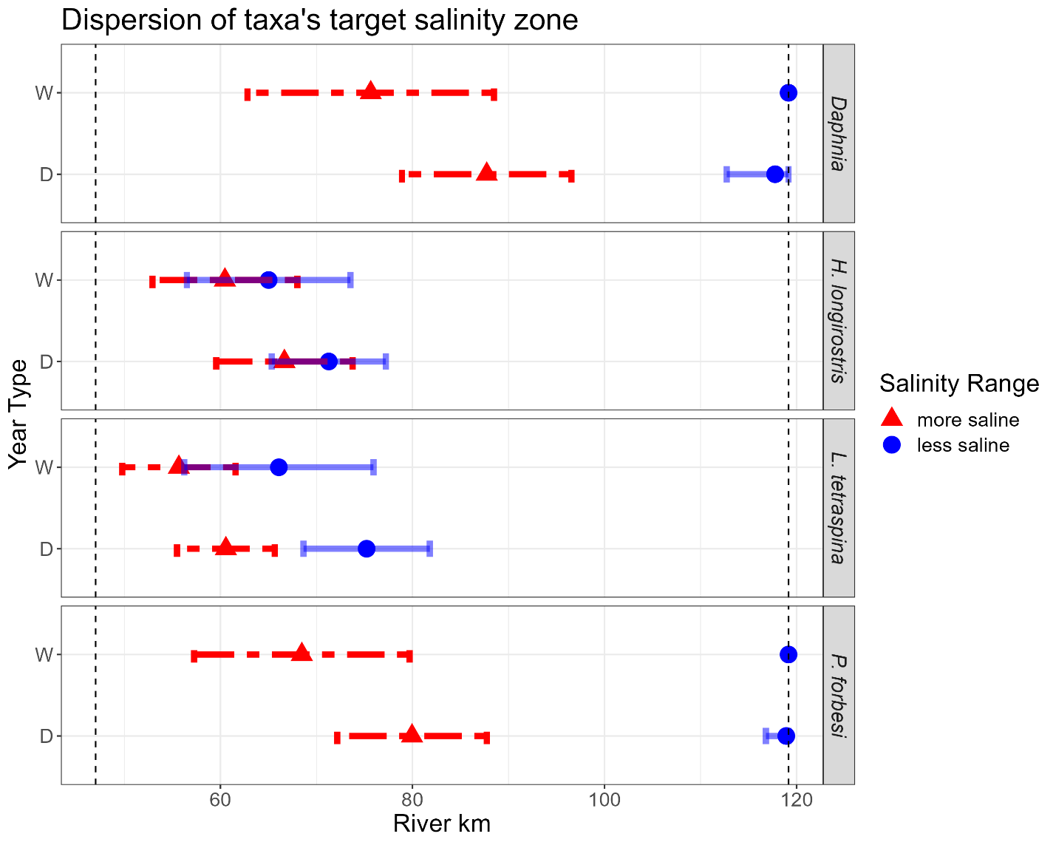

Figure 6 Spatial distribution of each taxa's 'preferred' salinity zone for Drought and Wet years. Vertical dashed lines represent the up and downstream extents of the study area. X-axis represents distance (km) from the Golden Gate bridge. The red dashed lines represent the range of RKM distribution for that taxon’s upper salinity bound (Figure 4) and the blue solid lines represent the range of RKM distribution for that taxon’s lower salinity bound.

# Discussion

Assessing how zooplankton resources available to fish are affected by drought conditions is increasingly valuable for environmental managers in the estuary. While initial analysis of the impacts of drought on zooplankton abundance did not show significant changes at an estuary wide level, analysis at the regional level did show significant effects (Drought MAST Short-term Report). To further investigate this relationship, we narrowed our focus to specific key zooplankton taxa, their abundance correlation to salinity, and how that potentially fluctuated between drought and wet years. In drought years, *Daphnia spp.* saw significant decreases in abundance downstream in the Suisun Marsh and Suisun Bay (Figure 1). *Pseudodiaptomus forbesi* saw significant decreases downstream as well, although it also had significant increases in abundance upstream in the South-Central Delta during drought years (Figure 1). The more recently introduced *L. tetraspina* only saw increases in abundance during drought years, specifically in the Suisun Marsh and Confluence (Figure 1). The mysid *H. longirostris* was the only taxon of the four that showed no significant changes in regional abundance related to drought conditions.

Our modeling showed that the presence and abundance of the four taxa we investigated had significant correlation with salinity (Figure 2). Both *H. longirostris* and *L. tetraspina* had high probability of presence and high abundance within a wide range of salinity values spanning the LSZ, while *Daphnia spp.* and *P. forbesi* were both more limited to the freshwater reaches of the estuary. This aligns with previous research showing that H. longirostris and L. tetraspina have broad salinity tolerances (Bouley and Kimmerer 2006, Avila and Hartman 2020), while Daphnia spp. and P. forbesi are more restricted to freshwater (Gonçalves et al. 2007, Kayfetz and Kimmerer 2017).

During drought years, the preferred salinity zone of *P. forbesi* shifts out of Suisun, where we see a decrease in their abundance, and stays upstream in the estuary, where we see an increase in their abundance (Figure 5). Kimmerer et al. (2018b) found a similar trend with correlations between *P. forbesi* abundance with flow in Suisun during periods of high freshwater flow, but no correlation between flow and abundance in freshwater regions. Similarly, the ‘preferred’ salinity zone of *Daphnia* spp. narrows during drought years, and we see a large and significant decrease in their abundance downstream. This relationship between spatial changes in the preferred salinity zone and abundance during drought years was not observed for either *L. tetraspina* or *H. longirostris*.

*L. tetraspina* was the only one of the taxa examined that showed a significant increase in abundance (~35% increase) within its ‘preferred’ salinity zone. The increase in *L. tetraspina* within its ‘preferred’ salinity zone during drought years may be connected to changes in predation pressure (such as the abundance of its predator *Acartiella sinensis* (Slaughter et al. 2016)), or related to actual changes in production of the taxa within those regions. Because *L. tetraspina* is better able to avoid predation by clams (Bouley and Kimmerer 2006, Gould and Kimmerer 2010), and better able to take advantage of food resources such as ciliates rather than phytoplankton (Gould and Kimmerer 2010), they may have a competitive advantage over other species during drought periods. However, competition is difficult to observe in zooplankton.

*H. longirostris*, the only species with no significant regional changes in abundance between drought and wet years, also saw no major spatial shifting of its preferred salinity zone. Relatively little research has been conducted on *H. longirostris* to date, but they appear to have a greater temperature tolerance and smaller size at maturity than native mysids such as *N. mercedis* (Avila and Hartman 2020).. Like *L. tetraspina, H. longirostris* was more abundant in a wider range of brackish water (Avila and Hartman 2020), compared to *P. forbesi* and *Daphnia* spp.

Prior work in the estuary has shown that *P. forbesi* abundances in freshwater were not correlated to freshwater flow, but did find that abundance was positively related with freshwater flow in the low salinity zone (Kimmerer et al. 2018b). Our study supports this trend by showing decreases in Suisun and the Confluence during droughts, however we did detect a slight increase in the freshwater, south-central region, contrary to the findings of Kimmerer et al (2018b). This difference may be due to inclusion of a wider range of data sources in our data set and additional drought years. While the decrease in Suisun and the Confluence was partially due to the shift in their preferred salinity zone, other factors may also have contributed. One potential mechanism for decreased abundance of taxa in Suisun is the increase in *P. amurensis* (Winder et al. 2011) (CITE CLAM PAPER) *P. forbesi* is food limited in the low-salinity zone (Kimmerer et al. 2014), and both abundance and grazing rates of *P. amurensis* increase during drought years (cite clam/jellies drought paper), putting greater strain on the limited food supply for copepods.

Less research has been conducted on *Daphnia* spp. in the Estuary. One of the few studies examining *Daphnia* spp. distribution and environmental factors in the Delta found them positively correlated with chlorophyll, negatively correlated with salinity, and unrelated to net flow (Orsi and Mecum 1986). Chlorophyll in the South Delta increases during droughts (Cite Water quality chlorophyll paper) so we would have expected increases in *Daphnia* spp. in that region. However *P. forbesi*, which was introduced after Orsi and Mecum 1986 (Orsi and Walter 1991), also increased in the South Delta (Figure 1), potentially competing with *Daphnia* spp. for the increased food resources.

The species that had brackish salinity tolerances, *Limnoithona tetraspina* and *Hyperacanthomysis longirostris*, did not have a negative relationship to drought. With a wider salinity tolerance, these taxa were relative unaffected by shift of the freshwater zone upstream during droughts, unlike *P. forbesi* and *Daphnia* spp., which are restricted to lower salinities and thus moved with the shifting freshwater zone. This suggests that in Suisun Bay and Marsh, a key habitat zone containing important marsh areas, drought conditions have the largest negative impact on the abundance of zooplankton with lower tolerances to salinity.

## Ecological and Management Implications

The decline in the abundance of many pelagic zooplankton species has resulted in the limitation of food resources for many fish species (Sommer et al. 2007)). For management decisions to support increases in zooplankton abundance that will result in more food for fishes, better understanding of the factors that impact low pelagic biomass in the estuary is required)(Brown et al. 2016). Our study has shown that drought, and the related changes in salinity, significantly impacts the availability of key zooplankton resources in the estuary. The spatial overlap of predators and their prey, also known as the match/mismatch hypothesis, is an important factor driving recruitment strength that can be significantly impacted by climate conditions and climate change (Durant et al. 2007). *Pseudodiaptomus forbesi* and *Daphnia* spp. are both important food items to Age-0 Delta Smelt and juvenile salmon in the estuary (Slater and Baxter 2014, Sturrock et al. 2022). Some of the highest densities of Delta Smelt have historically been found in Suisun Bay and Suisun Marsh, with their lowest occurrences in the South Central Delta (Merz et al. 2011). Similarly, juvenile salmon in the estuary utilize important restored tidal wetlands within Suisun Marsh)(Aha et al. 2021). Drought conditions that result in shifting of important prey like *P. forbesi* and *Daphnia* spp. upriver, and into the South Central Delta where salmon and smelt are found less frequently (Merz et al. 2011, Buchanan et al. 2018) can result in a mismatch between the fish and the prey they need to successfully recruit.

Even though the abundance of *L. tetraspina* increased in Suisun Marsh during drought years (Figure 1), its high occurrence in the LSZ does not necessarily mean it can sustain fish populations. To achieve similar gut fullness values as small amounts of larger prey would achieve, Delta Smelt can have very large numbers of *L. Tetraspina* in their guts (> 1000 individuals; CDFW Diet Study data, Slater et al. 2019). Despite L. tetraspina being the most abundant copepod in the estuary, it’s small size and mostly motionless behavior may increase its ability to avoid predation by visual feeders (Bouley and Kimmerer 2006, Kimmerer 2006, Greene et al. 2011). Even though it now accounts for 95% of the adult copepod abundance and roughly 35% of copepod biomass in the LSZ (Merz et al. 2016, Barros 2021), it is not actively selected for by Age-0 Delta Smelt (Slater and Baxter 2014, Slater et al. 2019), and appears to be selected against by larval Longfin Smelt (Jungbluth et al. 2021).

While both *L. tetraspina and H. longirostris* either increase or maintain abundance during drought years, this may not correlate to an ability to replace other zooplankton prey that decline during drought, such as *P. forbesi* and *Daphnia* spp. The differing importance and quality of different zooplankton taxa as food resources for fishes means that overall patterns of zooplankton biomass in the estuary may not be as useful when considering how drought impacts food availability for fishes. The value of specific zooplankton species, and the relationship between their regional abundance and salinity and drought needs to be understood to properly inform potential management actions.

Understanding how the abundance of these four important zooplankton taxa interact with salinity and drought conditions can facilitate effective management efforts that aim to increase the availability of food resources for fishes. Availability of zooplankton resources for the release of hatchery and cultured fish is important knowledge to ensure sufficient food supply for those fish to survive and reproduce (Beauchamp et al. 2004). Salmon and Delta Smelt released into Suisun Marsh or Suisun Bay during a drought year will find decreased availability of important food items like *Daphnia* spp. and *P. forbesi*, which have shifted upstream with the distribution of freshwater. This is particularly important to keep in mind because salmonid release sites frequently move downstream during dry years (Sturrock et al. 2019), and Delta Smelt experimental releases are currently being planned at a variety of sites in the upper estuary (USFWS 2020). Of course moving the release of these fish to the South Central Delta during droughts, where prey are more abundant, may also be counterproductive as this region is typically hotter and can produce toxic algal blooms (Lehman et al. 2017).

## Conclusions

Managed increases in freshwater outflow through the estuary is an important action that could improve ecosystem productivity and populations of listed fish species (Sommer 2020). When considering potential flow actions as a method to try to increase food availability for fish, it is important to account for how the flows will drive the distribution of salinity in the estuary. During drought conditions will releases be enough to cause the freshwater zone to shift downstream and increase abundance of important zooplankton taxa? If the flow actions do manage to shift salinity downstream, and increase target zooplankton abundance, does it correlate with a decrease in other potentially important upstream areas? Outcomes can be taxa and region specific, so it is necessary for managers to be specific about what results they are aiming to achieve and where. Our study shows that the distribution of salinity in the estuary is an important factor in the regional availability of zooplankton, so actions that impact salinity other than outflow may also be useful. The Suisun Marsh Salinity Control Gates, as well as seasonal salinity barriers upstream could also impact the distribution and availability of important zooplankton species in the estuary.

Aha, N. M., P. B. Moyle, N. A. Fangue, A. L. Rypel, and J. R. Durand. 2021. Managed Wetlands Can Benefit Juvenile Chinook Salmon in a Tidal Marsh. Estuaries and Coasts **44**:1440-1453. 10.1007/s12237-020-00880-4

Ambler, J. W., J. E. Cloern, and A. Hutchinson. 1985. Seasonal cycles of zooplankton from San Francisco Bay. Pages 177-197 *in* James E. Cloern and Frederic H. Nichols, editors. Temporal Dynamics of an Estuary: San Francisco Bay. Springer Dordrecht. <https://doi.org/10.1007/978-94-009-5528-8>

Avila, M., and R. Hartman. 2020. San Francisco Estuary mysid abundance in the fall, and the potential for competitive advantage of *Hyperacanthomysis longirostris* over *Neomysis mercedis*. California Fish and Wildlife **106**:19-38,

Barros, A. 2021. Zooplankton Trends in the Upper SFE, 1974-2018. IEP Newsletter **40**:5-14,

Barros, A., J. A. Hobbs, M. Willmes, C. M. Parker, M. Bisson, N. A. Fangue, A. L. Rypel, and L. S. Lewis. 2022. Spatial Heterogeneity in Prey Availability, Feeding Success, and Dietary Selectivity for the Threatened Longfin Smelt. Estuaries and Coasts **45**:1766-1779. 10.1007/s12237-021-01024-y

Bashevkin, S.M., R. Hartman, M. Thomas, A. Barros, C.E. Burdi, A. Hennessy, T. Tempel, and K. Kayfetz. 2022. Interagency Ecological Program: Zooplankton abundance in the Upper San Francisco Estuary from 1972-2020, an integration of 5 long-term monitoring programs ver 3. Environmental Data Initiative. https://doi.org/10.6073/pasta/89dbadd9d9dbdfc804b160c81633db0d

Beauchamp, D. A., C.J. Sergeant, M. M. Mazur, J. M. Scheuerell, D. E. Schindler, M. D. Scheuerell, K. L. Fresh, D. E. Seiler, and T. P. Quinn. 2004. Spatial–Temporal Dynamics of Early Feeding Demand and Food Supply for Sockeye Salmon Fry in Lake Washington. Transactions of the American Fisheries Society **133**:1014-1032. 10.1577/T03-093.1

Bollens, S. M., J. Breckenridge, J. R. Cordell, C. Simenstad, and O. Kalata. 2014. Zooplankton of tidal marsh channels in relation to environmental variables in the upper San Francisco Estuary. Aquatic Biology **21**:205-219. <https://doi.org/10.3354/ab00589>

Bollens, S. M., J. K. Breckenridge, R. C. Vanden Hooff, and J. R. Cordell. 2011. Mesozooplankton of the lower San Francisco Estuary: spatio-temporal patterns, ENSO effects and the prevalence of non-indigenous species. Journal of Plankton Research **33**:1358-1377. 10.1093/plankt/fbr034

Bouley, P., and W. J. Kimmerer. 2006. Ecology of a highly abundant, introduced cyclopoid copepod in a temperate estuary. Marine Ecology Progress Series **324**:219-228. doi:10.3354/meps324219

Brown, L. R., W. Kimmerer, J. L. Conrad, S. Lesmeister, and A. Mueller–Solger. 2016. Food webs of the Delta, Suisun Bay, and Suisun Marsh: an update on current understanding and possibilities for management. San Francisco Estuary and Watershed Science **14**. 10.15447/sfews.2016v14iss3art4

Buchanan, R. A., P. L. Brandes, and J. R. Skalski. 2018. Survival of Juvenile Fall-Run Chinook Salmon through the San Joaquin River Delta, California, 2010–2015. North American Journal of Fisheries Management **38**:663-679. doi:10.1002/nafm.10063

Burdi, C. E., S. M. Breining-Aday, and S. B. S. 2022.. 2022. Interagency Ecological Program: Zooplankton and water quality data in the San Francisco Estuary collected by the Summer Townet and Fall Midwater Trawl monitoring programs. ver 2. . Environmental Data Initiative. <https://doi.org/10.6073/pasta/00db7da0265df448f167c823fb063a9a>

Burdi, C. E., S. B. Slater, T. L. Bippus, and J. A. Jimenez. 2021. Mysid and Amphipod Length-Weight Relationships in the San Francisco Estuary. IEP Newsletter **40**:15-25,

Burris, Z. P. L., R. D. Baxter, and C. E. Burdi. 2022. Larval and juvenile Longfin Smelt diets as a function of fish size and prey density in the San Francisco Estuary. California Fish and Wildlife **108**. [www.doi.org/10.51492/cfwj.108.11](https://cawater.sharepoint.com/sites/dwr-str/drought/Shared%20Documents/Invertebrate%20Team/SFEWS_paper/www.doi.org/10.51492/cfwj.108.11)

Carlton, J. T., J. K. Thompson, L. E. Schemel, and F. H. Nichols. 1990. Remarkable invasion of San Francisco Bay (California USA) by the Asian clam *Potamocorbula amurensis*. I. Introduction and dispersal. Marine Ecology Progress Series **66**:81-95, <Go to ISI>://PREV199192109845

Cloern, J. E. 2019. Patterns, pace, and processes of water-quality variability in a long-studied estuary. Limnology and Oceanography **64**:S192-S208. <https://doi.org/10.1002/lno.10958>

Cloern, J. E., A. E. Alpine, B. E. Cole, R. L. J. Wong, J. F. Arthur, and M. D. Ball. 1983. River discharge controls phytoplankton dynamics in the northern San Francisco Bay estuary. Estuarine, Coastal and Shelf Science **16**:415-429. <https://doi.org/10.1016/0272-7714(83)90103-8>

Corline, N. J., R. A. Peek, J. Montgomery, J. V. E. Katz, and C. A. Jeffres. 2021. Understanding community assembly rules in managed floodplain food webs. Ecosphere **12**:e03330. <https://doi.org/10.1002/ecs2.3330>

Durant, J. M., D. O. Hjermann, G. Ottersen, and N. C. Stenseth. 2007. Climate and the match or mismatch between predator requirements and resource availability. Climate Research **33**:271-283, <https://www.int-res.com/abstracts/cr/v33/n3/p271-283>

Gifford, S. M., G. Rollwagen-Bollens, and S. M. Bollens. 2007. Mesozooplankton omnivory in the upper San Francisco Estuary. Marine Ecology Progress Series **348**:33-46,

Goertler, P., K. Jones, J. Cordell, B. Schreier, and T. Sommer. 2018. Effects of Extreme Hydrologic Regimes on Juvenile Chinook Salmon Prey Resources and Diet Composition in a Large River Floodplain. Transactions of the American Fisheries Society **147**:287-299. <https://doi.org/10.1002/tafs.10028>

Gonçalves, A. M. M., B. B. Castro, M. A. Pardal, and F. Gonçalves. 2007. Salinity effects on survival and life history of two freshwater cladocerans (Daphnia magna and Daphnia longispina). Annales de Limnologie - International Journal of Limnology **43**:13-20. 10.1051/limn/2007022

Gould, A. L., and W. J. Kimmerer. 2010. Development, growth, and reproduction of the cyclopoid copepod *Limnoithona tetraspina* in the upper San Francisco Estuary. Marine Ecology Progress Series **412**:163-177,

Greene, V. E., L. J. Sullivan, J. K. Thompson, and W. J. Kimmerer. 2011. Grazing impact of the invasive clam *Corbula amurensis* on the microplankton assemblage of the northern San Francisco Estuary. Marine Ecology Progress Series **431**:183-193,

Hamilton, S., S. Bartell, J. Pierson, and D. Murphy. 2020. Factors Controlling Calanoid Copepod Biomass and Distribution in the Upper San Francisco Estuary and Implications for Managing the Imperiled Delta Smelt (Hypomesus transpacificus). Environmental Management **65**:587-601. 10.1007/s00267-020-01267-8

Hammock, B. G., S. P. Moose, S. S. Solis, E. Goharian, and S. J. Teh. 2019. Hydrodynamic Modeling Coupled with Long-term Field Data Provide Evidence for Suppression of Phytoplankton by Invasive Clams and Freshwater Exports in the San Francisco Estuary. Environmental Management. 10.1007/s00267-019-01159-6

Hartman, R., S. M. Bashevkin, A. Barros, C. E. Burdi, C. Patel, and T. Sommer. 2021. Food for Thought: Connecting Zooplankton Science to Management in the San Francisco Estuary. San Francisco Estuary and Watershed Science **19**:art1. <https://doi.org/10.15447/sfews.2021v19iss3art1>

Hunter JR. 1981. Feeding Ecology and predation of marine fish larvae. In: Lasker R, editor. Marine Fish Larvae: Morphology, Ecology, and Relation to Fisheries. Vol. 1. Seattle: University of Washington Press. p. 33–77.IEP Drought MAST. 2022. Ecological Impacts of Drought on the Sacramento-San Joaquin Delta with special attention to the extreme drought of 2020-2021 PRELIMINARY REPORT. Interagency Ecological Program, Sacramento, CA, <https://www.waterboards.ca.gov/drought/tucp/docs/2021/20220201_report_cond7.pdf>

Jassby, A. D., W. J. Kimmerer, S. G. Monismith, C. Armor, J. E. Cloern, T. M. Powell, J. R. Schubel, and T. J. Vendlinski. 1995. Isohaline position as a habitat indicator for estuarine populations. Ecological Applications **5(1)**:272-289,

Jungbluth, M. J., J. Burns, L. Grimaldo, A. Slaughter, A. Katla, and W. Kimmerer. 2021. Feeding habits and novel prey of larval fishes in the northern San Francisco Estuary. Environmental DNA:1-22. <https://doi.org/10.1002/edn3.226>

Kayfetz, K., and W. Kimmerer. 2017. Abiotic and biotic controls on the copepod *Pseudodiaptomus forbesi* in the upper San Francisco Estuary. Marine Ecology Progress Series **581**:85-101. <https://doi.org/10.3354/meps12294>

Kimmerer, W., F. Wilkerson, B. Downing, R. Dugdale, E. S. Gross, K. Kayfetz, S. Khanna, A. E. Parker, and J. K. Thompson. 2019. Effects of Drought and the Emergency Drought Barrier on the Ecosystem of the California Delta. San Francisco Estuary and Watershed Science **17**. <https://doi.org/10.15447/sfews.2019v17iss3art2>

Kimmerer, W. J. 2002. Effects of freshwater flow on abundance of estuarine organisms: physical effects or trophic linkages? Marine Ecology Progress Series **243**:39-55. <https://doi.org/10.3354/meps243039>

Kimmerer, W. J. 2006. Response of anchovies dampens effects of the invasive bivalve *Corbula amurensis* on the San Francisco Estuary foodweb. Marine Ecology Progress Series **324**:207-218, <Go to ISI>://PREV200700031242

Kimmerer, W. J., J. R. Burau, and W. A. Bennett. 1998. Tidally oriented vertical migration and position maintenance of zooplankton in a temperate estuary. Limnology & Oceanography **43**:1697-1709. <https://doi.org/10.4319/lo.1998.43.7.1697>

Kimmerer, W. J., E. Gartside, and J. Orsi. 1994. Predation by an introduced clam as the likely cause of substantial declines in zooplankton of San Francisco Bay. Marine Ecology Progress Series **113**:81-93. <https://doi.org/10.3354/meps113081>

Kimmerer, W. J., E. S. Gross, A. M. Slaughter, and J. R. Durand. 2018a. Spatial Subsidies and Mortality of an Estuarine Copepod Revealed Using a Box Model. Estuaries and Coasts. 10.1007/s12237-018-0436-1

Kimmerer, W. J., T. R. Ignoffo, K. R. Kayfetz, and A. M. Slaughter. 2018b. Effects of freshwater flow and phytoplankton biomass on growth, reproduction, and spatial subsidies of the estuarine copepod *Pseudodiaptomus forbesi*. Hydrobiologia **807**:113-130. <https://doi.org/10.1007/s10750-017-3385-y>

Kimmerer, W. J., T. R. Ignoffo, A. M. Slaughter, and A. L. Gould. 2014. Food-limited reproduction and growth of three copepod species in the low-salinity zone of the San Francisco Estuary. Journal of Plankton Research **36**:722-735. <https://doi.org/10.1093/plankt/fbt128>

Kratina, P., and M. Winder. 2015. Biotic invasions can alter nutritional composition of zooplankton communities. Oikos **124**:1337-1345. doi:10.1111/oik.02240

Lehman, P. W., T. Kurobe, S. Lesmeister, D. Baxa, A. Tung, and S. J. Teh. 2017. Impacts of the 2014 severe drought on the *Microcystis* bloom in San Francisco Estuary. Harmful Algae **63**:94-108. <https://doi.org/10.1016/j.hal.2017.01.011>

Merz, J. E., P. S. Bergman, J. L. Simonis, D. Delaney, J. Pierson, and P. Anders. 2016. Long-term seasonal trends in the prey community of Delta Smelt (*Hypomesus transpacificus*) within the Sacramento-San Joaquin Delta, California. Estuaries and Coasts **39**:1526-1536. <https://doi.org/10.1007/s12237-016-0097-x>

Merz, J. E., S. Hamilton, P. S. Bergman, and B. Cavallo. 2011. Spatial perspective for delta smelt: a summary of contemporary survey data. California Fish & Game **97**:164-189,

Modlin, R. F., and J. J. Orsi. 1997. Acanthomysis bowmani, a new species, and A. aspera Ii, Mysidacea newly reported from the Sacramento-San Joaquin Estuary, California (Crustacea: Mysidae). Proceedings of the Biological Society of Washington **10**:439-446,

Orsi, J. J., and W. L. Mecum. 1986. Zooplankton distribution and abundance in the Sacramento-San Joaquin Delta in relation to certain environmental factors. Estuaries **9**:326-339,

Orsi, J. J., and T. E. Walter. 1991. *Pseudodiaptomus forbesi* and *P. marinus* (Copepoda: Calanoida) the latest copepod immigrants to California's Sacramento-San Joaquin Estuary. Pages 553-562 *in* Proceedings of the Fourth International Conference on Copepoda. Bulletin of the Plankton Society of Japan, Hiroshima,

Rollwagen-Bollens, G., S. Gifford, and S. M. Bollens. 2011. The role of protistan microzooplankton in the upper San Francisco Estuary planktonic food web: source or sink? Estuaries and Coasts **34**:1026-1038. <https://doi.org/10.1007/s12237-011-9374-x>

Slater, S. B., and R. D. Baxter. 2014. Diet, prey selection and body condition of age-0 Delta Smelt, *Hypomesus transpacificus*, in the upper San Francisco Estuary. San Francisco Estuary and Watershed Science **14**. <http://dx.doi.org/10.15447/sfews.2014v12iss3art1>

Slater, S. B., A. Schultz, B. G. Hammock, A. Hennessy, and C. Burdi. 2019. Patterns of Zooplankton Consumption by Juvenile and Adult Delta Smelt (*Hypomesus transpacificus*). Pages 9-54 *in* A. A. Schultz, editor. Directed Outflow Project: Technical Report 1. U.S. Bureau of Reclamation, Bay-Delta Office, Mid-Pacific Region, Sacramento, CA.,

Slaughter, A., T. R. Ignoffo, and W. Kimmerer. 2016. Predation impact of Acartiella sinensis, an introduced predatory copepod in the San Francisco Estuary, USA. Marine Ecology Progress Series **547**. 10.3354/meps11640

Sommer, T. 2020. How to Respond? An Introduction to Current Bay-Delta Natural Resources Management Options. San Francisco Estuary and Watershed Science **18**. <https://doi.org/10.15447/sfews.2020v18iss3art1>

Sommer, T., C. Armor, R. Baxter, R. Breuer, L. Brown, M. Chotkowski, S. Culberson, F. Feyrer, M. Gingras, B. Herbold, W. Kimmerer, A. Mueller-Solger, M. Nobriga, and K. Souza. 2007. The collapse of pelagic fishes in the upper San Francisco Estuary. Fisheries **32**:270-277. [https://doi.org/10.1577/1548-8446(2007)32[270:TCOPFI]2.0.CO;2](https://doi.org/10.1577/1548-8446(2007)32%5b270:TCOPFI%5d2.0.CO;2)

Sturrock, A. M., M. Ogaz, K. Neal, N. J. Corline, R. Peek, D. Myers, S. Schluep, M. Levinson, R. C. Johnson, and C. A. Jeffres. 2022. Floodplain trophic subsidies in a modified river network: managed foodscapes of the future? Landscape Ecology. 10.1007/s10980-022-01526-5

Sturrock, A. M., W. H. Satterthaite, K. M. Cervantes-Yoshida, E. R. Huber, H. J. W. Sturrock, S. Nusslé, and S. M. Carlson. 2019. Eight decades of hatchery salmon releases in the California Central Valley: Factors influencing straying and resilience. Fisheries **44**:433-444,

Suzuki, K. W., K. Nakayama, and M. Tanaka. 2009. Horizontal distribution and population dynamics of the dominant mysid Hyperacanthomysis longirostris along a temperate macrotidal estuary (Chikugo River estuary, Japan). Estuarine, Coastal and Shelf Science **83**:516-528. <https://doi.org/10.1016/j.ecss.2009.04.023>

Tiffan, K. F., J. M. Erhardt, and S. J. St. John. 2014. Prey Availability, Consumption, and Quality Contribute to Variation in Growth of Subyearling Chinook Salmon Rearing in Riverine and Reservoir Habitats. Transactions of the American Fisheries Society **143**:219-229. 10.1080/00028487.2013.839958

Turner, J. L. 1966. Seasonal distribution of crustacean plankters in the Sacramento-San Joaquin Delta. Ecological Studies of the Sacramento-San Joaquin Estuary: Zooplankton, zoobenthos, and fishes of San Pablo and Suisun Bays, zooplankton and zoobenthos of the Delta. **133**,

USFWS. 2020. Delta Smelt Supplementation Strategy. U. S. Fish and Wildlife Service, San Francisco Bay-Delta Fish and Wildlife Office,, <https://www.fws.gov/project/delta-smelt-supplementation>

Winder, M., and A. D. Jassby. 2011. Shifts in zooplankton community structure: implications for food web processes in the upper San Francisco Estuary. Estuaries and Coasts **34**:675-690. <https://doi.org/10.1007/s12237-010-9342-x>

Winder, M., A. D. Jassby, and R. Mac Nally. 2011. Synergies between climate anomalies and hydrological modifications facilitate estuarine biotic invasions. Ecology Letters **14**:749-757. <https://doi.org/10.1111/j.1461-0248.2011.01635.x>

Wood, S. N. 2011. Fast stable restricted maximum likelihood and marginal likelihood estimation of semiparametric generalized linear models. Journal of the Royal Statistical Society: Series B (Statistical Methodology) **73**:3-36. <https://doi.org/10.1111/j.1467-9868.2010.00749.x>