Table of Contents
1 Project Overview 1
1.1 Document Introduction 1
1.2 Project Introduction 1
1.3 Goals and Constraints 1
2 Software Views 1
2.1 Wire-frame View 1
2.2 Package View 1
2.3 Class Diagram View 1
2.3.1 Creator Package 1
2.3.2 Simulator Package 2
2.3.3 Engine Package 2
2.3.4 Model Package 2

- Project Overview
  - Document Introduction
This document is intended to provide a brief overview of the Connectionist Vehicle Framework. The intended audience of this document should already have a working knowledge of common software engineering and programming terms. Due to the nature of this document and the intended audience no terms which are assumed to be common knowledge will be explained.

  - Project Introduction
The goal of this project is to create a library to facilitate the simulation and creation of connection based agents. A user will be able to create simple agents based on the Braitenberg vehicle model using a graphical editor. The user will then be able to simulate these created vehicles in a simulator program to evaluate their behavior independently of other variables which would be introduced in the actual simulation or game environment.

  - Goals and Constraints
This library should be portable to any engine or other simulation framework written in C++.
- Software Views
  - Wire-frame View
  - Package View

This view details the pa
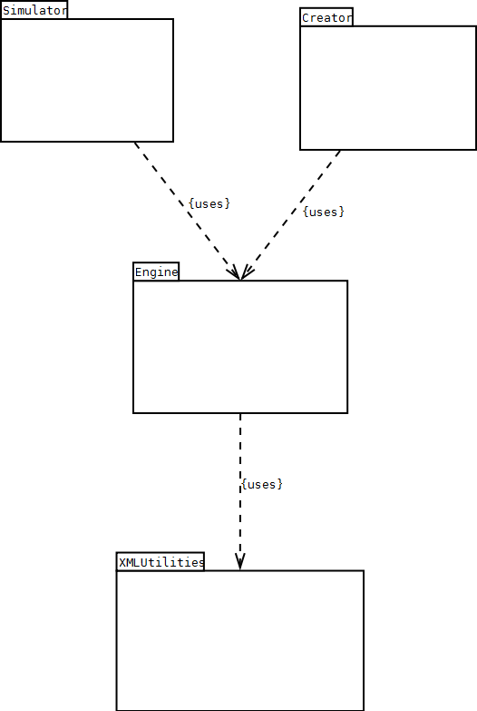
  - Class Diagram View
    - Creator Package
    - Simulator Package
    - Engine Package
The same engine and XML utilities will be used to create and simulate these vehicles, thus the entire framework will share a common base to eliminate coding redundancy.
    - Model Package

