Integrate Playwright with Azure Devops Pipeline
Step1: Repeat step 1 to 6 above from Option1
Step2: Click on Pipelines then click on New Pipeline 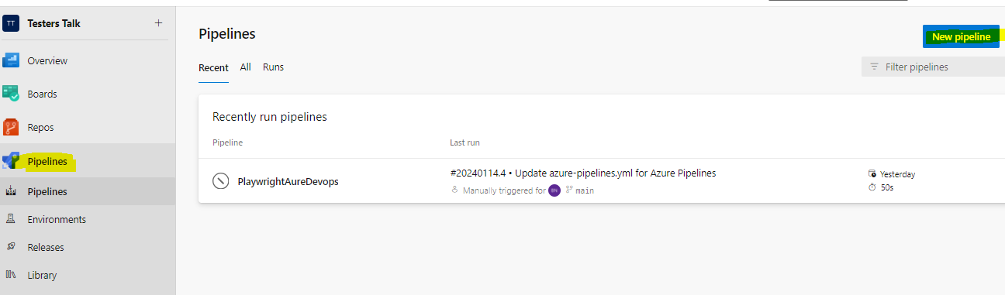
Step3: Click on Use the classic editor & Click on Continue 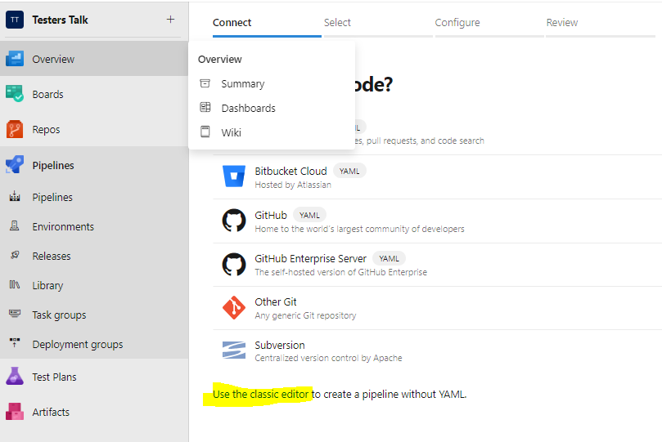 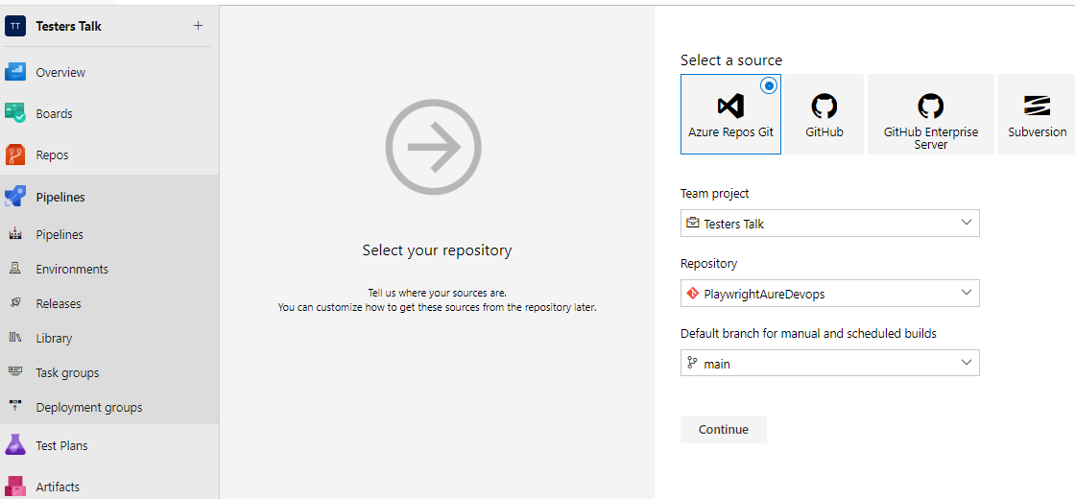
Step4: Click on Emtpy job
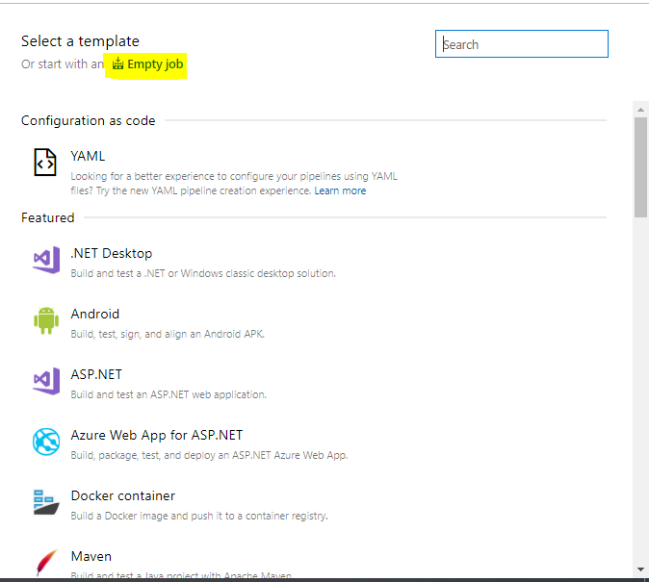
Step5: Click on + icon, Search for Node and add Node.js tool
installer 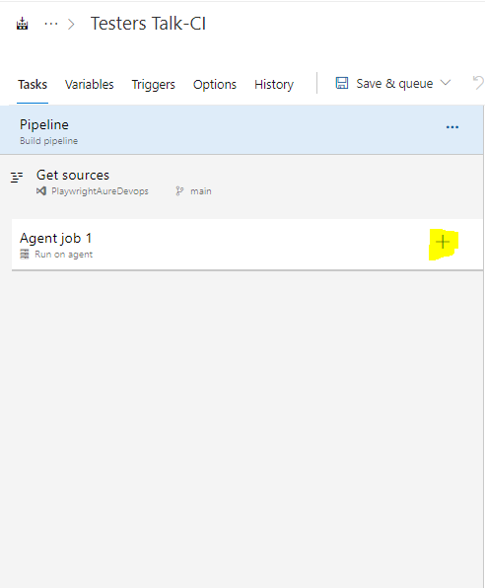

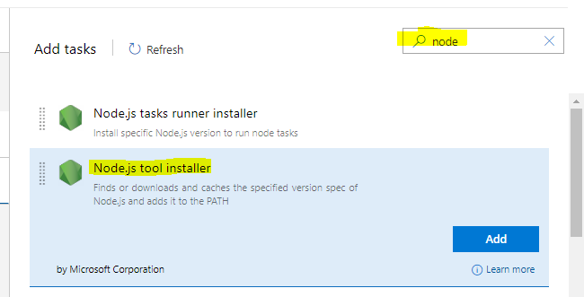
Step6: Select just now added task and add Node v16 becuase playwright supports for Node v14 and above
- 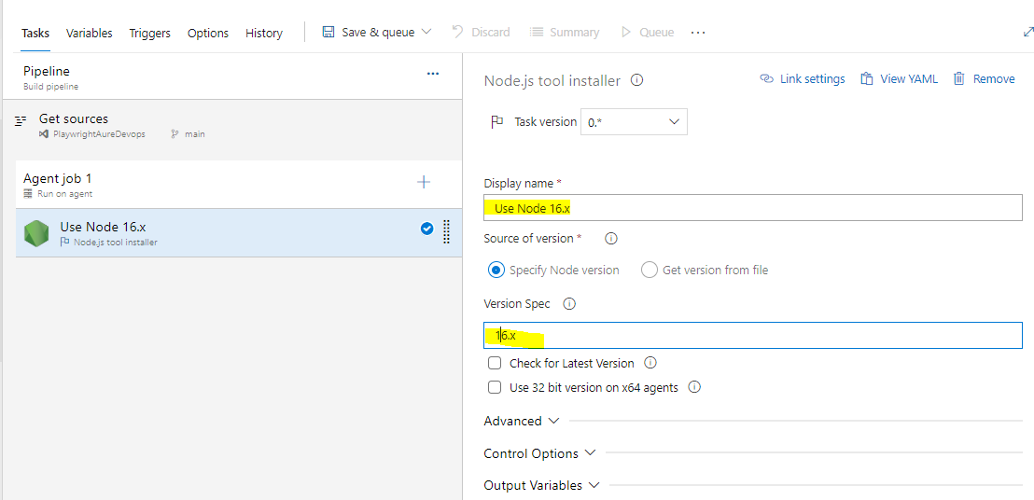
Step7: Click on + icon, Similary add Command line task, Display name: Install Playwright & Dependencies Script: npm install && npx playwright install 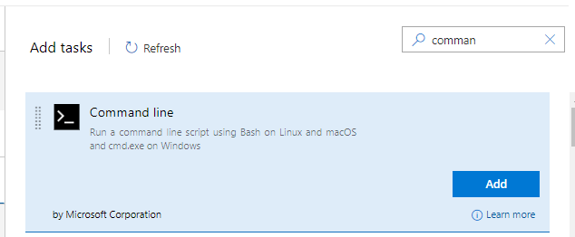 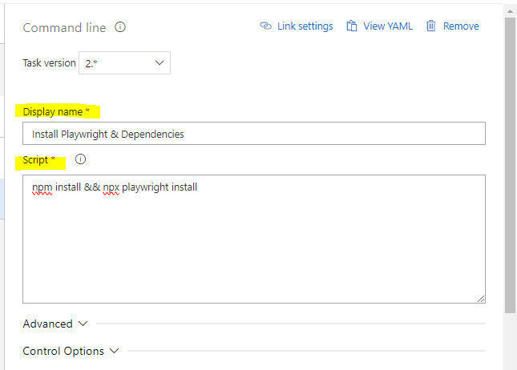
Click on Advanced-> Click on little icon(i) & select the Link. This will enable working directory for the task. 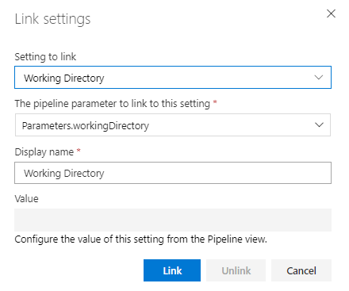
Step8: Add another task by clicking on + icon, search for npm & Add npm 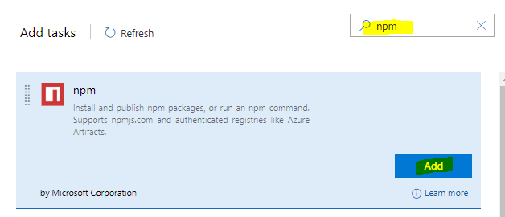
Enter Display name, Select Command as custom & Enter Command and Arguments as run tests 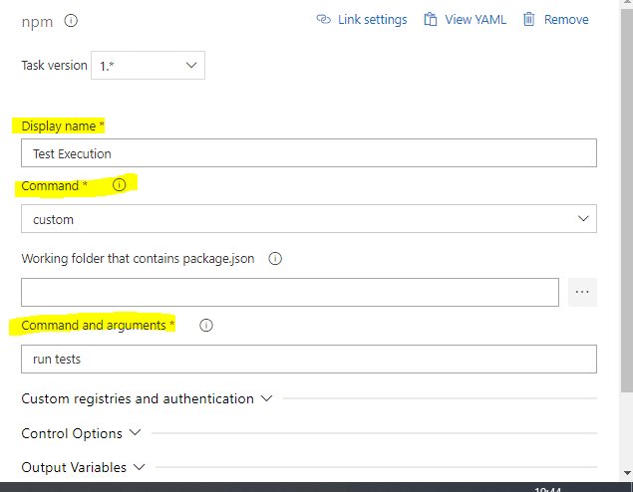
In this task we are referring to the package.json file. 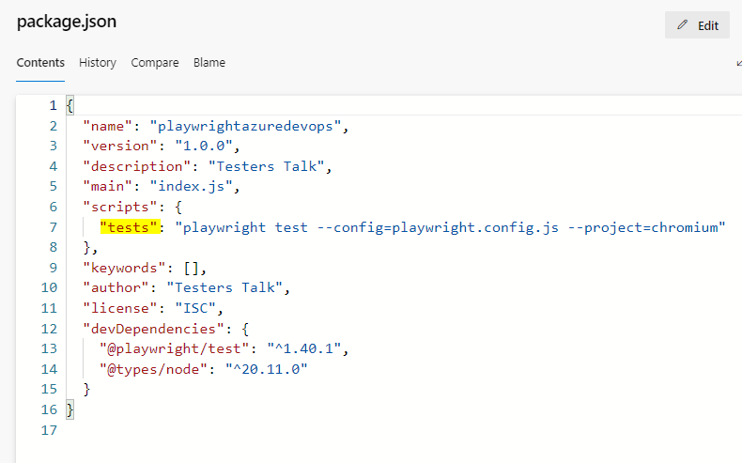
Step9: Once everthing is completed now it is a time run script. Click on Save & queue. 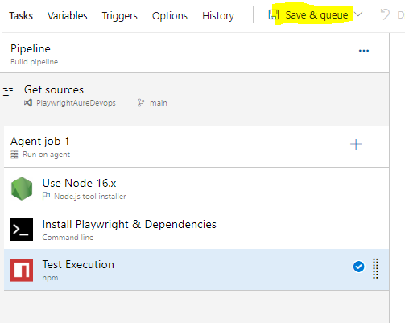
Add commit message then click save & run.
Step10: It looks like this 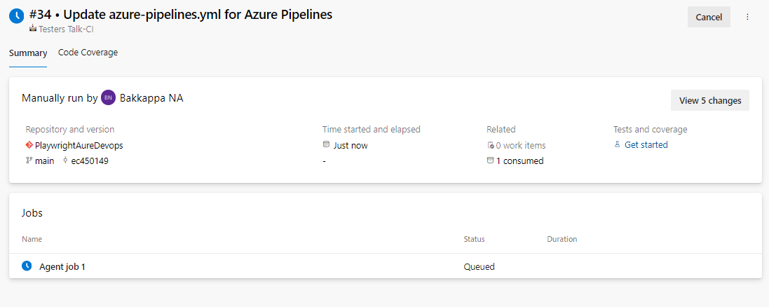
Click on Job and you will see a screen like this 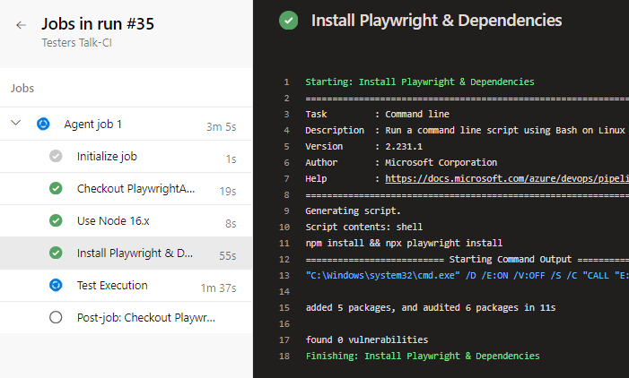
Step11: We can also upload playwright-report using Publish Pipeline Artifacts task 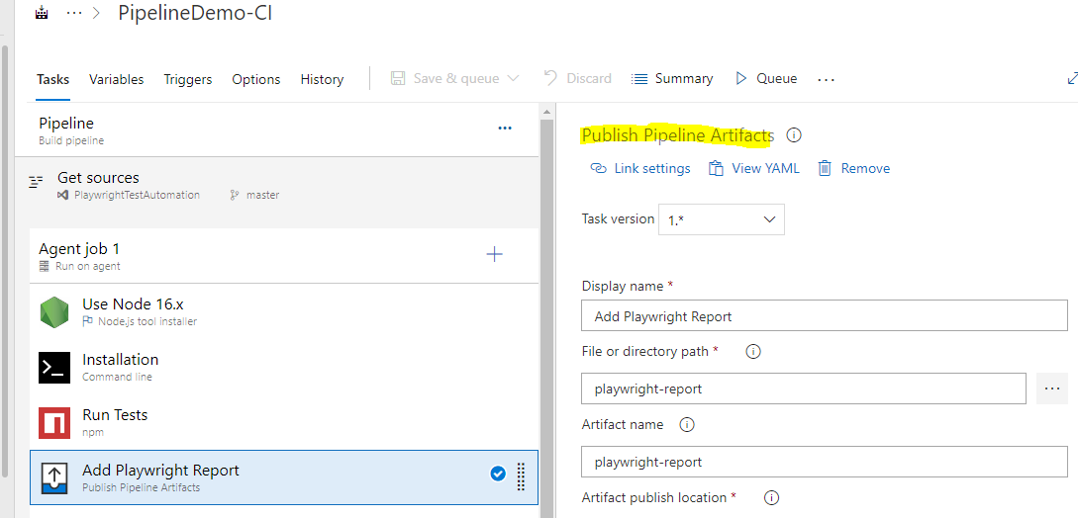
Step12: Let's Publish Test Results using Publish Test Results task 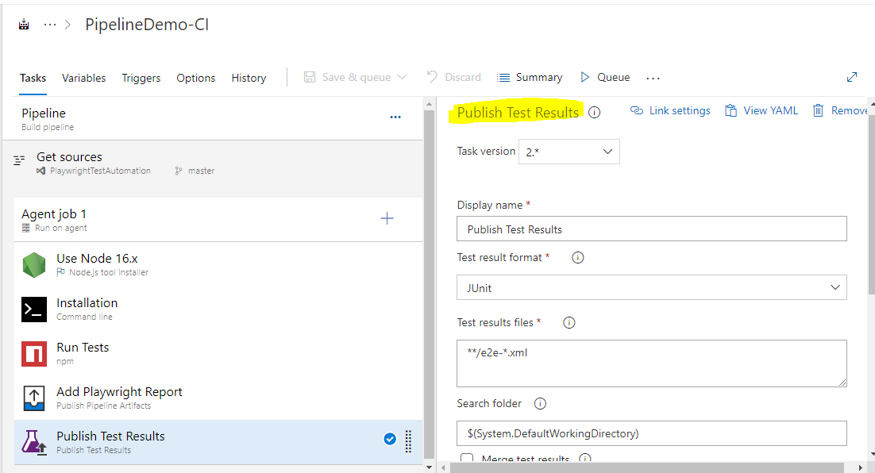
Let's run the pipeline 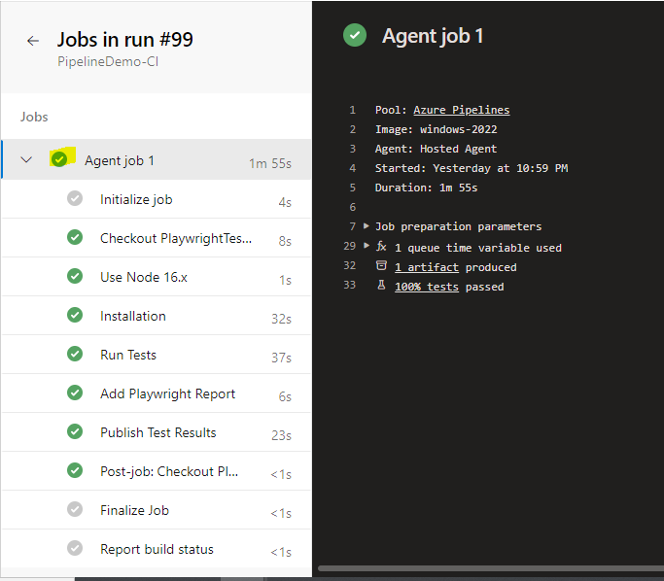
Artifacts are published & also we have published test results 