BUSINESS PLAN

FOR

ROOSTER KING



**TABLE OF CONTENTS**

Contents

EXECUTIVE SUMMARY 3

VISION 4

MISSION 4

CORE VALUES 4

Acronyms 5

1.1 Problem Statement 6

1.2 Business Concept 6

2.1 Sales & Marketing Strategy 9

2.2 Market Survey 10

2.4 SWOT Analysis 11

3.1 Production Cycle 13

3.3 Broiler Brooding Production Plan 15

3.4 Stepwise & Staged Production Strategy Plan for 2019 15

3.6 Production Performance: Monitoring & Evaluation Strategy 17

3.9 Organizational Plan and Partnership Strategy 18

3.11 Risk Management 19

4.0 FINANCIAL PLAN 20

4.1 Initial Investment: Capital injection span over 4-year period(2014 to 2018) 21

4.2 Funding Requirements 22

4.2.1 Breakdown of the operational costs 23

4.3 Bird Costing (Costing Model applied to 1000 birds) 24

4.4 Sensitivity Analysis 25

4.5 Projected Income 27

4.6 Balance Sheet 28

4.7 Payback Period 29

4.9 Breakeven Analysis 30

REFERENCES 33

Annexure 36

# EXECUTIVE SUMMARY

The proposed Rooster King broiler project aims to start producing 15,000 broilers per cycle that will be graded according to weight (1.2kg – 2.4kg) and according customers’ preferences; sold as live chickens to Surrey abattoir, among other customers. Rooster King broiler project will primarily start with 4 employees (3 General workers and 1 supervisor) who are involved in the rearing of the broilers. After 2 years, Rooster King has capacity to produce 23,000 broilers per cycle in its current single chicken brooder house, but to manage risk, the business will initially rear 9,000 birds and thereafter will increase capacity in a documented stepwise production approach.

To date, the founder of the business concept has injected an estimate of US$ 130,000.00 mainly towards construction and setting up of the brooder infrastructure facilities for brooding broiler chickens.

To achieve satisfactory results and minimize labour costs, Rooster King business

will be managed by the founder, Arthur Gwatidzo, with the assistance of 4 employees, and veterinary technical consultants(partners).

# VISION

To be the consumers’ preferred choice of premier chicken, helping our valued customers to live longer, healthier lives in Africa.

# MISSION

To produce prime quality chicken while adhering to the highest levels of specifications, international standards and norms, attaining customers satisfaction as well as sustaining the lives of our employees.

# CORE VALUES

*Excellence*  
We vow to be diligent in our work and consistently deliver the best quality in everything we do.  
  
*Innovative*  
We will be agile and flexible in our work. We will continually improve the quality of the poultry we produce. We will do this by continually improving the breeding, feeding, housing and watering of the broilers and the environment in our care.  
  
*Integrity*  
We will act with honesty and integrity in the conduct of our broiler xxx farming.  
  
*Stewardship*  
We vow to have a commitment to the stewardship of our broilers, our environment and our people.  
  
*Teamwork*  
We will create a teamwork environment where every person is a valued member, treated with respect, encouraged to contribute and recognized and rewarded for their efforts.

**Brand Slogan/Tagline**

•••*munch midday, midnight*•••

# Acronyms

API - Application Programming Interface

SADC - South African Development Community

WFP - World Food Programme

FCR - Feed Cost Ratio

FAO - Food and Agriculture Organization

ZIMASSET - Zimbabwe Agenda for Sustainable Socio-Economic Transformation

# 1.1 Problem Statement

Poverty eradication is at the top of WFP, United Nations, Word Bank, AU, SADC, among several international bodies' agenda [20] [21] [22] [23] [24] [25] with hunger and malnutrition being some of the main complex challenges that contribute to poverty in the SADC region. Reports [22] show Zimbabwe alone, an estimated 2.8 million are facing food insecurity and chronic malnutrition. Although development goals and policies have been mapped at international and national level for Africa and Zimbabwe, there is slow turnaround progress. With that in mind, common cheaper sources of protein will help to alleviate the challenges mentioned above. One of the suggested sources of protein is chicken.

FAO has estimated that world poultry production will need to grow by 2-3% per year by 2030, to meet the growing demand for poultry (chicken, ducks, fowl, turkeys, geese etc) worldwide.

This business concept unveils commercial broiler chicken production to contribute towards eradication of malnutrition and elimination of hunger. Furthermore, it seeks to strengthen Zimbabwe's national capacity for improved food security and nutrition, and economic growth.

Furthermore, as the business grows, Rooster King will create employment thereby contributing towards the goals of ZIMASSET and SADC to alleviate poverty in Zimbabwe and Africa at large.

# 1.2 Business Concept

Rooster King broiler production will entail production and marketing broilers that have been graded according to weight (1.2kg – 2.3kg), packaged, labelled and sold in bulk quantities (20+ birds) as slaughtered whole or live chickens. At commencement, our focus target market segment will be abattoirs, supermarkets, hotels, schools, and restaurants in Marondera, Chitungwiza and Harare. Our website will also open doors to a larger market audience ([www.tengahuku.com](http://www.tengahuku.com/)), among other marketing strategies that we shall utilize.

Backyard broiler production has been practiced before in our family, with smaller quantities between 50 and 120 broilers per cycle.

The innovation in the broiler production will be organised as follows:

**Processing and Grading**: The dressed broilers will be weighed and graded according to

the weights and standards that meet the market requirements. The market analysis results

showed that Surrey abattoir, hotels and restaurants preferred whole broilers weighing between 1.2 kg and 1.5kg while the supermarkets and schools and the general consumer at large preferred those weighing 1.2kg up to 2kg carcass weight. The supermarkets

will buy the whole birds and then transform some of the birds to mixed cutlets and specific cuts of 250g, 500g, 750g, 1kg, 1.5kg and 2kg

**1.3 Project Site/Brooding Facility Description**

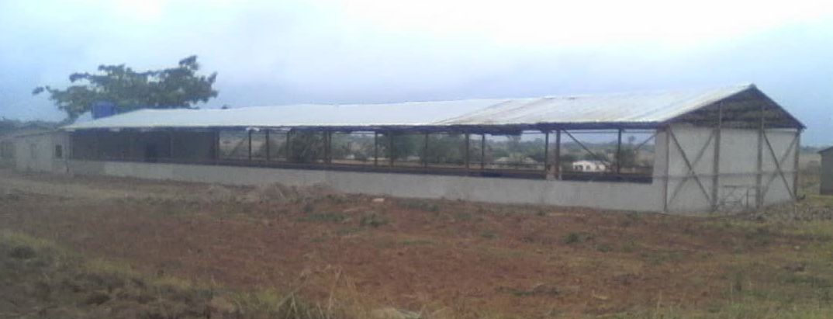

The project aims to initially start with producing 9,000 quality broiler chickens per cycle that meet the customers ‘expected standards. To cater for mortality rate 11,160-day-old chicks will be procured.

The land is fully owned by Rooster King and this premise has:

- 1 Fully constructed and fitted permanent steel structure chicken run: 45 metres x 12 metres;

- 1 storeroom for stock feeds (approx. 5 metres x 5 metres);

- 1 administration office (approx. 5 metres x 5 metres);

- 1 room (approx. 3.5metres X 12 metres) for rearing day-old chicks

- 55 metre fully installed and operational water borehole;

- 2 x 5,000L water tanks;

-Power generator used for filling water tanks with water from borehole;

- Ablution and shower facilities for Rooster King staff;

- Underground septic tank to deal with waste management;

- Handheld Digital Thermo-Hygrometer for monitoring broiler environment

- Handheld Digital Infrared Thermometer for monitoring broiler environment

The following equipment has already been purchased for the broiler project, but not yet fitted/installed:

-A full solar power system with 4 x 325-watt solar panels, 4 x 20-hour batteries, load controller, power inverter and all accessories for the installation of electrical power;

-2,560 broiler capacity battery chicken cages with nipple drinkers and feeding troughs;

-1,000-day-old chicks capacity battery chicken cages with nipple drinkers and feeding troughs;

-Manure scrapper machine for battery chicken cages;

- 2 x 45 metre tarpaulin curtains to install on the sides of the chicken run for weather control;

- 8 Channel CCTV kit system for security surveillance of chicken run premise;

Precise location of the broiler project brooding facilities is at Corner Seke Road & Marondera Road, (also popularly known as10 Miles junction), Marondera in Zimbabwe and this rural communal settlement area of Makanyazingwa 1.5km along Mahusekwa Road, Seke District in Marondera. Makazingwa rural communal lands are under the chieftainship and traditional leadership of Chief Svosve. Being an under-developed area, there are no water systems and the rural area is also not electrified.

Surrey abattoirs is located exactly 16.5km from the Premise. From the premise to this 10 Mile junction landmark is 1.5km of dust road and from there its tarred road to all the main market areas. There are several boarding schools within 10km radius of the premise, including Waddilove Primary School, Waddilove High School, Lendy Park High School, Watershed College, Ruzawi School, Diggleford School, Marondera High School, amongst others. Marondera CBD and township areas are approximately 18km from the broiler project premise. Marondera area has an estimate population of 60,000 people. Chitungwiza, one of the major towns in the province with an estimated population of 340,000 people is located 50km away from the broiler project premise. And lastly, from our premise to Harare, the capital city of Zimbabwe, the distance is 65km. Harare has an estimate population of 1.5 million people.

The general surrounding areas of the premise has several small-scale peasant maize farmers and the community habitants are of very low social status who take up maize farming as their way of living There are no industries and no companies within 10km radius from the broiler project premise.

# 2.1 Sales & Marketing Strategy

Rooster King will have to produce a quality that is preferred by their

potential buyers and that is above usual market standards. There will be need for periodic

market research to maintain customer conformity and determine current preferences. The

management will also go out to abattoirs, supermarkets, schools and restaurants to advertise their special broiler through tasting and giving free samples.

Key Marketing Strategy:

(i) Door to door marketing

(ii)Facebook Paid advertising for Business

(iii)Facebook page

(iv)We have launched our website [www.tengahuku.com](http://www.tengahuku.com/) to help with marketing and advertising of the product.

(v)Launch a Mobile app on Google Play Store and Apple App Store, to allow users to press bulk orders for chicken

(vi)Publish *video skits* through famous comedians in Zimbabwe, to market the product brand

Having a strong background in software development, the founder of the business has created a website, [www.tengahuku.com](http://www.tengahuku.com/) (in-house software development) to help with marketing and advertising the chicken products. The website is derived from the Shona phrase, “Tenga huku”, which means *buy chicken*. Shona is one of the African primary languages spoken in Zimbabwe. Customers can also place orders online, through this website. As part of a long-term strategy, the founder will develop a mobile app for the fulfilment of bulk chicken orders from Rooster King customers in pressing orders for broilers, buying bulk chicken (live broilers or slaughtered whole or cutlets) and track and trace the delivery of bulk chicken. Deliveries will first start in areas within 70km radius, and the delivery distance radius will be increased as the demand of the broiler produce increases. The mobile app is intended to be created and launched by December 2020. Already, the software development of the APIs to be used by the website and the mobile app has already started. No costs will be incurred for the software development of the website and the mobile app, except for costs associated with hosting the mobile app on Google Playstore and Apple App Store and costs associated with hosting the website live on the internet.

# 2.2 Market Survey

As of 4 September 2018, severe countrywide chicken shortages have been reported by several Southern African news media houses, to the extent of causing one of the major Zimbabwean chicken fast food outlets to temporarily halt its operations [1][2][7][8][9]. The major reasons are that high costs of stock feeds which has pushed some of the small-scale broiler producers out of business, and another reason is that the broiler poultry industry is slowly recovering from an outbreak avian influenza which hit Zimbabwe in January 2018. High costs of stock feeds are also hampering the broiler production industry growth [3]. Zimbabwe Poultry Association(ZPA) has reported that local producers of chicken and chicken products are failing to meet local demand so much that some of the broilers chicken consumed in Zimbabwe is being imported from neighbouring countries like Botswana and South Africa [4][5] [10].

Furthermore, the findings from the market analysis revealed that most customers do

not like the taste of these imported chickens from Zimbabwean neighbouring countries [6]. The general consumers describe the imported chicken as “fatty” and “tasteless.” [6]

This finding underscores a need to augment efforts of the local broiler producers and to

increase the supplies of home grown broilers. In addition, Rooster King broiler commercial production strives to take an additional step and produce a quality broiler that their potential buyers want.

**2.3 Target markets**

The project will initially focus on supplying broiler produce to primary & secondary education boarding schools in the Marondera area, hotels, restaurants, Surrey Meat abattoirs and other individual bulk buyers in Marondera, Chitungwiza and Harare. We are also optimistic that a broader target audience will be served through the website of the business which is available on the internet.

Marondera has a population of approx. 60,000 people and is 15km away from the poultry farming premise, Chitungwiza has 250,000 people and is located 30km from the farming site. Harare has a population of 1.5 million people with distance from site being 60km apart.

Our broad and diverse marketing techniques will help us to advertise and market our broilers across these three target areas.

Delivery transport will be arranged for chicken supply in Harare and its surrounding towns, offering supplies at a discounted rate for bulk buyers who require volumes above 200 chickens or more.

# 2.4 SWOT Analysis

The main local competitors for this project within 70km radius are Surrey poultry farms, Drummond, Irvine Chickens and other small-scale producers. There are also chicken brands important from regional countries which are slightly cheaper, but customers do not favour their quality. Though Irvine, Surrey and Drummond are the major chicken producers in Zimbabwe, the companies are offering grower scheme programs to small-scale farmers to capacitate their chicken production and chicken sales to the nation of Zimbabwe. However, only Irvines Chickens, Lunar Chickens and Surrey Group companies, which are the major players in the chicken industry, have the internet marketing, though their websites but they do not have track and trace features when you order online. We intend to keep our customers fully engaged through the journey of them pressing an order online and the chicken delivery being dispatched to the delivery destination. Rooster King, intends to have a full online ordering and fulfilment service feature through their website by December 2020.

|  |  |
| --- | --- |
| **STRENGTH**  -The surrounding area has veldts which has good grass to use for bedding  -Integration of different projects (poultry production and chicken production) is also available as there is a 12-acre piece of arable land on the same premise  -Labour is very affordable in these rural areas due to the high unemployment rate due to non-existence of companies and non-existence of industries  -The chicken run, and additional storerooms have already been completely constructed  -A water borehole exists on premise and adequate water storage tanks have already been installed  -A full solar system has already been purchased with adequate electrical power backup to offer lighting for the chicken run and to power infrared heat lamp for the room which will rear day-old chicks for the first 21 days.  -An 8 Channel CCTV system will be mounted, and this will also assist in the security surveillance of the chicken brooder house. | **WEAKNESS**  -At this stage the premise is not refrigerated which makes the project rely more on the sales of live chickens to abattoirs.  -Only one chicken brooder house is available. At the time of disinfection of the brooder house, the chicken run will be idle for 2 weeks of the production cycle as part of biosecurity and disease control. This implies that clients might fail to get chicken orders from the broiler project. |
| **OPPORTUNITIES**  -This project promotes food security of the nation and will boosts its agricultural production. In Zimbabwe, agriculture is still the main backbone of the country’s economy [11]  -The project will create jobs and an income to members of the community who will be employed.  -The project will impact the lives of the previously disadvantaged and marginalised groups by creating opportunities for them to thrive, through education and skills development  -This project is a development to a rural community  -Future developments will be to expand the project such that feeds can be made on site. This will provide a means of income to peasant farmers who will sell raw materials (soybeans and maize) to this project  -Good road networks and good distance to key points: Although general road infrastructure has dilapidated in Zimbabwe, road access from the project is still very good and is still tarred. Distance from the premise to the main broiler abattoir is about 17 kilometres. Distance from the premise to Marondera is about 15 kilometres. It takes about 1 hour to drive from the project premise to Harare (Zimbabwe’ capital city) and the distance is 65 kilometres. From Chitungwiza to the project premise, the distance is 50 kilometres. | **THREAT**  *High Initial Investment*: To date, the project has used over US$130,000 to drill and install borehole, construction of the brooder house, construction of storerooms, procure battery chicken cages with drinkers and feeders, procure power generator and procure a full solar system for the electrification of the brooder house.  *High Operational Costs*: The costs associated with procuring day old 9,000-day old chicks, adequate stock feeds and medicines for the cycle etc amount to almost US$40,000.00  *Livestock diseases*: Animal diseases poses a threat to broilers. Some community members in the area do rear cattle and mixing animals in an area can cause disease transmission. Best practices of biosecurity measures will need to be enforced on the premise, for instance, installing foot baths at entry points to the chicken brooder house. Predators e.g. birds, rodents are a potential threat in these rural areas. Wire mesh will need to be mounted on the perimeters of the chicken brooder building. |

*Diagram 1.1 Tabulated Strength Weaknesses Opportunities and Threats Analysis*

**3.0 OPERATIONAL PLAN**

# 3.1 Production Cycle

Diagram 1.2 below, shows the calendar for broiler production. Each cycle should be 6 or and 8 weeks

depending on the weight of the chickens that is on order. The average number of production

cycles are estimated to be 5.5 per annum considering the disinfection period of 10 days

before loading new chicks.

Each cycle should be 6 to 8 weeks depending on the weight of the chickens that is on order. The average number of production cycles are estimated to be 7.4 per annum considering the disinfection period of 10 days before reloading new chicks into the brooder house.

Targeted Broiler Brooding Period = 42 Days

Cleaning/Disinfecting Period = 10-14 Days

Full Cycle = 42 + 14 = 56 Days

Number of Production Cycles per annum (365/56) = 6.5 production cycles per year

The diagram below summarises the brooding cycle to be adhered to by the business. The diagrams illustrate the key date of events and the key activities to take place in each production cycle.

|  |  |  |  |  |  |  |  |  |  |  |  |
| --- | --- | --- | --- | --- | --- | --- | --- | --- | --- | --- | --- |
| Day Number | Day 1 to 14 | | Day  15 to 17 |  | Day 31 |  |  | To overlap with Week 1,2 &3 of incoming production cycle | | | |
| Activities  (Week Number) | 1 | 2 | 3 | 4 | 5 | 6 | 7 | 8 | 9 | 10 | 11 |
| Starter Phase Feed Diet  -infrared heating  -controlled lighting environment |  |  |  |  |  |  |  |  |  |  |  |
| Transfer 16 Day old chicks into the main brooder house |  |  |  |  |  |  |  |  |  |  |  |
| Change of Feed  (from Starter to Grower Feed Diet) |  |  |  |  |  |  |  |  |  |  |  |
| Grower Phase + Lighting Program |  |  |  |  |  |  |  |  |  |  |  |
| Change of Feed  (from Grower to Finisher Feed Diet) |  |  |  |  |  |  |  |  |  |  |  |
| Finisher Phase + Lighting Program |  |  |  |  |  |  |  |  |  |  |  |
| Sales Phase |  |  |  |  |  |  |  |  |  |  |  |
| Slaughtering & dressing |  |  |  |  |  |  |  |  |  |  |  |
| disinfestation of the brooder house & laying bedding materials and Preparation of brooder house |  |  |  |  |  |  |  |  |  |  |  |
| Collection of 1 Day Old Chicks |  |  |  |  |  |  |  |  |  |  |  |

*Diagram 1.2 Illustration of the Full Broiler Brooding Production Cycle*

Diagram Key:

|  |  |
| --- | --- |
|  | * 6 to 8 Week Cycle |
|  | * Denotes activity |

**3.2 Lighting and Lighting Programs**

Lighting and the use of tried and tested broiler brooderlighting schedules will be used for broiler growth. Lighting is one of the most critical factors which can accelerate the growth rates of birds. Research has shown that effective combining of light periods and darkness periods in brooder houses is key to the final body weight of birds [35] [36] [37][38] The diagram below reveals the lighting program that will be utilised for our commercial broiler production.

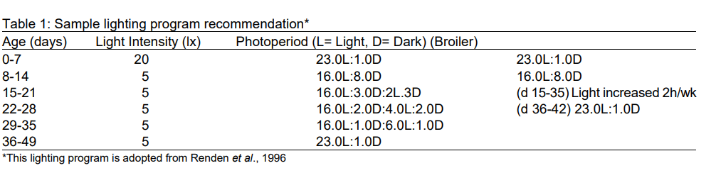

*Diagram 1.3 Lighting Program for use in improving broiler yield*

Diagram 1.3 above shows that the highest light intensity is to be used in the first week of the starter phase of day-old chicks. Thereafter, the lighting intensity is to be reduced four-fold times and that lighting intensity is to be kept as is until broiler slaughter. Photoperiods marked “D”, show the number of hours in which the lights are to be completely switched off (feeding birds in darkness). Photoperiods marked “L”, are the number of hours in which the lights are to be switched on.

# 3.3 Broiler Brooding Production Plan

Cobb 500 breed of day old chicks will be procured from Profeeds in Marondera town or from Irvines in Marondera. Stock feeds will be procured from Marondera Central Business District as well. Disinfectant chemicals and veterinary medicines (Vitamin Stress Pack, medication and antibiotics, Chlorex etc) will be procured from Profeeds or Irvines. Day old chicks would be managed in the brooders for 2-3 weeks in one of the “day-old chicks room” before they are transferred to the main chicken run. This room will have infrared heat lamps to help keep the room temperature at around 33 degrees Celsius. A handheld digital thermo-hygrometer will be used to monitor the environment’s room temperature. A handheld IR650 digital infrared thermometer will be used to regularly monitor the body temperature of each chick or broiler. During the brooding period chicks should be properly fed and given vaccinations to keep them in good health. The cycle covers a period of approximately 56 days. After the cycle is complete the fowl run is cleaned and disinfected for 10 days. Proper types of feeds and proper feeding practices must be adhered, to ensure expected maturation at the expected time. Monitoring the chicks for diseases and growth will be an ongoing process.

# 3.4 Stepwise & Staged Production Strategy Plan for 2019

To minimize the risk of project failure with large quantity of broilers, Rooster King propose making use of a staged broiler production and expansion. This will give the business time to learn lessons and making necessary positive adjustments in preparation for the succeeding broiler cycle from the previous.

Having constructed the chicken brooder house and storerooms with expansion in mind, to accommodate large quantities of broilers, the facts below will assist the project with speedy expansion:

* *Spaciousness*: The chicken brooder house is 45 metres long and 12 metres wide and 4.5 metres high. From the floor to the apex of the roof, the height is 6.5 metres;
* *Innovation*: A set of 2,560 bird capacity battery chicken cages was purchased to experiment with the use of stack tier battery chicken cages in order to maximize on the use of space of a chicken brooder house. Battery cages aims to maximize space in a brooder house by stacking tiers of cages towards the roof. This is innovative use of space to save on construction costs incurred in building another brooder house for project expansion.
* *Use of tarpaulin curtains* – These will help in regulating air, humidity and temperature in the brooder house. The curtains can either be opened and closed with ease.
* *Use of Lighting and Lighting Programs*: Confirmed research studies on broiler commercial production report that the use of lighting and implementing a proper lighting program will stimulate bird growth and increase yield production. Furthermore, as the broilers feed throughout the day and night, this will shorten the breeding period.

Targeted broiler brooding Period to be implemented is 6 weeks (42 days) per production cycle.

For any live chickens sold to Surrey Meats Abattoir, the breeding period is 35 days (6 weeks). Several restaurants and abattoirs prefer purchasing broilers at 35 days of age.

|  |  |  |  |  |
| --- | --- | --- | --- | --- |
| Dates  (Breeding Period) | Rest Period  (cleaning & disinfect) | Day Old Chicks Purchased | Mortality Rate | Estimate Broilers Produced |
| 1 February 2019 to 15 March 2018 | 10 to 14 Days  (16 Mar 2019 to 31 Mar 2019) | 11,160 | 2,160 | 9,000 |
| 1 April 2019 to 14 May 2018 | 10 to 14 Days  (15 May 2019 to 29 May 2019) | 11,160 | 2,160 | 9,000 |
|  | Addition of more battery chicken 4 Tier Cages for Broiler Capacity Expansion in The Chicken Brooder House | | |  |
| 1 June 2019 to 31 Jul 2019 | 10 to 14 Days  (16 Jul 2019 to 31 Jul 2019) | 14,880 | 2,880 | 12,000 |
| 1 Aug 2019 to 30 Sep 2019 | 10 to 14 Days  (16 Sep 2019 to 30 Sep 2019) | 18,600 | 3,600 | 15,000 |
| 1 Oct 2019 to 30 Nov 2019 | 10 to 14 Days  (16 Nov 2019 to 30 Nov 2019) | 18,600 | 3,600 | 15,000 |

*Table 1.1 Proposed Stepwise Incremental Broiler Production Strategy*

**3.5 Broiler Product Processing and Grading**

After maturation the chickens will then be graded to weight according customers’

requirements before slaughter or before delivery as live chickens to the abattoir or any other customer. Those weighing 1.5kg -1.9kg would be supplied to the Surrey abattoir and will be delivered live chickens. Surrey Abattoirs is located 16km away. In some instances, for bulk sales above 200 birds, Surrey abattoir will provide transport at the expense of the broiler supplier at US$0.05 per bird. Those birds which weigh 1.2 up to 2.4kg will be delivered to supermarkets as they require an assortment of weights for customers to choose from. The chicken cuts will be supplied to the supermarkets and individual customers.

# 3.6 Production Performance: Monitoring & Evaluation Strategy

Performance evaluation will be carried out at discrete points in time and often seek an outside perspective from other technical experts. This section will outline the main outcomes to monitor and evaluate and then assess the results achieved.

Outcomes have been adopted from [29] [31] [32] [33]

-Average Feed Conversion Ratio

-Feed Cost Ratio (FCR) - FCR is used to assess the efficiency of feed in both number and quality. FCR is determined by number of feed use as increasing of chicken weight

Other metrics to be used for monitoring and evaluating the broiler yield are:

-Average cost of production (Cost analysis of broiler production)

-Net Profit per broiler

-Liveability percentage

-Body weight at marketing

-Age (days) at Marketing: Intended mean 42 Days

**3.7 Transportation**

Some customers will collect their chickens while others may request deliveries. Deliveries at

a cost will only be done for customers without transport who order mainly 20 broilers or more.

Initially, we will use hired transport until such a time when Rooster Kings has purchased

its own delivery truck(s). All the products will be delivered on time to satisfy the

customers.

**3.8 Product Pricing**

A live chicken or slaughtered chicken that has been reared for average of 40 to 55 days is sold at a price between US$6.00 to US$8.00 per bird.

Per kilogram, chicken is sold between the prices of US$3.00 to US$4.00 [14] [15] [16] [17] [18]

# 3.9 Organizational Plan and Partnership Strategy

Arthur Gwatidzo is the main and sole founder of the broiler project.

To assist with the day-to-day operational activities, 2 full-time employees will be employed.

Since the broilers will need to be monitored 24 hours a day, for starters, 2 working shifts will be implemented. Per every 4,500 broilers in the main brooder house plus 2000-day old chicks in the “day old chicks room”, ideally 2 employees per 12-hour shift (which includes a 2-hour break) will need to be onsite. (5-hours work, 2 hours break, 5-hours work cycle).

To rear 9,000 broilers in the main brooder and 2,000-day-old chicks per production cycle of 55 days, 12 employees will be hired on a contract basis. Lay-offs will take place during the rest cycle period where only 4 employees will be required for 2 weeks, the period in which cleaning and disinfection of the premise will be done.

A veterinary doctor will be given a contract for regular visits to the project site for livestock monitoring.

A driver with a bakkie will be hired for their transport services when need arises. Hiring costs will be incurred per delivery load.

For mentorship and strategic advisory services, I will solicit assistance from technical experts from Irvine’s out grower scheme programme who specialize in assisting emerging farmers doing contract broiler farming. A consultant bookkeeper or accountant will be hired one day per every month to assist with bookkeeping.

These are broiler producers in Marondera and Chitungwiza surrounding areas who are already into broiler production. These producers will assist in providing a look and learn environment in their project sites. Rooster King employees will be expected to visit these other broiler producers’ projects’ sites and observe each step of the broiler production cycle.

**3.10 Training and Capacity**

Rooster King will start by employing 3 general workers and 1 supervisor (qualified personnel in the commercial broiler field) to help with the day-to-day operations of brooding the broilers. Rooster King staff will receive training mainly through Command Agriculture training programs launched by the government and solicit training and advice from large scale commercial broiler farmers both in Zimbabwe and in South Africa and consult local technical experts (including Irvines Chicken Technical experts, Surrey experts and veterinary specialists). Also, the management of Rooster King will make use of informal training methods like watching YouTube videos on broiler commercial farming and broiler farming best practices and reading materials from recommended.

# 3.11 Risk Management

Some researches [29] [30] recommend the risk mitigation techniques below:

Risk Mitigation Techniques

1. Biosecurity Measures
2. Vaccinations and Disease Control

Stringent disease control measures will be enforced. The main common diseases that

were controlled at the two farms were NCD and IBD. NCD vaccines (Strains Hitchner

Bl and La Sota) vaccines were used while IBD vaccine (Type 1 and CU 1M for

intermediate and mild outbreaks and LC 75 for intermediate plus) was used against IBD three vaccinations were conducted during the first 21 days of

life and these were administered orally (via drinking water).

|  |  |  |
| --- | --- | --- |
| Age | Route | Vaccination Type |
| 10 days | Drinking water | Hitchner B1 |
| 12 days | Drinking water | Gumboro |
| 21 days | Drinking water | La Sota |

*Table 1.3 Vaccination Routine*

1. Footbaths: Construction of Footbaths at every entry point into the brooder
2. Wire Mesh Perimeter Fencing: Installation of wire mesh on the perimeter walls of the brooder will prevent intrusion by rodents, birds etc.)
3. Disinfection: Regular Cleaning and Disinfection of brooder at every 7th week of the production cycle. Thereafter, to be left idle for 10 days to 14 days
4. Regular monitoring of chicken heat stress
5. Waste Management: Regular changing of bedding and proper disposal of litter to reduce pollution and potential dissemination of infectious diseases
6. Regular consultation by veterinary doctor at brooder premise
7. Regular assessment of production performance and inferenced decision making (diagram already explained).
8. Staged & Incremental Production strategy (already described)

# 4.0 FINANCIAL PLAN

This section details calculations, assumptions and methodologies used as a foundation for

the projections of the expected financial performance of Rooster King broiler project.

Please note that Zimbabwe uses United States dollar as local currency. Therefore, where need arises rates items will be pegged and converted from any foreign currency to United States dollar. Due to the current prevailing economy decline in Zimbabwe, some equipment was outsourced from either China or South Africa to facilitate the implementation of the project. In some cases, equipment was outsourced externally due to the favourable costs associated with procuring the equipment, as opposed to purchasing the equipment locally.

# 4.1 Initial Investment: Capital injection span over 4-year period(2014 to 2018)

The below table 1.3 shows different funds that the founder for the establishment of Rooster King broiler production project has already injected into the project since August 2014 when construction of the project started. An estimate of US$130,000 has been injected into the project over a period of 4 years (from August 2014 to current date in year 2018). Main source of funding was monthly salary savings.

|  |  |
| --- | --- |
| Item Description | Costs (US$) |
| Siting of Borehole + drilling and casing of 55metre borehole + borehole pump procurement and fitting + Procurement and fitting of 2 x 5,000L water tanks + water tank stands | 15,000.00 |
| Procurement of Steel from Steelmakers (400km away from site) + transportation | 40,000.00 |
| Design & Fabrication of Steel + Assembling onsite | 15,000.00 |
| Procurement of Roofing Sheets + Assembling on brooder house + labour | 10,000.00 |
| Purchase of 2,560 broiler capacity battery chicken cages and other accessories for day Old Chicks from China. Shipping to Durban South Africa + Delivery to site and border clearance duty to ZIMRA | 15,000.00 |
| Procurement building material for storeroom and side walls of brooder house + ablution pit latrine & shower facilities + Labour costs for builder:  -Quarry stone, bricks, cement, river sand, pit sand.  -Costs for delivery trucks + labour for builders and offloading trucks | 15,000.00 |
| Procurement of tarpaulin curtains for sides of brooder house (to curb rains and excessive winds onto broilers) | 1,000.00 |
| Procurement + delivery of full solar system from South Africa to Zimbabwe + border clearance  Items include:  4 x 150AH AGM Luminous battery  1 x 3000W Sine Wave Inverter  1 x MPPT Solar charge controller with load control  4 X 325 W Canadian Solar Panels  Other connecting + fitting accessories | 7,000.00 |
| Purchase of electric power generator powering the borehole pump and filling the water tanks on premise | 4,000.00 |
| Purchase of electrical wiring + electrical fitting components (Electrician labour) | 5,000.00 |
| 8 Channel CCTV kit System | 1,000.00 |
| Wire Mesh | 600.00 |
| Other | 1,400.00 |
| TOTAL | US$130,000.00 |

*Table 1.4 Summary of Initial investment funds injected by the founder into the business start-up*

# 4.2 Funding Requirements

Rooster King seek for funding, either in the form of a funding grant or a financial funding award. Funding is required to mainly cover the operational costs of the first round of the broiler cycle. Water fonts are water containers for broilers and tube feeders are the containers which hold the solid feeds. A total amount of US$78,651.26 worth of funding is required to commence with commercial broiler production business.

Fencing is crucial as it prevents rodents and birds and other animals from entering the brooder house. Birds and other creatures are a health risk as they are potential disease carriers and spreaders. Chicken plucking machines are crucial as they will speed up the process of plucking of bird feathers after slaughter. A cold room is necessary to store any slaughtered chicken as we wait for delivery. Cold storage refrigeration rooms will aid in keeping the slaughtered birds at a lowly optimal temperature which prevents meat from getting spoiled. Stock feeds form over 75% of the operational costs of any broiler poultry business. With that in mind, making your own feeds will help to reduce the stock feed costs which in turn increases the profit margin. The main items to be covered by the operational costs are to purchase:

(i) 11,160 Broiler Day-old chicks

(ii) Broiler Feeds for the first 35 days

(iii) Labour Costs

(iv) Veterinary consultation fees

(v) Medication and vaccination of the 11,240 birds

(vi) PVC Water Fonts and PVC Tube Feeders

(vii) 2 X Chicken plucker machine

(viii) Feed Mixer

Operational Costs + Purchase of Key Items for the Brooding Facility

|  |  |
| --- | --- |
| **Item Description** | **Item Cost (in USD)** |
| Total Variable Costs in table 1.6 below | $45, 651.26 |
| Purchase of 2 Chicken Plucker Machines | $1,500.00 |
| Purchase of Mesh Wire to Fence Brooder House | $1,500.00 |
| 800 x 4L Water Fonts and 800 x Tube Feeders | $10,300.00 |
| 1 x Cold Storage Refrigeration Room (Portable or Fixed Room Converted) | $10,000.00 |
| 1 Feed Mixer | $10,000.00 |
| **TOTAL FUNDING SOUGHT** | **US$78,651.26** |

*Table 1.5 Summary of Funding Sought*

# 4.2.1 Breakdown of the operational costs

|  |  |  |
| --- | --- | --- |
| Number of day-old chicks | | 11,160 chicks |
|  | **Quantity** | **Total Costs(US$)** |
| Cost of day-old chicks |  | $13,825.00 |
|  |  |  |
| **Stock feed:** |  |  |
| Broiler Starter 1 - 14 Days @ 0.5kg feed per bird | 5620.0kg | $4158.80 |
| Broiler Grower 15 - 28 Days @ 1.5kg feed per bird | 16860.0kg | $12139.20 |
| Transport of feed @ $12/per tonne | 39340.0kg | $472.08 |
|  |  |  |
| **Veterinary Medicines + other overheads:** |  |  |
| Vitamins Stress Pack @ U$3/100g | 11240.0g | $337.20 |
| Medication / antibiotics, etc @ US$5/100grams | 11240.0g | $562.00 |
| Vaccinations Lasota @ US$5.50/1000 doses | 11240 doses | $61.82 |
| Chlorex to use with vaccine @ US$4 / unit | 11.2 units | $44.96 |
| Mortalities @ 240 birds per every 1000 birds | 2160 birds | $2810.00 |
| Labour, fuel costs, brooding, litter, water and other farm costs @ US$0.20/BIRD (Estimate) |  | $2248.00 |
| **Total Variable Costs - Sub Total** |  | **$45651.26** |
|  |  |  |
| Profitability @ US$7 per bird |  |  |
| Selling price for live birds (US$) |  |  |
| Expected gross income |  | $78680.00 |
| Less total variable costs |  | $45651.26 |
| **Profit** |  | **$33028.74** |
| Percentage profit margin (%) |  | 41.98% |

*Table 1.6 Operational Cost Breakdown*

# 4.3 Bird Costing (Costing Model applied to 1000 birds)

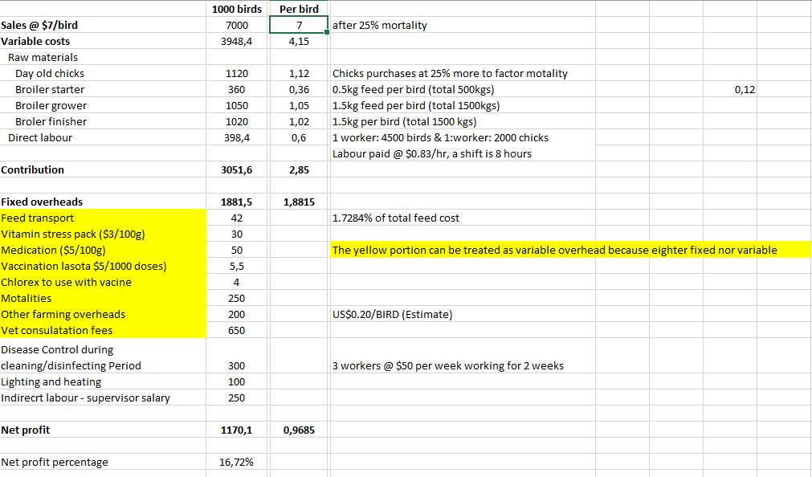

# 4.4 Sensitivity Analysis

|  |  |  |  |  |
| --- | --- | --- | --- | --- |
| **This analysis is based on a production level of 1000 birds** | | | | |
|  | | | |  |
|  |  |  |  |  |
| Selling price per bird | @ $6 | @ $7 | @ $8 | @ $9 |
| sales | 6000 | 7000 | 8000 | 9000 |
| Variable costs | 3948,4 | 3948,4 | 3948,4 | 3948,4 |
| Raw materials |  |  |  |  |
| Day old chicks | 1120 | 1120 | 1120 | 1120 |
| Broiler starter | 360 | 360 | 360 | 360 |
| Broiler grower | 1050 | 1050 | 1050 | 1050 |
| Broiler finisher | 1020 | 1020 | 1020 | 1020 |
| Direct labour | 398,4 | 398,4 | 398,4 | 398,4 |
|  |  |  |  |  |
| Contribution | 2051,6 | 3051,6 | 4051,6 | 5051,6 |
|  |  |  |  |  |
| Fixed overheads | 1881,5 | 1881,5 | 1881,5 | 1881,5 |
| Feed cost | 42 | 42 | 42 | 42 |
| Vitamin stress pack ($3/100g) | 30 | 30 | 30 | 30 |
| Medication ($5/100g) | 50 | 50 | 50 | 50 |
| Vaccination lasota $5/1000 doses) | 5,5 | 5,5 | 5,5 | 5,5 |
| Chlorex to use with vaccine | 4 | 4 | 4 | 4 |
| Mortalities | 250 | 250 | 250 | 250 |
| Other farming overheads | 200 | 200 | 200 | 200 |
| Vet consultation fees | 600 | 650 | 600 | 650 |
| Disease Control during cleaning/disinfecting Period | 300 | 300 | 300 | 300 |
| Lighting and heating | 100 | 100 | 100 | 100 |
| Indirect labour - supervisor salary | 250 | 250 | 250 | 250 |
|  |  |  |  |  |
| Net profit | 170,1 | 1170,1 | 2170,1 | 3170,1 |
|  |  |  |  |  |
| Net profit percentage | 2,84% | 16,72% | 27,13% | 35,22% |
|  |  |  |  |  |

# 4.5 Projected Income



# 4.6 Balance Sheet



# 4.7 Payback Period



**4.8 Net Present Value**



# 4.9 Breakeven Analysis

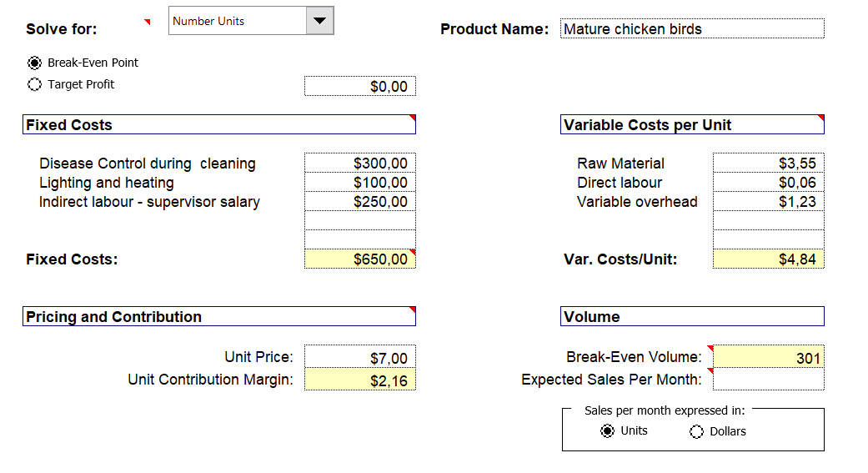

**4.9.1 Breakeven Chart**

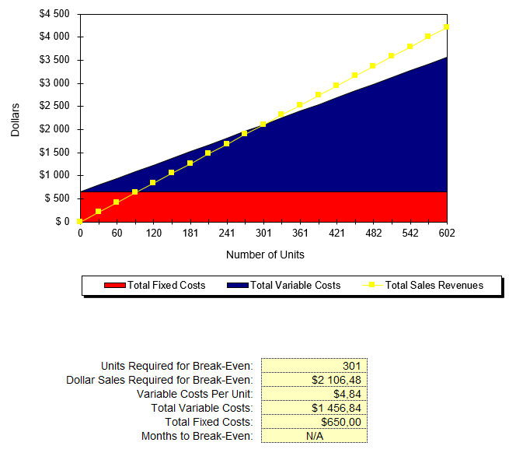

**4.9.2 Break Even Table**

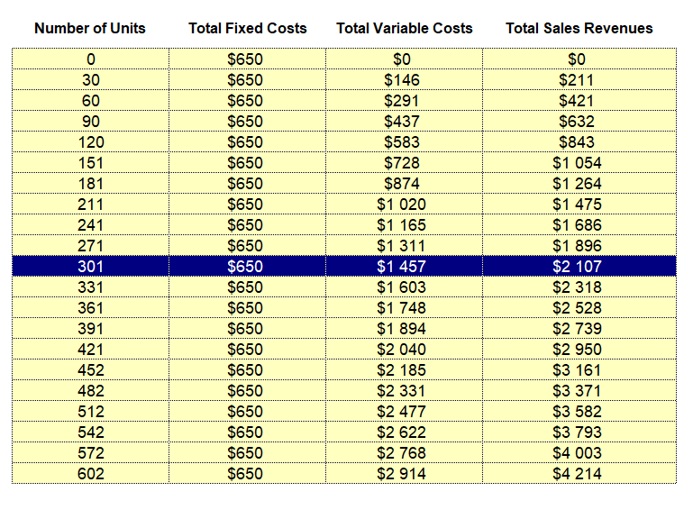

# REFERENCES

[1] News24.com *Famous Zim Fast Food outlet runs out of chicken amid shortage* <https://www.news24.com/Africa/Zimbabwe/famous-zim-fast-food-outlet-runs-out-of-chicken-amid-shortage-report-20180904>

[2] MyZimbabwe.co.zw *Latest Chicken Shortage hits chicken inn* <https://www.myzimbabwe.co.zw/news/30886-latest-chicken-shortage-hits-chicken-inn.html>

[3] ThePoultrysitre.com *Egg shortage grips Zimbabwean poultry industry* <http://www.thepoultrysite.com/poultrynews/39682/egg-shortage-grips-zimbabwean-poultry-industry/>

[4] Bulawayo24.com *Zimbabwe hardly exports poultry to South Africa and Botswana* <https://bulawayo24.com/index-id-news-sc-national-byo-111944.html>

[5] Dailynews.co.zw <https://www.dailynews.co.zw/articles/2018/05/21/poultry-imports-hurt-zpa>

[6] GMASSURE. *Zimbabwe Scientists dispel chicken myth* <http://www.gmassure.org/uploads/media/Zim%20scientists%20dispel%20GM%20chicken%20myth.pdf>

[7] The Standard Newspaper. *Zimbabwe poultry industry on the rebound* <https://www.thestandard.co.zw/2018/02/04/poultry-industry-rebound-2/>

[8] The Chronicles Newspaper. *Chicken Inn Runs out of Chicken* <https://www.chronicle.co.zw/chicken-inn-runs-out-of-chicken/>

[9] Channel Africa. *Zimbabwe fast food outlet runs out of chicken* <http://www.channelafrica.co.za/sabc/home/channelafrica/economy/details?id=3ad870af-fd90-4af0-adab-6413f682485e&title=Zimbabwe%20fast%20food%20outlet%20runs%20out%20of%20chicken>

[10] ThePoultrysite.com *Zimbabwe battles illegal chicken imports from neighbour*. <http://www.thepoultrysite.com/poultrynews/36433/zimbabwe-battles-illegal-chicken-imports-from-neighbour/>

[11] Food and Agriculture Organization of the United Nations. *Zimbabwe at a glance*. <http://www.fao.org/zimbabwe/fao-in-zimbabwe/zimbabwe-at-a-glance/en/>

[12] Farmers Weekly. *5 Cattle diseases that can kill your business*

<https://www.farmersweekly.co.za/animals/cattle/5-cattle-diseases-that-can-kill-your-business/>

[13] Food and Agriculture Organization of the United Nations. *Animal Disease Control Issues, Options, and Impacts* <http://www.fao.org/wairdocs/LEAD/x6170e/x6170e0h.htm>

[14] Numbeo. *Cost of Living* <https://www.numbeo.com/cost-of-living/country_result.jsp?country=Zimbabwe>

[15] Bulawayo24.com *Shops raise chicken prices by 40%* <https://bulawayo24.com/index-id-news-sc-national-byo-103643.html>

[16] Expatistan*. Cost of Living, Harare* <https://www.expatistan.com/cost-of-living/harare>

[17] Surrey Meats <http://www.surreygroup.org/>

[18] DailyNews Newspaper <https://www.dailynews.co.zw/articles/2017/12/15/pricing-madness>

[19] United Nations Development Program Report. *Assessment of Development Results – Evaluation of UNDP Contribution to Zimbabwe.*

[*http://www.zw.undp.org/content/dam/zimbabwe/docs/key%20documents/UNDP_ZW_ADR_Zimbabwe_2015.pdf*](http://www.zw.undp.org/content/dam/zimbabwe/docs/key%20documents/UNDP_ZW_ADR_Zimbabwe_2015.pdf)

[20] South African Development Community. *Poverty Eradication & Policy Dialogue" (2016)*. <https://www.sadc.int/themes/poverty-eradication-policy-dialogue/>

[21] United Nations News. Malnutrition mounts in eastern and southern Africa as El Niño takes hold – UNICEF. <https://news.un.org/en/story/2016/02/522432-malnutrition-mounts-eastern-and-southern-africa-el-nino-takes-hold-unicef>

[22] World Food Programme Zimbabwe Overview <http://www1.wfp.org/countries/zimbabwe>

[23] Africa Union Press Release, July 25, 2018.

*Improving Food Security in Africa through enhanced partnerships and Post-Harvest Management*. <https://au.int/en/pressreleases/20180725/improving-food-security-africa-through-enhanced-partnerships-and-post-harvest>

[24] FAO in Zimbabwe (2018). Zimbabwe at a glance. <http://www.fao.org/zimbabwe/fao-in-zimbabwe/zimbabwe-at-a-glance/en/>

[25] Word Bank. *Zimbabwe Overview*. <https://www.worldbank.org/en/country/zimbabwe/overview>

[29] Agricultural Economics Research Review Vol. 24 July-December 2011 pp 317-323 *Production Performance and Economic Appraisal of Broiler Farms in Anand District of Gujarat*. Page 318

<https://ageconsearch.umn.edu/bitstream/119385/2/15-AS-Shaikh.pdf>

[30] University of Stellenbosch G.N. Kelebemang. *Efficiency Of Broiler Production: A Case Study Of Two Commercial Enterprises Around Gaborone (Botswana)*

<http://scholar.sun.ac.za/bitstream/handle/10019.1/50334/kelebemang_efficiency_2005.pdf?sequence=1&isAllowed=y>

[31] South African Journal of Animal Science 2017, Volume 47, Issue 1. Page 16-25. *Evaluation of various feeding programmes on growth performance, carcass and meat qualities of Thai indigenous crossbred chickens* <http://www.scielo.org.za/pdf/sajas/v47n1/04.pdf>

[32] Journal of Advanced Agricultural Technologies June 2017, Volume 4, Issue 2. Page 196-199. *Performance of Broiler Farmer in Partnerships System at Surakarta, Indonesia*

<http://www.joaat.com/uploadfile/2017/0704/20170704103409773.pdf>

[33] Poultry Science Journal, Article 9, Volume 6, Issue 1. Page 89-97. *Evaluation of Miswak (Salvadorapersica) as a Herbal Additive in Broiler Chickens* <http://psj.gau.ac.ir/article_4006_08a289248974cae5f6068310acba02ca.pdf>

[35] International Journal of Poultry Science 5 (4): 301-308, 2006. *A Review of Lighting Programs for Broiler Production*

<http://www.once.group/wp-content/uploads/2018/08/A-Review-of-Lighting-Programs-for-Broiler-Production-2006.pdf>

[36] Department of Animal and Poultry Science, University of Saskatchewan, Saskatoon, Canada (2015). *Basing Turkey Lighting Programs on Broiler Research: A Good Idea? A Comparison of 18 Daylength Effects on Broiler and Turkey Welfare* <https://www.ncbi.nlm.nih.gov/pmc/articles/PMC4880844/pdf/animals-06-00027.pdf>

[37] Poultry Science Journal (2016) Volume Issue 2. Page 81 to 87. *Intermittent Photoperiod Schedule does not Influence Brain and Serum Melatonin and Selected Serum Antioxidant Enzymes Activity in Broiler Chickens* <http://psj.gau.ac.ir/article_3263_e58689c658156dd52335e64c6f0959b8.pdf>

[38] Renden, J.A., E.T. Moran, Jr. and S.A. Kincaid, 1996. Simmons, P.C.M., 1982. *Effect of lighting regimes on Lighting programs for broilers that reduce leg problems without loss of performance or yield*. Poultry. Sci., 75: 1345-1350.

<https://academic.oup.com/ps/article-pdf/75/11/1345/4538073/poultrysci75-1345.pdf>

# Annexure



Figure 1.0 Proposed Logo for Rooster King commercial broiler production business

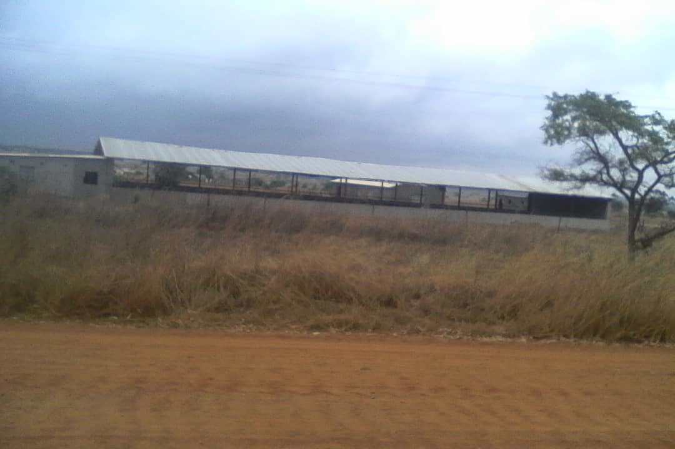

*Figure 1: Brooder House, Store Rooms and Day-old Chick Room Side Elevation – before installation of solar electrical equipment*

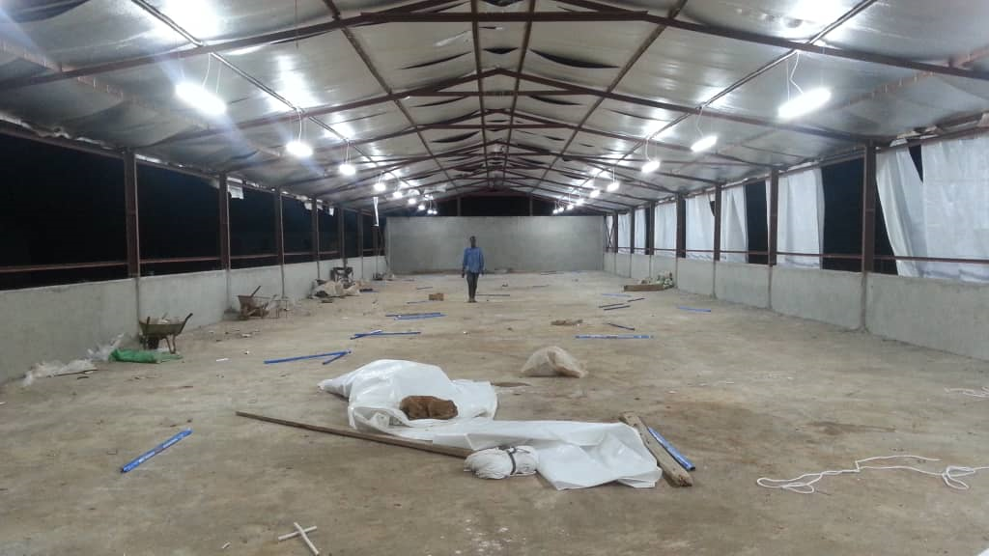

*Figure 2: Lighting in Main Broiler Brooder house*

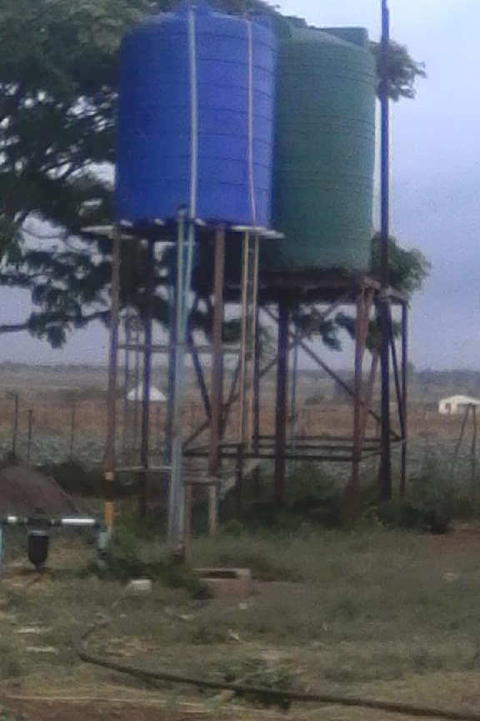

*Figure 3: Borehole Infrastructure + Water Tanks*

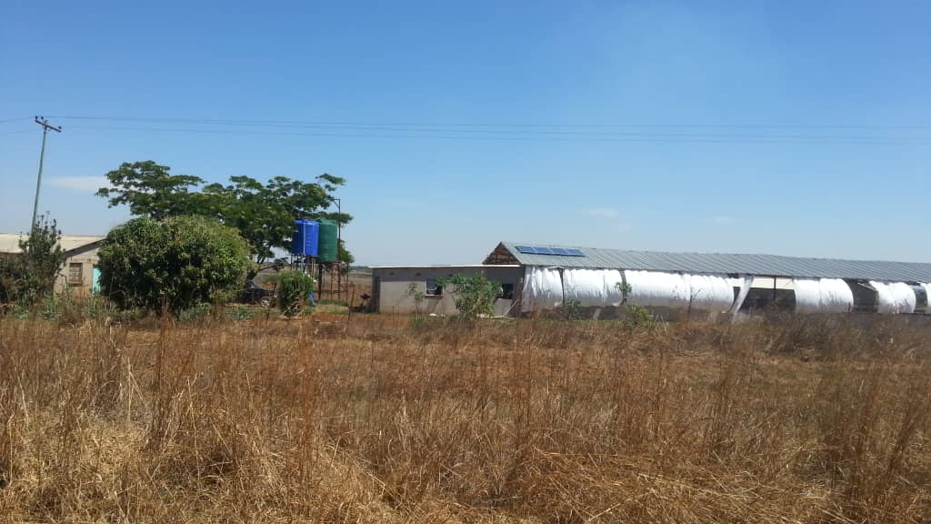

*Figure 8: Mounted Solar Equipment for Brooder House Lighting and Turpaulin Curtains to Control Weather Conditions (wind & rains)*