**The Wealth Distribution Model**

(WealthDistribution.nlogo)

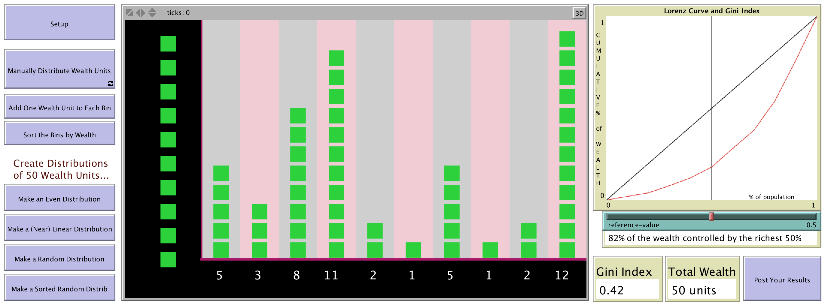

To begin, launch the NetLogo application by navigating to the Flash Drive on your computer and double-clicking the NetLogo shortcut. Then open the model “WealthDistribution.nlogo” which is also on the Flash Drive.

**Exploration 1: *Random Distributions of Wealth***

In this model, we’re looking at 10 different subgroups of a population. (When they’re put in order, they would be the 10 *deciles* of the population.) We will be able to explore and change how wealth is distributed among these groups.

To get started, press **Setup**. Now, press **Make a Random Distribution** several times to see a few distributions of wealth in your population. Pause when you find one that is really uneven or unequal. Then press **Post Your Results** (which is at the far right-hand side of the interface). Fill in the form explaining what you have produced. Make particular note of the Lorenz curve (the red curve in the plot), and the Gini index.

**Exploration 2: *Equal Distributions of Wealth***

Press **Setup** again to clear the distribution. Now, make an equal or uniform distribution of wealth, either with 50 total wealth units by pressing the **Make an Even Distribution** button, or with a different total wealth by pressing the **Add one Wealth Unit to Each Bin** button one or more times.

Notice that when you have a completely equal wealth distribution, the Lorenz curve is on top of the black line. Why is that? To explore, move a single wealth unit from one bin to another in your distribution, and watch what happens to the Lorenz curve (the red graph) and the Gini Index. Discuss in your group until you have an explanation of what happened that everyone agrees with.

Press **Sort the Bins by Wealth** to put the population groups into order as wealth deciles. Move the **reference-value** slider under the Lorenz Curve and Gini Index plot. What are the connections between the decile distribution of wealth and the Lorenz curve?

**Exploration 3: *A Strong Middle Class and Economic Change***

Press **Setup** again to clear the distribution. Now, create a distribution that could represent what you think is a population with a “strong middle class.” When you have done this (and when you have achieved consensus in the group) press the **Post your Results** button and send in your graph and reasoning. NOTE: If the group cannot achieve consensus, you can make multiple distributions reflecting the different positions on what a “strong middle class” should look like.

Next, make a small change to the wealth of your population that would correspond to some economic reality. Your change could involve new domestic policy, changes in international trade, the discovery of natural resources – anything that would change the wealth of your simulated population. When you make this happen, what change occurs in the Lorenz curve and Gini Index? Discuss this in your group until you reach agreement about your explanation; then press the **Post Your Results** button again and send in your thinking.

***What Do You Think?***

The Gini index is used in many discussions of economic equality and equity. There are many comparative discussions and listings of the Gini index in different countries.

(e.g., <https://www.cia.gov/library/publications/the-world-factbook/rankorder/2172rank.html> and see also the Wikipedia page <https://en.wikipedia.org/wiki/List_of_countries_by_income_equality> )

However, many of these listings base their calculation on income rather than wealth. The question to you is, *What is the difference, and what difference would it make to use income rather than wealth? Would this tend to increase or decrease the Gini index? Always? Why or in what circumstances?*