Do Anticipatory Alpha and Beta Oscillations Reflect Learned Expectancy in a Gamified Reinforcement Learning Task?
King’s College London

Abstract
Anticipatory alpha and beta oscillations have been linked to learned reward expectancy, yet most prior work relies on highly simplified cue-outcome paradigms with fixed, easily learned contingencies that may not capture how the brain tracks expectancy in more naturalistic settings. The present pilot study examined whether individually fitted RW models better capture the relationship in a more gamified reinforcement learning paradigm with fluctuating reward contingencies. Five high trait anxious participants performed the Cannonball task (720 trials) with 64-channel EEG measurements. Alpha (8–13 Hz) and beta (13–30 Hz) power were obtained in parieto‐occipital and sensorimotor regions of interest respectively and correlated with trial-wise RW expected value V(t) at both a fixed learning rate and individually optimised rates via grid search. A temporal generalization technique using Support Vector Regression (SVR) was also applied to investigate whether broadband EEG spatial patterns consistently encoded V(t) over the anticipatory window. Both alpha and beta value failed to correlate with V(t) in any person at the fixed learning rate and an individually optimised one. The R² values for the SVRs were consistently close to 0 over the full period of anticipation, suggesting that the encoding of V(t) was not robust in broadband EEG spatial space patterns. These findings suggest that the relationship between anticipatory oscillations and learned expectancy does not generalise straightforwardly to more complex paradigms, and that effect sizes are likely small. The pilot estimates demonstrated here offer an empirical foundation to build a confirmatory replication with more participants.

Introduction
A central function of the brain is predicting the future. Instead of simply registering stimuli, the brain actively modifies internal information about the world in response to incoming sensory data, as proposed in the predictive processing framework (Clark, 2013). One of the best-studied forms of this predictive update is associative learning. This refers to the way that organisms form associations between stimuli and outcomes. But after decades of research, the exact neural mechanisms that regulate evolving expectations on a trial-by-trial basis are still unclear in a world that approximates higher-order, less-trivial aspects of the learning experience. Most EEG studies on associative learning have employed highly simplified paradigms, pairing a neutral cue to aversive or rewarding outcome with fixed, easily learned contingencies (Riels et al., 2021; Klimesch, 1999). In experiments where conditions are uncertain and dynamically changing, these designs can provide experimental control, but that’s not how the brain predicts expectancy. Moreover, most of the previous work tends to consider neural correlates at the group level based on averages of conditions, blurring meaningful individual differences among expectations updates. Another limitation is that most academic work has concentrated only on alpha oscillations and the role of beta oscillations for reward expectancy has been poorly examined, although there is an increasing body of literature connecting beta dynamics and predictive coding and motor preparation (Dyck & Klaes, 2024).
Riels et al. (2021) was one of the studies that examined alpha oscillations and expectancy, demonstrating that time-varying alpha power tracked learned expectancy during associative learning. However, their paradigm retained a simple cue-aversive noise structure, assumed a fixed learning rate across all participants, and did not examine beta oscillations. The present study therefore attempted a conceptual replication in a more ecologically valid, gamified reinforcement learning task with fluctuating reward contingencies, fitting the Rescorla–Wagner model individually to each participant and extending the analysis to beta oscillatory dynamics.

Computational Modelling
Predictive processing reframes conditioning not as a simple stimulus response but as the brain’s continuous updating of its internal models to minimize surprise (prediction error) from sensory input. In reinforcement learning, reducing reward prediction error enables the system to refine associative relationships by improving its internal representations (Sprevak & Smith, 2023). One of the most widely used computational models is the Rescorla-Wagner model (RW), which emphasizes learning from unpredicted outcomes. Fitting associative strength and prediction error parameters to neural time series leverages trial-by-trial variability in brain data while providing conceptually meaningful data reduction. This approach has been used to quantify learning in a wide range of tasks, in human participants and animal model studies including reinforcement learning (Costa et al., 2016), social decision making (Zhang et al., 2020) and category learning (Rodriguez et al., 2006) Hence, this technique was used to characterize the role of alpha and beta power values during experience-based updating of expectancy.
Figure 1.
Rescorla-Wagner Model (Simplified).
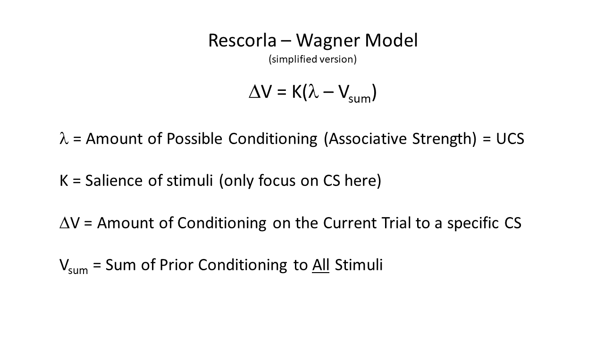
Note. Diagram illustrating the Rescorla-Wagner model update rule with key parameter definitions.

Alpha Band
Changes in alpha-band spectral power (8–13 Hz) have been consistently linked to distinct cognitive processes (Klimesch, 1999). Increases in alpha power are typically associated with internally oriented cognition, such as mental imagery (Bartsch et al., 2015), boredom (Raffaelli et al., 2018), and anticipation (Bonnefond & Jensen, 2012). Conversely, decreases in alpha power are observed during cortical engagement with relevant or salient sensory input (Klimesch, 1999). Collectively, one could hypothesize that updating learned representations involves dynamic fluctuations in alpha-band neural activity. It can be effectively tested because alpha oscillations are both high in amplitude and exhibit a favourable signal-to-noise ratio, enabling reliable quantification at the single-trial and time-point levels (Başar & Güntekin, 2012).
Stimulus saliency and changing expectancy are key factors linking associative strength in the Rescorla-Wagner (RW) model to alpha-band neural oscillations. When a neutral stimulus is consistently paired with a meaningful outcome, behavioural and physiological responses to that conditioned stimulus adapt in systematic ways, enhancing the organism's preparedness for the anticipated event (Clark, 2004). Expectancy rises as the associative strength between the conditioned and unconditioned stimuli strengthens (e.g., Perruchet, 2015). Together, these findings support that associative strength in the RW model is mirrored by fluctuations in alpha power. Given that alpha power and phase timing vary substantially across individuals (Haegens et al., 2014), models incorporating individualized learning rates and neural profiles can provide a more comprehensive account of associative learning than traditional group- or trial-averaged approaches.

Extension to Beta Bands
In addition to alpha oscillations, the study extended its analysis to beta oscillations. Beta oscillations have been linked to the top-down predictive coding framework, representing the brain’s expectations. Beta band oscillations show power increases after reward delivery in reinforcement learning tasks, indicating a role in learning from feedback and in maintaining task-related information (HajiHosseini et al., 2020).
Regarding expectancy, beta oscillations have also been closely linked with expectancy in motor action. Beta power in the motor cortex is suppressed before and during movement (Dyck & Klaes, 2024). Investigating beta in conjunction with alpha power during reward expectancy was therefore considered novel in the present context, given that a motor action was required for participants to receive reward feedback. This study therefore examined whether beta oscillatory dynamics during anticipation in a reinforcement learning task follow a similar pattern of suppression.

Temporal Generalization Using SVM Classifier
In addition to the conceptually driven Rescorla–Wagner (RW) model, the study employed data-driven approaches to test whether fluctuations in alpha power reflect the updating of associative strength during learning. Support vector machine (SVM) classification distinguishes observations based on feature sets and has been widely applied in neuroscience to characterise fMRI voxel patterns associated with specific stimulus categories (Haxby et al., 2014) and to identify EEG time periods that discriminate between cognitive states (Bae & Luck, 2018). SVM classifiers thus enable the detection of neural representational patterns corresponding to cognitive or behavioural states elicited by the experimental task (Weaverdyck et al., 2020). Temporal generalization analyses further exploit the time-resolved nature of EEG data to assess the stability and evolution of neural representations across time points (King & Dehaene, 2014). Combining this approach with individual RW modelling allows for a computational characterization of how alpha and beta power dynamics relate to the trial-by-trial updating of associative memories, as well as testing whether the spatial distribution of alpha and beta power encodes information about both experience and expectancy across different phases of the learning cycle.

Hypotheses
The present study analyzes whether anticipatory neural oscillations represent the internal expectancy states of participants during a reinforcement learning task. We specifically ask if trial-by-trial shifts in alpha and beta power (measured in the period immediately preceding outcome delivery) follow learned expected value (V(t)) as derived from the Rescorla–Wagner model.

We predict that pre-outcome parieto-occipital alpha power will be positively associated with RW expected value V(t): on trials when participants have learned to strongly anticipate a reward, alpha power will be more intense than on trials with low expectancy, representing an internally oriented preparatory state.
We also predict that pre-outcome beta power will be proportional to RW expected value V(t). If beta suppression reflects the motor system's release from a stable holding state in anticipation of an upcoming action, then trials on which reward is strongly expected (and thus motor preparation is more certain) should show deeper or more sustained suppression during the anticipatory motor action window compared to low-expectancy trials. This predicts a negative relationship between V(t) and pre-outcome beta power, mirroring the positive relationship predicted for alpha but arising from a distinct mechanism: not inhibitory gating of irrelevant input, but disinhibition of the motor system.

Lastly, the spatial arrangement of broadband EEG activity that encodes RW expected value V(t) will be temporally stable throughout the pre-outcome window. If TGM shows sustained off-diagonal decoding, this would suggest that during anticipation, the same neural representation of learned expectancy persists instead of appearing transiently at a given timepoint. Although Riels et al. (2021) applied SVM classification to band-limited alpha power, the present study uses Support Vector Regression (SVR) on raw broadband EEG voltage, reflecting the continuous nature of V(t) as a target variable and allowing decoding performance to be quantified as variance explained (R²) rather than classification accuracy.

Method

Design
This study employed a within-subjects correlational design, examining trial-by-trial relationships between model-derived expectancy estimates and anticipatory oscillatory power within each participant, with individual differences examined descriptively across participants.

Participants
The participants were collected from a larger study investigating serotonergic and noradrenergic influences on decision-making in anxiety. Participants were recruited via advertisements to the general public in the London area posted on social media (e.g., Facebook), search engines (e.g., Google) and marketplace websites (e.g., GumTree). Adverts for the study directed participants to an online screening survey, where they provided demographic information before completing the State Trait Inventory of Cognitive and Somatic anxiety. If they scored above the pre-specified cut off for inclusion (43), they were directed to follow-up questions to assess other exclusion criteria (with the exception of those requiring in-person assessment, such as blood pressure). The main inclusion criteria were that they had to be aged 18-55, have high trait anxiety. They were not included if they had a previously diagnosed psychotic or personality disorder, or had medical conditions that could render them unsuitable for the study. The full list of the inclusion and exclusion criteria was in the Appendix.
This was exploratory research dedicated to looking at the feasibility of replicating the study. Therefore, it would have been inappropriate to conduct any a priori power calculation based on Riels et al., 2021 to determine sample size. Power calculations require assumptions about effect sizes, variability between subjects, and alpha/beta levels. If we had simply made a fully powered calculation using the original parameters, we could have risked giving a misleadingly precise sample size, since there were significant deviations in paradigm, which would have substantially changed both effect sizes and variability. Hence, the original parameters may not have generalised well to our conceptual replication. Instead, we recruited a pragmatic sample based on constraints like time, budget, and participant recruitment to obtain pilot estimates of effect sizes and variability to inform a fully powered confirmatory replication. The final sample comprised five participants (N = 5). Detailed demographic information is not reported in order to protect the anonymity of participants given the small sample size.
Given the exploratory nature and small sample size of this study, covariates were not formally included in the statistical analyses. However, several variables were identified as important to control for in a confirmatory replication. At the within-subject level, trial number is the primary concern. Progressive fatigue and rising electrode impedance as conductive gel dries may systematically degrade EEG signal quality independently of any neural effect of interest (Ferree et al., 2001; Tran et al., 2020). At the between-subjects level, trait anxiety and age are relevant covariates, as both alpha oscillatory dynamics and individual reinforcement learning rates are known to vary with anxiety severity (Knyazev et al., 2004).
This study received ethical approval from the relevant Research Ethics Committee. All procedures were low risk; EEG recording, behavioural testing, and blood sampling were conducted by trained personnel, and participants were screened thoroughly for contraindications prior to enrolment. The wider study involves administration of pharmacological agents with established clinical safety profiles, with all sessions monitored by a medically qualified team member in accordance with Good Clinical Practice. Given that participants were recruited for high trait anxiety, protocols were in place to signpost appropriate clinical or support services should mental health concerns arise during or after the study. Informed consent was obtained from all participants prior to data collection, data were stored securely, and participants were fairly compensated for their time. As EEG data may constitute sensitive neurodata, access was restricted to the study team and purposes were clearly communicated to participants.

Task
In this task, participants made decisions that determine the amount of monetary rewards they earn. The design allowed choices to be made through simple, habitual responses. The task was presented as a game in which participants shoot at “aliens” using cannonballs of two different colours. During each trial, they must choose which colour cannonball to use, knowing that some colours may explode before reaching the target. There are 720 trials in total, 360 per block, 5 sets of contingencies (90/10, 70/30, 50/50, 30/70, 10/90). Each set of contingencies (segment) appears twice per block (so, four times across the whole task). Each segment has between 30-42 trials. The approximate time per trial was around 1250ms.
Figure 2.
Example trial from the goal-directed decision-making task.

Note. Participants fire cannonballs at aliens flying around space. They must learn which colour ball to use and select from the left or right side of the cannon to choose the ball colour.

Procedure
After providing informed consent, participants were seated in a sound-attenuated, dimly lit room. Following the instructional procedures, research assistants fitted the EEG recording net onto each participant’s head, adjusted sensor placement and impedance as necessary, and then exited the room before initiating the task. The Cannonball task was administered as part of a larger multi-session EEG study lasting approximately 2 hours in total; the task itself took approximately 30 minutes. Prior to beginning, participants read on-screen instructions explaining the task. The 720 trials were completed without scheduled breaks, though participants were free to pause briefly between trials if needed. Following completion of the task, the EEG net was removed and participants were debriefed.

Data Acquisition and Analysis
EEG data were continuously recorded through a 64 channel in the BioSemi convention at 1024 Hz. We also used 6 external channels for EOG, ECG and reference electrodes for artifact correction. All channels were pre-processed with 40hz low-pass and 0.1 Hz high pass filters. We first visually inspected the raw EEG data and manually removed bad channels using an interactive channel‑inspection interface. For each dataset, we computed the power spectral density (PSD) to verify that the spectrum showed a physiologically plausible 1/f‑like decrease in power with increasing frequency rather than flat broadband noise. In these PSD plots we confirmed the presence of mains‑related peaks at 50 Hz and their 100 Hz harmonics, and we noted any channels with unusual spectral features (e.g. flat spectra, abnormally high broadband power, or very sharp narrowband peaks) as candidates for exclusion or re‑recording due to potential bad channels, loose electrodes, or other hardware problems.
To attenuate mains interference, we then applied a notch filter centered at 50 Hz and its 100 Hz harmonic, which selectively removed line‑noise components at these frequencies from the continuous EEG while minimizing distortion of neighboring frequencies.
Channels were marked as “flat” and excluded from further processing when their standard deviation was less than 1 μV, as such near‑zero variance typically reflects disconnected, shorted, or bridged electrodes rather than genuine brain activity and can introduce numerical instabilities or atypical components in independent component analysis (ICA). This was used to identify and remove components reflecting ocular artefacts (eye blinks and saccades) and cardiac artefacts. Components were selected for rejection on the basis of their topography, time course, and spectral profile, following standard MNE-Python procedures (Gramfort et al., 2013).
Channels were marked as “noisy” when their standard deviation exceeded five times the median across all channels, because this abnormally high variance usually indicates movement, poor contact, or persistent non‑neural artifacts. Consistent with the assumption that ICA operates on a mixture of reasonably comparable sources, these flat and hyper‑noisy channels were excluded from ICA fitting so that the decomposition focused on common artifacts and brain sources present in the remaining high‑quality channels. Following ICA and subsequent artifact‑rejection procedures, we reconstructed a complete montage by interpolating the previously rejected channels from surrounding electrodes. For subsequent analyses, we implemented two parallel band‑pass–filtering pipelines on the continuous data.
We rejected epochs with residual large-amplitude artifacts. The peak-to-peak threshold was 150 µV and a flat threshold of 1 µV. We extracted mean power from the time period of action selection to outcome.

Statistical Analysis Methods
All EEG preprocessing and time-frequency analyses were carried out in Python using the MNE-Python toolbox (Gramfort et al., 2013). The main analysis approach was to correlate trial-wise oscillatory power with model-derived variables within each participant, then average the resulting correlation coefficients across the group. Group-level inferential statistics are not reported, as N = 5 is insufficient to draw population-level conclusions. Within-participant correlations are nonetheless tested for significance, as these are computed across hundreds of trials per participant and thus carry sufficient degrees of freedom for meaningful hypothesis testing at the individual level. Results should be interpreted as pilot effect size estimates rather than confirmatory findings.

Epoching and Time Windows
Epochs were time-locked to outcome onset and extracted from −0.7 to +0.8 s. The post-outcome window captures canonical feedback ERP components (feedback-related negativity, ~250 ms; P300, ~350 ms). The pre-outcome window of 700 ms was chosen to encompass at least five complete cycles of the alpha band lower bound , the minimum required for reliable instantaneous amplitude estimation via the Hilbert transform (Cohen, 2014).
Anticipatory oscillatory power was quantified in the 500 ms immediately preceding outcome delivery. This window falls within the action-to-outcome interval (~1250 ms in the present task), capturing the period during which participants awaited feedback following their response. A 50 ms edge buffer was applied to each side of the filtered signal to mitigate filter onset/offset ringing (Widmann et al., 2015), yielding an effective analysis window of −0.45 to −0.05 s.

EEG Post-Processing
We extracted band-limited alpha and beta power by band-pass filtering the EEG in the alpha (8–13 Hz) and beta (13–30 Hz) ranges and applying a Hilbert transform to obtain the instantaneous amplitude envelope at each time point, following standard MNE procedures. For each trial, we squared the envelope and averaged over a pre-outcome anticipatory window (−0.5 to 0 s relative to outcome onset; edges trimmed by 50 ms on each side to reduce filter ringing) across channels within a posterior alpha ROI (PO3, PO7, PO8, Oz, O1, O2) and a sensorimotor beta ROI (C3, Cz, C4, CP3, CP4, FC3, FC4), yielding a single power scalar per trial for each band. These trial-level band-limited power estimates were then correlated, on a trial-by-trial basis within each participant, with the model-derived expected values V(t) from the Rescorla–Wagner model, to assess how strongly anticipatory neural activity reflected learned expectations and unsigned surprise.

Rescorla–Wagner Model Fitting to Neural Data
To estimate the learning rate that best captures how alpha and beta (power track reward expectancy, a Rescorla-Wagner (RW) model was fit directly to trial-wise oscillatory power for each frequency band separately. The RW update rule was:

V(t+1) = V(t) + α · (R(t) − V(t))

where V(t) is the expected value before trial t, R(t) is the binary outcome, and α is the learning rate. Starting from V(0) = 0.5, V(t) was simulated across the full trial sequence for each candidate learning rate in a grid spanning α = 0.001 to 0.99 (200 steps). Oscillatory power was extracted as the mean squared Hilbert envelope in the anticipatory window across parieto-occipital channels (and sensorimotor channels log-transformed to reduce positive skew, and z-scored with trials exceeding ±3 SD removed (Cohen, 2014). The learning rate α and bias term ε were treated as free parameters. The optimal α was identified as the value maximising the absolute Pearson correlation between V(t) and log-power across trials (Fren T.Y. Smulders et al., 2018), with ε solved analytically as the OLS intercept.

Temporal Generalization
To examine whether the spatial pattern of anticipatory EEG activity encoding the Rescorla–Wagner expected value V(t) was stable or evolved across the pre-outcome window, we applied a temporal generalisation approach. Raw EEG voltage was extracted across all 64 scalp channels in a pre-outcome anticipatory window (−500 to 0 ms), yielding a trial × channel × time feature matrix. The target variable was the RW model's learned value estimate V(t) on each trial.
At each training timepoint, a linear Support Vector Regression (SVR; C = 1) with z-score normalisation across channels was fitted to predict V(t) from the EEG spatial pattern. The trained regressor was then tested at every other timepoint in the window, producing a time × time Temporal Generalisation Matrix (TGM) of decoding performance, quantified as R². Model performance was estimated using 5-fold cross-validation, and R² values were averaged across folds. Chance-level performance corresponds to R² = 0 (equivalent to predicting the mean V(t)).
This approach allows us to distinguish between two patterns of anticipatory neural coding: a rapidly evolving representation, which would produce above-chance decoding only near the diagonal of the TGM, and a temporally stable representation, which would produce sustained off-diagonal decoding, indicating that the same spatial pattern encoding expected value persists across the anticipatory window.

Results
Prior to examining correlations with V(t), trial-level log-power was inspected for each participant. Alpha power at the parieto-occipital ROI clustered around a grand mean of approximately −25 ln V² across participants, with comparable within-participant trial variability (Figure 3A). Beta power at the sensorimotor ROI was distributed around approximately −26 ln V² (Figure 3B), approximately 1 ln V² lower than alpha, consistent with the different spatial origins of the two signals.
Figure 3.
Trial-Level Log-Power Distributions for Alpha and Beta Bands by Participant.
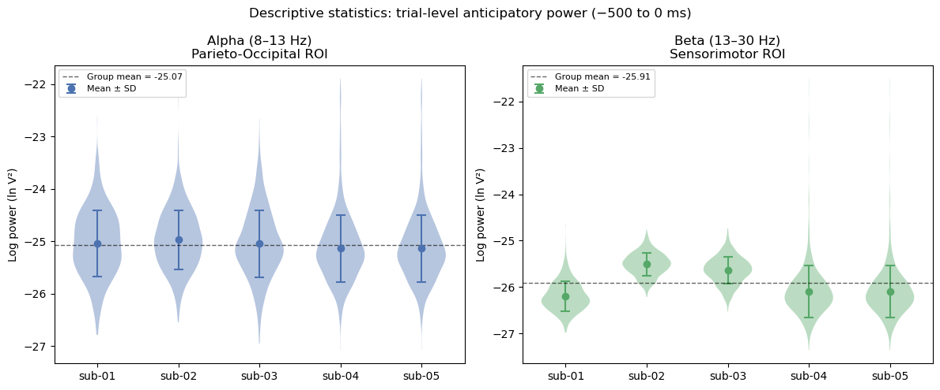
Note. Violin plots show the distribution of trial-level log-power per participant. Dashed lines indicate grand mean across participants. Dots and error bars show participant means ± 1 SD. (A) Alpha power (8–13 Hz) at the parieto-occipital ROI. (B) Beta power (13–30 Hz) at the sensorimotor ROI.

Anticipatory Power Correlations at Fixed Learning Rate
The first analysis tested whether anticipatory alpha and beta power tracked learned expectancy at a fixed learning rate of α = 0.3. It did not. Neither alpha power (sub-01: r = .045; sub-02: r = .041; sub-03: r = .057; sub-04: r = −.034; sub-05: r = −.044) nor beta power (sub-01: r = −.025; sub-02: r = .014; sub-03: r = .052; sub-04: r = .003; sub-05: r < .001) showed a meaningful association with V(t) in any participant (all p > .10). Effect sizes were uniformly close to zero, the direction of the relationship was inconsistent across participants, and there was no evidence of a group-level effect.
Figure 4.
Alpha and Beta Power Correlations With RW Expected Value V(t) at Fixed Learning Rate.
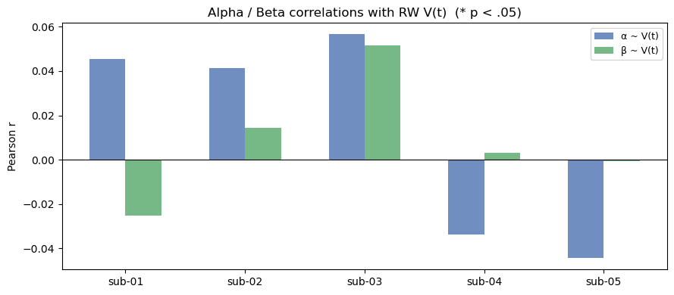
Note. Alpha (α) and beta (β) Pearson r with RW expected value V(t) at fixed learning rate α = 0.3, per participant. Asterisks (*) indicate p < .05.

RW Learning Rate Grid Search
A grid search was then run across α = 0.01–0.99 to find, for each participant, the learning rate that produced the strongest correlation between pre-outcome power and V(t). The rationale was straightforward: if the fixed rate of 0.3 was simply a poor fit for some participants, optimising it individually might reveal an underlying relationship that the fixed-rate analysis missed.
For alpha power, significant peak correlations emerged in four of five participants. Three (sub-03: α = 0.01, r = −.095, p = .011; sub-04: α = 0.02, r = −.078, p = .037; sub-05: α = 0.03, r = −.084, p = .025) showed significant negative correlations at slow learning rates, meaning alpha power tended to be lower on trials where accumulated expectancy was high. Sub-02 went in the opposite direction, showing a significant positive correlation at a faster learning rate (α = 0.55, r = .088, p = .019). Sub-01 did not reach significance at any tested learning rate (peak r = −.070, p = .062).
For beta power, significant peak correlations were found in three of five participants. Sub-03 showed the strongest effect (α = 0.04, r = −.127, p < .001), and sub-02 also showed a significant negative relationship at a slow learning rate (α = 0.01, r = −.099, p = .008). Sub-05 again diverged, showing a significant positive correlation at the fastest learning rate tested (α = 0.99, r = .125, p = .001). Sub-01 and sub-04 did not reach significance (p > .08).
Figure 5.
Best-Fit RW Learning Rates and Peak Correlations by Participant.
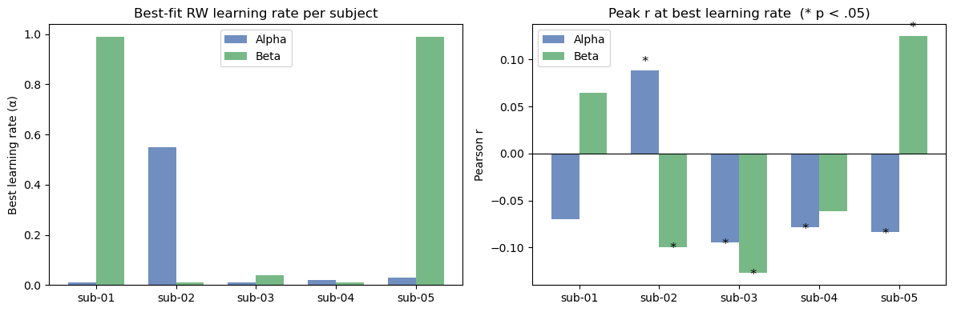
Note. Left: best-fit Rescorla-Wagner learning rate (α) for alpha and beta power per participant. Right: peak Pearson r at optimal α. Asterisks (*) indicate p < .05.

Temporal Generalisation of V(t) Decoding
The final analysis asked whether any spatial pattern of broadband EEG activity reliably encoded V(t) across the pre-outcome window. A temporal generalisation approach was used, applying Support Vector Regression (SVR; linear kernel, C = 1) with 5-fold cross-validation. At every combination of training and test timepoints within the −500 to 0 ms window, the SVR was trained to predict V(t) from the 64-channel EEG spatial pattern, with performance quantified as R².
The results were clear. Across all five participants, R² values were consistently negative throughout the temporal generalisation matrix (all subject-level maxima < −0.016), meaning the model did worse than simply predicting the mean V(t) at every timepoint. No above-chance decoding was found anywhere on or off the diagonal for any participant.
Figure 6.
Temporal Generalisation Matrices for SVR Decoding of RW Expected Value V(t).
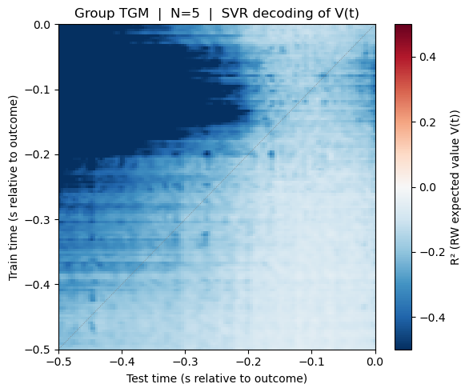
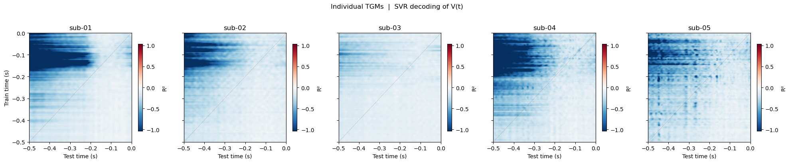
Note. Top: group TGM (N = 5) showing R² for SVR decoding of V(t) from 64-channel EEG at each train–test timepoint pair (−500 to 0 ms). Bottom: individual-participant TGMs. Chance = R² = 0.

Discussion

The study examined whether anticipatory alpha and beta oscillations tracked learned expectancy, as indexed by the Rescorla Wagner expected value, in a gamified reinforcement learning task. Across all three analyses the results did not provide consistent support for the hypotheses. The central finding was that correlations between oscillatory power and V(t) were near zero, even under more favourable analytical conditions.

Absence of effects at a fixed learning rate
In the case of V(t) calculated at a fixed learning rate of α = 0.3, neither alpha nor beta power showed a meaningful association with expected value in any participant (alpha: range r = −.044 to .057; beta: range r = −.025 to .052). This was not entirely unexpected. Fixing the learning rate across all participants assumes that everyone updates their expectations at the same pace, which is unlikely given the well-documented variability in individual learning dynamics. Hence, the null result here may say more about model not being specific enough than about the relationship between anticipatory oscillations and expectancy itself, which motivated the grid search analysis.

Near-zero effect sizes as the key finding
However, even when learning rates were individually optimised in the grid search, correlations remained small in absolute terms (alpha: max |r| = .095; beta: max |r| = .127), and the temporal generalisation analysis produced R² values at or below zero throughout, suggesting that broadband EEG spatial patterns carried no reliable information about V(t). Taken together, the near-zero effect sizes across all three analyses are arguably the most important finding of this pilot. If the true effect were moderate or large, some signal would be expected to emerge even at N = 5, particularly in the grid search where analytical conditions were optimised per participant. The consistently small effects instead suggest that paradigm differences from Riels et al. (2021) are likely to explain the relationship between anticipatory oscillations and learned expectancy, and that any power calculation for a confirmatory replication should be based on these pilot estimates rather than the original effect sizes.

High Variation between individual learning rates
There also was significant variability in optimal learning rates among participants — perhaps a qualitative divide as opposed to a gradient. Most participants showed peak effects at very low learning rates (α = 0.01–0.04), while sub-02 and sub-05 only arrived at significance at very rapid learning rates (α = 0.55 and 0.99, respectively). Crucially, however, all peak correlations remained small in absolute terms (max |r| = .095 for alpha, .127 for beta). This means that participants may have taken very different approaches to following reward contingencies, and no one learning rate can explain this data at the group level. One reason for this heterogeneity is that the participants of slow optimal learning rate were efficiently averaging reward history across a great number of trials, and their V(t) was then biased towards later, more fatiguing periods of the task, in the latter increasing with independent time-on-task effects (Tran et al., 2020), rather than via a genuinely independent modulation of variable expectancy. Regardless, the consistently near-zero effect sizes suggest that any relationship between anticipatory oscillations and V(t) is at best weak in this paradigm, and that a confirmatory replication would require more flexible modelling approaches capable of capturing dynamic, individually varying learning processes rather than assuming a fixed update timescale (Pike & Robinson, 2022).
The present data suggest that participants may cluster into qualitatively distinct learner types: those who integrate reward history slowly across many trials and those who update rapidly, and that these groups may show opposite relationships between oscillatory power and V(t) at any given fixed rate. If so, a group average could in principle reflect a mixture of opposing effects rather than a coherent neural signal, and the replication of Riels et al. in a larger sample should treat learning rate as a subject-level variable rather than a fixed parameter.

Failure of temporal generalisation
The temporal generalisation analysis returned uniformly negative R² values close to 0 for all participants, that is, no spatial pattern of broadband EEG activity consistently encoded V(t) at any point in the pre-outcome window. This is the most clear-cut null result of this experiment. The SVR approach is highly likely to be underpowered (at N = 5). Multivariate decoding techniques involve much larger trial numbers and sample sizes to obtain credible estimates, especially in the present data set which likely does not have the statistical power to detect anything other than very substantial effects. The null TGM finding thus is more an indication of the challenge to perform this task than of the failure to have a genuine neural equivalent of expectancy.

Strengths
Despite the null findings, the study has several notable strengths. The combination of model-based and data-driven analyses (fitting the Rescorla-Wagner model at the individual level alongside SVM temporal generalisation) is a meaningful methodological advance over approaches that rely on coarse condition averages. Linking trial-level expected value and prediction error directly to oscillatory power provides finer-grained, mechanistically interpretable insights into associative learning than group-level comparisons would allow. The gamified Cannonball task also improves on the simple cue-aversive noise paradigm used by Riels et al. (2021) in terms of ecological validity and participant engagement, and the extension to beta oscillations broadens the inferential scope of the study beyond what a single-band approach would allow.

Limitations
Several methodological limitations should be considered when interpreting these findings. The fast-paced, gamified nature of the Cannonball task almost certainly introduced signal contamination that would not have been present in the simpler paradigm used by Riels et al. (2021). The continuous motor demands of the task meant that movement-related artefacts and motor-preparatory beta activity were likely present throughout the anticipatory window, making it hard to cleanly isolate any expectancy-related oscillatory signal from background motor noise.
A related issue is that the overlapping trial structure of a 720-trial task means neural responses to successive outcomes were never fully temporally separated. Without proper deconvolution of the EEG signal, pre-outcome power estimates may partly reflect lingering contamination from the preceding trial's feedback rather than genuine anticipatory activity on the current trial. This is a particular concern for the RW model correlations, which assume that trial-level power estimates reflect each trial's expectancy state in isolation.
With N = 5, all findings should be treated as pilot effect size estimates rather than inferential results. The study was never powered to detect effects reliably, and the pattern of individual differences observed probably will not generalise to a broader population.
One could also argue that the paradigm deviates too substantially from Riels et al. (2021) to constitute a meaningful conceptual replication, as the shift from a simple cue-aversive noise design to a complex gamified task changes multiple factors simultaneously including reinforcement type, cognitive load, motor demands, and task context. Furthermore, the task is embedded within a larger drug study on a high-anxiety sample, meaning pharmacological effects on alpha and beta dynamics cannot be controlled for, and the timing of the task within the broader battery adds a further source of uncontrolled variability.
A more fundamental limitation is the temporal simplicity of the Rescorla-Wagner model itself. Although fitting it at the individual level improves on condition-averaged approaches, the model updates a single associative strength based only on the most recent trial's prediction error and cannot capture longer sequences of past decisions or second-order contingency effects.

Future Directions
Therefore, an alternative to the Rescorla-Wagner model, a recurrent neural network (RNN), could be adopted in future in order to better learn complex temporal relationships for long trial sequences and latent internal representation possibly closer to EEG dynamics structure (Botvinick et al., 2020). Whereas the Rescorla-Wagner model relies on a fixed update rule, an RNN trained using trial-by-trial behavioural and neural data may capture, theoretically, individual differences in the amount of time participants work with reward history over, leading to more accurate and better-targeted predictions of anticipatory oscillatory behaviour. That proposed approach, however, falls outside the scope of the current pilot, as it would need a large amount of training data and participants. A confirmatory replication must be nevertheless architected with this longer-term direction in mind, and design which includes trial number as a within-subject covariate, use proper EEG deconvolution for overlapping trial responses, as well as power calculations which derive from the pilot effect sizes shown here and not those reported by Riels et al. (2021).
Additionally, scalp EEG as a recording modality is also limited in nature. Different from electrocorticography (ECoG) or invasive depth electrodes, scalp EEG captures neural signals through multilayered attenuation, with scalp, skull, and dura acting as a spatial low-pass filter, blurring cortical signal sources contributing to every electrode’s signal. This volume conduction issue implies that a single scalp electrode represents a weighted mixture of activity that originates in a relatively large cortical location rather than a singular neural population, dramatically reducing spatial resolution to between 5–9 cm² versus the sub-millimetre focus achievable with invasive arrays (Leuthardt et al., 2004). The consequence for the current study is that any expectancy-oriented signal, localised to a distinctively narrow spatial generator (e.g., a specific subregion of posterior parietal cortex), will be analysed geospatially across the parieto-occipital ROI, thereby reducing sensitivity and possibly reducing correlation with V(t). Future work aiming to correctly localise the neural substrates of anticipatory oscillations during reinforcement learning would benefit from ECoG recordings in clinical populations or high-density EEG with source modelling, where both offer substantially improved spatial specificity and more reflective measurements overall.

To conclude, the current study found very little evidence to support that anticipatory alpha or beta oscillatory power tracks learned expectancy in the context of gamified reinforcement learning, with correlations still hovering virtually at or around zero with individually optimised analytical conditions. However, this doesn't preclude a genuine relationship between anticipatory oscillations and expectancy. Rather, it implies that the effect found by Riels et al. (2021) may not generalise straightforwardly to more complex paradigms and that, in this context, effect sizes are likely small. The pilot estimates presented in this report nevertheless give an empirical starting point for designing a more adequately powered confirmatory replication, and the combination of individual-level RW modelling with temporal generalisation remains a potentially useful framework for future investigation.
References
Bae, G.-Y., & Luck, S. J. (2017). Dissociable Decoding of Spatial Attention and Working Memory from EEG Oscillations and Sustained Potentials. The Journal of Neuroscience, 38(2), 409–422. https://doi.org/10.1523/jneurosci.2860-17.2017
Bartsch, F., Hamuni, G., Miskovic, V., Lang, P. J., & Keil, A. (2015). Oscillatory brain activity in the alpha range is modulated by the content of word-prompted mental imagery. Psychophysiology, 52(6), 727–735. https://doi.org/10.1111/psyp.12405
Başar, E., & Güntekin, B. (2012). A short review of alpha activity in cognitive processes and in cognitive impairment. International Journal of Psychophysiology, 86(1), 25–38. https://doi.org/10.1016/j.ijpsycho.2012.07.001
Bonnefond, M., & Jensen, O. (2012). Alpha Oscillations Serve to Protect Working Memory Maintenance against Anticipated Distracters. Current Biology, 22(20), 1969–1974. https://doi.org/10.1016/j.cub.2012.08.029
Botvinick, M., Wang, J. X., Dabney, W., Miller, K. J., & Kurth-Nelson, Z. (2020). Deep Reinforcement Learning and Its Neuroscientific Implications. Neuron, 107(4), 603–616. https://doi.org/10.1016/j.neuron.2020.06.014
Clark, A. (2013). Whatever next? Predictive brains, situated agents, and the future of cognitive science. Behavioral and Brain Sciences, 36(3), 181–204. https://doi.org/10.1017/s0140525x12000477
Cohen, M. X. (2014). Analyzing Neural Time Series Data. The MIT Press. https://doi.org/10.7551/mitpress/9609.001.0001
Costa, Vincent D., Dal Monte, O., Lucas, Daniel R., Murray, Elisabeth A., & Averbeck, Bruno B. (2016). Amygdala and Ventral Striatum Make Distinct Contributions to Reinforcement Learning. Neuron, 92(2), 505–517. https://doi.org/10.1016/j.neuron.2016.09.025
Dyck, S., & Klaes, C. (2024). Training-related changes in neural beta oscillations associated with implicit and explicit motor sequence learning. Scientific Reports, 14(1). https://doi.org/10.1038/s41598-024-57285-7
Ferree, T. C., Luu, P., Russell, G. S., & Tucker, D. M. (2001). Scalp electrode impedance, infection risk, and EEG data quality. Clinical Neurophysiology, 112(3), 536–544. https://doi.org/10.1016/s1388-2457(00)00533-2
Fren T.Y. Smulders, Sanne ten Oever, Franc, Conny W.E.M. Quaedflieg, & Vincent. (2018). Single-trial log transformation is optimal in frequency analysis of resting EEG alpha. European Journal of Neuroscience, 48(7), 2585–2598. https://doi.org/10.1111/ejn.13854
Gramfort, A. (2013). MEG and EEG data analysis with MNE-Python. Frontiers in Neuroscience, 7. https://doi.org/10.3389/fnins.2013.00267
Haegens, S., Cousijn, H., Wallis, G., Harrison, P. J., & Nobre, A. C. (2014). Inter- and intra-individual variability in alpha peak frequency. NeuroImage, 92, 46–55. https://doi.org/10.1016/j.neuroimage.2014.01.049
HajiHosseini, A., & Hutcherson, C. A. (2021). Alpha oscillations and event-related potentials reflect distinct dynamics of attribute construction and evidence accumulation in dietary decision making. ELife, 10. https://doi.org/10.7554/elife.60874
Haufe, S., Meinecke, F. C., Görgen, K., Sven Dähne, Haynes, J.-D., Blankertz, B., & Bießmann, F. (2014). On the interpretation of weight vectors of linear models in multivariate neuroimaging. NeuroImage, 87, 96–110. https://doi.org/10.1016/j.neuroimage.2013.10.067
Haxby, J. V., Connolly, A. C., & Guntupalli, J. S. (2014). Decoding Neural Representational Spaces Using Multivariate Pattern Analysis. Annual Review of Neuroscience, 37(1), 435–456. https://doi.org/10.1146/annurev-neuro-062012-170325
King, J-R., & Dehaene, S. (2014). Characterizing the dynamics of mental representations: the temporal generalization method. Trends in Cognitive Sciences, 18(4), 203–210. https://doi.org/10.1016/j.tics.2014.01.002
Klimesch, W. (2012). Alpha-band oscillations, attention, and controlled access to stored information. Trends in Cognitive Sciences, 16(12), 606–617. https://doi.org/10.1016/j.tics.2012.10.007
Knyazev, G. G., Savostyanov, A. N., & Levin, E. A. (2004). Alpha oscillations as a correlate of trait anxiety. International Journal of Psychophysiology, 53(2), 147–160. https://doi.org/10.1016/j.ijpsycho.2004.03.001
Leuthardt, E. C., Schalk, G., Wolpaw, J. R., Ojemann, J. G., & Moran, D. W. (2004). A brain–computer interface using electrocorticographic signals in humans. Journal of Neural Engineering, 1(2), 63–71. https://doi.org/10.1088/1741-2560/1/2/001
Perruchet, P. (2015). Dissociating conscious expectancies from automatic link formation in associative learning: A review on the so-called Perruchet effect. Journal of Experimental Psychology: Animal Learning and Cognition, 41(2), 105–127. https://doi.org/10.1037/xan0000060
Pike, A. C., & Robinson, O. J. (2022). Reinforcement Learning in Patients With Mood and Anxiety Disorders vs Control Individuals. JAMA Psychiatry, 79(4). https://doi.org/10.1001/jamapsychiatry.2022.0051
Raffaelli, Q., Mills, C., & Christoff, K. (2017). The knowns and unknowns of boredom: a review of the literature. Experimental Brain Research, 236(9), 2451–2462. https://doi.org/10.1007/s00221-017-4922-7
Riels, K., Ramos Campagnoli, R., Thigpen, N., & Keil, A. (2021). Oscillatory brain activity links experience to expectancy during associative learning. Psychophysiology, 59(5). https://doi.org/10.1111/psyp.13946
Rodriguez, P. F., Aron, A. R., & Poldrack, R. A. (2006). Ventral–striatal/nucleus–accumbens sensitivity to prediction errors during classification learning. Human Brain Mapping, 27(4), 306–313. https://doi.org/10.1002/hbm.20186
Sprevak, M., & Smith, R. (2023). An Introduction to Predictive Processing Models of Perception and Decision‐Making. Topics in Cognitive Science. https://doi.org/10.1111/tops.12704
Tran, Y., Craig, A., Craig, R., Chai, R., & Nguyen, H. (2020). The influence of mental fatigue on brain activity: Evidence from a systematic review with meta‐analyses. Psychophysiology, 57(5). https://doi.org/10.1111/psyp.13554
Weaverdyck, M. E., Lieberman, M. D., & Parkinson, C. (2020). Tools of the Trade Multivoxel pattern analysis in fMRI: a practical introduction for social and affective neuroscientists. Social Cognitive and Affective Neuroscience, 15(4), 487–509. https://doi.org/10.1093/scan/nsaa057
Widmann, A., Schröger, E., & Maess, B. (2015). Digital filter design for electrophysiological data – a practical approach. Journal of Neuroscience Methods, 250, 34–46. https://doi.org/10.1016/j.jneumeth.2014.08.002
Zhang, L., & Gläscher, J. (2020). A brain network supporting social influences in human decision-making. Science Advances, 6(34), eabb4159. https://doi.org/10.1126/sciadv.abb4159

Appendix
All participants must:
1. Be aged between 18 and 55 years of age.
2. Have a high level of trait anxiety, as assessed using the trait component of the self-report State Trait Inventory of Cognitive and Somatic Anxiety (STICSA). The threshold for inclusion will be a score of 42 or higher. This threshold will be applied to both healthy individuals and participants that will have a current or previous clinical diagnosis of an anxiety and/or mood disorder.
3. Be physically healthy, defined as having not clinically relevant abnormalities identified by a detailed medical history and full examination including blood pressure and pulse rate measurement, 12-lead ECG and clinical laboratory test.
4. Have sufficient language skills to complete validated questionnaires and cognitive tasks.
5. Provide a personally signed and dated informed consent document indicating that the participant has been informed of and agrees to comply with all aspects of the study.
6. Be willing and able to comply with scheduled visits, dosing plan, laboratory trials and any other necessary procedures.
7. Agree to use a medically accepted and highly effective method of contraception throughout the study, if of childbearing potential.
All participants must not:
1. Have a current or previously diagnosed psychotic disorder or personality disorder, based on the determination of the investigators.
2. Have scored 70 or lower in the WASI at the screening visit.
3. Have a medically significant condition which renders them unsuitable for the study (e.g., diabetes, severe cardiovascular disease, severe respiratory disease (e.g. COPD), hepatic or renal failure etc.).
4. Have a diagnosis of epilepsy, or a family history of epilepsy or seizures.
5. Be pregnant or breastfeeding. Participants of childbearing potential must have a negative pregnancy test at screening and at all subsequent drug sessions.
6. Currently consume alcohol in excess of 28 units a week or more than 6 cups of caffeinated drinks per day.
7. Smoke more than 5 cigarette per day.
8. Have taken illicit drugs 7 days prior to admission or current use of drugs of abuse including amphetamines, MDMA, cannabis and opioids.
9. Have taken any other medication during the course of the study that has not been discussed. This should be documented by the investigators. (As an exception, 1g paracetamol/24 hours may be taken up to 24 hours prior to any visit).
10. Have consumed alcohol or caffeine within 12 hours and/or nicotine 4 hours prior to the screening visit and study days 1, 2 and 3 until discharged at the end of each of those visits.
11. Have consumed grapefruit juice or Seville oranges-containing products 24 hours prior to admission.
12. Have used any prescribed medication (aside from the contraceptive pill or hormone replacement theory) in the 3 weeks prior to enrolment or non-prescription medication (other than paracetamol) in the previous 7 days.
13. Have a significant history of drugs of abuse (including benzodiazepines) or positive drugs of abuse test.
14. Have received another new chemical entity in the 1 month before dosing or taken part in another research study using drugs within 1 month before dosing.
15. Have an acute illness within 2 weeks before the start of study.
16. Have any clinically significant abnormalities in clinical chemistry (including liver function tests), haematology or urinalysis results.
17. Have self-reported HIV, hepatitis B or hepatitis C.
18. Have a definite or suspected personal or family history of intolerance or hypersensitivity to drugs and/or their excipients, judged to be clinically relevant by the investigator.
19. Have a history or presence of gastrointestinal, hepatic or renal disease or other condition known to interfere with absorption, distribution, metabolism or excretion of drugs.
20. Have diagnosed hypertension, or supine systolic BP outside of the range of 90 to 140 mmHg and a supine diastolic BP outside the range of 40 to 90 mmHg, after a period of acclimatisation.
21. Have a decrease in systolic BP of > 25 mmHg or a decrease in diastolic BP of > 15 mmHg when going from resting in bed to standing position, with or without symptoms such as dizziness or light-headedness. (For determination of orthostatic hypotension, lying and standing BP will be recorded after the subject has rested for 10 minutes and has had resting BP recorded followed by measurements 5 minutes after standing).
22. Have had treatment in the previous 3 months with any drug known to have a well-defined potential for hepatotoxicity (e.g.,halothane).
23. Has a risk of suicide or self-harm according to the investigator’s clinical judgment.
24. Be a subject who, in the opinion of the investigator, should not participate in the study for reasons of safety.

