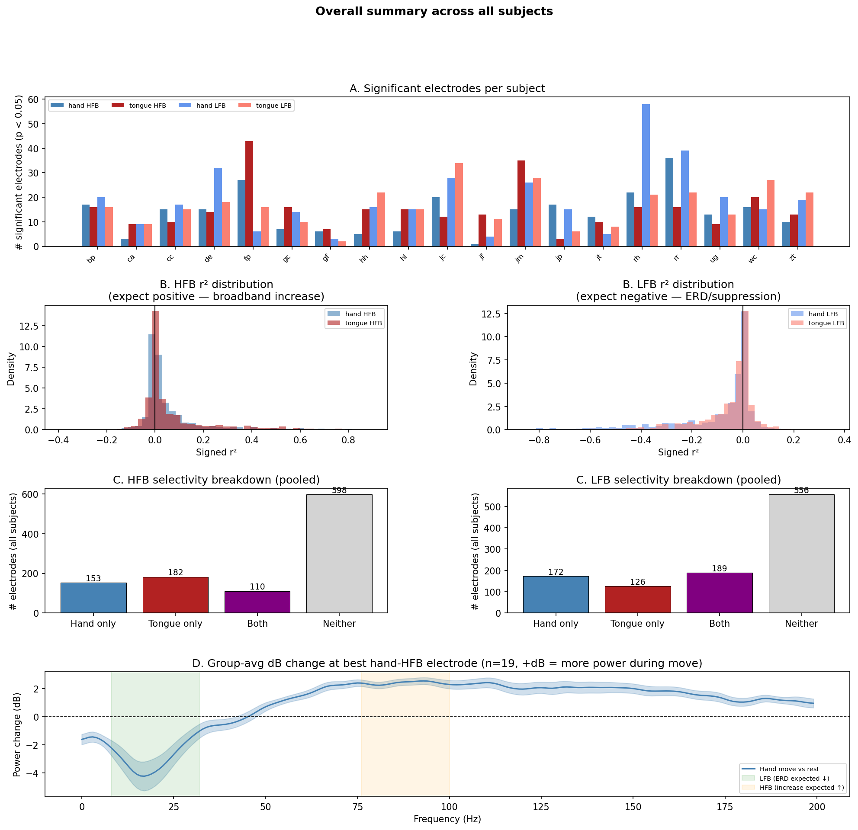

Summary
We investigated how hand and tongue movements modulated neural power in high frequency broadband (HFB, ~70-115 Hz) and low frequency bands (LFB, ~0-30 Hz) using electrocorticographic recordings from 19 subjects performing Miller's motor_basic paradigm. By comparing movement periods to rest, we assessed both the statistical significance and effect size of power changes at each electrode across the cortical surface.
Plot A shows the number of significant electrodes (p < 0.05) per subject for hand and tongue movements in both HFB and LFB bands. Electrode counts vary substantially across subjects, reflecting the stochastic nature of clinical electrode placement.

We can then look at the effect sizes of the significant electrodes from A. The reason why most of the effect sizes for both LFB and HFB are at 0 is because the majority of the electrodes are unrelated to hand and tongue movements. B(top) shows the effect sizes (r^2) of high frequency broadband. The electrodes that deviate from 0 show a positive effect size for B(top), reflecting the increase in neural power in high frequency broadband during hand and tongue movements. This is consistent with HFB reflecting increased local neuronal population activity beneath the electrode during motor execution. On the other hand, for LFB, the electrodes that deviate from 0 show a negative effect size. This is an event related desynchronization, reflecting the breakdown of synchronous beta oscillations during movements.
Panel C shows the breakdown of HFB electrode selectivity pooled across all subjects. Of the 1,043 total electrodes, the majority (598) showed no selectivity for either movement, consistent with the zero-peak observed in Panel B. Of the remaining electrodes, 153 responded selectively to hand movement only, 182 to tongue movement only, and 110 to both. The fact that hand-only and tongue-only electrodes outnumber the both category suggests that HFB captures spatially specific motor representations, with distinct electrode populations encoding hand and tongue movements separately. On the other hand , LFB reported 189 for both, 172 for hand and 126 for tongue. This spatial specificity is a key advantage of HFB over LFB, which tends to suppress broadly and non-selectively across the peri-central cortical surface during movement.
Panel D shows the group-averaged decibel (dB) change in neural power across frequencies at the best hand electrode, comparing movement to rest across all 19 subjects. A positive dB value indicates greater power during movement relative to rest, while a negative value indicates suppression. Two distinct patterns are visible. In the low frequency range (green shaded region, ~0-30 Hz), there is a clear power decrease bottoming out at approximately -5 dB around 20 Hz, reflecting the event-related desynchronization (ERD) of beta oscillations during hand movement. In the high frequency range (orange shaded region, ~70-115 Hz), there is a sustained power increase of approximately +2 dB, reflecting the broadband neuronal activity increase during motor execution. These two effects are opposite in direction, consistent with the opposing signed r² distributions seen in Panel B.

我们利用19名受试者在执行Miller的“motor_basic”范式期间的皮层电图记录，研究了手部与舌部运动如何调节高频宽带（HFB，约70-115 Hz）和低频段（LFB，约0-30 Hz）的神经功率。通过将运动期与静息期进行比较，我们评估了皮层表面每个电极处功率变化的统计显著性及效应量。
图A展示了每位受试者中，对于手部和舌部运动在HFB和LFB频段下具有显著性的电极数量（p < 0.05）。不同受试者间的电极数量差异很大，这反映了临床电极放置的随机性。
接下来，我们观察图A中那些显著电极的效应量。对于LFB和HFB，大多数效应量为0，原因是大部分电极与手部及舌部运动无关。图B（上）显示了高频宽带（HFB）的效应量（r²）。偏离0的电极显示出正的效应量，反映了在手部和舌部运动期间，高频宽带神经功率的增加。这与HFB反映运动执行期间电极下方局部神经元群体活动增强的结论一致。另一方面，对于LFB，偏离0的电极显示出负的效应量。这是一种事件相关去同步化，反映了运动期间beta振荡同步性的破坏。
图C显示了汇总所有受试者的HFB电极选择性分类。在总共1043个电极中，大多数（598个）对两种运动均无选择性，这与图B中观察到的零值峰值一致。在剩余的电极中，153个仅对手部运动有选择性响应，182个仅对舌部运动有选择性响应，110个对两种运动均有响应。手部专属和舌部专属电极数量超过“两者均响应”的类别，表明HFB能够捕捉到具有空间特异性的运动表征，即不同的电极群体分别编码手部和舌部运动。相比之下，LFB频段的数据为：两者均响应189个，手部专属172个，舌部专属126个。这种空间特异性是HFB相较于LFB的关键优势，因为LFB在运动期间倾向于在中央周皮层表面产生广泛且非选择性的抑制。
图D显示了在所有19名受试者中，最佳手部电极处神经功率随频率变化的群体平均分贝（dB）变化（运动期相对于静息期）。dB值为正表示运动期间功率相对于静息期增加，负值则表示抑制。可以看到两种不同的模式。在低频范围（绿色阴影区，约0-30 Hz），功率明显下降，在大约20 Hz处达到约-5 dB的最低点，反映了手部运动期间beta振荡的事件相关去同步化（ERD）。在高频范围（橙色阴影区，约70-115 Hz），功率持续增加约+2 dB，反映了运动执行期间宽带神经元活动的增强。这两种效应方向相反，与图B中观察到的r²分布符号相反的现象一致。

