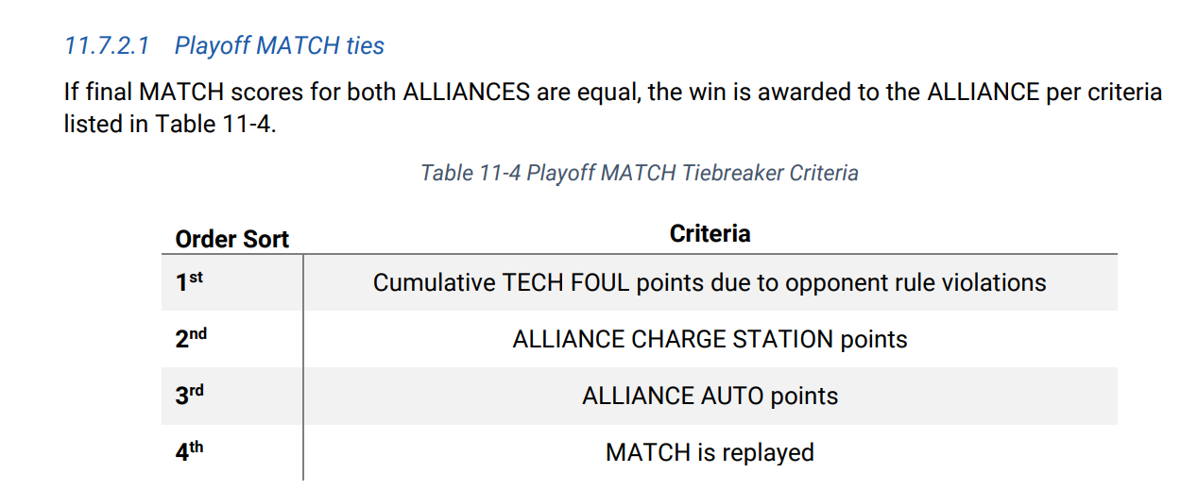

[
Charged Up℠ Team Update 16 March 7, 2023]
Section 11.7.2.2 Playoff Finals
If a Finals MATCH ends in a tie score, the tie is not broken using the criteria in Table 11-4, the MATCH remains a tie. In the case where an ALLIANCE hasn’t won 2 MATCHES after 3 MATCHES have been played (because of tied MATCHES), the Playoffs proceed with up to 3 additional Finals MATCHES, called Overtime MATCHES, until an ALLIANCE has won 2 Finals MATCHES. In the case where the Overtime MATCH scores for both ALLIANCES are equal, the win for that Overtime MATCH is awarded based on the criteria listed in Table 11-4.
[
Charged Up℠ Game Manual Page 123] 11.7.2.2 Playoff Finals Once a single ALLIANCE remains in each Upper and Lower bracket, those ALLIANCES proceed to the Finals round. The first ALLIANCE to win 2 MATCHES in the Finals becomes the event’s Champions. If a Finals MATCH ends in a tie score, the tie is not broken using the criteria in Table 11-4, the MATCH remains a tie. In the case where an ALLIANCE hasn’t won 2 MATCHES after 3 MATCHES have been played (because of tied MATCHES), the Playoffs proceed with up to 3 additional Finals MATCHES, called Overtime MATCHES, until an ALLIANCE has won 2 Finals MATCHES. In the case where the Overtime MATCH scores for both ALLIANCES are equal, the win for that Overtime MATCH is awarded based on the criteria listed in Table 11-4.

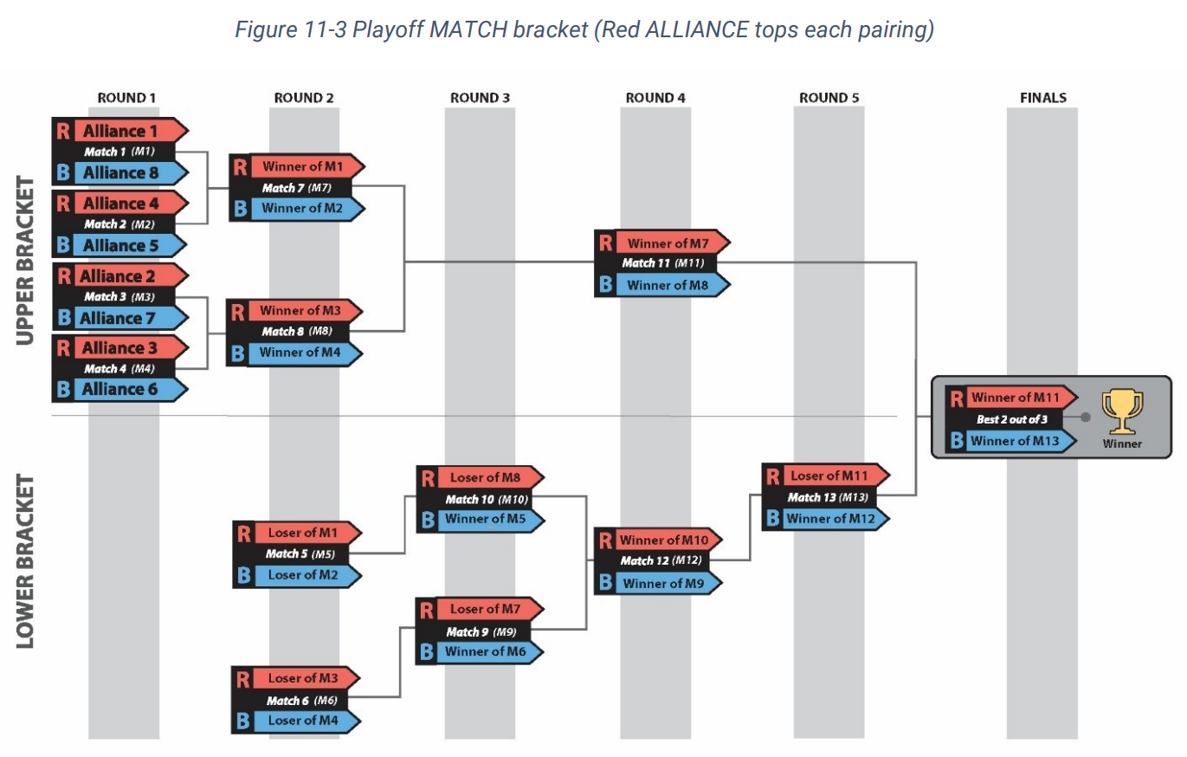
Table 11-3 Typical Playoff MATCH Schedule
Match | MATCH | Blue | Red | Blue Gap (minutes) | Red Gap (minutes) | Winner moves to | Loser moves to
1 | Upper Bracket  Round 1 – MATCH 1 | ALLIANCE 8 | ALLIANCE 1 |  |  | Red – MATCH 7 | Red – MATCH 5
2 | Upper Bracket  Round 1 – MATCH 2 | ALLIANCE 5 | ALLIANCE 4 |  |  | Blue – MATCH 7 | Blue – MATCH 5
3 | Upper Bracket  Round 1 – MATCH 3 | ALLIANCE 7 | ALLIANCE 2 |  |  | Red – MATCH 8 | Red – MATCH 6
4 | Upper Bracket  Round 1 – MATCH 4 | ALLIANCE 6 | ALLIANCE 3 |  |  | Blue – MATCH 8 | Blue – MATCH 6
8-minute Break
5 | Lower Bracket  Round 2 – MATCH 5 | Loser of MATCH 2 | Loser of MATCH 1 | 24m | 31m | Blue – MATCH 10 | 1ST Eliminated
6 | Lower Bracket  Round 2 - MATCH 6 | Loser of MATCH 4 | Loser of MATCH 3 | 17m | 24m | Blue – MATCH 9 | 2ND Eliminated
7 | Upper Bracket  Round 2 - MATCH 7 | Winner of MATCH 2 | Winner of MATCH 1 | 38m | 45m | Red – MATCH 11 | Red – MATCH 9
8 | Upper Bracket  Round 2 - MATCH 8 | Winner of MATCH 4 | Winner of MATCH 3 | 31m | 38m | Blue – MATCH 11 | Red – MATCH 10
8-minute Break
9 | Lower Bracket  Round 3 - MATCH 9 | Winner of MATCH 6 | Loser of MATCH 7 | 24m | 17m | Red – MATCH 12 | 3RD Eliminated
10 | Lower Bracket  Round 3 - MATCH 10 | Winner of MATCH 5 | Loser of MATCH 8 | 38m | 17m | Blue – MATCH 12 | 4TH Eliminated
8-minute Break
11 | Upper Bracket  Round 4 - MATCH 11 | Winner of MATCH 8 | Winner of MATCH 7 | 30m | 37m | Red – Match 14  1st Finalist Alliance | Red – MATCH 13
12 | Lower Bracket  Round 4 - MATCH 12 | Winner of MATCH 9 | Winner of MATCH 10 | 24m | 17m | Blue – MATCH 13 | 5TH Eliminated
15-minute Awards Break
13 | Lower Bracket  Round 5 - MATCH 13 | Winner of MATCH 12 | Loser of MATCH 11 | 17m | 24m | Blue – MATCH 14  2nd Finalist Alliance | 6TH Eliminated
15-minute Awards Break
Handshake / High Five with the Two Finalist Alliances
14 | Finals MATCH  Match 14 | Winner of MATCH 13 | Winner of MATCH 11 | 17m | 44m | MATCH 15 | MATCH 15
15-minute Awards Break
15 | Finals MATCH  Match 15 | Winner of MATCH 13 | Winner of MATCH 11 | 17m | 17m | Winner Alliance  or MATCH 16* | Finalist Alliance  or MATCH 16*
15-minute Awards Break
16 | * Finals Tiebreaker*  * Match 16 * | Winner of MATCH 13 | Winner of MATCH 11 | 17m | 17m | Winner Alliance  or MATCH 17* | Finalist Alliance  or MATCH 17*
Possible Winner and Finalist Awards
17 | * Overtime MATCH *  * Match 17 * | Winner of MATCH 13 | Winner of MATCH 11 |  |  | Winner Alliance  or MATCH 18* | Finalist Alliance  or MATCH 18*
Possible Winner and Finalist Awards
18 | * Overtime MATCH *  * Match 18 * | Winner of MATCH 13 | Winner of MATCH 11 |  |  | Winner Alliance  or MATCH 19* | Finalist Alliance  or MATCH 19*
Possible Winner and Finalist Awards
19 | * Overtime MATCH *  * Match 19 * | Winner of MATCH 13 | Winner of MATCH 11 |  |  | Winner Alliance | Finalist Alliance
* if required Possible Winner and Finalist Awards

Charged Up℠ Team Update 16 March 7, 2023] - Section 11.7.2.2 Playoff Finals
… If a Finals MATCH ends in a tie score, the tie is not broken using the criteria in Table 11-4, the MATCH remains a tie.
…the Playoffs proceed with up to 3 additional Finals MATCHES…until an ALLIANCE has won 2 Finals MATCHES.
…where the Overtime MATCH scores for both ALLIANCES are equal, the win for that Overtime MATCH is awarded based on the criteria listed in Table 11-4

