**Nutriscore – a Java Application**

The aim of the program is to reconstruct a nutriscore slider using Java Swing.



# Code structure

The program is built using the following structure.

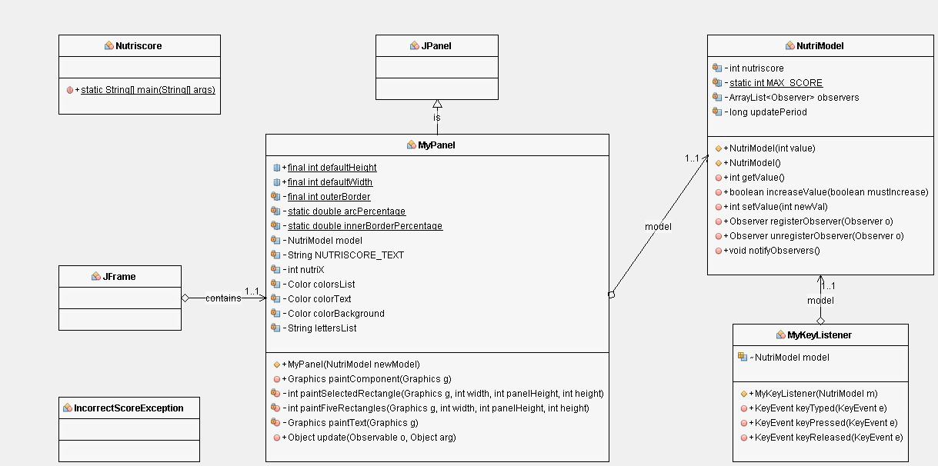

The value of the model is updated through a request to <https://www.random.org/>, that provides every 10 seconds a value between 0 and 4. As an Observer, the panel then repaints.

The left and right keys also provide control, for testing purposes.

# Jar generation

Compilation and JAR generation are handled by the script “compile.sh”.

NB: JAR generation is still a work in progress: the JAR obtained with this script does not run, so we provide an executable archive that was generated with an IDE.