**Curriculum Vitae ARTHUR DE OLIVEIRA**

Personal information / data



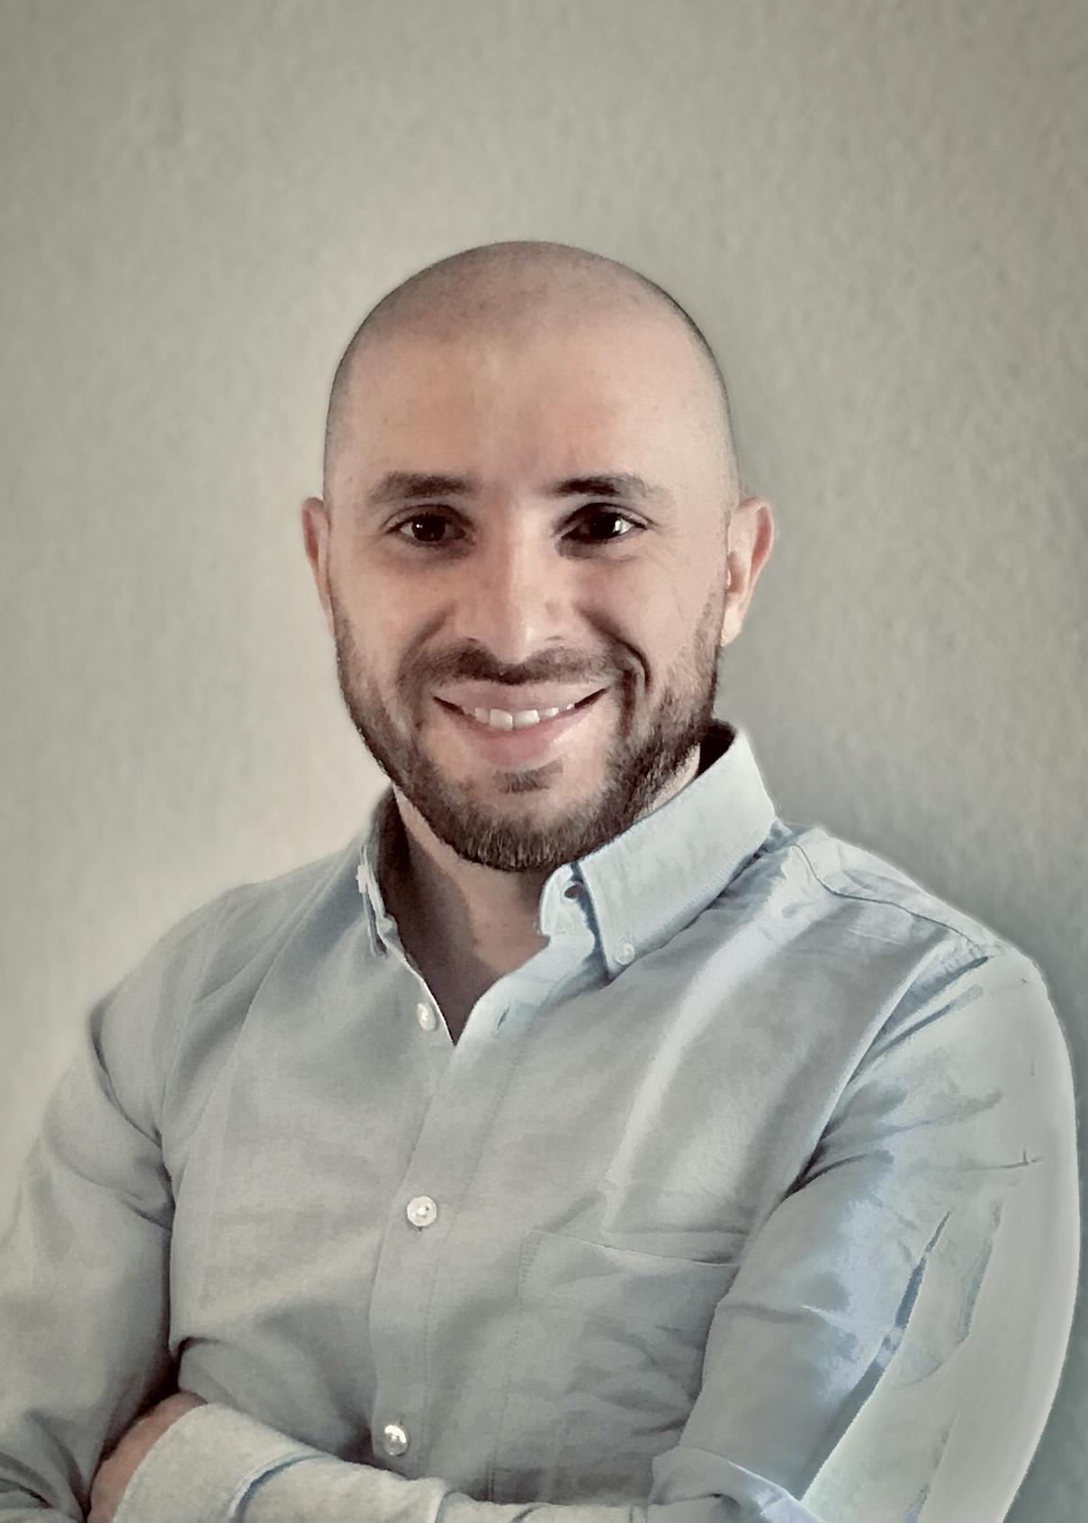

Mobile 0176 / 75393455

Email arthurmeibak@gmail.com

Date and place of birth 24.11.1983 in Sao Paulo

Nationality Brazilian

Marital Status Married

Work Permit Aufenthaltserlaubnis

Recent Activity

12/2022 – Today Attending a B1 German course taught by a private teacher,

Stuttgart, Germany

04/2023 – Today Minijob as kitchen helper at Lou’s Catering, Leinfelden, Germany

Professional career / professional experience

08/2019 – 03/2023 **Marketing Analyst at Justitia Journal, São Paulo, Brazil**

* Analyzing data to make the journal better positioned in the appropriate indicators.
* Translating analysis into reports, so that my colleagues and I could have a better understanding about the publishing market in Brazil.
* Clarifying authors about the requirements for publishing academic articles in the journal, as well as the deadlines for their submission.
* Providing guidance to authors on the best strategies for their articles to be approved for publication in the journal.
* − Using data analysis to increase people’s acknowledgment about the journal. It was achieved by using SEO analytics not only to promote the journal in search engines, but to understand where the domain traffic comes from, and which contents are more engaging.

06/2014 – 07/2019 **Data Analyst at Transparência Brasil, São Paulo, Brazil**

* Gathering and analyzing data to create measurable indicators regarding the work of Brazilian congressmen.
* Performing research on a variety of politics related subjects, such as the presence of women in the Brazilian parliament, and the use of the Freedom of Information Law in Brazil.
* Administering media resources, evaluating press releases and communicating information to colleagues.

04/2012 – 07/2014 **Translator at Uvocorp, São Paulo, Brazil**

* Proofreading, rewriting, quality-checking, and follow-up with other service providers.
* Setting up translation projects, memories, glossaries, templates, and style guides using SDL Studio Trados, Multiterm, MemoQ, and Microsoft Office.

School education and studies / Academic education

08/2011 – 06/2014 **Bachelor of International Relations at the University of São**

**Paulo, Brazil**

* Overall grade: 2.05

Other activities

02/2011 – 03/2012 **External Collaborator at Educar para o Mundo, São**

**Paulo, Brazil**

* Planning and instituting specific human rights procedures to uphold cultural, social and economic rights.
* Assessing impact of each human rights activity by analyzing human rights issues regarding groups of immigrants living in Sao Paulo.
* Caring out human rights activities respecting gender equality, social, economic and ethnicity of the community.

Special knowledge

**Languages**: Portuguese Native speaker

English Fluent

German B1 level

French Intermediate

Spanish Intermediate

**Software**: HTML5, CSS3, JavaScript, React, Github, VS Code,

Bootstrap, Saas, Styled-components, UX/UI, Flexbox,

jQuery, Microsoft Office.

Interests / Hobbies

playing football, cooking, gardening, listening to music



Stuttgart, 19.06.2023,