Jingtang Ma

Lab1

Q1

(b)

Before rownames (college) = college[,1]:

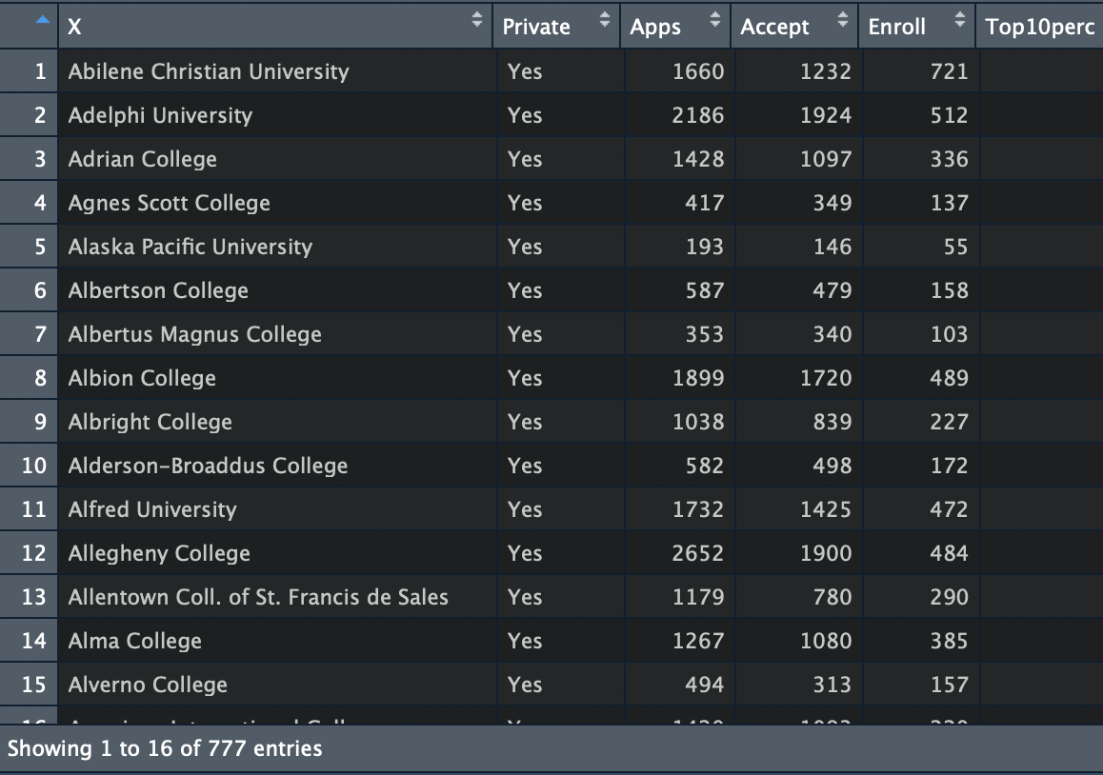

After rownames (college) = college[,1]:

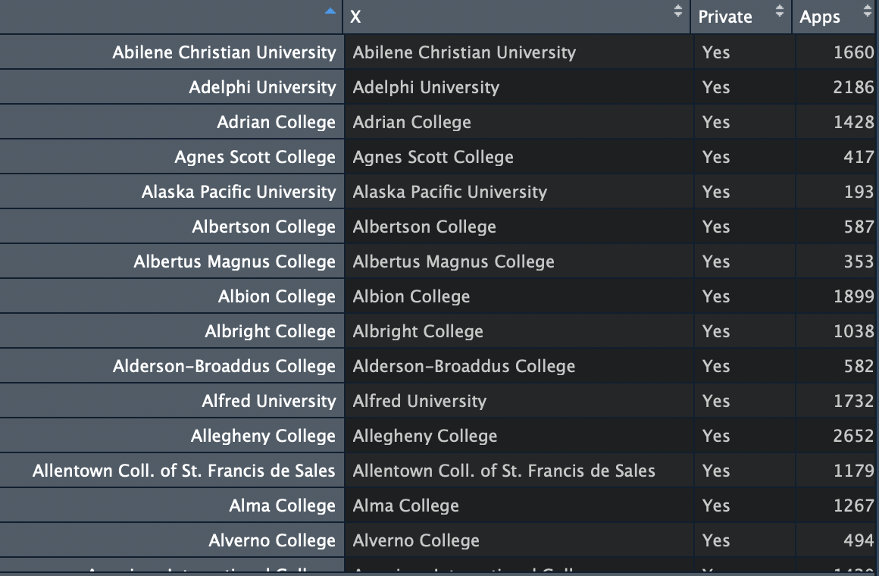

(c)  
(i)

(ii)

(iii)



(iv)

(v)

(vi)

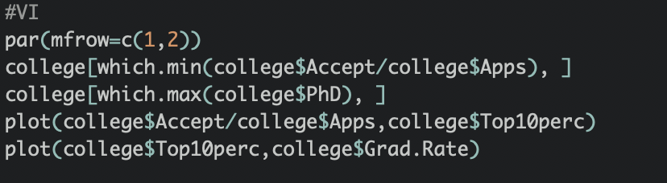

I found four interesting things:

1. The acceptance rate of Princeton University is the lowest.
2. The number of PhD students of Texas A&M University at Galveston is the largest.
3. When the admission rate is increasing, the number of students from Top10 high school is decreasing.
4. When the number of students from Top10 high school is increasing, the grad rate is also increasing.

Q2

(a)

Quantitative: mpg, cylinders, displacement, horsepower, weight, acceleration, year.

Qualitative: origin, name

(b)

Mpg: 9.0 to 46.6

Cylinders: 3 to 8

Displacement: 68 to 230

Horsepower: 46 to 230

Weight: 1613 to 5140

Acceleration: 8.0 to 24.8

Year: 70 to 82

Output:

(c)

Output:

Mean of each quantitative predictor:

Mpg: 23.45

Cylinders: 5.47

Displacement: 194.41

Horsepower: 104.47

Weight: 2977.58

Acceleration: 15.54

Year: 75.98

standard deviation of each quantitative predictor:

Mpg: 7.81

Cylinders: 1.71

Displacement: 104.64

Horsepower: 38.49

Weight: 49.40

Acceleration: 2.76

Year: 3.7

(d)

Output:

(e)

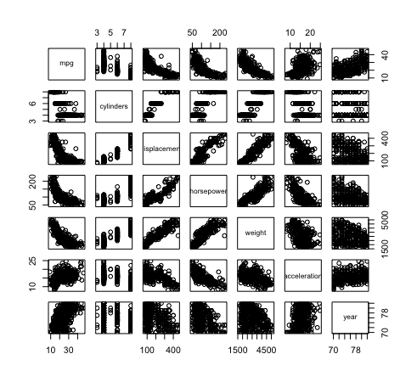

According to the scatterplot matrix above, I found some of cool predictors:

1. When cylinders are increasing, mpg is decreasing. Means if we want more cylinders, we have to pay more money for gasoline.
2. When weight is increasing, mpg is decreasing. If you have a heavy car, you should pay more for gasoline
3. There is a good news, we know that you will pay more when your car heavy. But when weight is increasing, horsepower is also increasing.



(f)

According to the plots above:

* If we know cylinders, displacement, horsepower, and weight are increasing, we can predict that mpg is decreasing.
* If we know cylinders, acceleration and year are increasing, we can predict that mpg is increasing.

Q3

(a)

This data frame is housing values in suburbs of Boston

The Boston data frame has 506 rows and 14 columns.

The columns represent each characters and the rows represent each houses.

(b)

The picture contains all of things for housing values in suburbs of Boston.We can easier find when crime rate is increasing, weighted mean of distances to five Boston employment centres is decreasing,

(c)

Yes, when crime rate is increasing, proportion of owner-occupied units built prior to 1940 is going to increasing and full-value property-tax rate per \$10,000 is increasing. When crime rate is increasing, weighted mean of distances to five Boston employment centres and median value of owner-occupied homes in \$1000s are decreasing.

(d)

According to the picture above, we know