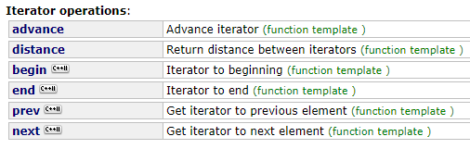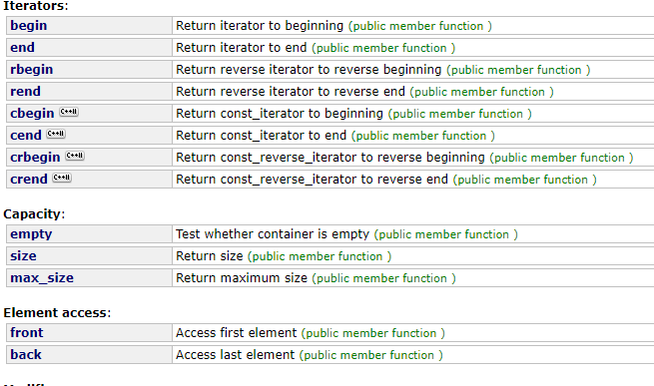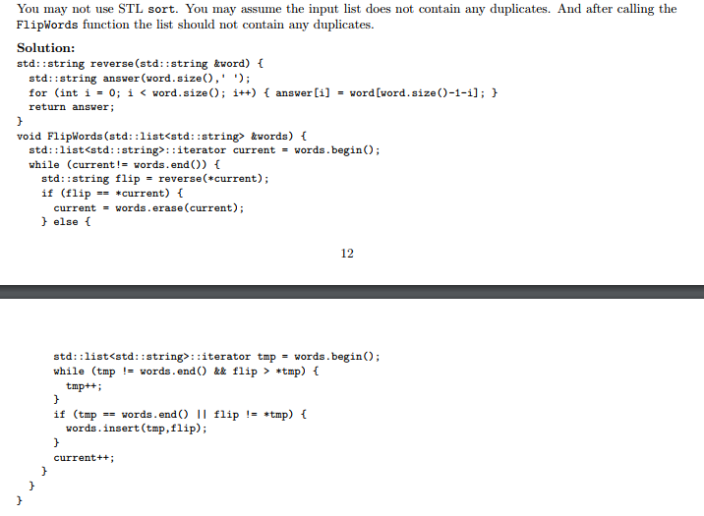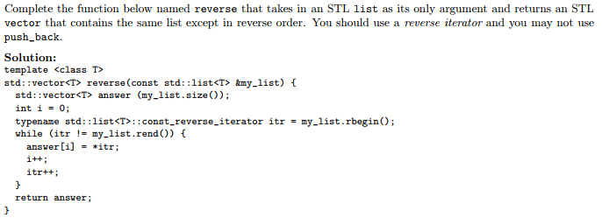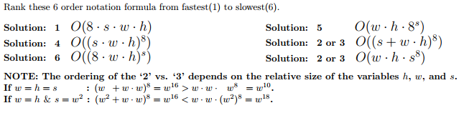

List<int>::const_iterator it1 = lst.begin()

List<int>::iterator it2 = lst.begin()

Recursion: examine frames of the stack

Dr. Memory for leaks (takes a long time to run

Backtrace to find crash

Gdb variable values

Watchpoint to see semantic errors.

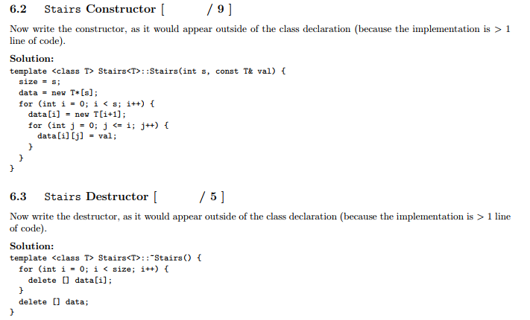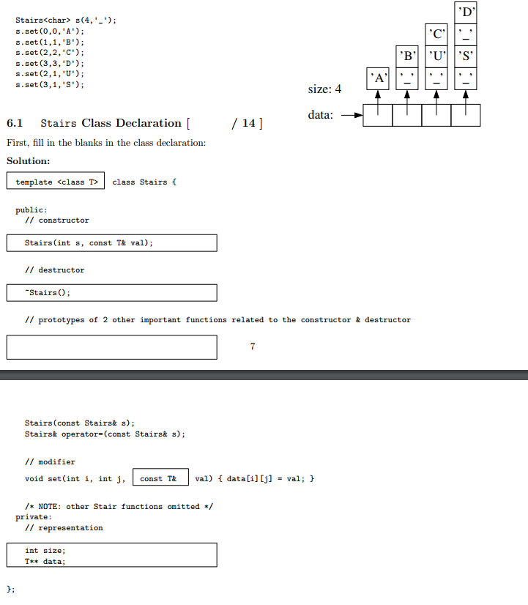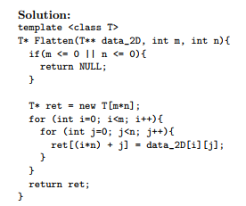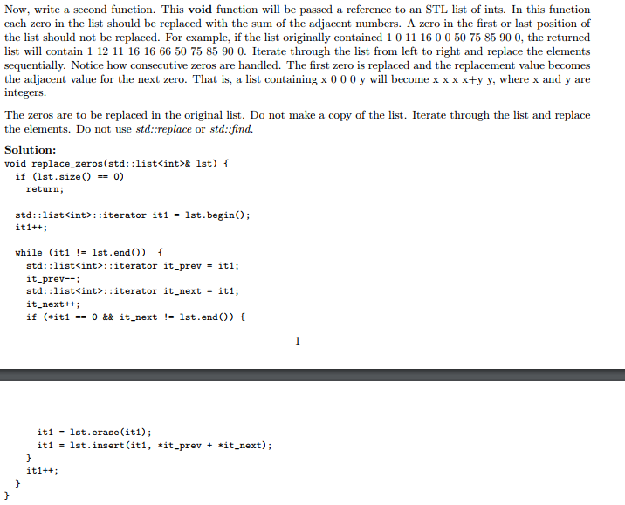

Above is outside of the class declaration so need :: stuff

Memory Errors:

New used with [], then delete with []

** with new have to delete [] and delete

Changing a 2D data structure to a 1D data structure