Curso: C++ Moderno
Período: 1º semestre/2017
Aluno: Arthur Nunes de Paiva Santos Queiroz

Lista de exercícios Módulo 05: Semântica de transferência e encaminhamento perfeito

Questões
Questão 1 1
Questão 2 2
Questão 3 4
Questão 4 5
Questão 5 6
Questão 6 7
Questão 7 8

Questão 1
lmplemente as funções de transferência para a classe BigInt.
BigInt.h
#ifndef BIGINT_H
#define BIGINT_H

#include <cstdint>
#include <algorithm>
#include <iostream>

struct BigInt{
int sig_;
int len_;
uint8_t* mag_;

BigInt(int sig, int len)
: sig_(sig), len_(len), mag_( len ? new uint8_t[len] : nullptr)
{
// std::cout << "BigInt: Construtor" << std::endl;
}

BigInt(const BigInt& bi)
: sig_(bi.sig_), len_(bi.len_), mag_( bi.len_ ? new uint8_t[bi.len_] : nullptr)
{
std::copy(bi.mag_, bi.mag_ + len_, mag_);
// std::cout << "BigInt: Construtor de copia" << std::endl;
}

BigInt& operator=(const BigInt& bi){
sig_ = bi.sig_;
len_ = bi.len_;
delete[] mag_;
mag_ = len_ ? new uint8_t[len_] : nullptr;
std::copy(bi.mag_, bi.mag_ + len_, mag_);
// std::cout << "BigInt: Atribuicao por copia" << std::endl;
return *this;
}

BigInt(BigInt&& bi)
: sig_(bi.sig_), len_(bi.len_), mag_(nullptr)
{
mag_ = bi.mag_;
bi.len_ = 0;
bi.mag_ = nullptr;
// std::cout << "BigInt: Construtor de transferencia" << std::endl;
}

BigInt& operator=(BigInt&& bi){
sig_ = bi.sig_;
len_ = bi.len_;
delete[] mag_;
mag_ = bi.mag_;
bi.len_ = 0;
bi.mag_ = nullptr;
// std::cout << "BigInt: Atribuicao por transferencia" << std::endl;
return *this;
}

~BigInt(){
delete[] mag_;
}
};

#endif // BIGINT_H

Questão 2
Refatore o operator= para utilizar o copy-and-swap e compare a performance.
O benchmark foi realizado utilizando a biblioteca Nonius (v1.1.2).
Fonte: http://www.bfilipek.com/2016/01/micro-benchmarking-libraries-for-c.html
https://github.com/libnonius/nonius
main.cpp
#include "nonius/main.h++"
#include "../exe01/BigInt.h"

template <class T>
void swap(T& a, T& b){
T t(a);
a = b;
b = t;
}

template <class T>
void fast_swap(T& a, T& b){
T t(std::move(a));
a = std::move(b);
b = std::move(t);
}

constexpr int BIG_INT_LEN = 100000;
constexpr int TEST_NUM_COUNT = 1000;

void test_swap(int count){
BigInt a(1, BIG_INT_LEN);
BigInt b(1, BIG_INT_LEN);

for(int i = 0; i < count; i++){
swap(a, b);
}
}

void test_fast_swap(int count){
BigInt a(1, BIG_INT_LEN);
BigInt b(1, BIG_INT_LEN);

for(int i = 0; i < count; i++){
fast_swap(a, b);
}
}

NONIUS_BENCHMARK("SwapTest", []
{
test_swap(TEST_NUM_COUNT);
})

NONIUS_BENCHMARK("FastSwapTest", []
{
test_fast_swap(TEST_NUM_COUNT);
})
makefile
TARGET = main
INCLUDE = ../../lib/nonius-1.1.2/include/
CXX = g++
CXXFLAGS = -std=c++11 -pthread -I$(INCLUDE)

.PHONY: default all clean

default: $(TARGET)
all: default

OBJECTS = $(patsubst %.cpp, %.o, $(wildcard *.cpp))
HEADERS = $(wildcard *.h)

%.o: %.c $(HEADERS)
$(CXX) $(CXXFLAGS) -c $< -o $@

.PRECIOUS: $(TARGET) $(OBJECTS)

$(TARGET): $(OBJECTS)
$(CXX) $(CXXFLAGS) $(OBJECTS) -o $@

clean:
-rm -f *.o
-rm -f $(TARGET)
$(RM) tool
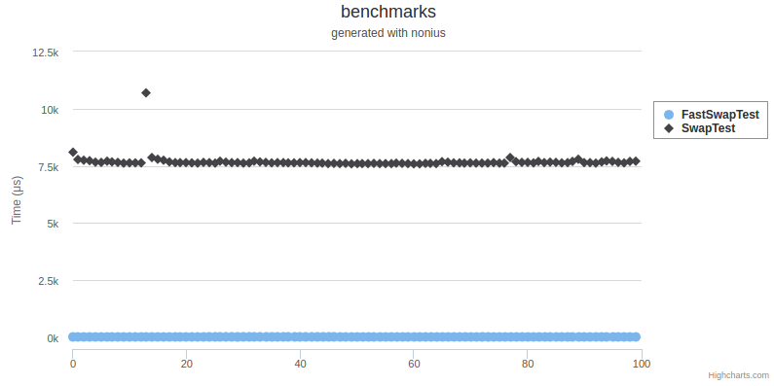

Questão 3
lmplemente um swap para BigInt e injete-o no namespace std.
main.cpp
#include "../exe01/BigInt.h"

namespace std{

void fast_swap(BigInt& a, BigInt& b){
BigInt t(std::move(a));
a = std::move(b);
b = std::move(t);
}

}

constexpr int BIG_INT_LEN = 100000;
constexpr int TEST_NUM_COUNT = 1000;

int main(){
BigInt a(1, BIG_INT_LEN);
BigInt b(1, BIG_INT_LEN);

for(int i = 0; i < TEST_NUM_COUNT; i++){
std::swap(a, b);
}
}

Questão 4
Substitua o array "puro" de BigInt por um std: :vector e revisite a implementação.
main.cpp
#ifndef BIGINT_H
#define BIGINT_H

#include <cstdint>
#include <algorithm>
#include <vector>
#include <iostream>

struct BigInt{
int sig_;
int len_;
std::vector<uint8_t> mag_;

BigInt()
: sig_(1), len_(0), mag_(0){
// std::cout << "BigInt: Construtor" << std::endl;
}

BigInt(int sig, int len)
: sig_(sig), len_(len), mag_( len)
{
// std::cout << "BigInt: Construtor" << std::endl;
}

BigInt(const BigInt& bi)
: sig_(bi.sig_), len_(bi.len_), mag_(bi.mag_)
{
// std::cout << "BigInt: Construtor de copia" << std::endl;
}

BigInt& operator=(const BigInt& bi){
sig_ = bi.sig_;
len_ = bi.len_;
mag_ = bi.mag_;
// std::cout << "BigInt: Atribuicao por copia" << std::endl;
return *this;
}

BigInt(BigInt&& bi)
: sig_(bi.sig_), len_(bi.len_), mag_(std::move(bi.mag_))
{
bi.len_ = 0;
// std::cout << "BigInt: Construtor de transferencia" << std::endl;
}

BigInt& operator=(BigInt&& bi){
sig_ = bi.sig_;
len_ = bi.len_;
mag_ = std::move(bi.mag_);
bi.len_ = 0;
// std::cout << "BigInt: Atribuicao por transferencia" << std::endl;
return *this;
}

~BigInt(){
}
};

#endif // BIGINT_H

Questão 5
Defina uma classe Point3D, composta por BigInts, e implemente suas funções especiais.
Point3D.h
#ifndef POINT3D_H
#define POINT3D_H

#include <cstdint>
#include <algorithm>
#include <vector>
#include "../exe04/BigInt.h"

class Point3D {
std::vector<BigInt> coord_;

public:
Point3D() : coord_({BigInt(),BigInt(),BigInt()})
{
std::cout << "Point3D: Construtor" << std::endl;
}

Point3D(const BigInt& x, const BigInt& y, const BigInt& z) : coord_(3)
{
coord_.push_back(x);
coord_.push_back(y);
coord_.push_back(z);
}

Point3D(const Point3D& bi)
: coord_(bi.coord_)
{
std::cout << "Point3D: Construtor de copia" << std::endl;
}

Point3D& operator=(const Point3D& bi){
coord_ = bi.coord_;
std::cout << "Point3D: Atribuicao por copia" << std::endl;
return *this;
}

Point3D(Point3D&& bi)
: coord_(std::move(bi.coord_))
{
bi.coord_ = {BigInt(),BigInt(),BigInt()};
std::cout << "Point3D: Construtor de transferencia" << std::endl;
}

Point3D& operator=(Point3D&& bi){
coord_ = std::move(bi.coord_);
bi.coord_ = {BigInt(),BigInt(),BigInt()};
std::cout << "Point3D: Atribuicao por transferencia" << std::endl;
return *this;
}

~Point3D(){
}

const BigInt& x(){
return coord_[0];
}

const BigInt& y(){
return coord_[1];
}

const BigInt& z(){
return coord_[2];
}
};

#endif // POINT3D_H

Questão 6
Simule uma fábrica que invoca construtores diferentes de Point3D.
Point3DFactory.h
#ifndef POINT3DFACTORY_H
#define POINT3DFACTORY_H

#include "../exe05/Point3D.h"

struct Point3DFactory {
template<class T = Point3D>
static T create(T&& p){
return T(std::forward<T>(p));
}
};

#endif // POINT3DFACTORY_H

Questão 7
Veriﬁque se as sobrecargas chamadas são as que você espera.
main.cpp
#include "../exe06/Point3DFactory.h"

int main()
{

Point3D source;
Point3D target1 = Point3DFactory::create(source);
Point3D target2 = Point3DFactory::create(std::move(source));

return 0;
}

