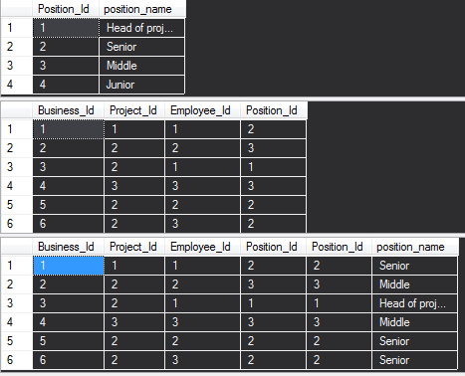

/*1.*/

select position_name, count(position_name) from Project_employment as pe left join Position p

on pe.Position_Id = p.Position_Id

group by position_name;

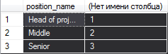

/*2.*/



select position_name from Position p

where p.Position_Id not in (select Position_Id from Project_employment);



/*3*/

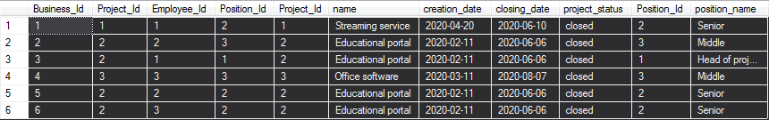

select * from Project_employment;

select pe.Project_Id, p.name, pe.Position_Id, po.position_name, count(*) from Project_employment pe

left join Project p on p.Project_Id = pe.Project_Id

left join Position po on po.Position_Id = pe.Position_Id

group by pe.Project_Id, p.name, pe.Position_Id, po.position_name;

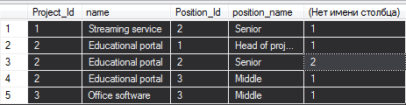

/* 4*/

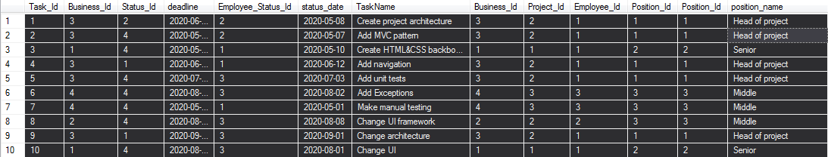

select f.Project_Id, f.name, avg(f.c) from (select pe.Project_Id, p.name, pe.Employee_Id, count(*) c from Task t

join Project_employment pe on t.Business_Id = pe.Business_Id

join Project p on pe.Project_Id = p.Project_Id

group by pe.Project_Id, p.name, pe.Employee_Id) as f

group by f.Project_Id, f.name;

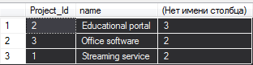

/* 5 */

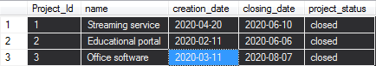

select p.name, DateDiff(DAY, p.creation_date, p.closing_date) from Project p;

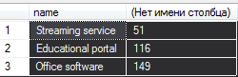

/* 6*/

Update Task

Set deadline = '2020-08-31',

Status_Id = 3

where Task_Id = 8;

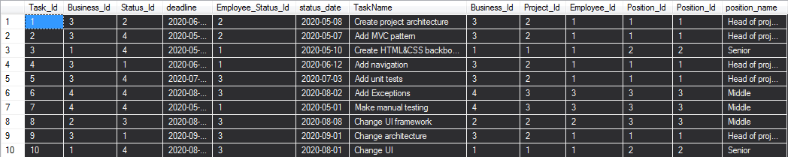

create function GetObj

(

)

returns table

as

return

(

select f.Employee_Id, count(*) as c2 from (select pe.Employee_Id, count(*) as c from Task t

left join Project_employment pe on pe.Business_Id = t.Business_Id

left join Project p on pe.Project_Id = p.Project_Id

group by pe.Employee_Id, t.Status_Id

having Status_Id <> 4) as f

group by f.Employee_Id);

select p.Employee_Id, p.c2 from GetObj() p

where p.c2 = (select min(p2.c2) from GetObj() p2);



/* 7 */



create function GetObjMax

(

)

returns table

as

return

(

select f.Employee_Id, count(*) as c2 from (select pe.Employee_Id, count(*) as c from Task t

left join Project_employment pe on pe.Business_Id = t.Business_Id

left join Project p on pe.Project_Id = p.Project_Id

where t.deadline < CONVERT(date, getdate())

group by pe.Employee_Id, t.Status_Id) as f

group by f.Employee_Id);

select p.Employee_Id, p.c2 from GetObjMax() p

where p.c2 = (select max(p2.c2) from GetObjMax() p2);



/* 8 */

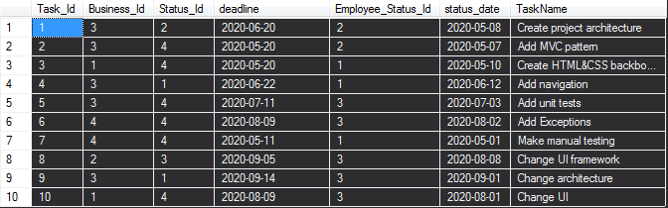

Update Task

set deadline = DATEADD(day, 5, deadline)

where Task_Id in (

select t1.Task_Id from Task t1

where t1.Status_Id <> 4);

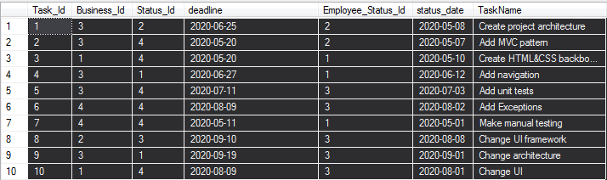

/*9*/

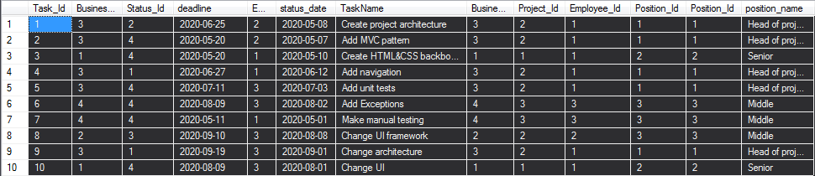

select p.Project_Id, p.name, count(*) as opened from Task t

left join Project_employment pe on pe.Business_Id = t.Business_Id

left join Project p on pe.Project_Id = p.Project_Id

group by p.Project_Id, p.name, t.Status_Id

having Status_Id = 1;



/* 10 */

update Project

set project_status = 'open',

closing_date= '2020-05-05'

where Project_Id = 1;

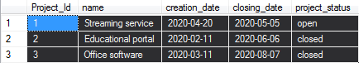

CREATE FUNCTION Task10Id

(

)

RETURNS TABLE AS RETURN

(

select p2.Project_Id as id, p2.m as minim, p2.d2 as d from

(select p1.Project_Id, min(p1.Status_Id) as m, max(p1.d1) as d2 from

(select p.Project_Id, t.Status_Id, max(t.deadline) as d1, count(*) as c from Project p

left join Project_employment pe on pe.Project_Id= p.Project_Id

left join Task t on t.Business_Id = pe.Business_Id

group by p.Project_Id, t.Status_Id, t.deadline) as p1

group by p1.Project_Id) as p2

where p2.m = 4

);

update Project

set project_status = 'closed',

closing_date = res.d

from (select * from Task10Id()

) as res

where res.id = Project.Project_Id;

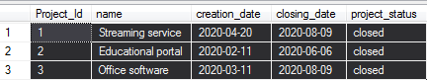

/*11*/

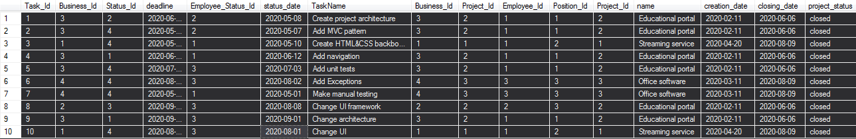

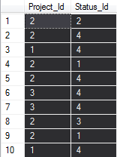

CREATE FUNCTION Task11Id

(

)

RETURNS table return

(select t1.Project_Id, t1.Employee_Id, min(t1.Status_Id) as m from (select p.Project_Id, pe.Employee_Id, t.Status_Id from Task t

left join Project_employment pe on pe.Business_Id = t.Business_Id

left join Project p on pe.Project_Id = p.Project_Id

group by p.Project_Id, pe.Employee_Id, t.Status_Id) as t1

group by t1.Project_Id, t1.Employee_Id);

select * from Task11Id() as t

where t.m = 4;



/* 12 */

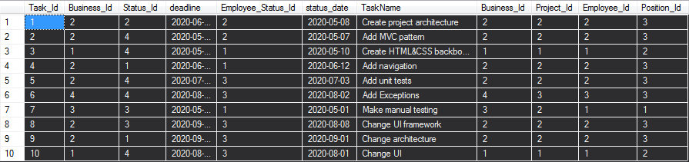

declare @index int;

declare @projectId int;

declare @businessTask int;

declare @businessEmployee int;

CREATE procedure GetTaskByName(

@name varchar(50),

@projectId int output,

@id int output,

@businessId int output

)

as

begin

set @id = (select top 1 Task_Id from Task t

left join Project_employment pe on pe.Business_Id = t.Business_Id

left join Project p on pe.Project_Id = p.Project_Id

where TaskName = @name);

set @projectId = (select top 1 p.Project_Id from Task t

left join Project_employment pe on pe.Business_Id = t.Business_Id

left join Project p on pe.Project_Id = p.Project_Id

where TaskName = @name);

set @businessId = (select top 1 t.Business_Id from Task t

left join Project_employment pe on pe.Business_Id = t.Business_Id

left join Project p on pe.Project_Id = p.Project_Id

where TaskName = @name);

end;

exec GetTaskByName 'Make manual testing', @projectId output, @index output, @businessTask output;

select @index, @projectId, @businessTask;



CREATE function GetSpecificWorker

(@ProjectId integer

)

returns table

as

return

(

select pp.Project_Id, pp.Employee_Id, pp.b as business, pp.c as cnt from (select pe.Project_Id, pe.Employee_Id, pe.Business_Id as b, count(*) as c from Task t

left join Project_employment pe on pe.Business_Id = t.Business_Id

left join Project p on pe.Project_Id = p.Project_Id

group by pe.Project_Id, pe.Employee_Id, pe.Business_Id

) as pp

where pp.Project_Id = @projectId

);

update Task

set Business_Id = (select min(pii.business) from GetSpecificWorker(@projectId) as pii

where pii.cnt = (select min(p3.cnt) from GetSpecificWorker(@projectId) p3))

where Business_Id = @businessTask;

