Query Document

Relatório de Empréstimos Bancários

# Resumo

# **KPI’s**

## Total de pedidos de empréstimo:

SELECT COUNT(id) AS Total_Pedidos_Emprestimos FROM bank_loan_data



## MTD pedidos de empréstimo:

SELECT COUNT(id) AS MTD_Total_Pedidos_Emprestimos FROM bank_loan_data

WHERE MONTH(issue_date) = 12 AND YEAR(issue_date) = 2021



## PMTD pedidos de empréstimo:

SELECT COUNT(id) AS PMTD_Total_Pedidos_Emprestimos FROM bank_loan_data

WHERE MONTH(issue_date) = 11 AND YEAR(issue_date) = 2021



## Valor Total Financiado:

SELECT SUM(loan_amount) as Valor_Total_Financiado from bank_loan_data



## MTD Valor Total Financiado:

SELECT SUM(loan_amount) as MTD_Valor_Total_Financiado from bank_loan_data

WHERE MONTH(issue_date) = 12 AND YEAR(issue_date) = 2021



## PMTD Valor Total Financiado:

SELECT SUM(loan_amount) as PMTD_Valor_Total_Financiado from bank_loan_data

WHERE MONTH(issue_date) = 11 AND YEAR(issue_date) = 2021



## Valor Total Empréstimos Pagos:

SELECT SUM(total_payment) as Valor_Total_Pago from bank_loan_data



## MTD Valor Total Empréstimos Pagos:

SELECT SUM(total_payment) as MTD_Valor_Total_Pago from bank_loan_data

WHERE MONTH(issue_date) = 12 AND YEAR(issue_date) = 2021



## PMTD Valor Total Empréstimos Pagos:

SELECT SUM(total_payment) as PMTD_Valor_Total_Pago from bank_loan_data

WHERE MONTH(issue_date) = 11 AND YEAR(issue_date) = 2021



## Taxa Juros Média:

SELECT ROUND(AVG(int_rate), 0)/100 AS Taxa_Juros_Media FROM bank_loan_data



## MTD Taxa Juros Média:

SELECT ROUND(AVG(int_rate), 1)/100 AS MTD_Taxa_Juros_Media FROM bank_loan_data

WHERE MONTH(issue_date) = 12 AND YEAR(issue_date) = 2021



## PMTD Taxa Juros Média:

SELECT ROUND(AVG(int_rate), 1)/100 AS PMTD_Taxa_Juros_Media FROM bank_loan_data

WHERE MONTH(issue_date) = 11 AND YEAR(issue_date) = 2021



## Média DTI:

SELECT ROUND(AVG(dti), 1) / 100 AS Media_DTI from bank_loan_data



## MTD Média DTI:

SELECT ROUND(AVG(dti), 1) / 100 AS MTD_Media_DTI from bank_loan_data

WHERE MONTh(issue_date) = 12 and YEAR(issue_date) = 2021



## PMTD Média DTI:

SELECT ROUND(AVG(dti), 1) / 100 AS PMTD_Media_DTI from bank_loan_data

WHERE MONTh(issue_date) = 11 and YEAR(issue_date) = 2021



## Porcentagem de Bons Empréstimos:

SELECT

(COUNT(CASE WHEN loan_status = 'Fully Paid' OR loan_status = 'Current' THEN id END) * 100)

/

COUNT(id) AS Porcentagem_Emprestimos_Bons

FROM bank_loan_data



## Quantidade de Empréstimos Bons:

SELECT COUNT(id) AS Total_Emprestimos_Bons FROM bank_loan_data

WHERE loan_status = 'Fully Paid' or loan_status = 'Current'



## Valor Total de Empréstimos Bons:

SELECT SUM(loan_amount) AS Valor_Total_Emprestimos_Bons FROM bank_loan_data

WHERE loan_status = 'Fully Paid' or loan_status = 'Current'



## Valor de Empréstimos Bons Pago:

SELECT SUM(total_payment) AS Valor_Emprestimos_Bons_Recebido FROM bank_loan_data

WHERE loan_status = 'Fully Paid' or loan_status = 'Current'



## Porcentagem de Empréstimos Ruins:

SELECT

(COUNT(CASE WHEN loan_status = 'Charged Off' THEN id END) * 100)

/

COUNT(id) AS Porcentagem_Emprestimos_Ruins

FROM bank_loan_data



## Quantidade de Empréstimos Bons:

SELECT COUNT(id) AS Total_Emprestimos_Ruins FROM bank_loan_data

WHERE loan_status = 'Charged Off'



## Valor Total de Empréstimos Ruins:

SELECT SUM(loan_amount) AS Valor_Total_Emprestimos_Ruins FROM bank_loan_data

WHERE loan_status = 'Charged Off'



## Valor de Empréstimos Ruins Pago:

SELECT SUM(total_payment) AS Valor_Emprestimos_Ruins_Recebido FROM bank_loan_data

WHERE loan_status = 'Charged Off'



Situação do empréstimo

SELECT

loan_status,

COUNT(id) AS Contagem_Emprestimos,

SUM(total_payment) AS Total_Recebido,

SUM(loan_amount) AS Total_Financiado,

ROUND(AVG(int_rate / 100), 2) AS Taxa_Juros_Media,

ROUND(AVG(dti / 100), 2) AS DTI_Media

FROM

bank_loan_data

GROUP BY

loan_status

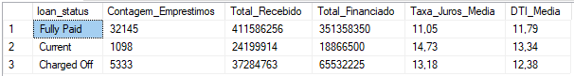

## MTD Situação do empréstimo

SELECT

loan_status,

SUM(total_payment) AS MTD_Total_Recebido,

SUM(loan_amount) AS MTD_Total_Financiado

FROM bank_loan_data

WHERE MONTH(issue_date) = 12

GROUP BY loan_status

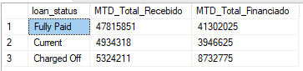

**RELATÓRIO DE EMPRÉSTIMO BANCÁRIO | VISÃO GERAL**

**MESES**

SELECT

MONTH(issue_date) AS Num_Mes,

DATENAME(MONTH, issue_date) AS Nome_Mes,

COUNT(id) AS Total_Pedidos_Emprestimos,

SUM(loan_amount) AS Total_Financiado,

SUM(total_payment) AS Total_Recebido

FROM bank_loan_data

GROUP BY MONTH(issue_date), DATENAME(MONTH, issue_date)

ORDER BY MONTH(issue_date)

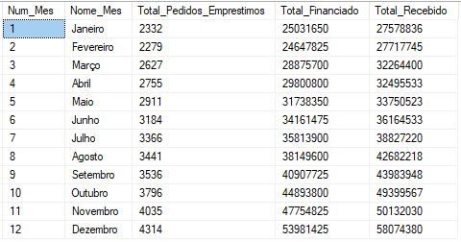

**ESTADOS**

SELECT

address_state AS Estado,

COUNT(id) AS Total_Pedidos_Emprestimos,

SUM(loan_amount) AS Total_Financiado,

SUM(total_payment) AS Total_Recebido

FROM bank_loan_data

GROUP BY address_state

ORDER BY SUM(loan_amount) DESC

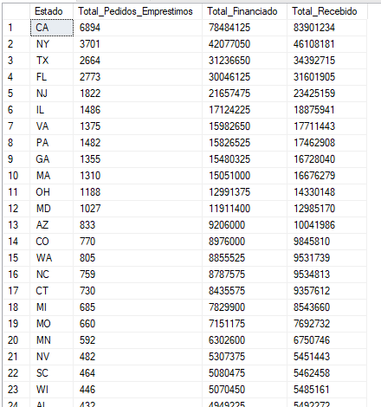

**PRAZOS**

SELECT

term AS Prazo,

COUNT(id) AS Total_Pedidos_Emprestimos,

SUM(loan_amount) AS Total_Financiado,

SUM(total_payment) AS Total_Recebido

FROM bank_loan_data

GROUP BY term

ORDER BY term

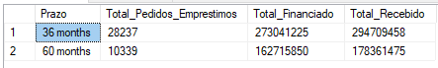

**TEMPO NO EMPREGO ATUAL**

SELECT

emp_length AS tempo_emprego_atual,

COUNT(id) AS Total_Pedidos_Emprestimos,

SUM(loan_amount) AS Total_Financiado,

SUM(total_payment) AS Total_Recebido

FROM bank_loan_data

GROUP BY emp_length

ORDER BY emp_length

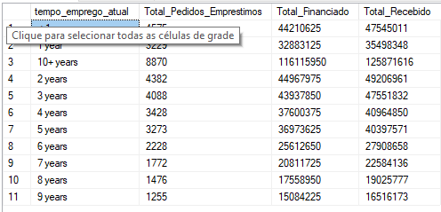

**PROPÓSITO**

SELECT

purpose AS Motivo,

COUNT(id) AS Total_Pedidos_Emprestimos,

SUM(loan_amount) AS Total_Financiado,

SUM(total_payment) AS Total_Recebido

FROM bank_loan_data

GROUP BY purpose

ORDER BY purpose

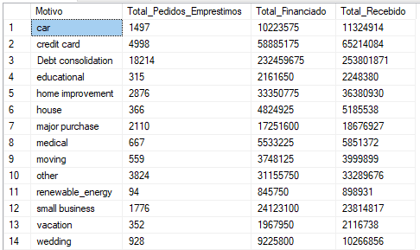

**STATUS PROPRIEDADE DA CASA**

SELECT

home_ownership AS status_propriedade_casa,

COUNT(id) AS Total_Pedidos_Emprestimos,

SUM(loan_amount) AS Total_Financiado,

SUM(total_payment) AS Total_Recebido

FROM bank_loan_data

GROUP BY home_ownership

ORDER BY home_ownership

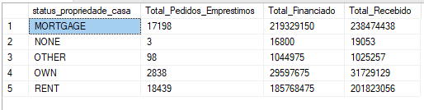

Nota: Aplicamos múltiplos filtros em todos os dashboards. Você também pode verificar os resultados dos filtros modificando a consulta e comparando os resultados.  
Por exemplo:  
Veja os resultados quando selecionamos a **Grade A** nos filtros dos dashboards.

SELECT

purpose AS Motivo,

COUNT(id) AS Total_Pedidos_Emprestimos,

SUM(loan_amount) AS Total_Financiado,

SUM(total_payment) AS Total_Recebido

FROM bank_loan_data

WHERE grade = 'A'

GROUP BY purpose

ORDER BY purpose

