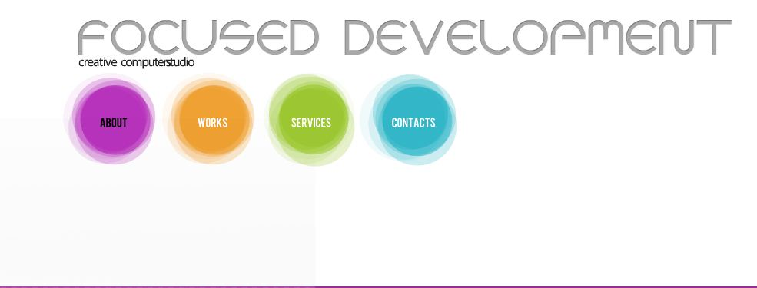

Focused Development has been in the Charlotte area for 15 years. We can solve your computer problems in your home or business. We are a family owned company that believes in excellent customer service.

We are committed to providing excellent IT services at affordable rates. We always put our clients in first place. We understand that your time is valuable so we will show up on time for appointments and provide services in a timely manner. Our experienced IT professionals can help you meet all of your computing needs.

making technology work you

INFORMATION TECHNOLOGY SOLUTIONS

THAT WORK FOR YOUR HOME & BUSINESS.

simplifying **IT**

COMPUTER REPAIR

We will service your computer no matter the brand. We can also pick it up from you.

WEBSITE CREATION & MANAGEMENT

We will build a website for you to meet your needs or will customize a template that you choose.

NETWORK ADMINISTRATION

We will setup and monitor you network no matter how large or small. SOHO setups are welcomed here.

CALL TO FIND OUT MORE OR TO MAKE AN APPOINTMENT

.

**www.FOCUSEDDEVELOPMENT.com**

SERVICES AVAILABLE

**Concord, NC 28027 Tel 704.763.7990 Fax 480.393.5582**