Zero2Automated: Custom Sample Analysis
by Arthur Verschaeve

- Test environment: Windows 8.1 Pro
- Immediately upon unzipping the sample executable, Microsoft Defender was triggered.
- Using PEStudio, a VirusTotal score was retrieved: 57/70. This is immediately suspicious.
- The MD5 hash given for the program is A84E1256111E4E235250A8E3BB11F903. A simple google search for this hash, or a search on the virustotal website, would probably already reveal a lot.
- Information retrieved using DIE:

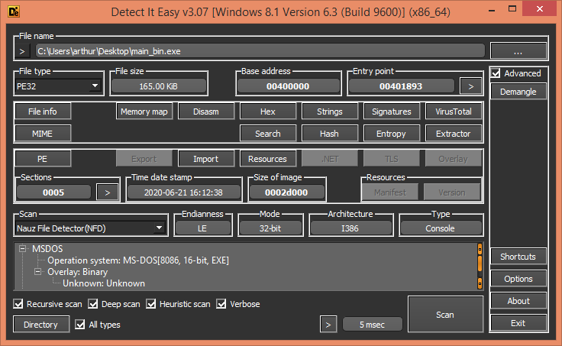

- The entropy looks really high in the .rsrc section: this is usually a strong indicator of some kind of encryption.

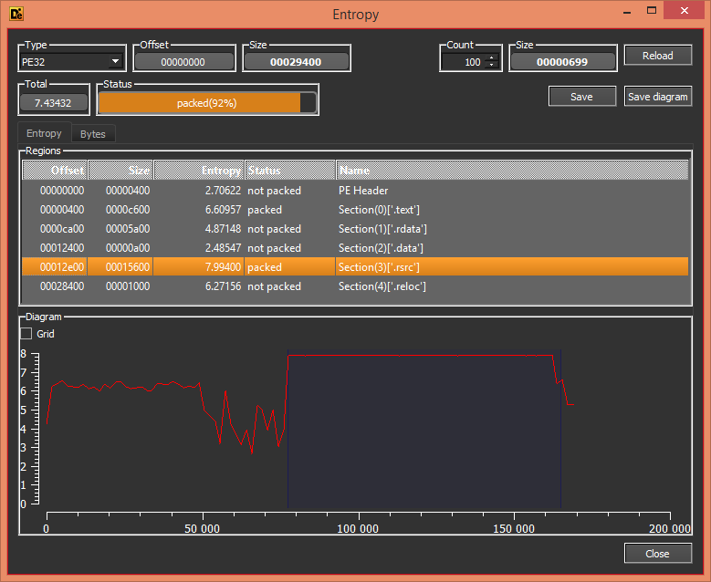

- The strings used in the program seem obfuscated or encrypted in some way too.

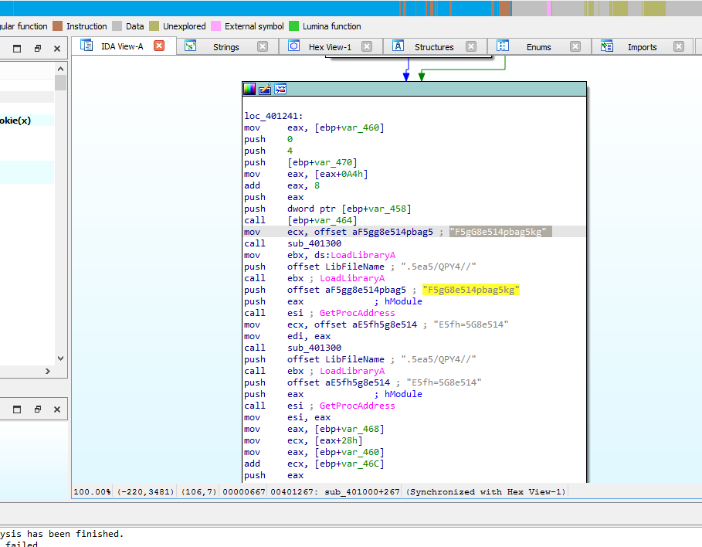

In the strings subview, right before these strings, I find “abcdefghijklmnopqrstuvwxyz” and “ABCDEFGHIJKLMNOPQRSTUVWXYZ”. To me, this is a hint towards some rotary cipher.

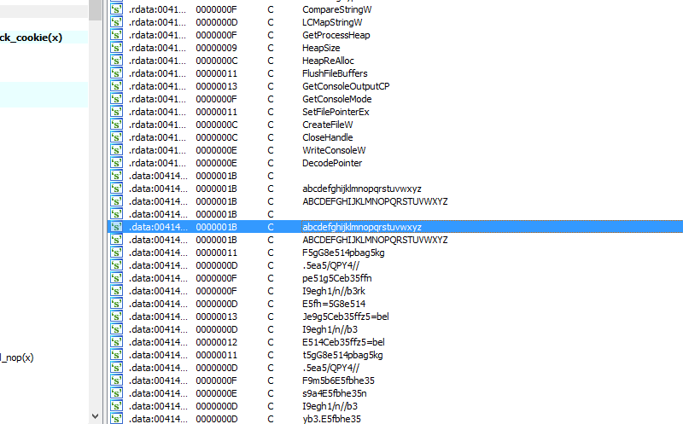

I experimented with some different alphabets and different rotary ciphers and ended up with this code, that seems to decrypt the strings well.

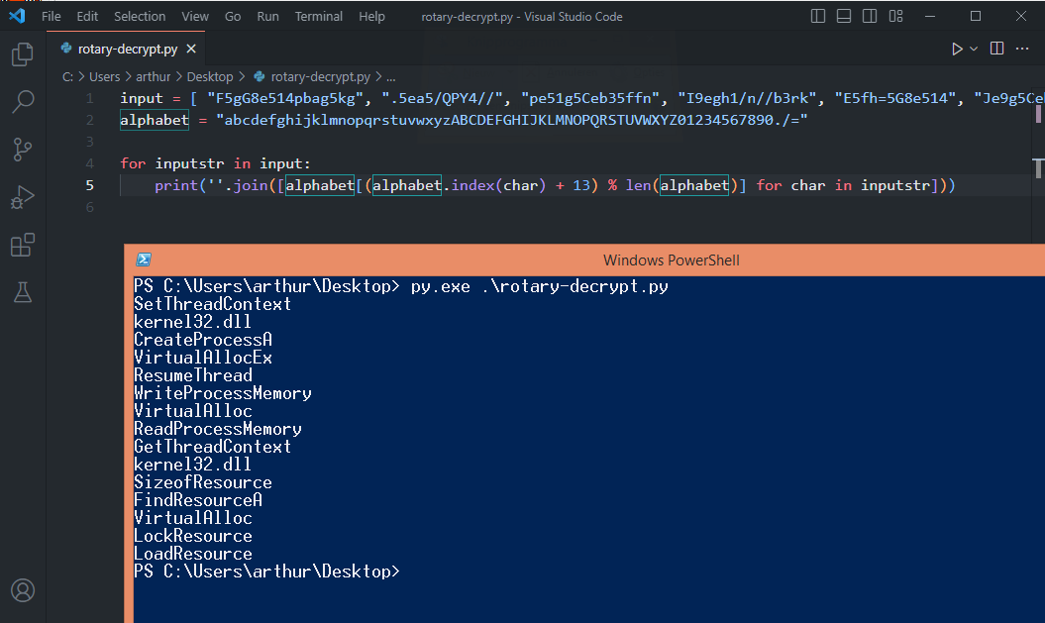

These all look like windows APIs, specifically some of these are often used to perform process injection. Renaming the variables in IDA, we can easily identify the routines and what they do: decrypt the strings using the ROT13 cipher, find all necessary resources in kernel32.dll, allocate memory for the new executable, …

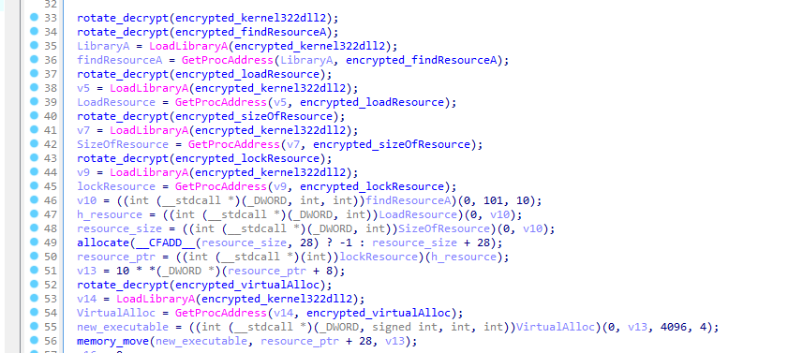

- After this, an RC4 decryption procedure starts, to retrieve the next stage of the executable. We can derive the key from the following stage of the decryption process:

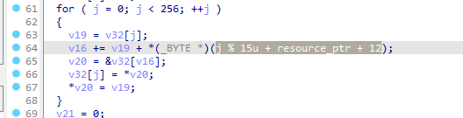

The key seems to be 15 characters long, and stored at index 12 of the resource section. I use a tool called resource hacker now to retrieve this key: “kkd5YdPM24VBXmi”.

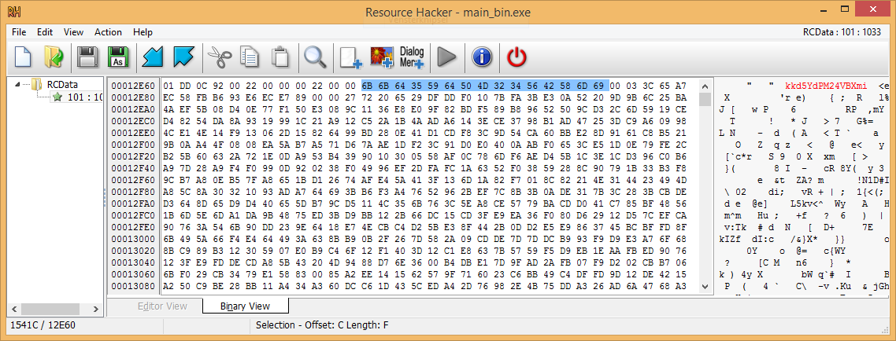

- After the decryption process a call sub_401000(new_executable); is made. That procedure looks like code that does Process Hollowing, or RunPE. Analising this part in detail does not seem necessary at this point: we essentially know what it does. It’s what the second stage actually does that interests us.

- Using resource hacker I also saved the resource itself in a separate file. Now, I used the script in decrypt-resource.py to decrypt that part using the key I found and ARC4 (an open-source Python implementation of RC4). The second stage file this generates opens up in IDA as a valid PE file.

- The entropy value of this second stage file is quite low: there’s probably not another executable stored inside.

- The strings subview in IDA is the first thing I checked out on stage2.exe. There are mostly typical PE strings in there, but this “cruloader” one stood out:

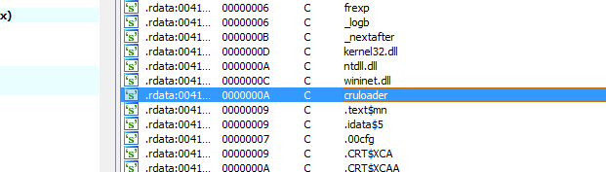

Given this string, it seems safe to assume this stage is a loader. This stage is probably meant to download and execute a new payload.

- First, the file name of the current module is fetched, and then there seems to be a loop operation. The \ character is searched in the string, and parts of the file name are removed until there is no \ character left. Basically, I think this strips off the file path until only the file name is left.

- Then the filename is passed through the following computation. By googling the constants, I found out this is probably CRC32.

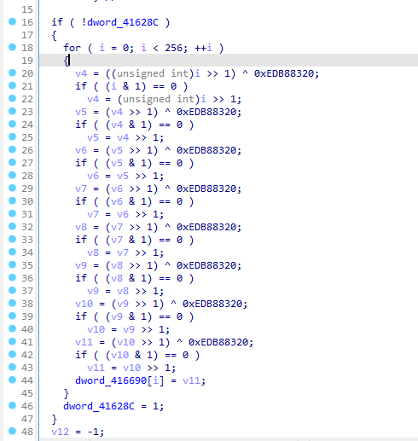

- Then, there is a check that seems to compare the CRC32 checksum of the file name to 0xB925C42D. A Google search reveals this is the hash for svchost.exe.

If true, the sample proceeds to download additional content from the internet.
If false, the code performs some anti-analysis tests and then injects code into svchost.exe.

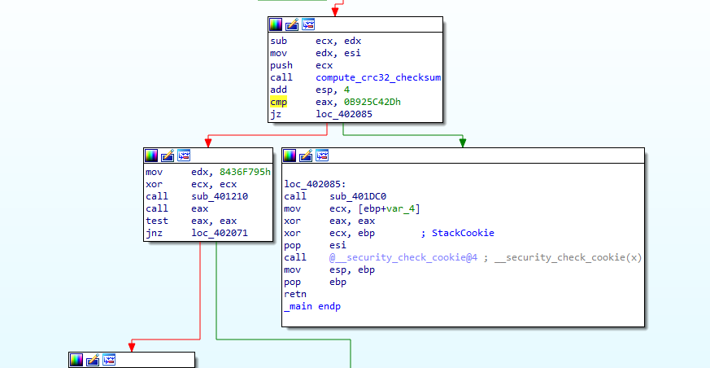

- It is procedure sub_401DC0 that is supposed to proceed to downloading a payload. The procedure itself does not (yet) look like a typical downloading procedure though:

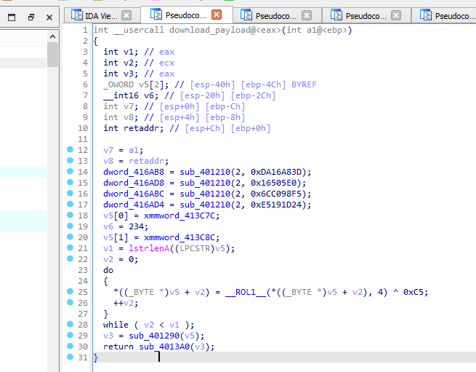

Instead, there again seems to be some kind of hashing going on (lines 14-17). Again, I did an online search for the hash values. I found the following:

https://github.com/tildedennis/malware/blob/master/phasebot/api_hashes

It looks like the sub_401210 procedure here is meant to resolve APIs using hash values. The reveals the program is looking up the following functions:

    - InternetOpenA
    - InternetOpenUrlA
    - InternetReadFile
    - InternetCloseHandle

- It is clear that sub_401290 is a procedure that downloads something, and the parameter must be a URL (IDA already inferred that). So the loop right above it must be the one that computes v5 = the URL we are fetching.

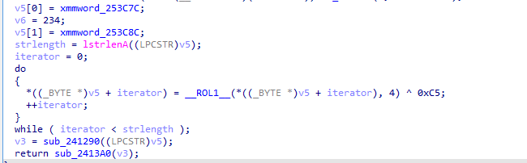

The procedure does the following for every byte: it rotates left by 4, and then XORs with 0xC5. This can be reversed with some CyberChef magic:
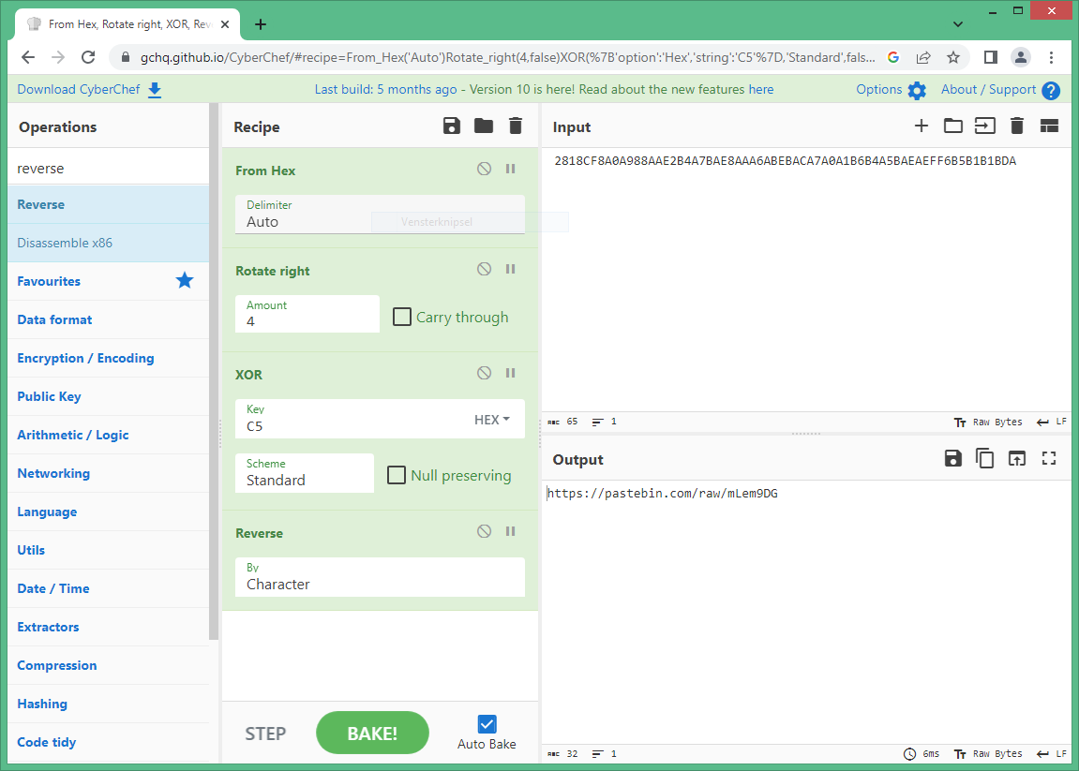

This pastebin URL is a good first indicator of compromise. It contains the following:
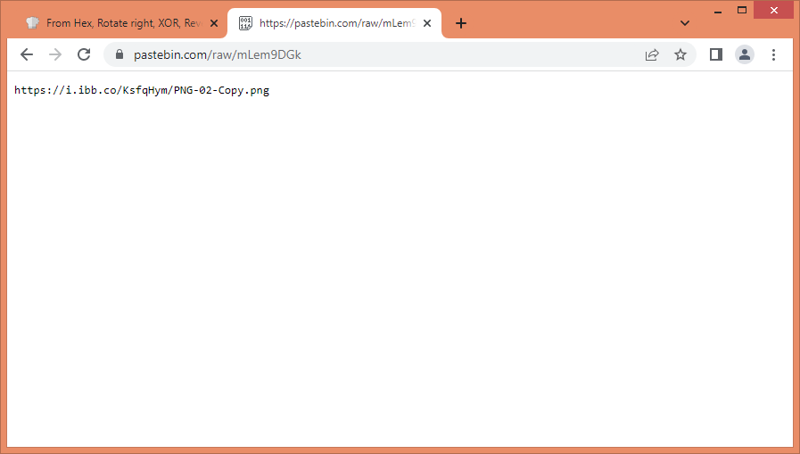

This is a second https://i.ibb.co/KsfqHym/PNG-02-Copy.png

- Once the pastebin url is fetched, one more function gets called: sub_2413A0. Again, a similar encryption process in the beginning: this time for “\output.”. Some API’s get resolved in the same way as before too:

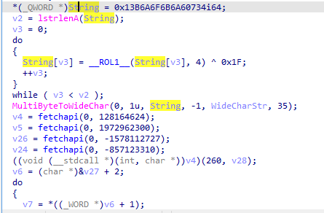

This time the APIs used are the ones to retrieve a temporary directory, create a directory, create a file and write to it.

- Underneath there’s one more encryption loop, this time with key 0x9a hiding the string “cruloader”.

It looks like we loop over the contents of https://i.ibb.co/KsfqHym/PNG-02-Copy.png, decrypt it with key 0x61 this time, until we reach the string “cruloader”. The file pointer then points to everything after “cruloader”.

I translated that all to Python to retrieve the third stage executable, in a script called fetch- third-stage.py.

- The last part of the second stage is a function that decrypts the value “C:\Windows\System32\svchost.exe”. I skipped further analysis of the second stage and assumed the third stage would be injected into there.

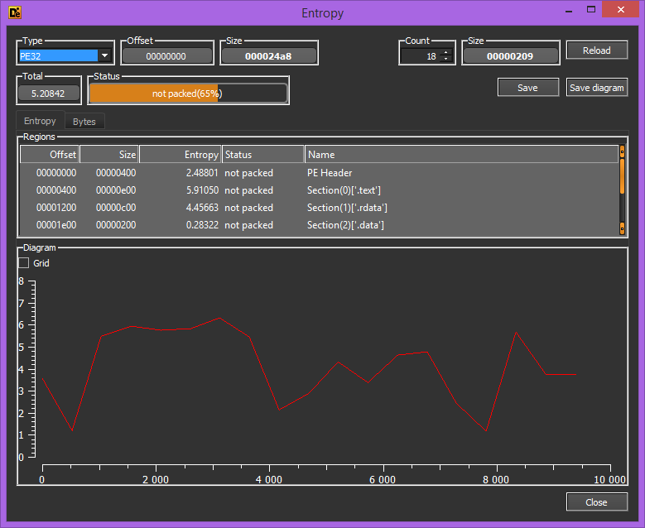
- The entropy of the third stage file is really low, and so is the file size itself. I guess there will be not much work left to do.

- The analysis of the third stage file in IDA is indeed quite simple. It simply creates a message box:

