

Website design proposal

January 26, 2020

Gyan academy

House No: 116, Street No: 2, Opp : Bapuji Nursing Home, Bapuji Nagar, Nacharam, Hyderabad - 500076

Table of Contents

About Gyan Academy 2

Current Process 3

Need for Automation 4

Requirement 5

Website Pages 6

Student Management 6

Login 6

Welcome Page . 6

Fee Details 7

Courses 9

Attendance 10

Assignment 10

Announcement 11

Event Calendar 12

Gate Pass 13

Progress Card 13

Parents Concern Form 14

Fee Structure 15

TC Request 16

Leave Application 17

Teachers Management 17

Non Teaching Staff 18

Clerk 18

Admin 18

# About Gyan Academy

Gyan Academy was started in 2015 by 2 enthusiast (Richa Jha and Mukta Jha), who wanted to contribute in building Nation. As education is the first and best way to achieve their goal, they started educational institute with the name Gyan Academy on December 1st 2015.

They started with teaching Vedic Maths, to the students of class 3 to 10. Along with this they even had academic coaching and training. They even concentrated on Handwriting, Olympiad, Hindi and English Grammar development.

They wanted every student to excel on the subjects like maths and science and for that they started aptitude training for students from 3rd class. They also had General awareness classes to get ready for the coming future.

Now as a second step, they even want to add primary school up to UKG along with day care. They will also include ABACUS to the list of training provided by Gyan Academy

# Current Process

Currently Gyan Academy maintains details of student in excel file and when they pay fees, they give manual receipt. Every month they have to check who paid the fees and manually call or mail each individual to pay the fees.

Every enquiry is noted in the register and then followed up. Attendance is taken in register manually.

Every course offered has different fees and each student can be given different discounts. All these are maintained in register and while paying fees it is validated against discount given and fees asked. The discount goes from 0% to 100%. Different type of discounts given are, Sibling discount, teacher discount, Colony discount, credit line discount, goodwill discount etc.,

Progress report is first noted in register and keyed in excel to generate the report and give it to the family of student.

Parents meet the teachers on parent teacher meet, to get their ward progress details of give complains/ Suggestion if they have any

Teachers salary is given in bank and then noted in the register. All the calculation of leaves taken or extra hour work is done manually and then payslip is generated in excel and hard copy is given to the teachers

All the fee details and expenses made are maintained manually to check the current financial status of month/ quarter/ year.

# Need for Automation

Maintaining student details in Excel or register is very hectic and chances of making error or loosing data is very high.

Fee details are crucial and having them in register, getting that checked every week or day and then calling or mailing each individual is a tedious job. If automated can happen automatically and can consolidate details automatically

Keeping enquiry and then converting them into registered student, is again difficult, as each time we have to check who is registered and who is not and then we have to call them individually. It happens sometime that we call the parent of people already registered and never call people whom we should actually call. Also if they show no interest , still sometime we make them call, as we don’t have any record

Keeping track of fees is very difficult. Each individual pays different fees and keeping track becomes tedious.

Parents has to wait long to get progress report or the to see the activity happening at the academy. They have to wait till PTM to give any suggestions or raise any concern.

Teachers salary depends on the number of days they come to office. Tracking the attendance in register has lot of chances of mistake. Like marking wrong days attendance or not marking current day.

Computerised pay slip will help teacher to download it as and when required

All the expense and income will be managed online so that whenever management what, they can see the status of business and decide accordingly

# Requirement

The requirement is to convert the manual process to automation and make life easier

# Website Pages

Common Welcome page for student, teacher, clerk and Admin with login button, where they can select if they are student / teacher / clerk or admin

## Student Management

### Login

Once selected the type of user the login screen will appear. Should have forgot password and reset condition should be admission number / email ID / Mobile number. The mail will go to email / link will go on the mobile to reset the password. Link should expire in 2 hours

### Welcome Page .

Once logged in should have following things. Login Page Profile Tab

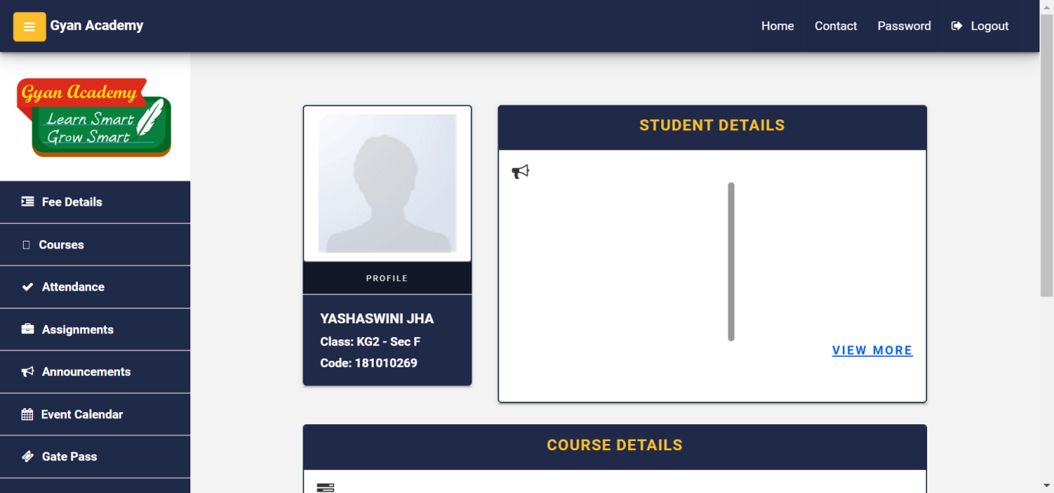

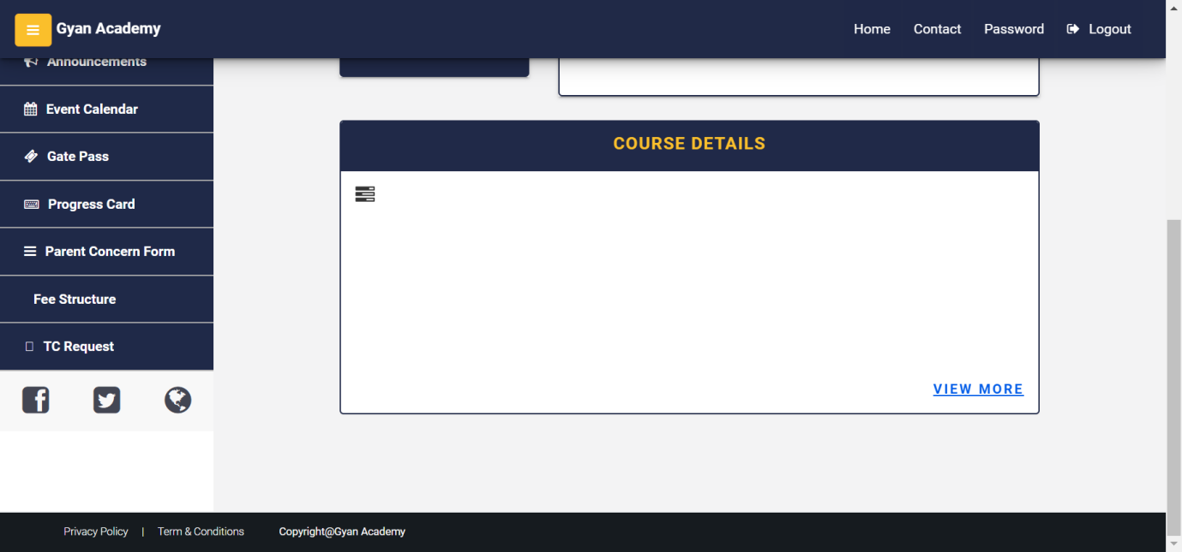

### Fee Details

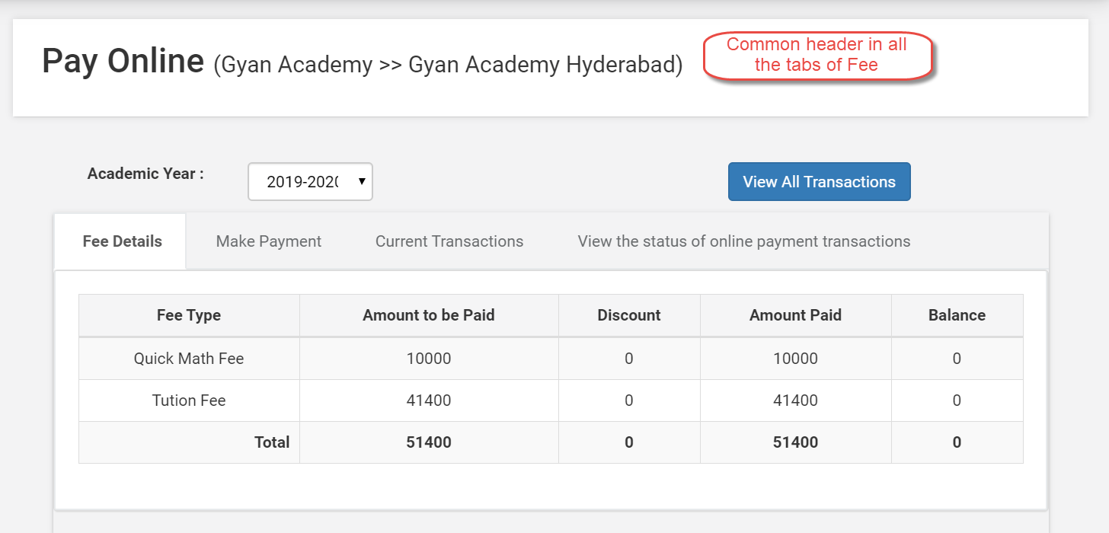

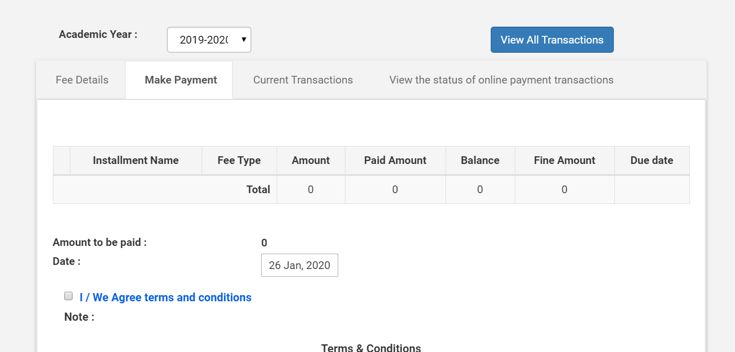

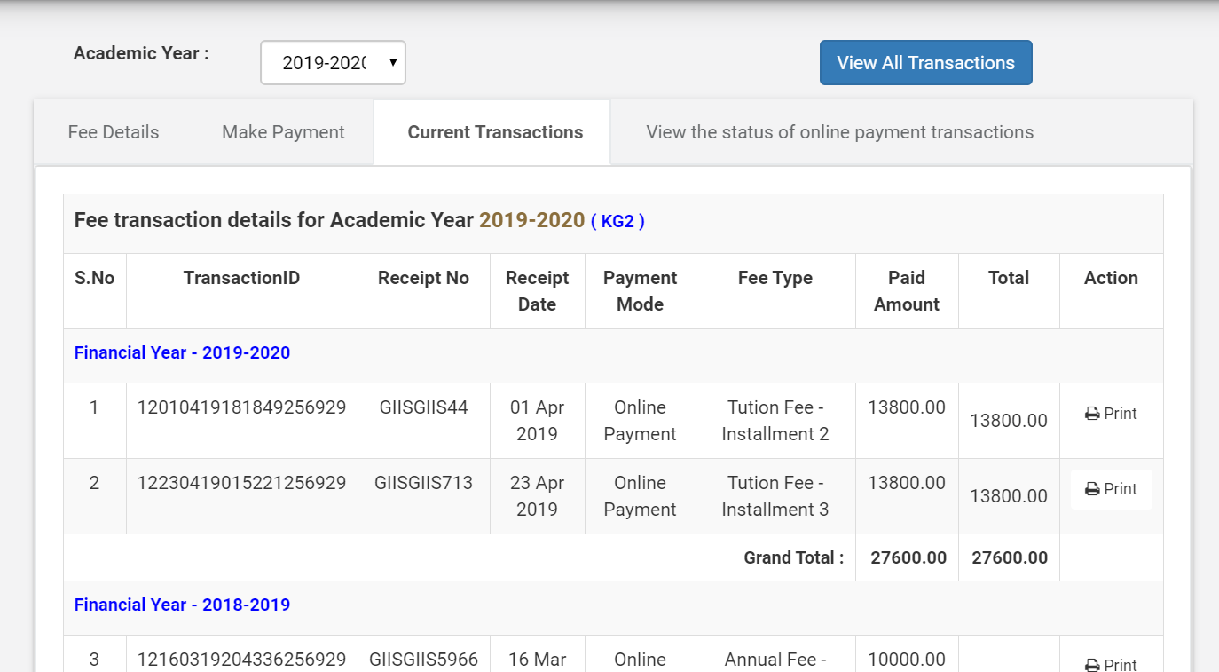

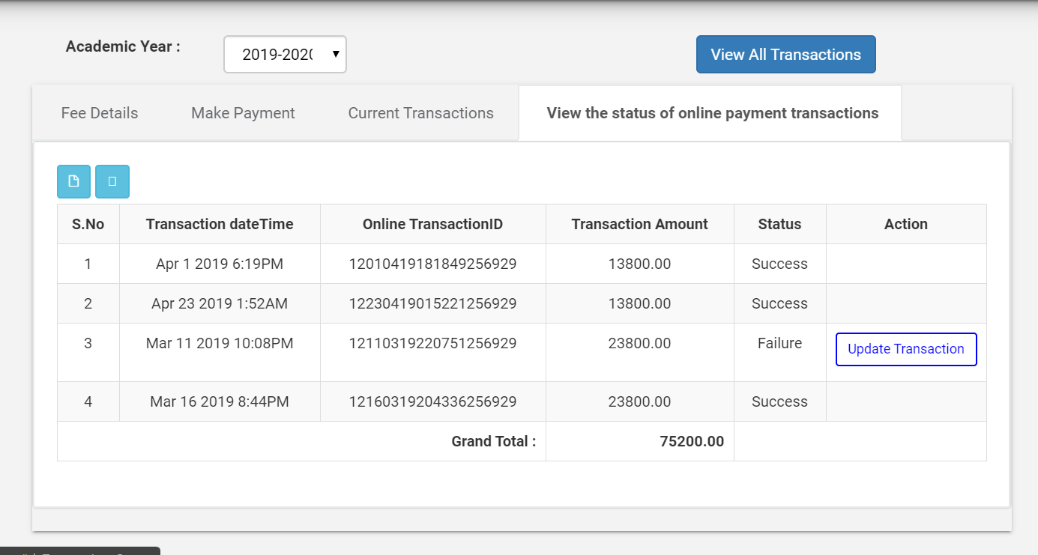

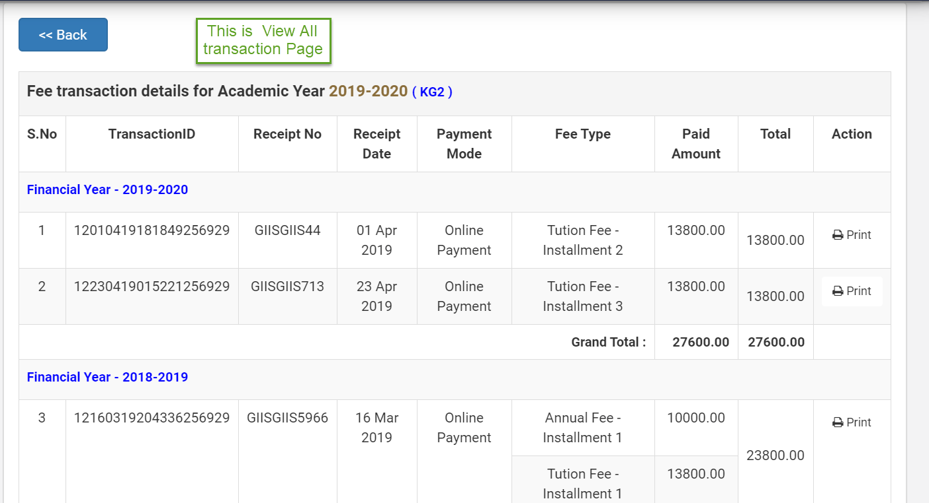

### Courses

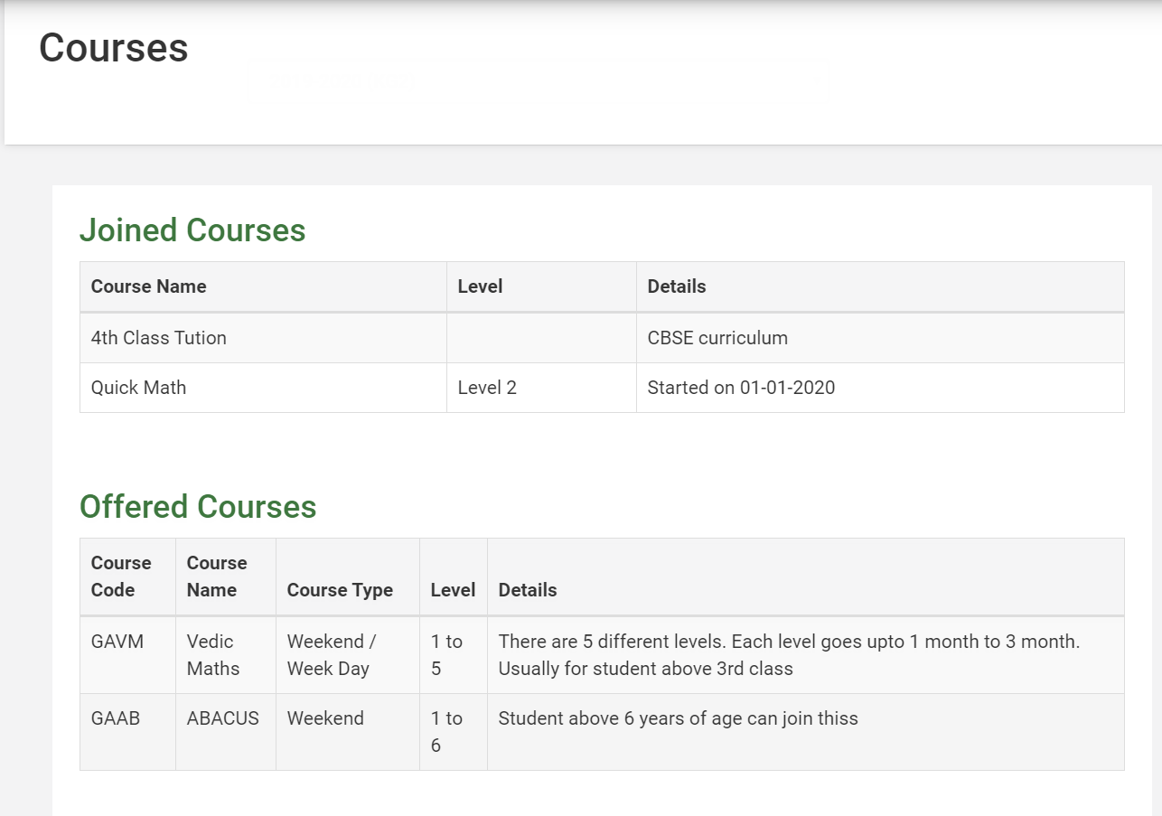

### Attendance

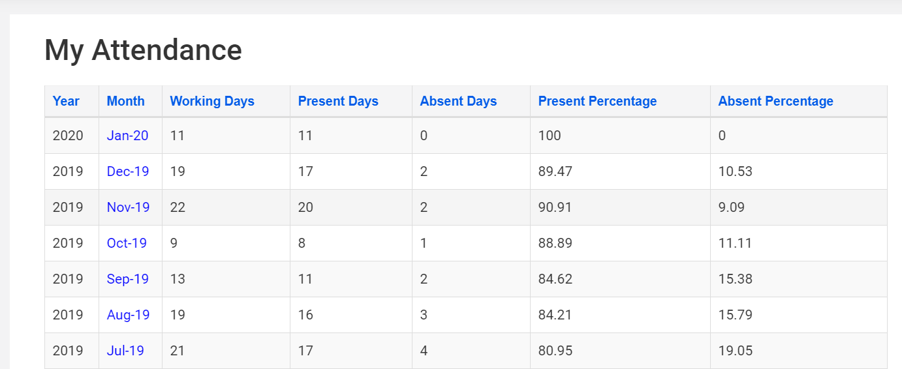

When user clicks on month, following pop will appear

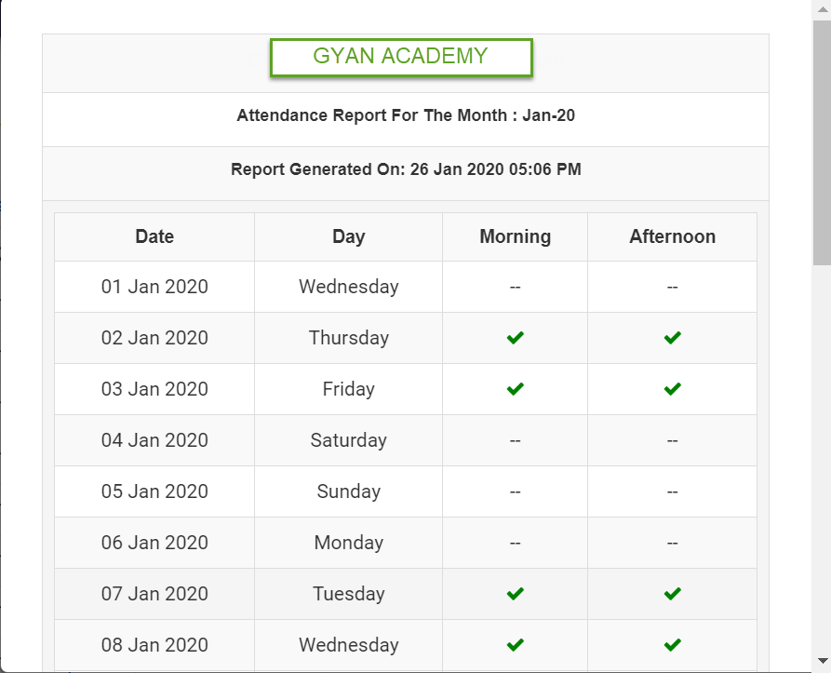

### Assignment

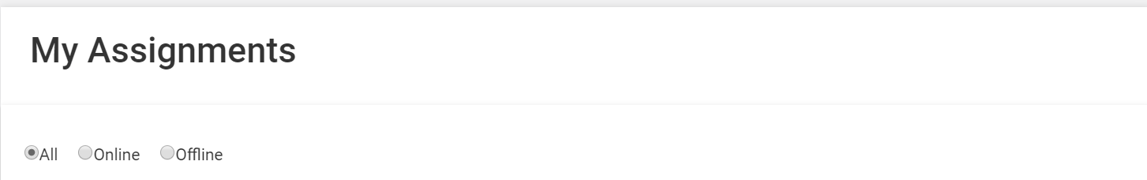

We will upload the worksheets in offline section. Where user can download the same. In online we will write what they have to do and come and next day we will mark if that is done by them or not. In both Online and Offline.. All will obviously have both online and offline content. Every thing will be sorted by Date in descending order

### Announcement

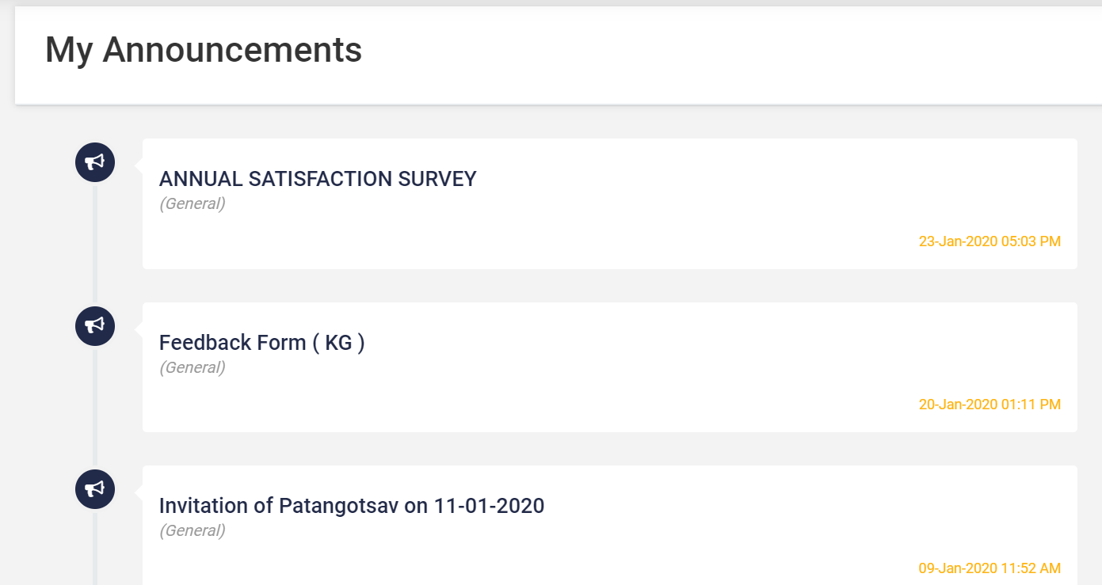

When they click on any of the announcements. Window should popup something like shown below

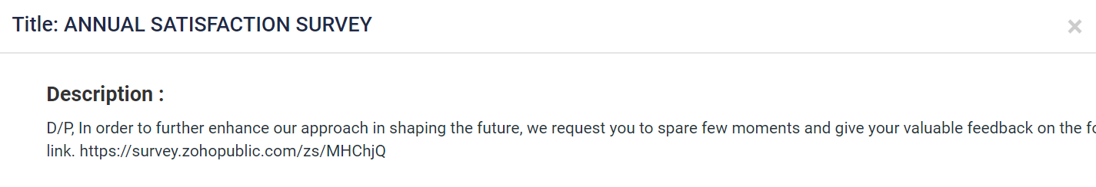



### Event Calendar

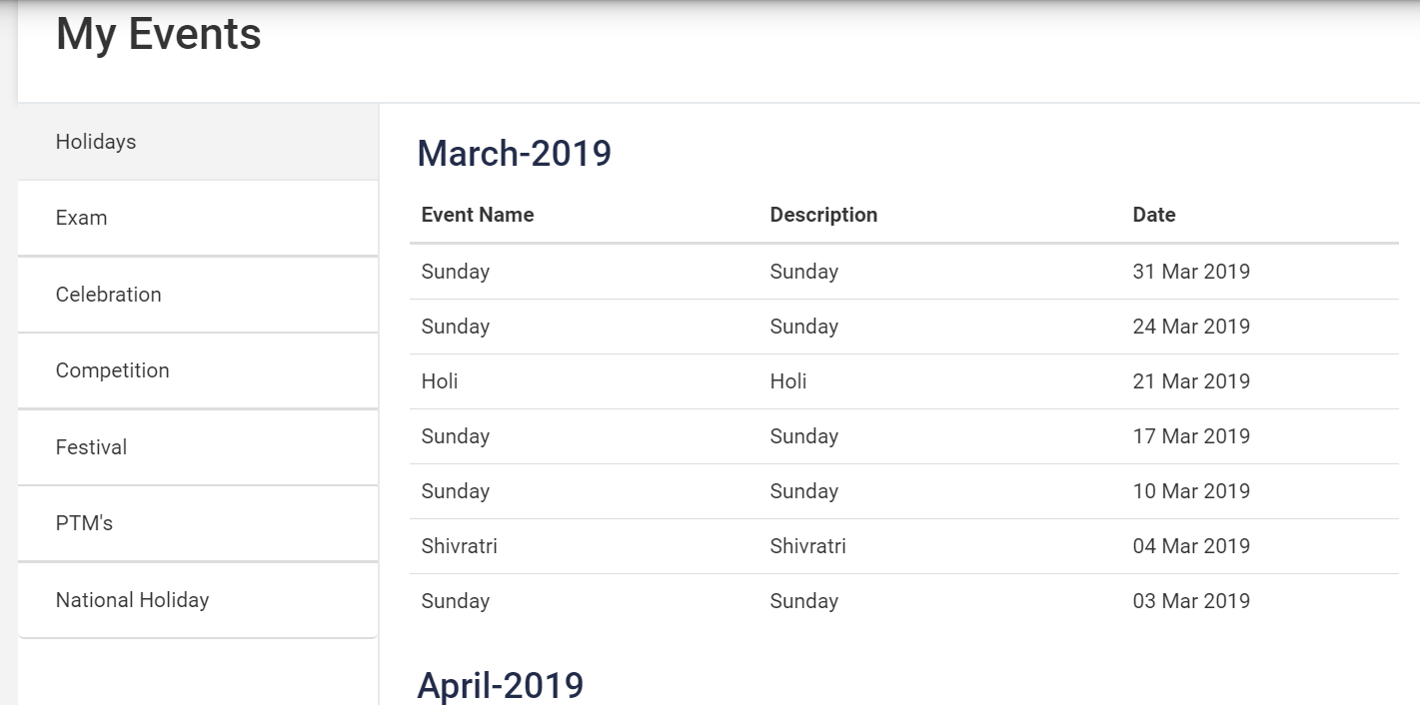

All the Tab will have same table with 3 column and month as header

### Gate Pass

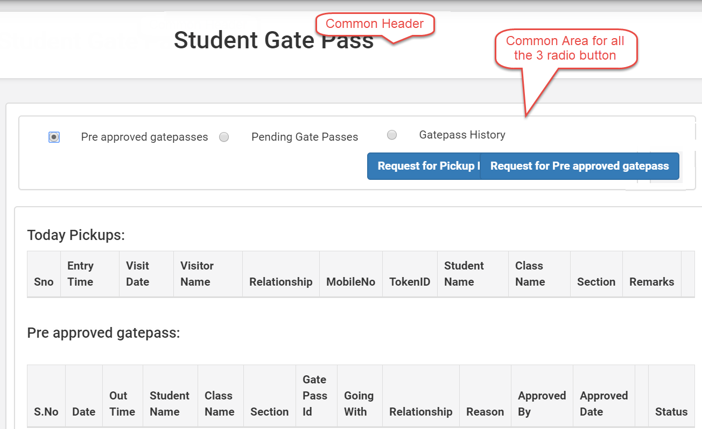

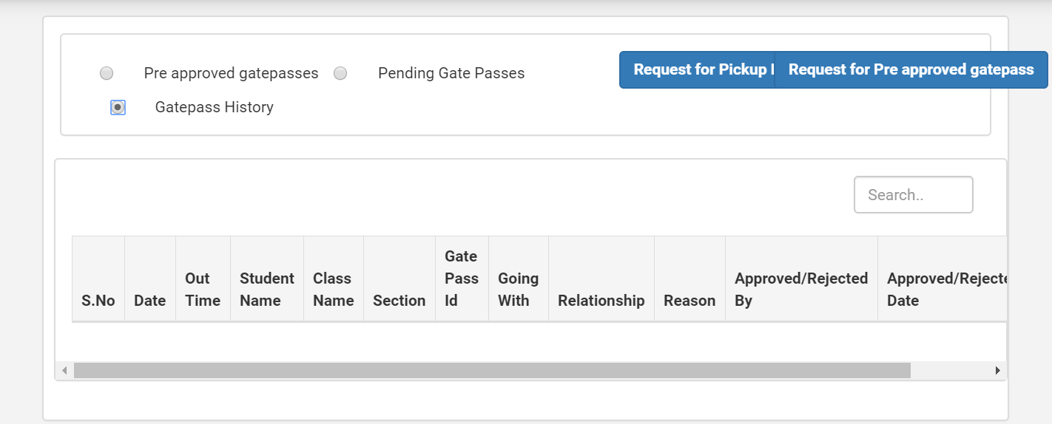

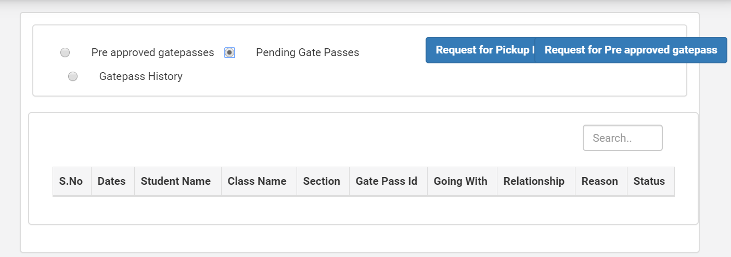

### 

### Progress Card

Should have table with following details

|  |  |  |
| --- | --- | --- |
| My Progress Card | | |
| Course | Vedic Maths | |
| Period | Level | Status |
| Jan to March 2020 | 2 | Download |

### Parents Concern Form

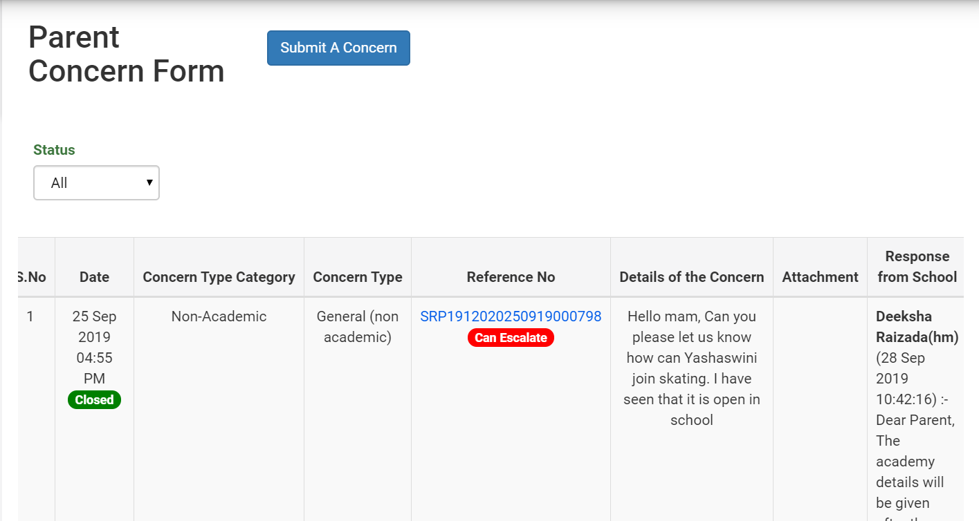

When they click on submit concern

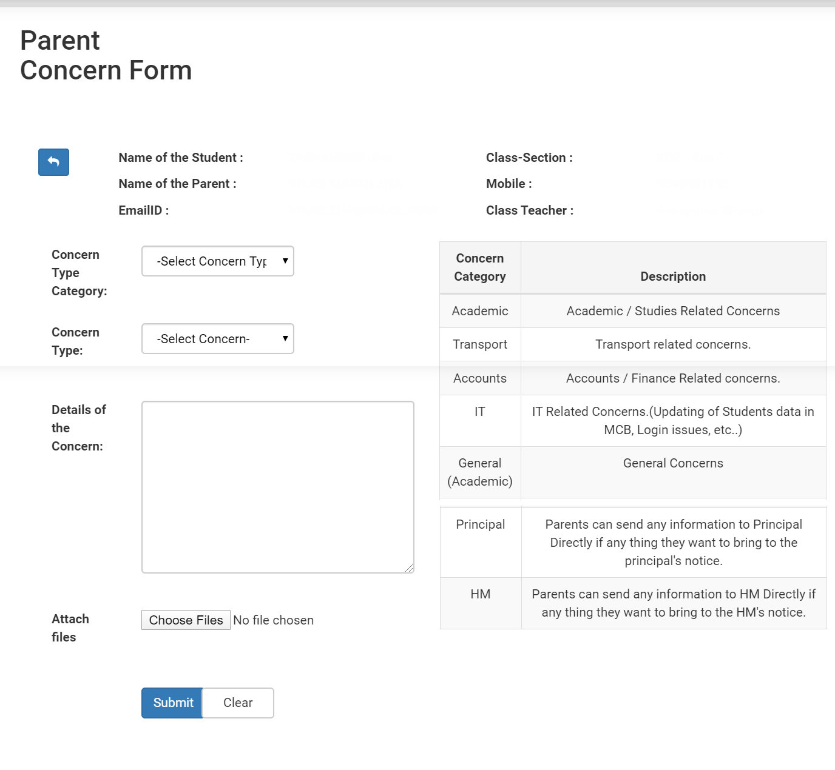

### Fee Structure

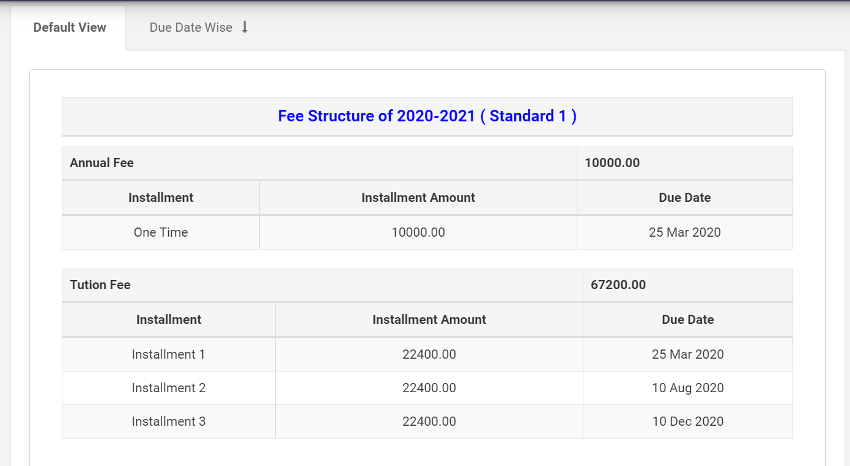

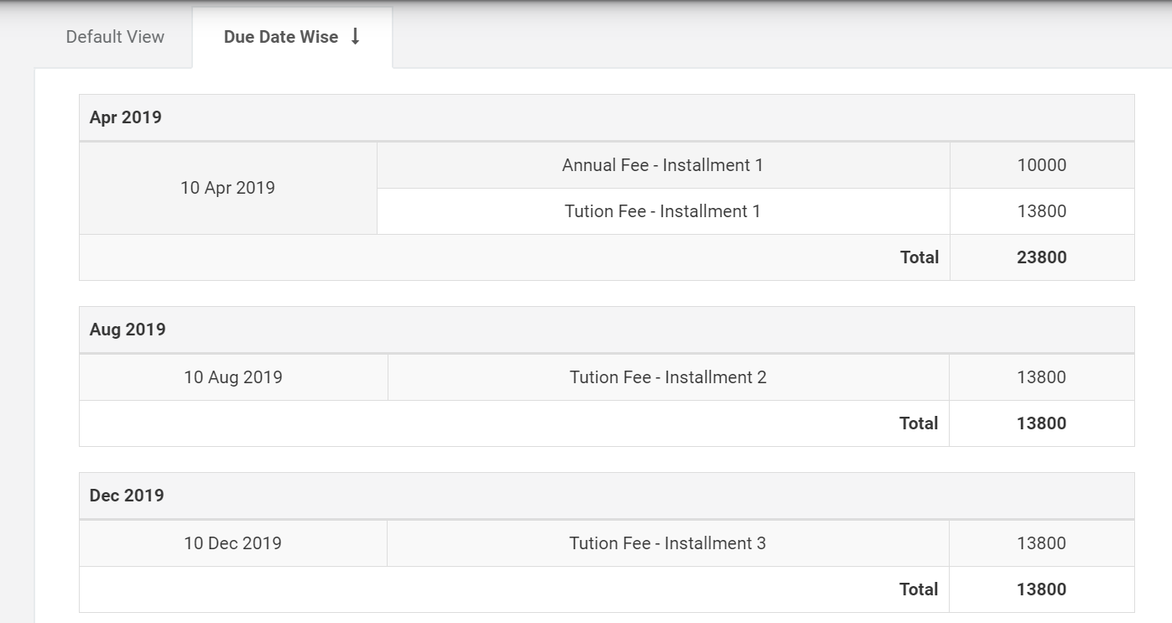

This page will have the total fees the student is paying along with individual course fee

### TC Request

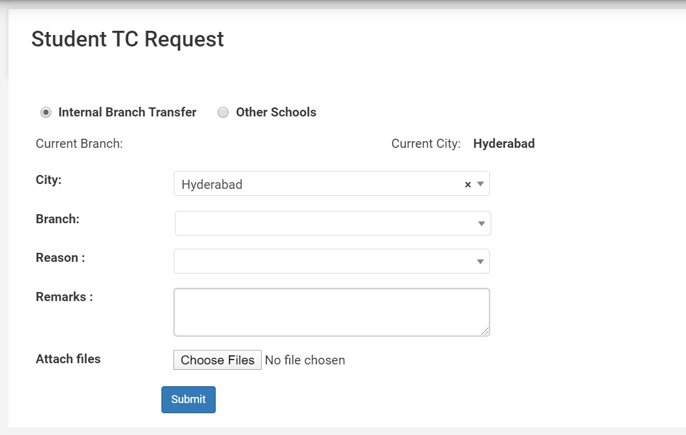

https://www.youtube.com/watch?v=CzkzwFwnbWQhttps://www.youtube.com/watch?v=CzkzwFwnbWQ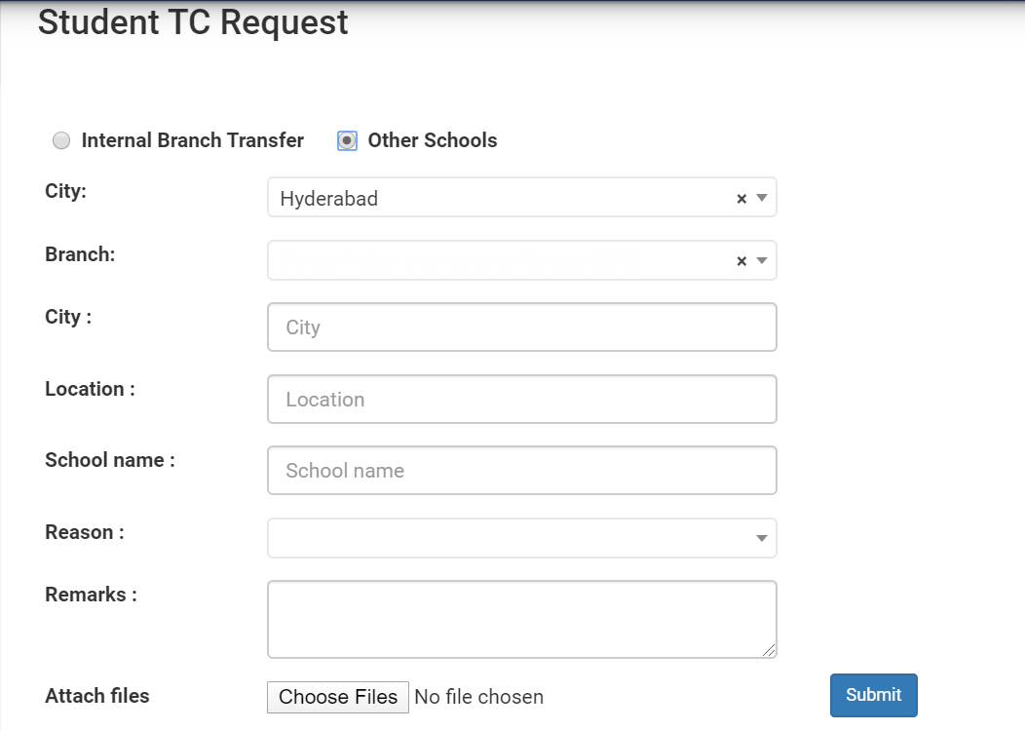

### Leave Application

Should be allowed to apply leave online or send leave application online

## Teachers Management

Practically I don’t have any demo to give for teacher management. But I need following

1. Login should be same as student Management
2. Menu should be having following things
3. Login should have personal profile
4. Salary details
5. Leave application
6. Assignment: where in teacher can upload common activity for all or individual activity. Page looks same as student assignment. Only difference is in student they can only download and see. Here she can upload and mark completion
7. Parent message. If teacher want to send mail to individual parent or all parent of particular group, she can
8. Parent concern. Teacher can see the concern raised by parent of his / her student and can answer the same
9. Student Attendance: teacher should be able to update student attendance
10. Self-attendance: should be allowed to see self-attendance
11. Event Calendar. Same as student. Only difference is there will be two section. Student and teacher. Some times student have holiday but teacher don’t
12. Class Activity : here teacher can update what she did in class, common and student wise both.
13. Student leave application she can approve or reject online
14. As early as teacher joins, a unique ID and email ID will be created for teacher / Staff
15. Exit process

## Non Teaching Staff

1. Can see student profile except fees
2. Can see teachers profile, excluding salary, DOB and other confidential information
3. Can apply leave online
4. Salary slip
5. Exit process
6. Unique Email ID will be generated

## Clerk

1. Clerk can see any details of student including his fees. Where as she can see any details of teacher excluding salary. All the menu of Student and teacher will be available with clerk along with details given below
2. She will have sections like.
   1. Accept fees
   2. Admit student
   3. Add teacher
   4. Admission enquiry
   5. Message to Staff
   6. Announcement (She can send to individual or common)
   7. Daily Expenses / Income
3. Unique Email ID will be generated
4. Will have access to contact us page

## Admin

1. Should have all the access. In edit mode. Now his activities should control everything.
   1. He will create courses and levels
   2. Decide fees and individual discount, after which it will be updated on website and parent can pay it to clerk or online
   3. Decide teacher salary
   4. Any profile change will be done by Admin and not by anyone (Teacher and student both)
   5. Student or teacher profile will get created only after admin approves it. After which clerk can add additional details
   6. Leave application from teacher and student will directly goes to admin. Where he/she approves or rejects it
   7. Can see financial report
   8. Should have access to all the 3 roles (Student / Teacher / Clerk )