THE GEN AI WORKFORCE SHIFT
Mapping Generative AI Exposure Across HR Occupations

A Skills-Based Analysis Using O*NET Data and Python

Author | Arti Sharma
Degree | Master of Science, HR Analytics (Candidate, 2026)
Date | April 2026
Data Source | O*NET 30.2 Database, U.S. Department of Labor
Tools | Python, Pandas, Matplotlib, Google Colab
Repository | github.com/arti-hr-analytics/genai-impact-hr-workforce

Keywords: Generative AI | HR Analytics | Workforce Automation | O*NET | People Analytics | Future of Work

Table of Contents

Foreword 1
Abstract 1
1. Introduction 1
2. Methodology 2
2.1 Data Sources 2
2.2 Occupation Selection 2
2.3 AI Exposure Scoring 2
2.4 Limitations 3
3. Findings 3
3.1 AI Exposure Rankings Across HR Occupations 3
3.2 Task Exposure Composition Analysis 4
3.3 Skills Analysis -- AI-Resistant vs Higher Exposure 4
4. Recommendations for HR Leaders 5
5. Conclusion 6
6. References 6
Acknowledgements and Disclosure 7

List of Figures
Figure 1: Gen AI Exposure by HR Occupation 3
Figure 2: Task Exposure Composition by HR Occupation 4
Figure 3: Top HR Skills -- AI-Resistant vs Higher AI Exposure 5

List of Tables
Table 1: HR Occupations Ranked by AI Exposure Score 3

Foreword

Before this paper begins with data, I want to be transparent about why it exists, because I believe the motivation behind research matters as much as the methodology.
I have spent a significant part of my career working across the full breadth of the Human Resources function. Over the years, I have touched every part of the discipline, from recruitment and onboarding, to compensation, employee relations, compliance, learning and development, and performance management. That journey eventually led me to lead an HR department and shape people strategy for the organization I served.
In that time, I had a front-row seat to one of the most significant shifts in the history of the profession. I watched HR evolve from manual, paper-based processes to digitized HRIS platforms, from intuition-driven hiring to structured competency frameworks, from reactive compliance functions to strategic business partnership. Each wave of technology transformed what HR professionals did, and what skills they needed to remain relevant.
Generative AI feels fundamentally different. It is not simply automating tasks. It is automating thinking. That distinction prompted me to pursue a Master of Science in HR Analytics, and this paper, conducted independently out of professional curiosity, is the result of that pursuit.
I also want to acknowledge something this paper itself embodies: the value of combining human expertise with analytical capability. The research presented here was conducted using data science tools and computational support, with all design, interpretation, and recommendations guided by professional judgment and lived experience in HR. That combination is precisely the model this paper advocates for every HR professional navigating the AI era.
As Josh Bersin, one of the world's leading HR industry analysts, has observed:
“AI will not replace HR professionals. But HR professionals who use AI will replace those who don’t.”
Josh Bersin, HR Industry Analyst and Founder, The Josh Bersin Company
What the data ultimately revealed was both sobering and clarifying. No HR occupation is untouched by Gen AI exposure. But the analysis also maps a clear path forward, showing precisely which competencies retain the highest value in an AI-augmented workplace, and which areas require the most urgent attention from HR leaders and professionals alike.
Arti Sharma
MS, HR Analytics | April 2026

ABSTRACT
Generative Artificial Intelligence (Gen AI) is rapidly transforming the modern workplace, yet its specific impact on Human Resources functions remains underexplored. This study applies a skills-based analytical framework to assess the Gen AI task exposure of 8 HR occupations using task-level data from the O*NET 30.2 Database, comprising 180 HR-specific task statements across occupations ranging from HR Assistants to HR Managers. Each task was scored on a 1 to 5 AI exposure scale using a keyword-based rubric grounded in established automation research. Results indicate that HR Assistants show the highest task exposure score (3.95/5.0), with 58% of their O*NET documented task statements classified as high-exposure. Education Administrators demonstrate the lowest exposure score (3.00/5.0). Notably, even senior roles such as HR Managers score in the moderate-exposure range (3.31/5.0), indicating that Gen AI will reshape HR functions across all levels. Skills analysis reveals a bifurcation among top HR competencies: some of the most important skills, such as Active Listening and Social Perceptiveness, are classified as AI-resistant, while others of equal importance, such as Critical Thinking and Writing, show higher AI exposure. These findings carry significant implications for HR workforce planning, reskilling strategies, and the future design of HR roles.
Keywords: Generative AI, HR Analytics, Workforce Automation, O*NET, People Analytics, Future of Work
Note: Keywords are included to improve discoverability when this paper is indexed on research platforms such as SSRN, Google Scholar, or LinkedIn.

1. INTRODUCTION
Generative AI is no longer a distant technological possibility. It is an active force reshaping how organizations operate, hire, and manage their people. According to Goldman Sachs (2023), Gen AI could affect approximately 300 million jobs globally, with white-collar, cognitive roles facing disproportionate exposure. Yet paradoxically, the Human Resources function, the very function responsible for managing workforce transformation, has received limited attention in automation research.
The scale of this gap is significant. According to the U.S. Bureau of Labor Statistics Occupational Employment and Wage Statistics (2025), the HR occupations studied in this analysis collectively employ approximately 1.5 million workers in the United States. HR professionals are simultaneously expected to lead organizational AI adoption while navigating uncertainty about their own role evolution. Understanding which specific HR tasks and occupations carry the highest Gen AI exposure is therefore both timely and strategically important.
This study addresses the following research question: To what extent are HR occupations exposed to Generative AI automation, and which specific task clusters and skills drive that exposure?
Using task-level data from the U.S. Department of Labor's O*NET 30.2 Database, the most comprehensive occupational information system in the United States, this analysis scores 180 HR-specific task statements across 8 occupations for Gen AI exposure and identifies which HR skills are most likely to retain their value in an AI-augmented workplace.
The findings are intended to inform HR leaders, workforce planners, and HR professionals as they navigate the most significant technological shift in the history of the profession.

2. METHODOLOGY

2.1 Data Sources
This study draws on two primary data sources. First, the O*NET 30.2 Database, published by the U.S. Department of Labor's Employment and Training Administration, provided task statements, skill importance ratings, and occupational classifications for all HR-related occupations. O*NET is updated quarterly and represents the most comprehensive occupational information system available in the United States. Second, automation exposure frameworks published by McKinsey Global Institute (2023) and the World Economic Forum's Future of Jobs Report (2025) informed the AI exposure scoring rubric applied in this study.

2.2 Occupation Selection
Eight HR occupations were selected based on Standard Occupational Classification (SOC) codes relevant to the HR function:
- HR Managers (11-3121.00)
- Training and Development Managers (11-3131.00)
- HR Specialists (13-1071.00)
- Labor Relations Specialists (13-1075.00)
- Compensation, Benefits and Job Analysis Specialists (13-1141.00)
- Training and Development Specialists (13-1151.00)
- HR Assistants (43-4161.00)
- Education Administrators, Postsecondary (11-9033.00)

2.3 AI Exposure Scoring
A total of 180 HR-specific task statements were extracted from the O*NET Tasks database. Each task statement was scored on a 1 to 5 scale for Generative AI exposure using a keyword-based rubric:
- Score 5 (High Exposure): Task statements involving scheduling, processing, maintaining records, tracking, calculating, screening, or generating documents, functions Gen AI can perform with high accuracy.
- Score 3 (Moderate Exposure): Task statements involving coordination, evaluation, analysis, or implementation, where Gen AI can assist but human oversight remains essential.
- Score 1 (Low Exposure): Task statements involving counseling, negotiating, mediating, coaching, advising, or strategic judgment, functions requiring distinctly human capabilities.

Occupation-level AI exposure scores were calculated as the average score across all task statements for that occupation. Skills analysis used O*NET importance ratings (scale 1 to 5) to identify the most critical HR competencies and classify them as AI-resistant or higher AI exposure.

2.4 Limitations
This study acknowledges several limitations. First, the exposure scores reflect the proportion of O*NET documented task statements classified at each exposure level. They do not represent the proportion of actual working time devoted to those tasks, nor do they imply that those roles face elimination. Rather, they identify which occupations contain the highest concentration of task descriptions that align with current Gen AI capabilities. Second, the keyword-based scoring approach, while grounded in established automation research, involves subjective classification. Future research employing natural language processing or machine learning may yield more granular results. Third, the analysis reflects task exposure rather than actual adoption rates of Gen AI tools within HR departments.

3. FINDINGS

3.1 AI Exposure Rankings Across HR Occupations
Analysis of 180 HR task statements across 8 occupations reveals meaningful variation in Gen AI exposure scores, ranging from 3.00 to 3.95 on a 5-point scale. Table 1 presents the full ranking by occupation.
Occupation | AI Exposure Score | Exposure Level | High Exposure Tasks
HR Assistants | 3.95 | High Exposure | 11 of 19 (58%)
T&D Managers | 3.83 | High Exposure | 5 of 12 (42%)
T&D Specialists | 3.50 | High Exposure | 8 of 20 (40%)
Compensation Specialists | 3.45 | Moderate Exposure | 9 of 22 (41%)
HR Specialists | 3.31 | Moderate Exposure | 9 of 26 (35%)
HR Managers | 3.31 | Moderate Exposure | 9 of 26 (35%)
Labor Relations Specialists | 3.29 | Moderate Exposure | 12 of 28 (43%)
Education Administrators | 3.00 | Moderate Exposure | 6 of 27 (22%)
Table 1: HR Occupations Ranked by AI Exposure Score

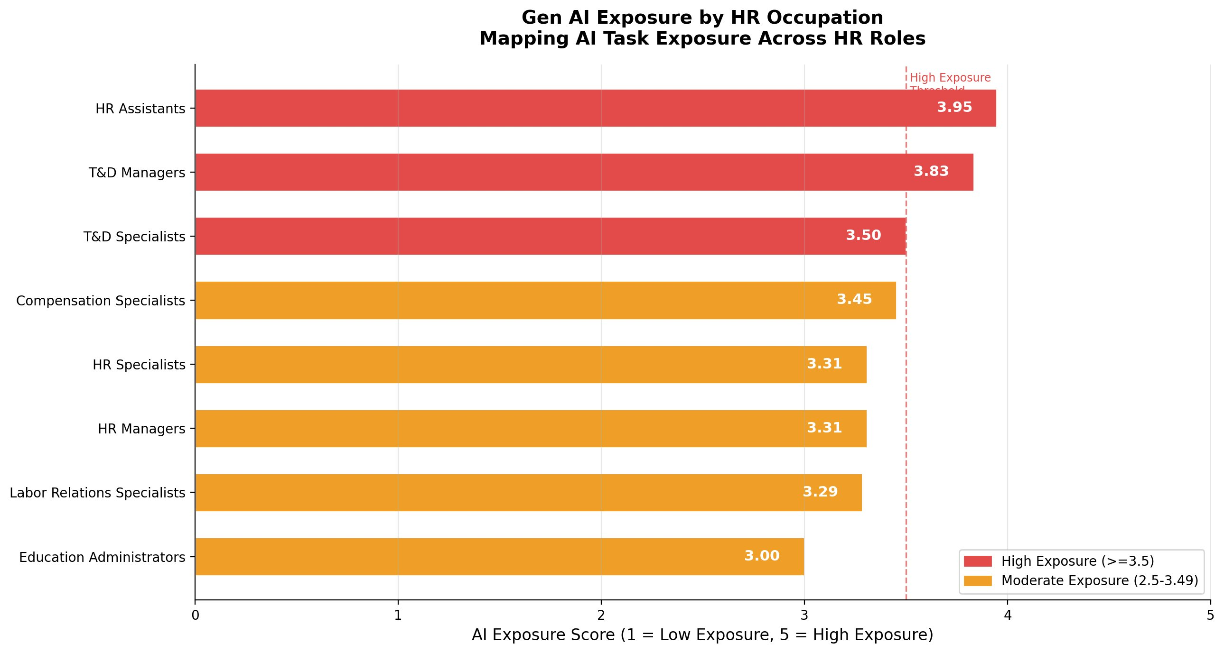
Figure 1: Gen AI Exposure by HR Occupation

3.2 Task Exposure Composition Analysis
Examination of task-level data reveals that 38% of all HR task statements analyzed score in the high-exposure category, 43% in the moderate-exposure category, and 18% in the low-exposure category. HR Assistants show the highest exposure profile, with 58% of their O*NET documented task statements classified as high-exposure.
It is important to note that these percentages reflect the proportion of O*NET task statements classified at each exposure level. They do not represent the proportion of actual working time devoted to those tasks, nor do they imply that those roles face elimination. Rather, they identify which occupations contain the highest concentration of task descriptions that align with current Gen AI capabilities.
This finding resonates with the realities of day-to-day HR operations. Tasks such as scheduling interviews, maintaining employee records, processing documentation, generating offer letters, and coordinating onboarding logistics have long formed the operational backbone of HR departments. These are precisely the task types that Gen AI handles most efficiently. In contrast, Labor Relations Specialists show the highest proportion of low-exposure task statements at 29%, reflecting the negotiation, mediation, and advocacy work that characterizes that occupation.
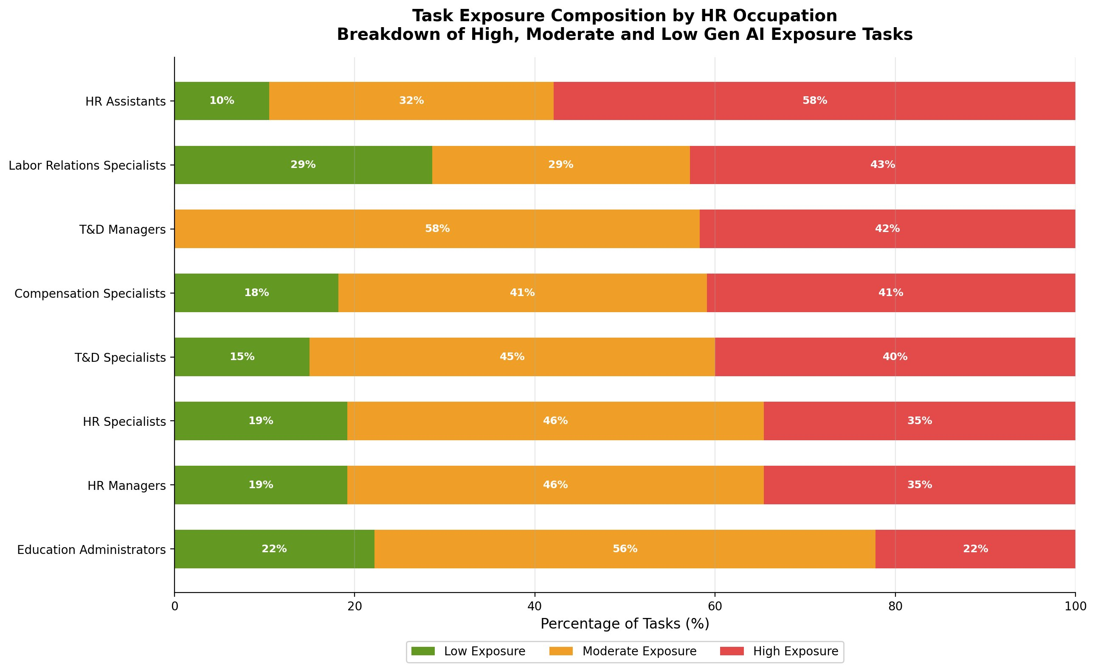
Figure 2: Task Exposure Composition by HR Occupation

3.3 Skills Analysis -- AI-Resistant vs Higher Exposure Competencies
Analysis of O*NET skill importance ratings across all 8 HR occupations reveals an important bifurcation among the most valued HR competencies. The top-rated skills do not fall neatly into one category. Instead, they split across the AI exposure spectrum, presenting HR professionals and organizations with both opportunities and areas requiring deliberate investment.
Active Listening and Speaking score highest in importance (4.08/5.0) and are classified as AI-resistant, as they depend on real-time human judgment, empathy, and social intelligence. Critical Thinking (3.84) and Writing (3.83) score almost equally high in importance but show higher AI exposure, given that Gen AI tools demonstrate strong capability in structured reasoning and content generation. Social Perceptiveness (3.64) and Judgment and Decision Making (3.55) are both highly important and AI-resistant, reinforcing the value of interpersonal and ethical judgment in HR roles.
This bifurcation has a direct practical implication: HR professionals face a dual development imperative. On one hand, they must build AI literacy and the ability to leverage Gen AI tools in areas such as writing, analysis, and critical thinking workflows. On the other hand, they must deepen the distinctly human competencies, listening, relationship-building, and judgment, that Gen AI cannot replicate. The most effective HR professionals of the next decade will be those who do both.
Dave Ulrich, widely regarded as the father of the modern HR Business Partner model, has consistently argued that the future of HR lies in its ability to create human value that technology cannot: “HR is not about HR. It is about delivering value to employees, customers, investors, and communities.” The skills data in this study supports that view while adding a critical nuance: delivering that value in an AI-augmented world will require proficiency on both sides of the exposure spectrum.
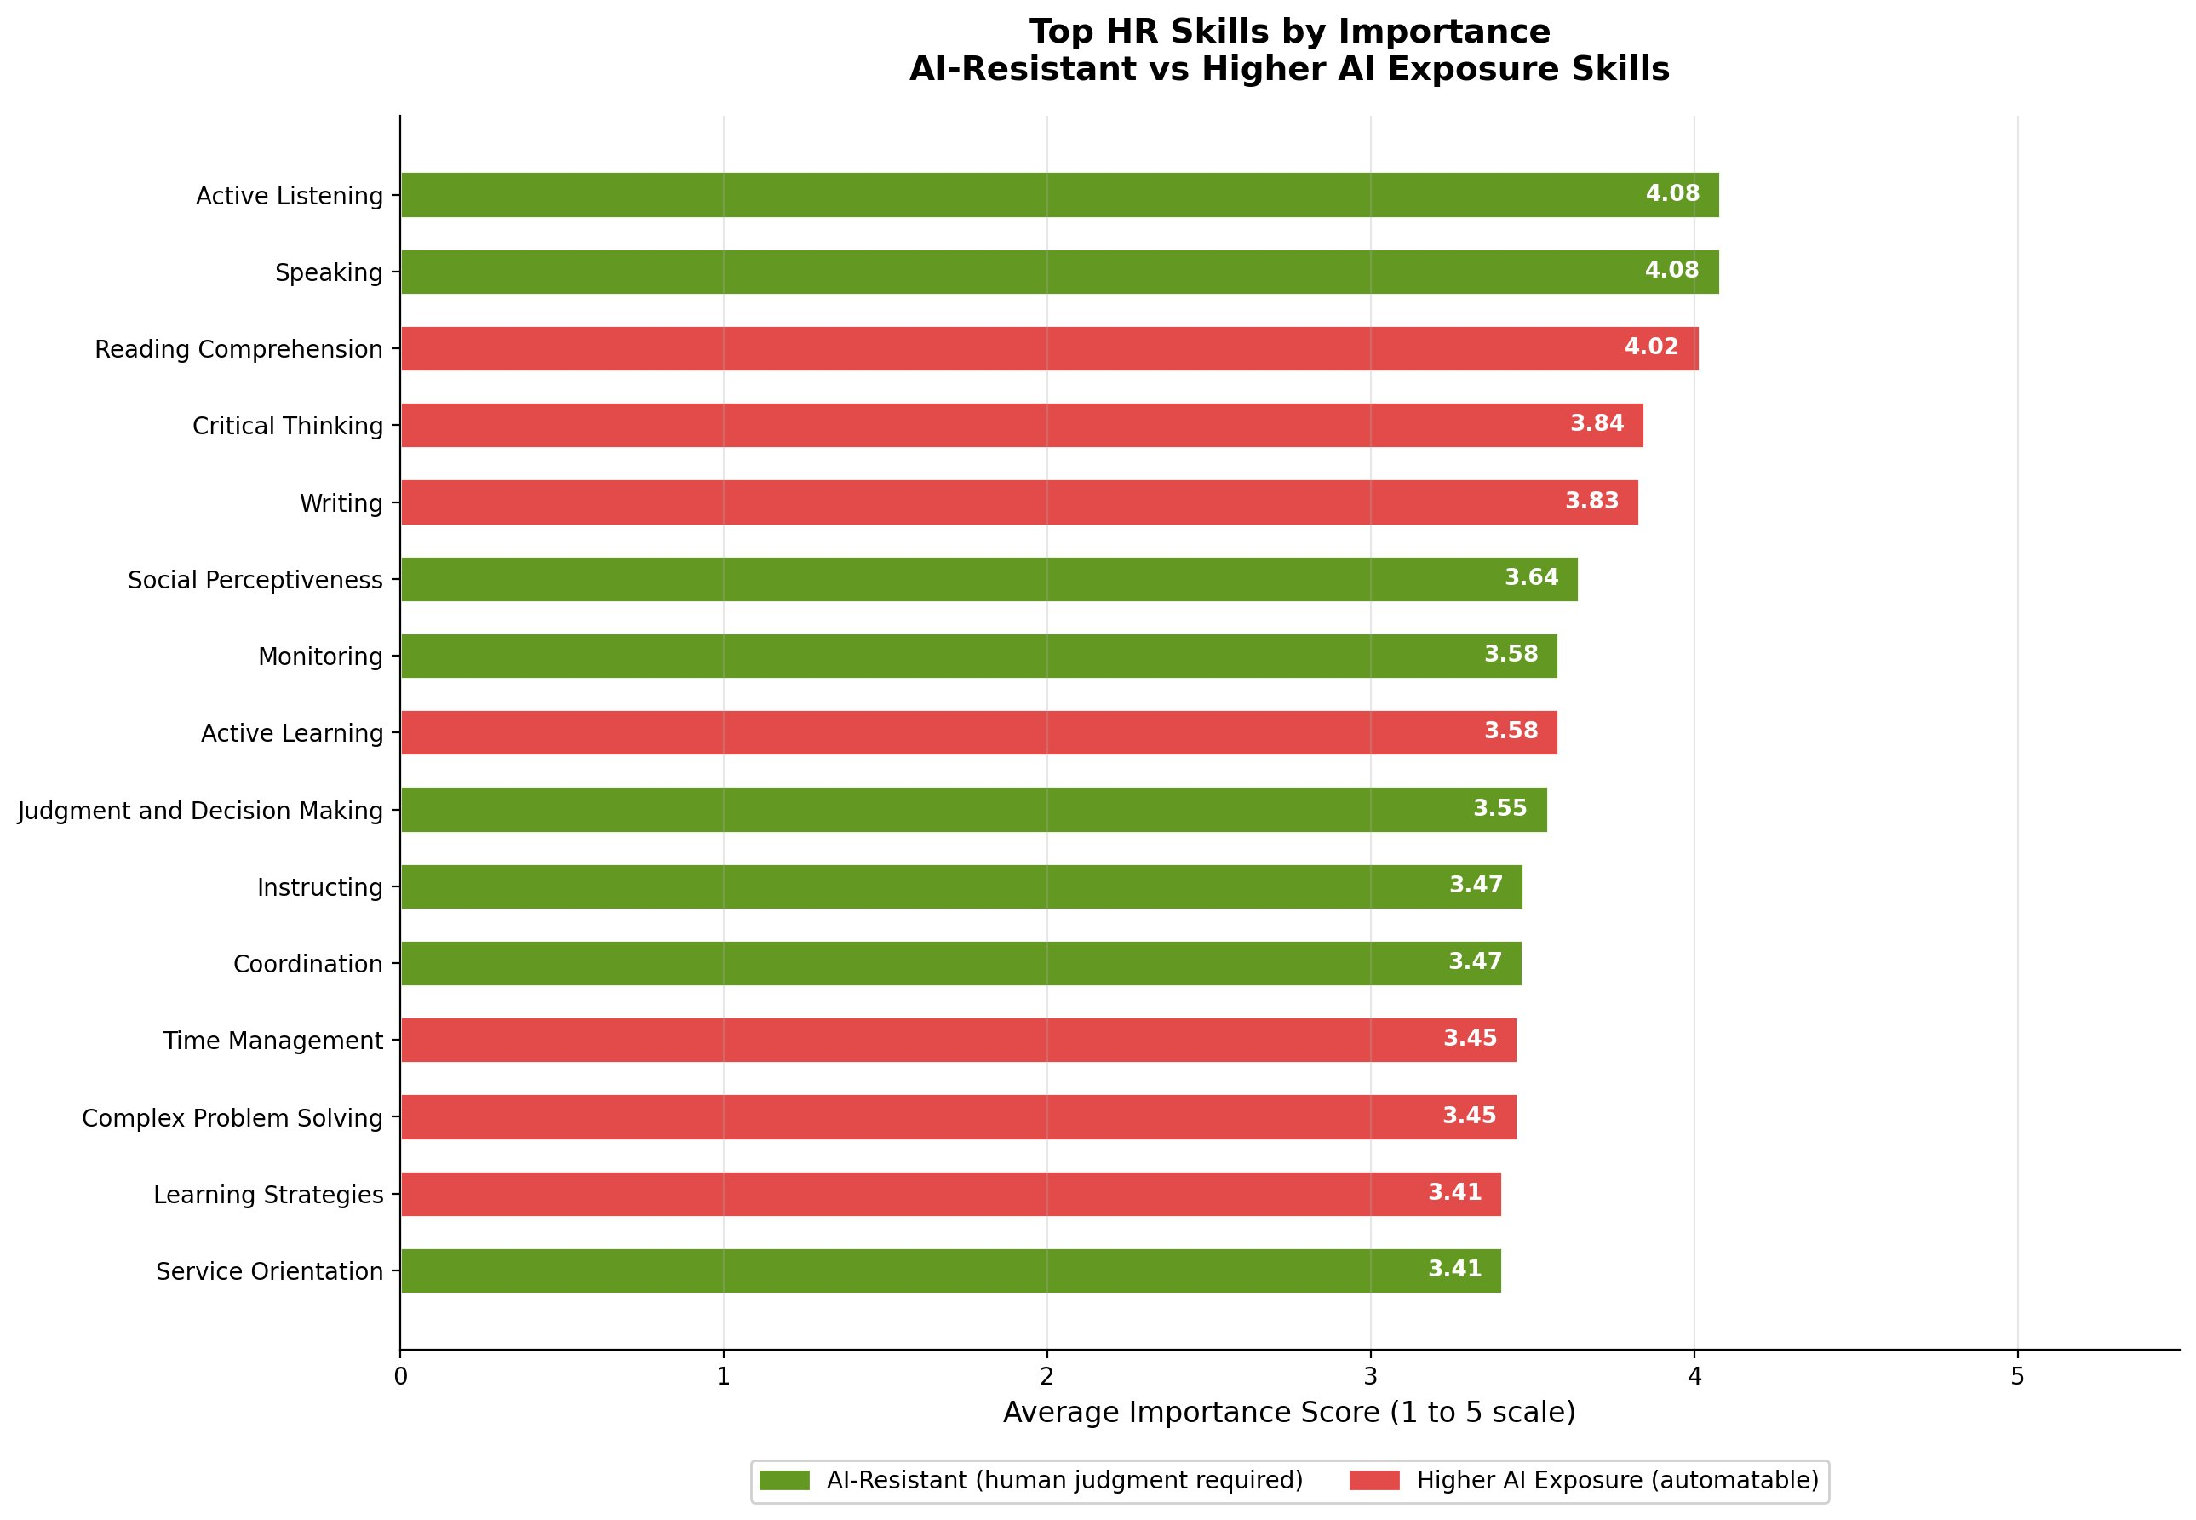
Figure 3: Top HR Skills by Importance -- AI-Resistant vs Higher AI Exposure

4. RECOMMENDATIONS FOR HR LEADERS
Based on the findings of this study and informed by extensive firsthand experience leading HR strategy across all people functions, five recommendations are offered for HR leaders and workforce planners:
- Reskill HR Assistants and T&D Professionals Proactively. With the highest task exposure scores in this study, these roles stand to be most affected by Gen AI integration. Organizations should invest in reskilling programs focused on data literacy, AI tool management, and higher-order HR competencies.
- Redesign HR Roles Around AI Augmentation. Rather than framing Gen AI as a replacement consideration, HR leaders should redesign job descriptions to pair human judgment with AI efficiency. Recruiters, for example, can redirect time freed from screening and scheduling toward candidate experience and cultural assessment.
- Invest in Both AI Literacy and Human Skills Development. The skills analysis reveals a dual imperative. HR professionals need foundational AI literacy to work effectively with tools that touch Critical Thinking and Writing workflows, while simultaneously deepening AI-resistant competencies such as Active Listening, Social Perceptiveness, and Judgment and Decision Making.
- Conduct an Internal HR Task Exposure Audit. Every HR department should map its own task portfolio against AI exposure frameworks. This study provides a replicable methodology that HR analytics teams can adapt using their own role data and O*NET SOC codes.
- Build Organization-Wide AI Literacy. HR functions at all levels will benefit from foundational AI literacy to effectively leverage Gen AI tools, evaluate their outputs, and manage their implications in people decisions.

5. CONCLUSION
This study presents evidence that Generative AI carries meaningful and differentiated implications for HR occupations, with entry-level and training-focused roles showing the highest task exposure and senior roles showing moderate but still notable exposure. The findings suggest that HR, as a relationship-driven and judgment-intensive function, is not insulated from the current wave of AI development.
Equally important is what the skills analysis reveals. The most valued HR competencies do not uniformly resist or embrace AI exposure. They bifurcate. Some of the most critical skills are already in the crosshairs of Gen AI capability. Others remain firmly human. That distinction matters enormously for how organizations design development programs, hiring criteria, and HR operating models going forward.
This study also illustrates something the author believes is critically important: that HR professionals do not need to wait for someone else to define AI's impact on their field. Using publicly available data, open-source tools, and thoughtful application of emerging technology, any HR professional can conduct meaningful, data-driven research on the questions that matter most to their career and their organizations.
The HR profession has adapted to every major wave of change before this one. The journey from paper-based processes to digital platforms to AI-augmented workflows is a testament to that resilience. The professionals who will thrive are those who lead that adaptation with curiosity, data, and a deep commitment to the human dimension of work.

6. REFERENCES
Bersin, J. (2023). HR Technology 2024: What's Hot and What's Not. The Josh Bersin Company. https://joshbersin.com
Goldman Sachs. (2023). The Potentially Large Effects of Artificial Intelligence on Economic Growth. Goldman Sachs Global Investment Research. https://www.goldmansachs.com/insights/pages/generative-ai-could-raise-global-gdp-by-7-percent.html
McKinsey Global Institute. (2023). The State of AI in 2023: Generative AI's Breakout Year. McKinsey and Company. https://www.mckinsey.com/capabilities/quantumblack/our-insights/the-state-of-ai-in-2023-generative-ais-breakout-year
Ulrich, D. (2023). The Future of HR: Value Creation through People. RBL Group. https://rbl.net
U.S. Bureau of Labor Statistics. (2025). Occupational Employment and Wage Statistics (OEWS). U.S. Department of Labor. https://www.bls.gov/oes/
U.S. Department of Labor. (2026). O*NET 30.2 Database. Employment and Training Administration. https://www.onetcenter.org/database.html
World Economic Forum. (2025). The Future of Jobs Report 2025. World Economic Forum. https://www.weforum.org/reports/the-future-of-jobs-report-2025
Stanford Institute for Human-Centered Artificial Intelligence. (2025). AI Index Report 2025. Stanford University. https://aiindex.stanford.edu/report/

Acknowledgements and Disclosure
This research was conducted independently, driven by the author's personal and professional interest in understanding the impact of Generative AI on the Human Resources profession. It is not affiliated with any academic institution, program, or commissioned engagement. The views, findings, and recommendations expressed here are solely the author's own, informed by extensive experience leading people strategy across all HR functions.
The author gratefully acknowledges the U.S. Department of Labor's O*NET program for providing free public access to occupational data that made this analysis possible.
A note on tools and process: This research was conducted using data science and analytical tools, with computational support used to accelerate data processing and visualization. All research design, analytical decisions, interpretation of findings, and strategic recommendations reflect the author's original thinking and professional judgment. The use of modern tools to support research, including AI-assisted capabilities, is itself consistent with the message of this paper: that thoughtful integration of technology with human expertise produces outcomes that neither could achieve alone. This note is included in the spirit of transparency that the author advocates for all HR professionals engaging with AI.

