ARTI BHATIA

CS5A, 16

**PAGING**

Q- Implement pass one of a two pass assembler.

Program:

//Program to implement paging technique

#include <stdio.h>

#define MAX 50

int main()

{

    int page[MAX], i, n, f, ps, off, pno;

    int choice = 0;

    printf("\nEnter the no of peges in memory: ");

    scanf("%d", &n);

    printf("\nEnter page size: ");

    scanf("%d", &ps);

    printf("\nEnter no of frames: ");

    scanf("%d", &f);

    for (i = 0; i < n; i++)

        page[i] = -1;

    printf("\nEnter the page table\n");

    printf("(Enter frame no as -1 if that page is not present in any frame)\n\n");

    printf("\npageno\tframeno\n-------\t-------");

    for (i = 0; i < n; i++)

    {

        printf("\n\n%d\t\t", i);

        scanf("%d", &page[i]);

    }

    do

    {

        printf("\n\nEnter the logical address(i.e,page no & offset):");

        scanf("%d%d", &pno, &off);

        if (page[pno] == -1)

            printf("\n\nThe required page is not available in any of frames");

        else

            printf("\n\nPhysical address(i.e,frame no & offset):%d,%d", page[pno], off);

        printf("\nDo you want to continue(1/0)?:");

        scanf("%d", &choice);

    } while (choice == 1);

    return 1;

}

Output:

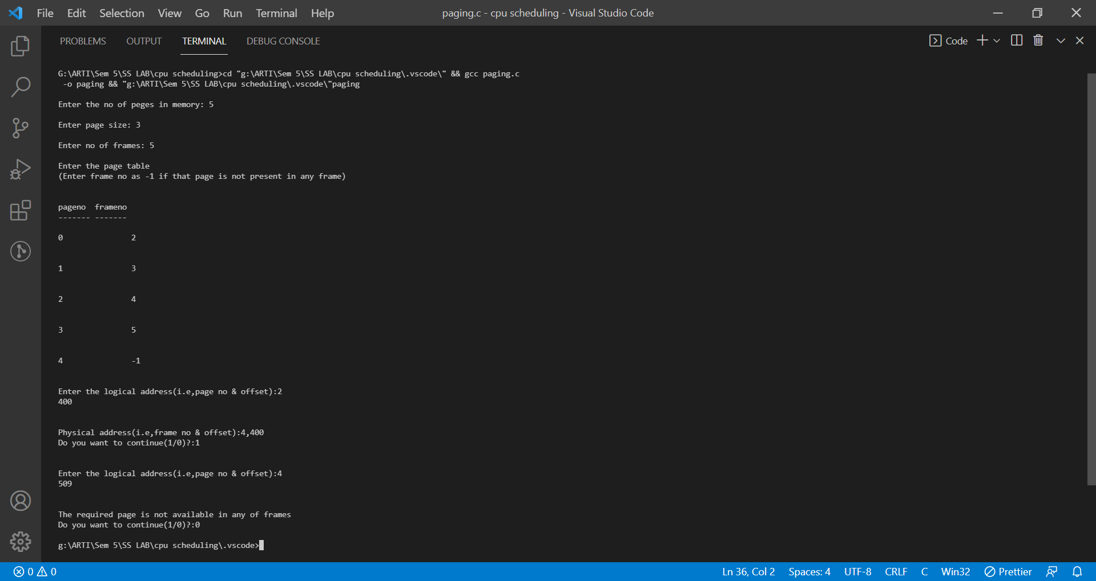

Algorithm:

