2000rupees note Ban

The **Reserve Bank of India (RBI) has decided to withdraw the Rs 2000 denomination banknotes from circulation**. But existing notes will continue to be legal tender, the RBI announced on Friday.

The central bank has advised the public to deposit Rs 2000 banknotes, which were introduced after Rs 500 and Rs 1000 notes were withdrawn during the demonetization exercise six years ago, into their bank accounts and /or exchange them into banknotes of other denominations at any bank branch.

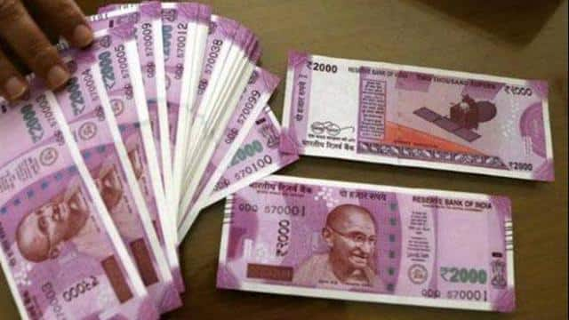

When 2000-rupee notes were introduced in 2016 they were intended to replenish the Indian economy's currency in circulation quickly after demonetization. However, the central bank has frequently said that it wants to reduce high-value notes in circulation and had stopped printing 2000-rupee notes over the past four years. "This denomination is not commonly used for transactions," the Reserve Bank of India said in its communication while explaining the decision to withdraw these notes.

Rupa Rege Nitsure, group chief economist at L&T Finance Holdings told Reuters that “this withdrawal will not create any big disruption, as the notes of smaller quantity are available in sufficient quantity." He added, "Also in the past 6-7 years, the scope of digital transactions and e-commerce has expanded significantly."

However, Yuvika Singhal, an economist at QuantEco Research pointed out that small businesses and cash-oriented sectors such as agriculture and construction may face inconvenience in the near term.

The value of 2000-rupee notes in circulation is 3.62 trillion Indian rupees ($44.27 billion). This is about 10.8% of the currency in circulation."This withdrawal will not create any big disruption, as the notes of smaller quantity are available in sufficient quantity,". But small businesses and cash-oriented sectors such as agriculture and construction could see inconvenience in the near term, To the extent that people holding these notes chose to make purchases with them rather than deposit them in bank accounts, there could be some spurt in discretionary purchases such as gold.

As the government has asked people to deposit or exchange the notes for smaller denominations by Sept. 30, bank deposits will rise. This comes at a time when deposit growth is lagging bank credit growth. This will ease the pressure on deposit rate hikes, said Karthik Srinivasan, group head – of financial sector ratings at rating agency ICRA Ltd.

Banking system liquidity will also improve.

"Since all the 2000-rupee notes will come back in the banking system, we will see a reduction in cash in circulation and that will in turn help improve banking system liquidity," said Madhavi Arora, an economist at Emkay Global Financial Services.

To deposit a Rs 2,000 note, you can follow these general steps:

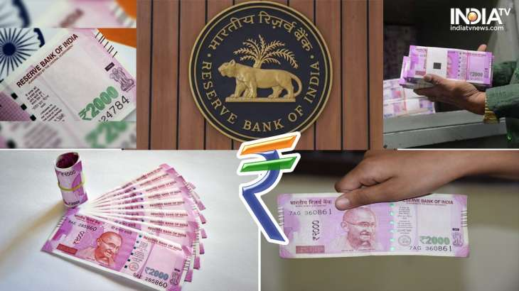

* Visit a Bank/Branch: Go to your nearest bank branch where you hold an account or have banking facilities.
* Carry Identification Documents: Carry valid identification documents such as an Aadhaar card, PAN card, voter ID, or passport along with your bank account details.
* Fill out the Deposit Slip: Obtain a deposit slip from the bank and fill in the required details, including your bank account number, name, and the denomination and number of the Rs 2,000 notes you wish to deposit.
* Submit the Deposit: Hand over the filled deposit slip along with the Rs 2,000 note(s) to the bank teller or follow the instructions provided by the bank staff.
* Acknowledgment and Receipt: Once the deposit is processed, the bank will provide you with an acknowledgment slip or receipt confirming the deposit of the Rs 2,000 note(s).

The exchange/deposit limit for Rs 2,000 notes set by the Reserve Bank of India (RBI) is subject to the individual’s Know Your Customer (KYC) compliance. According to the announcement, bearers would be allowed to trade up to Rs 20,000 (10 2,000-Rupee notes) at a time. However, it is advisable to check with your bank or RBI for any updated guidelines or restrictions regarding the exchange or deposit of Rs 2,000 notes.