Software Requirements Specification (SRS) Doc
Location Based Advertising,Team no. 24:Kritika Agrawal,Aakash Mittal , Arushi Singhal

Brief problem statement
We have to create a platform on which users can advertise their product based on location. User will buy slots based on time and location for his advertisement and upload advertisement . On server side , a sequence of advertisements will be created for display at a particular time , location and bundle of devices. Device will ping its location to the server and corresponding advertisements will be displayed. The advertisements will be beamed on the screens with GPS module attached (For e.g. Android TV, Tab), fitted inside the vehicles (for e.g. RTC buses).

System requirements
- OSM API
- MVC framework (Django)

Users profile
- Administrator: Well acquainted with the use of computer.
- Local business owner: Not expected to know much about computers. Should atleast know how to open a website.

Feature requirements (described using use cases)

No. | User Case Name | Description | Release
- 1 | Division of region into zones | Overall area where advertisements can be displayed will be divided into square zones and user will be identified on the basis of the zone he is located in. | R1
- 1 | Updating information about each zone | Number of bundles,slots available,price etc. will be updated by the administrator. | R2
- 3. | Selecting a zone | User will select a zone where he wants to advertise | R1
 | Selection of bundles | User will select Number of bundles he wants to advertise his product on. | R2
 | Selection of slots | User will select number of slots he wants for his advertisement . One slot will be of 30 s. If his advertisement is of 45s (for eg.) then he has to buy two slots. | R1
 | Selection of number of weeks | User will select the time period ,in terms of number of weeks , for which he wants to advertise. Week will be on monday-sunday basis. | R2
 | Check Availability | Checking if the number of slots,bundles and time period for which user is demanding is available or not for the selected zone. | R2
 | Calculate Cost | Calculating amount he has to pay for his selection. | R2
 | Upload Advertisement | User will upload his advertisement He will also enter the exact duration of his advertisement. | R1
 | Login | Anyone using the web app has to login.System will check if the user is administrator or user. | R1
 | Login to display | Device on which advertisement will be displayed will ping to the server by login in through a id given to it. | R1
 | Display Advertisements | Advertisements corresponding to the location of the device which has pinged and time will start playing. | R1
 | User History | When user is logged in , he can check his previous activities. | R2
 | Edit advertisement | When user is logged in , he can edit the advertisements which are still live and is uploaded by him. He can delete the current ad and upload new one but cant change number of slots and bundles when his account is still live. | R2
 | Managing Users | Administrator can regulate users.He will have the power to add or delete them or any content uploaded by them. | R2

Use case diagram

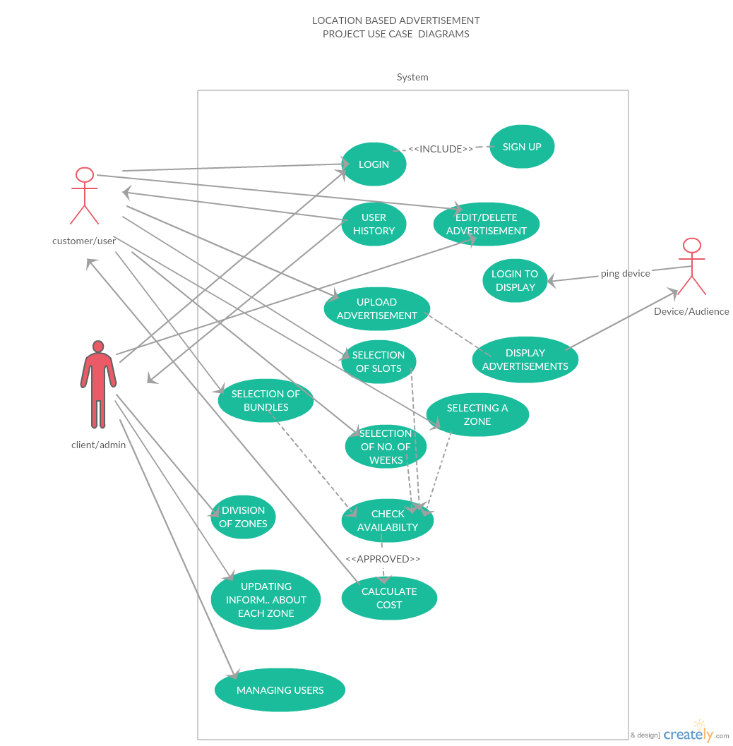

DETAILS OF ALL USE CASES
Use case number: | 3
Use case name: | Selecting a zone
Overview: | User will select a zone where he wants to advertise
Type: | Essential
Actors: | user
Pre-condition: | Login and uploaded advertisement
Main flow : | 1.user select the zone  2. According the zone cost will be decided.  3.Followed by selection of slots and bundles.
Alternate flow:
Alternate flow:
Alternate flow:
Post-condition: | true
Cross-reference: | Validate login

Use case number: | 4
Use case name: | Selecting bundles
Overview: | User will select Number of bundles he wants to advertise  his product on.
Type: | Essential
Actors: | User
Pre-condition: | Login and upload advertisement.
Main flow : | 1.user select the number of bundles  2.number of bundles for each zone is pre-decided.  3. cost may vary for bundles in different zone
Alternate flow: | If that much bundle is not available then customer has to reduce number of bundles.
Alternate flow: | Total cost also depends on the number of bundles.
Alternate flow:
Post-condition: | true
Cross-reference: | Validate login

Use case number: | 5
Use case name: | Selecting a slot
Overview: | User will select number of slots he wants for his  advertisement . One slot will be of 30 s. If his  advertisement is of 45s (for eg.) then he has to buy two  slots
Type: | Essential
Actors: | user
Pre-condition: | Login and upload advertisement
Main flow : | 1.user select the number of slots.  2. according to the number of slots final cost will be decided.
Alternate flow: | If that much slot is not available then customer has to reduce the number of slots.
Alternate flow: | Timing for each slot is fix so if customer advertisement increase the time of one slot then he has buy two or more slots depending upon the time of each slot and advertisement time.
Alternate flow: | The customer can't increase or decrease the number of slots after submitting the advertisement for display.
Post-condition: | true
Cross-reference: | Validate login

Use case number: | 6
Use case name: | Selecting of number of weeks
Overview: | User will select the time period ,in terms of number of  weeks , for which he wants to advertise. Week will be on  monday-sunday basis.
Type: | Essential
Actors: | user
Pre-condition: | Login and upload advertisement
Main flow : | 1.user will select the number of weeks  2. according to the number of weeks cost will be decided.
Alternate flow: | 1.Each week starts on monday and will end on sunday.
Alternate flow: | User can't edit number of weeks after submission and same advertisement will be shown for that number of weeks
Alternate flow:
Post-condition: | true
Cross-reference: | Validate login

Use case number: | 15
Use case name: | Managing User
Overview: | Administrator can regulate users.He will have the power  to add or delete them or any content uploaded by them.
Type:
Actors: | Admin
Pre-condition: | Admin has to log In
Main flow : | 1.admin can add and delete the advertisement uploaded by the user.  2. can see user info and has excess to all the functionalities which the user has
Alternate flow:
Alternate flow:
Alternate flow:
Post-condition: | true
Cross-reference: | Validate login

Use case number: | 9
Use case name: | Upload advertisements
Overview: | User will upload his advertisement He will also enter the  exact duration of his advertisement.
Type: | Essential
Actors: | user
Pre-condition: | User has logged in
Main flow : | User will upload the advertisement along with the time of the advertisement.
Alternate flow: | If the time of the advertisement exceeds the time decided for one slot then either user has to increase the number of slots as the Time for each slot is fix or else the advertisement will automatically cut.
Alternate flow:
Alternate flow:
Post-condition: | true
Cross-reference: | Validate login

Use case number: | 10
Use case name: | login
Overview: | Anyone using the web app has to login.System will check  if the user is administrator or user.
Type: | Essential
Actors: | User/admin
Pre-condition: | Sign up
Main flow : | 1. user will login with email-id and password'  2. system will check if that id already exist and if not then it will ask for correct id and password.  3. system will detect if it's a user or admin and accordingly power will be given.
Alternate flow: | If the login is not validate then the message will be prompt.
Alternate flow: | If that id is not found then the user will be asked to to do sign up first.
Alternate flow:
Post-condition: | true
Cross-reference: | Validate login

Use case number: | 11
Use case name: | Login to diaplay
Overview: | Device on which advertisement will be displayed will  ping to the server by login in through a id given to it.
Type:
Actors: | Device/end-user
Pre-condition: | Sign up
Main flow : | 1.user will logged in with email-id and password
Alternate flow: | If not validate ask to re-enter the id and password again
Alternate flow: | If that id is not found then the user will be asked to to do sign up first.
Alternate flow:
Post-condition: | true
Cross-reference: | Validate login

Use case number: | 12
Use case name: | Dispaly Aadvertisement
Overview: | Advertisements corresponding to the location of the  device which has pinged and time will start playing.
Type:
Actors: | user
Pre-condition: | Log in
Main flow : | 1.user will first log-in  2.device location will be pinged to the server and accordingly advertisement will be shown.  3. each device has unique id.
Alternate flow: | If the id and password is not validate then msg will be displayed.
Alternate flow:
Alternate flow:
Post-condition: | true
Cross-reference: | Validate login

