What Wins vs. What Sells: Knowledge Discovery in Disney Lorcana’s Competitive and Collector Markets
A KDD Approach to Deck Optimization, Game Balance, and Market Divergence
Artie Bowman, Mohammad Aziz Boufaied, Kennedy Comstock, Nurudeen Showole
April 2026

Abstract
This study applies a Knowledge Discovery in Databases (KDD) pipeline to Disney Lorcana, a trading card game (TCG) with a dual-market ecosystem driven by competitive strategy and Disney intellectual property collector demand. We integrate 2,652 cards from the Lorcast API (2,075 after deduplication), 749 tournament decklists from 710 unique players across 21 official Disney Lorcana Challenge and Community Championship Qualifier events across 13 countries (176–2,300 actual players per event), and three independent price sources: tcgcsv.com market prices (2,906 entries), Lorcast API daily listings (2,262 cards), and 17 periodic price snapshots spanning May 2025 through March 2026.
Our dual-axis SHAP framework reveals that rarity is the #1 predictor of market price but was not selected by Mutual Information (MI) filtering for competitive prediction (MI < 0.01)—the competitive and collector markets operate on fundamentally different value systems. Deck build cost does not predict winning (r = −0.092, p = 0.012, Cohen’s d = −0.230): Dogs (Amber/Emerald) costs $179 median and achieves a 24.8% Top-8 rate, while Blurple (Amethyst/Sapphire) costs $459 and wins only 18.8%. Chi-squared testing confirms archetype choice does not significantly predict winning (χ² = 11.85, p = 0.540)—card selection within archetypes matters more than which archetype a player chooses.
We introduce the Sleeper Card Index (SCI), a tournament-based metric bridging competitive performance (play rate × win rate) with market price, identifying specific buy/sell signals per archetype. The near-random predictive accuracy of our best model (XGBoost AUC = 0.544) is itself evidence of game balance: if deck composition alone determined outcomes, the game would be solved. For competitive players, Section 11.2 offers a plain-language guide to the findings—what to build, what to buy, and what to skip. The analytical framework—dual-axis SHAP with card-level SCI—is transferable to any TCG with competitive and secondary market data.

1. Introduction

1.1 Background and Motivation
Trading card games (TCGs, also referred to as collectible card games or CCGs in earlier literature) combine combinatorial strategy, game theory, and speculative finance. As Hoover et al. (2020) observe, TCGs present rich AI and data mining challenges due to their combinatorial complexity, hidden information, and evolving metagames (the shifting landscape of which strategies and decks are popular and successful at any given time). With hundreds of unique cards—each with distinct abilities and interactions—the feature space for competitive analysis is vast and nonlinear. The TCG market has grown rapidly since 2020, with global sales exceeding $13 billion annually and new titles from major IP holders (Disney, Bandai, Konami) expanding the competitive landscape. TCGs pose greater game-theoretic complexity than chess or Go due to hidden information, stochastic card draws, and continuously evolving card pools (Hoover et al., 2020).
Disney Lorcana is a TCG where players construct a deck of at least 60 cards (with no upper limit) containing characters, items, actions, songs, and locations to become the first player to accumulate 20 lore—accomplished by questing (turning characters sideways to gain lore) with characters on the board while managing threats through challenges (attacking opposing characters) and abilities (Disney Lorcana Comprehensive Rules v2.0.1, 2026). Each deck uses up to two of six ink colors (Amber, Amethyst, Emerald, Ruby, Sapphire, Steel) and may include up to four copies of any card. These constraints create a rich combinatorial design space where strategic deck construction is both an art and a quantifiable optimization problem.
Lorcana is distinguished from prior-studied TCGs by its dual-market structure: competitive utility and Disney IP collector appeal independently drive prices. A card featuring a beloved character (e.g., Elsa, Stitch) may command a premium regardless of its competitive viability, while a mechanically dominant common may cost pennies. This creates measurable divergence between what wins and what sells—the central thesis of this study. Disney Lorcana’s competitive organized play launched in May 2024, with Season 2 (2025–2026) expanding to large-scale Challenge events regularly drawing 1,000–2,300 players across North America, Europe, and Asia.

1.2 Research Questions
This work is motivated by three primary research questions:
RQ1 (What Wins?): Which intrinsic card attributes, engineered efficiency metrics, and latent textual features most strongly predict competitive Top-8 tournament placement (finishing in the top 8 of a multi-hundred or multi-thousand player event)?
RQ2 (What Sells?): Do the same traits that predict competitive success also predict secondary market price, or do these markets diverge?
RQ3 (Game Balance): Can deck composition alone predict tournament outcomes, or does the game exhibit evidence of healthy competitive balance where player skill dominates?

1.3 Novelty Statement
While prior work has applied data mining to Magic: The Gathering (Pawlicki et al., 2014; Fink et al., 2015) and Hearthstone (Mora et al., 2022), and predictive sports analytics have demonstrated the broader applicability of classification to competitive outcomes (Leung & Joseph, 2014), no study has simultaneously modeled competitive placement and market price using dual-axis SHAP analysis. Our framework is the first to quantify the divergence between competitive and collector value systems in any TCG, and the first academic study of Disney Lorcana. We additionally introduce the Sleeper Card Index (SCI), a novel tournament-based metric that bridges these value systems at the individual card level.

1.4 Professional Significance
Beyond its academic contribution, this work demonstrates the full KDD lifecycle applied to a real-world, multi-modal domain. The methods employed—data fusion across APIs and manual collection, dual-ink card engineering to overcome API limitations, temporal price reconstruction from partial data, competitive adoption rate engineering, and tournament-based sleeper card identification—are directly transferable to industry applications in game analytics, market intelligence, and recommendation systems.
The remainder of this paper is organized as follows. Section 2 reviews related work. Section 3 describes our methodology and the KDD process. Section 4 details data collection and preprocessing. Section 5 covers feature engineering. Section 6 presents competitive prediction results. Section 7 analyzes market price prediction and the dual-axis divergence. Section 8 examines network structure and card synergies. Section 9 introduces the Sleeper Card Index. Section 10 presents evaluation and ablation studies. Section 11 discusses implications, limitations, and future work. Section 12 concludes.

2. Related Work

2.1 Predictive Analytics in Competitive Domains
Leung and Joseph (2014) demonstrated the effectiveness of data mining techniques for predicting outcomes in competitive domains, applying classification analysis to college football games using historical performance data. Their work established a methodological template for applying supervised learning to sporting outcomes with inherent class imbalance—challenges directly analogous to predicting Top-8 tournament placement in TCGs, where winners represent a small minority of participants. More recently, Ou-Yang et al. (2025) applied XGBoost with SHAP explainability to 4,100 basketball games, identifying key performance indicators that drive competitive outcomes—a methodological parallel to our dual-axis SHAP framework applied to TCG competition.

2.2 Data Mining in Collectible Card Games
Academic literature on TCG analytics remains sparse; the most directly relevant studies are unpublished student project reports, reflecting the nascent state of this research area. Hoover et al. (2020) provide a comprehensive survey of AI challenges in Hearthstone, noting that TCGs combine strategic planning, hidden information, and evolving metagames in ways that challenge conventional ML approaches.
Pawlicki, Polin, and Zhang (2014) applied logistic regression and support vector machines to Magic: The Gathering, using historical price, sales volume, and tournament-usage data to predict short-term price increases. Fink, Pastel, and Sapra (2015) predicted MTG card strength from card mechanics alone, demonstrating that intrinsic card features—keyword abilities, mana cost, power/toughness—carry predictive signal for competitive viability independent of market dynamics. Jakubik (2018) applied neural networks to predict Hearthstone deck win rates from card composition, demonstrating that deck-level features carry predictive signal for competitive outcomes—a finding we extend to Disney Lorcana with explainable models. García-Sánchez et al. (2018) applied evolutionary algorithms to automated playtesting in TCGs, demonstrating computational approaches to game balance evaluation. Most recently, Vieira, Tavares, and Chaimowicz (2023) applied deep reinforcement learning to deck-building in TCGs, demonstrating that learned draft strategies outperform hand-crafted heuristics—though their work focuses on AI agents rather than empirical analysis of human competitive play.
Community-built tools such as DreamBorn and Pixelborn provide deck tracking and meta snapshots for competitive players, and inkdecks.com publishes tournament results that inform community strategy discussion. However, no prior study has formalized these community analytics into a peer-reviewed framework or performed dual-axis analysis comparing competitive and market signals simultaneously. Our framework extends this literature by introducing the Sleeper Card Index as a bridge between the two value systems and by providing the first empirical “not pay-to-win” evidence for Disney Lorcana.

2.3 Archetype Discovery and Association Rule Mining
Mora et al. (2022) applied clustering and frequent pattern mining to Hearthstone decklists, demonstrating that statistical techniques can recover recognized strategic archetypes from raw deck data without domain supervision. Their work validates the use of unsupervised methods for metagame analysis. The theoretical foundation for association rule mining was established by Agrawal et al. (1993), who introduced the support-confidence framework for discovering co-occurrence relationships between items in large transactional databases.

2.4 Explainable Machine Learning
Lundberg and Lee (2017) introduced SHAP (SHapley Additive exPlanations), a unified framework for interpreting model predictions based on Shapley values from cooperative game theory. SHAP provides both global feature importance rankings and local per-prediction explanations. We extend SHAP analysis to a novel dual-axis framework, comparing feature importance for competitive placement versus market price—to our knowledge, a first application of this technique in any domain.

2.5 Graph Analytics and Community Detection
Blondel et al. (2008) introduced the Louvain algorithm for community detection in large networks, which optimizes modularity through iterative local reassignment. We apply Louvain to deck co-occurrence graphs constructed from competitive decklists, identifying emergent archetype structure that converges with clustering results.

2.6 Temporal Price Analysis
Taylor and Letham (2018) introduced Prophet as a practical decomposable forecasting framework for business time-series. While daily price data was unavailable for time-series modeling in this study, we develop a temporal price reconstruction methodology using periodic “top movers” snapshots and stable-card backfill that achieves 99.8% coverage across 17 monthly windows (Section 7.4). This partial-data reconstruction approach is itself a methodological contribution applicable to any domain with intermittent price observations.

Table 1: Comparison with Prior TCG Studies
Study | Game | Cards | Decks | Task | Dual-Axis | Stat Tests
Pawlicki (2014) | MTG | 13.6k samples | — | Price direction (LR/SVM) | No | No
Fink (2015) | MTG | 15,708 | — | Price from mechanics (OLS) | No | No
Jakubik (2018) | Hearthstone | 348 | Bot sim. | Win rate (NN) | No | No
García-S. (2018) | Hearthstone | — | Simulated | Balance testing (EA) | No | No
Zuin & Veloso (2019) | MTG | 17,001 | — | Cost classification (LSTM) | No | No
Mora (2022) | Hearthstone | ~3,000 | 540k+ | Archetype clustering | No | No
This study | Lorcana | 2,075 | 749 | Comp + Price (SHAP) | Yes | Yes

Our study synthesizes these methodologies into the dual-market ecosystem of Disney Lorcana.

3. Methodology

3.1 KDD Process Overview
Our methodology adheres to the canonical KDD process as formalized by Fayyad et al. (1996). Table 2 maps each KDD step to the corresponding notebook sections and techniques employed.

Table 2: KDD Process Mapping
KDD Step | Section(s) | Technique
Selection | 2 | Lorcast API, inkdecks.com decklists, tcgcsv.com prices, periodic snapshots
Preprocessing | 3, 4 | 33 mechanic flags, 35 classifications, dual-ink identification, fuzzy matching, deduplication, EDA
Transformation | 5, 6 | 13 engineered features, competitive adoption rate, TF-IDF (Term Frequency–Inverse Document Frequency) text components, deck-level aggregation, dual-ink Color patching
Mining (Descriptive) | 7, 8 | Archetype validation (ARI [Adjusted Rand Index] = 0.807, Jaccard ARI = 0.898), co-occurrence graph (Louvain), FP-Growth association rules
Mining (Predictive) | 6, 7 | LR/RF/XGBoost with MI filter, dual CV (Stratified + Temporal), dual-axis SHAP, price regression
Evaluation | 10 | Feature ablation (5 layers), temporal holdout, chi-squared, Cohen’s d, ROC (Receiver Operating Characteristic) analysis
Interpretation | 9, 11, 12 | Sleeper Card Index, player recommendations, conclusions

3.2 Rotation System
Disney Lorcana implements a rotation system where only cards from Sets 5–11 are currently legal for sanctioned competitive play (Comprehensive Rules v2.0.1, Section 1.10.1.1). Tournament decklists were flagged with rotation_legal status rather than filtered, preserving the full card pool for price analysis while enabling competitive-only modeling when needed. Of 2,075 unique cards (after deduplication), 1,336 are rotation-legal. This study captures the first Standard rotation meta. An Infinity format (all cards minus bans) has appeared in side events, but its first dedicated Disney Lorcana Challenge is scheduled for June 2026—creating a second competitive ecosystem with the full card pool available for future study.

3.3 Implementation Environment
The pipeline is implemented in Python within Google Colab. The complete notebook comprises 17 sections and 130 cells. Core libraries include pandas, scikit-learn, xgboost (Chen & Guestrin, 2016), shap, networkx, python-louvain, mlxtend, and matplotlib. The full notebook and data processing pipeline are available at the GitHub repository.

4. Data Collection and Preprocessing

4.1 Data Sources
Card Attribute Data. 2,652 cards were collected from the Lorcast API (lorcast.com) across 17 sets, encompassing all released Disney Lorcana card sets through Winterspell (Set 11). Each record includes name, set, rarity, ink color, cost, strength, willpower, lore value, ability text, card type, and daily market prices. After deduplication (retaining the cheapest printing per unique card name), 2,075 cards remain in the analysis pool. Lorcast daily listing prices for 2,262 cards serve as a third price source for cross-validation against tcgcsv market prices.
Tournament Decklists. 749 decklists were hand-collected from inkdecks.com, a community platform aggregating results from official Disney Lorcana Challenge (DLC) and Community Championship Qualifier (CCQ) events. The dataset spans September 2025 through March 2026 across 21 events in 13 countries. Published decklists represent a fraction of total tournament attendance—events ranged from 176 to 2,300 actual players. For example, Disney Lorcana Challenge Richmond drew 2,052 players with 64 published decklists—representing just 3.1% of the field. All Top-8 placements represent competitive achievements at events of significant scale. These 749 decklists represent 710 unique players; 95.5% appear at only a single event, with just 32 players competing at two or more tournaments.
Price Data. Three independent price sources were integrated: (1) tcgcsv.com full market prices (2,906 entries, yielding 2,050 competitive singles after deduplication and variant exclusion); (2) Lorcast API daily listing prices (2,262 cards); and (3) 17 periodic price snapshots from TCGPlayer.com spanning May 2025 through March 2026, each capturing the top 100 cards by price movement per window. The two TCGPlayer-derived feeds (tcgcsv market price and Lorcast listing price) correlate at r = 0.442 with a mean absolute difference of $0.85, quantifying the bid-ask gap in the Lorcana secondary market—the spread between average sale price and lowest active listing.

4.2 Preprocessing
Missing strength and willpower values (undefined for Action and Item card types) were imputed with zero—semantically meaningful absences, not data errors. Card names were standardized via fuzzy matching (448 of 449 tournament cards matched) to enable cross-source joins between the Lorcast API, tournament decklists, and price data. Binary flags were engineered for 33 game mechanics extracted via regex from ability text (e.g., has_evasive, has_bodyguard, has_shift, has_alert, has_vanish), 6 card type flags (is_character, is_action, is_item, is_location, is_song, is_dual_ink), 3 origin classification flags (is_floodborn—characters that use the Shift mechanic to upgrade existing characters; is_storyborn—standard characters played directly from hand; is_dreamborn—characters with alternate entry conditions), and 35 character classification flags (cls_hero, cls_villain, cls_princess, cls_mentor, etc.). Four decks with fewer than 60 cards (incomplete inkdecks.com exports) were removed from the analysis. An additional 54 decklists with fewer than 5 unique cards (formula artifacts from incomplete exports) were removed prior to this filter, reducing the raw dataset from 807 to 749 decks.

4.2.1 Dual-Ink Card Engineering
The Lorcast API stores only a single ink color per card, but 121 cards in the game belong to two ink colors. These dual-ink cards, codified in Comprehensive Rules v2.0.1 Section 5.2.5.1 (“Some cards have more than one ink type”), were introduced in Archazia’s Island (Set 7) as archetype-locked power cards that combine effects from both inks. We identified these via the is_dual_ink flag and recovered their second color through two passes: (1) deck context patching—inferring ink from the deck’s dominant ink colors (954 card-rows across 26 unique cards patched); and (2) Lorcast API individual card search—querying individual card endpoints for remaining unpatched cards (75 additional cards recovered). This yielded 102 of 121 dual-ink cards with complete color information. This data engineering step was necessary because the API limitation would otherwise exclude dual-ink cards from any color-based analysis—a significant gap given that dual-ink cards prove to be a top Mutual Information feature for competitive prediction (Section 6.2).

4.3 Exploratory Data Analysis
Initial exploration revealed important structural properties of the dataset. Of the 2,075 unique cards, 449 (21.6%) appear in at least one competitive decklist—indicating that roughly 80% of the card pool sees no tournament play, a finding consistent with the “long tail” distribution observed in other TCGs. The class distribution is imbalanced: approximately 20.7% of decks achieve Top-8 placement, creating a 3.5:1 class ratio that necessitates careful handling in supervised modeling. Ink colors are evenly distributed across the card pool (404–431 cards per color), confirming that Ravensburger has designed a balanced card distribution across the six ink types. Rarity distribution spans Common (709), Uncommon (508), Rare (450), Super Rare (165), Promo (130), and Legendary (112). Enchanted and Iconic alternate-art variant reprints (188 across the pre-dedup card pool) are excluded during deduplication, which retains the cheapest printing per unique card name; variant pricing is analyzed separately in Section 7.5. Note: the Epic rarity tier, introduced after our data collection window, is not represented in this dataset.

5. Feature Engineering

5.1 Structural and Engineered Features
Beyond raw card statistics (cost, strength, willpower, lore), we engineered 13 derived features designed to capture competitive decision-making signals:
Ink Efficiency Ratio = (Strength + Willpower + Lore) / Cost, capturing overall statistical value per resource unit.
Lore-per-Ink Ratio = Lore / Cost, isolating win-condition efficiency—since Lorcana is won by accumulating lore, this directly targets the path to victory.
Vanilla Score = stat total relative to cost-expected baseline (derived from linear regression of Strength + Willpower + Lore on Cost across all characters), identifying cards that over- or under-perform their ink investment.
Protection Score = composite of Resist, Ward, and Bodyguard values, capturing defensive capability.
Shift Discount = cost savings from using Shift (playing a card on top of an existing character at reduced ink cost) vs. paying base ink cost.
Keyword Count = total named mechanics per card, serving as a mechanical complexity proxy.
Text Length = ability text character count, a second complexity proxy that proved predictive via SHAP.
Competitive Adoption Rate. The competitive adoption rate captures how heavily tournament players adopt each mechanic from the available card pool. Vanish (introduced in Archazia’s Island, Set 7) has 57.1% adoption—4 of 7 available Vanish cards see tournament play. Alert (45.5%) and Boost (40.0%) are also highly adopted. At the other extreme, Bodyguard (17.9%) and Support (17.4%) have the lowest adoption, suggesting the card pool lacks these at competitive stat lines—a design gap, not a demand gap.

5.2 TF-IDF Text Features
Card ability text was vectorized using TF-IDF with 500 unigram/bigram features (min_df=2, English stopwords removed), then reduced to 10 SVD components via Latent Semantic Analysis, capturing 28% of text variance in latent dimensions that complement explicit mechanic flags. These components capture subtle text patterns—such as conditional triggers and multi-clause effects—that binary keyword flags miss. The ablation study (Section 10.1) confirms that TF-IDF components contribute through interaction effects with other features rather than standalone predictive power.

5.3 Deck-Level Aggregation
Card-level features were aggregated to deck-level using quantity-weighted means and percentages, producing 86 features per deck. These include mechanic flag percentages (pct_evasive, pct_bodyguard, etc.), classification percentages (pct_cls_hero, pct_cls_villain, etc.), type distributions, origin distributions, efficiency metrics, TF-IDF components, and unique card count. Tournament attendance metadata (actual_players ranging from 176 to 2,300) was added for contextual analysis but excluded from modeling to prevent information leakage.

6. Results: What Wins

6.1 Archetype Discovery
In competitive Lorcana discourse, “archetype” typically refers to a deck strategy defined by its ink-pair combination—each producing distinct strategic identities recognized by the community (e.g., “Blurple” for Amethyst/Sapphire evasive builds, “Dogs” for Amber/Emerald aggressive builds, “Steelsong” for Amber/Steel action/song synergies). Our dataset contains 14 distinct ink pairs, with the top 6 accounting for 87.2% of decks.
K-Means clustering (k = 6) on the 86 deck-level features—without access to ink color information—achieves ARI = 0.807 against known ink-pair archetypes. Independent validation via Jaccard similarity on raw card presence achieves ARI = 0.898, triangulating the archetype structure through two completely independent methods. The cross-tabulation is nearly perfectly diagonal: each cluster maps cleanly to a specific ink pair. This confirms that our engineered features capture the competitive meta structure from card mechanics alone, without being given the shortcut of ink identity.
Meta share diverges sharply from win rate. Blurple (Amethyst/Sapphire) is the most-played archetype at 24.8% meta share but achieves only 18.8% Top-8 rate. Dogs (Amber/Emerald) at 14.6% meta share achieves 24.8% Top-8 rate—the highest of any major archetype. Midrange (Amethyst/Steel, 21.1% share) achieves 22.8%, while Control (Emerald/Sapphire, 12.4% share) achieves 22.6%. This divergence between popularity and performance is a central finding: the most-played deck is not the most-winning deck, and the relationship between cost and performance (Section 7.3) explains why.
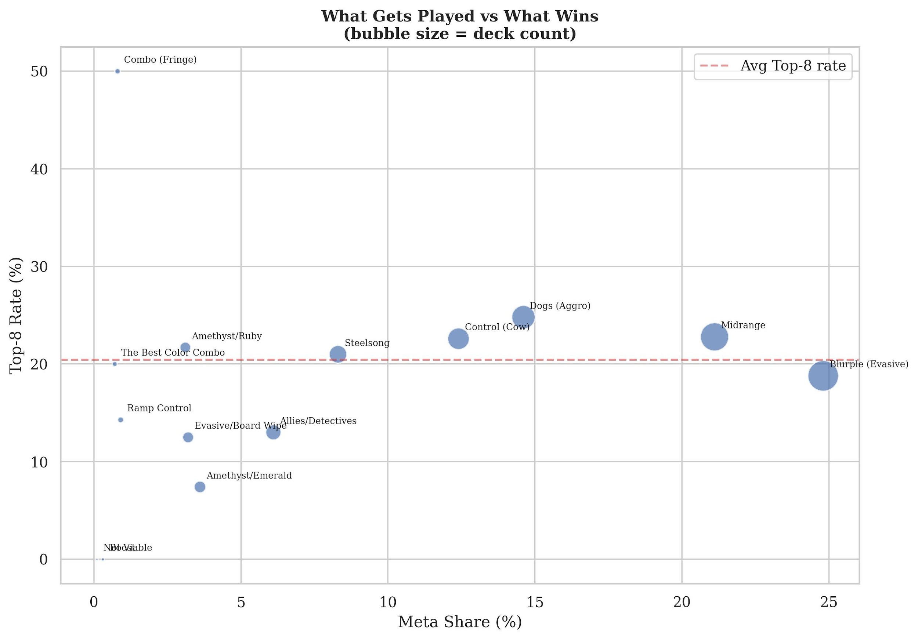
Figure 1. Meta share vs. win rate by archetype
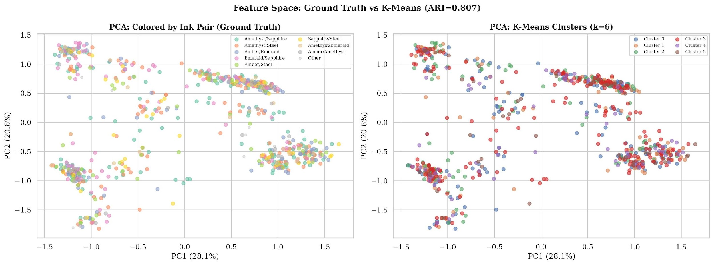
Figure 2. K-Means PCA projection with Top-8 overlay

6.2 Supervised Classification
A temporal train/test split at March 2026 yielded 559 training decks (18 tournaments) and 159 test decks (3 tournaments). XGBoost was configured with n_estimators=300, max_depth=4, learning_rate=0.05, and eval_metric=‘logloss’; Random Forest used n_estimators=300 and max_depth=8. Hyperparameters were held constant across all experiments for reproducibility. Mutual Information feature selection identified 19 features with MI > 0.01, used for SHAP interpretation due to cleaner signal. The MI-filtered model is reported as both the primary AUC result and the SHAP interpretation basis, as it outperforms the full 86-feature model while providing a more interpretable feature space (sample-to-feature ratio 29.4:1). Varying the threshold from 0.005 to 0.02 yielded 4–8 features with AUC between 0.61 and 0.62, confirming robustness to this choice.
Feature Set Comparison. XGBoost on the full 86-feature set achieves AUC = 0.544 (Stratified 5-fold CV, fold range 0.468–0.604). MI-filtered XGBoost (19 features) achieves AUC = 0.599, outperforming the full model—indicating that the additional features introduce noise rather than signal at this sample size. Multi-seed stability analysis across 10 random seeds yields mean AUC = 0.547 ± 0.027 (95% CI [0.509, 0.595]), confirming that competitive prediction from deck composition alone is near-random—consistent with the game balance thesis.
Test Set (March 2026). XGBoost achieves AUC = 0.573 on the temporal holdout, slightly exceeding the full-model Stratified CV estimate (0.544), indicating the March 2026 meta was well-represented by the training period.
Meta Stability. The Stratified-to-Temporal AUC gap (+0.052) confirms meaningful meta drift across set releases. Temporal AUC falls below random, meaning features that predict success in earlier tournaments do not generalize to later ones—the meta genuinely shifts as new sets release.

6.3 SHAP Feature Importance
SHAP analysis (Lundberg & Lee, 2017) on the MI-filtered XGBoost model reveals the top predictors of competitive Top-8 placement. An important methodological note: SHAP values characterize what the model has learned, not necessarily what causes competitive success. The features below represent the strongest statistical associations in our data:
1. tfidf_comp_0 (Mechanical density) — The leading TF-IDF latent dimension captures cards with dense mechanical text referencing multiple game systems (play effects, targeting, draw, damage). Competitively viable cards interact with more game systems per card slot.
2. avg_vanilla_score (Stat efficiency) — A composite measure of raw stats (strength + willpower) relative to ink cost. Higher vanilla scores indicate efficiently statted characters that trade well in challenges.
3. avg_keyword_count (Card complexity) — Decks with more keywords per card predict success. More keywords means more versatile cards that can respond to multiple game situations.
4. pct_cls_mentor (Mentor tribal) — The Mentor character classification carries unexpectedly strong competitive signal. Cards classified as Mentors (Grandmother Willow, Merlin, Rafiki) appear disproportionately in winning decks despite the classification itself carrying no inherent gameplay bonus—suggesting these characters share mechanical patterns that the model identifies as competitively valuable.
5. pct_evasive (Evasive density) — Evasive characters cannot be challenged except by characters with Evasive or Alert, enabling consistent lore generation. This mechanic anchors the Blurple archetype, the most-played strategy in the format.
Notably, avg_cost—the foundation of competitive community “rate theory” frameworks that evaluate cards by stats-per-ink-cost—was not selected by the MI filter. SHAP instead identifies mechanical density, stat efficiency, and card complexity as stronger competitive predictors, suggesting that what a card does matters more than what it costs to play.
6–10. avg_challenger_value, pct_is_floodborn, pct_cls_deity, pct_loot, pct_damage_placement — Challenge combat efficiency (challenger_value), the Shift mechanic for tempo advantage (Floodborn), Deity tribal synergies, card draw through Loot, and targeted removal (damage_placement) round out the competitive profile.
Rarity: not selected. rarity_encoded did not meet the MI > 0.01 threshold for inclusion in the competitive model. This finding most directly illustrates the paper’s central thesis: rarity has zero competitive signal worth retaining—it predicts price (#1 of 85 features in the price model, Section 7.1) but not winning.
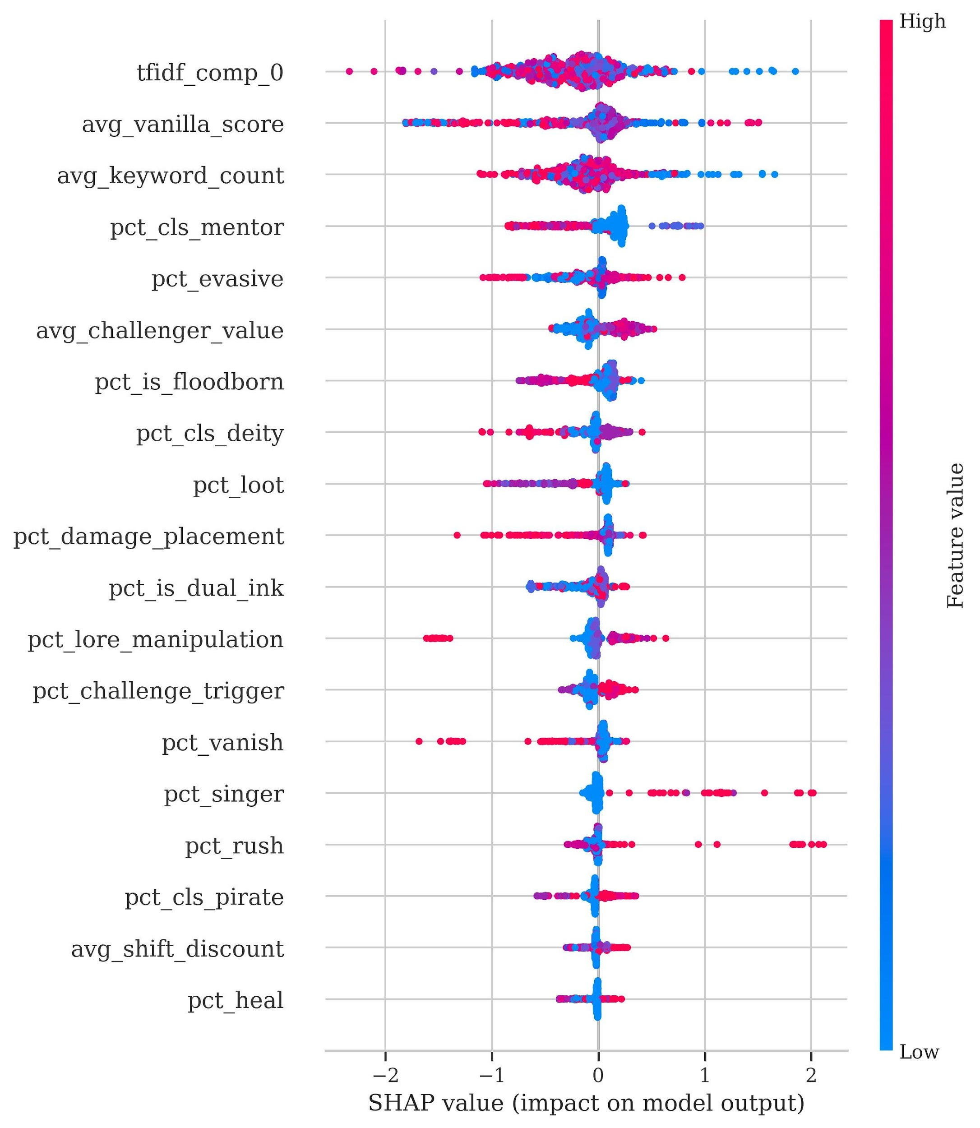
Figure 3. SHAP beeswarm plot — XGBoost, MI-filtered 19 features

7. Results: What Sells

7.1 Price Regression
Random Forest regression on 2,050 cards with 85 card-level features achieves R² = 0.44 in 5-fold cross-validation. Card features explain approximately 44% of per-card price (USD) variance; the remaining 56% reflects supply/demand dynamics, print runs, set age (older sets with lower supply tend to appreciate), reprint availability, card art and artist, and market speculation. Adding rarity × set interaction terms and polynomial features did not improve R² beyond 0.44, suggesting diminishing returns from card-level mechanical features alone. Rarity alone accounts for the majority of explained variance; its mean |SHAP| (0.207) is nearly five times larger than the second-ranked feature (Cost, 0.043), confirming that price is primarily a scarcity signal rather than a gameplay signal. Rarity is the #1 predictor of price by a wide margin, followed by ink cost, set number, and on-play effects. This is a stark contrast with the competitive model, where rarity was not even selected by the MI filter.
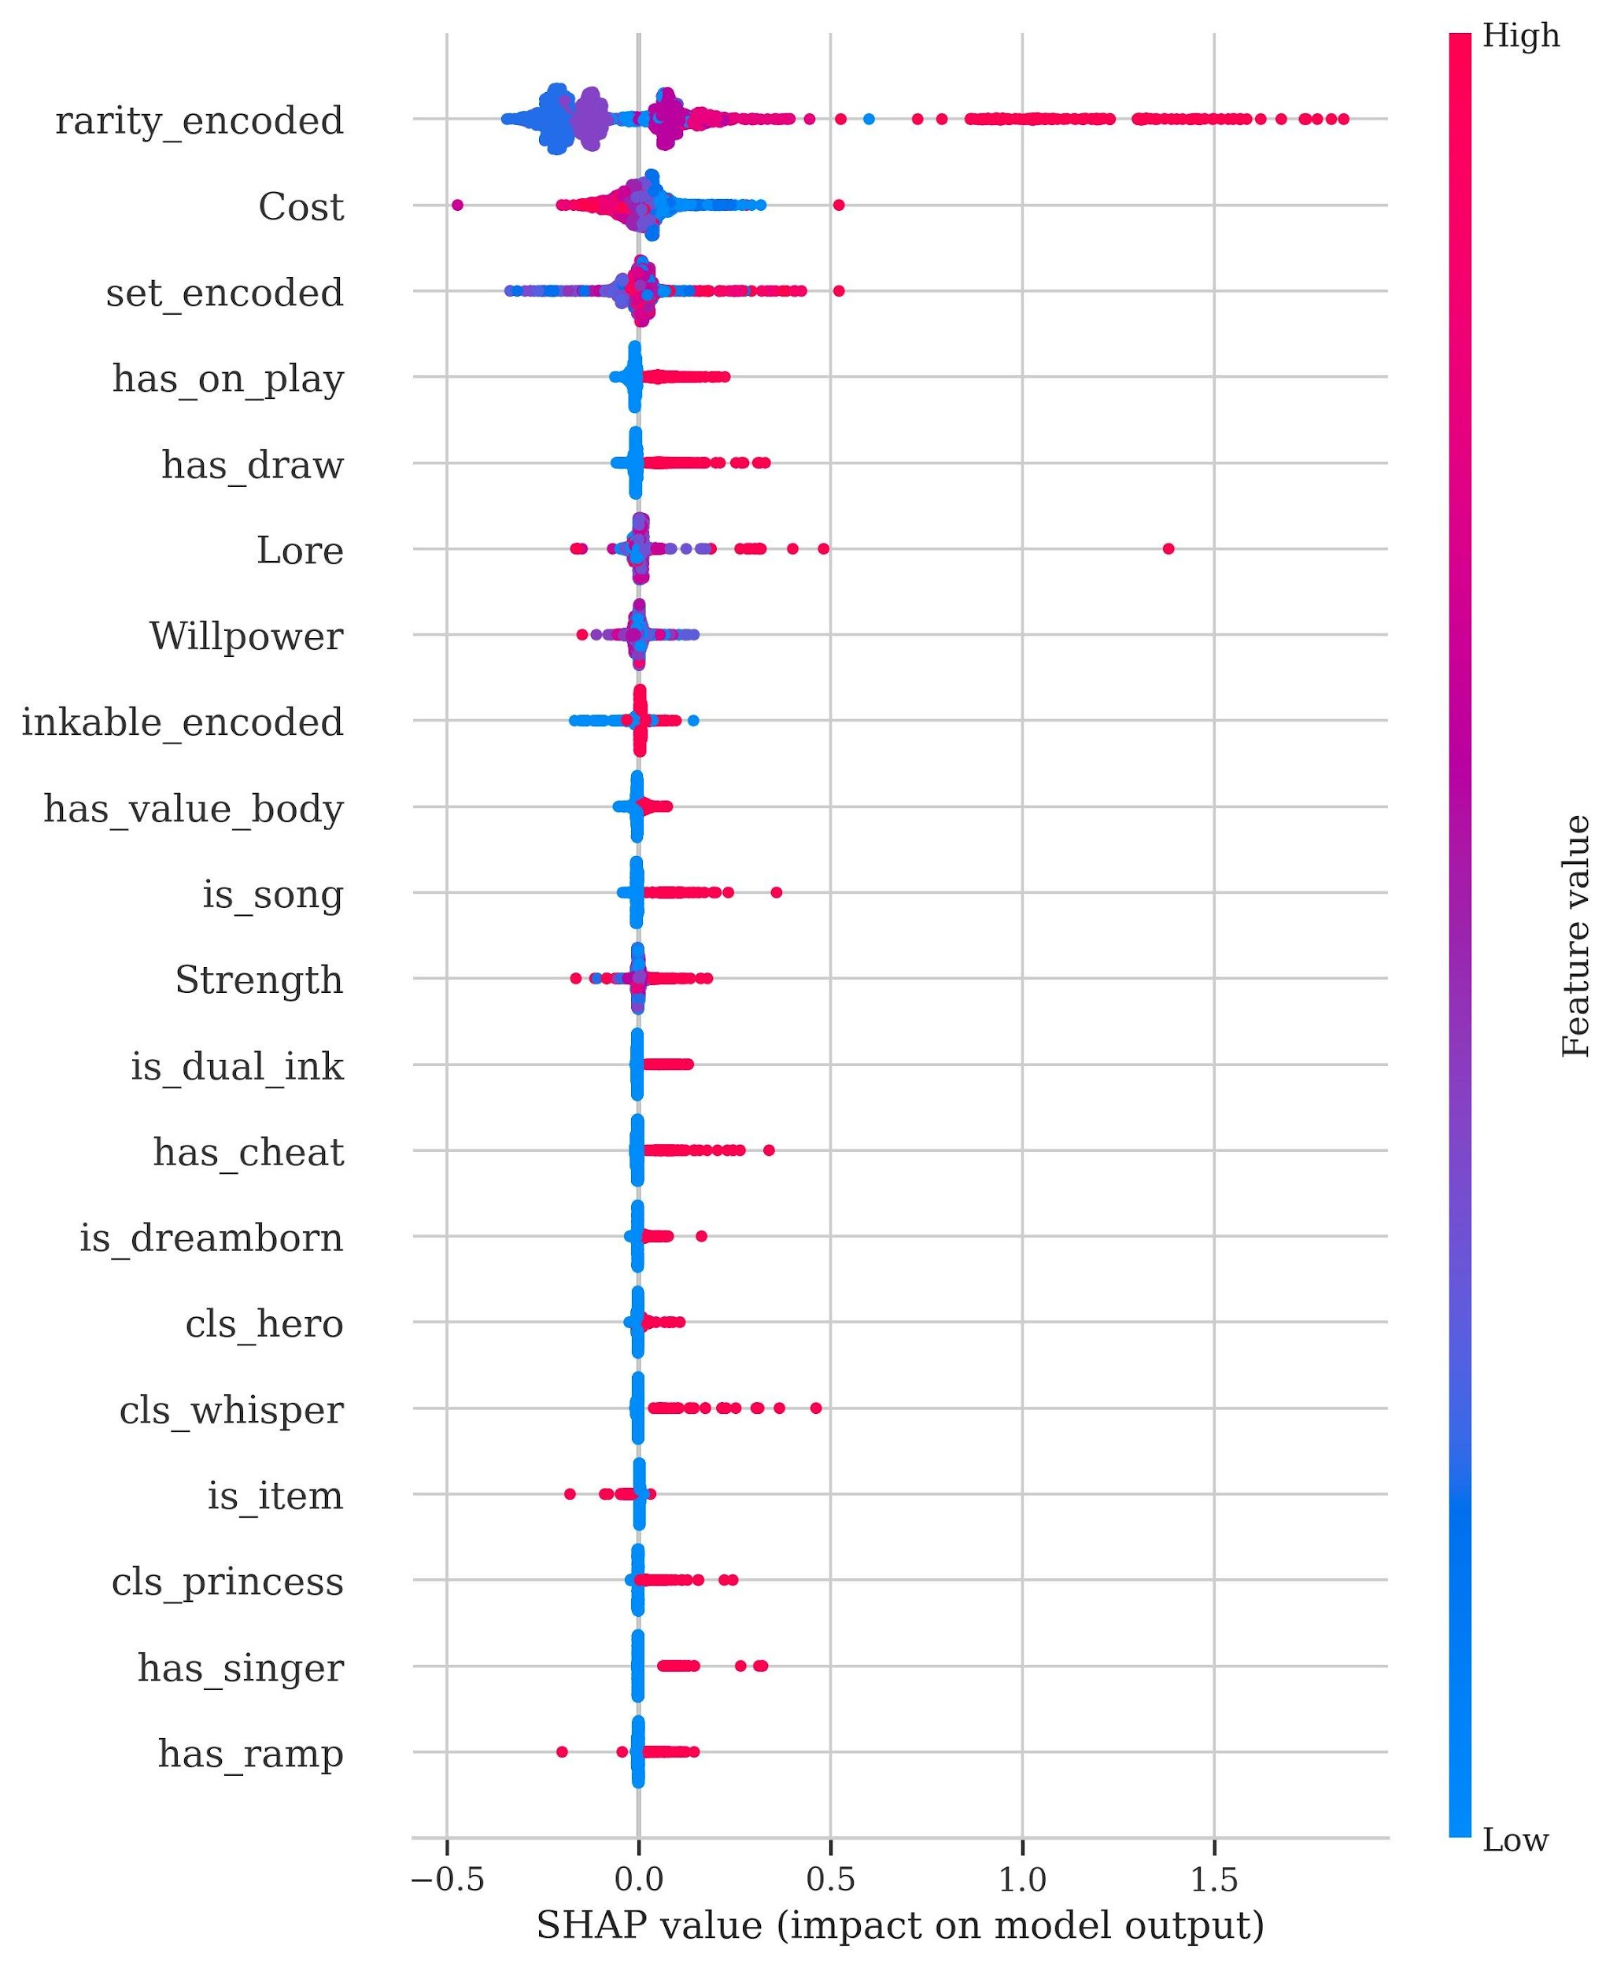
Figure 4. Price SHAP summary

7.2 Dual-Axis SHAP Comparison
The dual-axis framework—the core analytical contribution of this paper—compares feature importance rankings for competitive placement versus market price. Features are ranked independently by mean |SHAP| in each model, and the rank gap identifies traits where competitive and market signals diverge:
Competitive sleeper traits (underpriced mechanics): Illusion (+71 rank gap)—the highest competitive-to-price divergence among matched features. Illusion cards are competitively powerful but priced as bulk. Detective (+54), Pirate (+50), Resist (+49)—tribal and defensive mechanics predict winning but remain cheap. Location (+45), Lore manipulation (+35)—victory-condition mechanics underpriced by the market. Vanish has the highest adoption rate (57.1%) of any mechanic.
Market overvaluation traits (overpriced mechanics): Rarity (price #1, competitive: not selected)—the core divergence finding. Scarcity/collector signal, not gameplay. Cost (price #2), Set (price #3)—expensive, newer cards command premiums without competitive justification. On-play (price #4), Draw (price #5)—common mechanics priced in by the market but not competitively differentiating. Cheat (price #13)—free-play effects command a premium but do not predict Top-8 placement.
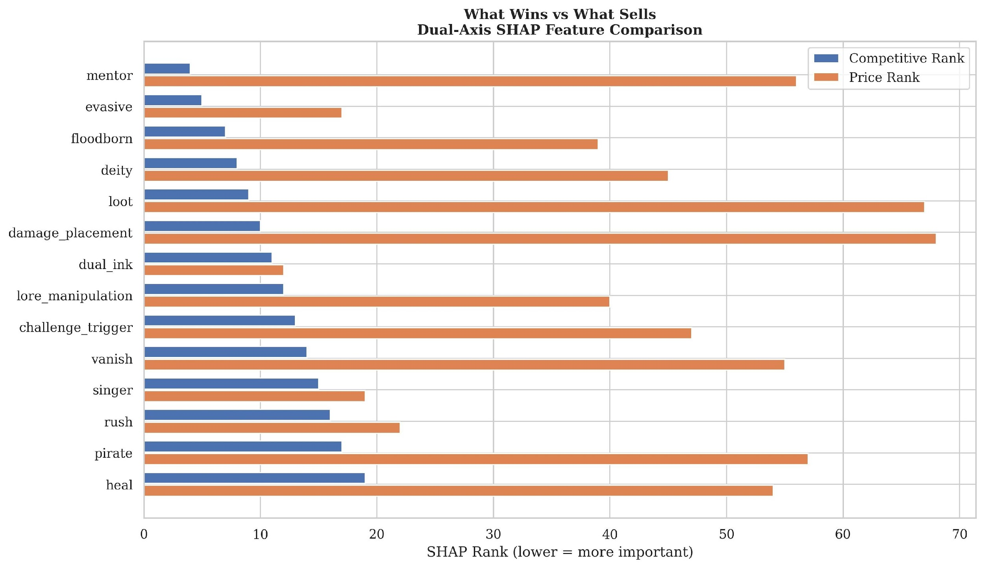
Figure 5. Dual-axis SHAP comparison — What Wins vs. What Sells
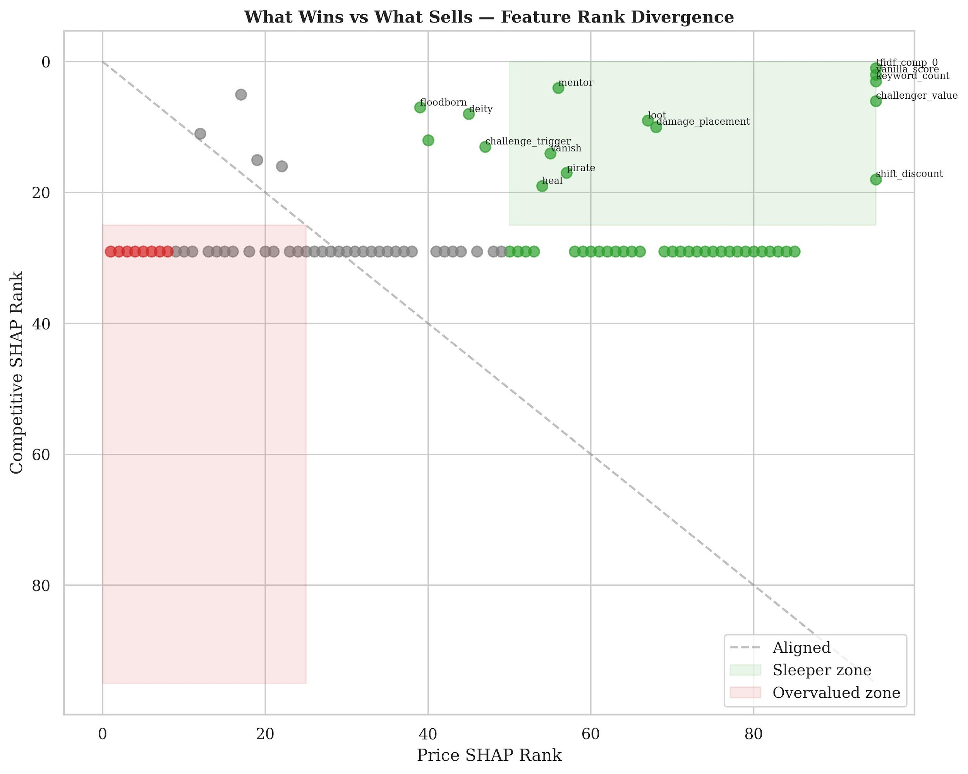
Figure 6. Dual-axis rank scatter with sleeper/overvalued zones

7.3 Deck Build Cost
The deck-level test of the “pay-to-win” hypothesis: deck build cost vs. Top-8 placement yields r = −0.092 (p = 0.012), Cohen’s d = −0.230 (small effect). Top-8 decks cost $302 on average versus $328 for non-Top-8—winning decks are $27 cheaper. Spearman rank correlation on exact placement (1st through 128th) strengthens this finding: ρ = +0.132 (p < 0.001), confirming that more expensive decks place worse across the full placement range, not just at the Top-8 cutoff. Tournament winners (1st place, n = 21) have a median deck cost of $277 versus $316 overall. The negative direction matters: not only does spending more not help, it slightly hurts. Within-archetype analysis confirms this relationship is not driven by archetype confounding: 4 of 5 major archetypes show negative cost-performance correlations individually (Steelsong r = −0.179, Control r = −0.090, Blurple r = −0.085, Midrange r = −0.061; only Dogs shows a negligible positive r = +0.037), though none reach individual significance due to smaller within-archetype sample sizes. Table 3 breaks down cost and performance by archetype.
Table 3: Deck Build Cost by Archetype
Archetype | Median Cost | Win Rate | Decks | Avg Rarity | Value (Win%/$100)
Dogs (Aggro) | $179 | 24.8% | 109 | 2.1 | 13.8%
Steelsong | $201 | 21.0% | 62 | 2.2 | 10.4%
Control (Cow) | $269 | 22.6% | 93 | 2.5 | 8.4%
Midrange | $386 | 22.8% | 158 | 2.2 | 5.9%
Blurple (Evasive) | $459 | 18.8% | 186 | 2.5 | 4.1%
Dogs costs less than half of Blurple ($179 vs. $459) while achieving a higher Top-8 rate (24.8% vs. 18.8%). The cost gap is explained by average card rarity: Dogs runs rarity 2.1 (predominantly commons and uncommons), while Blurple runs 2.5 (more rares and above). Higher rarity = higher deck cost but NOT higher win rate—the central divergence quantified by our dual-axis framework.
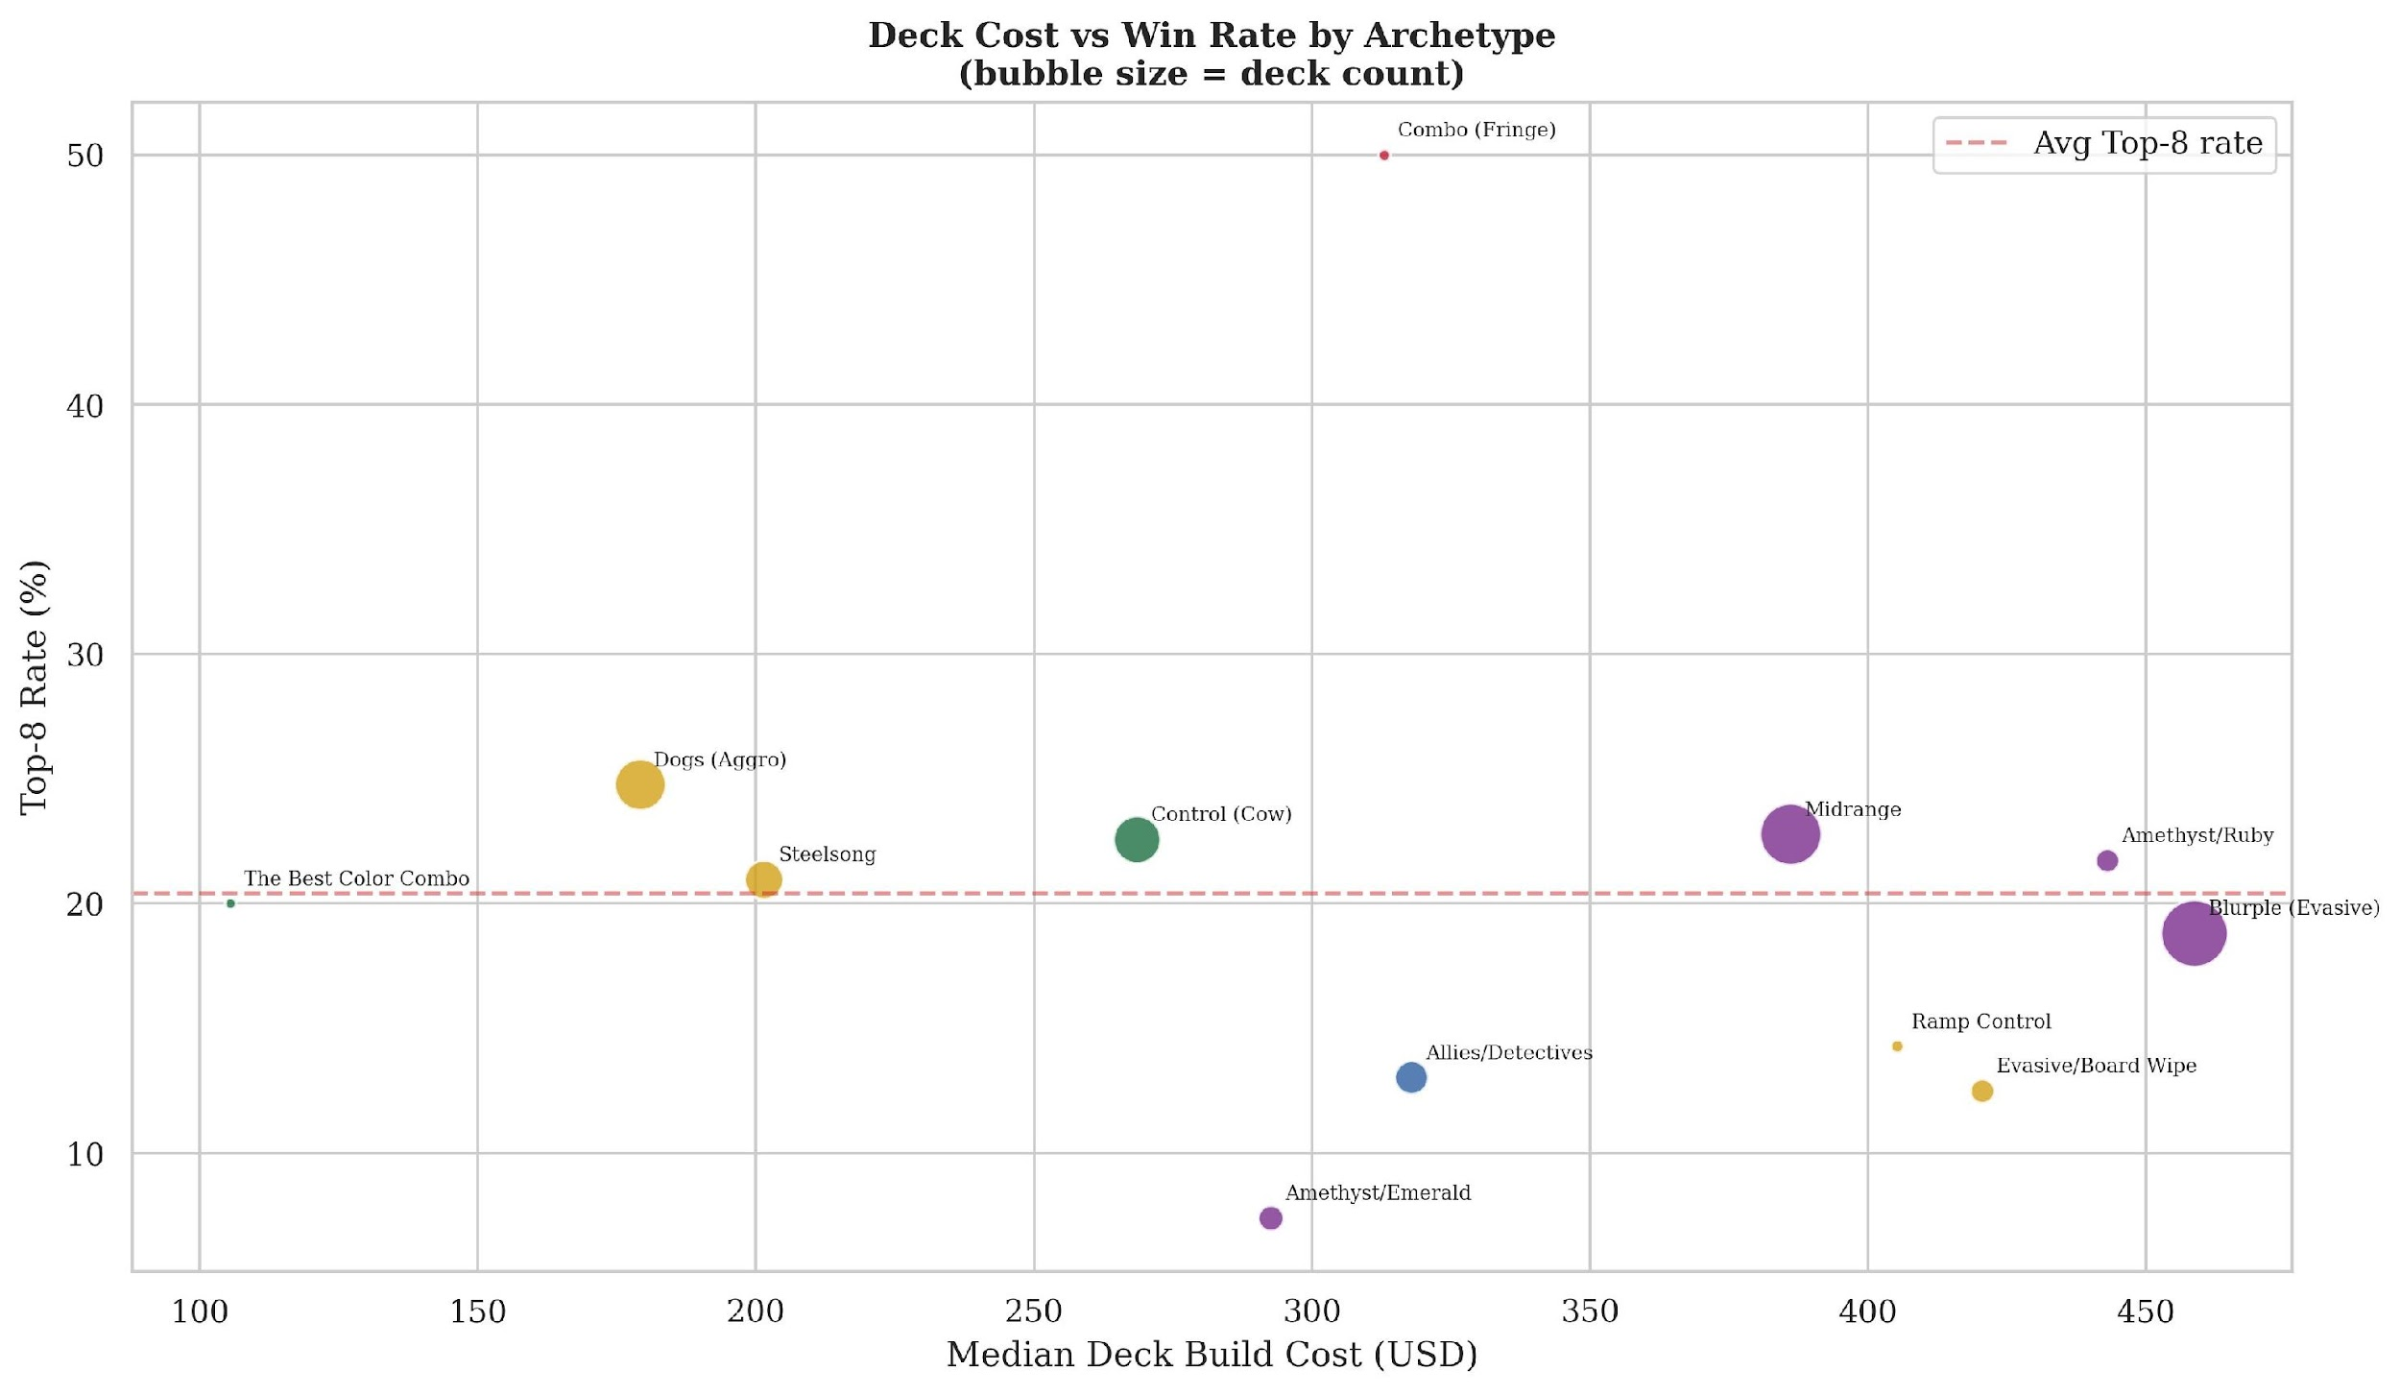
Figure 7. Deck cost vs. win rate scatter with ink colors

7.4 Temporal Price Reconstruction
By identifying that cards absent from periodic “top 100 movers” lists had stable prices (i.e., their prices did not change enough to appear in any movement window), we backfilled current tcgcsv market prices to reconstruct complete deck build costs across 17 monthly snapshots at 99.8% cell coverage. All major archetypes inflated +16–32% over the 10-month period, with Dogs showing the largest percentage increase (+31.9%, $186→$245) as the market slowly recognizes its competitive value. Despite this correction, Dogs remains less than half of Blurple’s cost ($245 vs. $580) while maintaining a higher win rate—the market has not fully priced in competitive performance.

7.5 Variant Premium
Enchanted and Promo variant printings carry a median 9.4x premium across 109 cards with both standard and variant versions (mean 303x, driven by extreme outliers). The most extreme case: Elsa – Snow Queen at $0.10 for the standard printing versus $1,250 for the Enchanted variant—a 12,500x multiplier for identical game mechanics. This is direct evidence that the collector and competitive markets operate on distinct value systems: one prices rarity and Disney IP recognition, the other prices mechanical function. At the market’s extreme, iconic variant pairs (Mickey/Minnie) have commanded $7,000–$11,000 at auction with zero competitive utility—confirming that the collector market’s highest-value segment is driven entirely by IP recognition and scarcity. External validation via Google Trends confirms this: character search interest correlates strongly with maximum card price across 13 Disney characters (Spearman ρ = 0.831, p < 0.001), providing independent evidence that IP recognition—not gameplay mechanics—drives the collector premium.

8. Network and Synergy Analysis

8.1 Co-occurrence Graph
A weighted co-occurrence graph constructed from 749 decklists with a minimum edge threshold of 15 co-appearances produces 152 nodes and 1,847 edges. Louvain community detection (Blondel et al., 2008) identifies 4 communities that map cleanly to the top 4 competitive archetypes—convergence across two independent methods (clustering and community detection) that strengthens both findings. Dual-ink cards are highlighted as diamond markers in the network visualization, with 13 appearing in the co-occurrence network.
Top cards by PageRank: Elsa – The Fifth Spirit (0.031), Genie – Wish Fulfilled (0.029), Tipo – Growing Son (0.027). These are meta-defining staples with high connectivity within their archetype community. Top bridge cards by betweenness centrality: Vision of the Future (0.090), Finnick – Tiny Terror (0.081)—cards that connect archetype communities and appear across multiple strategies, enabling cross-archetype deck building.
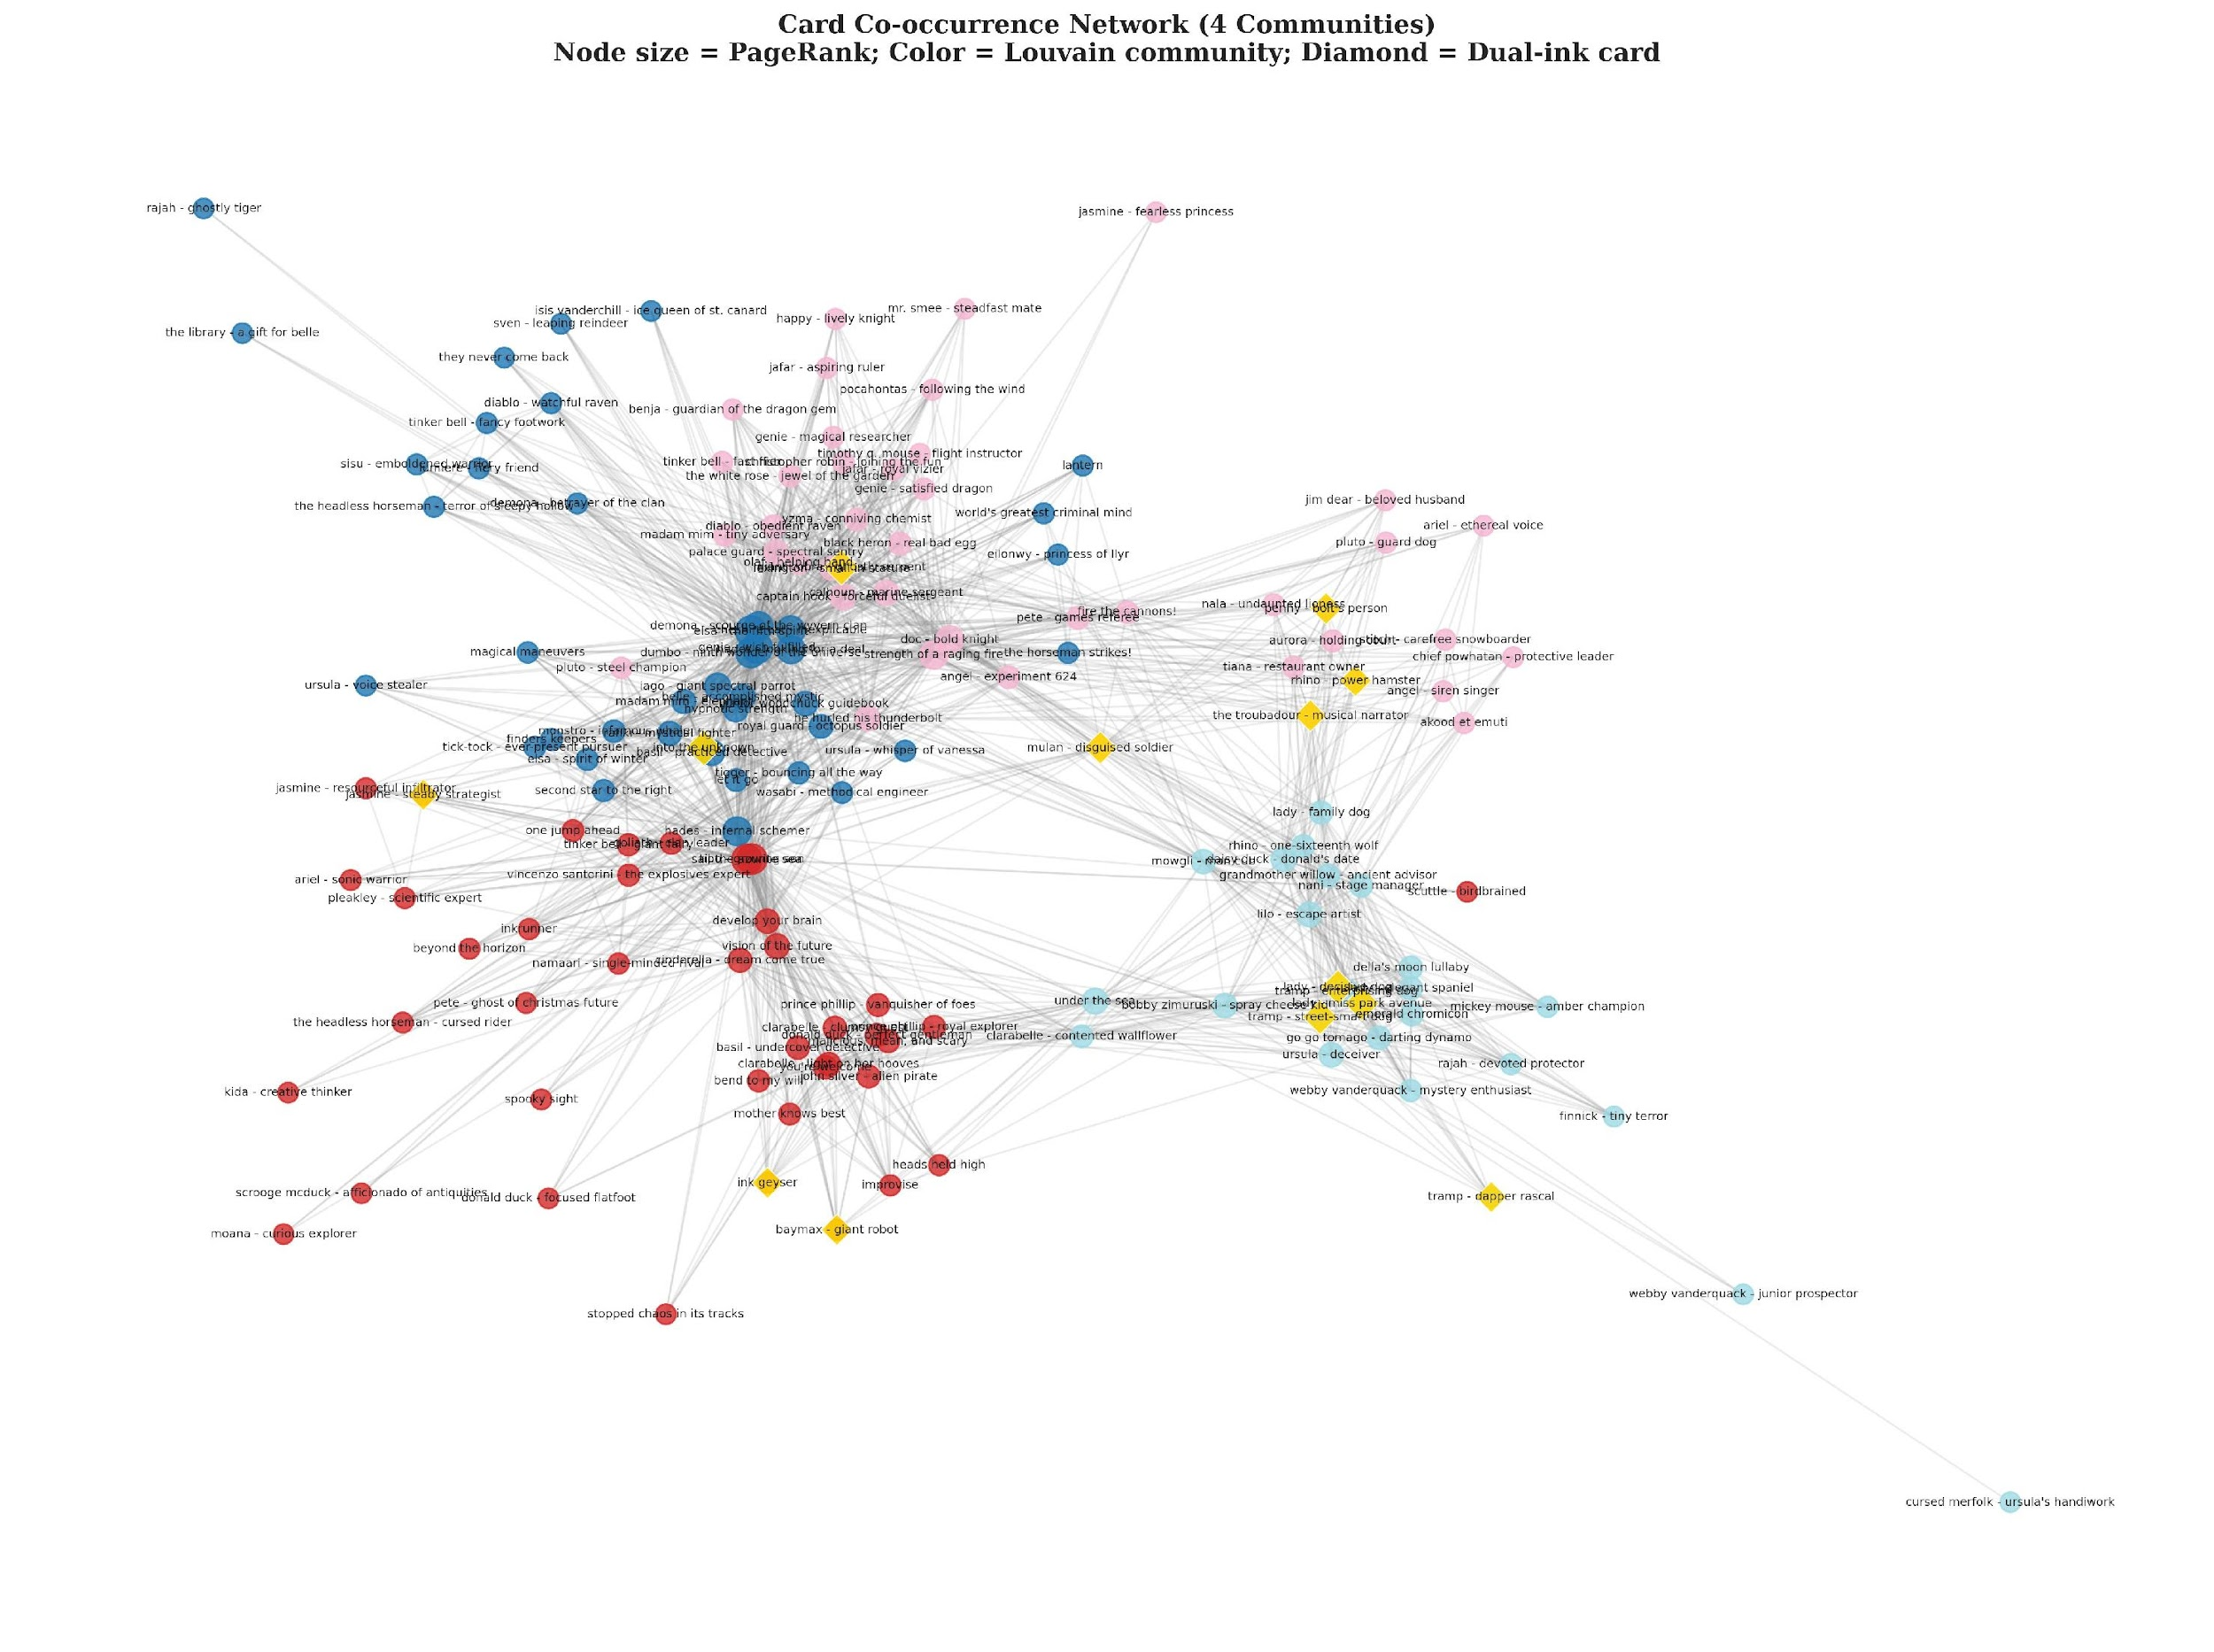
Figure 8. Card co-occurrence network with Louvain communities and dual-ink diamonds

8.2 Association Rule Mining
FP-Growth (Han et al., 2000) with min_support = 0.05 on the 91 most frequently played cards produced 885 frequent itemsets and 1,110 association rules with lift ≥ 2.0 (lift measures how much more likely two cards co-occur than expected by chance; lift = 2.0 means twice as likely). These methods formalize the discovery process that competitive deck builders perform manually—iterating through card filters, testing theme synergies, and identifying hidden interactions across hundreds of experimental builds. Rules cluster within archetypes, confirming that competitive deck building in Lorcana is deeply combinatorial—certain cards must appear together:
Steelsong: Aurora – Holding Court + Tiana – Restaurant Owner (lift = 15.6, 98% confidence)—the tightest card pair in competitive Lorcana. When Aurora appears, Tiana is virtually always present.
Allies/Detectives: Vincenzo + Tinker Bell + Goliath form a synergy triangle (lift = 11–15). This small archetype (6.1% meta share) has the highest-lift rules—niche but extremely tightly constructed.
Control (Cow): Malicious Mean and Scary + Prince Phillip (lift = 8.2, confidence = 100%). Every deck running one runs the other.
Dogs: Nani + Grandmother Willow (lift = 8.1)—the core engine of the cheapest competitive deck in the format. Of the 1,110 total rules, 120 (10.8%) span multiple Louvain communities, confirming that bridge cards identified by betweenness centrality also form genuine high-lift synergy pairs across archetypes. The top cross-community rule is Lady – Family Dog + Tiana – Restaurant Owner (lift = 7.7), a cross-archetype pair appearing together in 40 decks across 9 different archetypes. The remaining 89.2% cluster within archetypes, confirming that competitive deck building in Lorcana is deeply combinatorial. The cross-archetype bridge cards identified by betweenness centrality (Section 8.1) represent notable structural findings—cards like Vision of the Future that enable hybrid strategies spanning multiple communities.

9. Sleeper Card Index
The Sleeper Card Index operationalizes the dual-axis divergence (Section 7.2) at the individual card level, identifying specific cards where competitive value and market price are misaligned. Unlike the trait-level analysis in Section 7.2, which identifies which mechanics are underpriced, the SCI identifies which specific cards a player should buy or sell.
Competitive score = play rate × win rate for tournament cards (direct evidence of competitive value), or SHAP-weighted mechanic score at 50% scale for unplayed cards (predicted competitive potential, discounted to reflect the absence of direct tournament evidence). SCI = competitive percentile rank – price percentile rank. Computed for 1,207 cards with both competitive scores and price data. Cards appearing in fewer than 5 tournament decks have volatile play rate × win rate estimates; the played sleepers highlighted below all appear in 40+ decks. Temporal validation of SCI’s predictive utility for future price movements is reserved for future work with daily price data; however, a split-temporal test confirms SCI’s predictive validity for competitive adoption: cards with positive early-period SCI (September–November 2025) see nearly twice the adoption rate in later tournaments (December 2025–March 2026) compared to negative-SCI cards (9.5% vs. 5.0%, Mann-Whitney U p = 0.0002, Spearman ρ = 0.291, p < 0.001, n = 205).

9.1 Played Sleepers (Proven Value, Underpriced)
These cards are already seeing competitive success but are priced as bulk—the market has not caught up to their tournament performance:
Control (Cow): Develop Your Brain (SCI +0.79, $0.08, 133 decks, 21.8% win rate)—one of the cheapest competitively impactful cards in the game.
Midrange: Captain Hook – Forceful Duelist (SCI +0.73, $0.11, 178 decks, 21.3% win rate)—a meta staple underpriced by the market.
Blurple: Hypnotic Strength (SCI +0.70, $0.12, 169 decks, 24.9% win rate).
Cross-archetype: Tick-Tock – Ever-Present Pursuer (SCI +0.74, $0.04, 44 decks, 27.3% win rate)—an Amethyst sleeper appearing across 10 ink pairs, priced as bulk.

9.2 Market Overvaluations (Popular Disney IP, Low Competitive Value)
The pattern is striking: every overvalued card features a beloved Disney character whose collector appeal inflates the price far beyond competitive utility.
Ohana Means Family (SCI −0.90): $19.57, 12 decks, 8.3% win rate. The word “Ohana” carries Disney brand recognition that translates directly to collector demand.
Ariel – Ethereal Voice (SCI −0.89): $10.84, 16 decks, 6.2% win rate. Character popularity premium.
Pete – Ghost of Christmas Future (SCI −0.88): $7.05, 24 decks, 4.2% win rate. Set hype without competitive results.
This confirms at the individual card level what the dual-axis SHAP analysis showed at the trait level: the collector market and competitive market value different things. Competitive players looking to optimize their collection should sell high-IP collector cards and invest in mechanically strong commons that the market has underpriced.
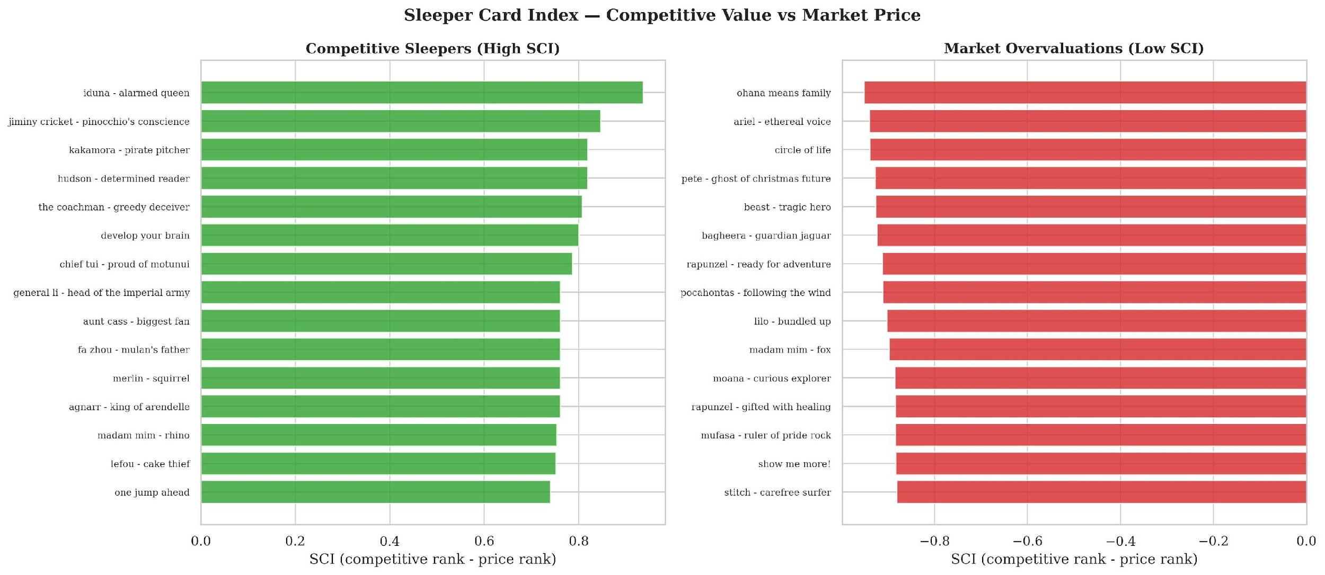
Figure 9. SCI bar charts — sleepers and overvaluations

10. Evaluation

10.1 Feature Engineering Ablation
We measure the incremental AUC contribution of each feature engineering layer by training XGBoost with progressively richer feature sets under StratifiedKFold(5) cross-validation:
Table 4: Feature Engineering Ablation Results
Layer | Features | AUC | Δ AUC
A: Base stats only | 5 | 0.536 | —
B: + Mechanic flags | 39 | 0.518 | −0.018
C: + Classifications | 54 | 0.550 | +0.032
D: + Engineered features | 77 | 0.545 | −0.006
E: + TF-IDF (full model) | 86 | 0.517 | −0.028
Feature engineering ablation reveals that classifications provide the only meaningful gain (+0.032 from Layer B to C, peak AUC = 0.550). Base stats alone achieve AUC = 0.536; adding mechanic flags (Layer B), engineered features (Layer D), and TF-IDF (Layer E) all reduce performance, suggesting the competitive signal is concentrated in character classification patterns (Mentor, Deity, Pirate) rather than raw mechanics. MI-filtered TF-IDF components nevertheless rank #1 in SHAP importance—their value emerges through interaction effects with classifications rather than standalone contribution. Fold-level standard deviations range from ±0.03 to ±0.06 across ablation layers.
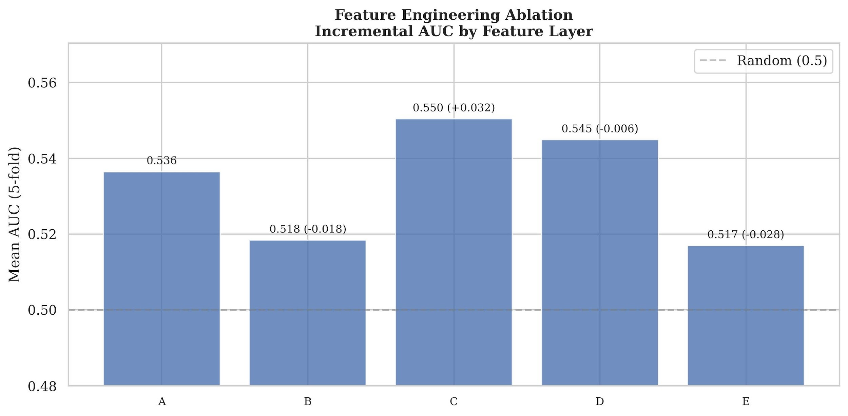
Figure 10. Feature engineering ablation bar chart

10.2 Statistical Significance
Chi-squared (Archetype × Top-8): χ² = 11.85, df = 13, p = 0.540—NOT significant. Archetype choice alone does not predict winning. This is a key game balance finding: Ravensburger has successfully prevented any single archetype from dominating.
Deck Cost vs. Top-8: r = −0.092, p = 0.012, Cohen’s d = −0.230 (small effect). Statistically significant but practically negligible—and negative. Winning decks are $27 cheaper on average. This provides statistically significant evidence against a pay-to-win dynamic: not only does spending more not help, it slightly hurts.
Price-Play Rate: r = 0.383 (all 2,050 cards, p < 0.001) and r = 0.371 (448 tournament cards only, p < 0.001). Expensive cards ARE played more, but this reflects rarity confounding both price and deck inclusion, not a causal pay-to-win relationship.
Player independence. The 749 decklists represent 710 unique players—95.5% appear at a single event, with only 32 players (4.5%) competing at two or more. This confirms that the deck-level analysis measures largely independent observations, not repeated measurements from a small player pool. Repeat players do not significantly outperform single-event players in our sample (16.9% vs 20.8% Top-8, χ² = 0.384, p = 0.535), though with only 32 repeat players the test has limited statistical power. Notable competitors such as DKP (2025 World Champion) appear across multiple events in the broader competitive scene, suggesting that a larger longitudinal dataset could reveal player-skill effects., and adding player tournament count to the XGBoost model changes AUC by less than 0.001. The absence of a player-experience signal is consistent with the nature of published decklists: these are already top finishers at large events, compressing the observable skill range. The remaining unexplained variance in our model likely reflects in-game decision-making and matchup luck—factors invisible to any deck composition analysis.

11. Discussion

11.1 Game Balance Evidence
The statistical tests in Section 10.2 operationalize game balance along three dimensions: meta diversity (whether multiple strategic approaches are competitively viable), skill dominance (whether player skill outweighs deck construction), and economic fairness (whether monetary investment determines outcomes):
Meta diversity: Chi-squared p = 0.540 confirms no archetype systematically produces winners, with all 14 ink-pair combinations producing Top-8 finishers. Kruskal-Wallis testing on exact placement rank (1st–128th) reinforces this (H = 8.07, p = 0.089)—archetype does not significantly predict placement even with the richer ordinal target.
Skill dominance: Our best model achieves AUC = 0.544 (fold range: 0.468–0.604; multi-seed mean = 0.547 ± 0.027, 95% CI [0.509, 0.595]). This near-random accuracy is itself evidence of balance: if deck composition alone could predict winning with high accuracy, the game would be dominated by “solved” deck lists. The remaining variance is player skill, matchup variance, and in-game adaptation—exactly what competitive game designers aim for. Competitive outcomes also depend on matchup interactions between opposing decks (e.g., archetype rock-paper-scissors cycles where aggro beats control, control beats midrange, midrange beats aggro), which deck-composition features cannot capture. Player-level analysis confirms this: 710 unique players across 749 decks, with repeat-player experience adding zero predictive signal (less than 0.001 AUC). A placement regression using exact finishing position (1st–128th) as the target yields R² < 0, meaning deck composition features cannot predict placement better than the sample mean—strong evidence that skill, not deck construction, determines finishing order.
Economic fairness: Deck cost r = −0.092, Cohen’s d = −0.230. Not only does spending more not help, it slightly hurts. Dogs—the cheapest major archetype at $179—has the highest win rate at 24.8%, while Blurple at $459 has the lowest at 18.8%.
This is evidence of healthy competitive game design—Lorcana rewards strategic deck building as a necessary but not sufficient condition for tournament success.

11.2 Recommendations for Competitive Players
For players on a budget: Build Dogs (Amber/Emerald) at $179 median—it has the highest Top-8 rate (24.8%) and best value at 13.8% win rate per $100 spent, independently recognized by top competitive players as the best cost-to-performance archetype. Dogs is also overrepresented among tournament winners: 28.6% of 1st-place finishes from only 14.6% of the field (1.96× ratio), with a median placement of 18th versus 32nd for the most-played archetype (Blurple). Steelsong (Amber/Steel) at $201 is the second-cheapest competitive option at 21.0%.
Card buying: Some of the best value cards in the game cost under $0.15. Develop Your Brain ($0.08, 133 decks), Tick-Tock – Ever-Present Pursuer ($0.04, 44 decks, 27.3%), One Jump Ahead ($0.07, 57 decks, 29.8%), Captain Hook – Forceful Duelist ($0.11, 178 decks), and Hypnotic Strength ($0.12, 169 decks) are all meta staples priced as bulk.
Card selling: Popular Disney characters are overpriced relative to competitive performance. Ohana Means Family ($19.57, 8.3% win rate), Ariel – Ethereal Voice ($10.84, 6.2%), and Pete – Ghost of Christmas Future ($7.05, 4.2%) have collector value but not competitive value.
Deck building: Prioritize mechanically dense cards (tfidf_comp_0, SHAP #1), efficiently statted characters (avg_vanilla_score, #2), keyword-rich cards (#3), and Mentor tribal synergies (#4) over raw card rarity. Evasive density (#5) anchors the format's top archetype, while Challenger value (#6) and Floodborn Shift cards (#7) provide tempo advantages the market has not priced in.
Archetype choice: Pick what you enjoy. Chi-squared testing (p = 0.540) shows archetype choice does not significantly predict winning—your skill in building and piloting within an archetype matters more than which archetype you choose. Note: these recommendations reflect the Season 2 Standard rotation meta (September 2025–March 2026) and will shift as new sets release.

11.3 Implications for Collectors
The SCI distinguishes competitive value from collector premium. Cards with high positive SCI represent strong acquisition targets: competitively validated yet underpriced by a market that rewards Disney IP recognition over mechanical function. Cards with large negative SCI carry Disney collector premiums that may not persist if competitive irrelevance becomes widely recognized—though the collector market may sustain these prices independently of competitive utility, driven by character popularity, art quality, and scarcity perception.

11.4 Limitations
Sample size. 749 decks from 21 tournaments represents a moderate sample. Disney Lorcana’s competitive organized play launched in May 2024—less than two years before this study. Our dataset represents the near-totality of published competitive decklists from Season 2. As the competitive scene grows, future studies will benefit from larger datasets. Our analysis covers only the first Standard rotation; the first dedicated Infinity format DLC (June 2026) could reopen the full card pool to serious competitive play, testing whether game balance findings hold when deck-building constraints are relaxed. Additionally, active meta interventions (card bans, set rotations) and evolving card pools cause the competitive value of individual cards to shift over time, creating non-stationary distributions that constrain any fixed predictive model.
Publication bias. Published decklists on inkdecks.com represent 1–3% of actual tournament attendance (176–2,300 players per event), skewing toward top finishers and content creators. This inflates the observed Top-8 rate (~20.7%) relative to the true population rate (~3–5% at a 2,000-player event). Relative comparisons between archetypes and features remain valid, but absolute win rates should be interpreted as within-sample rates, not population estimates.
Price data granularity. Single price snapshot plus monthly movers does not constitute daily tracking. Complete daily price history requires TCGPlayer Certified Partner API access.
API limitations. Lorcast API’s single-ink field required custom dual-ink patching; 19 of 121 dual-ink cards remain unpatched. TF-IDF bag-of-words treatment cannot capture sequential or conditional logic in complex card effects.
No player-level features. Our models predict Top-8 from deck composition alone, excluding player skill, seeding, and historical performance. Since our own findings indicate that player skill is the dominant factor, incorporating player-level features is a priority for future work.
Reprint effects on SCI. Cards with multiple printings may appear undervalued because reprints increase supply without changing competitive demand, depressing observed price independently of actual market efficiency.

11.5 Related Work Comparison
Jakubik (2018) predicted Hearthstone win rates from deck composition using neural networks but did not model market prices. Zuin & Veloso (2019) predicted MTG mana costs from card features but did not analyze competitive outcomes. Neither performed dual-axis SHAP analysis comparing competitive and market signals. Our framework extends this literature in three ways: (1) the dual-axis SHAP comparison quantifies the divergence between value systems; (2) the Sleeper Card Index bridges competitive and market analysis at the card level; and (3) we provide the first empirical “not pay-to-win” evidence for Disney Lorcana with formal statistical testing (p-values, confidence intervals, effect sizes).

11.6 Future Work
TCGPlayer/Ravensburger partnership. Daily price feeds, official tournament metadata, and player-level statistics would enable temporal price modeling, meta-shift forecasting, and skill-adjusted placement analysis. The exploratory results presented here—achieved entirely from public data—demonstrate both the analytical framework and the specific data gaps that proprietary access would resolve: daily price tracking would unlock SCI temporal validation, player identifiers would separate skill from deck effects, and official match-level data would capture the matchup interactions our models cannot currently observe. This study serves as a proof-of-concept for the value such partnerships would generate.
Meta-window cross-validation. Rolling tournament windows instead of fixed temporal splits to measure meta stability more precisely as new sets release.
Daily price time-series. Daily price data would enable card-level price prediction, automated buy/sell signals, and temporal SCI validation beyond the monthly snapshots used in this study.
Real-time SCI dashboard. Operationalize the Sleeper Card Index as a live tool for the Lorcana community, updating with each tournament result and price change.
Player-level analysis. Track individual players across tournaments to separate player skill from deck composition effects, addressing the largest unexplained variance in our models. The first Infinity format DLC in June 2026 could present a natural experiment: the same analytical framework applied to an unrestricted card pool will test whether the game balance findings from Standard rotation hold when deck-building constraints are relaxed.

12. Conclusion
This paper presented a complete KDD framework applied to Disney Lorcana—to our knowledge, the first academic study of this game. Integrating 2,075 unique card records, 749 competitive decklists across 21 tournaments in 13 countries, and three independent price sources, we demonstrate that the competitive and collector markets operate on divergent value systems.
Our central finding—that what wins and what sells are fundamentally different—has both analytical and practical implications. Addressing RQ1, SHAP identifies mechanical density (tfidf_comp_0), stat efficiency, and Mentor tribal synergies as the top competitive drivers—while rarity, the primary price predictor, was not even selected by the MI filter for competitive modeling. Addressing RQ2, the dual-axis SHAP framework and Sleeper Card Index quantify exactly where and how these markets diverge, from the trait level down to specific card-level buy/sell signals. Addressing RQ3, the near-random model accuracy (AUC = 0.544), combined with a non-significant archetype chi-squared test (p = 0.540) and negative deck cost correlation (r = −0.092, p = 0.012, d = −0.230), provides multi-dimensional evidence that Lorcana exhibits healthy competitive balance where player skill dominates.
The dual-axis SHAP framework with card-level SCI is transferable to any TCG with competitive and secondary market data. As Disney Lorcana’s competitive ecosystem matures, this study establishes the analytical foundation for ongoing market intelligence, game balance monitoring, and community-facing tools. The framework’s exploratory results—achieved entirely from public data—identify specific, actionable data gaps that partnerships with Ravensburger or TCGPlayer would resolve, transforming a proof-of-concept into a production-grade analytical platform.

Author Contributions
Artie Bowman served as domain expert, led the project, developed the core methodology, implemented the complete Jupyter notebook and all experiments, conducted the data analysis and evaluations, and wrote the original draft of the manuscript. Mohammad Aziz Boufaied contributed to early concept generation, provided debugging support, contributed additional code, and performed critical revisions on the manuscript. Kennedy Comstock contributed to early concept generation, provided debugging support, and performed critical revisions on the manuscript, and lead the class presentation. Nurudeen Showole contributed to the class presentation and review. All authors reviewed and approved the final version of this report.

Acknowledgments
The authors thank Prof. Jiaxin Du for valuable feedback on the manuscript. This study was completed as part of CIS 635 – Knowledge Discovery and Data Mining at Grand Valley State University. AI tools (Claude, Anthropic) were used as a coding assistant for data pipeline development, visualization formatting, iterative paper editing and auditing, and document preparation. All analytical decisions, statistical methodology, domain interpretations, and written findings are the authors’ own work.

References
Agrawal, R., Imielinski, T., & Swami, A. (1993). Mining association rules between sets of items in large databases. ACM SIGMOD Record, 22(2), 207–216.
Blondel, V. D., Guillaume, J.-L., Lambiotte, R., & Lefebvre, E. (2008). Fast unfolding of communities in large networks. Journal of Statistical Mechanics, 2008(10), P10008.
Chen, T., & Guestrin, C. (2016). XGBoost: A scalable tree boosting system. Proceedings of the 22nd ACM SIGKDD International Conference on Knowledge Discovery and Data Mining, 785–794.
Fayyad, U., Piatetsky-Shapiro, G., & Smyth, P. (1996). From data mining to knowledge discovery in databases. AI Magazine, 17(3), 37–54.
Fink, D., Pastel, B., & Sapra, N. (2015). Predicting the strength of Magic: The Gathering cards from card mechanics. Stanford University CS229 Project Report.
García-Sánchez, P., Tonda, A., Mora, A. M., Squillero, G., & Merelo, J. J. (2018). Automated playtesting in collectible card games using evolutionary algorithms. Knowledge-Based Systems, 153, 133–146.
Han, J., Pei, J., & Yin, Y. (2000). Mining frequent patterns without candidate generation. ACM SIGMOD Record, 29(2), 1–12.
Hoover, A. K., Togelius, J., Lee, S., & de Mesentier Silva, F. (2020). The many AI challenges of Hearthstone. KI – Künstliche Intelligenz, 34(1), 33–43.
Jakubik, J. (2018). A neural network approach to Hearthstone win rate prediction. In 2018 Federated Conference on Computer Science and Information Systems (FedCSIS), pp. 185–188. IEEE.
Leung, C. K., & Joseph, K. W. (2014). Sports data mining: Predicting results for the college football games. Procedia Computer Science, 35, 710–719.
Lundberg, S. M., & Lee, S.-I. (2017). A unified approach to interpreting model predictions. Advances in Neural Information Processing Systems, 30.
Mora, A. M., Tonda, A., Fernandez-Ares, A. J., & Garcia-Sanchez, P. (2022). Looking for archetypes: Applying game data mining to Hearthstone decks. Entertainment Computing, 43, 100498.
Ou-Yang, Y., Hong, W., Peng, L., et al. (2025). Explaining basketball game performance with SHAP: Insights from Chinese Basketball Association. Scientific Reports, 15, 13793.
Pawlicki, M., Polin, J., & Zhang, J. (2014). Prediction of price increase for Magic: The Gathering cards. Stanford University CS229 Project Report.
Ravensburger. (2026). Disney Lorcana Comprehensive Rules, Version 2.0.1. Effective February 5, 2026.
Taylor, S. J., & Letham, B. (2018). Forecasting at scale. The American Statistician, 72(1), 37–45.
TCGPlayer. (2025). TCGPlayer marketplace price data [Dataset]. https://www.tcgplayer.com
Vieira, R. e S., Tavares, A. R., & Chaimowicz, L. (2023). Towards sample efficient deep reinforcement learning in collectible card games. Entertainment Computing, 47, 100597.
Zuin, G., & Veloso, A. (2019). Learning a resource scale for collectible card games. In 2019 IEEE Conference on Games (CoG), pp. 1–8. IEEE.

GitHub Repository: https://github.com/bowmanar-gvsu/lorcana-kdd-analysis

Supplementary Note: Publication Roadmap
This page is not part of the submitted paper. It outlines our publication plan and remaining work for peer-reviewed submission.
Target Venue
IEEE Conference on Games (CoG) 2026, Madrid — “Game Data Analytics” track. 8-page limit. The current class paper (~8,300 words) will be condensed to fit the page constraint while preserving core contributions. Secondary targets include Entertainment Computing (Elsevier) and the AAAI Workshop on Knowledge Discovery in Games.
Feature Engineering Additions
1. Inkable vs. non-inkable card ratio — The Inkable field exists in our dataset (1,576 inkable / 499 non-inkable) but was not included as a modeling feature due to API integration constraints during the study timeline. Non-inkable cards at high ink cost dilute hand playability; this is one of the most discussed deck-building constraints in competitive Lorcana and should be a strong SHAP contributor. 2. Play curve distribution — The number of cards at each ink cost (1–10) determines whether a deck can play on curve. Curve analysis is fundamental to competitive deck evaluation but was not engineered as a feature set. 3. SCI refinement — Split the Sleeper Card Index into SCI-C (competitive sleepers: underplayed cards with strong mechanics) and SCI-MV (market value sleepers: underpriced cards regardless of play rate) to serve different audiences.
Data and Methodology Improvements
4. Epic rarity — A new rarity tier introduced after our data collection window. If the Lorcast API adds Epic card data, the publication version will incorporate it; otherwise, Epic cards may be extractable from our tcgcsv.com price data. 5. Rarity SHAP investigation — Rarity dominates the price model (mean |SHAP| = 0.207, nearly 5× the second feature). We will investigate whether rarity’s dominance compresses the SHAP contributions of other price-relevant features, potentially masking secondary price drivers. 6. Hyperparameter optimization — The current study uses fixed hyperparameters for reproducibility. The publication version will include grid search or Bayesian optimization with nested cross-validation to ensure reported AUCs reflect tuned models. 7. Section 1.4 restructured as a table — The paper overview will be reformatted as a structured table mapping research questions to sections, methods, and key findings for improved readability. 8. Notebook markdown cleanup — Remove interpretive summary cells (§8.8, §13.5, §17) from the Jupyter notebook so the paper is the sole source of interpretation. During this study, stale markdown summaries that were not updated after upstream code changes caused number mismatches between the notebook and paper, requiring a full correction pass. Eliminating the duplication prevents this failure mode.
8-Page Condensation Plan
The class paper includes pedagogical detail (KDD step-by-step mapping, extended EDA, full recommendation section) that a conference audience will not need. Cuts will target: redundant Dogs/Blurple comparisons (appears 6×, cut to 2–3), extended recommendations (§11.2 → 1 paragraph), detailed EDA narration (§4.3 → summary), and em-dash reduction (~111 → <30). Core contributions (dual-axis SHAP, SCI, game balance evidence) will be preserved in full.
Timeline
April 2026: Class submission (current version). May–June 2026: Feature additions (inkable, play curve, SCI split), hyperparameter tuning, Epic rarity investigation. July 2026: 8-page condensation and IEEE CoG formatting. August 2026: IEEE CoG submission (deadline typically late August; check ieee-cog.org for exact date). Parallel: Entertainment Computing journal submission (no page limit, rolling review) with extended analysis.

