Build Your Own Windows 11: The ARTifect Walkthrough
Nov 3, 2026 · ARTifect PCs
This guide builds a tuned Windows 11 Pro installer from Microsoft's official ISO, using only Microsoft's own free tools. It's the process ARTifect PCs uses, and every step here was tested from scratch on real hardware (a Dell Precision 3551) and in a virtual machine in November 2026, on Windows 11 26H2 build 26300.9711.
The finished installer:
- installs straight to the desktop with a local account, with no Microsoft account screen
- has the October 2026 update built in, so it starts current
- leaves out 25 preinstalled apps, and catches apps Windows tries to put back after setup
- opens to a clean Start menu (three pins, no Recommended section) and a two-icon taskbar
- sets diagnostic data to the lowest level Pro allows and turns off ads, suggestions and background telemetry services
- is still genuine Windows: it activates with your own license and keeps getting every Windows Update
This isn't a pre-made "lite" ISO, and nothing is cracked. You build it yourself from your own Microsoft download. Please share this guide, not your finished ISO.
You make everything yourself. Every script and settings file is written out in full below. There's nothing to download except Windows itself and Microsoft's free tools, and the build carries your name, not ours.
Before you start: run every command in PowerShell as administrator, test in a virtual machine or spare PC first, and keep a stock Windows USB as a fallback.

Make it yours
Decide these once. Paste this into PowerShell (as administrator) with your own values at the start of each session, and every later step uses them.
Prefer scripts? Every step in this guide is also a readable script in the free ARTifect kit: github.com/artifectpcs/windows-11-kit. Edit scripts\00-Settings.ps1 once and run the numbered scripts in order.
About this edition: this is the generic build, made for most PCs. It keeps the Xbox app, Game Pass, Game Bar, Camera and Paint, and leaves memory integrity (VBS) on. The screenshots were taken during ARTifect's own gaming build, which is slightly different: it removes a few more apps and turns VBS off for a little extra performance. So if a screenshot doesn't match your screen exactly, that's why. The commands in this guide are the generic ones.
$Me = 'Your Name' # shows as Manufacturer in Settings > System > About
$Model = 'Custom PC' # shows as Model
$Url = 'https://example.com' # the "Online support" link in About
$Account = 'Setup' # temporary setup account (make your own after install)
$Wall = 'C:\windowsbuild\build\wallpaper.jpg' # your wallpaper (a 4K .jpg looks sharp everywhere)
Setting | Where it shows up
$Me, $Model, $Url | Settings → System → About → Support
$Account | The account Windows signs into on first boot. It has no password until you set one
$Wall | The desktop on first sign-in. It's a default, not a lock
If you close PowerShell partway through, paste this block again before carrying on.

1. Setup: folders and the ADK
Everything lives in one folder, C:\windowsbuild, so it's easy to find and easy to delete afterward. Avoid spaces in the path: DISM and oscdimg need quotes around any path with a space, and one missing quote gives a confusing error.
mkdir C:\windowsbuild\iso, C:\windowsbuild\build, C:\windowsbuild\mount, C:\windowsbuild\build\updates
Folder | Holds
iso | The files from Microsoft's ISO, which become your new ISO
build | Your working image, wallpaper and scripts
mount | The image while you edit it
build\updates | The update files
Install the Windows ADK with only Deployment Tools, which provides oscdimg for building the ISO. With winget:
winget install --id Microsoft.WindowsADK -e --override "/quiet /norestart /features OptionId.DeploymentTools"
Or download it from Microsoft's ADK page and tick only Deployment Tools. Check it worked:
Test-Path "${env:ProgramFiles(x86)}\Windows Kits\10\Assessment and Deployment Kit\Deployment Tools\amd64\Oscdimg\oscdimg.exe"
It should say True. You also need Rufus for the USB, a USB drive of 16 GB or more, and about 30 GB free on C:.

2. Get the ISO and keep only Pro
Download Windows 11 from Microsoft, copy its files out, and export only the Pro edition.
- Go to microsoft.com/software-download/windows11 and scroll to Download Windows 11 Disk Image (ISO) for x64 devices.
- Choose Windows 11 (multi-edition ISO for x64 devices) → Confirm → English (United States) → Confirm → 64-bit Download. The link works for 24 hours.
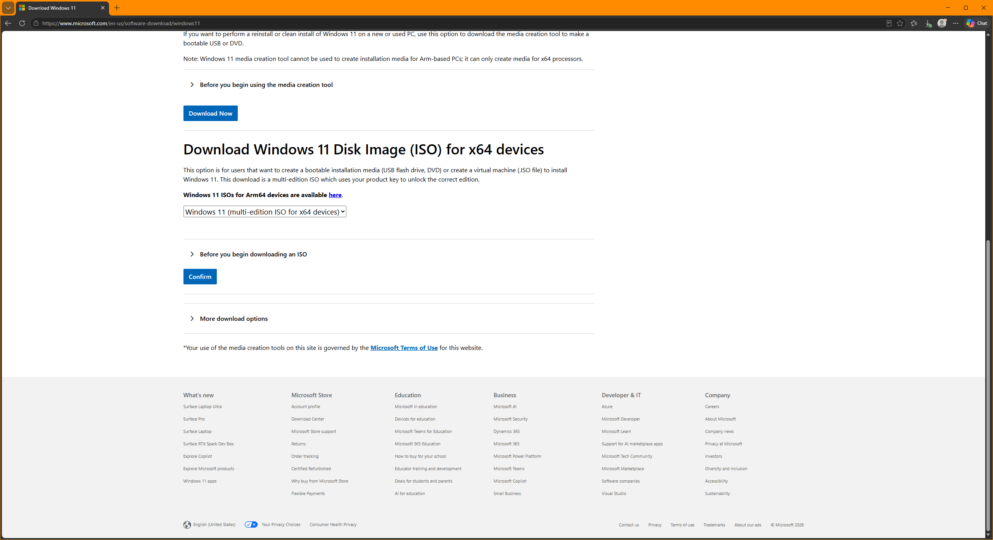
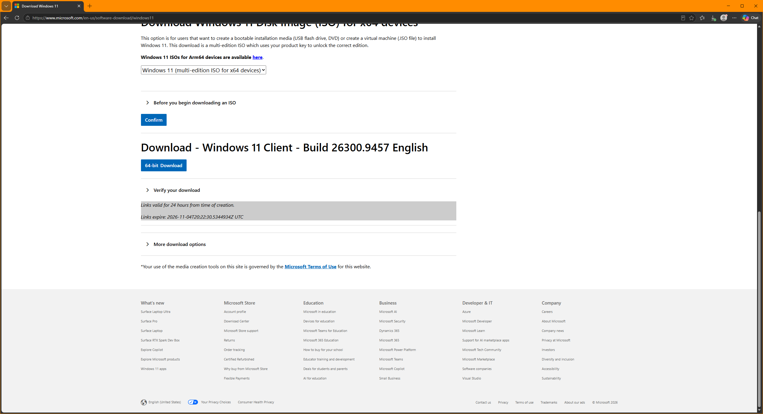
Straight from microsoft.com. The download page shows the build, the 24-hour link and a hash list for checking the file.
The file name changes with language and with each refresh Microsoft makes (ours was Windows11_Client_x64_en-us_26300_9457.iso), so don't type it. This finds the newest ISO in Downloads, whatever it's called, and copies its files out:
$iso = (Get-ChildItem "$env:USERPROFILE\Downloads\*.iso" | Sort LastWriteTime -Descending | Select -First 1).FullName
$iso
$drive = (Mount-DiskImage -ImagePath $iso -PassThru | Get-Volume).DriveLetter
robocopy "${drive}:\" C:\windowsbuild\iso /E
attrib -r C:\windowsbuild\iso\* /S /D
Dismount-DiskImage -ImagePath $iso
One ISO holds 11 editions. This finds Pro's position on its own and exports only Pro:
$wim = 'C:\windowsbuild\iso\sources\install.wim'
$pro = (Get-WindowsImage -ImagePath $wim | ? ImageName -eq 'Windows 11 Pro').ImageIndex
"Pro is index $pro"
dism /Export-Image /SourceImageFile:$wim /SourceIndex:$pro /DestinationImageFile:C:\windowsbuild\build\install.wim /Compress:max /CheckIntegrity
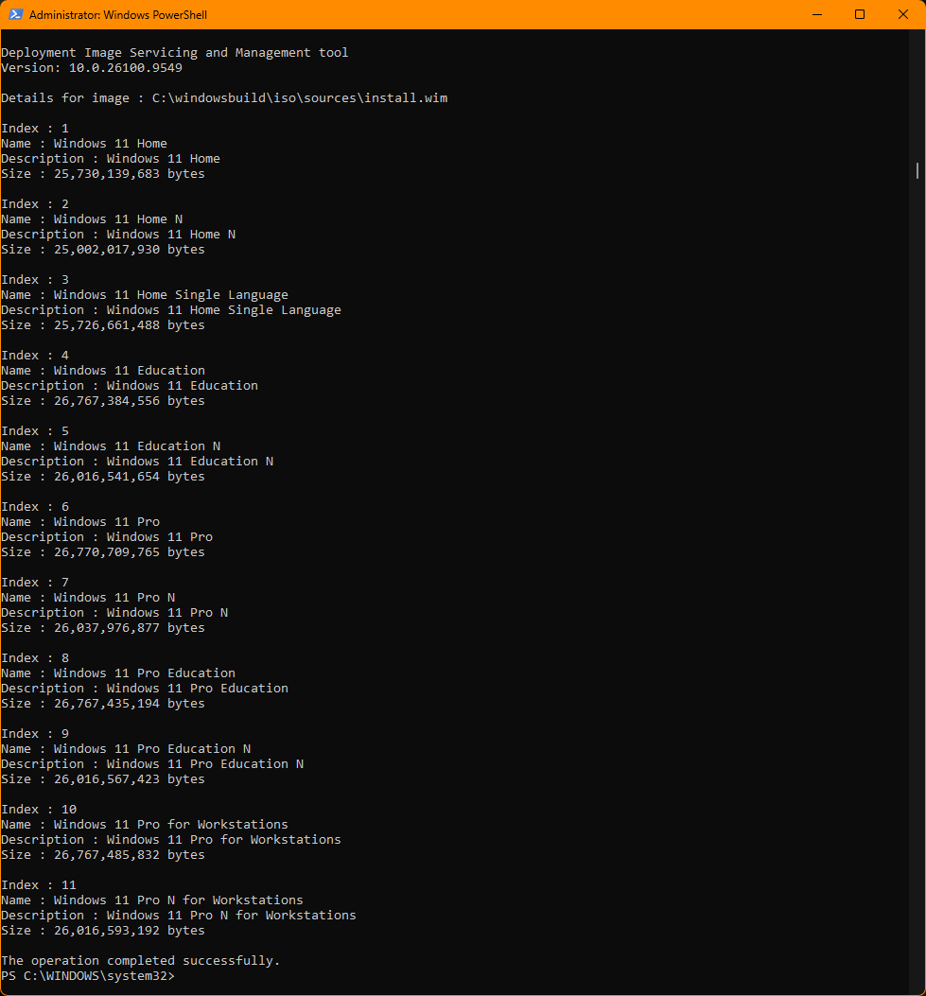
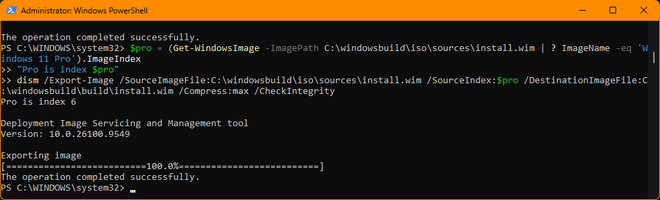
Eleven editions in one ISO; the script finds Pro (index 6) and exports only that.
From here on, your working image holds one edition, so Pro is Index 1.
Optional proof the file is untouched: expand Verify your download on Microsoft's page and compare its SHA256 with Get-FileHash $iso.

3. Mount and take inventory
Open the image into a folder, then save lists of what's inside. A whole Windows install sits in C:\windowsbuild\mount, ready to edit before it's ever installed.
dism /Mount-Image /ImageFile:C:\windowsbuild\build\install.wim /Index:1 /MountDir:C:\windowsbuild\mount
cd C:\windowsbuild\build
Get-AppxProvisionedPackage -Path C:\windowsbuild\mount | Select DisplayName, PackageName | Export-Csv apps.csv -NoTypeInformation
Get-WindowsOptionalFeature -Path C:\windowsbuild\mount | Select FeatureName, State | Export-Csv features.csv -NoTypeInformation
Get-WindowsCapability -Path C:\windowsbuild\mount | ? State -eq Installed | Select Name | Export-Csv capabilities.csv -NoTypeInformation
(Import-Csv apps.csv).Count
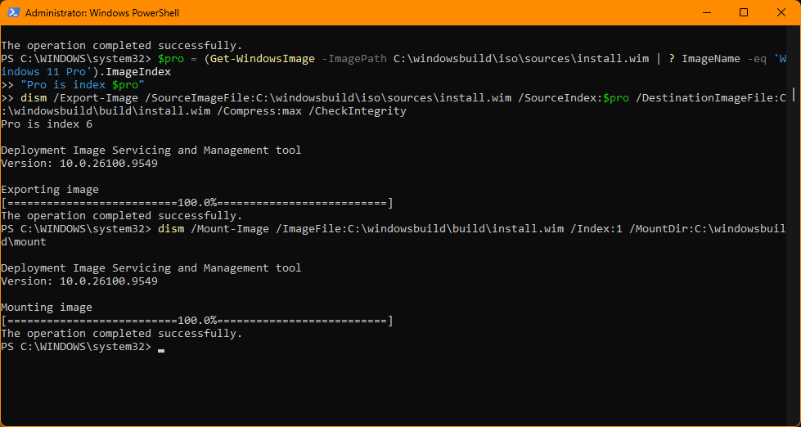
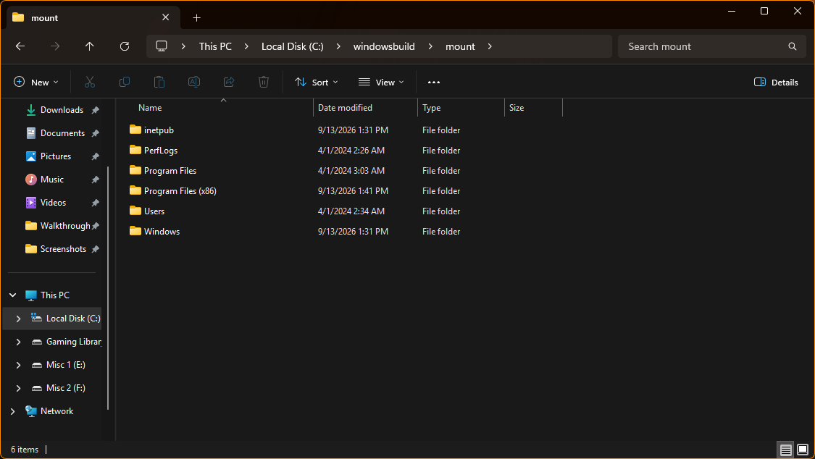
Mounted: a complete Windows install sitting in an ordinary folder, ready to edit.
The stock 26H2 image installs 47 apps for every new user. Open apps.csv in Notepad to see them all.
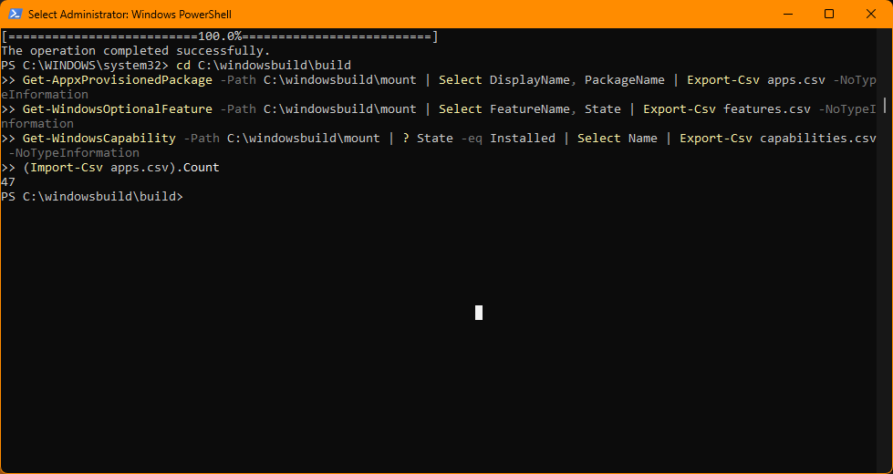
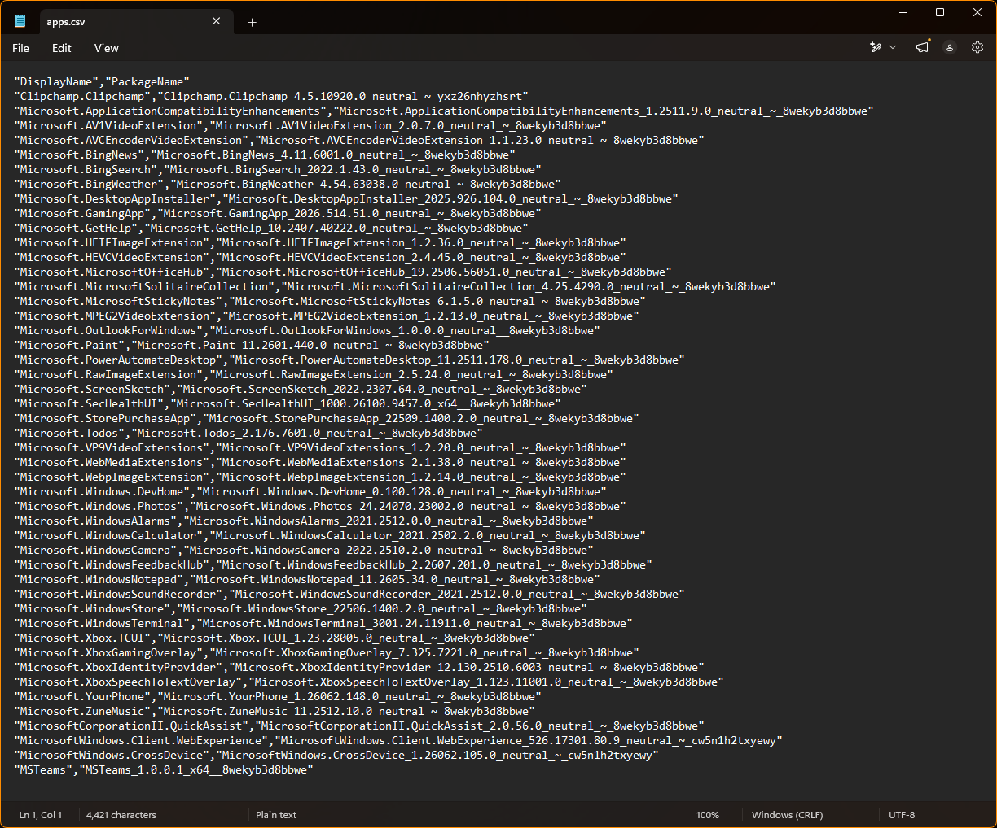
47 apps install for every new user on the stock image.
Close File Explorer windows inside the mount folder when you're done looking. An open window there is the most common reason the final save fails with "files in use."

4. Add the latest update (two files)
Add the newest cumulative update before removing anything. Microsoft's ISO is the launch build; ours was 26300.9457, while PCs already on 26H2 were at 26300.9711.
- Check your release's latest update on Windows release health. For November 2026 that's KB5127648, the October 13 update.
- Search the KB at the Microsoft Update Catalog. Six rows come up, because one KB covers 24H2, 25H2 and 26H2. Pick "…version 26H2 for x64-based Systems". The 24H2 and 25H2 x64 rows are the same size and sit right above it, so read carefully.
- Click Download. The pop-up lists two files: a small checkpoint update (kb5043080, about 509 MB) and the actual update (kb5127648, about 4.4 GB). Download both. Windows needs the older one as a base.
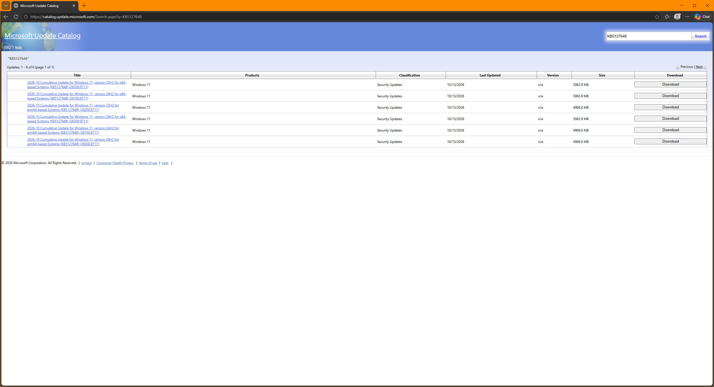
Six rows for one KB. Ours is the fourth: version 26H2 for x64.
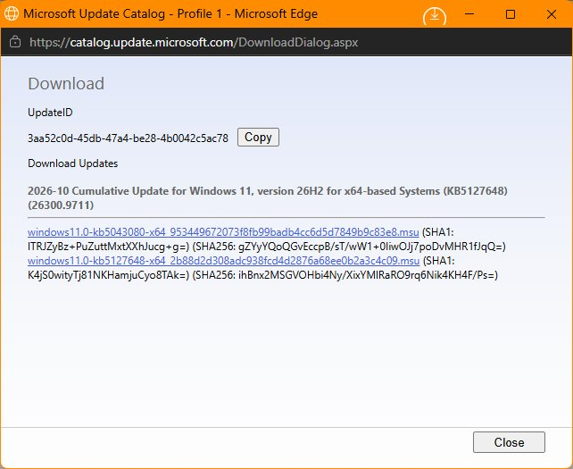
Two files: the checkpoint (kb5043080) and the October update (kb5127648). Download both.
Move-Item "$env:USERPROFILE\Downloads\windows11.0-kb*.msu" C:\windowsbuild\build\updates\
$cu = (Get-ChildItem C:\windowsbuild\build\updates\*kb5127648*.msu).FullName
dism /Image:C:\windowsbuild\mount /Add-Package /PackagePath:$cu
dism /Image:C:\windowsbuild\mount /Cleanup-Image /StartComponentCleanup /ResetBase
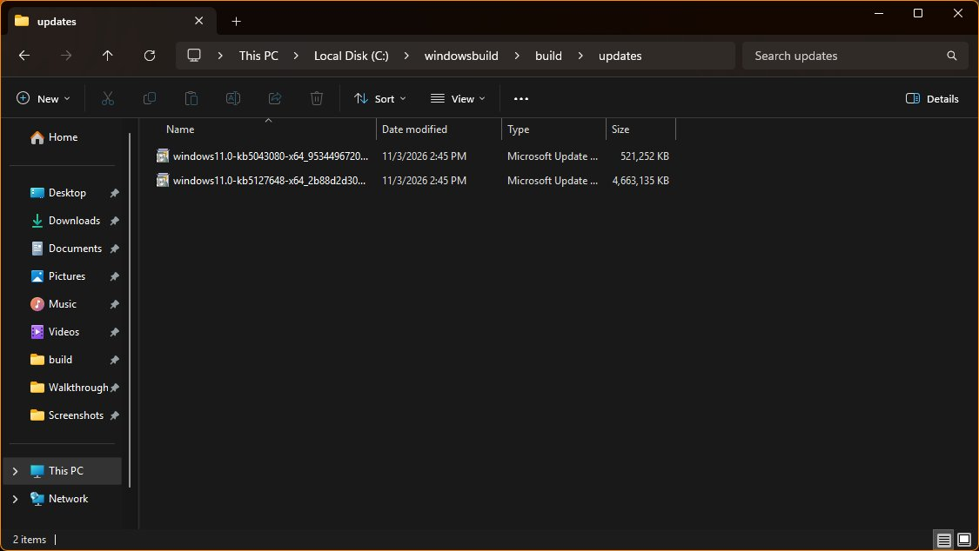
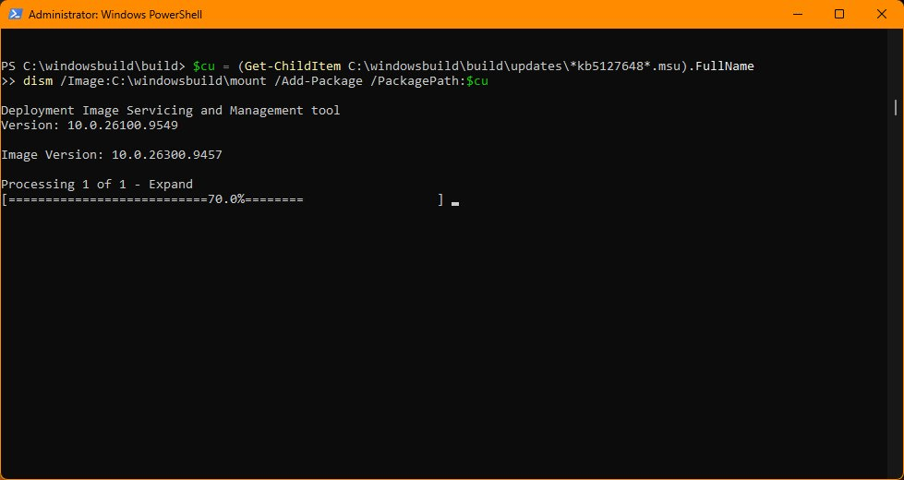
Point DISM at the newer file only. It finds the checkpoint in the same folder on its own. The update took about 5 minutes on a fast PC, and the cleanup 2 more.
Proof it worked: DISM prints the image version at the top of every command. It reads Image Version: 10.0.26300.9457 before the update and 10.0.26300.9711 after. (Checking ntoskrnl.exe instead shows 26100.9711; 24H2, 25H2 and 26H2 share core files, so ignore the 26100.)
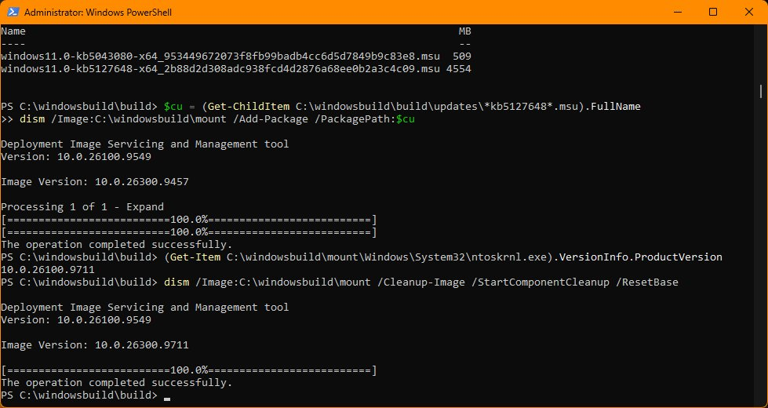
The before and after in one window: 9457 when the update went in, 9711 at the cleanup.

5. Remove apps
Remove apps by exact name, so nothing goes by accident. These 25 names come straight from the 26H2 image's own list.
$remove = @(
'Clipchamp.Clipchamp','Microsoft.BingNews','Microsoft.BingSearch','Microsoft.BingWeather',
'Microsoft.GetHelp','Microsoft.MicrosoftOfficeHub',
'Microsoft.MicrosoftSolitaireCollection','Microsoft.MicrosoftStickyNotes','Microsoft.OutlookForWindows',
'Microsoft.PowerAutomateDesktop','Microsoft.Todos','Microsoft.Windows.DevHome','Microsoft.WindowsAlarms',
'Microsoft.WindowsFeedbackHub','Microsoft.WindowsSoundRecorder',
'Microsoft.XboxSpeechToTextOverlay','Microsoft.YourPhone','MicrosoftCorporationII.QuickAssist','MSTeams',
'MicrosoftWindows.Client.WebExperience','MicrosoftWindows.CrossDevice'
)
Get-AppxProvisionedPackage -Path C:\windowsbuild\mount | ? DisplayName -in $remove | % {
Write-Host "Removing $($_.DisplayName)" -ForegroundColor DarkYellow
Remove-AppxProvisionedPackage -Path C:\windowsbuild\mount -PackageName $_.PackageName | Out-Null
}
"Apps left: " + (Get-AppxProvisionedPackage -Path C:\windowsbuild\mount).Count
It should go from 47 to 26. This generic build keeps the Xbox app and Game Pass (GamingApp), Game Bar (XboxGamingOverlay), Camera and Paint. Add any of them to the list only if you are sure nobody using this PC needs them.
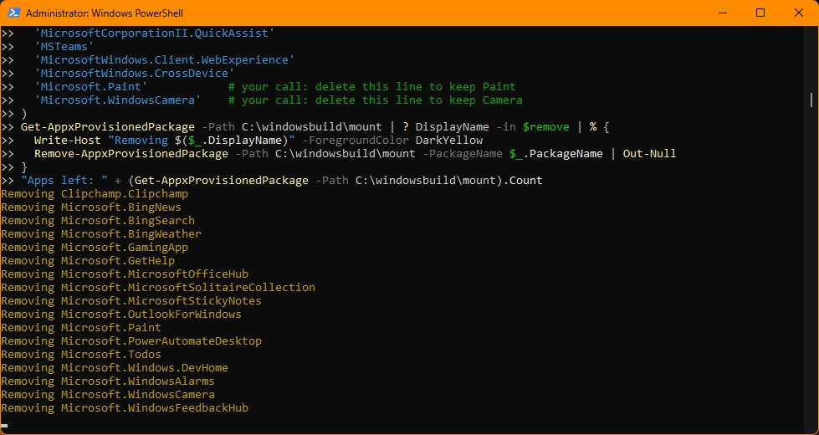
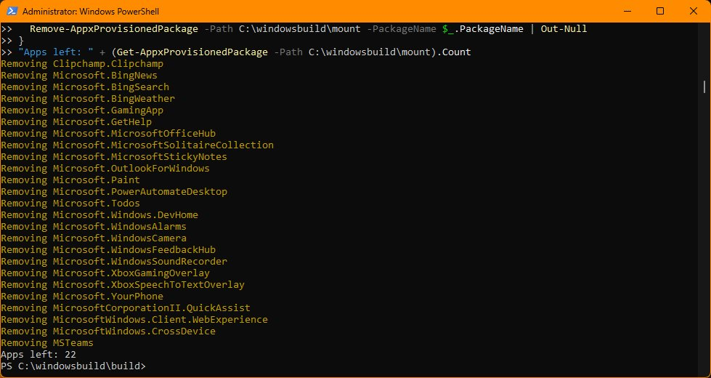
Keep these. Removing them breaks things that are hard to fix:
Keep | Why
Microsoft Store, Store purchase app | Installing and updating apps, buying games
App Installer | winget
Xbox Identity Provider, Xbox TCUI | Game Pass and Xbox sign-in in PC games
Windows Security | The security app
Media Player (ZuneMusic) | The only built-in way to play music and video files
The 9 codec packs | Photos and video in common formats
Photos, Calculator, Notepad, Terminal, Snipping Tool | Small, and people miss them right away
Copilot isn't in the 26H2 image at all. Windows adds it later through updates, so the app sweep in step 9 handles it.

6. Features and capabilities
Stock Windows already ships Hyper-V, WSL, Sandbox, SMB1, IIS and Recall turned off, so only a few changes are worth making.
Turn on .NET 3.5. Plenty of older games and launchers need it, and the ISO carries its files:
dism /Image:C:\windowsbuild\mount /Enable-Feature /FeatureName:NetFx3 /All /LimitAccess /Source:C:\windowsbuild\iso\sources\sxs
dism /Image:C:\windowsbuild\mount /Disable-Feature /FeatureName:WorkFolders-Client
dism /Image:C:\windowsbuild\mount /Disable-Feature /FeatureName:WindowsMediaPlayer
Remove four capabilities:
'App.StepsRecorder~~~~0.0.1.0','Browser.InternetExplorer~~~~0.0.11.0','MathRecognizer~~~~0.0.1.0','Media.WindowsMediaPlayer~~~~0.0.12.0' | % {
Write-Host "Removing $_" -ForegroundColor DarkYellow
Remove-WindowsCapability -Path C:\windowsbuild\mount -Name $_ | Out-Null
}
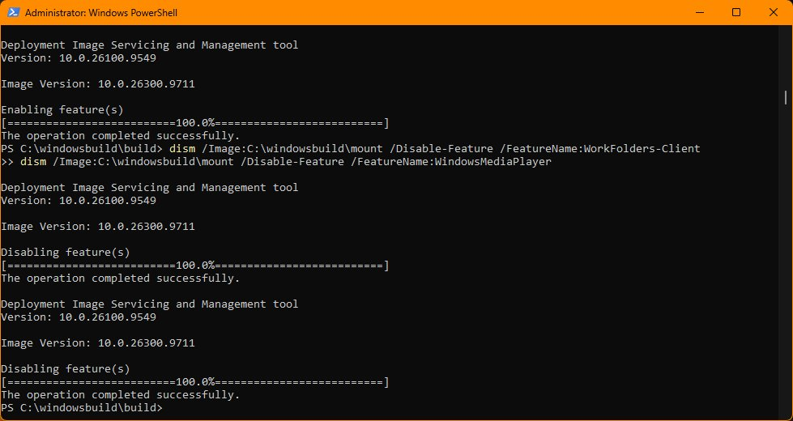
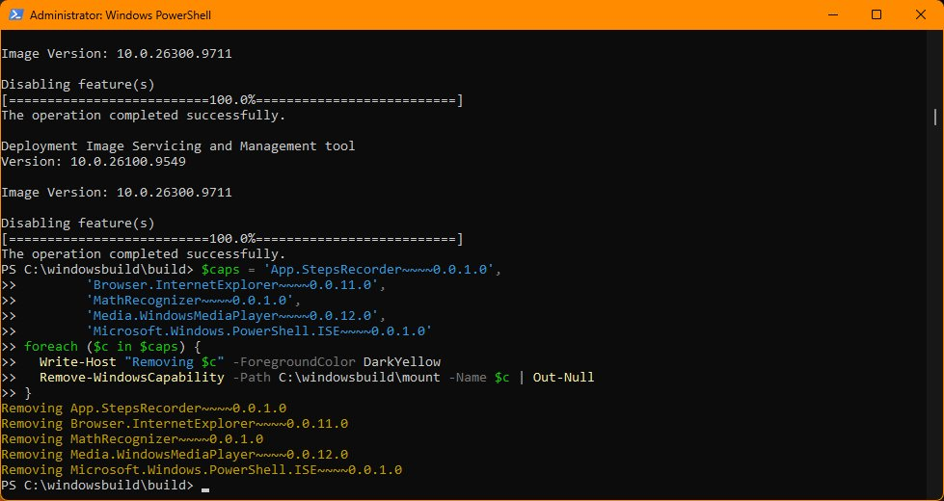
Our test run removed PowerShell ISE as a fifth capability. The steps above keep it.
Leave these capabilities alone:
- DirectX.Configuration.Database: games use it
- Every Wifi.Client and Ethernet.Client entry: these are built-in network drivers, and without them some PCs install with no connection
- Hello.Face: Windows Hello face sign-in
- Language.* packs, and VBSCRIPT, which some older installers still need
- PowerShell ISE: ARTifect testing found removing it broke powershell.exe on 25H2, so it stays
Match the machine's job: a gaming or streaming PC keeps Hyper-V, WSL and Sandbox off; a developer or local-AI PC turns them on.

7. Registry: privacy, services, Start menu, Edge
Settings written into the image's registry are in place before anyone signs in. This loads the image's three registry hives, applies everything, and unloads them. Close Registry Editor first.
reg load HKLM\OFFSW C:\windowsbuild\mount\Windows\System32\config\SOFTWARE
reg load HKLM\OFFSYS C:\windowsbuild\mount\Windows\System32\config\SYSTEM
reg load HKLM\OFFUSER C:\windowsbuild\mount\Users\Default\NTUSER.DAT
function Set-Reg($key, $name, $value) {
reg add $key /v $name /t REG_DWORD /d $value /f | Out-Null
Write-Host " $name = $value" -ForegroundColor DarkYellow
}
# Privacy (machine-wide)
Set-Reg 'HKLM\OFFSW\Policies\Microsoft\Windows\DataCollection' AllowTelemetry 0
Set-Reg 'HKLM\OFFSW\Policies\Microsoft\Windows\AdvertisingInfo' DisabledByGroupPolicy 1
Set-Reg 'HKLM\OFFSW\Policies\Microsoft\Windows\System' PublishUserActivities 0
Set-Reg 'HKLM\OFFSW\Policies\Microsoft\Windows\System' UploadUserActivities 0
Set-Reg 'HKLM\OFFSW\Policies\Microsoft\Dsh' AllowNewsAndInterests 0
Set-Reg 'HKLM\OFFSW\Policies\Microsoft\Windows\DeliveryOptimization' DODownloadMode 0
# Start menu: no placeholder apps, no Recommended section
Set-Reg 'HKLM\OFFSW\Policies\Microsoft\Windows\CloudContent' DisableCloudOptimizedContent 1
Set-Reg 'HKLM\OFFSW\Policies\Microsoft\Windows\CloudContent' DisableWindowsConsumerFeatures 1
Set-Reg 'HKLM\OFFSW\Policies\Microsoft\Windows\CloudContent' DisableSoftLanding 1
Set-Reg 'HKLM\OFFSW\Policies\Microsoft\Windows\Explorer' HideRecommendedSection 1
Set-Reg 'HKLM\OFFSW\Policies\Microsoft\Windows\Explorer' HideRecommendedPersonalizedSites 1
# Every new user
$cdm = 'HKLM\OFFUSER\Software\Microsoft\Windows\CurrentVersion\ContentDeliveryManager'
'SilentInstalledAppsEnabled','ContentDeliveryAllowed','PreInstalledAppsEnabled','OemPreInstalledAppsEnabled',
'SystemPaneSuggestionsEnabled','SubscribedContent-338388Enabled','SubscribedContent-338389Enabled',
'SubscribedContent-353694Enabled' | % { Set-Reg $cdm $_ 0 }
Set-Reg 'HKLM\OFFUSER\Software\Policies\Microsoft\Windows\Explorer' DisableSearchBoxSuggestions 1
Set-Reg 'HKLM\OFFUSER\Software\Policies\Microsoft\Windows\CloudContent' DisableTailoredExperiencesWithDiagnosticData 1
$adv = 'HKLM\OFFUSER\Software\Microsoft\Windows\CurrentVersion\Explorer\Advanced'
Set-Reg $adv Start_Layout 1; Set-Reg $adv Start_TrackProgs 0; Set-Reg $adv Start_TrackDocs 0; Set-Reg $adv Start_IrisRecommendations 0
# Services (Start = 4 means Disabled; offline images use ControlSet001)
'DiagTrack','dmwappushservice','MapsBroker','PeerDistSvc','SessionEnv' | % { Set-Reg "HKLM\OFFSYS\ControlSet001\Services\$_" Start 4 }
# Edge extras off
$edge = 'HKLM\OFFSW\Policies\Microsoft\Edge'
Set-Reg $edge HideFirstRunExperience 1; Set-Reg $edge HubsSidebarEnabled 0; Set-Reg $edge EdgeShoppingAssistantEnabled 0
Set-Reg $edge ShowMicrosoftRewards 0; Set-Reg $edge NewTabPageContentEnabled 0; Set-Reg $edge PersonalizationReportingEnabled 0
[gc]::Collect(); Start-Sleep 2
reg unload HKLM\OFFUSER; reg unload HKLM\OFFSYS; reg unload HKLM\OFFSW
Group | What it does
Privacy | Diagnostic data to the lowest level Pro allows, no ad ID, no activity history, no Widgets feed, no peer-to-peer update sharing
Start menu | DisableCloudOptimizedContent stops the placeholder pins (Outlook, Xbox, Solitaire) that install when clicked. HideRecommendedSection removes Recommended. These come from ARTifect's tested builds, and they replace any need for a saved Start layout file
New users | No silent "suggested" app installs, no web results in Start search, no tips
Services | Telemetry, push messages, offline maps, BranchCache and Remote Desktop configuration off. Take SessionEnv off the list if you remote into this PC
Edge | No sidebar, shopping pop-ups, Rewards or MSN feed
Honest notes:
- On Pro, AllowTelemetry 0 means the lowest level Pro allows ("Required"). Only Enterprise and Education turn it off completely.
- Don't disable the Delivery Optimization service (DoSvc). Windows Update needs it, and Windows switches it back on anyway. DODownloadMode 0 keeps the service but stops it sharing updates with other PCs.
- If reg unload says "Access is denied," wait a few seconds and run it again.

8. The answer file that works
An answer file named autounattend.xml in the root of the ISO answers Setup's questions for you. This is the one ARTifect tested on 26H2. A version with only an oobeSystem section gets ignored completely, so all three sections matter. Paste the Make it yours block first, because the file uses your account name.
@"
<?xml version="1.0" encoding="utf-8"?>
<unattend xmlns="urn:schemas-microsoft-com:unattend" xmlns:wcm="http://schemas.microsoft.com/WMIConfig/2002/State">
<settings pass="windowsPE">
<component name="Microsoft-Windows-Setup" processorArchitecture="amd64" publicKeyToken="31bf3856ad364e35" language="neutral" versionScope="nonSxS">
<DynamicUpdate><Enable>false</Enable><WillShowUI>Never</WillShowUI></DynamicUpdate>
<UserData>
<ProductKey><Key>VK7JG-NPHTM-C97JM-9MPGT-3V66T</Key><WillShowUI>Never</WillShowUI></ProductKey>
<AcceptEula>true</AcceptEula>
</UserData>
</component>
</settings>
<settings pass="specialize">
<component name="Microsoft-Windows-Deployment" processorArchitecture="amd64" publicKeyToken="31bf3856ad364e35" language="neutral" versionScope="nonSxS">
<RunSynchronous>
<RunSynchronousCommand wcm:action="add">
<Order>1</Order>
<Path>reg add HKLM\SOFTWARE\Microsoft\Windows\CurrentVersion\OOBE /v BypassNRO /t REG_DWORD /d 1 /f</Path>
</RunSynchronousCommand>
</RunSynchronous>
</component>
</settings>
<settings pass="oobeSystem">
<component name="Microsoft-Windows-International-Core" processorArchitecture="amd64" publicKeyToken="31bf3856ad364e35" language="neutral" versionScope="nonSxS">
<InputLocale>en-US</InputLocale><SystemLocale>en-US</SystemLocale><UILanguage>en-US</UILanguage><UserLocale>en-US</UserLocale>
</component>
<component name="Microsoft-Windows-Shell-Setup" processorArchitecture="amd64" publicKeyToken="31bf3856ad364e35" language="neutral" versionScope="nonSxS">
<OOBE>
<HideEULAPage>true</HideEULAPage>
<HideOnlineAccountScreens>true</HideOnlineAccountScreens>
<HideWirelessSetupInOOBE>false</HideWirelessSetupInOOBE>
<HideLocalAccountScreen>true</HideLocalAccountScreen>
<ProtectYourPC>3</ProtectYourPC>
</OOBE>
<UserAccounts>
<LocalAccounts>
<LocalAccount wcm:action="add">
<Name>$Account</Name><DisplayName>$Account</DisplayName><Group>Administrators</Group>
<Password><Value></Value><PlainText>true</PlainText></Password>
</LocalAccount>
</LocalAccounts>
</UserAccounts>
<AutoLogon>
<Username>$Account</Username><Enabled>true</Enabled><LogonCount>1</LogonCount>
<Password><Value></Value><PlainText>true</PlainText></Password>
</AutoLogon>
<FirstLogonCommands>
<SynchronousCommand wcm:action="add">
<Order>1</Order>
<CommandLine>powershell -NoProfile -WindowStyle Hidden -ExecutionPolicy Bypass -File C:\Windows\Setup\Scripts\FirstLogon.ps1</CommandLine>
<RequiresUserInput>false</RequiresUserInput>
</SynchronousCommand>
<SynchronousCommand wcm:action="add">
<Order>2</Order>
<CommandLine>powershell -NoProfile -WindowStyle Hidden -ExecutionPolicy Bypass -File C:\Windows\Setup\Scripts\Remove-ReturningApps.ps1 -Register</CommandLine>
<RequiresUserInput>false</RequiresUserInput>
</SynchronousCommand>
</FirstLogonCommands>
</component>
</settings>
</unattend>
"@ | Set-Content C:\windowsbuild\iso\autounattend.xml -Encoding UTF8
([xml](Get-Content C:\windowsbuild\iso\autounattend.xml)).unattend.settings.pass
The last line should list windowsPE, specialize and oobeSystem, which confirms the file is valid.
Part | What it does
windowsPE with the generic key | Skips the product key screen and makes Setup engage the answer file from the first screen
DynamicUpdate off | No "Checking for updates" mid-setup, so nothing gets pulled in that we removed
BypassNRO | Allows setup without a network or Microsoft account
HideOnlineAccountScreens, HideLocalAccountScreen, AutoLogon | No account screens; signs straight in to the account you named in $Account
FirstLogonCommands | Runs the two scripts from step 9
About the key: VK7JG-NPHTM-C97JM-9MPGT-3V66T is Microsoft's published generic Windows 11 Pro install key. It only picks the edition and does not activate Windows. Activate with your own license; a PC that has run activated Pro before reactivates on its own from its digital license.
Activation. Until Windows is activated, you'll see an "Activate Windows" watermark in the corner of the screen, and some personalization settings stay locked. Enter your own Windows 11 Pro key in Settings → System → Activation. A PC that has run activated Pro before reactivates on its own once it's online, from its digital license. This build isn't cracked or patched, so a genuine key activates it fully, exactly like a stock install.
About the setup account: it has no password and signs in automatically once, so the first-logon scripts can run. It is there to make setup easy, not to replace security. After install, open Settings → Accounts → Other users, add your own account as an administrator with a strong password or Windows Hello PIN, sign in as yourself, then remove the setup account. Never put a real password in this file.

9. Your name, wallpaper, taskbar and first-logon scripts
You write five files into the image here. Anything placed under the mount folder ends up on the installed PC. Paste the Make it yours block first if you've closed PowerShell since.
9a. Folders and your wallpaper:
$m = 'C:\windowsbuild\mount'
$scripts = "$m\Windows\Setup\Scripts"
mkdir $scripts, "$m\Windows\Web\Wallpaper\Custom" -Force | Out-Null
Copy-Item $Wall "$m\Windows\Web\Wallpaper\Custom\wallpaper.jpg"
9b. Your name in Settings → About:
reg load HKLM\OFFSW "$m\Windows\System32\config\SOFTWARE"
$oem = 'HKLM\OFFSW\Microsoft\Windows\CurrentVersion\OEMInformation'
reg add $oem /v Manufacturer /t REG_SZ /d $Me /f
reg add $oem /v Model /t REG_SZ /d $Model /f
reg add $oem /v SupportURL /t REG_SZ /d $Url /f
[gc]::Collect(); Start-Sleep 2
reg unload HKLM\OFFSW
9c. The first-logon script. Runs once when the account first signs in: sets your wallpaper, shows file extensions, and opens File Explorer to This PC.
@'
Add-Type @"
using System.Runtime.InteropServices;
public class Wp { [DllImport("user32.dll")] public static extern int SystemParametersInfo(int a, int b, string c, int d); }
"@
[Wp]::SystemParametersInfo(20, 0, "C:\Windows\Web\Wallpaper\Custom\wallpaper.jpg", 3)
$adv = "HKCU:\Software\Microsoft\Windows\CurrentVersion\Explorer\Advanced"
Set-ItemProperty $adv -Name HideFileExt -Value 0
Set-ItemProperty $adv -Name LaunchTo -Value 1
'@ | Set-Content "$scripts\FirstLogon.ps1"
9d. The app sweep. Windows puts some removed apps back once it's online. In our test, DevHome and Phone Link came back 27 minutes after the first sign-in. This script registers a task that checks at every startup, every sign-in and every 6 hours for 14 days, removes anything on your list that Windows provisioned, logs what it did, and then deletes itself. Apps the user installs from the Store are never touched, because they aren't provisioned.
@'
param([switch]$Register)
$ErrorActionPreference = 'SilentlyContinue'
$Task = 'Remove Returning Apps'
$Dir = "$env:ProgramData\CustomWindows"
$Log = "$Dir\app-sweep.log"
$List = "$PSScriptRoot\Sweep-List.txt"
New-Item -ItemType Directory $Dir -Force | Out-Null
function Log($msg) { "$(Get-Date -Format s) $msg" | Add-Content $Log }
if ($Register) {
$end = (Get-Date).AddDays(14).ToString('s')
$act = New-ScheduledTaskAction -Execute 'powershell.exe' -Argument "-NoProfile -WindowStyle Hidden -ExecutionPolicy Bypass -File `"$PSCommandPath`""
$boot = New-ScheduledTaskTrigger -AtStartup; $boot.Delay = 'PT2M'; $boot.EndBoundary = $end
$logn = New-ScheduledTaskTrigger -AtLogOn; $logn.EndBoundary = $end
$tick = New-ScheduledTaskTrigger -Once -At (Get-Date).AddHours(6) -RepetitionInterval (New-TimeSpan -Hours 6) -RepetitionDuration (New-TimeSpan -Days 14)
$tick.EndBoundary = $end
$set = New-ScheduledTaskSettingsSet -AllowStartIfOnBatteries -DontStopIfGoingOnBatteries -StartWhenAvailable -DeleteExpiredTaskAfter (New-TimeSpan -Days 1)
$who = New-ScheduledTaskPrincipal -UserId 'SYSTEM' -LogonType ServiceAccount -RunLevel Highest
Register-ScheduledTask -TaskName $Task -Action $act -Trigger $boot, $logn, $tick -Settings $set -Principal $who -Force | Out-Null
Log "registered '$Task' for 14 days"
Start-ScheduledTask -TaskName $Task
exit
}
$patterns = Get-Content $List | Where-Object { $_ -and $_ -notmatch '^\s*#' }
Log 'sweep start'
$gone = @()
foreach ($p in Get-AppxProvisionedPackage -Online) {
if ($patterns | Where-Object { $p.DisplayName -like $_ }) {
Remove-AppxProvisionedPackage -Online -PackageName $p.PackageName | Out-Null
Log " deprovisioned $($p.DisplayName)"; $gone += $p.DisplayName
}
}
foreach ($a in Get-AppxPackage -AllUsers | Where-Object { $_.Name -in $gone -and -not $_.NonRemovable }) {
Remove-AppxPackage -Package $a.PackageFullName -AllUsers
Log " removed $($a.Name)"
}
Log "sweep done ($($gone.Count) found)"
'@ | Set-Content "$scripts\Remove-ReturningApps.ps1"
9e. The sweep's list. One pattern per line. Add or remove lines to match the apps you removed in step 5:
@'
# Apps to remove if Windows puts them back
*DevHome*
*CrossDevice*
*YourPhone*
*Clipchamp*
*Bing*
*Solitaire*
*Todos*
*OutlookForWindows*
*Teams*
*Copilot*
*WebExperience*
*WindowsAlarms*
*FeedbackHub*
*OfficeHub*
*PowerAutomate*
*QuickAssist*
*StickyNotes*
*SoundRecorder*
*GetHelp*
'@ | Set-Content "$scripts\Sweep-List.txt"
9f. The taskbar. Start is handled by the registry in step 7, but the taskbar has its own layout; without this file it shows an Outlook placeholder. This pins File Explorer and Edge only:
$shell = "$m\Users\Default\AppData\Local\Microsoft\Windows\Shell"
mkdir $shell -Force | Out-Null
@'
<?xml version="1.0" encoding="utf-8"?>
<LayoutModificationTemplate xmlns="http://schemas.microsoft.com/Start/2014/LayoutModification"
xmlns:defaultlayout="http://schemas.microsoft.com/Start/2014/FullDefaultLayout"
xmlns:start="http://schemas.microsoft.com/Start/2014/StartLayout"
xmlns:taskbar="http://schemas.microsoft.com/Start/2014/TaskbarLayout" Version="1">
<CustomTaskbarLayoutCollection PinListPlacement="Replace">
<defaultlayout:TaskbarLayout>
<taskbar:TaskbarPinList>
<taskbar:DesktopApp DesktopApplicationID="Microsoft.Windows.Explorer" />
<taskbar:DesktopApp DesktopApplicationLinkPath="%ALLUSERSPROFILE%\Microsoft\Windows\Start Menu\Programs\Microsoft Edge.lnk" />
</taskbar:TaskbarPinList>
</defaultlayout:TaskbarLayout>
</CustomTaskbarLayoutCollection>
</LayoutModificationTemplate>
'@ | Set-Content "$shell\LayoutModification.xml" -Encoding UTF8
Check all five are in place:
Get-ChildItem $scripts, "$m\Windows\Web\Wallpaper\Custom", $shell | Select Name
You should see FirstLogon.ps1, Remove-ReturningApps.ps1, Sweep-List.txt, wallpaper.jpg and LayoutModification.xml.

10. Save, compress and build the ISO
Save the image, shrink it, and build the bootable ISO.
Save. Close every File Explorer window inside the mount folder first:
cd C:\windowsbuild
dism /Unmount-Image /MountDir:C:\windowsbuild\mount /Commit
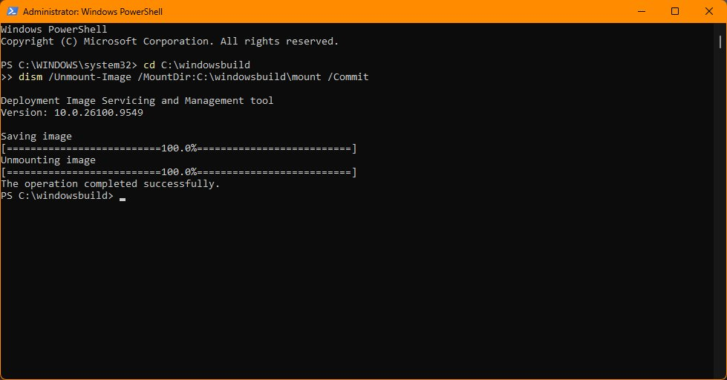
Compress. Even with one edition, the October update makes the image big: 6.95 GB with normal compression, and it grows with every monthly update. Microsoft's stronger recovery compression, which Setup reads natively, brought it to 5.23 GB in about 9 minutes. Use a 16 GB USB drive either way, so future rebuilds still fit:
Remove-Item C:\windowsbuild\iso\sources\install.wim
dism /Export-Image /SourceImageFile:C:\windowsbuild\build\install.wim /SourceIndex:1 /DestinationImageFile:C:\windowsbuild\iso\sources\install.esd /Compress:recovery
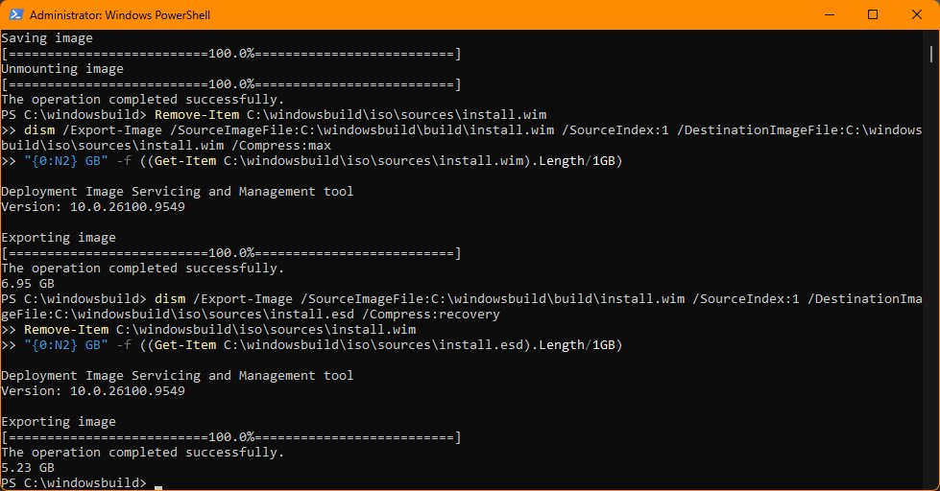
Build the ISO:
$adk = "${env:ProgramFiles(x86)}\Windows Kits\10\Assessment and Deployment Kit\Deployment Tools\amd64\Oscdimg"
& "$adk\oscdimg.exe" -m -o -u2 -udfver102 "-bootdata:2#p0,e,b$adk\etfsboot.com#pEF,e,b$adk\efisys.bin" C:\windowsbuild\iso C:\windowsbuild\My-Windows11.iso
 | Size
Microsoft's ISO (11 editions, launch build) | 8.42 GB
Pro only, with the October update, normal compression | 6.95 GB image
Finished ISO (recovery compression) | 6.04 GB
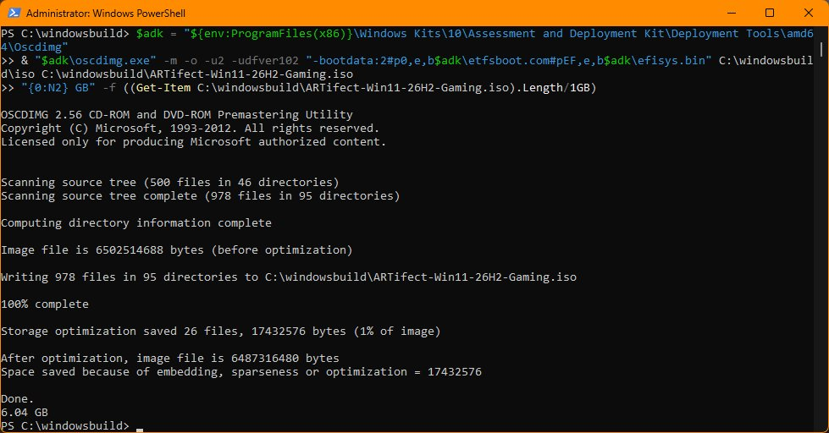
Smaller than Microsoft's download, and a month newer.

11. USB and install
Make the USB with Rufus:
- Device: your 16 GB USB drive. Everything on it is erased.
- Boot selection: your new ISO.
- Partition scheme: GPT. Target system: UEFI (non CSM). Rufus picks NTFS on its own because the image is over 4 GB, and current Rufus boots that with Secure Boot on.
- Optional: set the volume label to something you'll recognize, such as MYWINDOWS. It shows up in Setup's disk list.
- Click START. When Rufus offers Windows User Experience options, untick every box. Your answer file already handles all of it, and Rufus's own answer file can conflict with yours.
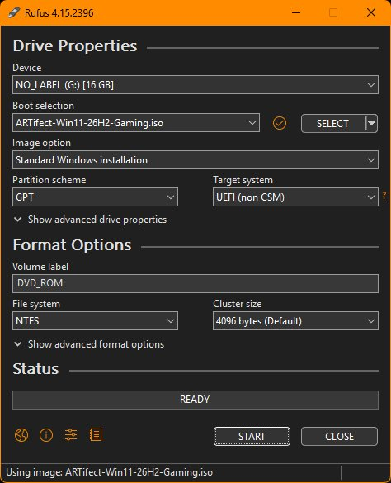
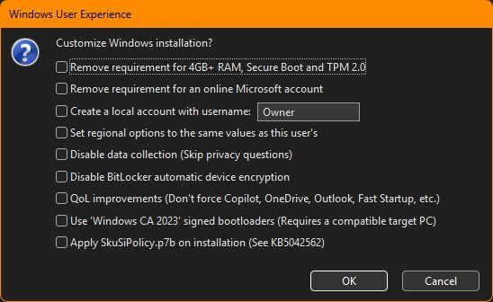
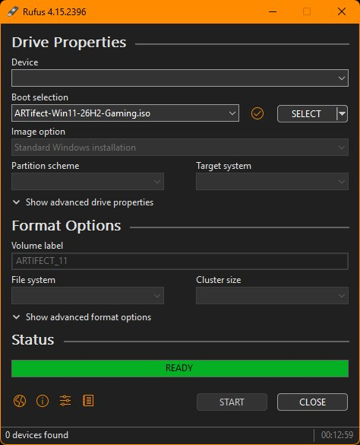
Install. Boot from the USB (F12 on Dell and most boards; F11 on some). What you should see:
- The language screen, then Install Windows 11 → tick the box agreeing everything will be deleted.
- No product key screen, and no edition picker. The recap reads "Install Windows 11 Pro."
- The disk screen. Delete the old partitions, select Disk 0 Unallocated Space, and click Next. Leave the USB (Disk 1) alone.
- "Installing Windows 11," and a few reboots.
- Straight to the desktop, signed in to the temporary setup account. No Microsoft account, network or privacy screens.
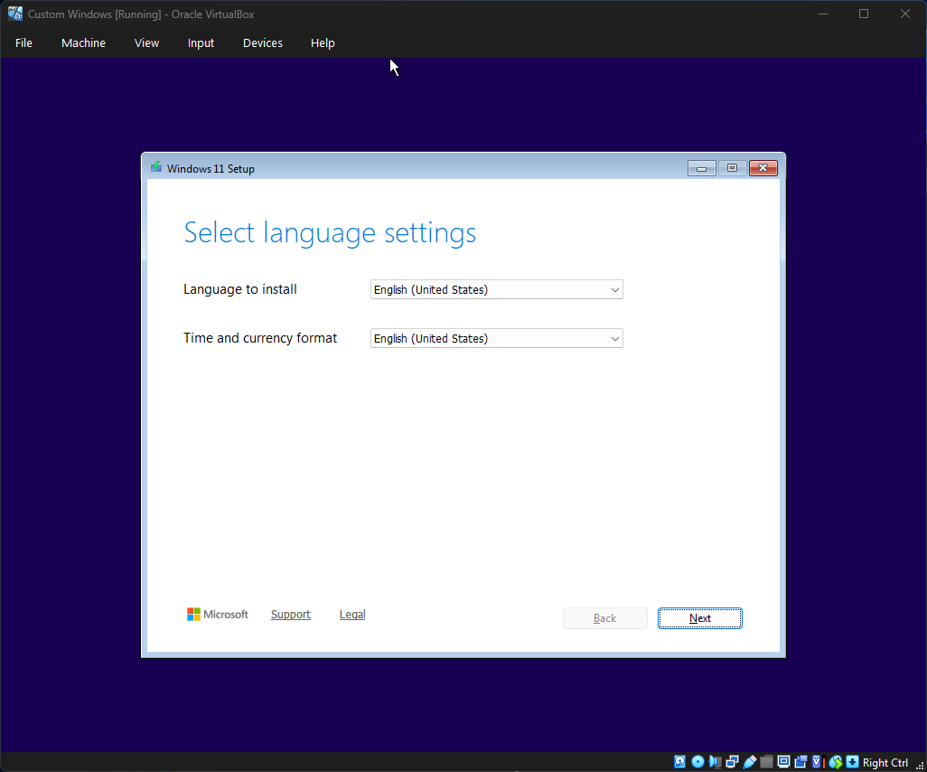
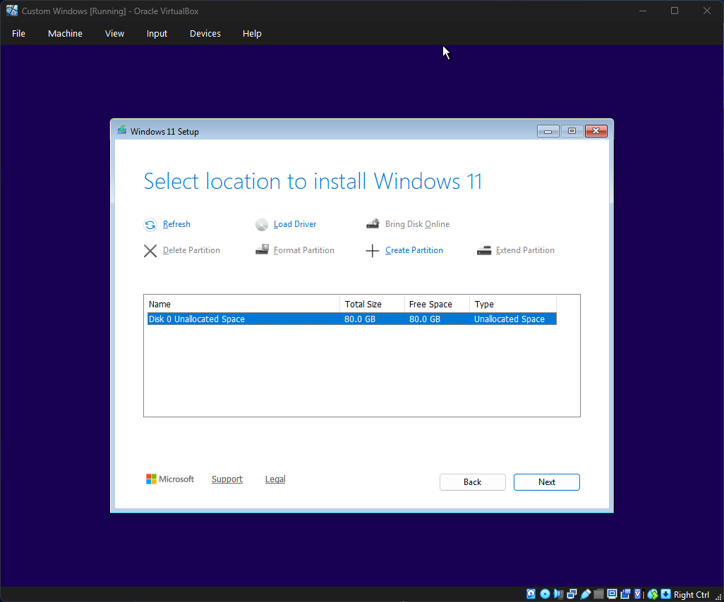
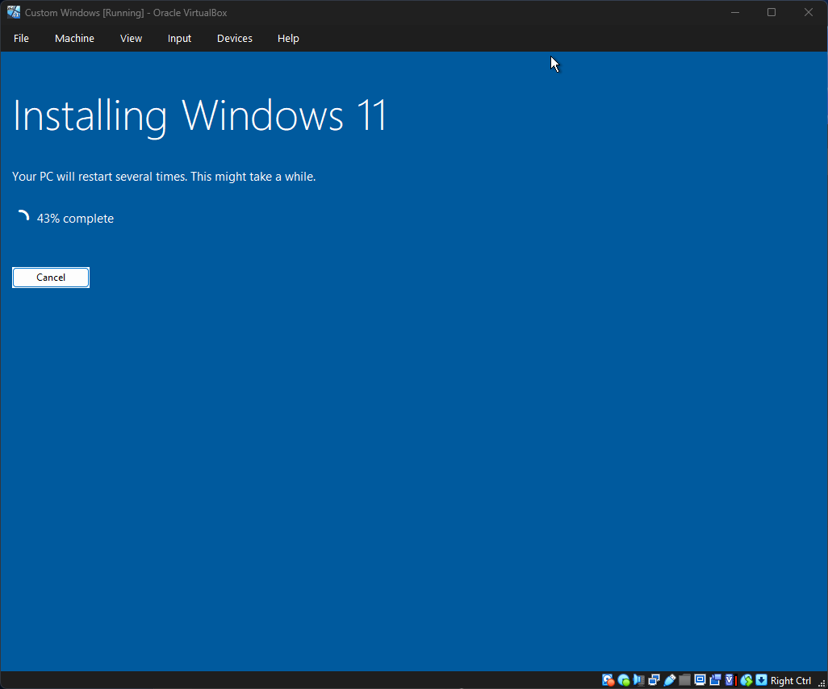
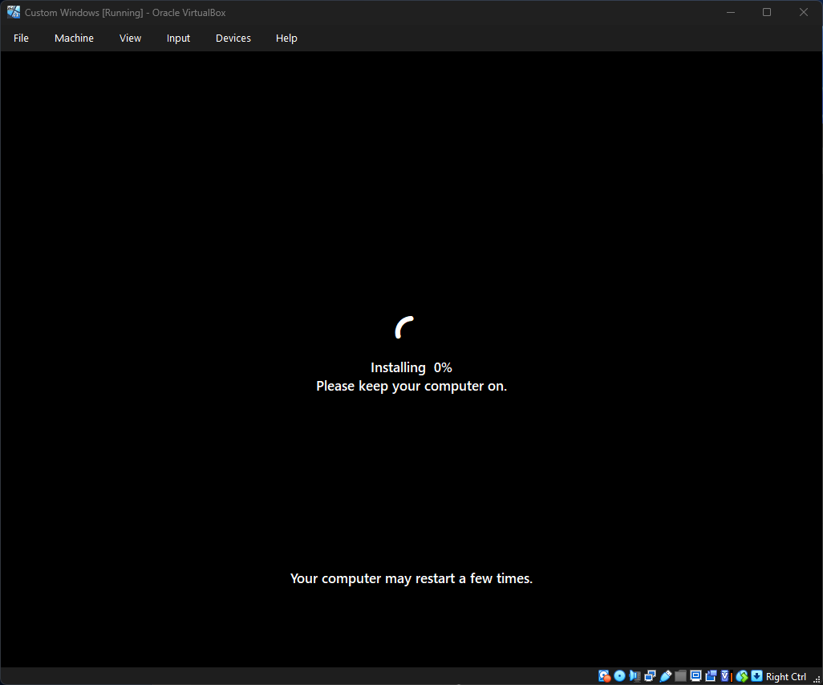
Setup in VirtualBox. No edition picker, because the image holds only Pro.
Dell laptops: if the disk screen shows no drives, the BIOS storage mode is RAID On. Press F2 at startup, set Storage → SATA/NVMe Operation to AHCI/NVMe, and boot the USB again. Only do this when you're wiping the drive anyway.
BitLocker: recent Windows 11 can switch on drive encryption by itself during setup, even with a local account, and with no Microsoft account the recovery key isn't backed up anywhere. If that matters to you, save the key from Settings → Privacy & security → Device encryption, or turn encryption off there.

12. Check it worked
Give the new install about 30 minutes online, then run this in PowerShell as administrator. Run it again after every feature update.
"Build: " + (Get-ItemProperty 'HKLM:\SOFTWARE\Microsoft\Windows NT\CurrentVersion' | % { "$($_.DisplayVersion) $($_.CurrentBuild).$($_.UBR)" })
"Apps provisioned: " + (Get-AppxProvisionedPackage -Online).Count
Get-AppxPackage -AllUsers | ? Name -match 'DevHome|CrossDevice|Getstarted|Clipchamp|Solitaire|OutlookForWindows' | Select Name
Get-Service DiagTrack,dmwappushservice,MapsBroker,PeerDistSvc,SessionEnv -EA 0 | ft Name,StartType -Auto
Get-ScheduledTask 'Remove Returning Apps' -EA 0 | ft TaskName,State -Auto
Get-Content C:\ProgramData\CustomWindows\app-sweep.log
Our tested result, on a fresh virtual machine:
Check | Expected | Ours
Build | Your update's build | 26H2 26300.9711
Apps provisioned | 22, or 23 once Edge updates itself | 23, the extra one is Microsoft.MicrosoftEdge.Stable
Returned apps | Nothing listed | Nothing
Services | All Disabled | All Disabled
Sweep task | Ready | Ready
Sweep log | Runs logged, removals if Windows tried | Caught DevHome and CrossDevice 27 minutes after setup; every sweep since removed 0
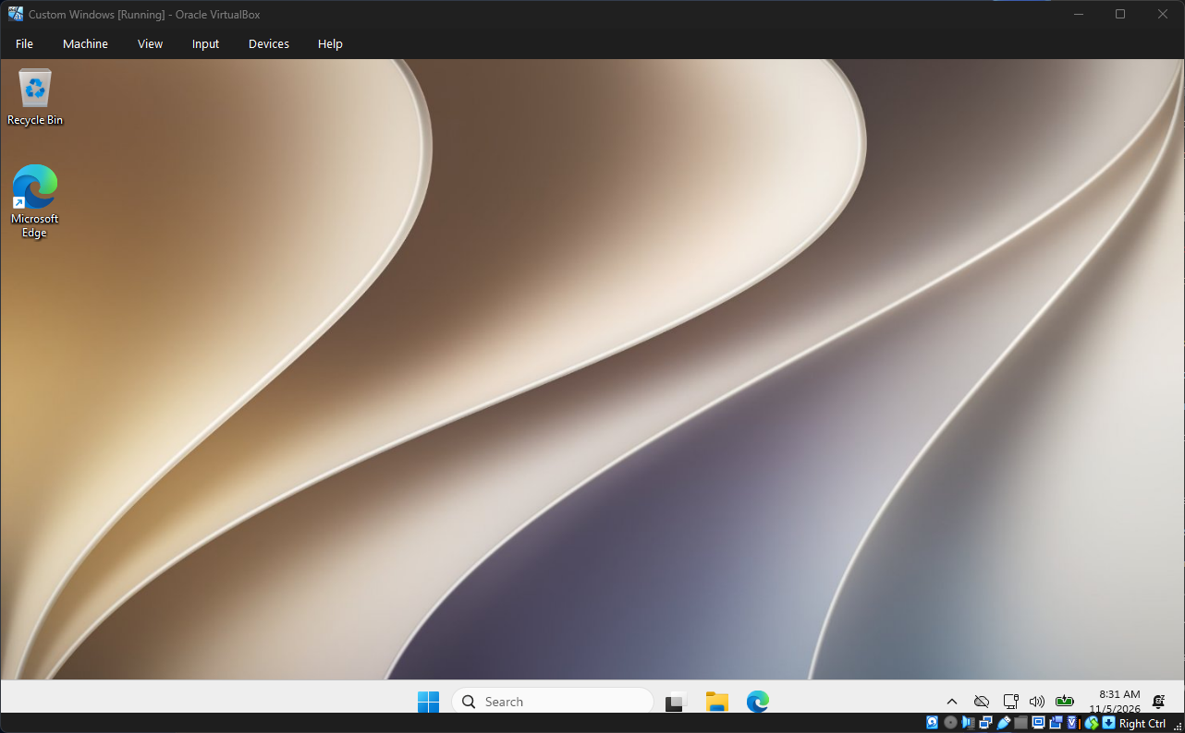
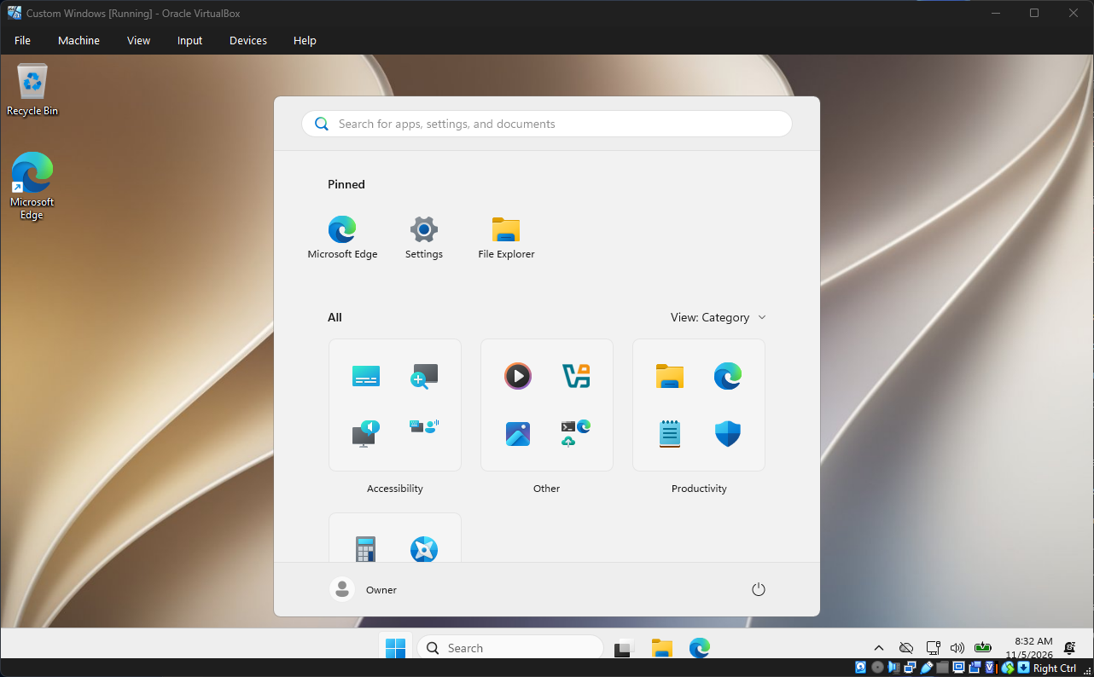
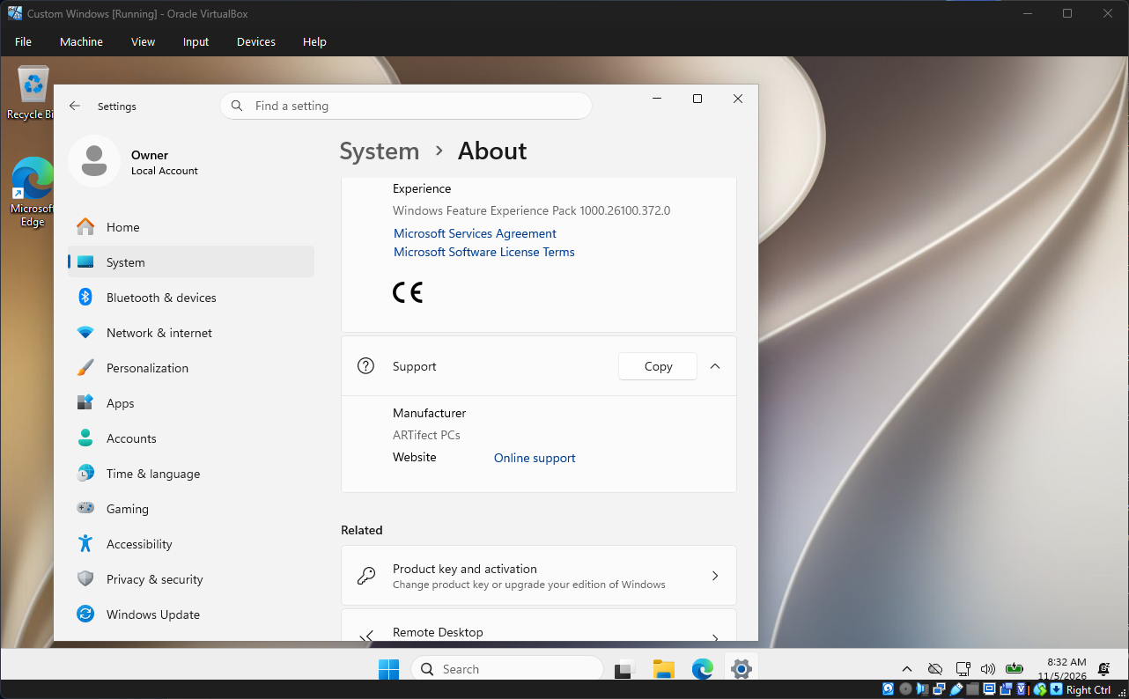
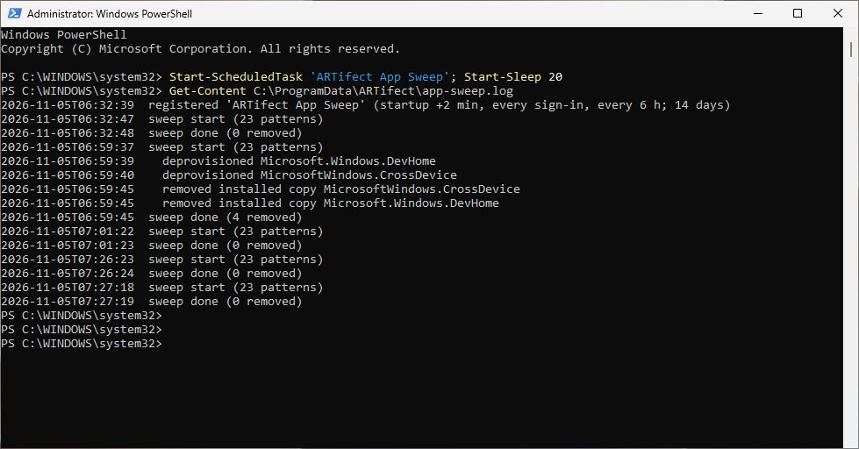
The finished build, and the sweep catching the apps Windows tried to put back at 6:59.
Also look at Start (only Edge, Settings and File Explorer, no Recommended section), the taskbar (File Explorer and Edge), your wallpaper, and Settings → System → Activation.
Keeping it current: installed PCs patch themselves through Windows Update as normal. For new installs, rebuild the ISO every few months with the newest update from step 4.
[image: Task Manager on the finished build: 112 processes, 1.8 GB memory, 0% CPU]
The finished build at idle, in a VirtualBox VM with 6 cores and 4 GB of memory: 0% CPU, 112 processes and 1.8 GB of memory in use, five minutes after boot.

Troubleshooting and FAQ
Problem | Fix
"The image is already mounted," or a mount error | dism /Cleanup-Mountpoints, then mount again
Unmount fails with "files in use" | Close File Explorer, Registry Editor and any terminal sitting in the mount folder
reg unload says "Access is denied" | Run [gc]::Collect(), wait a few seconds, try again
A command seems frozen | The PowerShell title bar says "Select": you clicked in the window and paused it. Press Esc
Copy-Item says the path is null | The file isn't where the command looks. Check with Get-ChildItem and fix the path
A Microsoft account screen appears | The answer file isn't being read. Check it's in the ISO or USB root and lists all three passes (step 8)
Placeholder apps in Start | The step 7 Start policies are missing from the image
The Dell shows no drives in Setup | BIOS storage mode: RAID On to AHCI/NVMe (step 11)
Rufus warns the file is over 4 GB | Let it use NTFS; current versions boot it with Secure Boot on
Is this legal? Yes. You're customizing your own copy of Windows with Microsoft's own tools and activating it with your own license. Share this guide, not your finished ISO.
Will it activate and update? Yes. It's standard Windows 11 Pro, so activation and Windows Update work as they do on a stock install.
Can I undo things? Mostly. Features turn back on in Windows Features, removed apps reinstall from the Store, privacy settings can be changed back in Settings, and a stock USB is always the last resort.
Rather skip all this? Every ARTifect PC ships with Windows set up this way, built and tested before it reaches you. Questions: @artifectpcs on TikTok, or artifectpcs.com.

