姓名：吴永强 学号：2011210613

3.5解：

(a).

**data** xiti3_5;

infile "E:\W学习文件\金融时间序列\应用时间序列\Data_CC\wages.dat" firstobs=**2** ;

input wages;

time=intnx('month',**'01jan1982'd**,_n_-**1**); /*时间还要改写*/

format time ddmmyy10.;

t=_n_;

t2=t\*\***2**;

**run**;

title "美国服装和纺织品行业工人的平均时薪的时间序列图";

**proc** **gplot** data=xiti3_5;

plot wages*time=**1**;

symbol1 c=red I= v=circle h=**1.5**;

**run**;

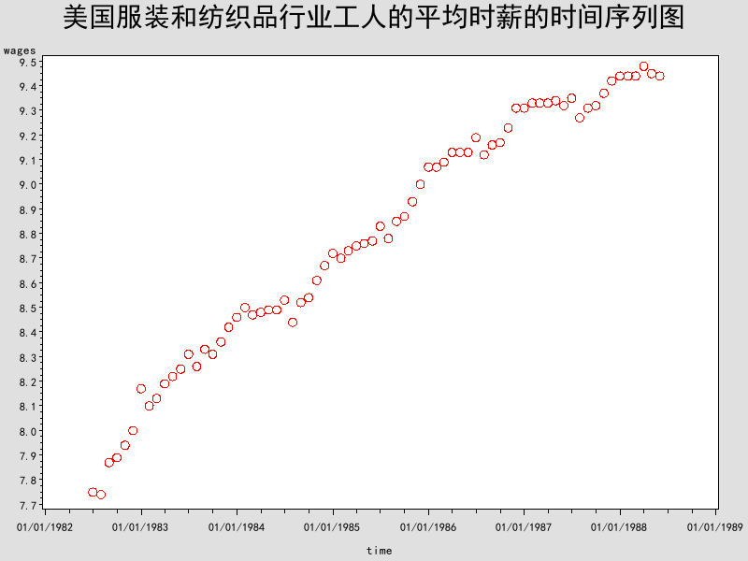

该图表明平均时薪有很强的增长趋势。

(b).

**proc** **reg** data=xiti3_5;

model wages=t/R; /*第二问的时间趋势的拟合*/

output out=out1 student=cancha1;

**run**;

运行的结果：

| **Analysis of Variance** | | | | | |
| --- | --- | --- | --- | --- | --- |
| **Source** | **DF** | **Sum of Squares** | **Mean Square** | **F Value** | **Pr > F** |
| **Model** | 1 | 17.06205 | 17.06205 | 2502.77 | <.0001 |
| **Error** | 70 | 0.47721 | 0.00682 |  |  |
| **Corrected Total** | 71 | 17.53926 |  |  |  |

|  |  |  |  |
| --- | --- | --- | --- |
| **Root MSE** | 0.08257 | **R-Square** | 0.9728 |
| **Dependent Mean** | 8.78639 | **Adj R-Sq** | 0.9724 |
| **Coeff Var** | 0.93971 |  |  |

| **Parameter Estimates** | | | | | |
| --- | --- | --- | --- | --- | --- |
| **Variable** | **DF** | **Parameter Estimate** | **Standard Error** | **t Value** | **Pr > |t|** |
| **Intercept** | **1** | 7.93144 | 0.01967 | 403.31 | <.0001 |
| **t** | **1** | 0.02342 | 0.00046821 | 50.03 | <.0001 |

拟合的参数是显著的，

(c).

**proc** **gplot** data=out1;

title "标准残差的时序图";

plot cancha1*time=**2**/overlay; /*第三问的标准差图*/

symbol2 c=red v=none i=join w=**2** l=**3**;

**run**;

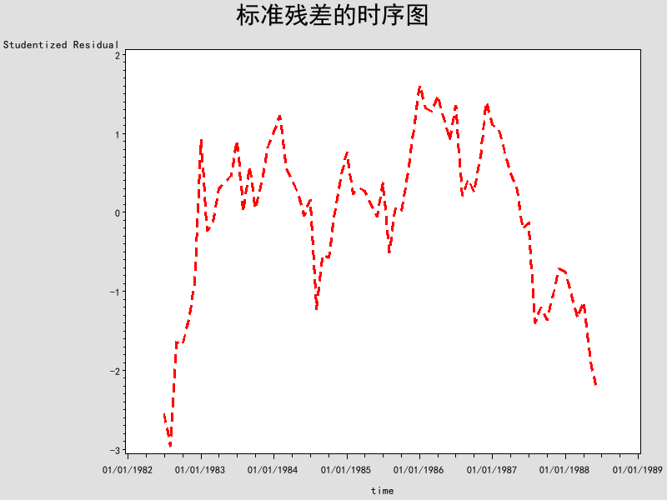

(d)

**proc** **reg** data=xiti3_5;

model wages=t t2/R ; /*第四问的时间趋势的拟合*/

output out=out2 student=cancha2;

**run**;

运行的结果：

| **Analysis of Variance** | | | | | |
| --- | --- | --- | --- | --- | --- |
| **Source** | **DF** | **Sum of Squares** | **Mean Square** | **F Value** | **Pr > F** |
| **Model** | 2 | 17.29994 | 8.64997 | 2493.91 | <.0001 |
| **Error** | 69 | 0.23932 | 0.00347 |  |  |
| **Corrected Total** | 71 | 17.53926 |  |  |  |

|  |  |  |  |
| --- | --- | --- | --- |
| **Root MSE** | 0.05889 | **R-Square** | 0.9864 |
| **Dependent Mean** | 8.78639 | **Adj R-Sq** | 0.9860 |
| **Coeff Var** | 0.67028 |  |  |

| **Parameter Estimates** | | | | | |
| --- | --- | --- | --- | --- | --- |
| **Variable** | **DF** | **Parameter Estimate** | **Standard Error** | **t Value** | **Pr > |t|** |
| **Intercept** | **1** | 7.79744 | 0.02141 | 364.13 | <.0001 |
| **t** | **1** | 0.03429 | 0.00135 | 25.33 | <.0001 |
| **t2** | **1** | -0.00014883 | 0.00001797 | -8.28 | <.0001 |

(e)

**proc** **gplot** data=out2;

title "标准残差的时序图";

plot cancha2*time=**2**/overlay; /*第五问的标准差图*/

symbol2 c=red v=jion i=join w=**2** l=**3**;

**run**;

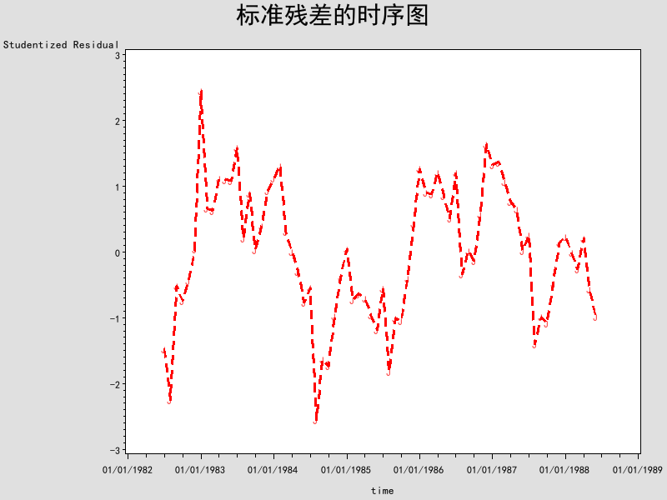

3.9解：

(a)

**data** xiti3_9;

infile "E:\W学习文件\金融时间序列\应用时间序列\Data_CC\prescrip.dat" firstobs=**2** ;

input prescrip;

time=intnx('month',**'01Aug1986'd**,_n_-**1**);

format time ddmmyy10.;

season=month(time);

t=_n_;

**run**;

**proc** **gplot** data=xiti3_9;

title "月度医药处方成本";

plot prescrip*time=**season**; /*第一问的时间序列图*/

symbol1 c=red I= v=circle h=**1.5**;

**run**;

运行的结果：

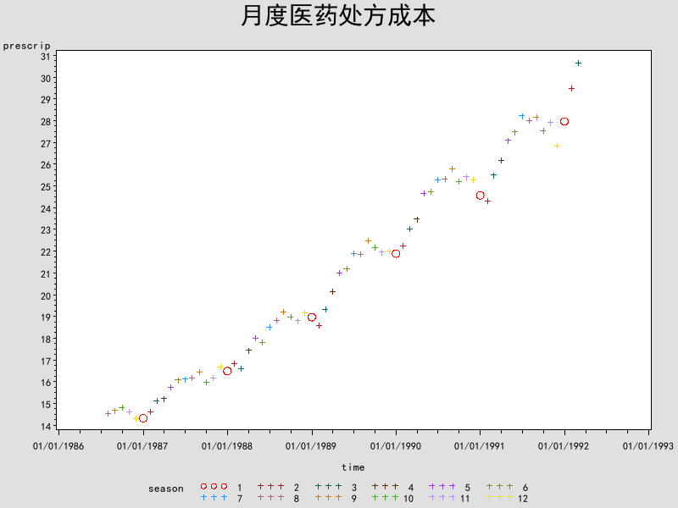

从上面图看出，月度医药处方成本有季节效应。

(b)

**data** wu;

set xiti3_9;

perprescrip=**100**\*(prescrip-lag(prescrip))/lag(prescrip); /*月度变化率*/

**run**;

**proc** **gplot** data=wu;

title "月度医药处方成本变化率图";

plot perprescrip*time=**1**;

symbol i=jion v=circle h=**1.5**;

**run**;

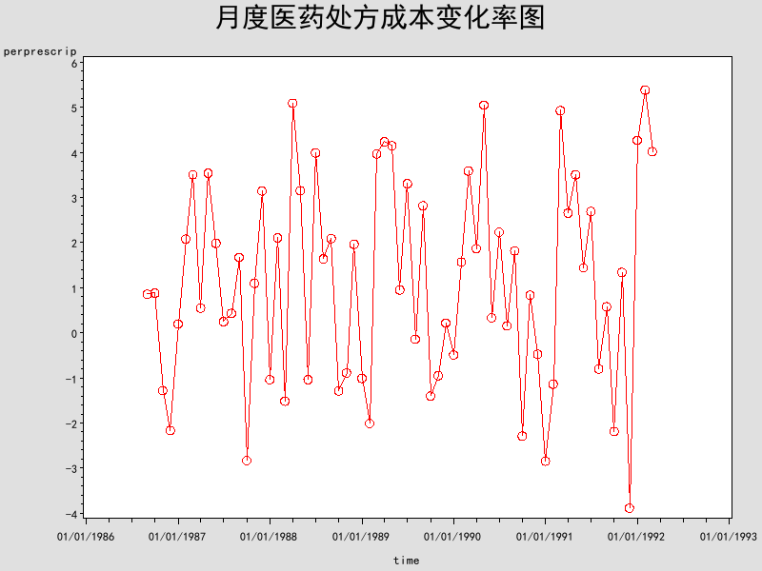

从图形来看，处方成本月对月变化率的序列看起来差不多平稳了。

(c)

**data** wu;

set wu;

x1=cos(**2**\***3.14159**\*t/**12**);

x2=sin(**2**\***3.14159**\*t/**12**);

**run**;

**proc** **reg** data=wu;

model perprescrip=x1 x2/R ;

output out=out r=residuals p=predicted student=sresiduals;

**run**;

The REG Procedure

Model: MODEL1

Dependent Variable: perprescrip

|  |  |
| --- | --- |
| **Number of Observations Read** | 68 |
| **Number of Observations Used** | 67 |
| **Number of Observations with Missing Values** | 1 |

| **Analysis of Variance** | | | | | |
| --- | --- | --- | --- | --- | --- |
| **Source** | **DF** | **Sum of Squares** | **Mean Square** | **F Value** | **Pr > F** |
| **Model** | 2 | 105.82697 | 52.91348 | 14.70 | <.0001 |
| **Error** | 64 | 230.38647 | 3.59979 |  |  |
| **Corrected Total** | 66 | 336.21343 |  |  |  |

|  |  |  |  |
| --- | --- | --- | --- |
| **Root MSE** | 1.89731 | **R-Square** | 0.3148 |
| **Dependent Mean** | 1.14395 | **Adj R-Sq** | 0.2933 |
| **Coeff Var** | 165.85556 |  |  |

| **Parameter Estimates** | | | | | |
| --- | --- | --- | --- | --- | --- |
| **Variable** | **DF** | **Parameter Estimate** | **Standard Error** | **t Value** | **Pr > |t|** |
| **Intercept** | **1** | 1.22171 | 0.23253 | 5.25 | <.0001 |
| **x1** | **1** | 0.65373 | 0.32985 | 1.98 | 0.0518 |
| **x2** | **1** | -1.65965 | 0.32688 | -5.08 | <.0001 |

拟合模型为：



(d)

**proc** **gplot** data=out;

title '百分比变化率的标准残差的时序图';

plot sresiduals * time;

symbol1 color=blue i=jion value=circle height=**1**;

**run**;

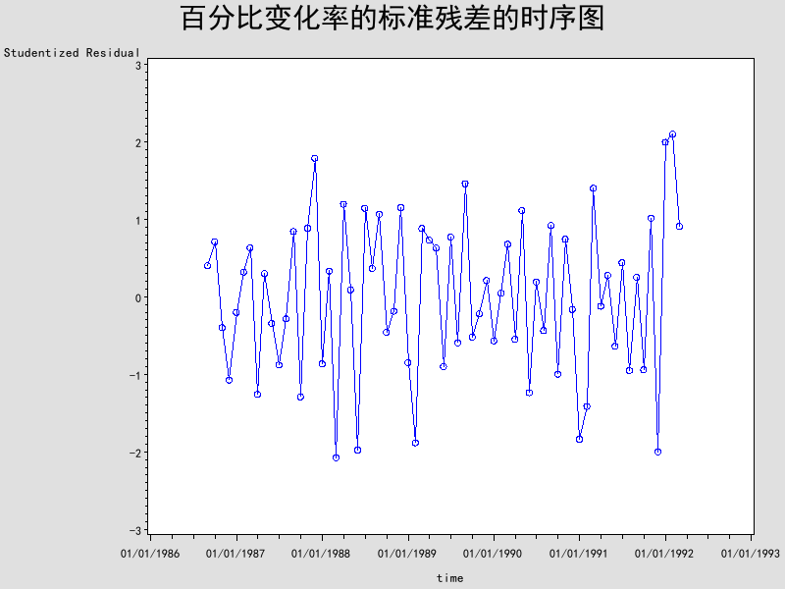

标准残差图看起来是随机序列，没有趋势。

3.11解：

(a)

**data** xiti3_11;

infile "E:\W学习文件\金融时间序列\应用时间序列\Data_CC\wages.dat" firstobs=**2** ;

input wages;

time=intnx('month',**'01jul1982'd**,_n_-**1**);

format time ddmmyy10.;

t=_n_;

t2=t\*\***2**;

**run**;

**proc** **reg** data=xiti3_11;

model wages=t t2/R ;

output out=out r=residuals student=sresiduals;

**run**;

运行的结果：

Dependent Variable: wages

|  |  |
| --- | --- |
| **Number of Observations Read** | 72 |
| **Number of Observations Used** | 72 |

| **Analysis of Variance** | | | | | |
| --- | --- | --- | --- | --- | --- |
| **Source** | **DF** | **Sum of Squares** | **Mean Square** | **F Value** | **Pr > F** |
| **Model** | 2 | 17.29994 | 8.64997 | 2493.91 | <.0001 |
| **Error** | 69 | 0.23932 | 0.00347 |  |  |
| **Corrected Total** | 71 | 17.53926 |  |  |  |

|  |  |  |  |
| --- | --- | --- | --- |
| **Root MSE** | 0.05889 | **R-Square** | 0.9864 |
| **Dependent Mean** | 8.78639 | **Adj R-Sq** | 0.9860 |
| **Coeff Var** | 0.67028 |  |  |

| **Parameter Estimates** | | | | | |
| --- | --- | --- | --- | --- | --- |
| **Variable** | **DF** | **Parameter Estimate** | **Standard Error** | **t Value** | **Pr > |t|** |
| **Intercept** | **1** | 7.79744 | 0.02141 | 364.13 | <.0001 |
| **t** | **1** | 0.03429 | 0.00135 | 25.33 | <.0001 |
| **t2** | **1** | -0.00014883 | 0.00001797 | -8.28 | <.0001 |

从上面的表格看出参数检验都是显著的。

所以拟合的方程为：



(b)

标准差的游程检验

**data** runcount;

keep runs n1 n2 n;

set out nobs=nobs end=last;

retain runs **0** n1 **0**;

prevpos=(lag(sresiduals) GE **0**);

currpos=(sresiduals GE **0** );

if currpos and prevpos then n1+**1**;

else if currpos and ^prevpos then do;

runs+**1**;

n1+**1**;

end;

else if ^currpos and prevpos then runs+**1**;

if last then do;

n2=nobs-n1;

n=nobs;

output;

end;

**run**;

/*These steps compute and display the Wald-Wolfowitz

(or runs) test statistic and its p-value.

*/

**data** waldwolf;

label z='Wald-Wolfowitz Z' pvalue='Pr > |Z|';

set runcount;

mu =(**2**\*n1*n2)/(n1+n2)+ **1**;

sigmasq=((**2**\*n1*n2)*(**2**\*n1*n2-n))/ ((n\*\***2**)*(n-**1**));

sigma=sqrt(sigmasq);

drop sigmasq;

if n GE **50** then Z=(runs - mu)/sigma;

else if runs-mu LT **0** then Z = (runs-mu+**0.5**)/sigma;

else Z = (runs-mu-**0.5**)/sigma;

pvalue=**2**\*(**1**-probnorm(abs(Z)));

**run**;

title 'Runs test for independence';

title2 'H0: The data are independence';

**proc** **print** data=waldwolf label noobs;

var runs mu z pvalue;

format pvalue pvalue.;

**run**;

运行的结果：

|  |
| --- |
| Runs test for independence |
| H0: The data are independence |

| **runs** | **mu** | **Wald-Wolfowitz Z** | **Pr > |Z|** |
| --- | --- | --- | --- |
| 14 | 36.75 | -5.43870 | <.0001 |

由于p值<0.05,因此我们拒绝标准残差独立性的假设。认为标准残差不是随机的。

(c)

**proc** **arima** data=out;

identify var=sresiduals nlag=**12**;

**run**;

运行的结果：

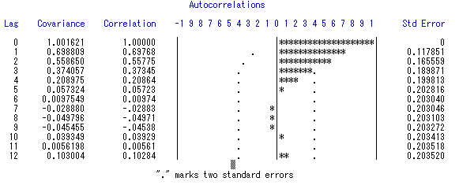

| **Autocorrelation Check for White Noise** | | | | | | | | | |
| --- | --- | --- | --- | --- | --- | --- | --- | --- | --- |
| **To Lag** | **Chi-Square** | **DF** | **Pr > ChiSq** | **Autocorrelations** | | | | | |
| **6** | 74.65 | 6 | <.0001 | 0.698 | 0.558 | 0.373 | 0.209 | 0.057 | 0.010 |
| **12** | 76.18 | 12 | <.0001 | -0.029 | -0.050 | -0.045 | 0.039 | 0.006 | 0.103 |

从自相关图和白噪声检验可以看出，该标准残差序列是存在序列相关的。

(d)

**proc** **univariate** data=out normal;

var sresiduals;

histogram sresiduals/normal;

qqplot sresiduals/normal(mu=**0** sigma=**1.00783328** color=red l=**1** w=**2**);

**run**;

运行的结果：

UNIVARIATE PROCEDURE

变量: sresiduals (Studentized Residual)

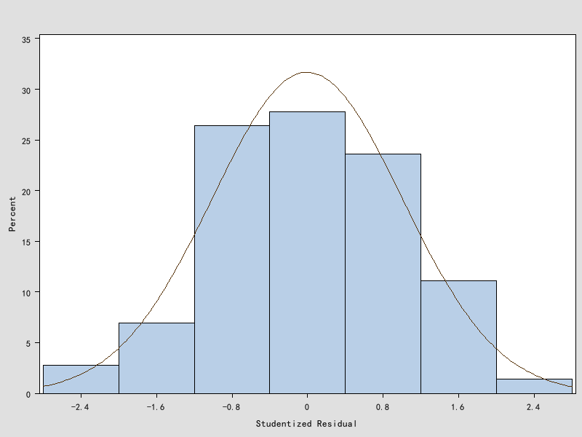

UNIVARIATE PROCEDURE

“sresiduals”的拟合正态分布

| **“正态”分布的参数** | | |
| --- | --- | --- |
| **参数** | **符号** | **估计值** |
| **均值** | Mu | -0.00348 |
| **标准差** | Sigma | 1.007833 |

| **“正态”分布的拟合优度检验** | | | | |
| --- | --- | --- | --- | --- |
| **检验** | **统计量** | | **P 值** | |
| **Kolmogorov-Smirnov** | **D** | 0.06731237 | **Pr > D** | >0.150 |
| **Cramer-von Mises** | **W-Sq** | 0.04331143 | **Pr > W-Sq** | >0.250 |
| **Anderson-Darling** | **A-Sq** | 0.30785384 | **Pr > A-Sq** | >0.250 |

三个正态性检验统计量的P值都>0.05，不能拒绝正态性零假设，认为标准残差是服从正态分布的。

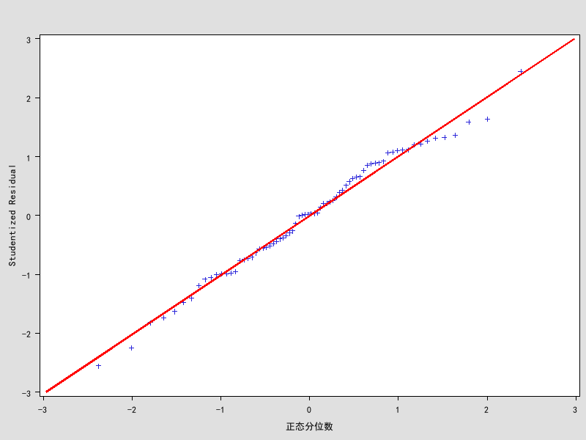

从上面的QQ图来看，大部分点都在一条直线上面，表明标准残差服从正态分布

3.15解：

(a)

**data** xiti3_15;

infile "E:\W学习文件\金融时间序列\应用时间序列\Data_CC\prescrip.dat" firstobs=**2** ;

input prescrip;

time=intnx('month',**'01Aug1986'd**,_n_-**1**);

format time ddmmyy10.;

season=month(time);

t=_n_;

**run**;

**data** wu;

set xiti3_15;

perprescrip=**100**\*(prescrip-lag(prescrip))/lag(prescrip); /*月度变化率*/

**run**;

**data** wu;

set wu;

x1=cos(**2**\***3.14159**\*t/**12**);

x2=sin(**2**\***3.14159**\*t/**12**);

**run**;

**proc** **reg** data=wu;

model perprescrip=x1 x2/R ;

output out=out r=residuals p=predicted student=sresiduals;

**run**;

运行的结果：

| **Analysis of Variance** | | | | | |
| --- | --- | --- | --- | --- | --- |
| **Source** | **DF** | **Sum of Squares** | **Mean Square** | **F Value** | **Pr > F** |
| **Model** | 2 | 105.82697 | 52.91348 | 14.70 | <.0001 |
| **Error** | 64 | 230.38647 | 3.59979 |  |  |
| **Corrected Total** | 66 | 336.21343 |  |  |  |

|  |  |  |  |
| --- | --- | --- | --- |
| **Root MSE** | 1.89731 | **R-Square** | 0.3148 |
| **Dependent Mean** | 1.14395 | **Adj R-Sq** | 0.2933 |
| **Coeff Var** | 165.85556 |  |  |

| **Parameter Estimates** | | | | | |
| --- | --- | --- | --- | --- | --- |
| **Variable** | **DF** | **Parameter Estimate** | **Standard Error** | **t Value** | **Pr > |t|** |
| **Intercept** | **1** | 1.22171 | 0.23253 | 5.25 | <.0001 |
| **x1** | **1** | 0.65373 | 0.32985 | 1.98 | 0.0518 |
| **x2** | **1** | -1.65965 | 0.32688 | -5.08 | <.0001 |

(b)

标准残差的游程检验

**data** runcount;

keep runs n1 n2 n;

set out nobs=nobs end=last;

retain runs **0** n1 **0**;

prevpos=(lag(sresiduals) GE **0**);

currpos=(sresiduals GE **0** );

if currpos and prevpos then n1+**1**;

else if currpos and ^prevpos then do;

runs+**1**;

n1+**1**;

end;

else if ^currpos and prevpos then runs+**1**;

if last then do;

n2=nobs-n1;

n=nobs;

output;

end;

**run**;

**data** waldwolf;

label z='Wald-Wolfowitz Z' pvalue='Pr > |Z|';

set runcount;

mu =(**2**\*n1*n2)/(n1+n2)+ **1**;

sigmasq=((**2**\*n1*n2)*(**2**\*n1*n2-n))/ ((n\*\***2**)*(n-**1**));

sigma=sqrt(sigmasq);

drop sigmasq;

if n GE **50** then Z=(runs - mu)/sigma;

else if runs-mu LT **0** then Z = (runs-mu+**0.5**)/sigma;

else Z = (runs-mu-**0.5**)/sigma;

pvalue=**2**\*(**1**-probnorm(abs(Z)));

**run**;

title 'Runs test for independence';

title2 'H0: The data are independence';

**proc** **print** data=waldwolf label noobs;

var runs mu z pvalue;

format pvalue pvalue.;

**run**;

|  |
| --- |
| Runs test for independence |
| H0: The data are independence |

| **runs** | **mu** | **Wald-Wolfowitz Z** | **Pr > |Z|** |
| --- | --- | --- | --- |
| 47 | 34.9706 | 2.94216 | 0.0033 |

检验的结果p值<0.05,因此我们拒绝零假设，认为该标准残差序列是不独立的。

(c)

**proc** **arima** data=out;

identify var=sresiduals nlag=**12**;

**run**;

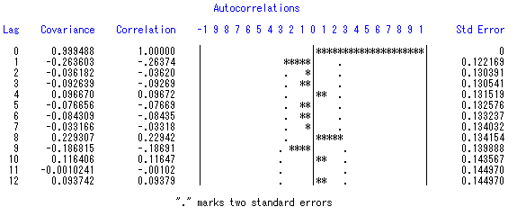

| **Autocorrelation Check for White Noise** | | | | | | | | | |
| --- | --- | --- | --- | --- | --- | --- | --- | --- | --- |
| **To Lag** | **Chi-Square** | **DF** | **Pr > ChiSq** | **Autocorrelations** | | | | | |
| **6** | 7.25 | 6 | 0.2983 | -0.264 | -0.036 | -0.093 | 0.097 | -0.077 | -0.084 |
| **12** | 16.08 | 12 | 0.1874 | -0.033 | 0.229 | -0.187 | 0.116 | -0.001 | 0.094 |

从自相关图和白噪声检验可以看出，该标准残差序列是不存在序列相关了。

(d)

**proc** **univariate** data=out normal;

var sresiduals;

histogram sresiduals/normal;

qqplot sresiduals/normal(mu=-**0.00003** sigma=**1.007289** color=red l=**1** w=**2**);

**run**;

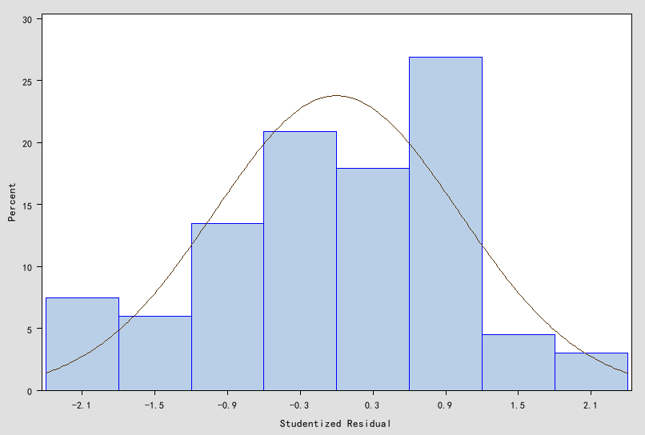

UNIVARIATE PROCEDURE

“sresiduals”的拟合正态分布

| **“正态”分布的参数** | | |
| --- | --- | --- |
| **参数** | **符号** | **估计值** |
| **均值** | Mu | -0.00003 |
| **标准差** | Sigma | 1.007289 |

| **“正态”分布的拟合优度检验** | | | | |
| --- | --- | --- | --- | --- |
| **检验** | **统计量** | | **P 值** | |
| **Kolmogorov-Smirnov** | **D** | 0.07723820 | **Pr > D** | >0.150 |
| **Cramer-von Mises** | **W-Sq** | 0.05210164 | **Pr > W-Sq** | >0.250 |
| **Anderson-Darling** | **A-Sq** | 0.33463718 | **Pr > A-Sq** | >0.250 |

三个正态性检验统计量的P值都>0.05，不能拒绝正态性零假设，认为标准残差是服从正态分布的。

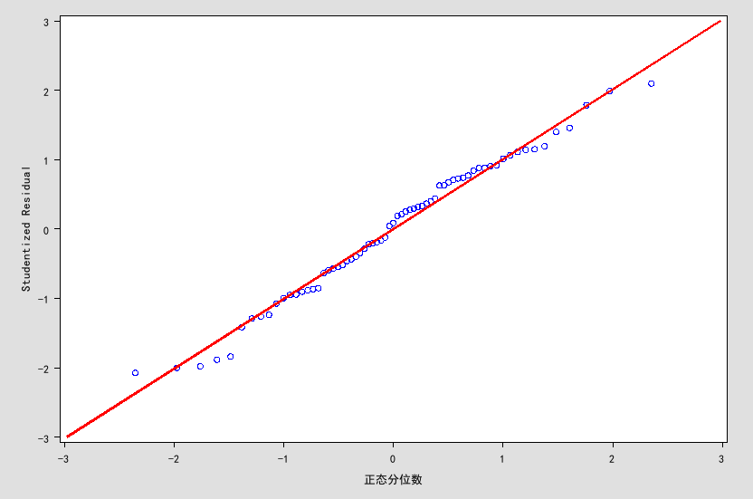

从上面的QQ图来看，大部分点都在一条直线上面，表明标准残差服从正态分布

3.16解：

(a)证明：

因为



由书上方程(3.2.3)



(b)证明：

如果n很大的时候，

所以 

(c)

**data** wo;

do i=-**0.99** to **0.99** by **0.1**;

t=i;

y=(**1**+t)/(**1**-t);

output;

end;

**run**;

title "模拟图";

**proc** **gplot** data=wo;

plot y*t=**1**;

symbol1 c=red I=spline v=circle h=**1.5**;

**run**;

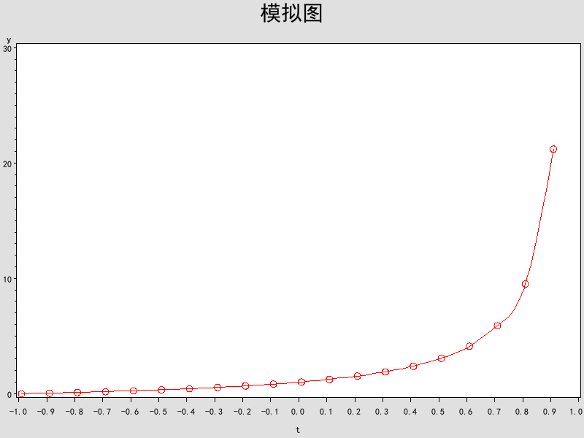

结论：当，均值的方差估计的结果比较好。当，均值的方差估计的结果就不是很好，而且当时，结果就更差

4.9解：

(a)  

**data** xiti4_9a;

phi1=**0.6**;

phi2=**0.3**;

max_lag=**20**;

rho1=phi1/(**1**-phi2);

rho2=(phi2*(**1**-phi2)+phi1\*\***2**)/(**1**-phi2);

array rho(**20**);

rho(**1**)=rho1;

rho(**2**)=rho2;

do i=**1** to max_lag ;

if i<**3** then w=rho(i);

else

rho(i)=phi1*rho(i-**1**)+phi2*rho(i-**2**);

wrho=rho(i);

output;

end;

**run**;

title "AR(2)的ACF";

**proc** **gplot** data=xiti4_9a;

plot wrho*i /vaxis=-**1** to **1** by **0.1**;

symbol c=red i=needle v=star h=**1.5** ;

**run**;

运行的结果：

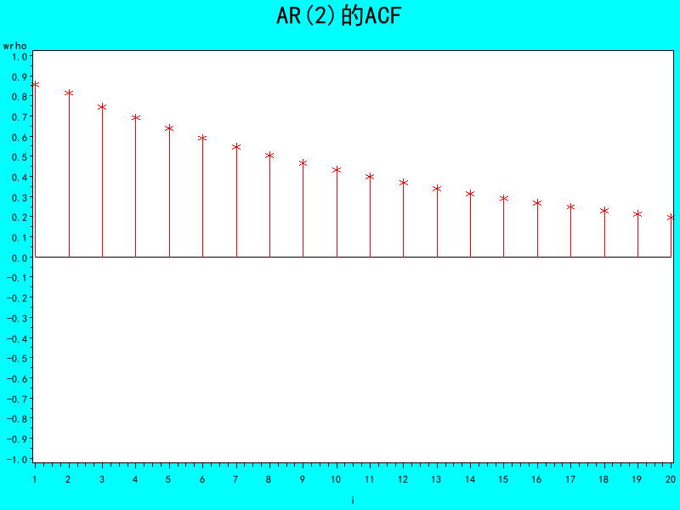

利用matlab求的特征根

>> solve('1-0.6*x-0.3*x^2=0')

ans =

-3.0816659994661327352822977069799

1.0816659994661327352822977069799

两个根都是实数，而且一个接近1，所以自相关系数衰减的速度比较慢。

(b)  

利用第一问的程序得到ACF图

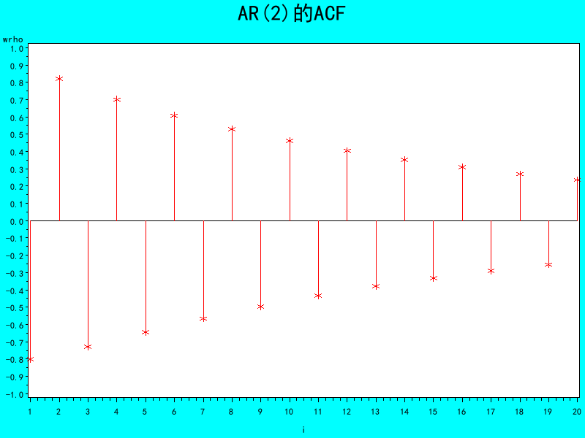

利用matlab求的特征根

>> solve('1+0.4*x-0.5*x^2=0')

ans =

-1.0696938456699068589183704448235

1.8696938456699068589183704448235

两个根都是实数，而且滞后两阶的自相关值(0.85)大于一阶值(0.8)。

(c)  

利用第一问的程序得到ACF图

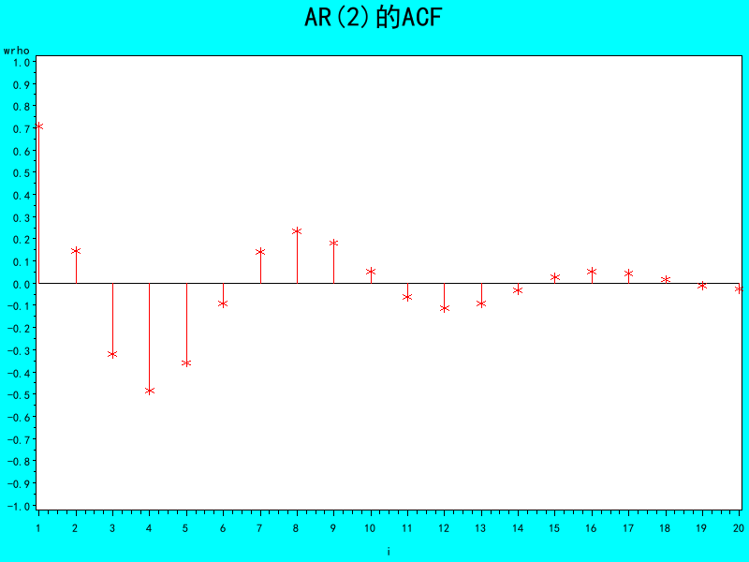

利用matlab求的特征根

>> solve('1-1.2*x+0.7*x^2=0')

ans =

0.85714285714285714285714285714286 - 0.8329931278350429244105932682208*i

0.8329931278350429244105932682208*i + 0.85714285714285714285714285714286

两个根都是复数，

>> R=sqrt(-(-0.7)) %阻尼因子

R =

0.8367

>> Ferq=acos(1.2/(2*R)) %频率

Ferq =

0.7711

>> Phase=atan((1-(-0.7))/(1-0.7)) %相位

Phase =

1.3961

(d)  

利用第一问的程序得到ACF图

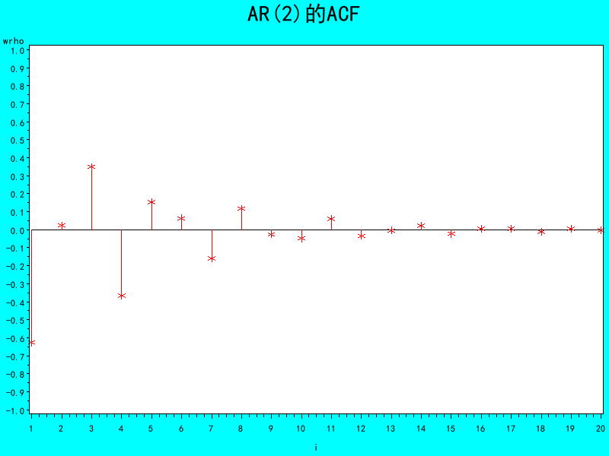

利用matlab求的特征根

>> solve('1+x+0.6*x^2=0')

ans =

0.9860132971832693404278880485936*i - 0.83333333333333333333333333333333

- 0.9860132971832693404278880485936*i - 0.83333333333333333333333333333333

两个根都是复数

>> R=sqrt(-(-0.6)) %阻尼因子

R =

0.7746

>> Ferq=acos(-1/(2*R)) %频率

Ferq =

2.2725

>> Phase=atan((1-(-0.6))/(1-0.6)) %相位

Phase =

1.3258

(e)  

利用第一问的程序得到ACF图

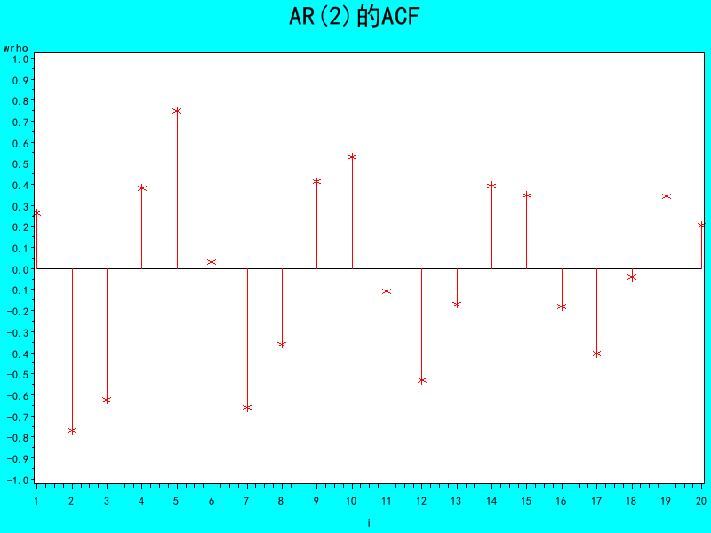

利用matlab求的特征根

>> solve('1-0.5*x+0.9*x^2=0')

ans =

0.27777777777777777777777777777778 - 1.0168336232068403712891227231227*i

1.0168336232068403712891227231227*i + 0.27777777777777777777777777777778

两个根都是复数

>> R=sqrt(-(-0.9)) %阻尼因子

R =

0.9487

>> Ferq=acos(0.5/(2*R)) %频率

Ferq =

1.3041

>> Phase=atan((1-(-0.9))/(1-0.9)) %相位

Phase =

1.5182

(f)  

利用第一问的程序得到ACF图

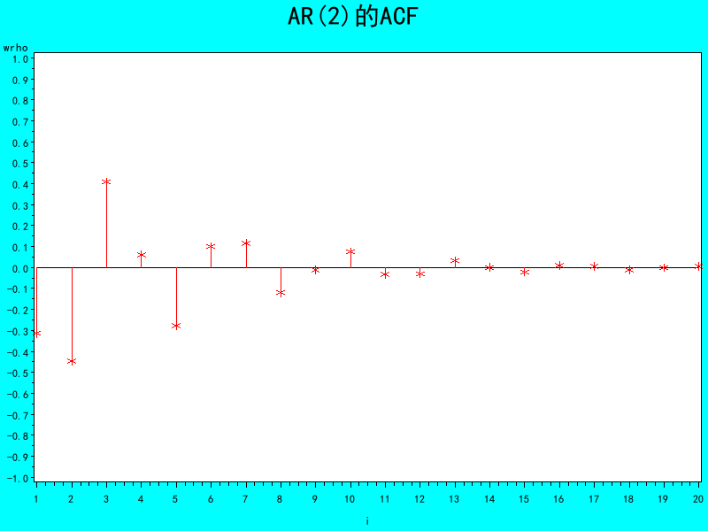

利用matlab求的特征根

>> solve('1+0.5*x+0.6*x^2=0')

ans =

- 1.2219065248845983454185409205812*i - 0.41666666666666666666666666666667

1.2219065248845983454185409205812*i - 0.41666666666666666666666666666667

两个根都是复数

>> R=sqrt(-(-0.6)) %阻尼因子

R =

0.7746

>> Ferq=acos(-0.5/(2*R)) %频率

Ferq =

1.8994

>> Phase=atan((1-(-0.6))/(1-0.6)) %相位

Phase =

1.3258

4.14解：

根据书4-1的图所示，存在在选定的使得 

令： 

所以 

 

假定是正态过程，则也是正态过程

因为  k>0

所以和不相关

因此存在白噪声序列使得，其中满足条件，k>0时，和不相关

4.22解：

若G是方程的根，且

所以





因此是方程的根

即

4.24解：

(a)

证明，利用数学归纳法

1) 

2) 

3) 假设t=k也成立  

则当t=k+1时，

综上所述，当t=k+1时，

所以对任意的t，

(b)

为了不失一般性，我们假设

所以  

因为   

所以 



由于AR(2)模型它的的一阶自相关函数为

所以 

(c)

利用(b)问的假设

我们构造一个变换

 代表期望的方差，代表期望的均值

这个变换就能满足想要的均值和方差

因为



因此上面那个变换满足题目要求。

4.25解：

(a)证明：

当t>0时



(b)

当t>0时



(c)

当t>0时

因为

所以若 



若



(d)

假设

利用反证法：若 则

所以



与t有关，这跟平稳矛盾，所以平稳时，

(e)

假设 平稳

所以

对两边取方差 









此时 所以