InvestTalent-AI CV parsing & Scoring Algorithm

Software Design Document

Version <2.0>
11/15/2025

Document Details

Approvals
The Supervisor and the Client shall approve this document.

Document Change Control

Initial Release: | 13th November 2025
Current Release: | 13th November 2025
Date of Last Review: | 13th November 2025
Date of Next Review: | 14th November 2025
Target Date for Next Update:

Distribution List
This following list of people shall receive a copy of this document every time a new version of this document becomes available:
Customer : Arcapita Investment Holdings(virtual client) / Dr. Faheem Khuhawar (Academic Supervisor)
Team Members:
Maryam Budawas(Project Manager/Supervisor)
Faheem Khuhawar (Academic Supervisor)

Change Summary
The following table details changes made between versions of this document

Version | Date | Modifier | Description
1.0 | November 13, 2025 | Maryam Budawas | Initial release - Database design and system architecture
2.0 | November 15th 2025 | Maryam Budawas | Finalizing everything

Table of Contents
Document Details 2
Introduction 4
References 4
Database Design 4
Enhanced Relational Database Diagram 4
Tables and Views Structure 4
Database Code 4
Software Design 5
Use Case Narratives 5
Activity Diagrams 5
Sequence Diagrams 5
Deployment Diagram 5
Graphical User Interface Design 6
GUI Hierarchy 6
Output Interfaces 6
Input interfaces 6

No table of figures entries found.

Introduction

This Software Design Document provides comprehensive technical specifications for the InvestTalent-AI recruitment automation system developed for Arcapita Investment Holdings. This document details the database architecture, software design decisions, and user interface specifications necessary to implement an AI-powered candidate screening and evaluation platform.

Project Overview: InvestTalent-AI is a web-based recruitment automation system that leverages artificial intelligence and natural language processing to streamline the candidate evaluation process for investment professional roles requiring Islamic finance expertise. The system automates resume parsing, candidate scoring, and ranking based on technical competence, transaction experience, and specialized knowledge.

Document Purpose: This document serves as the authoritative technical reference for system implementation, providing detailed specifications for database structure, software architecture, and user interface design. It is intended for:
- Development team (primary implementer)
- Academic supervisor (technical reviewer)
- Virtual client representative (requirements validator)
- Future maintainers and system administrators

Document Scope: This document covers:
- Database design including Enhanced Entity-Relationship Diagram (EERD)
- Table structures and relationships
- Database implementation code (SQL)
- Software architecture and component design
- User interface specifications and wireframes

Document Organization:
Section 2: Database Design - Data structure, ERD, table specifications, and SQL code
Section 3: Software Design - System architecture, use cases, and component interactions
Section 4: GUI Design - User interface hierarchy, input/output interfaces, and wireframes

References
- Django Software Foundation. (2025). Django documentation (Version 5.1). https://docs.djangoproject.com/
- Kopparapu, S. K. (2010). Automatic extraction of usable information from unstructured resumes to aid search. Proceedings of the 2010 IEEE International Conference on Data Mining Workshops, 1-7. https://doi.org/10.1109/ICDMW.2010.10
- PostgreSQL Global Development Group. (2025). PostgreSQL 16 documentation. https://www.postgresql.org/docs/16/
- Project Management Institute. (2021). A guide to the project management body of knowledge (PMBOK guide) (7th ed.). Project Management Institute.
- Schwalbe, K. (2021). Information technology project management (9th ed.). Cengage Learning.

Database Design

This section focuses on creating a static data structure that supports the InvestTalent-AI recruitment automation system. The database architecture is designed to efficiently store candidate information, parsed resume data, evaluation scores, and support AI-powered ranking functionality.

Enhanced Relational Database Diagram
The Enhanced Entity-Relationship Diagram illustrates the database schema for the InvestTalent-AI system, showing six interconnected entities that form the foundation of the recruitment automation platform.
Database Overview:
The database architecture follows a candidate-centric model where all entities relate to the central Candidate table. The design supports:
- One-to-one relationships for unique candidate attributes (Resume, Score)
- One-to-many relationships for multiple records per candidate (Education, Experience, Skills)
- Third Normal Form (3NF) compliance to eliminate data redundancy
- Referential integrity through foreign key constraints

Entity Relationship Diagram:
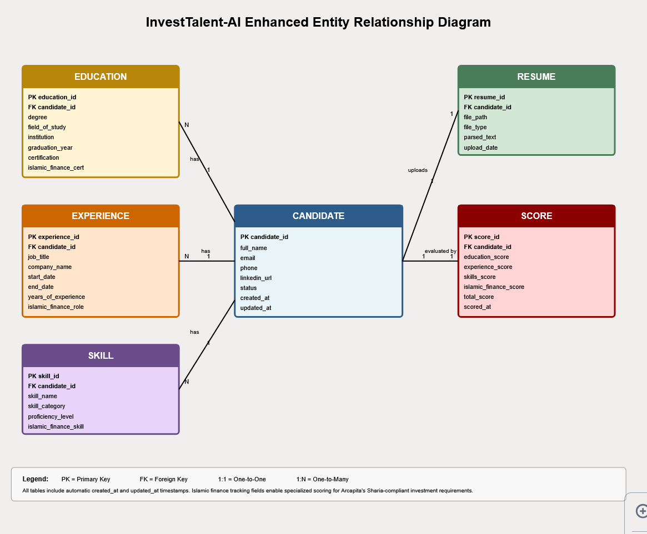
Figure 1: InvestTalent-AI Enhanced Entity-Relationship Diagram showing six entities with their relationships and cardinality.

Tables and Views Structure
This section describes the design decisions, structure, and purpose of each database table in the InvestTalent-AI system.

Table 1: Candidate
Purpose: Central entity storing core candidate information and application status.
Design Rationale:
- Primary table that all other tables reference through foreign keys
- Stores basic contact information and professional summary
- Includes status field for tracking candidates through recruitment workflow
- Email field has UNIQUE constraint to prevent duplicate applications
- Timestamps (created_at, updated_at) enable audit trail and sorting

Table Structure:
Column Name | Data Type | Constraints | Purpose
id | INTEGER | PRIMARY KEY, AUTO_INCREMENT | Unique identifier
name | VARCHAR(200) | NOT NULL | Candidate full name
email | VARCHAR(255) | NOT NULL, UNIQUE | Contact email (unique per candidate)
phone | VARCHAR(20) | NULL | Contact phone number
current_position | VARCHAR(200) | NULL | Current job title
years_experience | INTEGER | NOT NULL, DEFAULT 0 | Total years of professional experience
linkedin_url | VARCHAR(500) | NULL | LinkedIn profile link
status | VARCHAR(50) | NOT NULL, DEFAULT 'received' | Current recruitment stage
created_at | DATETIME | NOT NULL, AUTO | Record creation timestamp
updated_at | DATETIME | NOT NULL, AUTO | Last modification timestamp

Status Field Values:
- received - Application submitted
- screening - Under review by system/HR
- shortlisted - Passed initial screening
- interview - Interview scheduled
- offer - Offer extended
- hired - Successfully hired
- rejected - Application rejected

Table 2: Resume
Purpose: Stores uploaded CV files and extracted text content for processing.
Design Rationale:
- One-to-one relationship with Candidate (each candidate has exactly one resume)
- Stores file path for document retrieval
- parsed_text field stores extracted content from PDF/Word files
- file_type tracks document format for appropriate parsing

Table Structure:
Column Name | Data Type | Constraints | Purpose
id | INTEGER | PRIMARY KEY, AUTO_INCREMENT | Unique identifier
candidate_id | INTEGER | FOREIGN KEY (Candidate.id), NOT NULL | Links to candidate
file | VARCHAR(500) | NOT NULL | File path/storage location
file_type | VARCHAR(10) | NOT NULL | Document format (pdf, docx)
parsed_text | TEXT | NULL | Extracted text content from CV
uploaded_at | DATETIME | NOT NULL, AUTO | Upload timestamp

Foreign Key Constraint:
FOREIGN KEY (candidate_id) REFERENCES Candidate(id) ON DELETE CASCADE
When candidate deleted, their resume is automatically deleted

Table 3: Education
Purpose: Stores candidate educational qualifications and Islamic finance certifications.
Design Rationale:
- One-to-many relationship (candidate can have multiple degrees)
- Tracks formal education and specialized certifications
- has_islamic_finance_cert flag enables quick filtering for Islamic finance expertise
- Ordered by graduation_year (most recent first) for display
Table Structure:
Column Name | Data Type | Constraints | Purpose
id | INTEGER | PRIMARY KEY, AUTO_INCREMENT | Unique identifier
candidate_id | INTEGER | FOREIGN KEY (Candidate.id), NOT NULL | Links to candidate
degree | VARCHAR(100) | NOT NULL | Degree name (e.g., MBA, BBA)
institution | VARCHAR(200) | NOT NULL | University/institution name
field_of_study | VARCHAR(100) | NOT NULL | Major/specialization
graduation_year | INTEGER | NULL | Year graduated
has_islamic_finance_cert | BOOLEAN | NOT NULL, DEFAULT FALSE | Islamic finance certification flag
certification_names | TEXT | NULL | Names of certifications (CIFE, AAOIFI, etc.)

Design Note: The has_islamic_finance_cert boolean enables fast queries for candidates with Islamic finance qualifications, critical for Arcapita's requirements.

Table 4: Experience
Purpose: Stores candidate work history and Islamic finance experience.
Design Rationale:
- One-to-many relationship (candidate can have multiple jobs)
- Tracks company, position, and duration of employment
- is_islamic_finance flag identifies relevant industry experience
- is_current flag distinguishes current vs. past positions
- Ordered by start_date (most recent first)

Table Structure:
Column Name | Data Type | Constraints | Purpose
id | INTEGER | PRIMARY KEY, AUTO_INCREMENT | Unique identifier
candidate_id | INTEGER | FOREIGN KEY (Candidate.id), NOT NULL | Links to candidate
company | VARCHAR(200) | NOT NULL | Company name
position | VARCHAR(200) | NOT NULL | Job title
start_date | DATE | NOT NULL | Employment start date
end_date | DATE | NULL | Employment end date (NULL if current)
is_current | BOOLEAN | NOT NULL, DEFAULT FALSE | Currently employed flag
description | TEXT | NULL | Job responsibilities description
is_islamic_finance | BOOLEAN | NOT NULL, DEFAULT FALSE | Islamic finance role flag
Design Note: The is_islamic_finance field is critical for scoring candidates based on relevant industry experience in Islamic financial institutions.

Table 5: Skill
Purpose: Stores candidate technical and professional skills with proficiency levels.
Design Rationale:
- One-to-many relationship (candidate can have many skills)
- Categorizes skills by type (technical, finance, Islamic finance, soft skills, languages)
- Proficiency levels enable nuanced skill assessment
- Enables filtering and searching by skill categories

Table Structure:
Column Name | Data Type | Constraints | Purpose
id | INTEGER | PRIMARY KEY, AUTO_INCREMENT | Unique identifier
candidate_id | INTEGER | FOREIGN KEY (Candidate.id), NOT NULL | Links to candidate
skill_name | VARCHAR(100) | NOT NULL | Skill name
proficiency_level | VARCHAR(20) | NOT NULL, DEFAULT 'intermediate' | Skill level
category | VARCHAR(20) | NOT NULL, DEFAULT 'technical' | Skill category

Proficiency Levels:
- beginner - Basic knowledge
- intermediate - Working knowledge
- advanced - Strong proficiency
- expert - Master-level expertise

Skill Categories:
- technical - Programming, tools, software
- finance - Financial analysis, modeling
- islamic_finance - Sukuk, Murabaha, Sharia compliance
- soft_skill - Communication, leadership
- language - English, Arabic, etc.

Table 6: Score
Purpose: Stores AI-generated evaluation scores and candidate rankings.
Design Rationale:
- One-to-one relationship with Candidate (one score record per candidate)
- Breaks down scoring into components for transparency
- total_score aggregates all component scores
- rank field enables sorted candidate list display
- Allows algorithm refinement by adjusting component weights
Table Structure:
Column Name | Data Type | Constraints | Purpose
id | INTEGER | PRIMARY KEY, AUTO_INCREMENT | Unique identifier
candidate_id | INTEGER | FOREIGN KEY (Candidate.id), NOT NULL | Links to candidate
education_score | FLOAT | NOT NULL, DEFAULT 0.0, CHECK (0-100) | Education evaluation (0-100)
experience_score | FLOAT | NOT NULL, DEFAULT 0.0, CHECK (0-100) | Experience evaluation (0-100)
skills_score | FLOAT | NOT NULL, DEFAULT 0.0, CHECK (0-100) | Skills evaluation (0-100)
islamic_finance_score | FLOAT | NOT NULL, DEFAULT 0.0, CHECK (0-100) | Islamic finance expertise (0-100)
total_score | FLOAT | NOT NULL, DEFAULT 0.0, CHECK (0-100) | Overall score (0-100)
rank | INTEGER | NULL | Candidate ranking (1 = best)
evaluated_at | DATETIME | NOT NULL, AUTO | Scoring timestamp
Scoring Algorithm (Weighted):
total_score = (education_score × 0.25) +
(experience_score × 0.30) +
(skills_score × 0.25) +
(islamic_finance_score × 0.20)

Design Note: Component scores enable detailed analysis of candidate strengths/weaknesses and allow algorithm tuning based on Arcapita's priorities.

Database Relationships Summary:
One-to-One Relationships:
- Candidate ↔ Resume (each candidate has one resume)
- Candidate ↔ Score (each candidate has one score)
One-to-Many Relationships:
- Candidate → Education (candidate can have multiple degrees)
- Candidate → Experience (candidate can have multiple jobs)
- Candidate → Skill (candidate can have multiple skills)
Referential Integrity: All foreign keys use ON DELETE CASCADE to maintain data consistency - when a candidate is deleted, all related records are automatically removed.

Database Code
This section includes the Django ORM implementation code that generates the PostgreSQL database schema. Django's ORM automatically handles SQL generation, migrations, and database operations while maintaining the relationships and constraints defined in the ERD.
Implementation Framework
Technology Stack:
- Database Management System: PostgreSQL 18
- ORM Framework: Django 5.1
- Programming Language: Python 3.11
- Database Name: investtalent_db
- Character Encoding: UTF-8

Django Models Implementation:
The following Django models define the complete database structure. Each model class represents a database table, with class attributes mapping to table columns.

Model 1: Candidate
from django.db import models

class Candidate(models.Model):
STATUS_CHOICES = [
('received', 'Application Received'),
('screening', 'Under Screening'),
('shortlisted', 'Shortlisted'),
('interview', 'Interview Scheduled'),
('offer', 'Offer Extended'),
('hired', 'Hired'),
('rejected', 'Rejected'),
]

first_name = models.CharField(max_length=100)
last_name = models.CharField(max_length=100)
email = models.EmailField(unique=True)
phone = models.CharField(max_length=20, blank=True, null=True)
linkedin_url = models.URLField(blank=True, null=True)
professional_summary = models.TextField(blank=True, null=True)
status = models.CharField(max_length=20, choices=STATUS_CHOICES, default='received')
created_at = models.DateTimeField(auto_now_add=True)
updated_at = models.DateTimeField(auto_now=True)

class Meta:
db_table = 'candidate'
ordering = ['-created_at']

def __str__(self):
return f"{self.first_name} {self.last_name}"

Design Notes: The unique constraint on email prevents duplicate applications. STATUS_CHOICES enforces valid status values. Timestamps automatically track record creation and modification.
Model 2: Resume
class Resume(models.Model):
candidate = models.OneToOneField(Candidate, on_delete=models.CASCADE, related_name='resume')
file_path = models.FileField(upload_to='resumes/%Y/%m/')
file_type = models.CharField(max_length=10)
parsed_text = models.TextField()
uploaded_at = models.DateTimeField(auto_now_add=True)

class Meta:
db_table = 'resume'

def __str__(self):
return f"Resume for {self.candidate}"

Design Notes: OneToOneField ensures each candidate has exactly one resume. The on_delete=CASCADE removes the resume when the candidate is deleted. The parsed_text field stores extracted content for AI processing.
Model 3: Education
class Education(models.Model):
candidate = models.ForeignKey(Candidate, on_delete=models.CASCADE, related_name='educations')
degree = models.CharField(max_length=100)
field_of_study = models.CharField(max_length=100)
institution = models.CharField(max_length=200)
graduation_year = models.IntegerField()
has_islamic_finance_cert = models.BooleanField(default=False)

class Meta:
db_table = 'education'
ordering = ['-graduation_year']
verbose_name_plural = 'Education Records'

def __str__(self):
return f"{self.degree} in {self.field_of_study}"
Design Notes: ForeignKey allows multiple education records per candidate. The has_islamic_finance_cert flag enables quick filtering for Islamic finance expertise required by Arcapita.

Model 4: Experience
class Experience(models.Model):
candidate = models.ForeignKey(Candidate, on_delete=models.CASCADE, related_name='experiences')
company = models.CharField(max_length=200)
position = models.CharField(max_length=100)
start_date = models.DateField()
end_date = models.DateField(blank=True, null=True)
is_current = models.BooleanField(default=False)
description = models.TextField(blank=True, null=True)
is_islamic_finance = models.BooleanField(default=False)

class Meta:
db_table = 'experience'
ordering = ['-start_date']
verbose_name_plural = 'Experience Records'

def __str__(self):
return f"{self.position} at {self.company}"
Design Notes: The end_date can be null for current positions. The is_islamic_finance flag is critical for scoring candidates based on relevant industry experience.

Model 5: Skill
class Skill(models.Model):
PROFICIENCY_CHOICES = [
('beginner', 'Beginner'),
('intermediate', 'Intermediate'),
('advanced', 'Advanced'),
('expert', 'Expert'),
]

CATEGORY_CHOICES = [
('technical', 'Technical'),
('finance', 'Finance'),
('islamic_finance', 'Islamic Finance'),
('soft_skill', 'Soft Skill'),
('language', 'Language'),
]

candidate = models.ForeignKey(Candidate, on_delete=models.CASCADE, related_name='skills')
skill_name = models.CharField(max_length=100)
category = models.CharField(max_length=20, choices=CATEGORY_CHOICES)
proficiency_level = models.CharField(max_length=20, choices=PROFICIENCY_CHOICES)

class Meta:
db_table = 'skill'
unique_together = ['candidate', 'skill_name']
ordering = ['category', '-proficiency_level']

def __str__(self):
return f"{self.skill_name} ({self.proficiency_level})"
Design Notes: The unique_together constraint prevents duplicate skills for the same candidate. Categories enable filtering and analysis by skill type. Proficiency levels allow nuanced skill assessment.

Model 6: Score
class Score(models.Model):
candidate = models.OneToOneField(Candidate, on_delete=models.CASCADE, related_name='score')
resume = models.ForeignKey('Resume', on_delete=models.CASCADE, related_name='scores')
education_score = models.DecimalField(max_digits=5, decimal_places=2)
experience_score = models.DecimalField(max_digits=5, decimal_places=2)
skills_score = models.DecimalField(max_digits=5, decimal_places=2)
islamic_finance_score = models.DecimalField(max_digits=5, decimal_places=2)
total_score = models.DecimalField(max_digits=5, decimal_places=2)
rank = models.IntegerField(blank=True, null=True)
scored_at = models.DateTimeField(auto_now_add=True)

class Meta:
db_table = 'score'
ordering = ['-total_score']

def save(self, *args, **kwargs):
self.total_score = (
(self.education_score * 0.25) +
(self.experience_score * 0.30) +
(self.skills_score * 0.25) +
(self.islamic_finance_score * 0.20)
)
super().save(*args, **kwargs)

def __str__(self):
return f"Score for {self.candidate}: {self.total_score}"

Design Notes: Component scores enable detailed analysis of candidate strengths. The save method automatically calculates weighted total score using the formula: Education (25%), Experience (30%), Skills (25%), Islamic Finance (20%).
Database Migrations
Django generates SQL migrations automatically from these models. To create the database schema:
python manage.py makemigrations
python manage.py migrate

Generated SQL Example
Django automatically generates PostgreSQL CREATE TABLE statements. Example for the Candidate table:
CREATE TABLE "candidate" (
"id" bigserial NOT NULL PRIMARY KEY,
"first_name" varchar(100) NOT NULL,
"last_name" varchar(100) NOT NULL,
"email" varchar(254) NOT NULL UNIQUE,
"phone" varchar(20),
"linkedin_url" varchar(200),
"professional_summary" text,
"status" varchar(20) NOT NULL,
"created_at" timestamp with time zone NOT NULL,
"updated_at" timestamp with time zone NOT NULL
);

CREATE INDEX "candidate_email_idx" ON "candidate" ("email");
CREATE INDEX "candidate_status_idx" ON "candidate" ("status");

Foreign key constraints are automatically generated for all relationships with ON DELETE CASCADE to maintain referential integrity.
Summary
The Django ORM implementation provides type safety, automatic migrations, referential integrity enforcement, and protection against SQL injection. The complete models are contained in the recruitment/models.py file and are ready for implementation.

Software Design

This section includes software and programming design decisions using standard Unified Modeling Language (UML)

Use Case Narratives
For InvestTalent-AI, here are the 5 main use cases we documented:
The 5 Core Use Cases:
- Upload and Parse Resume - HR uploads CV, system extracts data
- Score Candidate - AI algorithm evaluates and scores candidate
- View Ranked Candidates - HR views sorted candidate list
- Review Candidate Details - HR examines individual candidate profile
- Update Candidate Status - HR moves candidate through recruitment stages

Use Case 1: Upload and Parse Resume
Use Case ID: UC-01
Use Case Name: Upload and Parse Resume
Primary Actor: HR Recruiter
Goal: Upload candidate resume and extract structured information automatically
Preconditions:
- HR user is logged into the system
- Candidate application exists in the system
Postconditions:
- Resume file is stored in the system
- Text is extracted and parsed
- Candidate record is populated with extracted information
Main Success Scenario:
- HR user navigates to candidate profile
- HR user clicks "Upload Resume" button
- System displays file upload dialog
- HR user selects PDF or Word document from computer
- System validates file type and size
- System uploads file to storage
- System extracts text from document using NLP parser
- System identifies and extracts: name, email, phone, education, experience, skills
- System populates candidate database fields with extracted information
- System displays "Resume uploaded successfully" message
- System shows parsed information for HR review
Alternative Flows:
- A1: Invalid file type - If file is not PDF/DOCX, system displays error message "Please upload PDF or Word document"
- A2: Parsing fails - If text extraction fails, system allows manual data entry
- A3: Duplicate email detected - System warns "Candidate with this email already exists"
Business Rules:
- Maximum file size: 5MB
- Supported formats: PDF, DOCX
- Email must be unique in system

Use Case 2: Score Candidate
Use Case ID: UC-02
Use Case Name: Score Candidate with AI Algorithm
Primary Actor: System (Automated Process)
Secondary Actor: HR Recruiter (triggers process)
Goal: Automatically evaluate candidate and generate composite score
Preconditions:
- Candidate record exists with parsed resume data
- Education, experience, and skills data populated
Postconditions:
- Candidate has component scores and total score
- Candidate is ranked among all candidates
- Score record is created in database
Main Success Scenario:
- System retrieves candidate data from database
- System calculates education score (0-100) based on:
  - Degree level (Bachelor's, Master's, PhD)
  - Relevant field of study
  - Institution reputation
  - Islamic finance certifications
- System calculates experience score (0-100) based on:
  - Total years of experience
  - Relevant industry experience
  - Islamic finance roles
  - Senior positions held
- System calculates skills score (0-100) based on:
  - Number of relevant technical skills
  - Proficiency levels
  - Finance-specific skills
  - Language capabilities
- System calculates Islamic finance score (0-100) based on:
  - Islamic finance certifications (CIFE, AAOIFI, IFQ)
  - Years in Islamic finance roles
  - Islamic finance skills identified
- System applies weighted formula: Total = (Education × 0.25) + (Experience × 0.30) + (Skills × 0.25) + (Islamic Finance × 0.20)
- System saves score components and total to database
- System recalculates rankings for all candidates
- System updates candidate rank field
- System displays updated score on candidate profile
Alternative Flows:
- A1: Insufficient data - If critical data missing, system assigns partial score with flag for manual review
- A2: Score update - If candidate data changes, system automatically recalculates scores
Business Rules:
- All component scores range from 0-100
- Total score cannot exceed 100
- Ranking: 1 = highest score
- Scores recalculated when candidate data updated

Use Case 3: View Ranked Candidates
Use Case ID: UC-03
Use Case Name: View Ranked Candidates Dashboard
Primary Actor: HR Recruiter
Goal: View sorted list of all candidates with scores and key information
Preconditions:
- HR user is logged into system
- At least one candidate has been scored
Postconditions:
- HR user views candidate rankings
- User can filter and search candidates
Main Success Scenario:
- HR user clicks "Dashboard" in main navigation
- System retrieves all scored candidates from database
- System displays candidates in table sorted by rank (highest score first)
- System shows for each candidate:
  - Rank number
  - Name
  - Email
  - Total score
  - Component scores (Education, Experience, Skills, Islamic Finance)
  - Current status
  - Application date
- HR user can sort by any column (name, score, date)
- HR user can filter by status (all, screening, shortlisted, interview)
- HR user can filter by score range (e.g., 80-100)
- HR user can search by name or email
- HR user clicks on candidate row to view full profile
Alternative Flows:
- A1: No candidates - System displays "No candidates found" message
- A2: Filter no results - System displays "No candidates match filters"
- A3: Export list - HR user can export filtered list to Excel
Business Rules:
- Default sort: by rank (descending)
- Pagination: 20 candidates per page
- Real-time updates when new candidates added

Use Case 4: Review Candidate Details
Use Case ID: UC-04
Use Case Name: Review Individual Candidate Profile
Primary Actor: HR Recruiter
Goal: View complete candidate information and make hiring decision
Preconditions:
- HR user is logged into system
- Candidate record exists with scores
Postconditions:
- HR user has reviewed candidate details
- User can take action (shortlist, reject, schedule interview)
Main Success Scenario:
- HR user clicks on candidate from dashboard
- System retrieves complete candidate record
- System displays candidate profile with sections:
  - Personal Information: Name, email, phone, LinkedIn
  - Professional Summary: Current position, years of experience
  - Scores: Total score, component breakdown with bar charts
  - Education: All degrees with institutions, years, certifications
  - Experience: Work history with companies, positions, dates, Islamic finance flags
  - Skills: All skills categorized by type with proficiency levels
  - Resume: Download link to original CV file
  - Application Status: Current stage and history
  - Timeline: Application received date, last updated
- HR user reviews all information
- HR user sees recommendation based on score (e.g., "Strong candidate - Recommend interview")
- System highlights Islamic finance qualifications
- HR user can download resume PDF
- HR user can add notes to candidate record
Alternative Flows:
- A1: Missing data - System shows "No data available" for incomplete sections
- A2: Resume not accessible - System displays error message
Business Rules:
- All candidate data visible to authorized HR users
- Score breakdown shown as percentages
- Islamic finance indicators highlighted in green

Use Case 5: Update Candidate Status
Use Case ID: UC-05
Use Case Name: Update Candidate Recruitment Status
Primary Actor: HR Recruiter
Goal: Move candidate through recruitment workflow stages
Preconditions:
- HR user is logged into system
- Candidate record exists
- User has permission to update status
Postconditions:
- Candidate status is updated
- Status change is logged with timestamp
- Candidate appears in correct filtered views
Main Success Scenario:
- HR user views candidate profile
- HR user clicks "Update Status" button
- System displays status dropdown with options:
  - Received
  - Screening
  - Shortlisted
  - Interview
  - Offer
  - Hired
  - Rejected
- HR user selects new status
- If status = "Rejected", system prompts for rejection reason
- If status = "Interview", system prompts for interview date/time
- HR user enters additional information (if required)
- HR user clicks "Save"
- System validates status transition is allowed
- System updates candidate status in database
- System records status change with timestamp and user
- System displays "Status updated successfully" message
- System updates dashboard view automatically
Alternative Flows:
- A1: Invalid transition - If moving from "Hired" back to "Screening", system displays error
- A2: Required fields missing - System shows "Please provide rejection reason"
- A3: Bulk status update - HR can select multiple candidates and update status together
Business Rules:
- Status transitions must follow workflow (cannot skip stages)
- Once "Hired" or "Rejected", cannot change back to earlier stages without admin approval
- All status changes logged for audit trail
- Email notifications sent to candidates on status change (optional)

Activity Diagrams
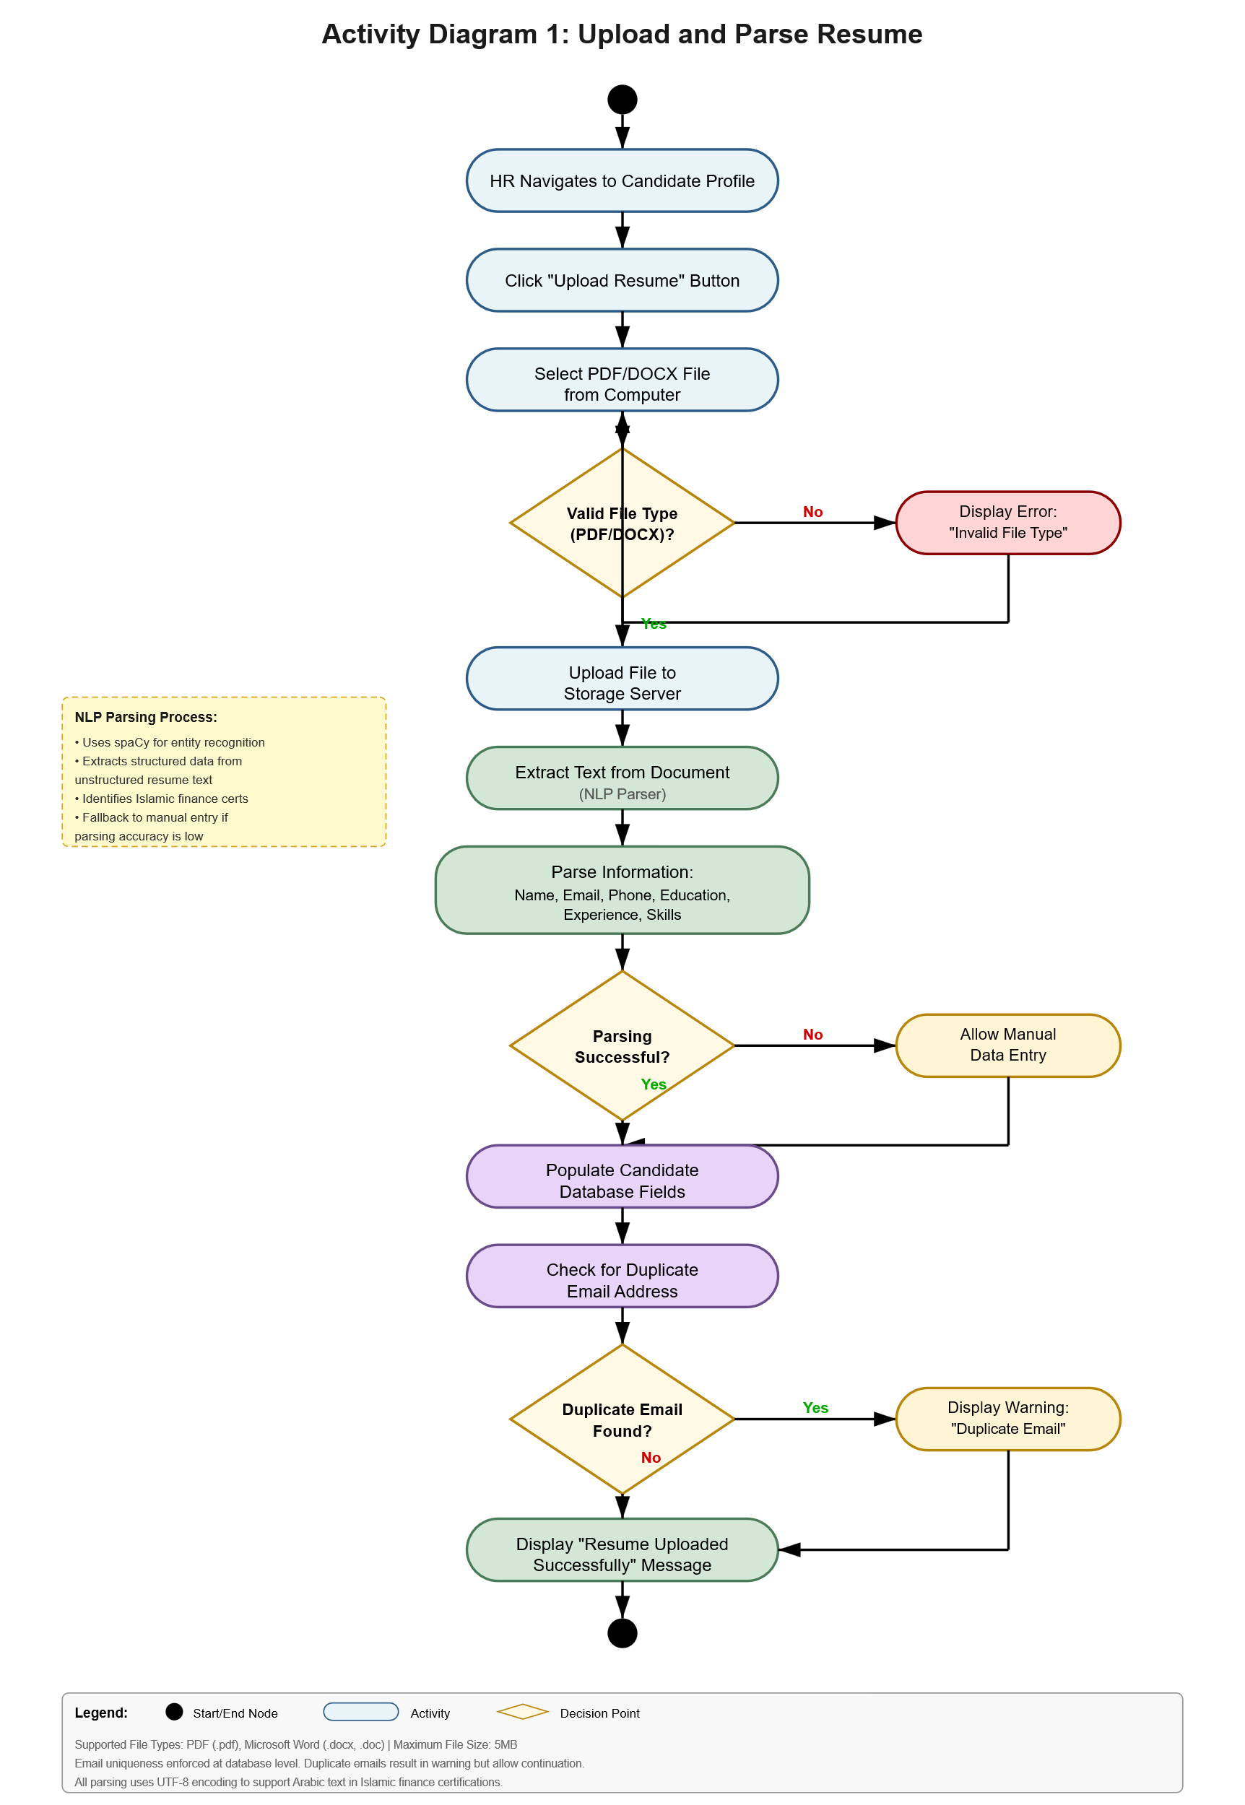

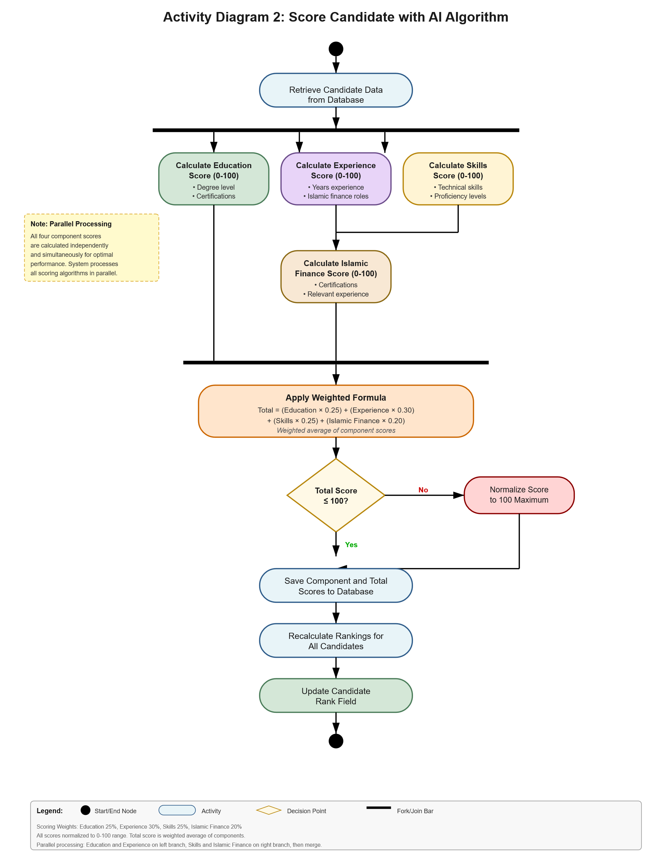

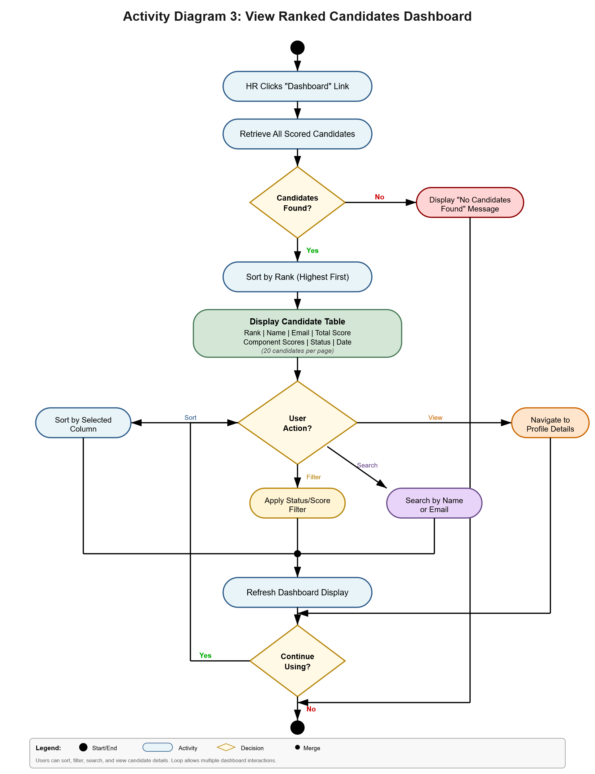

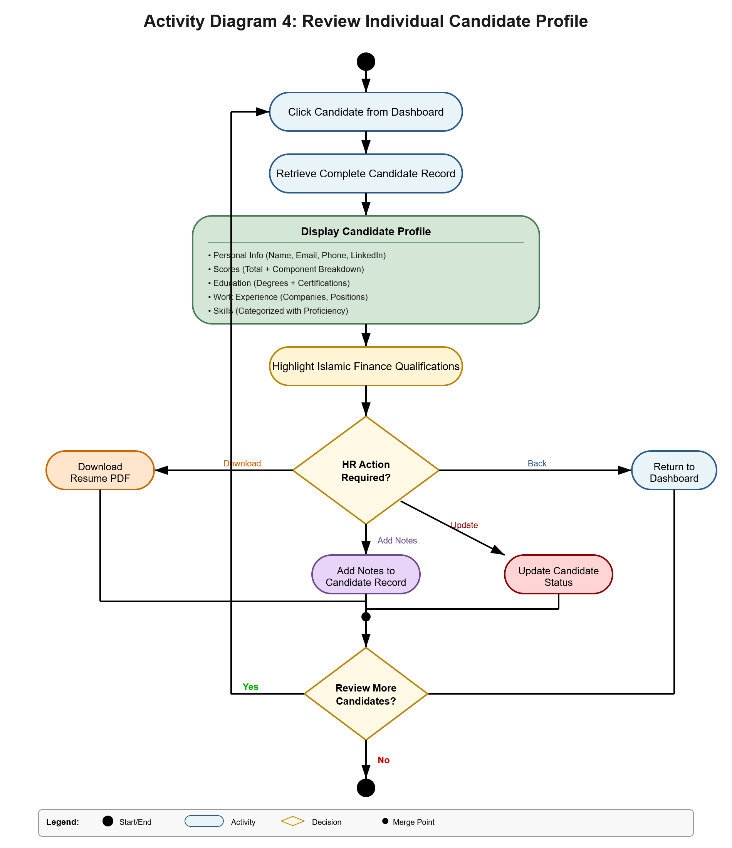

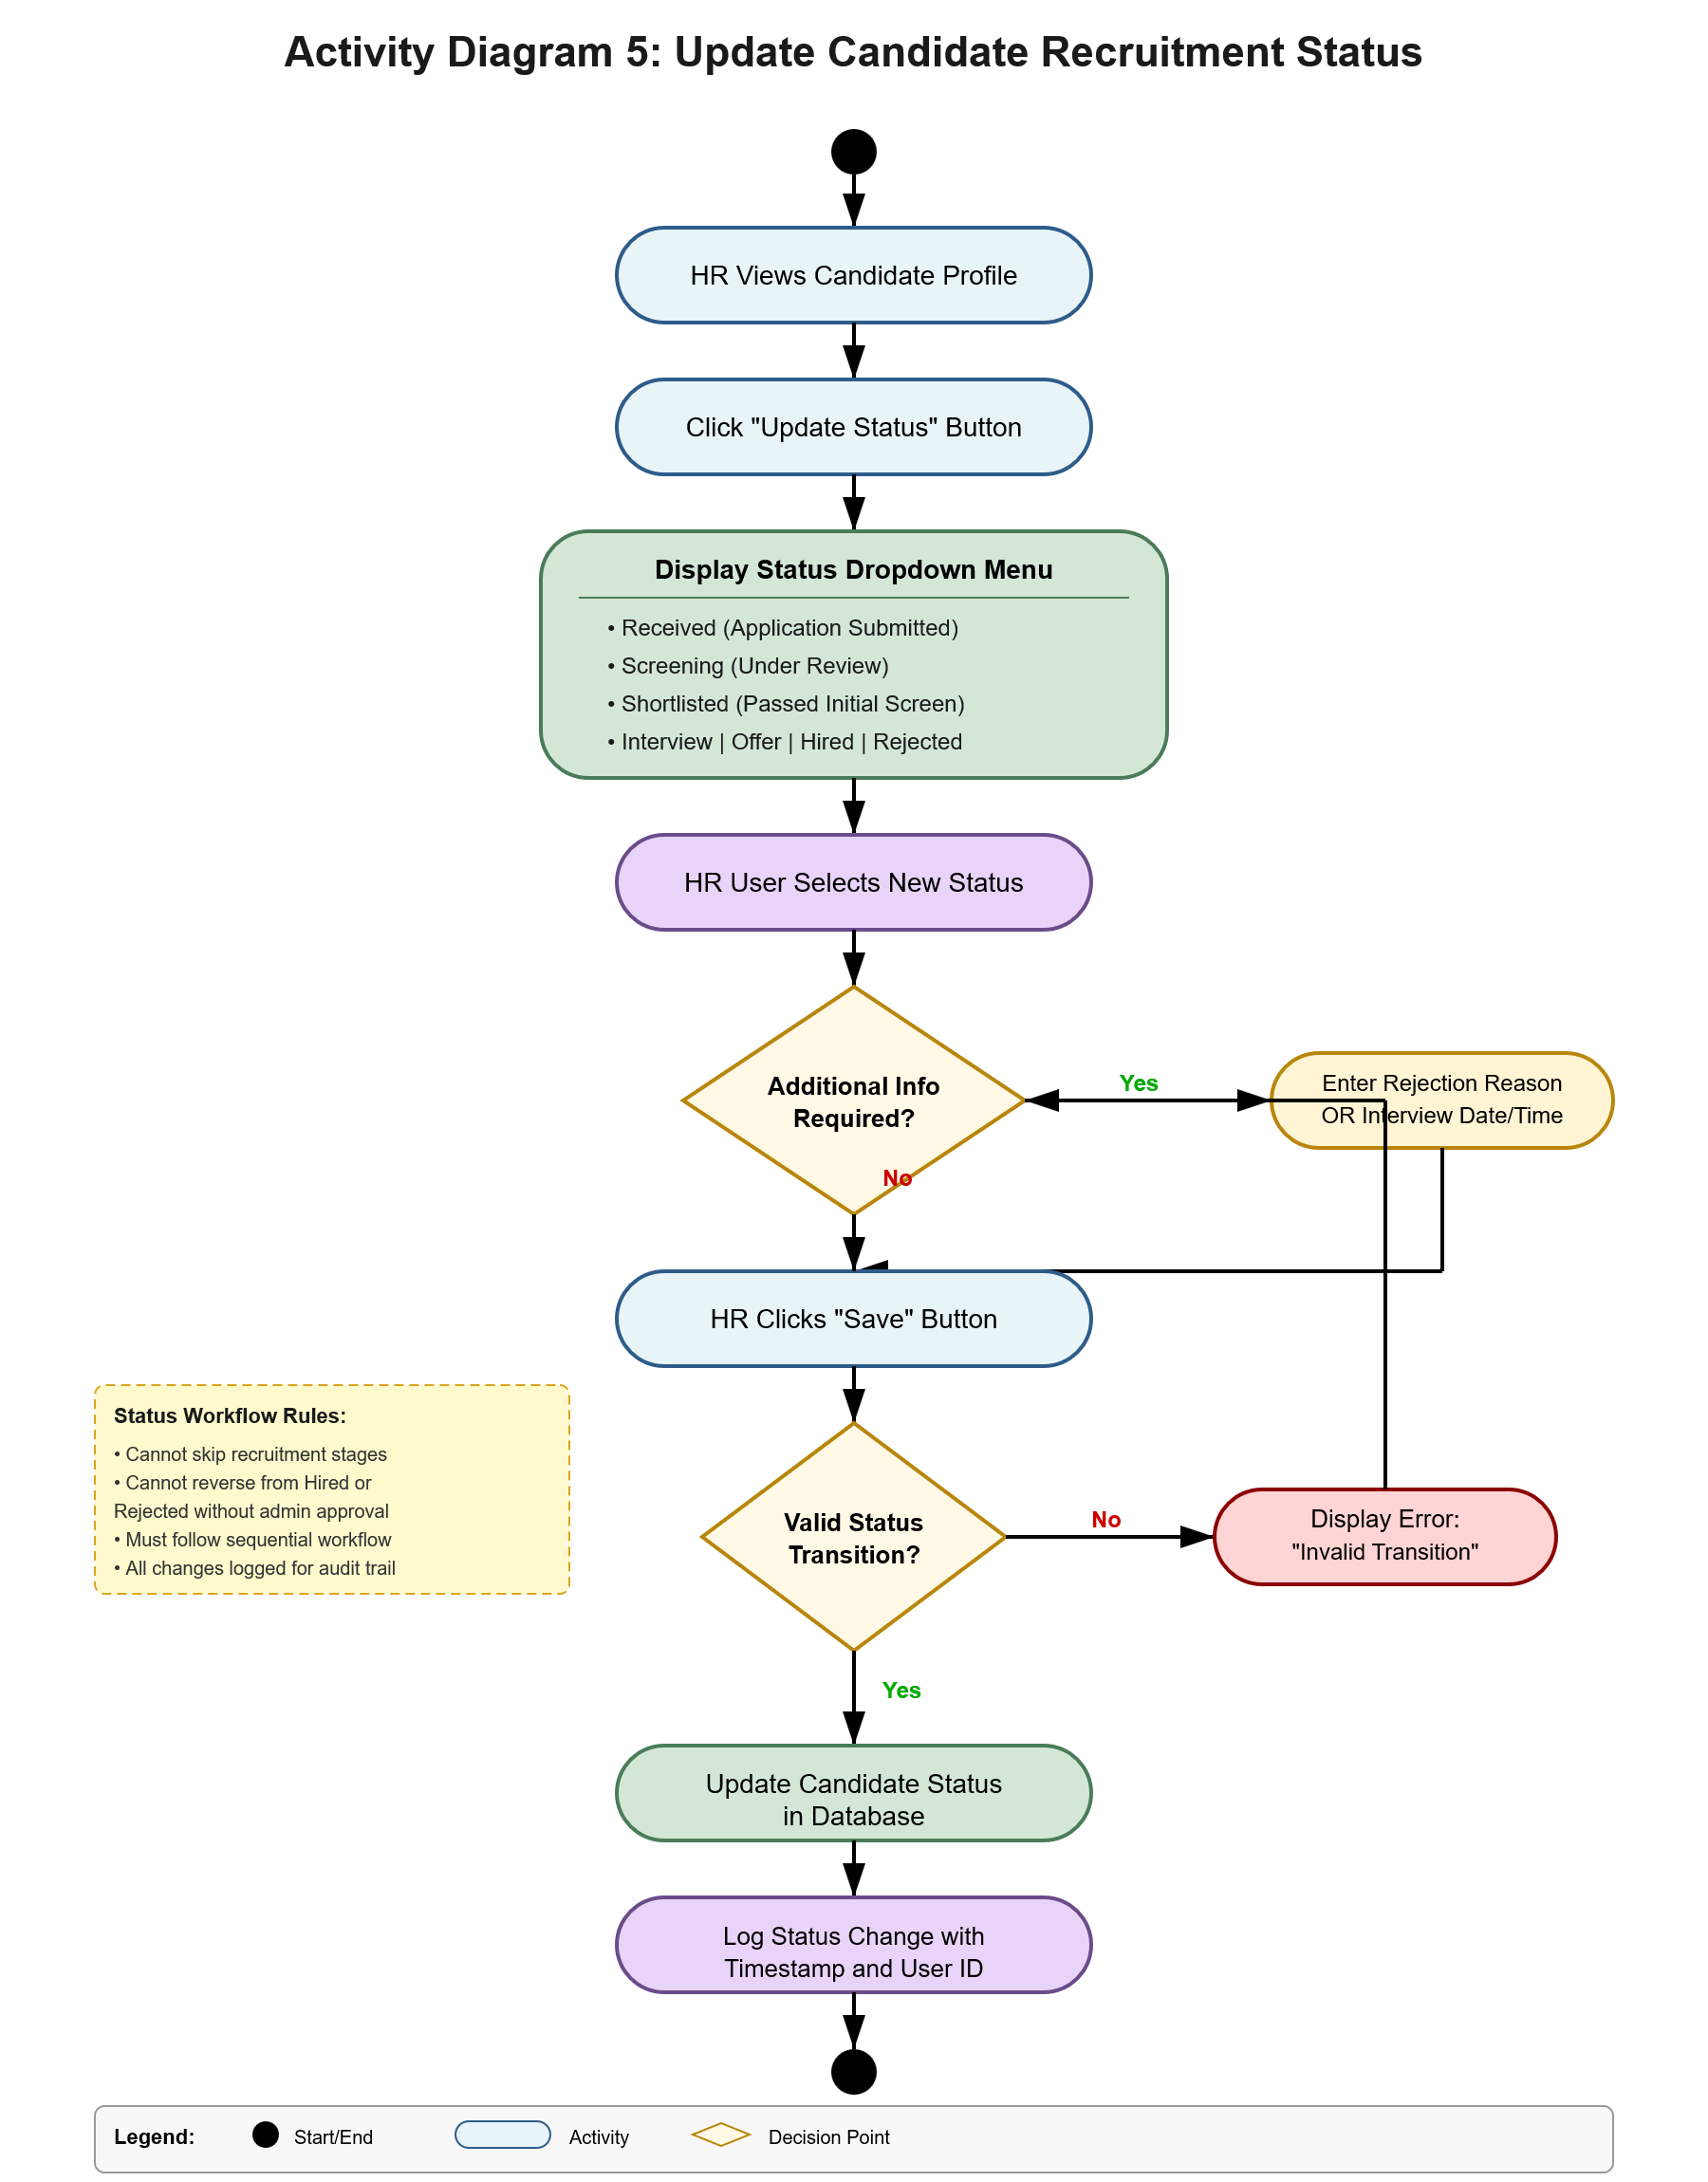

Sequence Diagrams
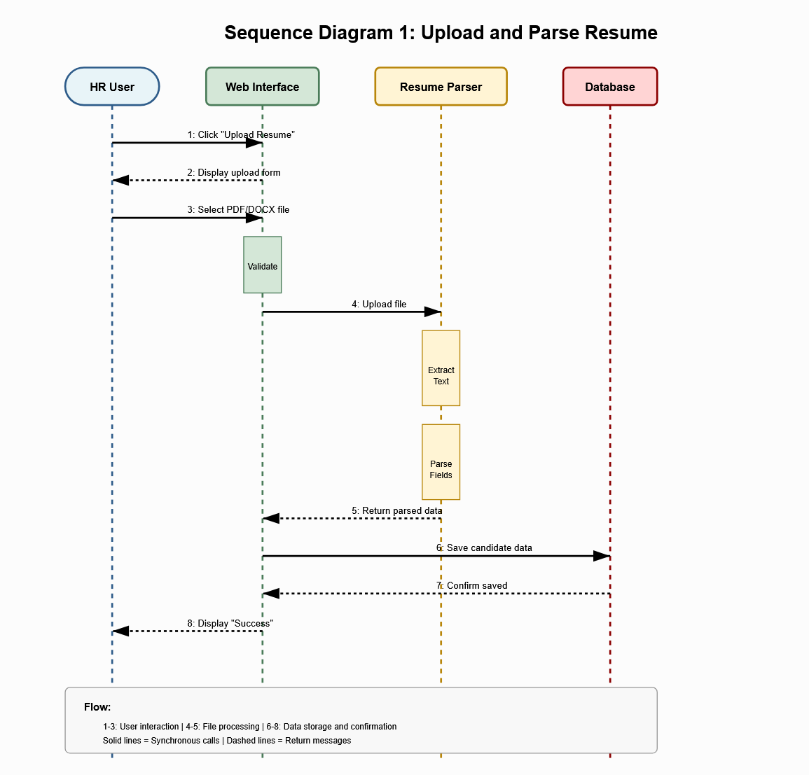

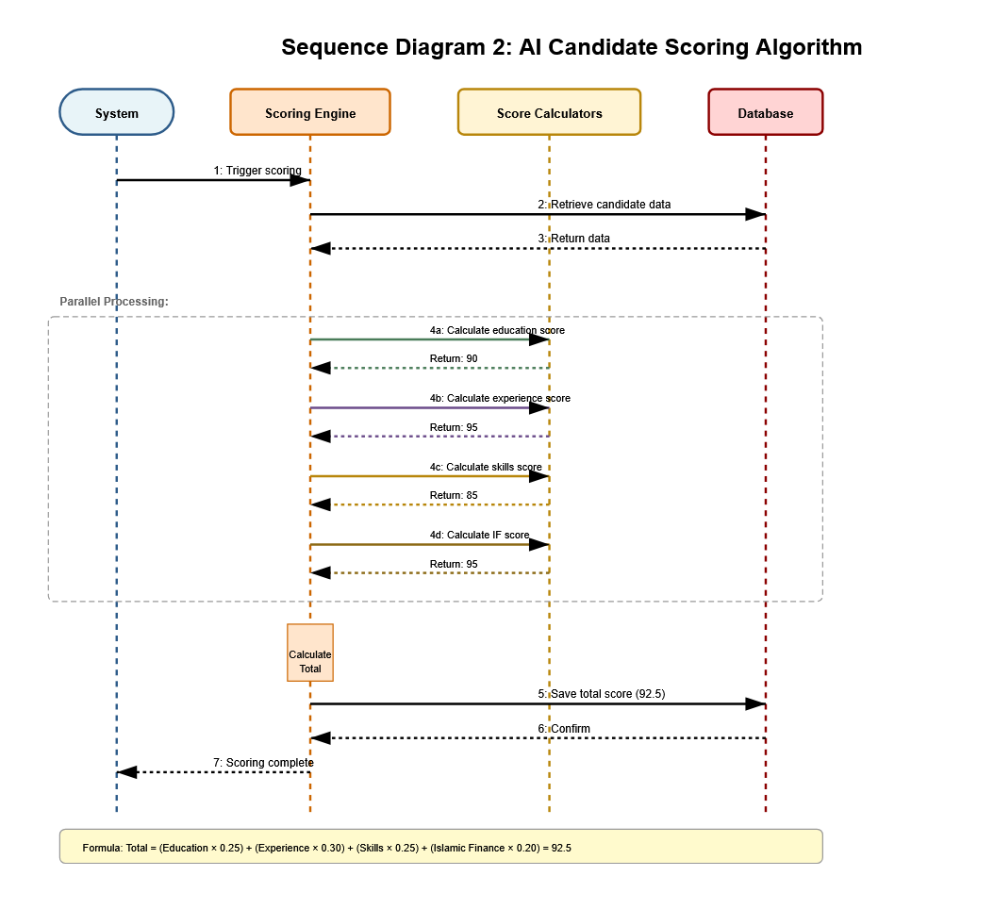

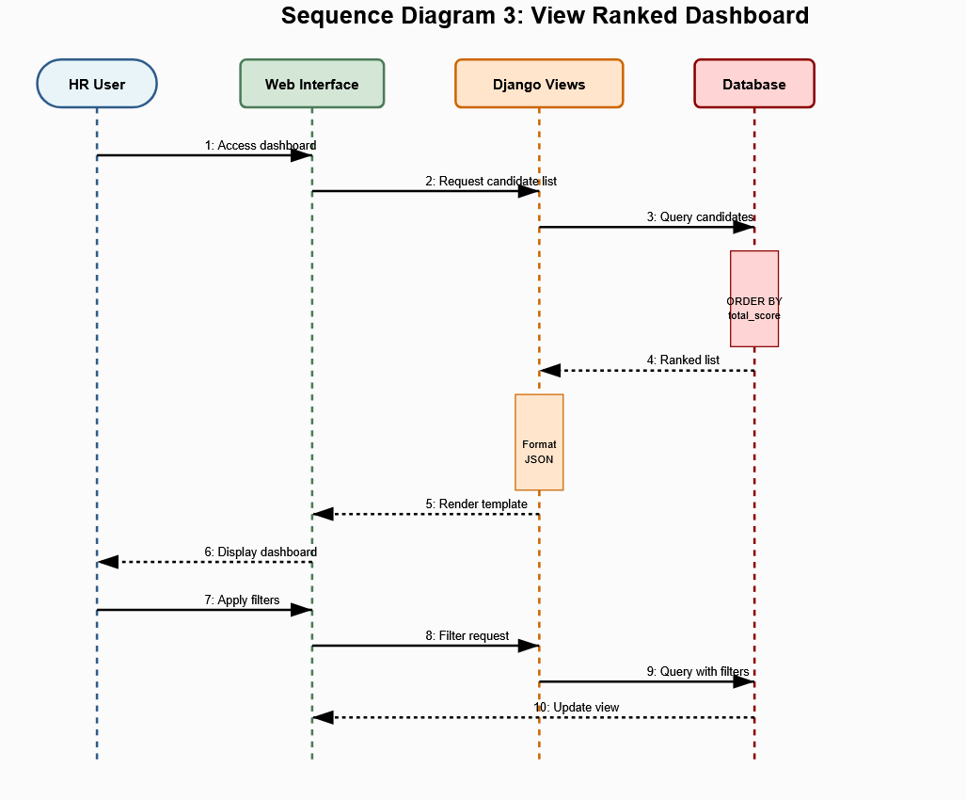

\
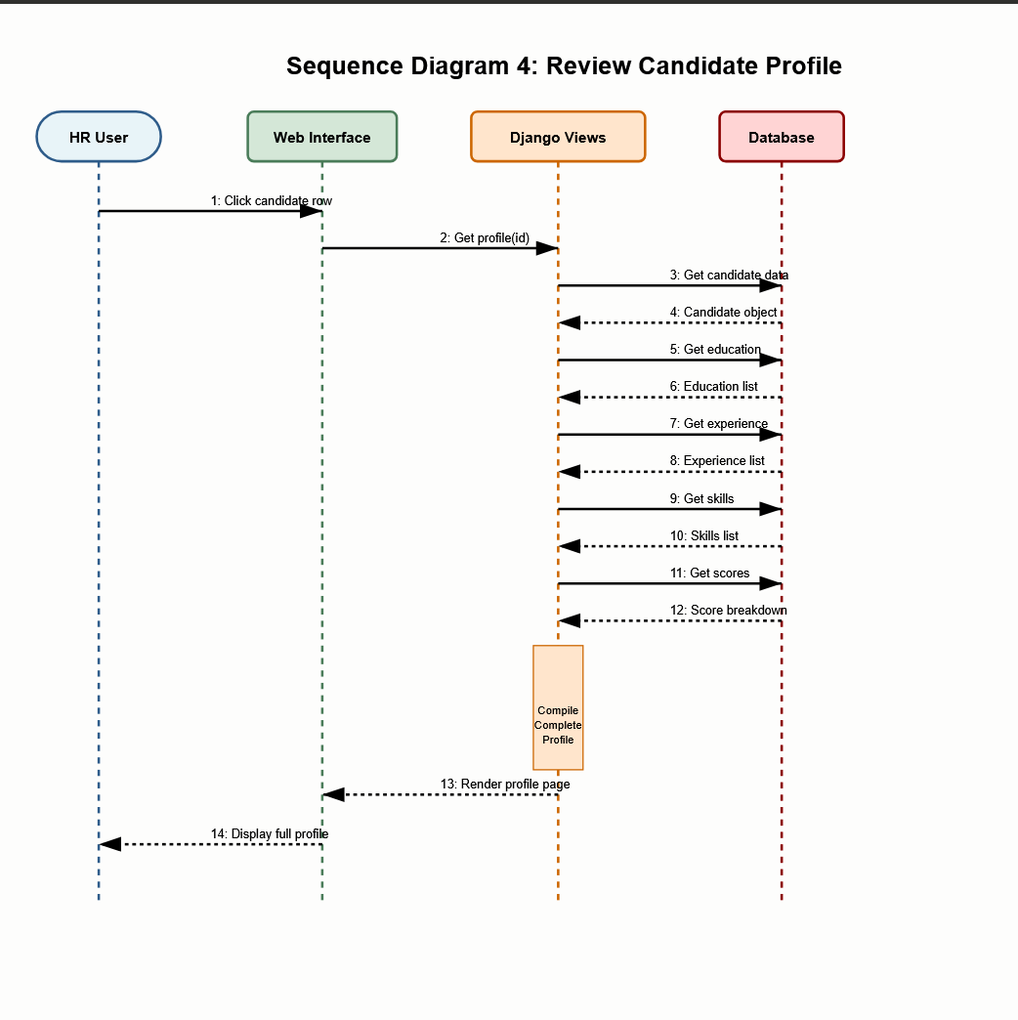

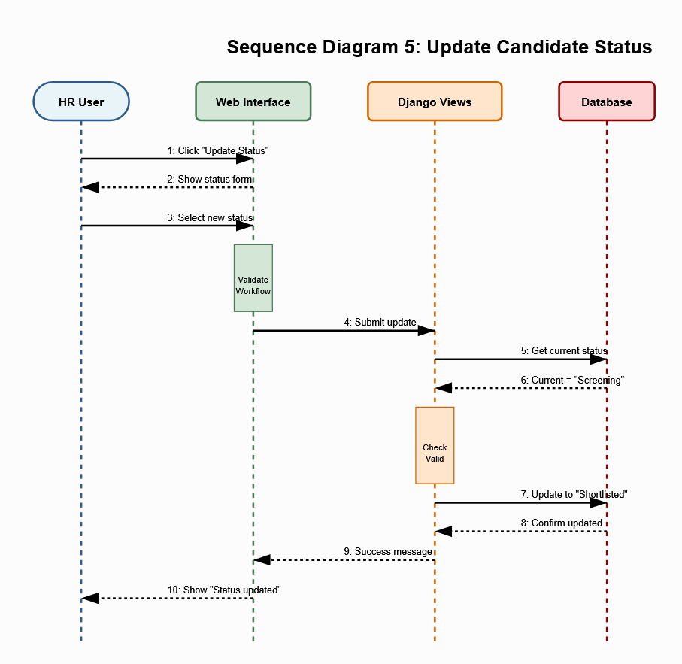

Deployment Diagram
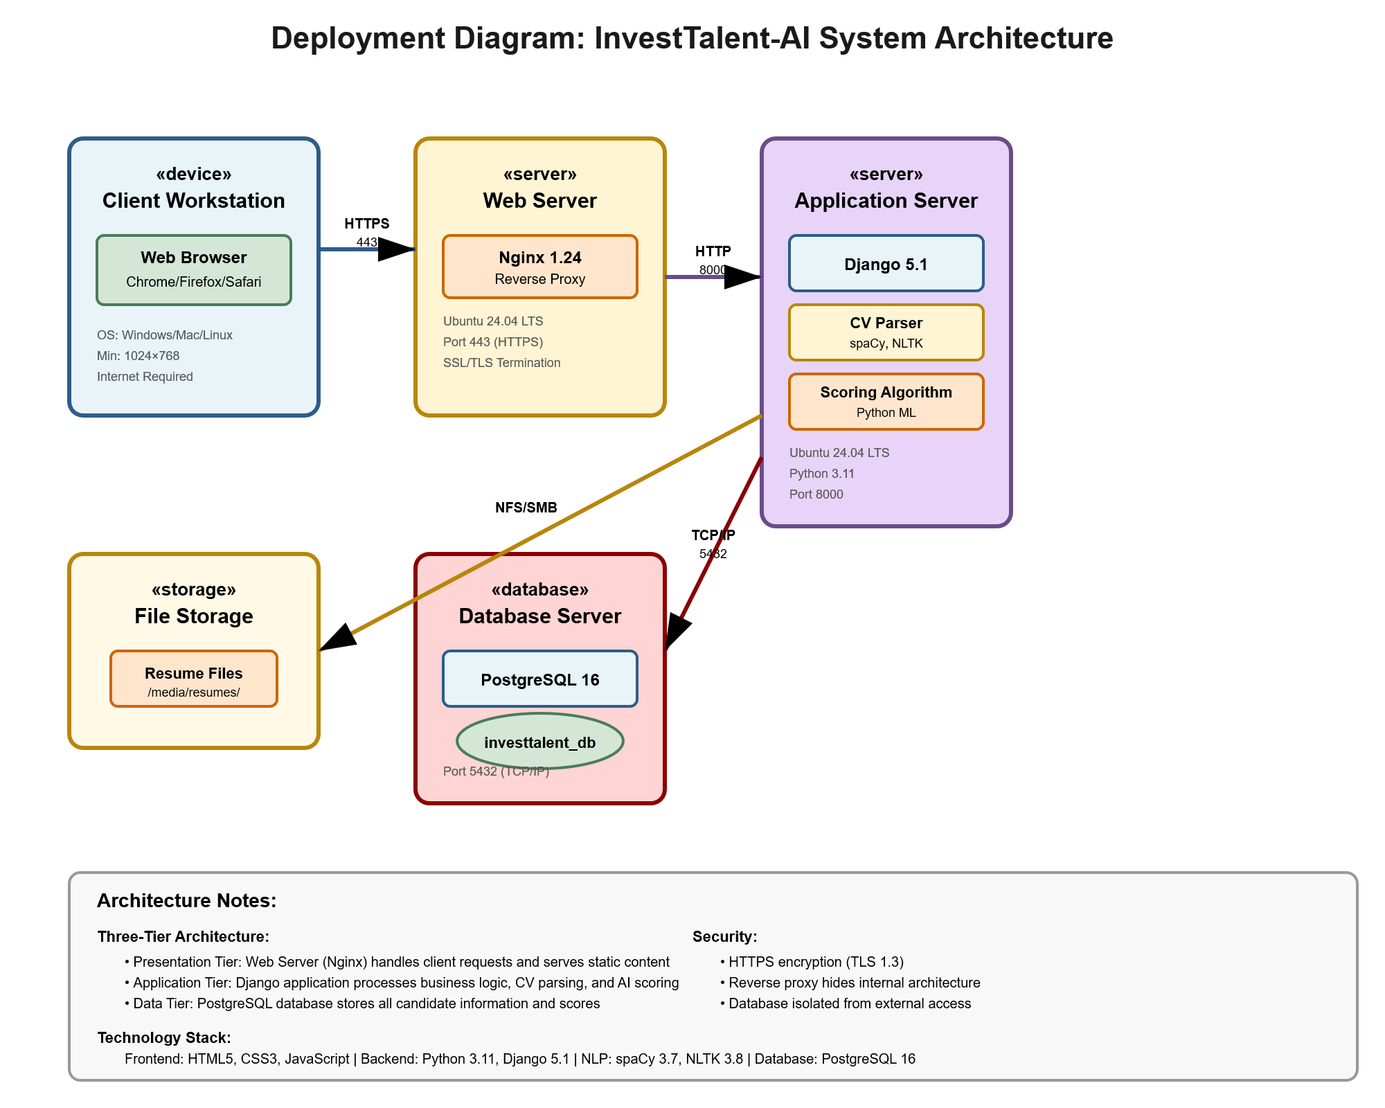

Graphical User Interface Design

This section includes the design decisions with regards to the user interface

GUI Hierarchy
The GUI hierarchy represents the navigation structure and relationship between all pages in the InvestTalent-AI system. The system follows a hub-and-spoke navigation pattern with the Dashboard serving as the central access point to all system functions.
System Navigation Flow:
The user journey begins at the Login Page (authentication gateway), which leads to the Dashboard (main hub). From the Dashboard, users can access four primary functions: Upload Resume (for adding new candidates), Search/Filter (for querying the database), Candidate Profile (for detailed candidate information), and Settings (for user preferences). The Candidate Profile page provides access to two secondary functions: Update Status (for changing recruitment stage) and Score Breakdown (for viewing detailed AI scoring analysis).
Navigation Hierarchy:
- Level 1: Login Page (entry point)
- Level 2: Dashboard (main hub - ranked candidates list)
- Level 3: Primary pages accessible from dashboard
  - Upload Resume
  - Search/Filter
  - Candidate Profile
  - Settings
- Level 4: Secondary pages accessible from candidate profile
  - Update Status
  - Score Breakdown

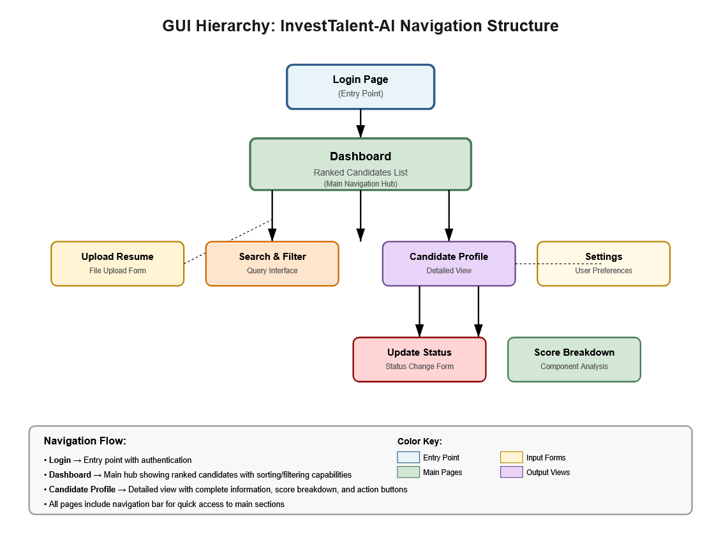
Figure 4.1: GUI Hierarchy showing complete navigation structure from login through all functional pages.
The navigation design ensures that critical functions (viewing candidates, uploading resumes) are no more than two clicks from the main dashboard, while less frequent actions (status updates, detailed scoring) are accessible through contextual navigation from the candidate profile page.

Output Interfaces
Output interfaces display information to users without requiring data entry. These interfaces present candidates, scores, and analytics generated by the system.
Dashboard - Ranked Candidates List
Purpose: Display all candidates ranked by AI-calculated total score, with filtering and sorting capabilities to help HR recruiters identify top candidates efficiently.

Interface Description:
The Dashboard is the primary output interface showing a comprehensive table of all candidates in the system. Candidates are displayed in ranked order with the highest-scoring candidate appearing first. The interface includes a navigation bar at the top with the InvestTalent-AI logo, Upload CV button, and user profile menu. Below the navigation is a filter bar allowing users to narrow results by status, score range, and keyword search.
The main content area displays the candidate table with the following columns:
- Rank: Numerical ranking (1, 2, 3, etc.)
- Name: Full candidate name with years of experience and highest degree
- Email: Candidate email address
- Total Score: Overall AI score (0-100) displayed in color-coded badge
- IF Score: Islamic Finance expertise score (0-100) highlighted for relevance
- Status: Current recruitment stage with color-coded badge
- Date: Application submission date
Key Features:
- Real-time filtering by status dropdown (All, Received, Screening, Shortlisted, Interview, Offer, Hired, Rejected)
- Score range slider for filtering by minimum score threshold
- Keyword search across candidate name and email fields
- Sortable columns - click any column header to sort ascending/descending
- Pagination showing 20 candidates per page with page navigation controls
- Color-coded scores: Green badges (80-100), Blue badges (60-79), Yellow badges (0-59)
- Islamic Finance (IF) score prominently displayed as key differentiator for Arcapita roles
- Export to Excel button for generating reports
User Interactions:
- Click any candidate row to navigate to detailed Candidate Profile page
- Apply multiple filters simultaneously to narrow search results
- Click column headers to sort by that attribute
- Use pagination controls to navigate between pages of results
- Click Export button to download filtered results as Excel spreadsheet

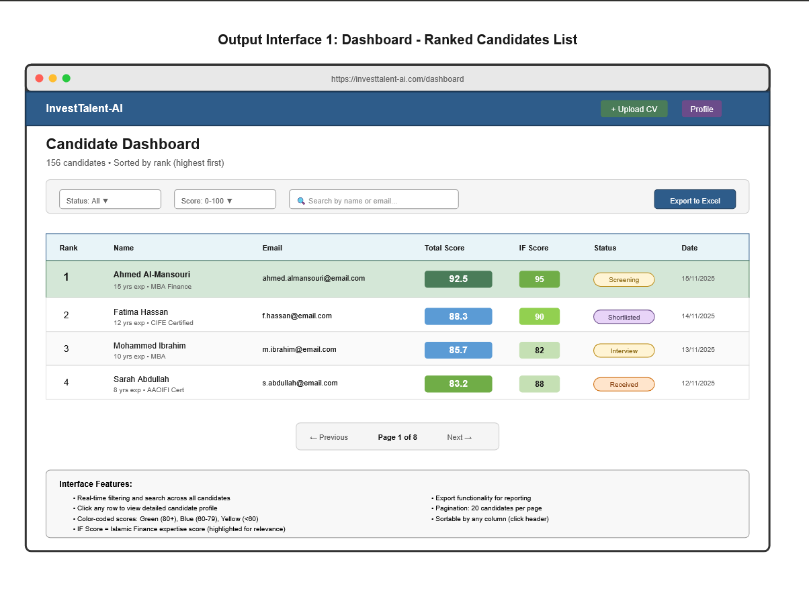
Figure 4.2: Dashboard showing ranked candidates with filtering options, color-coded scores, status badges, and navigation controls.

Design Rationale:
The dashboard prioritizes visibility of key decision-making information (rank, score, Islamic Finance expertise) while maintaining a clean, professional interface suitable for corporate HR environments. Color-coding provides instant visual feedback on candidate quality, while the prominent Islamic Finance score addresses Arcapita's specific requirement for Sharia-compliant investment expertise.

Candidate Profile - Detailed View
Purpose: Display comprehensive candidate information including personal details, AI-generated scores with component breakdown, complete qualifications, work history, and system recommendations.
Interface Description:
The Candidate Profile page provides a complete view of an individual candidate's information. The page header displays the candidate's initials in a circular avatar, full name, professional title, years of experience, contact information (email, phone, LinkedIn), and current recruitment status badge. Action buttons (Update Status, Download CV) are positioned in the top-right corner.
The page content is organized into distinct sections:
Overall Score Section:
- Large circular progress indicator showing total score (0-100)
- Numerical rank display (e.g., "Rank #1")
- Component score breakdown with horizontal progress bars:
  - Education Score (0-100) with 25% weight indicator
  - Experience Score (0-100) with 30% weight indicator
  - Skills Score (0-100) with 25% weight indicator
  - Islamic Finance Score (0-100) with 20% weight indicator
- Weighted formula display showing calculation method
Recommendation Box:
- AI-generated recommendation based on score range
  - 80-100: "Strong Candidate - Proceed to interview"
  - 60-79: "Qualified Candidate - Consider for next round"
  - 0-59: "Below Threshold - Review qualifications"
- Key strengths highlighted (e.g., "High Islamic finance expertise")
Islamic Finance Qualifications Highlight:
- Dedicated section with gold background emphasizing Sharia-compliant expertise
- Lists Islamic finance certifications (CIFE, AAOIFI, etc.)
- Shows years of experience in Islamic finance institutions
- Identifies Sharia-compliant investment product knowledge
Education Section:
- Lists all degrees with institution names and graduation years
- Displays certifications and professional qualifications
- Shows academic honors or distinctions
Experience Section:
- Work history in reverse chronological order
- Job titles, company names, employment dates
- Highlights Islamic finance-related roles
Skills Section:
- Technical skills displayed as colored tags/badges
- Skills categorized by type (Financial Analysis, Investment Tools, Languages)
- Proficiency levels indicated where available
Timeline Section:
- Application received date and time
- AI scoring completion timestamp
- Last status update date
Notes Section:
- Free-text area for HR comments
- Previous notes displayed with timestamps

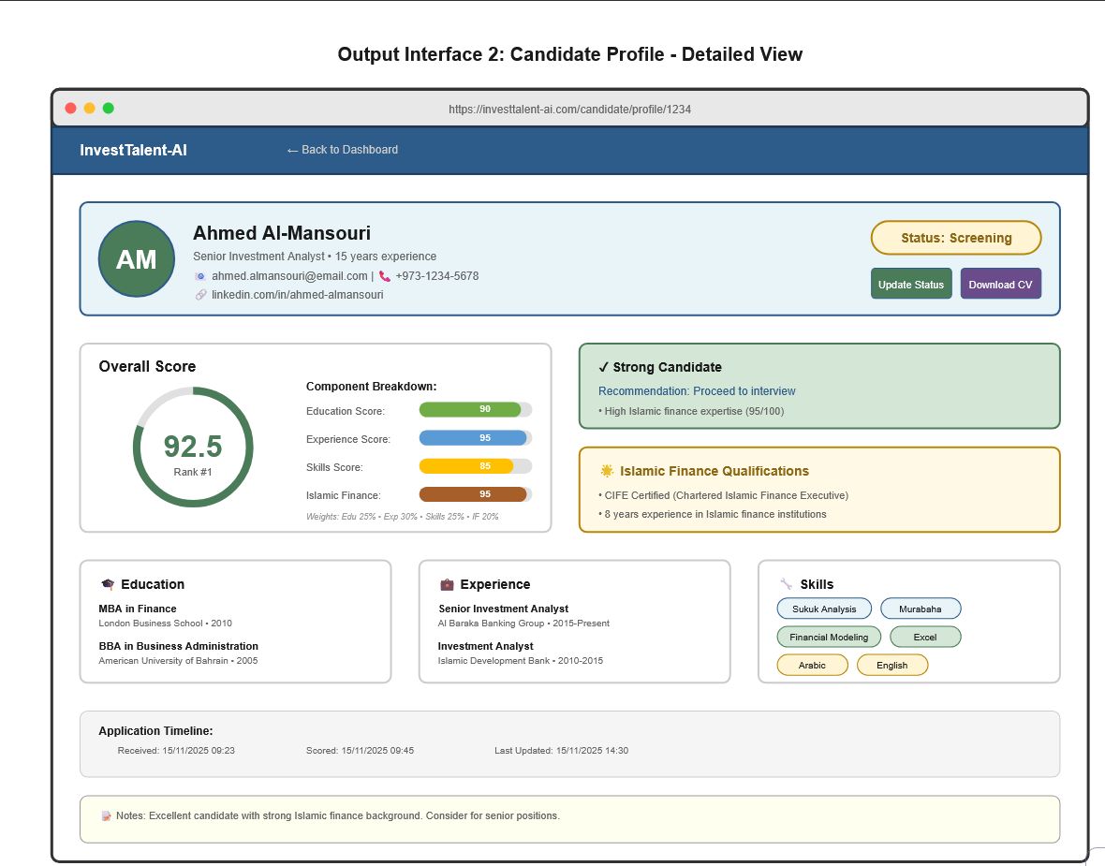
Figure 4.3: Candidate Profile showing complete information, score breakdown with visual indicators, qualification highlights, and recommendation.
Design Rationale:
The profile page emphasizes the AI scoring system's transparency by showing not just the final score but the component breakdown and weighting. The Islamic Finance qualifications section is visually distinguished to support Arcapita's primary hiring requirement. The recommendation system provides immediate guidance while allowing HR recruiters to review complete information before making decisions.

Score Breakdown - Component Analysis (Optional - accessed from profile)
Purpose: Provide detailed analysis of how each score component was calculated, showing the AI algorithm's reasoning.
Interface Description:
Displays detailed breakdown of the four scoring components with explanations of what factors contributed to each score. Shows comparison to average candidate scores and identifies specific strengths and weaknesses.

Input interfaces
Input interfaces allow users to enter data, upload files, and interact with the system to perform actions.

Login Page
Purpose: Authenticate HR users and control system access through secure credentials verification.
Interface Description:
The Login page features a centered authentication card on a light blue gradient background. The InvestTalent-AI logo appears at the top as a circular badge with "IT" initials, followed by the full application name and tagline ("Intelligent Recruitment for Islamic Finance Professionals").
The login card contains:
- "Sign In" header
- Email Address input field with placeholder text
- Password input field with masked characters
- "Remember me" checkbox on left
- "Forgot password?" link on right
- "Sign In" button (full width, green background)
- Security notice: "Secure authentication powered by AWS Cognito"
Input Fields:
- Email Address: Text input, required, validated for email format (name@domain.com)
- Password: Password input (masked), required, minimum 8 characters
- Remember Me: Checkbox, optional, maintains session for 30 days if selected
Validation Rules:
- Email must match valid format with @ symbol and domain
- Password must be minimum 8 characters
- Account locks after 5 failed login attempts
- Session expires after 30 minutes of inactivity
- HTTPS encryption required for all authentication
User Interactions:
- Enter email and password credentials
- Click "Sign In" button to authenticate
- Click "Forgot password?" to initiate password reset process
- Check "Remember me" to maintain session
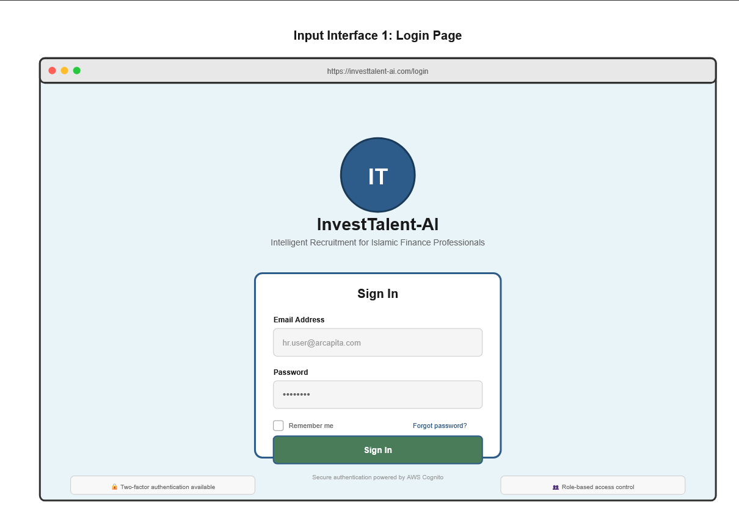
Figure 4.4: Login page with secure authentication fields, remember me option, and password recovery link.
Design Rationale:
The login page follows industry-standard authentication patterns with clear, simple inputs and strong visual hierarchy. Security features (HTTPS, account lockout, session timeout) protect sensitive recruitment data while maintaining usability for daily HR operations.

Upload Resume Form
Purpose: Allow HR users to upload candidate CVs in PDF or DOCX format for automated parsing and AI scoring.
Interface Description:
The Upload Resume page displays a prominent file upload area with drag-and-drop functionality. The interface includes:
- Page title: "Upload Candidate Resume"
- File upload zone with dashed border and upload icon
- "Click to browse" button for traditional file selection
- Supported formats notice: "PDF and DOCX files only, maximum 5MB"
- Upload progress bar (appears during upload)
- File validation messages (success or error)
Input Fields:
- File Upload: Required, accepts .pdf and .docx only, 5MB maximum size
- Candidate Email (Optional): Text input for duplicate checking before parsing
Upload Process Flow:
- User selects file via drag-and-drop or file browser
- System validates file type (.pdf or .docx only)
- System validates file size (must be ≤ 5MB)
- Progress bar shows upload status
- Resume Parser extracts text from document
- NLP algorithm identifies candidate information (name, email, education, experience, skills)
- System populates Candidate database fields
- System checks for duplicate email addresses
- Success message displays: "Resume uploaded successfully"
- User redirected to candidate profile for review/editing
Validation Rules:
- File type must be .pdf or .docx (other formats rejected)
- File size cannot exceed 5MB
- File name cannot contain special characters (@ # $ % &)
- Duplicate email warning displayed if candidate already exists
- If parsing fails, manual data entry form appears as fallback
Error Handling:
- Invalid file type: "Error: Only PDF and DOCX files are supported"
- File too large: "Error: File exceeds 5MB limit. Please compress and retry"
- Parsing failure: "Warning: Could not extract all fields. Please review and complete manually"
- Duplicate email: "Warning: Candidate with this email already exists. Continue anyway?"
User Interactions:
- Drag file onto upload zone OR click browse button
- Wait for upload and parsing completion
- Review success/error messages
- Proceed to candidate profile if successful
- Retry upload if error occurs
Design Rationale:
The upload interface prioritizes ease of use with modern drag-and-drop functionality while maintaining clear file format and size requirements. The automatic parsing reduces manual data entry, while the fallback to manual entry ensures all candidates can be added even if automated parsing fails.

Search and Filter Interface
Purpose: Enable HR users to query the candidate database using multiple criteria simultaneously to find specific candidates or candidate groups.
Interface Description:
The Search and Filter interface appears as a control bar directly above the candidates table on the Dashboard. It contains:
- Keyword Search Box: Full-width text input with search icon and placeholder "Search by name or email..."
- Status Filter Dropdown: Multi-select dropdown showing all recruitment statuses
- Score Range Slider: Dual-handle slider from 0 to 100 with current range display
- Date Range Picker: From-To date selectors for application date filtering
- Islamic Finance Filter: Checkbox "Certified in Islamic Finance only"
- Clear Filters Button: Resets all filters to default
- Export Button: Downloads filtered results
Input Fields:
- Search Text: Text input, searches across candidate name and email fields
- Status Filter: Multi-select dropdown (All, Received, Screening, Shortlisted, Interview, Offer, Hired, Rejected)
- Score Range: Dual slider, minimum 0 to maximum 100
- Date Range: Two date pickers (From date, To date)
- Islamic Finance: Checkbox, filters to candidates with IF certifications only
Filter Behavior:
- Filters apply in real-time as values change (no "Apply" button needed)
- Multiple filters combine with AND logic (all conditions must match)
- Results update immediately showing filtered candidate count
- Pagination resets to page 1 when filters change
- Filter state persists during session
Validation Rules:
- Score minimum cannot exceed maximum
- Date "From" cannot be after "To" date
- Search text minimum 2 characters to activate
- At least one character in search or one filter active required
User Interactions:
- Type in search box for instant keyword filtering
- Select one or multiple statuses from dropdown
- Drag slider handles to set score range
- Click date pickers to select from/to dates
- Check Islamic Finance box to show only certified candidates
- Click "Clear Filters" to reset all to defaults
- Click "Export" to download currently filtered results as Excel
Design Rationale:
The filter interface provides powerful search capabilities while maintaining simplicity through progressive disclosure. Common filters (search, status) are immediately visible, while advanced filters (date range, IF certification) are available but don't clutter the interface. Real-time filtering provides instant feedback without requiring extra button clicks.

Update Status Form
Purpose: Allow HR users to change a candidate's recruitment status with workflow validation and mandatory information collection.
Interface Description:
The Update Status form appears as a modal dialog overlay when clicking "Update Status" from the candidate profile. The form displays:
- Form title: "Update Candidate Status"
- Current status display (read-only badge)
- New status dropdown selector
- Conditional fields based on selected status:
  - If "Rejected": Rejection reason text area (mandatory)
  - If "Interview": Interview date/time picker (mandatory)
- Notes field (optional text area for all statuses)
- "Cancel" and "Save" buttons
Input Fields:
- New Status: Required dropdown, shows only valid next statuses based on workflow
- Rejection Reason: Required text area (appears only if status = Rejected), minimum 10 characters
- Interview Date/Time: Required date-time picker (appears only if status = Interview), must be future date
- Notes: Optional text area, maximum 500 characters
Status Workflow Rules:
- Received can move to: Screening, Rejected
- Screening can move to: Shortlisted, Rejected
- Shortlisted can move to: Interview, Rejected
- Interview can move to: Offer, Rejected
- Offer can move to: Hired, Rejected
- Hired is final (cannot change without admin approval)
- Rejected is final (cannot change without admin approval)
Validation Rules:
- Cannot skip recruitment stages (must follow sequential workflow)
- Rejection reason mandatory when status = Rejected, minimum 10 characters
- Interview date mandatory when status = Interview, must be future date
- Cannot reverse from Hired or Rejected status
- All status changes logged with timestamp and user ID for audit trail
Change Logging:
- System records: previous status, new status, change date/time, user who made change, reason/notes
- Change history visible on candidate profile timeline
User Interactions:
- Select new status from dropdown
- If "Rejected" selected, enter rejection reason in text area
- If "Interview" selected, pick date and time from calendar picker
- Optionally add notes about status change
- Click "Save" to confirm or "Cancel" to abort
Error Handling:
- Invalid transition: "Error: Cannot move from [current] to [selected]. Invalid workflow step."
- Missing rejection reason: "Error: Rejection reason is required when rejecting candidates."
- Past interview date: "Error: Interview date must be in the future."
- Admin override required: "Error: Status change from Hired/Rejected requires administrator approval."

Design Rationale:
The status update form enforces proper recruitment workflow to ensure candidates progress through stages logically while capturing necessary information (rejection reasons, interview scheduling) at appropriate points. The workflow validation prevents errors while the audit logging provides accountability and compliance tracking.

