PITCH: Geen Bezwaar Mogelijk (No Objection Possible)

Subject and Angle
Geen Bezwaar Mogelijk (No Objection Possible) is a video essay that reconstructs how the Dutch Tax Authority’s (Belastingdienst) risk-classification algorithm flagged tens of thousands of families as fraudulent, and what happened to them after. The piece intercuts archival news footage, parliamentary hearings, and affected families’ testimonies with animated data-flow visualizations that make the algorithm’s discriminatory logic legible to a lay audience. The argument is precise: the toeslagenaffaire was not a bureaucratic error but an architecture of control, one in which dual nationality became a risk signal, automated flags replaced human judgment, and appeals disappeared into institutional silence. The system didn’t malfunction. It performed exactly as designed.
The video essay moves through three acts. First, the input layer: what data entered the system (income, nationality, postcode, childcare provider) and how “risk profiles” were constructed. Second, the decision layer: animated sequences showing how the scoring model escalated flags into full benefit termination, debt collection, and forced repayment, often without human review. Third, the consequence layer: film footage and first-person accounts documenting divorces, evictions, children placed in state care, and suicides that followed. Each act pairs the technical diagram with the human cost, refusing the separation between “system” and “story.”

Why Me
I, Ahnjili ZhuParris, am a published scientist (PhD, Leiden University) and computational artist whose practice centers on building interactive tools that make algorithmic violence tangible for non-experts. My Mozilla Creative Media Award project Future Wake used machine learning to invert predictive policing, letting citizens predict police brutality. My installation VOICES at Ars Electronica exposed the opaque mechanics of voice-cloning algorithms. I bring both the technical fluency to accurately reconstruct the algorithm and the artistic practice to make that reconstruction felt.

Why Now
In 2026, the recovery process remains unfinished: thousands of families are still awaiting compensation, and recent reporting reveals that successor risk-scoring systems at the Belastingdienst have not been fully audited. The EU AI Act entered into force in 2024, yet its provisions on high-risk automated decision-making have not yet been tested against the Dutch welfare apparatus that produced the scandal. The toeslagenaffaire is not history. It is an ongoing condition, and its algorithmic infrastructure has not been dismantled.

Format and Length
Visual Essay. A 12–15 minute video essay combining archival footage (parliamentary hearings, news broadcasts, protest documentation), original animated data-flow diagrams, and interview audio. Treatment and sample visualizations attached.
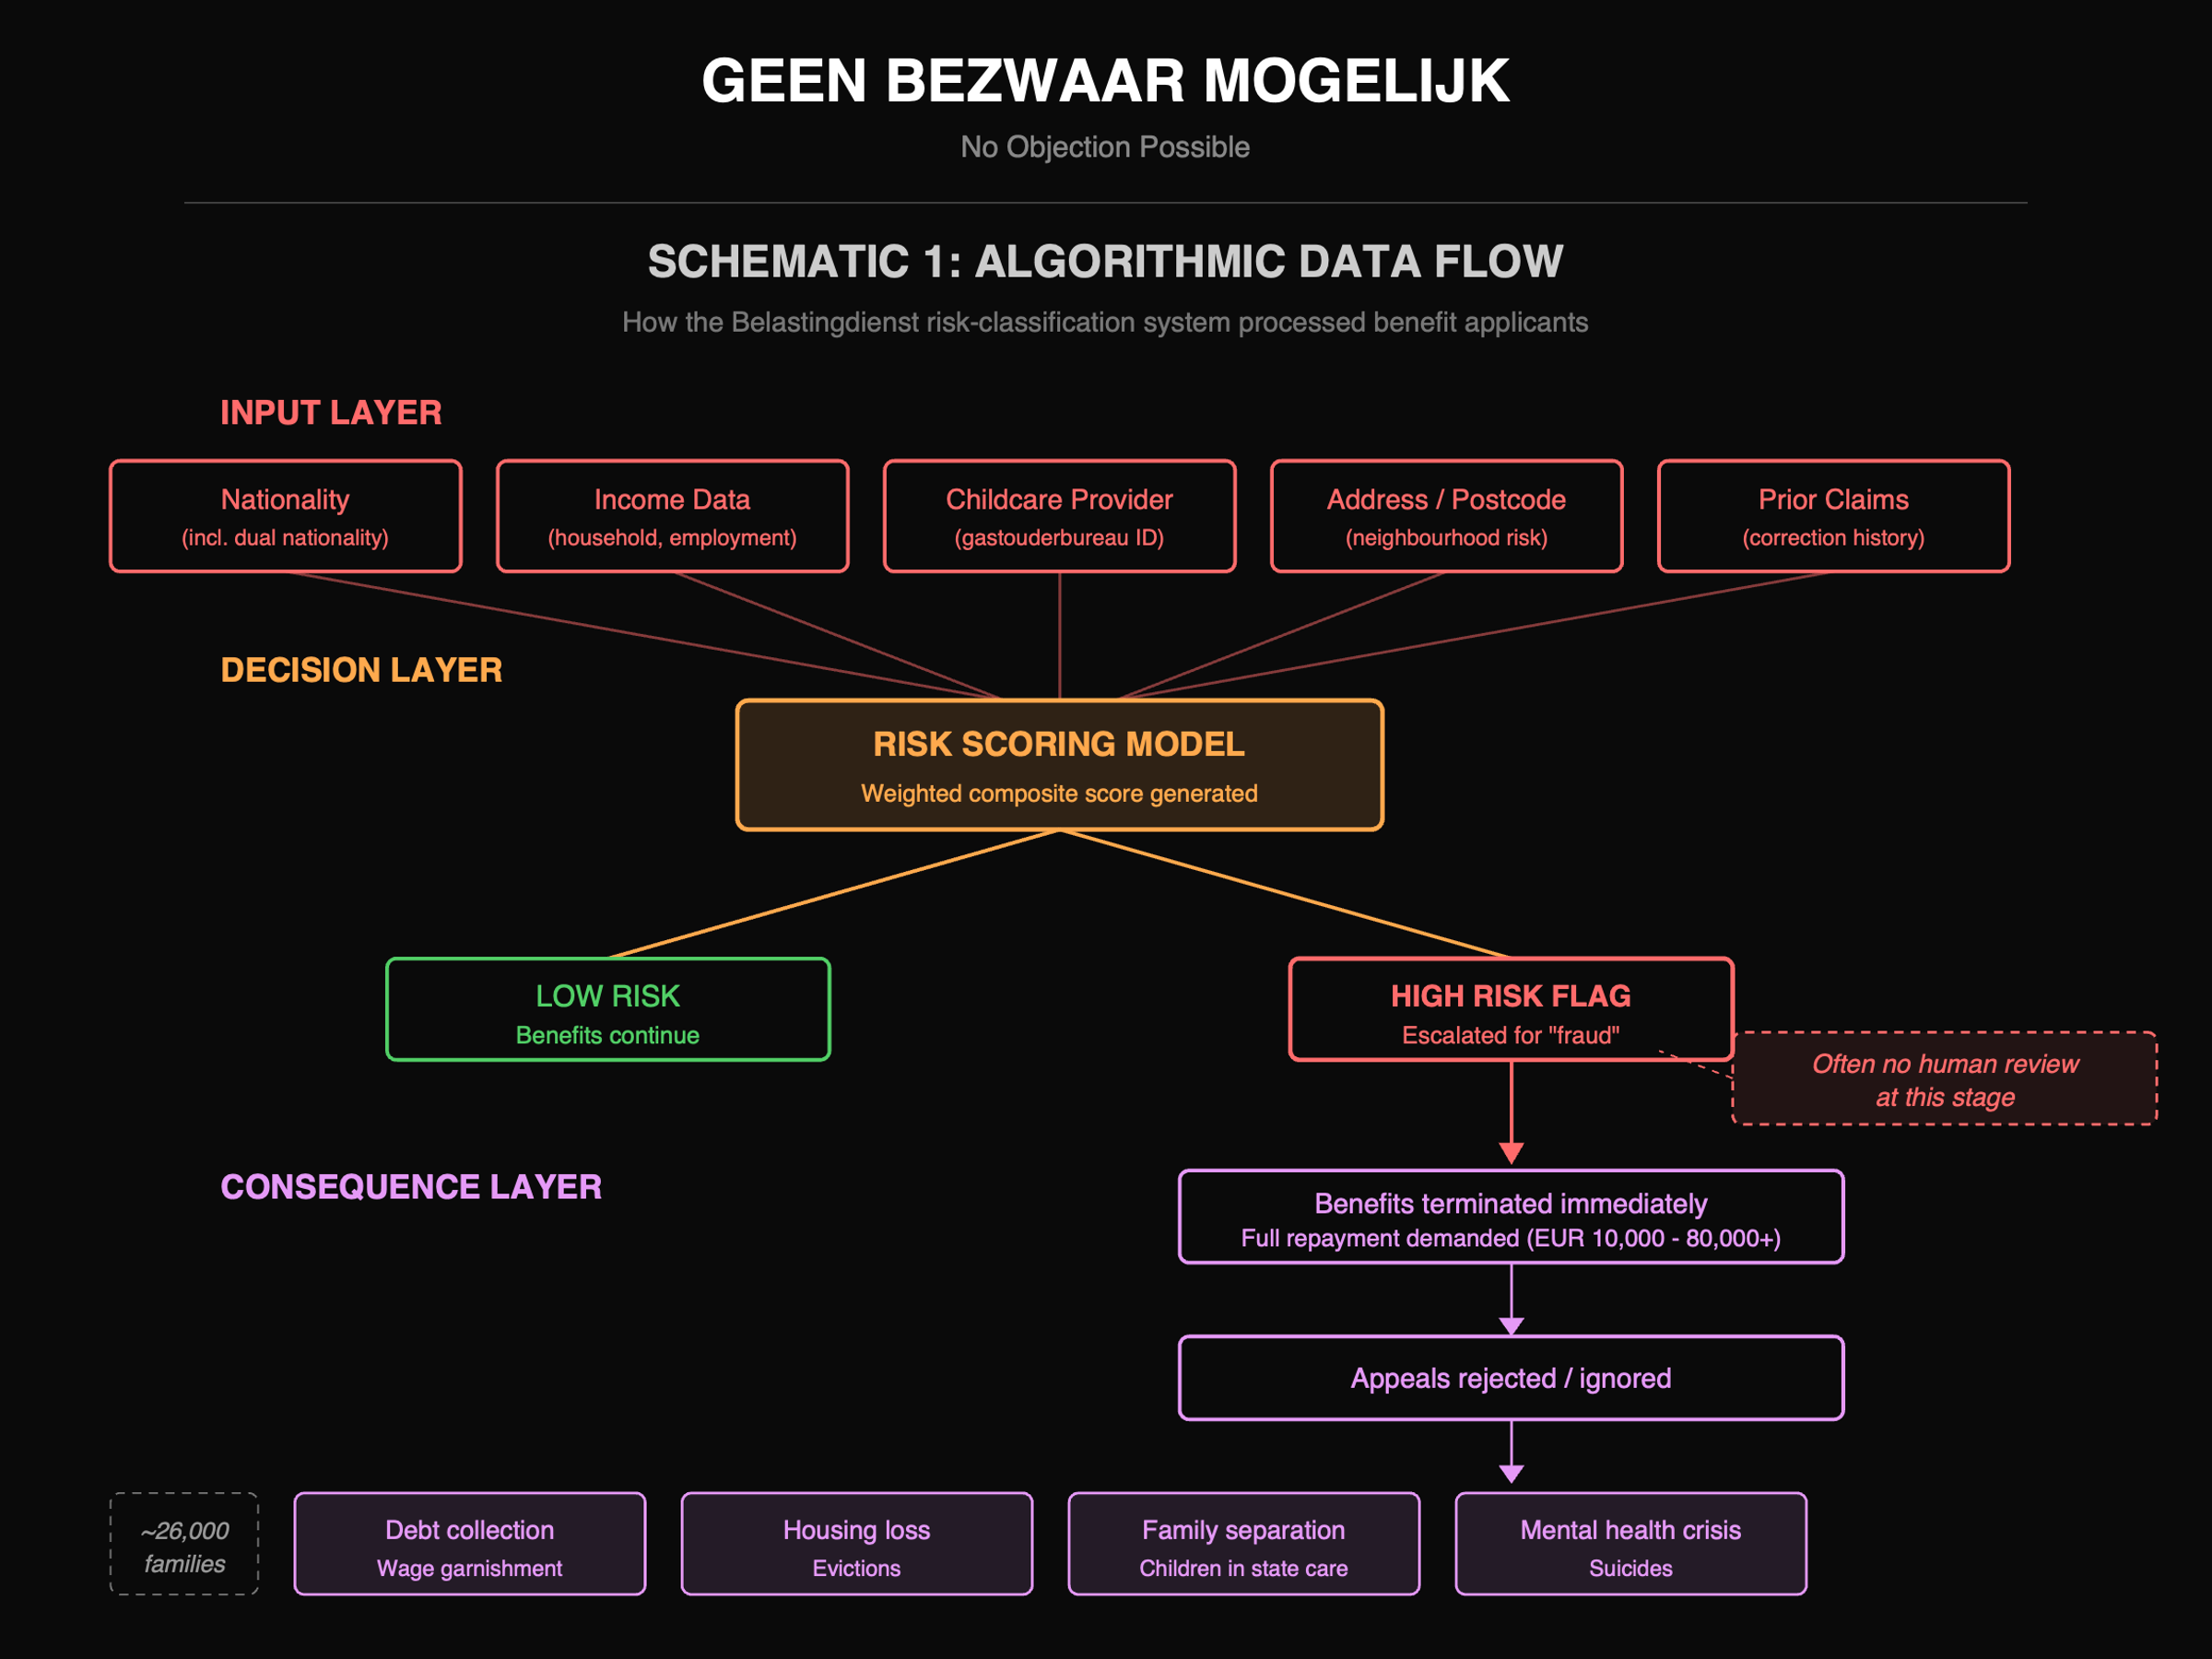

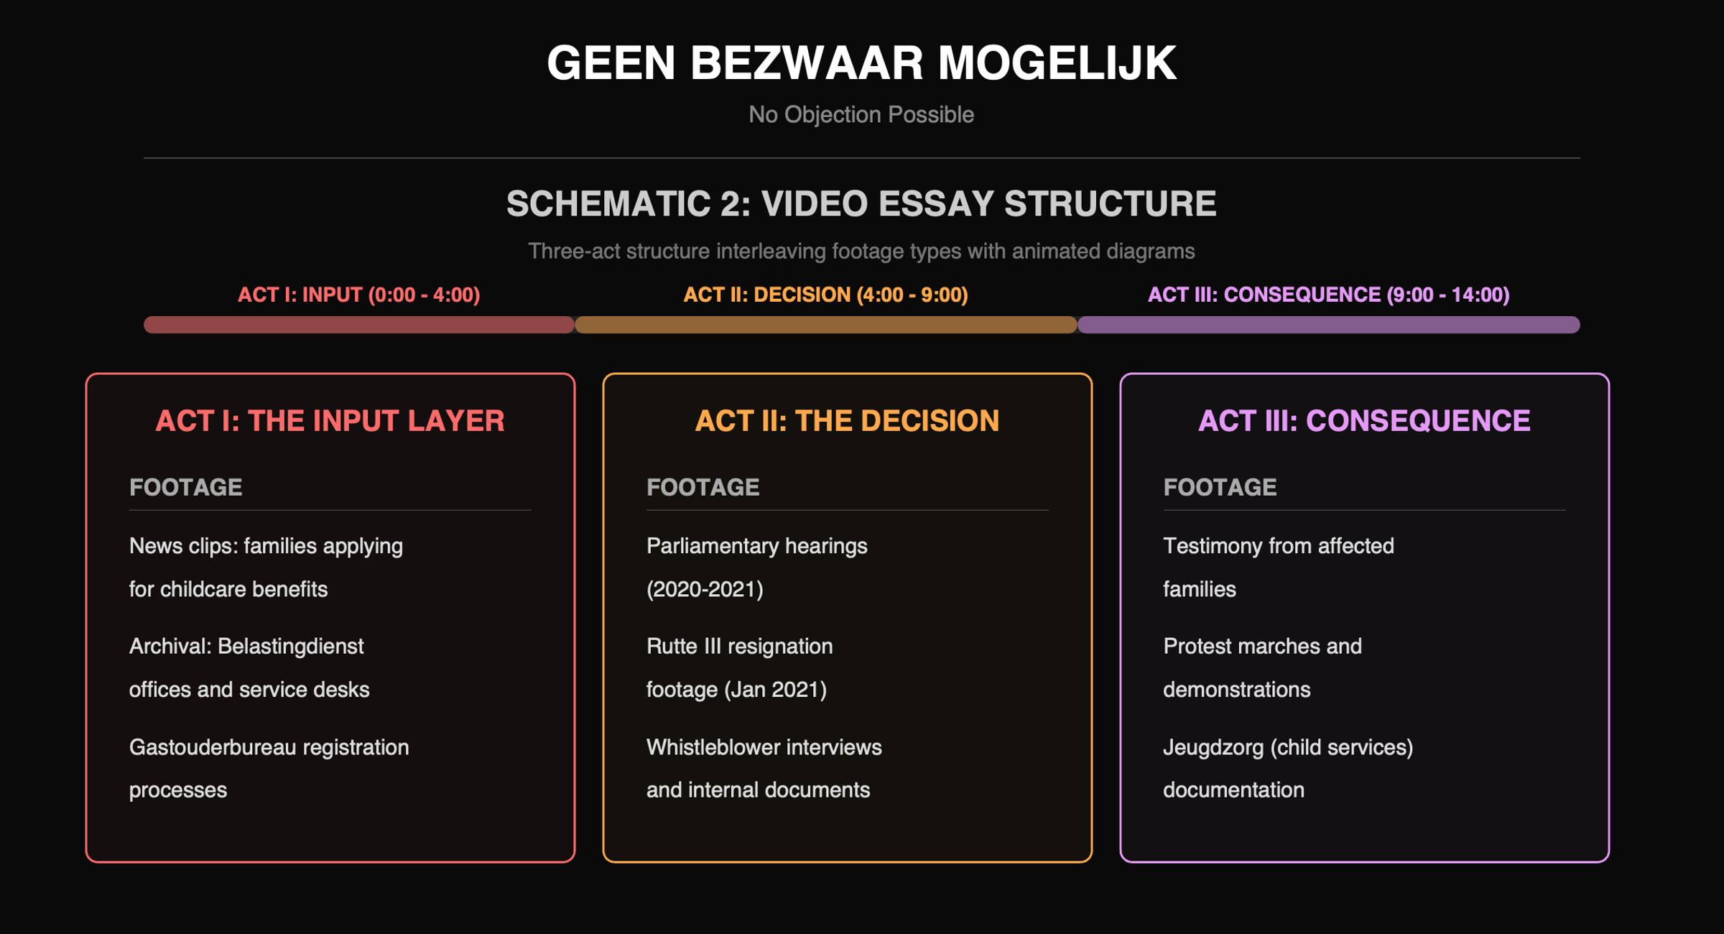

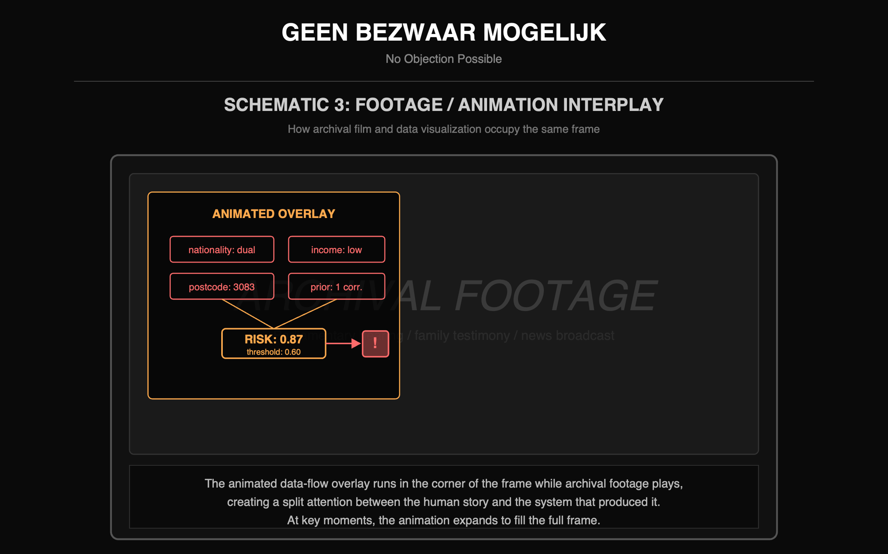

Biography
Ahnjili ZhuParris, PhD, is a published scientist, media researcher, computer vision AI engineer, and computational artist. She builds interactive tools and installations that make AI ethics tangible for non-experts. Her work has been supported by the Mozilla Foundation, IMPAKT, Constant, and the Processing Foundation, and shown at Ars Electronica, Identity2.0, and the CICA Museum. She holds a PhD in Medicine from Leiden University and an MSc in Cognitive Neuroscience from Radboud University. artificialnouveau.github.io | futurewake.com

