Library Project Management Database

TEAM 1

Hector Trevino

Kosuke Satake

Muna Bhattarai

**Honor Code:**

I pledge, on my honor, to uphold UT Arlington’s tradition of academic integrity, a tradition that values

hard work and honest effort in the pursuit of academic excellence.

I promise that I will submit only work that I personally create or that I contribute to group collaborations,

and I will appropriately reference any work from other sources. I will follow the highest standards of

integrity and uphold the spirit of the Honor Code.

**Task 1**

**Query 1. Add an extra column ‘Late’ to the Book_Loan table. Values will be 0-for non-late returns, and 1-for late returns. Then update the ‘Late’ column with '1' for all records that have a return date later than the due date and with '0' for those that were returned on time:**

ALTER TABLE BOOK_LOANS

ADD COLUMN Late INT;

UPDATE BOOK_LOANS

SET Late = CASE

WHEN Returned_date > Due_Date THEN 1

ELSE 0

END;

(21 records returned, 21 records affected)

**Query 2. Add an extra column ‘LateFee’ to the Library_Branch table, decide the late fee per day for each branch and update that column:**

ALTER TABLE LIBRARY_BRANCH

ADD COLUMN LateFee DECIMAL(8, 2);

UPDATE LIBRARY_BRANCH

SET LateFee = CASE

WHEN Branch_Id = 1 THEN 0.50

WHEN Branch_Id = 2 THEN 0.75

WHEN Branch_Id = 3 THEN 0.60

ELSE 0.00

END;

(3 records returned, 3 records affected)

**Query 3. Create a view vBookLoanInfo that retrieves all information per book loan:**

CREATE VIEW vBookLoanInfo AS

SELECT

BL.Card_No,

BORROWER.Name AS Borrower_Name,

BL.Date_Out,

BL.Due_Date,

BL.Returned_date,

CAST((julianday(BL.Returned_date) - julianday(BL.Date_Out)) AS INTEGER) AS TotalDays,

BOOK.Title AS Book_Title,

CASE WHEN BL.Returned_date > BL.Due_Date THEN CAST((julianday(BL.Returned_date) - julianday(BL.Due_Date)) AS INTEGER) ELSE 0 END AS DaysReturnedLate,

BL.Branch_Id,

CASE WHEN BL.Returned_date > BL.Due_Date THEN LIBRARY_BRANCH.LateFee * CAST((julianday(BL.Returned_date) - julianday(BL.Due_Date)) AS INTEGER) ELSE 0 END AS LateFeeBalance

FROM

BOOK_LOANS BL

JOIN

BORROWER ON BL.Card_No = BORROWER.Card_No

JOIN

BOOK ON BL.Book_Id = BOOK.Book_Id

JOIN

LIBRARY_BRANCH ON BL.Branch_Id = LIBRARY_BRANCH.Branch_Id;

(21 records returned, 21 records affected)

**Task 2**

**Requirements:**

1. **User checks out a book, add it to Book_Loan, the number of copies needs to be updated via trigger in the Book_Copies table. Show the output of the updated Book_Copies:**

Trigger.sql:

CREATE TRIGGER IF NOT EXISTS update_book_copies_after_loan

AFTER INSERT ON BOOK_LOANS

FOR EACH ROW

BEGIN

UPDATE BOOK_COPIES

SET No_Of_Copies = No_Of_Copies - 1

WHERE Book_Id = NEW.Book_Id AND Branch_Id = NEW.Branch_Id;

END;

GUI_Check_Out.py:

import sqlite3

import tkinter as tk

from datetime import datetime, timedelta

from dateutil.relativedelta import relativedelta

def execute_sql_file(file_path, db_path):

conn = sqlite3.connect(db_path)

cursor = conn.cursor()

with open(file_path, 'r') as sql_file:

sql_script = sql_file.read()

cursor.executescript(sql_script)

conn.commit()

conn.close()

def checkout_book(db_path, book_id, branch_id, card_no, date_out, due_date):

conn = sqlite3.connect(db_path)

cursor = conn.cursor()

cursor.execute("""

INSERT INTO BOOK_LOANS (Book_Id, Branch_Id, Card_No, Date_Out, Due_Date)

VALUES (?, ?, ?, ?, ?)

""", (book_id, branch_id, card_no, date_out, due_date))

conn.commit()

conn.close()

def on_checkout():

# Calculate due date as one month from date_out

date_out = datetime.strptime(date_out_entry.get(), "%Y-%m-%d")

due_date = date_out + relativedelta(months=1)

# Perform checkout

checkout_book(

db_path=db_path,

book_id=int(book_id_entry.get()),

branch_id=int(branch_id_entry.get()),

card_no=int(card_no_entry.get()),

date_out=date_out.strftime("%Y-%m-%d"),

due_date=due_date.strftime("%Y-%m-%d")

)

# Confirmation message

result_label.config(text="Book checked out successfully.")

# Path to your SQLite database

db_path = 'CSE3330.db'

# Execute the trigger creation script

execute_sql_file('1.Trigger.sql', db_path)

# Tkinter GUI setup

root = tk.Tk()

root.title("Book Checkout")

tk.Label(root, text="Book ID:").pack()

book_id_entry = tk.Entry(root)

book_id_entry.pack()

tk.Label(root, text="Branch ID:").pack()

branch_id_entry = tk.Entry(root)

branch_id_entry.pack()

tk.Label(root, text="Card No:").pack()

card_no_entry = tk.Entry(root)

card_no_entry.pack()

tk.Label(root, text="Date Out (YYYY-MM-DD):").pack()

date_out_entry = tk.Entry(root)

date_out_entry.pack()

checkout_button = tk.Button(root, text="Checkout", command=on_checkout)

checkout_button.pack()

result_label = tk.Label(root, text="")

result_label.pack()

root.mainloop()

GUI_BC.py:

import sqlite3

import tkinter as tk

from tkinter import ttk

# Connect to your database

connection = sqlite3.connect('CSE3330.db')

# Query the BOOK_COPIES table

query = "SELECT * FROM BOOK_COPIES"

cursor = connection.cursor()

cursor.execute(query)

rows = cursor.fetchall()

# Set up the GUI

root = tk.Tk()

root.title("Book Copies")

# Create a treeview to display the data

tree = ttk.Treeview(root, columns=('Book_Id', 'Branch_Id', 'No_Of_Copies'), show='headings')

tree.heading('Book_Id', text='Book ID')

tree.heading('Branch_Id', text='Branch ID')

tree.heading('No_Of_Copies', text='Number of Copies')

# Insert the data into the treeview

for row in rows:

tree.insert('', tk.END, values=row)

tree.pack(expand=True, fill='both')

# Start the GUI loop

root.mainloop()

# Close the database connection

connection.close()

Screenshot:

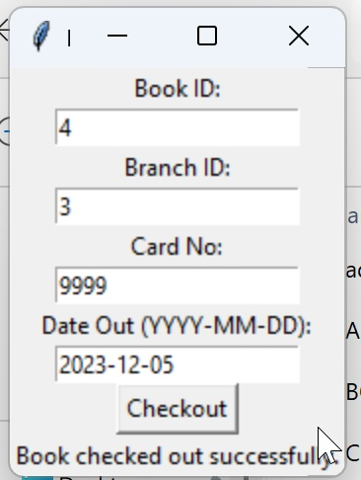

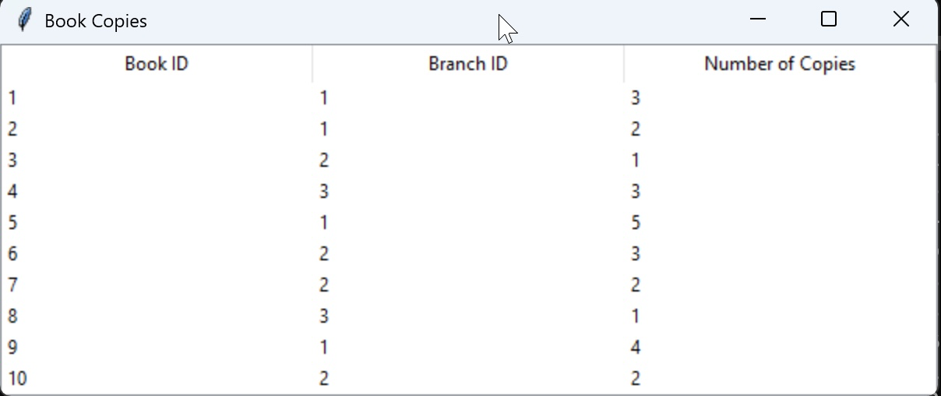

1. **Add information about a new Borrower. Do not provide the CardNo in your query. Output the card number as if you are giving a new library card. Submit your editable SQL query that your code executes:**

2.Add_BORROWER.sql:

INSERT INTO BORROWER (Name, Address, Phone)

VALUES (?, ?, ?);

GUI_Borrower.py:

import sqlite3

import tkinter as tk

from tkinter import messagebox

def insert_borrower(name, address, phone, file_path='2.Add_BORROWER.sql'):

try:

# Read SQL command from the file

with open(file_path, 'r') as file:

sql_command = file.read()

# Connect to the SQLite database

conn = sqlite3.connect('CSE3330.db')

cursor = conn.cursor()

# Execute the SQL command with the provided parameters

cursor.execute(sql_command, (name, address, phone))

conn.commit()

# Retrieve the last inserted row ID (card number)

card_number = cursor.lastrowid

messagebox.showinfo("Success", f"Borrower added successfully!\nCard Number: {card_number}")

except sqlite3.Error as error:

messagebox.showerror("Error", f"Error occurred: {error}")

finally:

conn.close()

def on_submit():

name = name_entry.get()

address = address_entry.get()

phone = phone_entry.get()

insert_borrower(name, address, phone)

# GUI Setup

root = tk.Tk()

root.title("Add Borrower")

# Labels and Entry Widgets

tk.Label(root, text="Name").grid(row=0, column=0)

name_entry = tk.Entry(root)

name_entry.grid(row=0, column=1)

tk.Label(root, text="Address").grid(row=1, column=0)

address_entry = tk.Entry(root)

address_entry.grid(row=1, column=1)

tk.Label(root, text="Phone").grid(row=2, column=0)

phone_entry = tk.Entry(root)

phone_entry.grid(row=2, column=1)

# Submit Button

submit_button = tk.Button(root, text="Submit", command=on_submit)

submit_button.grid(row=3, column=0, columnspan=2)

# Run the application

root.mainloop()

Screenshot:

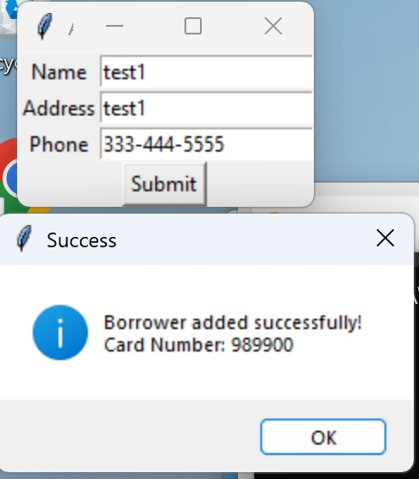

1. **Add a new Book with publisher (can use a publisher that already exists) and author information to all 5 branches with 5 copies for each branch:**

3.Add_BOOK.sql:

-- Insert a new book

INSERT INTO BOOK (Title, Publisher_name) VALUES (?, ?);

-- Insert author information

INSERT INTO BOOK_AUTHORS (Book_Id, Author_Name) VALUES (?, ?);

-- Insert book copies into each branch

INSERT INTO BOOK_COPIES (Book_Id, Branch_Id, No_Of_Copies) VALUES (?, ?, ?);

GUI_ADD_BOOK.py:

import sqlite3

import tkinter as tk

from tkinter import messagebox

def add_book(title, publisher_name, author_name, file_path='3.Add_BOOK.sql'):

try:

conn = sqlite3.connect('CSE3330.db')

cursor = conn.cursor()

# Read SQL commands from the file

with open(file_path, 'r') as file:

# Assuming the file has the queries in the correct order and format

insert_book_query, insert_author_query, insert_copies_query = file.read().split(';')[:-1]

# Insert the book and get the book_id

cursor.execute(insert_book_query, (title, publisher_name))

book_id = cursor.lastrowid

# Insert author information

cursor.execute(insert_author_query, (book_id, author_name))

# Insert book copies into each branch

for branch_id in range(1, 6):

cursor.execute(insert_copies_query, (book_id, branch_id, 5))

conn.commit()

messagebox.showinfo("Success", "Book added successfully to all branches!")

except sqlite3.Error as error:

conn.rollback()

messagebox.showerror("Error", f"Error occurred: {error}")

finally:

conn.close()

def on_submit():

title = title_entry.get()

publisher_name = publisher_entry.get()

author_name = author_entry.get()

add_book(title, publisher_name, author_name)

# GUI Setup

root = tk.Tk()

root.title("Add Book to Branches")

# Labels and Entry Widgets

tk.Label(root, text="Title").grid(row=0, column=0)

title_entry = tk.Entry(root)

title_entry.grid(row=0, column=1)

tk.Label(root, text="Publisher Name").grid(row=1, column=0)

publisher_entry = tk.Entry(root)

publisher_entry.grid(row=1, column=1)

tk.Label(root, text="Author Name").grid(row=2, column=0)

author_entry = tk.Entry(root)

author_entry.grid(row=2, column=1)

# Submit Button

submit_button = tk.Button(root, text="Submit", command=on_submit)

submit_button.grid(row=3, column=0, columnspan=2)

# Run the application

root.mainloop()

Screenshot:

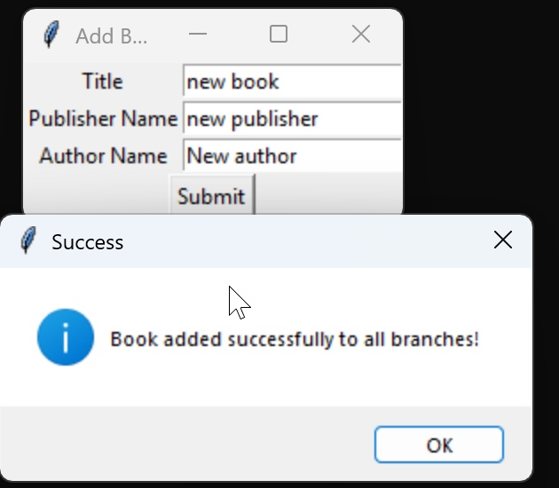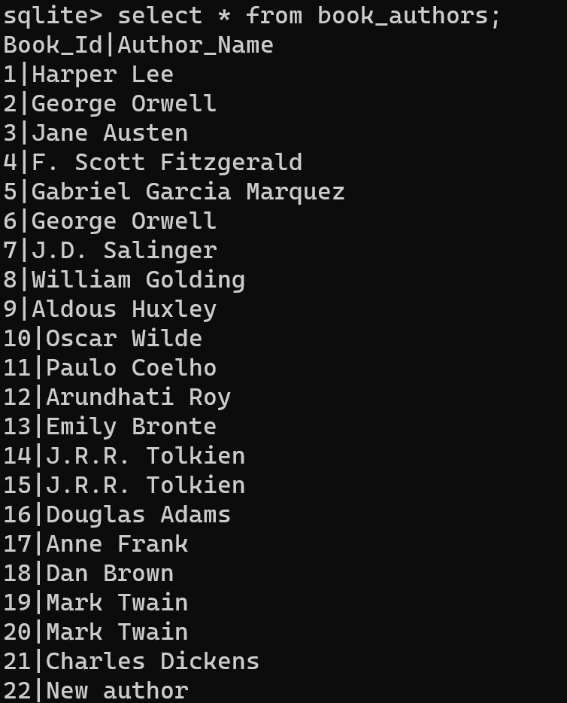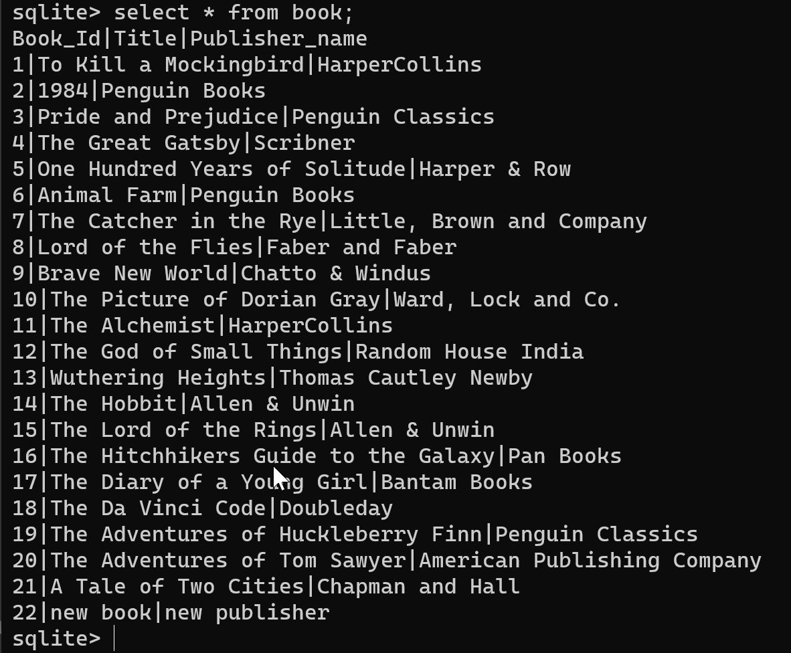

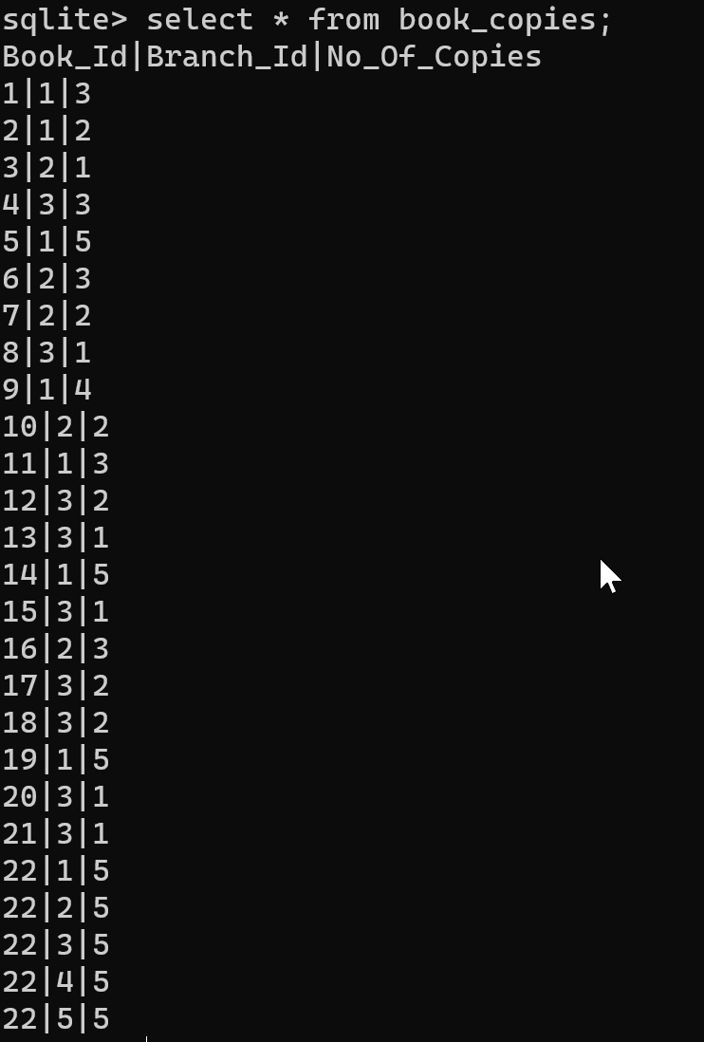

1. **Given a book title list the number of copies loaned out per branch:**

GUI_No_of_Copies.py:

import tkinter as tk

import sqlite3

def find_loaned_out_copies(book_title):

# Connect to your SQLite database

conn = sqlite3.connect('CSE3330.db')

cursor = conn.cursor()

# Updated SQL query to find loaned out copies per branch

query = """

SELECT LB.Branch_Name, COUNT(*) as Loaned_Out_Copies

FROM BOOK B

INNER JOIN BOOK_LOANS BL ON B.Book_Id = BL.Book_Id

INNER JOIN LIBRARY_BRANCH LB ON BL.Branch_Id = LB.Branch_Id

LEFT JOIN BOOK_COPIES BC ON B.Book_Id = BC.Book_Id AND LB.Branch_Id = BC.Branch_Id

WHERE B.Title = ? AND BL.Returned_date IS NULL

GROUP BY LB.Branch_Name;

"""

# Execute the query

cursor.execute(query, (book_title,))

results = cursor.fetchall()

# Close the database connection

conn.close()

return results

def on_search():

book_title = title_entry.get()

results = find_loaned_out_copies(book_title)

result_text = '\n'.join([f"{branch}: {count} copies" for branch, count in results])

result_label.config(text=result_text)

# Set up the GUI

root = tk.Tk()

root.title("Book Loan Search")

tk.Label(root, text="Enter Book Title:").pack()

title_entry = tk.Entry(root)

title_entry.pack()

search_button = tk.Button(root, text="Search", command=on_search)

search_button.pack()

result_label = tk.Label(root, text="", justify=tk.LEFT)

result_label.pack()

# Start the GUI loop

root.mainloop()

Screenshot:

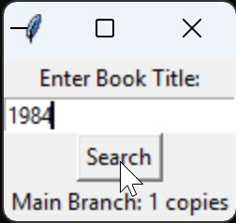

1. **Given any due date range list the Book_Loans that were returned late and how many days they were late:**

5.late_returns.sql:

SELECT BL.Book_Id, BL.Branch_Id, BL.Card_No, BL.Due_Date, BL.Returned_date,

JULIANDAY(BL.Returned_date) - JULIANDAY(BL.Due_Date) AS Days_Late

FROM BOOK_LOANS BL

WHERE BL.Returned_date > BL.Due_Date

AND BL.Due_Date BETWEEN ? AND ?

GUI_Due_Date_Range.py:

import tkinter as tk

import sqlite3

from datetime import datetime

def find_late_returns(start_date, end_date):

# Connect to your SQLite database

conn = sqlite3.connect('CSE3330.db')

cursor = conn.cursor()

# Read the SQL query from the file

with open('5.late_returns.sql', 'r') as file:

query = file.read()

# Execute the query

cursor.execute(query, (start_date, end_date))

results = cursor.fetchall()

# Close the database connection

conn.close()

return results

# Execute the query

cursor.execute(query, (start_date, end_date))

results = cursor.fetchall()

# Close the database connection

conn.close()

return results

def on_search():

start_date = start_date_entry.get()

end_date = end_date_entry.get()

results = find_late_returns(start_date, end_date)

result_text = '\n'.join([f"Book ID: {book_id}, Branch ID: {branch_id}, Card No: {card_no}, Due: {due}, Returned: {returned}, Days Late: {days_late}"

for book_id, branch_id, card_no, due, returned, days_late in results])

result_label.config(text=result_text)

# Set up the GUI

root = tk.Tk()

root.title("Late Book Returns Search")

tk.Label(root, text="Enter Start Date (YYYY-MM-DD):").pack()

start_date_entry = tk.Entry(root)

start_date_entry.pack()

tk.Label(root, text="Enter End Date (YYYY-MM-DD):").pack()

end_date_entry = tk.Entry(root)

end_date_entry.pack()

search_button = tk.Button(root, text="Search", command=on_search)

search_button.pack()

result_label = tk.Label(root, text="", justify=tk.LEFT)

result_label.pack()

# Start the GUI loop

root.mainloop()

Screenshot:

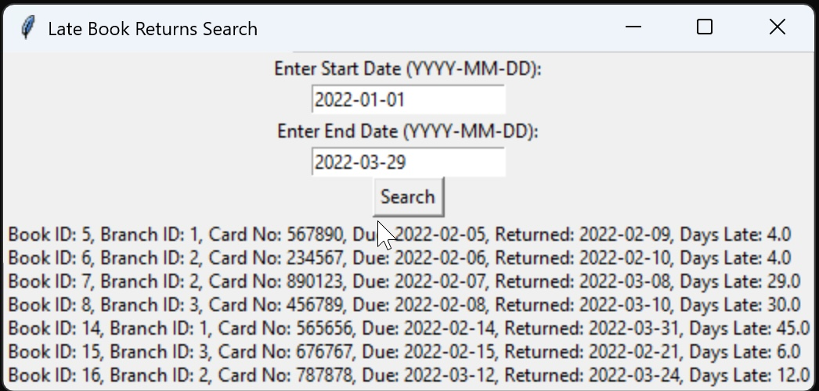

**6a. List for every borrower the ID, name, and if there is any lateFee balance. The user has the**

**right to search either by a borrower ID, name, part of the name, or to run the query with no**

**filters/criteria. The amount needs to be in US dollars. For borrowers with zero (0) or NULL**

**balance, you need to return zero dollars ($0.00):**

import tkinter as tk

from tkinter import ttk

import sqlite3

def execute_query(user_id=None, user_name=None):

conn = sqlite3.connect('CSE3330.db')

cursor = conn.cursor()

# Read the SQL query from the file

with open('6.List_for_Every_Borrower.sql', 'r') as file:

query = file.read()

cursor.execute(query, (user_id, user_name, user_id, user_name))

results = cursor.fetchall()

conn.close()

return results

def run_query():

user_id_input = entry_id.get()

user_name_input = entry_name.get()

results = execute_query(user_id_input or None, user_name_input or None)

# Clear the existing treeview content

for row in tree.get_children():

tree.delete(row)

# Populate the treeview with new results

for result in results:

tree.insert('', 'end', values=result)

# GUI setup

root = tk.Tk()

root.title("Borrower Query GUI")

# Entry fields for user input

label_id = tk.Label(root, text="Borrower ID:")

label_name = tk.Label(root, text="Borrower Name:")

entry_id = tk.Entry(root)

entry_name = tk.Entry(root)

# Button to run the query

query_button = tk.Button(root, text="Run Query", command=run_query)

# Treeview to display results

tree_columns = ("Borrower ID", "Borrower Name", "Late Fee Balance")

tree = ttk.Treeview(root, columns=tree_columns, show="headings")

for col in tree_columns:

tree.heading(col, text=col)

tree.column(col, anchor="center", width=100)

# Pack widgets

label_id.grid(row=0, column=0, padx=10, pady=5, sticky="e")

entry_id.grid(row=0, column=1, padx=10, pady=5)

label_name.grid(row=1, column=0, padx=10, pady=5, sticky="e")

entry_name.grid(row=1, column=1, padx=10, pady=5)

query_button.grid(row=2, column=0, columnspan=2, pady=10)

tree.grid(row=3, column=0, columnspan=2, padx=10, pady=10)

# Run the GUI

root.mainloop()

Screenshot:

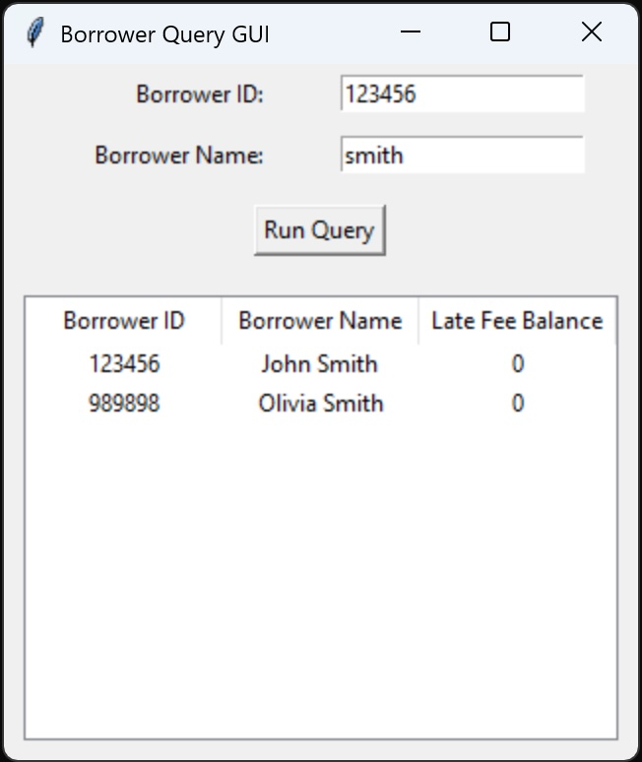

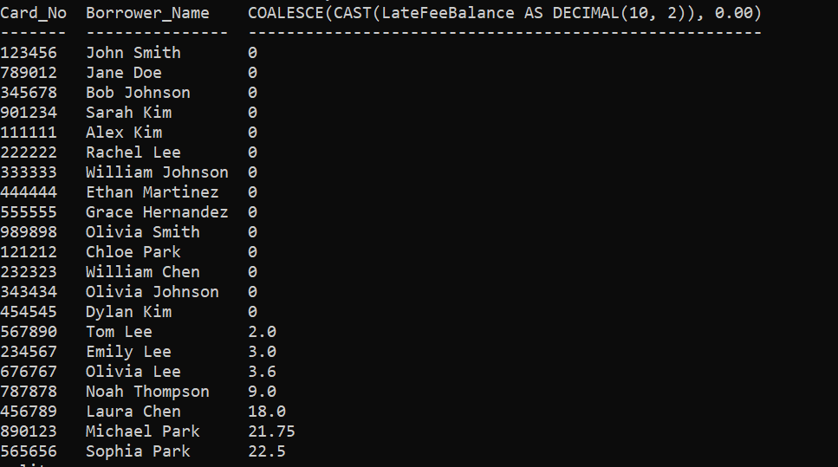

**6b. List book information in the view. The user must search with borrowerID and any of the**

**following search items: book id, books title, part of book title, or to run the query with no**

**filters/criteria. The late fee amount needs to be in US dollars. The late fee price amount needs**

**to have two decimals as well as the dollar ‘$’ sign. For books that they do not have any late**

**fee amount, you need to substitute the NULL value with a ‘Non-Applicable’ text:**

from tkinter import *

import sqlite3

from tkinter import ttk

def create_view():

conn = sqlite3.connect('CSE3330.db')

cursor = conn.cursor()

# Read SQL query from an external file

with open('6ba.sql', 'r') as file:

sql_query = file.read()

# Create the view

cursor.execute(sql_query)

# Commit the changes and close the connection

conn.commit()

conn.close()

def execute_query(Card_No=None, Book_Id=None, Title=None):

conn = sqlite3.connect('CSE3330.db')

cursor = conn.cursor()

# Read SQL query from an external file

with open('6bb.sql', 'r') as file:

sql_query = file.read()

# Add the WHERE clause dynamically to the SQL query

sql_query += f"""

WHERE

(

Card_No = ? OR

Book_Id = ? OR

Title LIKE '%' || ? || '%' OR

? IS NULL AND ? IS NULL AND ? IS NULL

)

ORDER BY

LateFee DESC NULLS LAST;

"""

cursor.execute(sql_query, (Card_No, Book_Id, Title, Card_No, Book_Id, Title))

results = cursor.fetchall()

conn.close()

return results

def run_query():

Card_No_input = entry_Card_No.get()

Book_Id_input = entry_Book_Id.get()

Title_input = entry_Title.get()

results = execute_query(Card_No_input or None, Book_Id_input or None, Title_input or None)

# Clear the existing treeview content

for row in tree.get_children():

tree.delete(row)

# Populate the treeview with new results

for result in results:

tree.insert('', 'end', values=result)

# GUI setup

root = Tk()

root.title("Book Query GUI")

# Entry fields for user input

label_Card_No = Label(root, text="Borrower ID:")

label_Book_Id = Label(root, text="Book ID:")

label_Title = Label(root, text="Book Title:")

entry_Card_No = Entry(root)

entry_Book_Id = Entry(root)

entry_Title = Entry(root)

# Button to create view and run the query

create_view_button = Button(root, text="Create View", command=create_view)

query_button = Button(root, text="Run Query", command=run_query)

# Treeview to display results

tree_columns = ("Borrower ID", "Book ID", "Book Title", "Late Fee Amount")

tree = ttk.Treeview(root, columns=tree_columns, show="headings")

for col in tree_columns:

tree.heading(col, text=col)

tree.column(col, anchor="center", width=100)

# Pack widgets

label_Card_No.grid(row=0, column=0, padx=10, pady=5, sticky="e")

entry_Card_No.grid(row=0, column=1, padx=10, pady=5)

label_Book_Id.grid(row=1, column=0, padx=10, pady=5, sticky="e")

entry_Book_Id.grid(row=1, column=1, padx=10, pady=5)

label_Title.grid(row=2, column=0, padx=10, pady=5, sticky="e")

entry_Title.grid(row=2, column=1, padx=10, pady=5)

create_view_button.grid(row=3, column=0, pady=5)

query_button.grid(row=3, column=1, pady=5)

tree.grid(row=4, column=0, columnspan=2, padx=10, pady=10)

# Run the GUI

root.mainloop()

Screenshot:

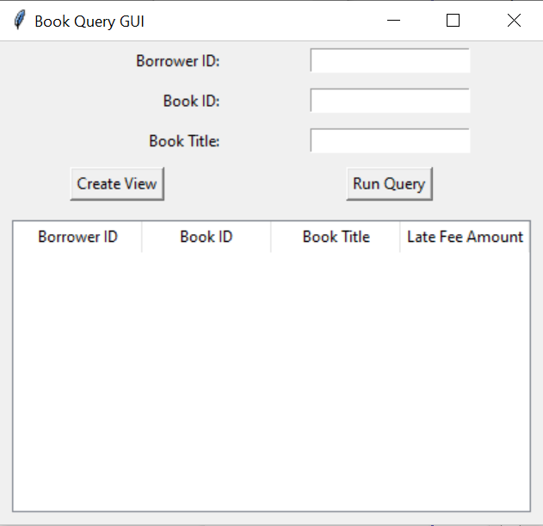

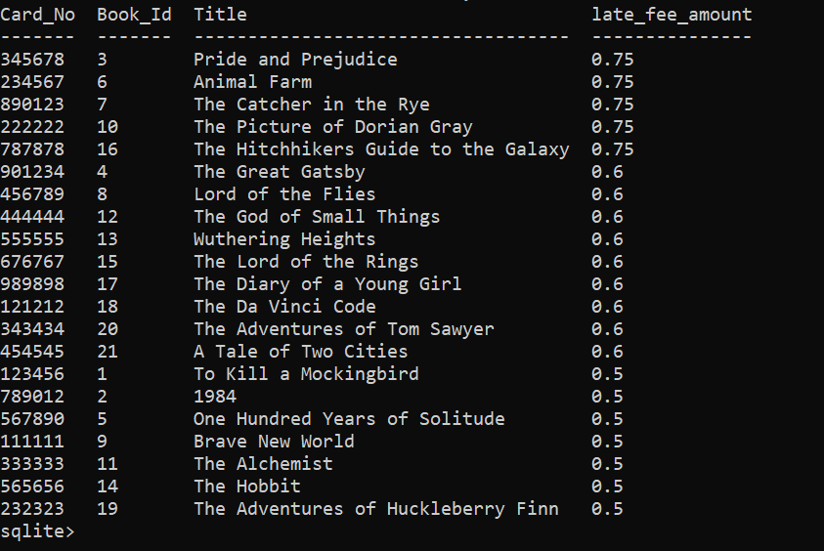

Contribution:

Trevino Hector: Task 1, Documentation

Kosuke Satake: Task 2, Documentation

Muna Bhattarai: Task 2, Documentation