Assignment4

Arti Mahaldar

2021-10-09

# Markdown Basics

# Favorite Food

Pizza  
Fruits  
Chicken

# Images

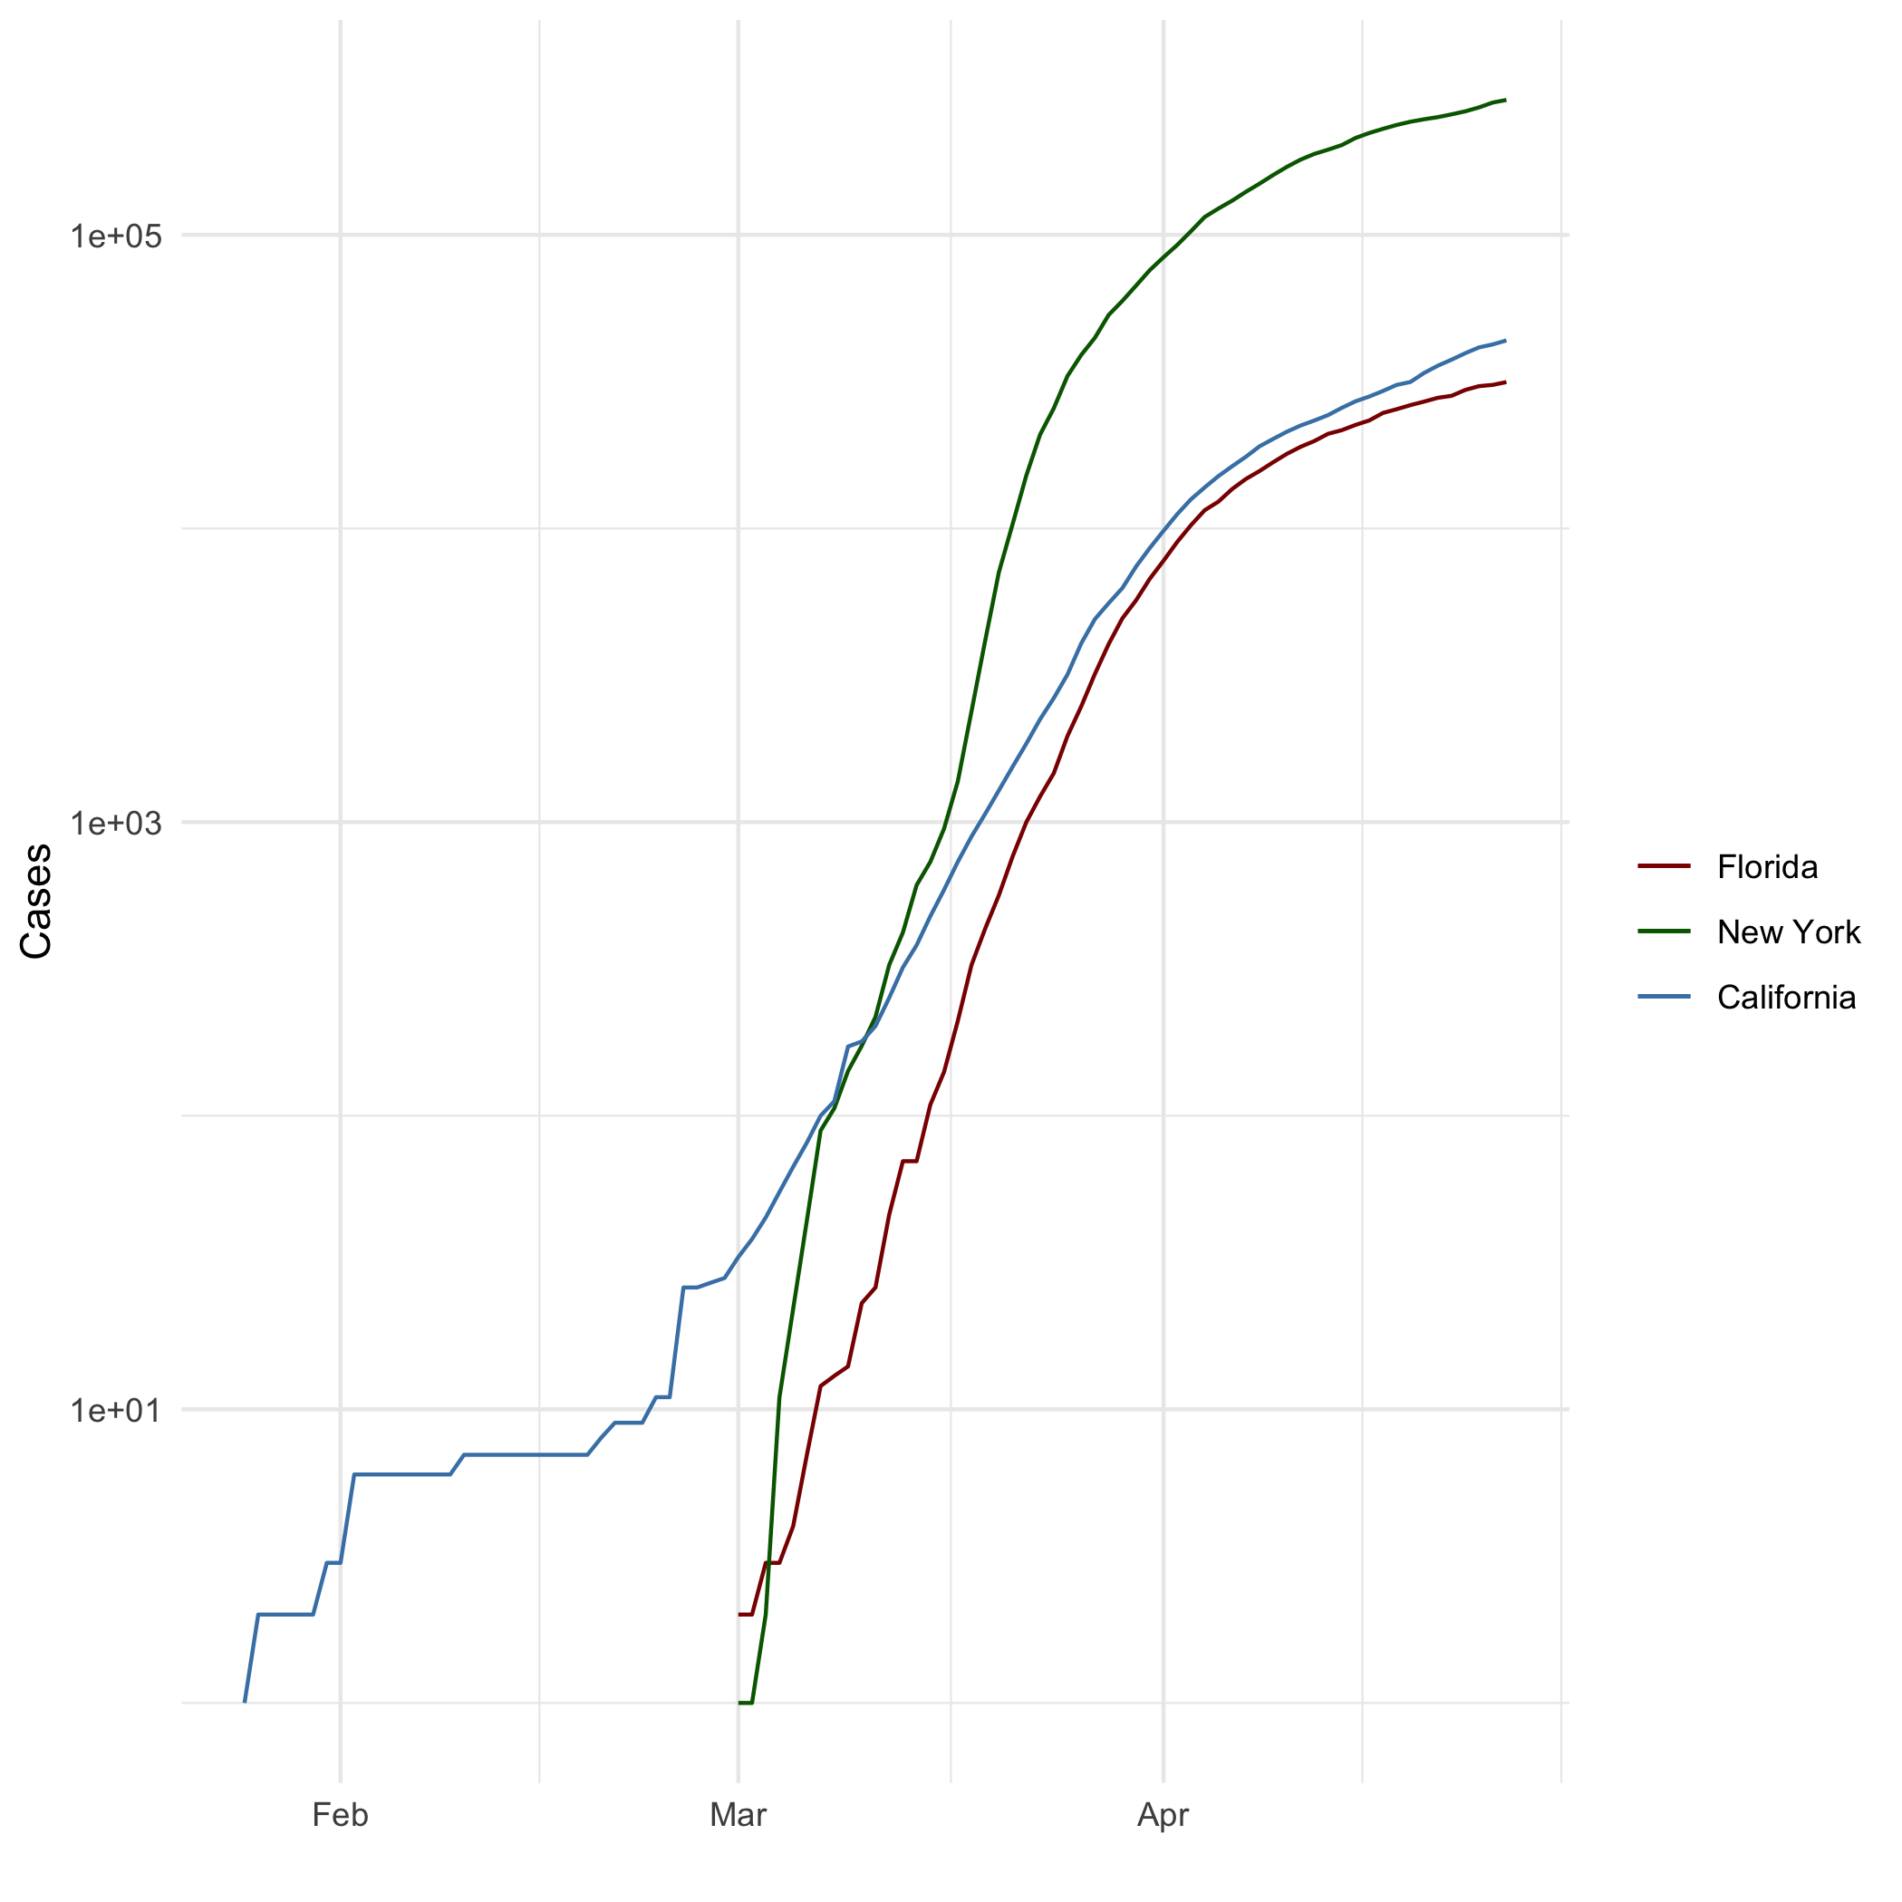

All cases log plot

# Add a Quote

In three words I can sum up everything I’ve learned about life: it goes on

# Add an Equation

$$E=mc^{2}$$

$$f(x)=β_{0}+β_{1}x+β_{2}x^{2}+β_{3}x^{3}+β_{4}(x-ξ)_{+}^{3}$$

$$(x-ξ)_{+}^{3}=\left\{\begin{matrix}(x-ξ)^{3} , & x>ξ \\ 0, & x≤ξ\end{matrix}\right.$$

$$\begin{matrix}(x≤ξ)⇒f(x) & =β_{0}+β_{1}x+β_{2}x^{2}+β_{3}x^{3} \\ (x>ξ)⇒f(x) & =β_{0}+β_{1}x+β_{2}x^{2}+β_{3}x^{3}+β_{4}(x^{3}-3x^{2}ξ+3xξ^{2}-ξ^{3}) \\ & =(β_{0}+β_{4}ξ^{3})+(β_{1}+3β_{4}ξ^{2})x+(β_{2}-3β_{4})\end{matrix}$$

# Add a Footnote

This is a footnote [1].

# Add citations

R for Everyone  
Discovering Statistics Using R

# Inline code

## NY Times COVID-19 Data

## R4DS Height vs Earnings

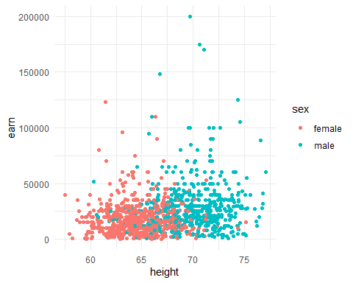

## Knitr Table with Kable

One Ring to Rule Them All

|  |  |  |  |  |
| --- | --- | --- | --- | --- |
| name | race | in_fellowship | ring_bearer | age |
| Aragon | Men | TRUE | FALSE | 88 |
| Bilbo | Hobbit | FALSE | TRUE | 129 |
| Frodo | Hobbit | TRUE | TRUE | 51 |
| Galadriel | Elf | FALSE | FALSE | 7000 |
| Sam | Hobbit | TRUE | TRUE | 36 |
| Gandalf | Maia | TRUE | TRUE | 2019 |
| Legolas | Elf | TRUE | FALSE | 2931 |
| Sauron | Maia | FALSE | TRUE | 7052 |
| Gollum | Hobbit | FALSE | TRUE | 589 |
|  |  |  |  |  |

## Pandoc Table

##   
##   
## name race in_fellowship ring_bearer age   
## ----------- -------- --------------- ------------- ------  
## Aragon Men Yes No 88   
## Bilbo Hobbit No Yes 129   
## Frodo Hobbit Yes Yes 51   
## Galadriel Elf No No 7000   
## Sam Hobbit Yes Yes 36   
## Gandalf Maia Yes Yes 2019   
## Legolas Elf Yes No 2931   
## Sauron Maia No Yes 7052   
## Gollum Hobbit No Yes 589

Note that the echo = FALSE parameter was added to the code chunk to prevent printing of the R code that generated the plot.

# References

Field, A., J. Miles, and Z. Field. 2012. *Discovering Statistics Using R*. SAGE Publications. <https://books.google.com/books?id=wd2K2zC3swIC>.

Lander, J. P. 2014. *R for Everyone: Advanced Analytics and Graphics*. Addison-Wesley Data and Analytics Series. Addison-Wesley. <https://books.google.com/books?id=3eBVAgAAQBAJ>.

1. This is a footnote in R markdown